**CARLOS HILADO MEMORIAL STATE UNIVERSITY TENANT MANAGEMENT SYSTEM**

_______________

A Capstone Project

Presented to the Faculty of

College of Business Management and Accountancy

Carlos Hilado Memorial State College,

Bacolod City

_______________

In Partial Fulfillment

of the Requirement for the Degree

Bachelor of Science in Information System

_______________

by:

Balansa Joshua D.

Lagos James O.

Ibabao Carl E.

January 2023

**TECHNICAL EDITOR**

This is to certify that the undersigned has reviewed and went through all the pages of the CAPSTONE PROJECT **CARLOS HILADO MEMORIAL STATE UNIVERSITYTENANT MANAGEMENT SYSTEM,** as in conformity with the set of rules that govern the composition of writing research.

Conforme:

________________________________   
**James O. Lagos**

Project Team Leader

APPROVAL SHEET

This Capstone Project entitled, **CARLOS HILADO MEMORIAL STATE UNIVERSITY TENANT MANAGEMENT SYSTEM** prepared and submitted by **Joshua D. Balansa, James O. Lagos, Carl E. Ibabao** in partial fulfillment of the requirements for the degree Bachelor of Science in Information Systems, has been examined and approved for Oral Examination.

|  |  |
| --- | --- |
|  | **ISAGANI M. AGUDO, PhD** |
|  | Capstone Adviser |

**PANEL OF EXAMINERS**

Approved by the Committee on Oral Examination with a grade of **PASSED** on

January 2021

**ARNEL C. MAGHINAY, PhD**

Chairman

|  |  |
| --- | --- |
| **ALFONSO D. SALES, JR., PhD** | **RYAN J. DELA GENTE, PhD** |
| Member | Member |

Accepted and approved in partial fulfillment of the requirements for the Degree Bachelor of Science in Information Systems.

**KENROSE S. LAGUYO, CPA, MBA**

Officer in-Charge, College of Business Management and Accountancy

**COORDINATOR'S ACCEPTANCE SHEET**

The Capstone Project

**CARLOS HILADO MEMORIAL STATE UNIVERSITY TENANT MANAGEMENT SYSTEM**

After having been recommended and approved by the panel of evaluators, is hereby accepted by the College of Business Management and Accountancy

**CARNIT GEORGE B. CORDOVA, PhD.**

Capstone Coordinator

January 2023

**DEAN'S ACCEPTANCE SHEET**

The Capstone Project

**CARLOS HILADO MEMORIAL STATE UNIVERSITY TENANT MANAGEMENT SYSTEM**

After having been recommended and approved by the panel of evaluators, is hereby accepted by the College of Business Management and Accountancy.

**KENROSE S. LAGUYO, CPA, MBA**

Officer in-Charge, College of Business Management and Accountancy

January 2023

ACKNOWLEDGMENT

We extend our sincere gratitude to our capstone adviser, Dr. Isagani M. Agudo, for his invaluable guidance and unwavering support throughout the entirety of our capstone project. We are truly grateful for his insightful advice, which has been instrumental in helping us achieve our academic goals. We would also like to express our heartfelt appreciation to our panelist Dr. Arnel C. Maghinay, Dr. Alfonso D. Sales Jr., Dr. Ryan J. Dela Gente and our capstone coordinator, Dr. Carnit George Cordova, for their unwavering passion, enthusiasm, and persistent efforts in ensuring that we work collaboratively and effectively towards fulfilling our project. They have gone above and beyond to help us complete our project, and for that, we are deeply grateful. To our parents and guardians, we extend our utmost thanks for their unwavering support, encouragement, and resources, which have enabled us to pursue and accomplish our academic goals. Their guidance and counsel have been invaluable in shaping our academic journey. We would also like to acknowledge and express our gratitude to our fellow participants, friends, and classmates who have been a constant source of support, encouragement, and motivation throughout our capstone project. Their unwavering support has been instrumental in helping us overcome the various difficulties, issues, and challenges that we encountered during the development of the system. Finally, we would like to express our gratitude to the Almighty God, who has been our guiding light throughout this entire journey.

TABLE OF CONTENTS

|  |  |
| --- | --- |
| **Title** | **Page** |
| ACKNOWLEDGMENT i  TABLE OF CONTENTS ii  LIST OF TABLES v  LIST OF FIGURES vi  ABSTRACT vii  CHAPTER I 1  INTRODUCTION 1  Background of the Study 2  Statement of the Objective 3  General Objective 3  Specific Objectives 3  Framework of the Study 4  Scope and Delimitation of the Study 5  Scope 5  Delimitation 5  Significance of the Study 6  Operational Definition of Terms 7  CHAPTER II 9  REVIEW OF RELATED LITERATURE 9  Local Studies 9  Bacolod North Public Market Stall Information System 9  Florete-Caperonce Realty Corporation University Dorm Management System 9  Iloilo Terminal Market Tenants Rental Monitoring System 10  Foreign Studies 11  Managing system and managing method for transferring data between tenants 11  Rental House Management System 11  House (Individual House/Apartment) Rental Management System 12  Related Systems 13  Synthesis 14  CHAPTER III 15  METHODOLOGY 15  Requirements Planning 16  User Design 17  Rapid Construction 17  Cutover 18  User's Acceptance Survey 18  Operational Feasibility 19  Front End 19  Back End 20  Technical Feasibility 21  Hardware Specification 21  Software Specification 21  Architectural Diagram 22  Physical View Diagram 23  Application Architecture Diagram 24  Feasibility Schedule 25  Work Breakdown 25  Cost Benefit Analysis 26  ERD Model 29  Data Flow Diagram 30  Data Dictionary 32  CHAPTER IV 34  Presentation of data, Results and Analysis 34  Presentation 34  Data Analysis 35  Participants of the Study 36  Interpretation of Data 37  Results 38  CHAPTER V 42  Summary of Findings, Conclusion and Recommendation 42  Summary of Findings 42  Conclusion 42  Recommendations 43  REFERENCES 44  APPENDICES 46  Survey Questionnaire 46  Complete Gantt Chart 47  Admin-side Screenshot 48  Client-side Screenshot 48  Supporting Document 48  Compliance Matrix 48  Curriculum Vitae 49 | |

LIST OF TABLES

|  |  |
| --- | --- |
| **Title** | **Page** |
| Table 1. Comparison of the Related Systems 13  Table 2. Minimum Hardware Requirements 21  Table 3. Minimum Software Requirements 21  Table 4. Gantt Chart 25  Table 5. Current Cost Benefit Analysis 26  Table 6. Current Cost Benefit Analysis 27  Table 7. Proposed Cost Benefit Analysis 27  Table 8. Proposed Cost Benefit Analysis 28  Table 9. Tenants 32  Table 10. Coordinators 32  Table 11. Users 32  Table 12. Payments 33  Table 13. Logs 33  Table 14. Distribution of respondents 36  **Respondents** 36  Table 15. Mean Distribution of the Respondent Responses on System Usefulness 38  Table 16. Mean Distribution of the Respondent Responses on Information Quality 39  Table 17. Mean Distribution of the Respondent Responses on Interface Quality. 40  Table 18. Mean Distribution of the Respondent Responses on System Usability 41 | |

LIST OF FIGURES

|  |  |
| --- | --- |
| **Title** | **Page** |
| Figure 1. Conceptual Framework of the Study 4  Figure 2. Rapid Application Development Model (RAD) 16  Figure 3. Architectural Diagram 22  Figure 4. Physical View Diagram 23  Figure 5. Application Architecture Diagram 24  Figure 6. Entity Relationship Diagram 29  Figure 7. Context Diagram 30  Figure 8. Data Flow Diagram 31 | |

ABSTRACT

This study focuses on developing a web-based Tenant Management System for the Carlos Hilado Memorial State University Talisay campus, designed to improve the management and monitoring of tenants. The system will simplify and streamline tenant management, from online tenant registration and real-time assessment of tenant requirements to generating tenant payment reports and email notifications. This proposed project helped enhance the Efficiency and effectiveness of the IGP Coordinator and provide an all-in-one platform in managing tenants. This project utilizes a conceptual framework and assesses the current tenant management system within the university to identify areas for improvement. Although the system has significant advantages but it has also limitations, such as users can only access it through the web, and it does not include automatic bill-paying and monitoring of tenant sales. the development process of the Tenant Management System for Carlos Hilado Memorial State University, which utilized the standard project process (SDLC) to identify existing problems and followed the rapid development method (RAD) to provide solutions. The proponents used their gained knowledge and insights to create designs and alter the software's direction, and the development process was divided into different stages. The Carlos Hilado Memorial State University Talisay Tenant Management System was developed to provide a fundamental monitoring mechanism for every individual, particularly the tenants. The system's ability to effectively monitor the tenants' activities and behaviors within the university's premises has garnered strong agreement among the participants, highlighting its potential usefulness in maintaining a secure and organized environment.

Keywords: Tenant Management System, Online registration, Real-time Assessment,

Efficiency and effectiveness, Web-based

CHAPTER I

INTRODUCTION

Tenant management at Carlos Hilado Memorial State University Talisay has been done manually, which has led to time-consuming and disorganized processes for managing and monitoring tenants. People desire a convenient and automated way of managing tenants, especially when applying online and monitoring and managing data. One of the key trends transforming organizations is digitalization, which affects how universities operate faster than manual processes (Parviainen et al., 2017).

As the amount of data available to organizations multiply, managing data effectively is becoming increasingly difficult. However, recent technological developments have greatly improved automated monitoring platforms (Booth John A, 2021).

To address these challenges, a web-based tenant management system can manage tenants within the campus, increasing productivity and improving the process of filling out the owner's manual for Carlos Hilado Memorial State University tenants. The system can work quickly and efficiently by storing information and data in a database, performing online assessments of tenant applications, storing tenant records and billing statements, and generating daily or monthly receipts and rental reports. This will reduce errors and make it easier to find data.

Background of the Study

The Carlos Hilado Memorial State University is a higher education institution in Bacolod City, Philippines. The university provides various academic programs and services to its students, faculty, and staff. As a government-funded institution, CHMSU relies on various sources of income, including tuition fees, research grants, and income from rental properties. One of the sources of income for the university is leasing the canteen to tenants within the campus.

Effective management of this rental is essential to ensure that they generate sufficient income for the university. However, managing tenants within the campus present unique challenges that require careful consideration. The university must ensure that the tenants abide by the rules and regulations set by the university, maintain the facilities in good condition, and pay rent on time. Failure to manage tenants effectively may result in financial losses, damages to university properties, and even legal issues.

Therefore, it is crucial to have an effective system in place to manage tenants manually within the Carlos Hilado Memorial State University, Talisay campus. This study aims to examine the current tenant management system in the university, identify areas for improvement, and recommend strategies to enhance the system's effectiveness. The findings of this study will be helpful for the university in enhancing its tenant management practices.

Statement of the Objective

General Objective

This project aims to create a comprehensive and user-friendly tenant management system for Carlos Hilado Memorial State University, Talisay campus. The system is designed to simplify and streamline the management of tenants, enhancing the Efficiency and effectiveness of the IGP Coordinator.

Specific Objectives

Specifically, this project aimed to develop a Tenant Management System for Carlos Hilado Memorial State University, Talisay campus of the following:

1. Online registration for tenants.
2. Real-time assessment of tenant requirements.
3. Management tenants’ information.
4. Generate tenant payment reports.
5. Email notification.
6. Data archiving of tenant records.
7. Evaluate the system's acceptability using the adopted survey instrument based on the Post-Study System Usability Questionnaire (PSSUQ)

Framework of the Study

The study utilized a conceptual framework, as depicted in Figure 1, which illustrates the relationship of the Carlos Hilado Memorial State University tenant management system. The primary objective of the framework is to provide users with a clear understanding of how the system operates and its functionality. The study's primary goal was to improve the process of tenant monitoring and management.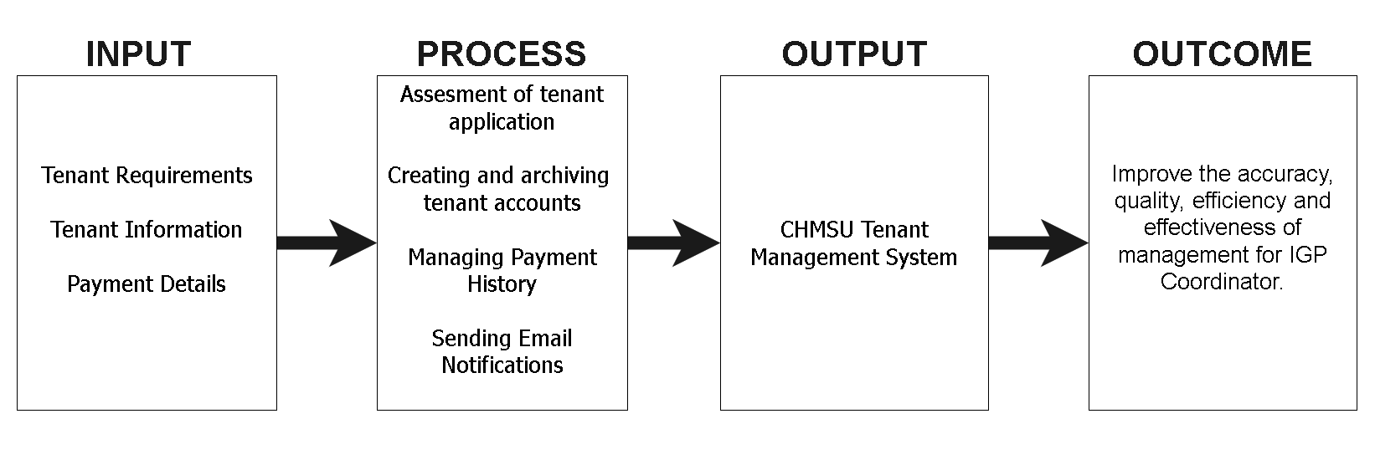

1. Conceptual Framework of the Study

Scope and Delimitation of the Study

The Carlos Hilado Memorial tenants' management system was developed to provide a more efficient and practical approach to managing the university's tenants. This system was specifically designed to cater to the unique needs of Carlos Hilado Memorial State University Talisay tenants.

Scope

The scope of this study is to assess the current tenant management system within the Carlos Hilado Memorial State University, Talisay campus, and identify areas for improvement of tenant management. It is designed to facilitate the IGP Coordinators and admin manage their data by automating and streamlining various tasks. The system aims to provide an all-in-one platform to manage tenants, online applications, tenant requirements assessment, payment history monitoring, and other related operations.

Delimitation

Although the Tenant Management System of Carlos Hilado Memorial State University Talisay has significant advantages, it has some limitations, including Users can only access the web. The system's effectiveness depends on the quality and availability of internet users who can only use the web to access it. Automatic bill payment and tenant sales monitoring are not features currently incorporated in the system.

Significance of the Study

The study aims to provide valuable insights to different groups of individuals who stand to benefit from the implementation of the Carlos Hilado Memorial State University Tenant Management System. This system was specifically developed to enhance the current process of monitoring tenants at the university and optimize its overall operations.

**Tenants**. The findings of this study are expected to bring significant benefits to tenants' businesses by enhancing their efficiency and effectiveness. The Carlos Hilado Memorial State University Tenant Management System is designed to facilitate electronic inquiries and payments, enabling tenants to manage their accounts with ease and convenience. This will allow tenants to focus on their core business activities while ensuring that their tenancy needs are met promptly and efficiently.

**IGP Coordinator**. The Carlos Hilado Memorial State University tenant management system was developed to serve as a valuable tool for the IGP Coordinator services in monitoring tenants' payment history and records. The system's advanced functionalities make it possible for the admin to track tenant information and generate reports with ease, allowing for a more streamlined and efficient tenant management process.

**University**. The Carlos Hilado Memorial State University Tenant Management System was specifically designed to replace the university's manual tenant management processes with a more streamlined and automated system. The system provides a comprehensive platform that allows for the easy monitoring of tenant data and payments, while also facilitating online tenant registration.

**Future Researcher**. This study presents an opportunity for the researcher to gain practical experience in project management within a real-world context. The Carlos Hilado Memorial State University Tenant Management System significantly contributes to the field, providing a foundation for future researchers who may encounter similar systems. The knowledge gained through this study is current and up-to-date, providing valuable insights into tenant management trends and practices.

Operational Definition of Terms

*Archiving* - Data archiving identifies inactive data and moves it from production systems to long-term storage technologies. Archival data is saved in order for it to be retrieved at any time.

*Email* Notification - an automated message sent via email to notify tenants and management of essential updates, deadlines, or events.

Functional Suitability - the extent to which the system meets specified functional requirements and user needs.

*Online* *Tenant Registration* - Registering tenants through an online platform typically involves submitting personal and contact information. This information is used to verify the tenant’s identity and to ensure that they are a good fit for the school. The information that is typically required includes the tenant’s name, address, phone number, email address, and social security number.

*Payment Reports* - a document that provides a summary of payments made by tenants, including rent, fees, and other charges.

*Real-time Tenant Assessment* - the real-time evaluation of tenant requirements and qualifications using a web-based platform

*Tenant Information Management* - collecting, storing, and managing tenant information in a centralized database.

*Performance* - the ability of the system to perform its intended functions efficiently and effectively under various conditions, such as high-volume usage or heavy data processing.

CHAPTER II

REVIEW OF RELATED LITERATURE

Local Studies

Bacolod North Public Market Stall Information System

This study aims to create a management system for market stalls that will handle public market transactions related to rent collection, such as tracking rental fees and generating lists of those who have paid. The system will also manage the market sections and allow the deletion of unnecessary vendor records. The study focuses on the Bacolod North Public Market Stall Information System, which provides information on each stall, stallholder, and common areas or facilities. It will automate vendor payments for rental charges and other market fees and provide the admin with information on the number of tenants in different categories. By monitoring rental fee due dates and generating payment lists, the system will manage the market sections and classify new tenants according to their payment mode and assigned sections. Overall, the system aims to simplify the process of managing market stalls and improve efficiency for administrators.

Florete-Caperonce Realty Corporation University Dorm Management System

This study looks at how SMS technology can be used to improve health. The study's focal point was a maternal health care program run by health centers in Pasay City, south of Manila. From the initial design to implementing an SMS appointment reminder system, health center staff were engaged. The system involved midwives enrolling pregnant patients in the maternal care program of the city for the SMS reminder system. The overall response from the patients and health center end-users was positive. Comparison with the manual tally of patients showed that the health centers had no difficulty adopting the system (Sarmiento et al., 2015).

Iloilo Terminal Market Tenants Rental Monitoring System

The Iloilo Terminal Market Rental Monitoring System is designed to improve rental collections and space management. It includes profiling modules for tenant information and billing statements, a mapping tool for finding available and unavailable spaces, and the ability to generate reports in various categories. The system can also send SMS notifications to clients with past-due or pending payments. Overall, the Iloilo Terminal Market Rental Monitoring System appears to be an effective solution that will streamline rental collections, space management, and reporting. It has the potential to improve the overall efficiency and profitability of the market, benefitting both tenants and the officer-in-charge (Pacheco, 2018).

.

Foreign Studies

Managing system and managing method for transferring data between tenants

Data storage, user information, and similar items are usually maintained in groups called tenants in cloud-based service systems, which corresponds to a specific area in the system for each client. A tenant can be a service provider that offers management/repair services and similar items for printers, multifunction peripherals, and the like to a client, a customer tenant owned by a customer such as a business or the like, and so forth (Kato, 2017).

Rental House Management System

According to Gommans et al., (2014). emphasizes the need for the housing sector to embrace technology to simplify the management of rental properties. The authors conducted a survey among rental home managers and found that all work was done manually, leading to significant paperwork. The article highlights the importance of creating a system for managing rental homes that can help rental managers work effectively and efficiently. The system should aim to streamline operations and reduce paperwork, making it easier for managers to handle rental properties.

House (Individual House/Apartment) Rental Management System

According to R.B. Shriram et al., (2019). This website application aids users in registering their own residence or flat to help you in locating the ideal rental residence or property. Additionally, we can locate your next rental using the search view in your target region. This website is made to meet all of our demands, whether we're buying, selling, renting, or property leasing and renting in India. We found the best opportunity to invest our entire life's worth of value here. Property enables us to keep the database of different property and agent information current

Related Systems

1. Comparison of the Related Systems

|  |  |  |  |  |  |
| --- | --- | --- | --- | --- | --- |
| Features | CHMSU Tenant Management System | Rental House Management System | Iloilo Terminal Market Tenants Rental Monitoring System | Bacolod Public Market Stall Information System | House Rental Management System |
| Online Application | ✓ | 🗶 | ✓ | 🗶 | ✓ |
| Monitoring of payments  records. | ✓ | ✓ | ✓ | ✓ | 🗶 |
| Real-time Application Assessment | ✓ | 🗶 | 🗶 | 🗶 | 🗶 |
| Manage and records data Process | ✓ | 🗶 | 🗶 | 🗶 | 🗶 |
| Real-time user logs | ✓ | ✓ | ✓ | ✓ | 🗶 |
| Email notification | ✓ | ✓ | 🗶 | 🗶 | 🗶 |
| Data Archiving | ✓ | 🗶 | 🗶 | 🗶 | 🗶 |
| Dynamic Report Generation | ✓ | ✓ | 🗶 | 🗶 | ✓ |

Synthesis

This system is based on research into both local and foreign systems, which served as a foundation for this study's development. It also lists the characteristics this system has and does not have.

The proponents' systems, the Carlos Hilado Memorial State University tenant management systems, are associated with the systems under discussion. The supporters thoroughly analyzed and evaluated the associated systems based on their modules and functionalities.

The related systems' proponents have recognized various features and elements that would make the suggested systems more cutting-edge, precise, and valuable for the university. Additionally, in order to improve the tenant management of Carlos Hilado Memorial State University, the proponents integrated several characteristics from relevant studies into the systems.

CHAPTER III

METHODOLOGY

In this chapter, the proponents discussed the process used to develop the Carlos Hilado Memorial State University tenant management system; the proposed method followed by the proponents is developing a standard project process (SDLC) to identify existing problems.

The proponents followed the rapid development method (RAD) to describe the current solutions to the problems. In this model, the stages have some connection, meaning many projects are happening simultaneously using the fast development process.

The proponents can use the knowledge and insights gained during the development process to create designs and change the direction of the software entirely. The software development process is divided into different processes. The main components of rapid software development are requirements planning, prototyping (user development and building), and failure.

.

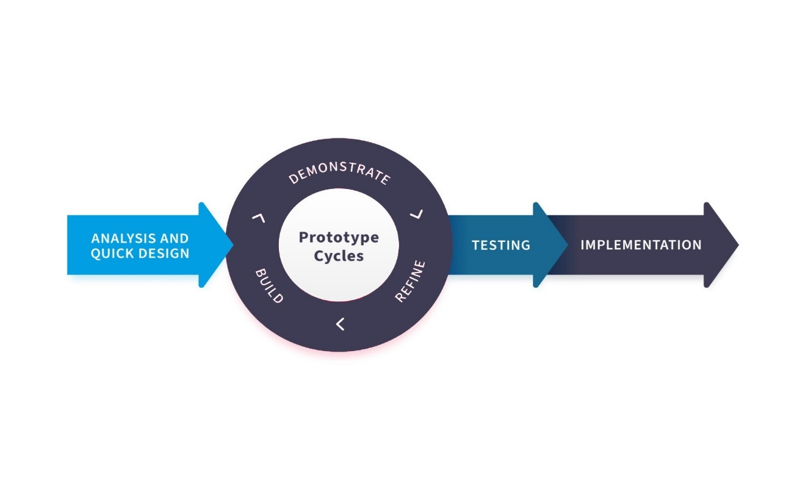

1. Rapid Application Development Model (RAD)

Requirements Planning

The early phase of any project is critical as it sets the foundation for the rest of the project. In the case of developing a new system, the first step is usually to delegate tasks and assignments among the proponents. This helps to ensure that each member has a clear understanding of their responsibilities and what is expected of them. Once the team had a basic idea of what they wanted to achieve, they needed to generate a concept for the system's title. This step is important as it helps to identify the purpose of the system and gives it a clear and concise name that can be easily remembered. After brainstorming ideas and evaluating different options, the team finally settled on a title that they felt best represented their goals and objectives.

User Design

The system development life cycle (SDLC) is a well-established process used by software development teams to design, develop, and deploy new systems. One of the most critical phases of the SDLC is the design and development phase, which comes after the planning phase. During this phase, the project team drafts a preliminary design for the proposed system. This design is based on various factors, including the system's purpose, user requirements, and the technologies that will be used to develop the system. The team also takes into account any constraints or limitations, such as budget and timeline. To start, the team will define the system's scope and identify its objectives, which will guide the design process. This includes identifying the system's functions, features, and capabilities. Next, the team will analyze the user requirements, which includes understanding how the system will be used, who will use it, and what they need it to do.

Rapid Construction

Following the testing phase, the project team analyzed the system development process. To ensure comprehensive coverage, they listed every possible system creation method. Each method was carefully scrutinized and evaluated to determine its Suitability for the project. After selecting the most appropriate development approach, the team coded each procedure to bring the system to life. From the initial prototype to the final system concept, the programmers meticulously researched and planned each aspect of the system to ensure optimal functionality.

Cutover

After a software system has undergone the necessary improvements and alterations during the development phase, it is crucial to ensure that it is fully functional and ready for deployment. This is where the rigorous testing phase comes in, which is a critical part of the software development life cycle. In system testing, the entire software system is tested to ensure that it meets all the requirements specified in the software design document. The objective is to ensure that the system is reliable, efficient, and performs its intended functions as expected. Finally, acceptance testing involves testing the software in the context of the user's environment to ensure that it meets their needs and expectations.

User's Acceptance Survey

Surveys are an effective tool to gain insight into user satisfaction and identify areas for ongoing process improvements. Analyzing survey results helps track the effects of improvements and make informed decisions about future development efforts. Surveys provide valuable feedback on user satisfaction and help identify areas for improvement, prioritize development efforts, gauge the effectiveness of past improvements, and determine if the system meets user needs. By gathering user input and addressing areas for improvement, developers can improve the quality and usability of the system, ensuring it remains relevant and effective.

Operational Feasibility

Front End

The front end is part of a software system or a website that users interact with directly. It includes the user interface, which allows users to interact with the system, and the presentation layer, which includes the design and layout of the system. The front end is essential to the user experience of a software system or website, as it provides the interface through which users interact with the system.

**HTML**

HTML is used to create the entire article and the system's structure. This language is used in the system's front end. When a user accesses the system, everything he sees is coded in HTML, and the proponents uses this to construct the website's layout.

**CSS3**

CSS3 is backward compatible with previous versions of the programming language. CSS3 is made up of small modules that make the application more user-friendly. Developers use CSS (Cascading Style Sheets) to style and format the visual presentation of web pages. It is easier to make changes to a site's layout without altering the HTML code.

**JavaScript**

JavaScript assists in the resolution of CSS layout concerns. JavaScript is a dynamic scripting language widely supported by most web browsers, making client-side interaction with administrators more engaging and convenient. The developer uses JavaScript to add interactivity and dynamic behavior to web pages.

Back End

The back end is part of a software system that handles the server-side logic and data processing. It includes the server, the database, and the application logic that connects the two.

**PHP**

PHP code is executed on the server side, allowing it to interact with databases, file systems, and other server-side technologies. The developer used PHP to provide built-in functions to connect to and interact with databases and handle form submissions on the server side. This means that data submitted by users through forms can be validated, processed, and stored in a database.

**MYSQL**

MySQL uses a client-server model, where a client application communicates with a server process to perform database operations. The developer used MySQL to insert, update, and delete database data. This enables web applications to change data in real-time and provides a range of security features to protect data in databases. This includes encryption, access control, and auditing.

**jQuery**

The jQuery library is built on shorter, easier-to-understand code. Simple syntax and open coding standards can shorten the implementation time. jQuery excels at handling cross-browser issues. The developer chooses this library to use less code and save time.

Technical Feasibility

Hardware Specification

1. Minimum Hardware Requirements

|  |  |
| --- | --- |
| **Hardware** | **Requirement Specification** |
| Processor | 2.4 GHz and above processor |
| Memory | 4 Gigabytes |
| Storage | 240 Gigabytes and above |
| Graphics Card | Video Card with a display resolution of at least 1024x768 |
| Network | 15/25 Mbps |

Software Specification

1. Minimum Software Requirements

|  |  |
| --- | --- |
| **Software** | **Requirement Specification** |
| Operating System | Linux, Mac OS X, Windows 7, 8, 10, 11 |
| Browser | Google Chrome, Microsoft Edge, Mozilla Firefox |

Architectural Diagram

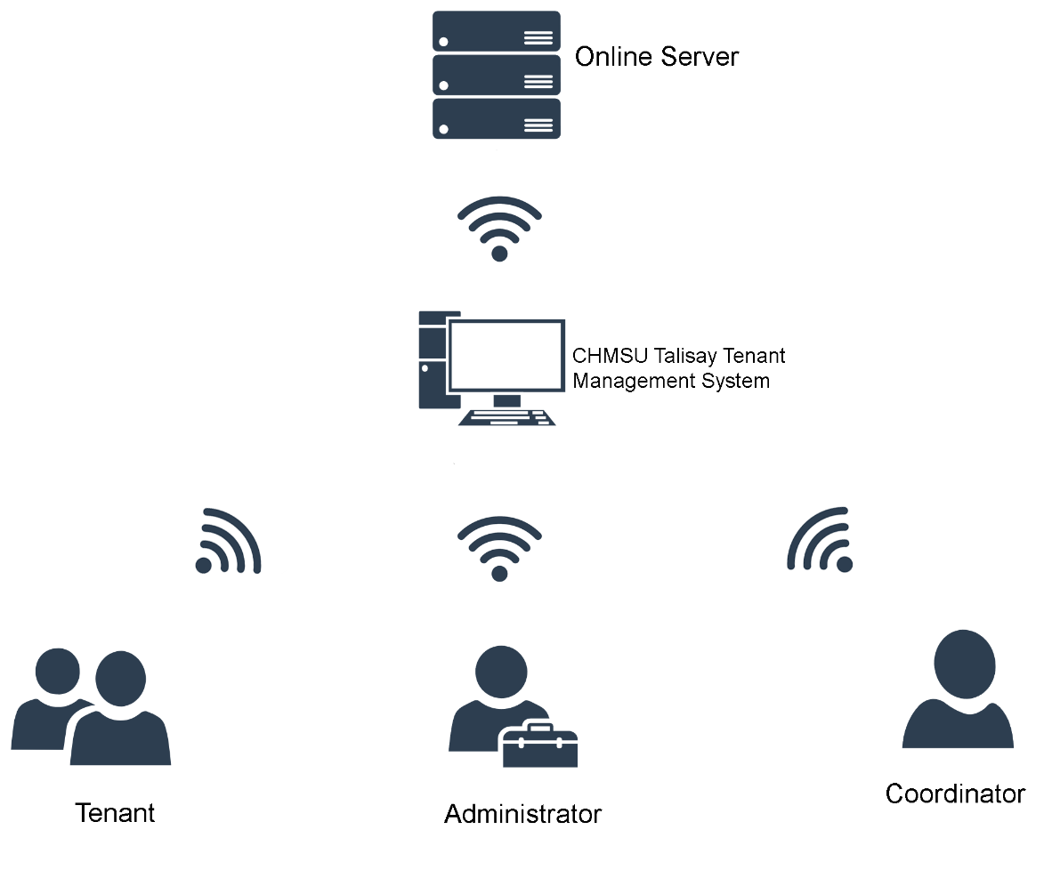The system's architectural diagram is depicted in Figure 3, providing a visual representation of its various functionalities. The diagram illustrates the system's hierarchical access structure, wherein the admin possesses full system access, including the ability to add and modify user accounts and monitor logs reports. In contrast, the coordinator's access is limited to monitoring tenant data, assessing tenant applications, and modifying relevant information. Finally, the tenant can access the system's features to check their status, enabling them to view their relevant account details and stay up-to-date with their payment status.

1. Architectural Diagram

Physical View Diagram

The physical view shows how system components are installed.to a set of computable physical nodes and explain the mapping between system software and physical hardware. It describes how to set up a software system. Concerned with the physical connections between these components as well as the architecture of software components on the physical layer.

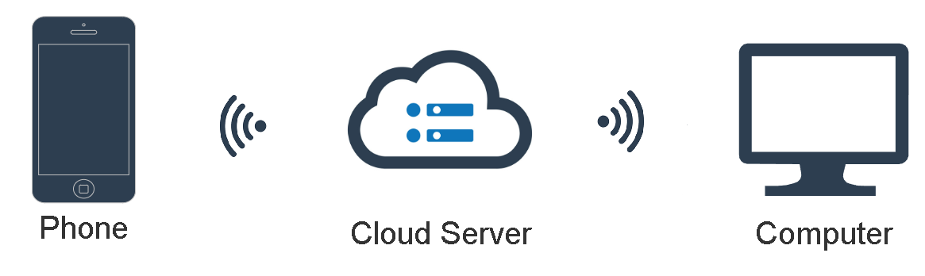

1. Physical View Diagram

Application Architecture Diagram

An architecture diagram is a visual representation of the structure of a software system, showing how various components of the system interact. It typically includes different layers, modules, and components of the system and the relationships and interactions between them.

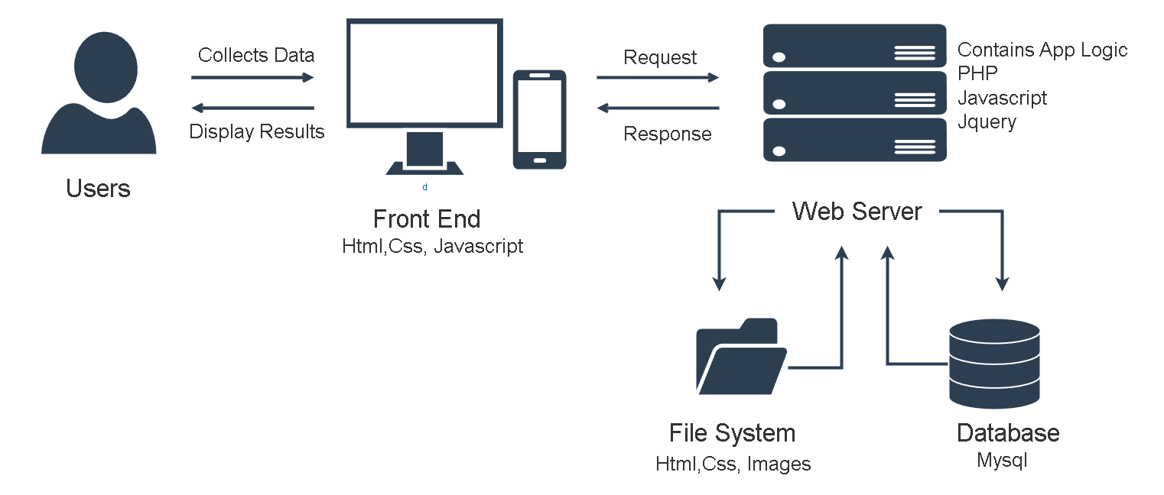

1. Application Architecture Diagram

Feasibility Schedule

Work Breakdown

A Gantt chart is a widely used tool for presenting project schedules visually. It displays the start and end dates of project components such as resources, planning, and dependencies; the chart aids in the planning, managing, and tracking of specific tasks and resources throughout the project, providing a comprehensive overview of project progress.

1. 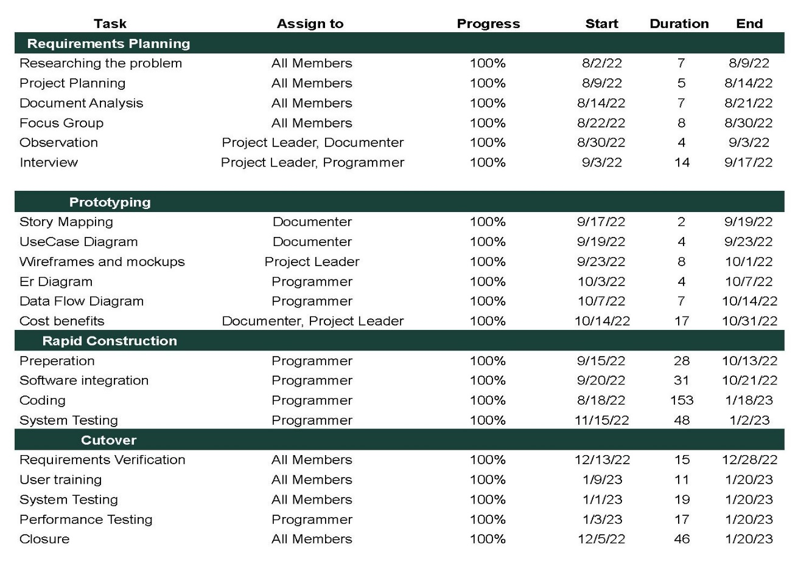Gantt Chart

Cost Benefit Analysis

The cost-benefit analysis of the system's development, breaks down the costs involved in its creation. The analysis includes estimates of monetary value for costs and benefits, including development costs, utility bills, and labor.

1. 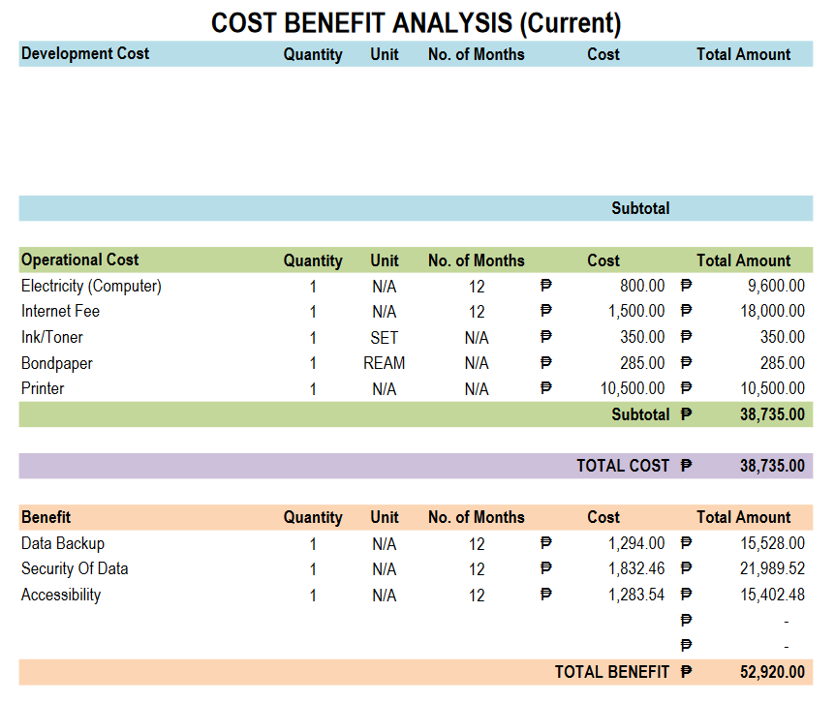Current Cost Benefit Analysis
2. 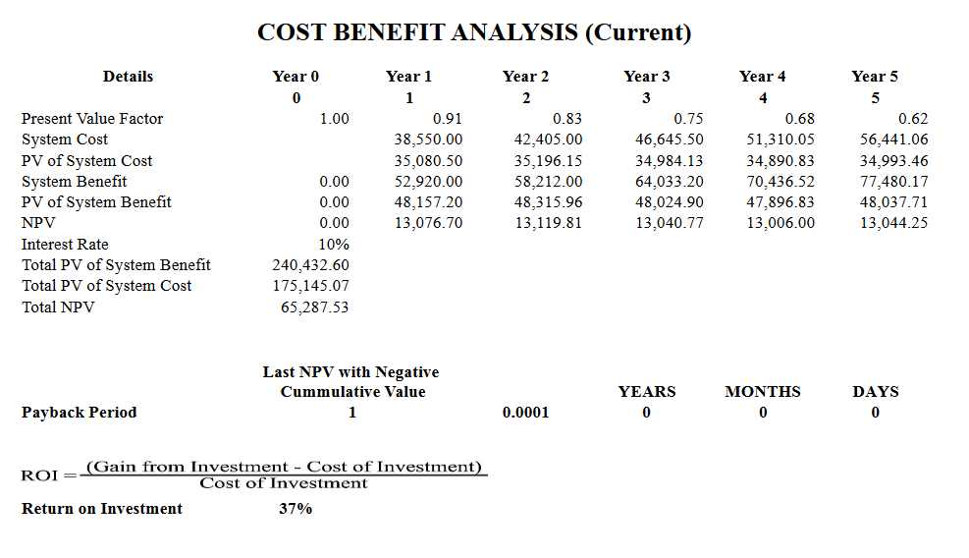Current Cost Benefit Analysis
3. 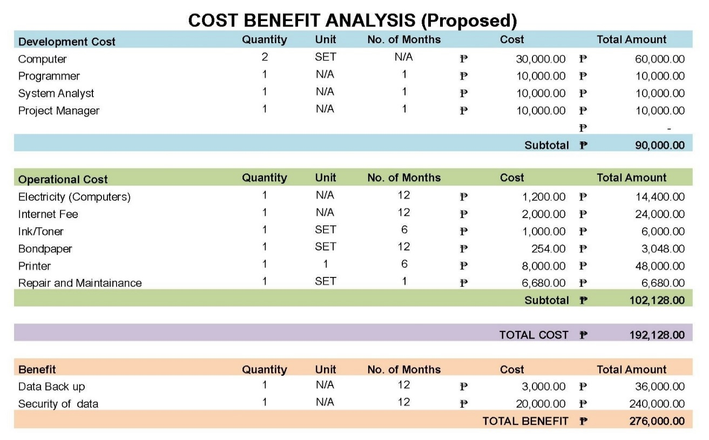Proposed Cost Benefit Analysis
4. 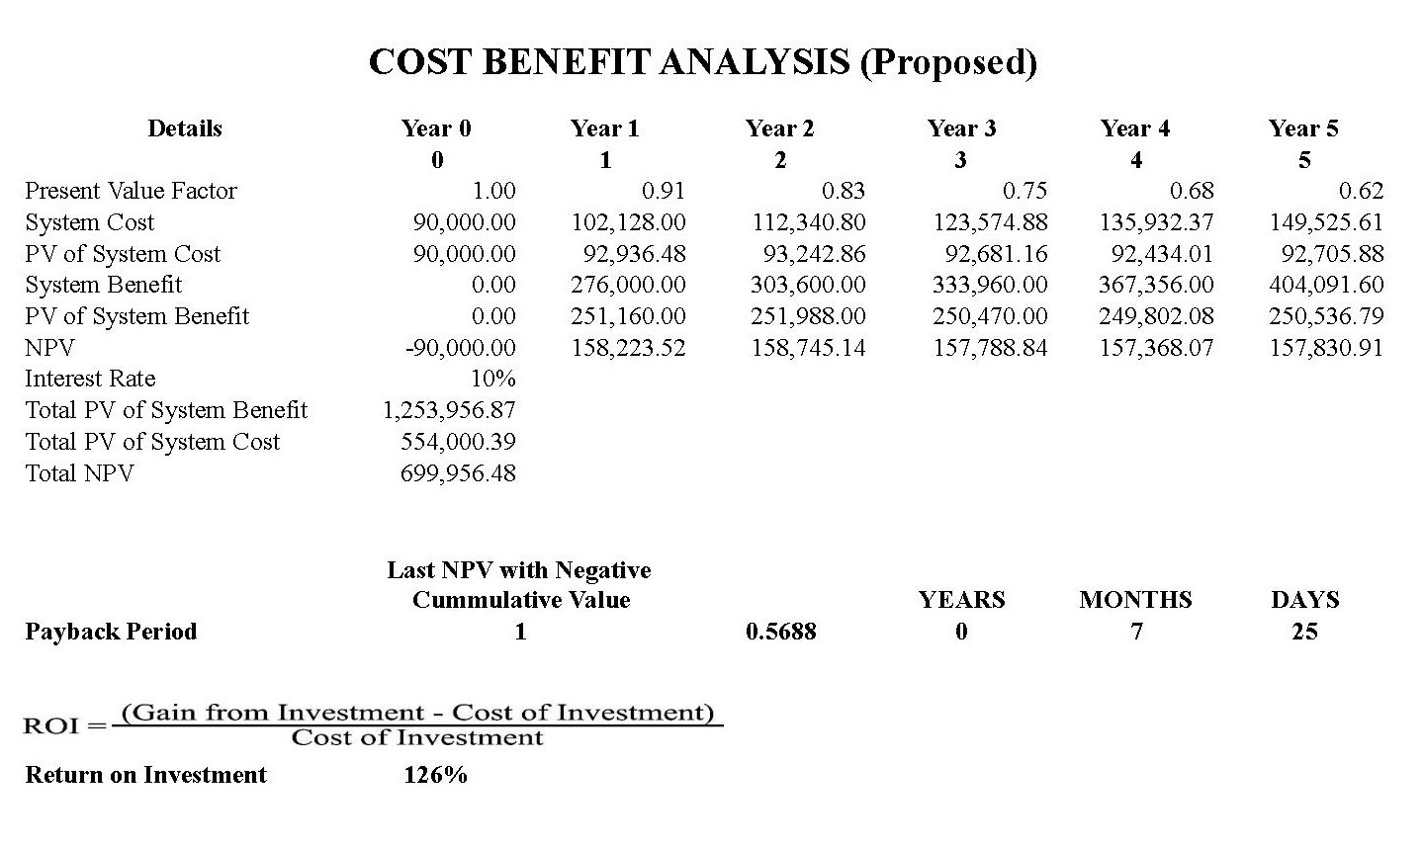Proposed Cost Benefit Analysis

ERD Model

Figure 6 shows the Entity Relationship Diagram of the study. An entity relationship diagram (ERD) represents the relationship between entity sets in a database. This figure shows the relationship of each entity. The data gathered into individual entities becomes the basis for recording and entities.

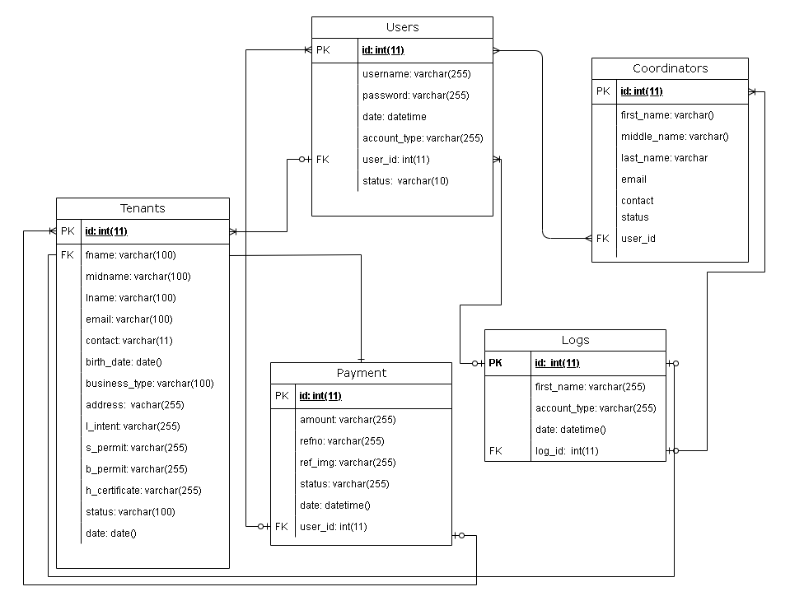

1. Entity Relationship Diagram

Data Flow Diagram

A context diagram is a high-level data flow diagram that provides an overview of the system, showing the interactions between the system and external entities. Context diagrams help determine the scope of a system and comprehend the system's main inputs and outputs. They can also be used to communicate to stakeholders the system's overall design and identify potential areas for further analysis.

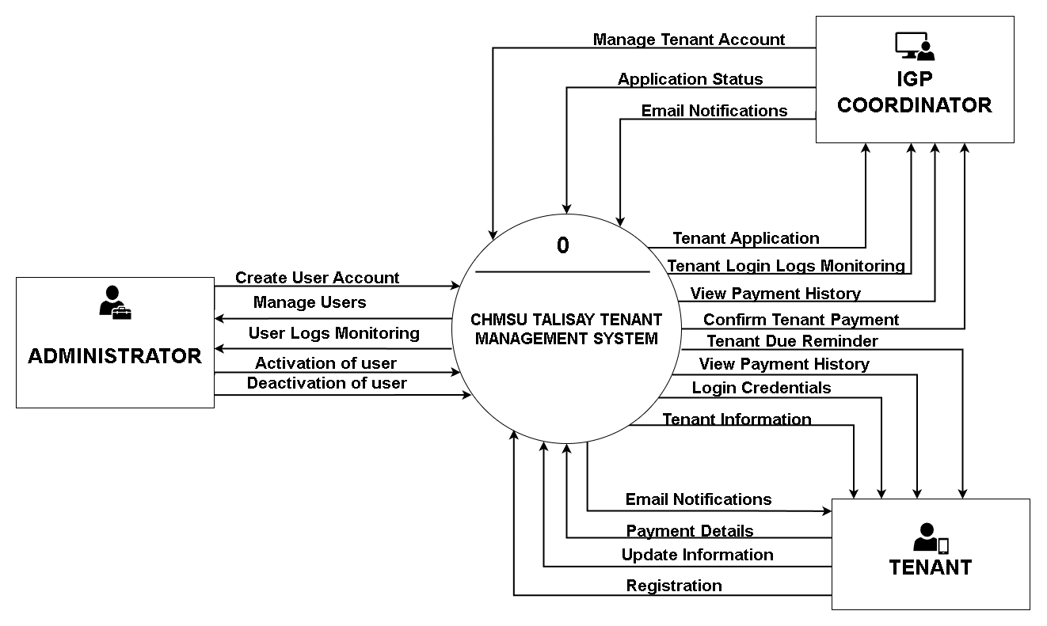

1. Context Diagram

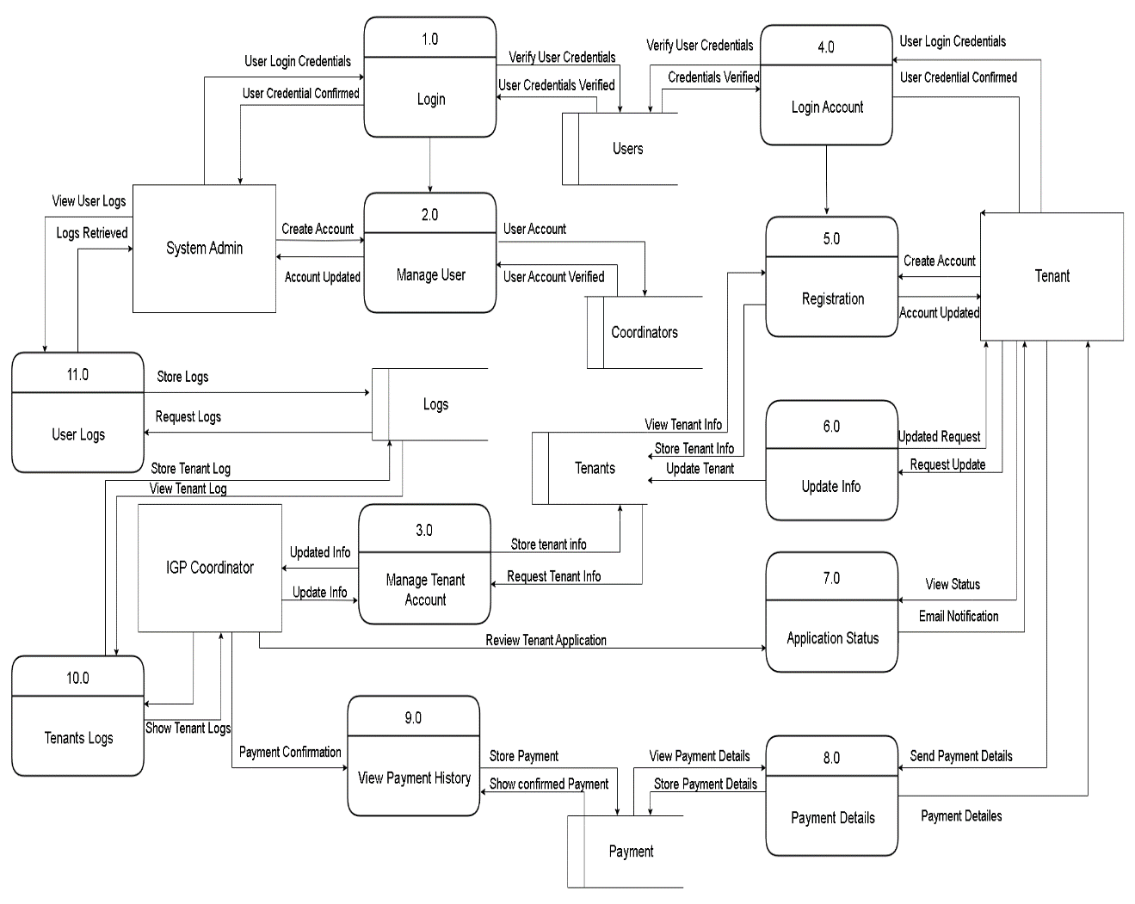A data flow diagram (DFD) graphically depicts data flow through an information system. It is used to represent data movement from a source to a destination and the processes that transform the data along the way. DFDs are an effective tool for understanding and analyzing data flow within a system, and they can be used to identify potential bottlenecks, errors, or other issues. They are also widely used in software development to aid in designing and documenting a system's structure. DFDs can be divided into levels, providing more information about the system.

1. Data Flow Diagram

Data Dictionary

1. Tenants

|  |  |  |  |  |
| --- | --- | --- | --- | --- |
| Field Name | Data Type | Data Format | Field Size | Description |
| id | int |  | 11 | System's auto Incremented sequence number |
| fname | varchar |  | 255 | Tenant First Name |
| midname | varchar |  | 255 | Tenant Middle Name |
| lname | varchar |  | 255 | Tenant Last Name |
| email | varchar |  | 255 | Tenant Email Address |
| Contact | varchar |  | 255 | Tenant Contact |
| birth_date | date | YYYY-MM-DD | 11 | Tenant Date of Birth |
| business_type | varchar |  | 255 | Tenant Business Type |
| address | varchar |  | 255 | Tenant Home address |
| l_intent | varchar |  | 255 | Tenant Letter of Intent |
| s_permit | varchar |  | 255 | Tenant Sanitary Permit |
| h_certificate | varchar |  | 255 | Tenant Health Certificate |
| status | varchar |  | 5 | Tenant Status |
| date | date | YYYY-MM-DD | 3 | Tenant registered date |

1. Coordinators

|  |  |  |  |  |
| --- | --- | --- | --- | --- |
| Field Name | Data Type | Data Format FfornFormat | Field Size | Description |
| id | int |  | 11 | System's auto Incremented sequence number |
| first_name | varchar |  | 255 | Coordinator First Name |
| Middle_name | varchar |  | 255 | Coordinator Middle Name |
| email | varchar |  | 255 | Coordinator Email |
| contact | varchar |  | 255 | Coordinator Contact Number |
| user_id | int |  | 11 | Coordinator user id |

1. Users

|  |  |  |  |  |
| --- | --- | --- | --- | --- |
| Field Name | Data Type | Data Format Format | Field Size | Description |
| id | int |  | 11 | System's auto Incremented sequence number |
| user_name | varchar |  | 255 | Users’ username |
| password | varchar |  | 255 | Users’ password |
| date | date | datetime | 255 | User’s creation date |
| Account_type | varchar |  | 255 | User’s account type |
| user_id | int |  | 11 | User’s id |
| status | varchar |  | 10 | User’s status |

1. Payments

|  |  |  |  |  |
| --- | --- | --- | --- | --- |
| Field Name | Data Type | Data Format | Field Size | Description |
| id | int |  | 11 | System's auto Incremented |
| amount | varchar |  | 255 | Payment amount |
| refno | varchar |  | 25 | Payment reference number |
| date | date | datetime | 255 | Payment date |
| User_id | int |  | 11 | Payment id |
| Field Name | Data Type | Data Format | Field Size | Description |
| id | int |  | 11 | System's auto Incremented |

1. Logs

|  |  |  |  |  |
| --- | --- | --- | --- | --- |
| Field Name | Data Type | Data Format | Field Size | Description |
| id | int |  | 11 | System's auto Incremented |
| first_name | varchar |  | 255 | Logs full name |
| account_type | varchar |  | 20 | Logs user type |
| date | date | datetime | 255 | Logs date and timestamp |
| log_id | int |  | 11 | Logs id |

CHAPTER IV

Presentation of data, Results and Analysis

This chapter explains and interprets the results of the user’s survey conducted for the system of Carlos Hilado Memorial State University Talisay Tenants Management System.

Presentation

Proponents have found it challenging to conduct research and collect data during the COVID-19 pandemic, as well as meet with supervisors and peers for support and collaboration due to remote work and virtual meetings. Furthermore, the pandemic has also impacted proponents' ability to develop and study the project, which can affect the ability to finish on time. Overall, the pandemic has posed significant challenges for proponents working on thesis projects, requiring them to be adaptable and resourceful in devising new research methods and completing their work.

Remote work and social distancing policies have disrupted communication and collaboration, making it more difficult for teams to work effectively. Proponents were able to continue developing systems during the pandemic by utilizing remote work and collaboration tools. These tools have enabled teams to communicate and collaborate despite physical distance effectively. This has enabled them to continue working on system development projects while also meeting the needs of the CHMSU Talisay Tenants Management System. The study outcomes are presented, evaluated, and interpreted in this chapter based on questionnaires distributed by the proponents and completed by 20 participants. The information offered in this chapter focuses on the Carlos Hilado Memorial State University Talisay Tenant Management System.

The proponents utilized the PSSUQ and Google Form survey methods to gather feedback on the system's usability. The proponents were able to present the results to the users through face-to-face demonstrations. The PSSUQ and Google Form survey were used to collect information from IGP Coordinator, tenants, and students to rate the system's usability and leave comments. The PSSUQ and survey provided the necessary information for the proponent to evaluate the system's outcome and receive feedback from various stakeholders. Overall, the team used a combination of methods to gather feedback, assess the system's usability, and present the findings to users.

Data Analysis

This section includes an examination of the data collected and gathered from the Carlos Hilado Memorial State University Talisay Tenant Management System respondents. The findings were arranged following the specific objectives outlined in Chapter One. The three specific objectives were providing an online registration platform, managing and monitoring tenants, and reporting generation. The objectives of this study were to create an online registration platform and manage tenants' data. Primary data were gathered through interviews and surveys, while secondary data came from research journals. The quantitative approach was used to present the responses' findings. The PSSUQ questionnaire was also used to collect data from study participants.

Participants of the Study

The respondents of the system were taken from the business affair staff and entrepreneur students of the Carlos Hilado Memorial State University. The total participants were 20 respondents.

1. Distribution of respondents

|  |  |  |
| --- | --- | --- |
| **Respondents** | **Role in the system** | **Number of Respondents** |
| IGP Coordinator | Admin | 1 |
| Business Affair Staff | Admin | 1 |
| Tenants | User | 2 |
| Student | Data Source | 16 |
| **Total**  int | | 20 |

**IGP Coordinator** – It was decided by the proponents to select one IGP Coordinator, as they will be the primary individuals responsible for operating and utilizing the system.

**Business Affair Staff** - The proponents have chosen one business affairs staff member, as they are also a key player in the future operation of the system.

**Tenants** – The proponent’s select one tenants since this system was develop for tenants.

**Students** - The proponents have selected seventeen students from Carlos Hilado Memorial State University to test the system's functionality and provide feedback for further improvements.

Interpretation of Data

Scale used in Evaluating the Post-Study System Usability Questionnaire (PSSUQ)

|  |  |
| --- | --- |
| **Mean Score Range** | **Interpretation** |
| 1.00 – 1.85 | Strongly agree |
| 1.86 – 2.71 | Agree |
| 2.72 – 3.57 | Somewhat agree |
| 3.58 – 4.43 | Neither agree or disagree |
| 4.44 -5.29 | Somewhat disagree |
| 5.30 – 6.15 | Disagree |
| 6.16 – 7.00 | Strongly disagree |

Results

1. Mean Distribution of the Respondent Responses on System Usefulness

|  |  |  |  |
| --- | --- | --- | --- |
| **Criteria** | **Mean** | **Standard Deviation** | **Interpretation** |
| Overall, I am satisfied with how easy it is to use this system. | 1.28 | 0.66 | Strongly Agree |
| It was simple to use this system. |  | 0.66 | Strongly Agree |
| I was able to complete the tasks and scenarios quickly using this system. | 1.28 | 0.66 | Strongly Agree |
| I felt comfortable using this system. | 1.28 | 0.66 | Strongly Agree |
| It was easy to learn to use this system. | 1.28 | 0.66 | Strongly Agree |
| I believe I could become productive quickly using this system. | 1.28 | 0.66 | Strongly Agree |
| **Total** | 1.28 | 0.66 | Strongly Agree |

The average System Usefulness (SYSUSE) rating is 1.28, interpreted as Strongly Agree. The functions, objectives, goals, and context of a system are referred to as its usefulness, in accordance with (MacDonald & Atwood, 2014). The features are more concentrated on what workers need for their employment. A task is what technology does to help the user do their necessary tasks. Users' goals are the aims they hope to accomplish. Finally, context describes how a system is utilized and how it might be incorporated into users' actual social and material circumstances.

1. Mean Distribution of the Respondent Responses on Information Quality

|  |  |  |  |
| --- | --- | --- | --- |
|  | **Mean** | **Standard Deviation** | **Interpretation** |
| The system gave error messages that clearly told me how to fix problems. | 1.18 | 0.47 | Strongly Agree |
| Whenever I made a mistake using the system, I could recover easily and quickly. | 1.18 | 0.47 | Strongly Agree |
| The information (such as online help, on-screen messages, and other documentation) provided with this system was clear. | 1.18 | 0.47 | Strongly Agree |
| It was easy to find the information I needed. | 1.18 | 0.47 | Strongly Agree |
| The information was effective in helping me complete the tasks and scenarios. | 1.18 | 0.47 | Strongly Agree |
| The organization of information on the system screens was clear. | 1.18 | 0.47 | Strongly Agree |
| **Total** | 1.18 | 0.47 | Strongly Agree |

Strongly Agree is the interpretation of the Information Quality (INFOQUAL) average value of 1.18. Information quality, according to DeLone, is information that is appropriate for usage. This suggests that important determinants of information quality are context and use. On the other side, information quality refers to the caliber of the information generated by the systems (DeLone & McLean, 2003).

1. Mean Distribution of the Respondent Responses on Interface Quality.

|  |  |  |  |
| --- | --- | --- | --- |
|  | **Mean** | **Standard Deviation** | **Interpretation** |
| The interface of this system was pleasant. | 1.23 | 0.52 | Strongly Agree |
| I liked using the interface of this system. | 1.23 | 0.52 | Strongly Agree |
| This system has all the functions and capabilities I expect it to have. | 1.23 | 0.52 | Strongly Agree |
| Overall, I am satisfied with this system. | 1.23 | 0.52 | Strongly Agree |
| **Total** | 1.23 | 0.52 | Strongly Agree |

Strongly Agree is the interpretation given to the average Interface Quality (INTERQUAL) value of 1.23. The term "interface quality" (Totz & Riemer, 2001) is used to describe user-friendliness that offers a wide array of capabilities for defining problems and processing, analyzing, and presenting conclusions. The interface shouldn't contain any unnecessary or annoying information. Exhibits should be as uniform as is practical. When users move from one area of the interface to another, they shouldn't have to remember information. Users shouldn't have to commit the instructions to memory. The instructions for using the system should be clear to see.

1. Mean Distribution of the Respondent Responses on System Usability

|  |  |  |  |
| --- | --- | --- | --- |
| **Criteria** | **Mean** | **Standard Deviation** | **Interpretation** |
| System Usefulness (SYSUSE) | 1.28 | 0.66 | Strongly Agree |
| Information Quality (INFOQUAL) | 1.18 | 0.47 | Strongly Agree |
| Interface Quality (INTERQUAL) | 1.23 | 0.52 | Strongly Agree |
| Total | 1.23 | 0.45 | Strongly Agree |

The table above shows the range of mean and its verbal interpretation. Based on the analysis of the collected data, the overall mean result of 1.23 was obtained, which is interpreted as "Strongly Agree" on the Likert scale. This result indicates that the Tenant Management System of Carlos Hilado Memorial State University, Talisay campus has the potential to assist the university by providing a fundamental monitoring mechanism for every individual, particularly the tenants. The system's ability to effectively monitor the tenants' activities and behaviors within the university's premises has garnered strong agreement among the participants, highlighting its potential usefulness in maintaining a secure and organized environment. With its positive reception, the system can serve as a valuable tool for the university in ensuring the well-being and safety of its users.

CHAPTER V

Summary of Findings, Conclusion and Recommendation

This chapter presents the summary of findings, conclusion and recommendations of the developed system of Carlos Hilado Memorial State University Talisay Tenant Management System.

Summary of Findings

The proponents of the Tenant Management System at Carlos Hilado Memorial State University's Talisay campus aimed to develop a system using the Rapid Application Development (RAD) methodology. To assess and evaluate the system, the proponents conducted an online survey. The population consisted of twenty respondents, including one IGP Coordinator, one Business Affairs staff member, two tenants, and seventeen students. The survey questionnaire used as the research instrument was the Post-Study System Usability Questionnaire (PSSUQ). The survey results were satisfactory.

Conclusion

Based on the study's findings, The proponents conclude that the system which is the Carlos Hilado Memorial State University Talisay Tenant Management System was found to be highly agreeable. in terms of system usefulness, information quality, and so on. The system's overall satisfaction and interface quality has proven to be an effective monitoring mechanism, particularly for tenants. Its ability to manage and monitor tenants, generate reports, and provide an online registration platform has received positive feedback from key stakeholders, including business affairs staff, tenants, and students. Proponents used data collection methods, such as the PSSUQ questionnaire and Google form survey, were successful, with an overall mean result of 1.23 on the Likert scale, indicating a strong agreement with the system's potential usefulness. The Tenant Management System has the potential to serve as a valuable tool for the university in ensuring the well-being and safety of its users. The approach of selecting one IGP Coordinator, one business affairs staff member, one tenant, and 17 students to test the system's functionality and provide feedback for improvements is a practical and effective approach that can be replicated in future development projects.

Recommendations

To improve the future use of the Tenant Management System, it is recommended that the university implements regular maintenance and updates to ensure the system remains secure and operates at optimal levels, provides incentives for tenants to use the system, such as discounts or exclusive access to certain facilities or services, considers integrating the Tenant Management System with other systems and platforms, such as social media or email, to enhance its reach and impact, and for future researchers it is recommended to conduct a comprehensive analysis of the current system to identify areas for improvement, such as ease of use, functionality, and security

REFERENCES

Berkman, M., & Karahoca, D. (2016). Re-Assessing the Usability Metric for User Experience (UMUX) Scale. Journal of Usability Studies, 11, 89-109. Retrieved February 2, 2023, from https://www.researchgate.net/publication/251453295_The_effect_of_interface_quality_on_success_-_An_integrative_approach_on_Mass_Customization_Design

Bersabal, R. A. (2013). Florete-Caperonce Realty Corporation University Dorm Management Information System. Retrieved January 9, 2023, from https://repository.cpu.edu.ph/Browyn Bate (2019) doi/abs/10.1080/02673037.2019.1621271

Delone, W., & McLean, E. (2003). The DeLone and McLean Model of Information Systems Success: A Ten-Year Update. Journal of Management Information Systems, 19, 9-30. https://doi.org/10.1080/07421222.2003.11045748

Gommans, H. P., Njiru, G. M., & Owange, A. N. (2014). Viewdoc/download?doi=10.1.1.653.4632&rep=rep1&type=pdf

Kato, K. (2017). Managing system and managing method for transferring data between tenants (United States Patent No. US9854056B2). https://patents.google.com/patent/US9854056B2/en?q=tenants+management+system&oq=tenants+management+system

MacDonald, C., & Atwood, M. (2014). What does it mean for a system to be useful? An exploratory study of usefulness. Proceedings of the Conference on Designing Interactive Systems: Processes, Practices, Methods, and Techniques, DIS. https://doi.org/10.1145/2598510.2598600

Pacheco, G. M. A., Gerochi, M. H., Nonaillada, J. C. S. H., & Pacheco, J. C. S. H. (2018). Bitstream/handle/20.500.12852/2256/BSIT_EboraHMM_2018_Ab.pdf?sequence=1&isAllowed=y

Parviainen, P. (2017). Tackling the digitalization challenge: How to benefit from digitalization in practice. ResearchGate. Retrieved October 11, 2022, from https://www.researchgate.net/profile/Paeivi-Parviainen

Shriram (2019). House (individual house/apartment) rental management system. (n.d.). Retrieved from https://d1wqtxts1xzle7.cloudfront.net/60721197/V8I9201919-libre.pdf

Totz, C., & Riemer, K. (2001, October 5). The effect of interface quality on success. Retrieved February 9, 2023, from https://www.researchgate.net/publication/251453295_The_effect_of_interface_quality_on_success_-_An_integrative_approach_on_Mass_Customization_Design

APPENDICES

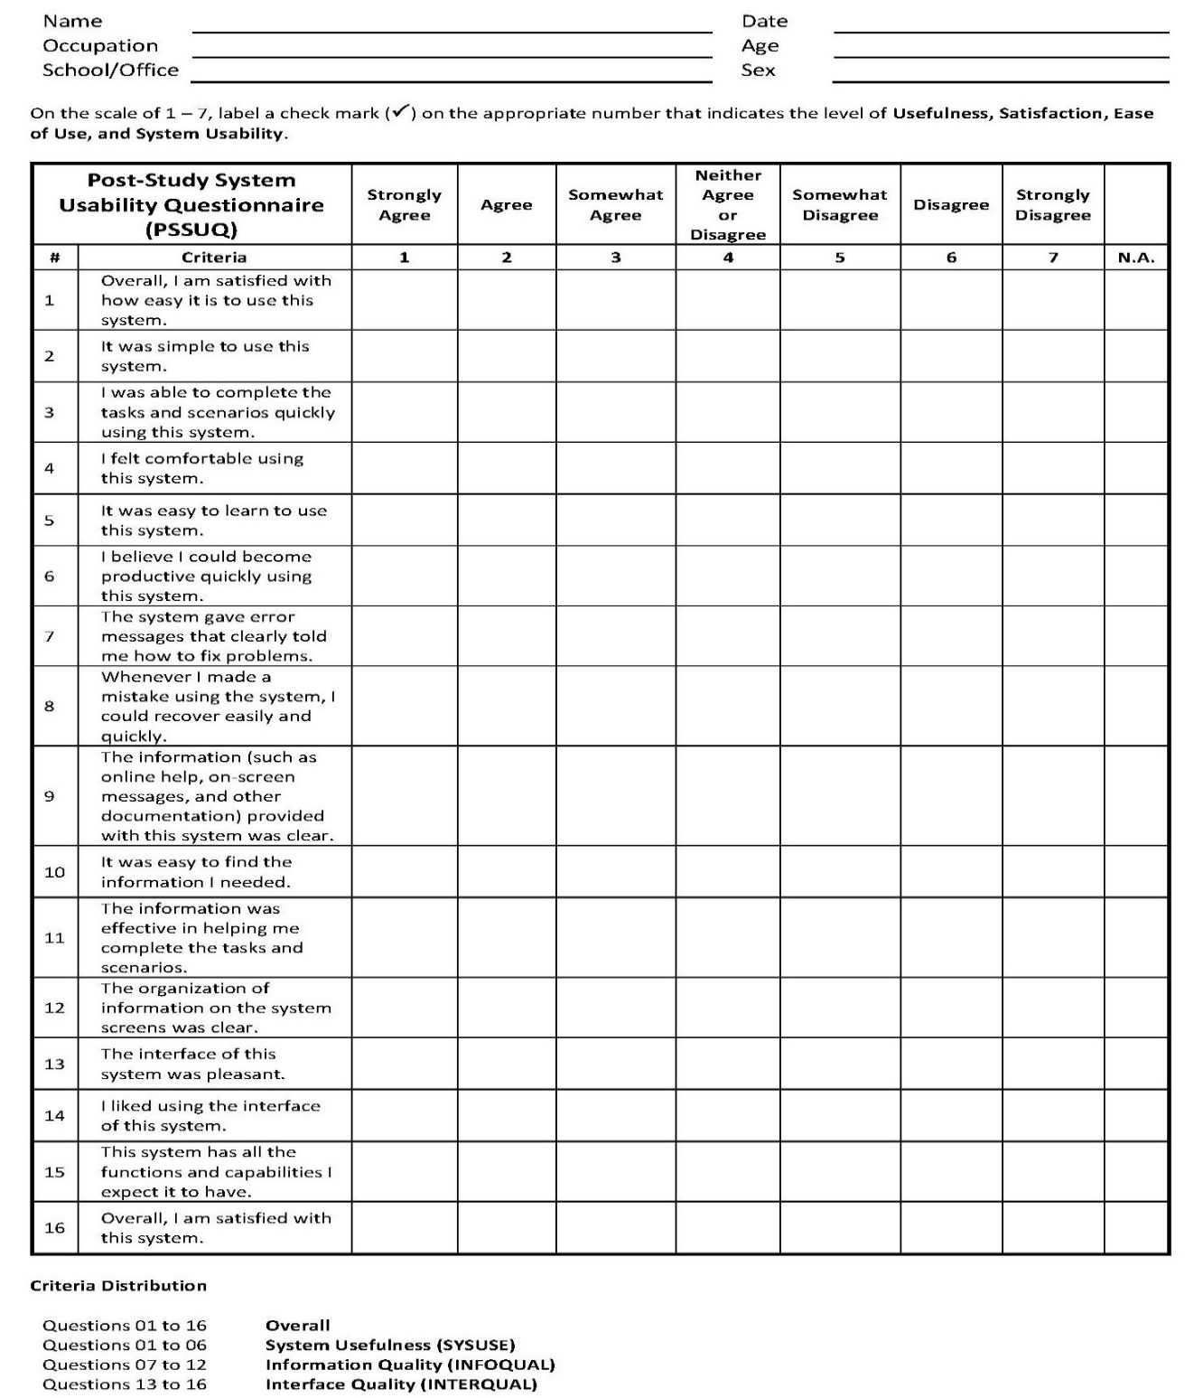Survey Questionnaire

Complete Gantt Chart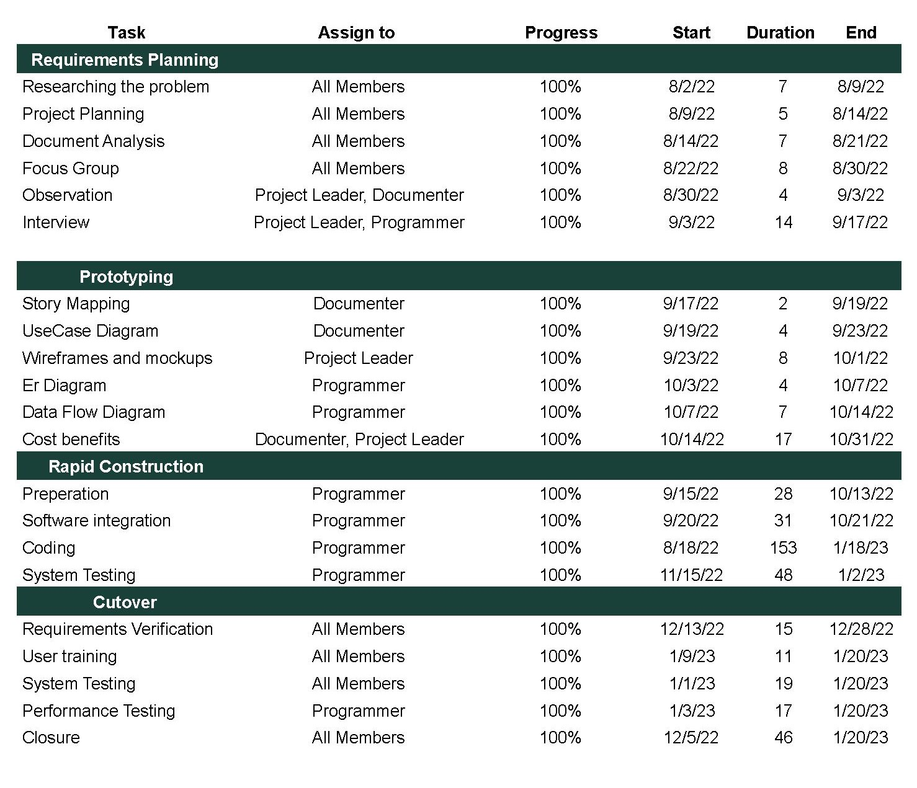

Admin-side Screenshot

Client-side Screenshot

Supporting Document

Compliance Matrix

Curriculum Vitae