Race Plan & Track – Quick User Guide
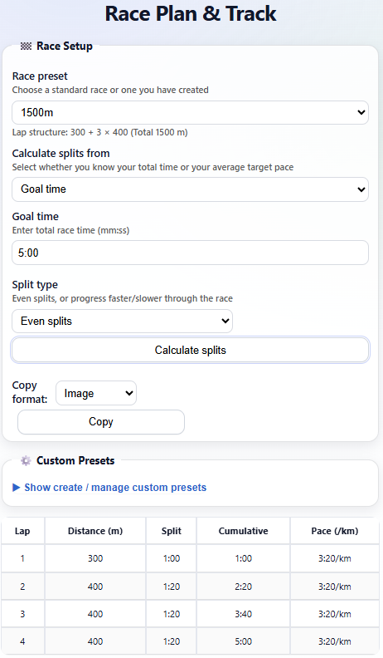
This quick reference guide explains how to use the Race Plan & Track web app on mobile phones and desktop computers. It is designed for a wide range of users, from teenagers to older adults. The guide focuses on the most common tasks.

1. Race Setup (Plan your race)
1. Select a Race Preset (for example 400m, 800m, 1500m).
2. Choose how to calculate splits:
• Goal time – enter the total race time.
• Average target pace – enter pace and unit.
3. Choose Split Type:
• Even splits – same effort throughout.
• Negative split – finish faster.
• Positive split – start faster.
4. Tap “Calculate splits” to generate your target splits.

2. Viewing & Copying Target Splits
After calculating splits, a table appears showing:
• Lap number
• Distance
• Split time
• Cumulative time
• Pace per kilometre
Copy options:
• Image – best for messages or email.
• Table – best for notes or spreadsheets.
Figure 1 - Screenshot: Race Setup screen (Race preset, goal time, split type, split table)

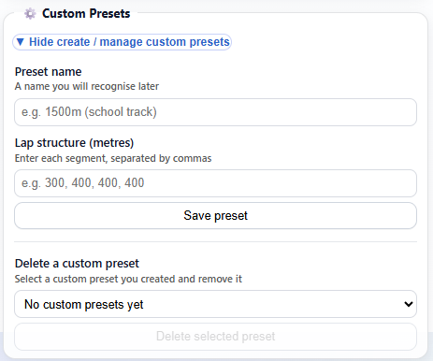
3. Custom Presets (Optional)
You can create your own race presets:
1. Tap “Show create / manage custom presets”.
2. Enter a preset name.
3. Enter lap distances separated by commas (e.g. 300, 400, 400, 400).
4. Save preset.
Custom presets can also be deleted from this section.
Note: Custom presents will remain available until you refresh the app. If you have race formats that you want added to the permanent list, please contact the administrator.
Figure 2 - Screenshot: Custom Presets section

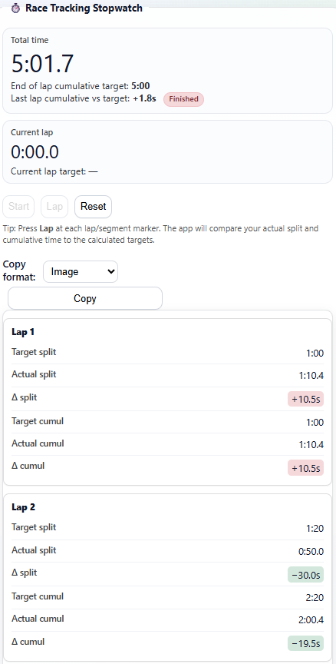
4. Race Tracking Stopwatch
Figure 3 - Screenshot: Race Tracking Stopwatch and Lap Log
The stopwatch appears after splits are calculated.
How to use:
1. Tap Start to begin timing.
2. Tap Lap at each lap marker.
3. The app compares your actual time to target time.
• Green = ahead/on target
• Red = behind
4. Tap Reset to clear and start again.

5. Copying the Lap Log
After recording laps, you can copy the lap log:
• Image – share results easily.
• Table – paste into notes, email, or Excel.
On mobile, a share menu may appear instead of copying directly.

Tips
• Always calculate splits before using the stopwatch.
• On mobile, scroll down to see results and stopwatch.
• Use Image copy for messaging apps.
• Use Table copy for detailed analysis.

Return to App

