Joshua Burkhart
9/20/2010
Dr. Greg Wolffe
CS 451
Homework: Digital Logic
1.
A | B | C | A ^ B ^ C | A ^ B' ^ C' | A' ^ B' ^ C' | A ^ B ^ C + A ^ B' ^ C' + A' ^ B' ^ C'
0 | 0 | 1 | 0 | 0 | 1 | 1
0 | 1 | 0 | 0 | 0 | 0 | 0
0 | 1 | 1 | 0 | 0 | 0 | 0
1 | 0 | 0 | 0 | 1 | 0 | 1
1 | 0 | 1 | 0 | 0 | 0 | 0
1 | 1 | 0 | 0 | 0 | 0 | 0
1 | 1 | 1 | 1 | 0 | 0 | 1

2.
F = (V + A + L)' = V' ^ A' ^ L'

3.
A = T ^ U ^ V + X ^ Y + Y = T ^ U ^ V + Y

4.
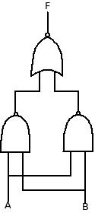

5.

