Joshua Burkhart & Brett Suing
4/20/2010
Dr. Guenter Tusch
CS 661
Analysis of Telomerase Function in Chromosomal Repair
Abstract
This paper relies on data from several other published studies regarding the function of telomerase in repairing chromosomal damage. Two studies were found to have seemingly contradicting results, though, after examining and comparing design, methods, and results between them, contradiction was uncertain. The most probable cause of contradiction remains comparison of cross-species chromosomal repair mechanisms. One study showed that the mTERT and mTR genes do not play a role in the DNA damage response. This paper will hope to show the same results using data produced by the previous study.
Introduction
The role of telomerase (both TR and TERT) in telomere length-maintenance is widely accepted. Less accepted, however, is the idea of telomerase holding roles outside of telomere length-maintenance. Some studies (The human telomerase RMA component, hTR, activates the DNA-dependent protein kinase to phosphorylate heterogeneous nuclear ribonucleoprotein A1(Nicholas S. Y. Ting et al.) hereafter referred to as Study[2]) show that TR may have an effect on chromosomal repair while others (Comparing effects of mTR and mTERT deletion on gene expression and DNA damage response: a critical examination of telomere length maintenance-independent roles of telomerase(Vidal-Cardenas SL, Greider CW) hereafter referred to as Study[1]) conclude that telomerase act as a transcription factor or have a role in the DNA damage response.
Definitions
Telomere - derived from Greek telos "end" and mere "part". A telomere is a DNA sequence at the end of a chromosome without which, the chromosome would lose information when a cell duplicated (mitosis). The loss of telomeres can lead to lead to several health problems including oncogenesis, autosomal dominant dyskeratosis congenita, and aplastic anemia (3). Telomeres work by 'capping' the end of the chromosome with useless information that can be destroyed during mitosis and rebuilt after mitosis is finished.
Telemerase- the enzyme that rebuilds telomeres. Its protein structure is made up of two separate molecules: Telomerase Reverse Transcriptase (TERT) and Telomerase RNA (TR). TR serves as a template for the telomere sequence and TERT transcribes TR's information into double-stranded DNA.
hTR- refers to human Telomerase RNA.
mTR- refers to mouse Telomerase RNA.
hTERT- refers to human Telomerase Reverse Transcriptase.
mTERT- refers to the mouse Telomerase Reverse Transcriptase.
Results of Previous Related Studies
Comparing effects of mTR and mTERT deletion on gene expression and DNA damage response: a critical examination of telomere length maintenance-independent roles of telomerase (Vidal-Cardenas SL,Greider CW.) concluded that “Gene expression profiles of mTERT–/– and mTR–/– G1 mice are similar to wild-type” and “mTERT–/– and mTR–/– cells do not show a difference in DNA damage response induction compared to wild-type”.
The human telomerase RMA component, hTR, activates the DNA-dependent protein kinase to phosphorylate heterogeneous nuclear ribonucleoprotein A1 (Nicholas S. Y. Ting, Brant Pohorelic, Yaping Yu, Susan P. Lees-Miller, and Tara L. Beattie) concluded “Phosphorylation of hnRNP A1 is stimulated not only by the presence of DNA but also by the telomerase RNA component, hTR. Furthermore, we show that hnRNP A1 is phosphorylated in vivo in a DNA-PK-dependent manner and that this phosphorylation is greatly reduced in cell lines which lack hTR.”
A possible role of repair proteins BRCA1 and DNA-PK in the processing of oxidative DNA damage(Alexandros G. Georgakilas) concludes “Accumulating evidence from different laboratories suggests an alternative (direct or indirect) effect of BRCA1 and DNA-PK in the processing of oxidatively-induced DNA damage like abasic sites, altered bases and/or single strand breaks. This potential function of these proteins in the repair of non-DSB DNA lesions in addition to their verified involvement in the repair of DSBs, raises significant issues in the predisposition of individuals to several diseases like breast and ovarian cancer since both of these genes have been involved in increased breast or ovarian cancer susceptibility.”.
Human Polynucleotide Kinase Participates in Repair of DNA Double-Strand Breaks by Nonhomologous End Joining but not Homologous Recombination(Feridoun Karmi-Busheri et al.) concludes “ the data presented here have further clarified the contribution of hPNK to the cellular response to ionizing radiation, camptothecin, UV light, and cisplatin. Together with data obtained from cell-free systems (7, 8), we have clearly established that hPNK participates in the NHEJ pathway, presumably processing the strand break termini before ligation ”.
Formulation Process
We will use the series matrix file(s) generated from Study[1], as other data sets are cost prohibitive or otherwise unavailable. modeling the data using appropriate techniques. We will examine the methods and results of Study[1] and Study[2] in an attempt to gain insight into the reason for their conflicting conclusions.
Model Description
To investigate the difference in telomere length, mice are used. The reason behind this is because mouse telomerase is thought to act in the same manner as human telomerase. The type of mice used for this experiment was mice with the C57BL/6J strain due to the presence of long telomeres. By the use of deleting telomerase components, the researchers were able to achieve mice with shortened telomeres. By knocking out these genes, they could compare the genes of the knock-out mice with short telomeres, and the mice from the wild, with no genetic deletions (Vidal-Cardenas, Greider, 2010).
For the statistical analysis of this paper, GEO data sets were recovered to produce heat maps through Spotfire software. The analysis of these heat maps included gene expression levels which would determine if the knock-out mice were different than the wild-type mice. The first heat maps (Figure 1 and 2) compare isolated liver RNA arrays comparing wild-type and knock-out mice in respect to the mTERT and mTR genes. Using hierarchical clustering, both of these genes showed that they clustered randomly. From this randomness, they concluded that the gene expression levels must be similar between the wild and knock-out mice. This study's results were able to be reproduced from data, which also found randomness between the genes and mice. The main point to take away from this analysis is that since there are no difference between the wild-type mice and the mice "breeded" to have shortened telomeres, these genes do not act any differently on the telomeres. So does this then have any effect on DNA damage of the telomeres? The gene, mTERT, may affect telomere length roles such as: cell proliferation, DNA damage response, and development pathways. To determine if there are then any differences in how these genes are expressed in wild-type verses the knock-out mice, another heat map was created. Figure 3 and 4, display heat maps based on gene expression of certain pathways that lead to DNA damage and other roles that may affect telomere length. Like the previous heat maps, the hierarchical clustering showed no significant difference between the wild-type mice and the knock-out mice. With no significant difference between the two, it again means that even when telomeres are shorten, the genes mTERT and mTR are still expressed at the same level.
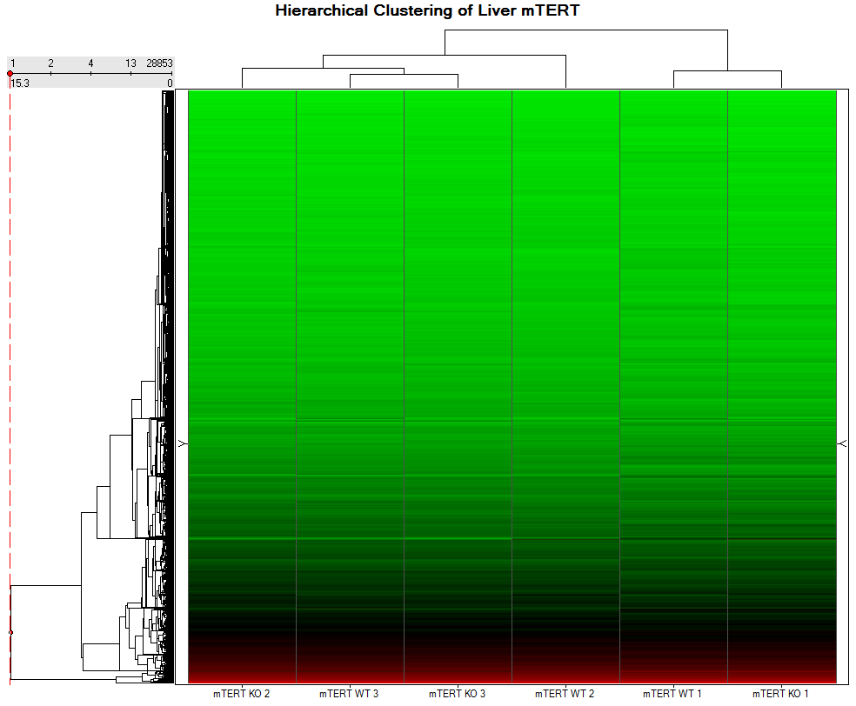
Figure 1
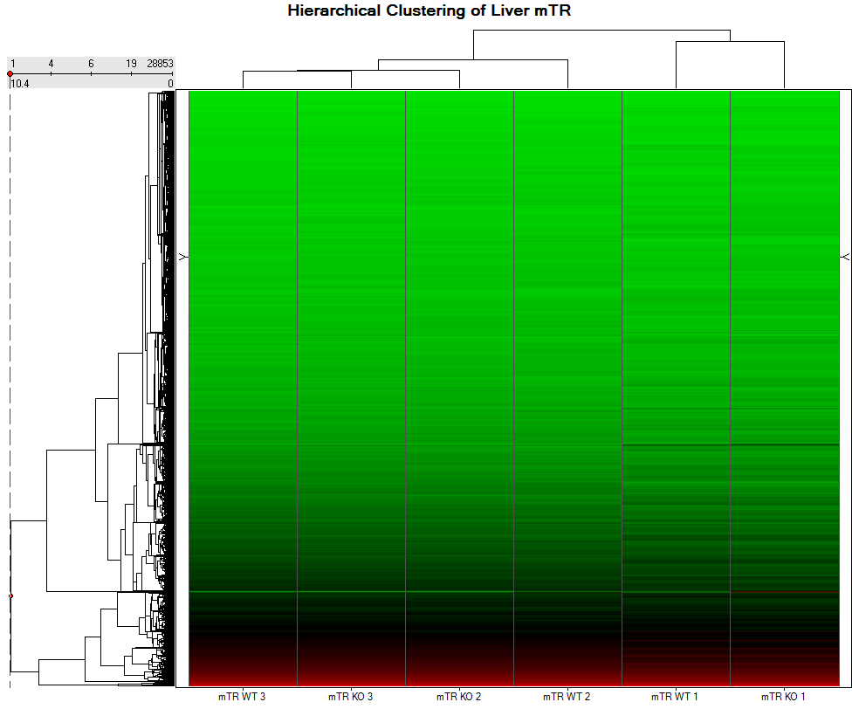
Figure 2
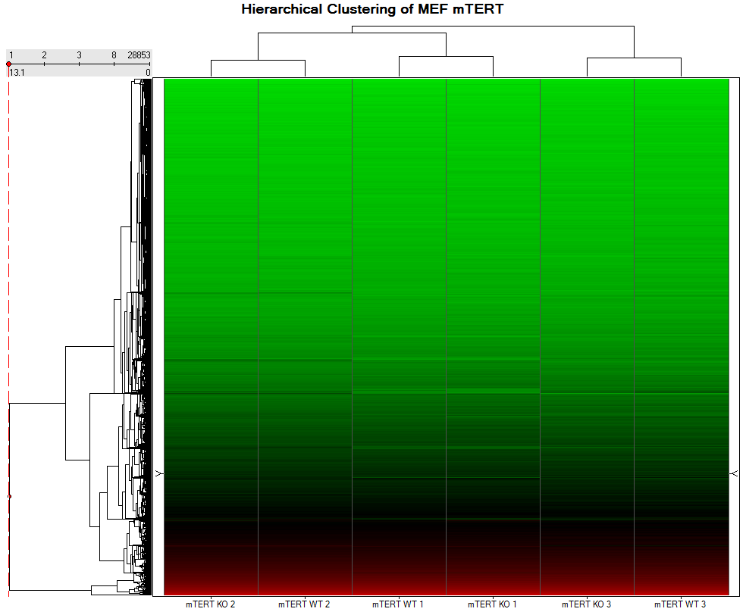
Figure 3
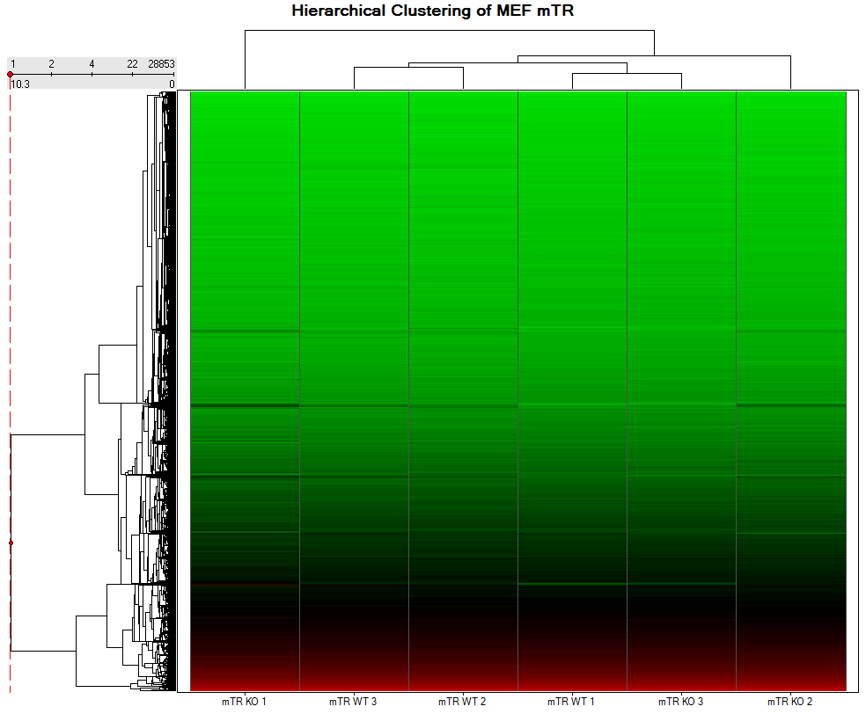
Figure 4
Results of Own Analysis
On careful examination of Study[1] and Study[2], both studies, though conducted in similar fashion, yielded altogether contradicting results. Study[1] used two techniques to test for telomerase's ability to repair chromosomes, gamma radiation at 5Gy (.57 Gy / minute) and camptothecin exposure. Study[2] found telomerase helpful in repairing damage due to "oxidative stress" brought on by .57Gy / minute [6]. Questions remained as to the total amount of y-exposure in each study as the first listed a total amount (5 Gy) and the second listed a rate (.57 Gy/min). Researchers were contacted in search of additional information.
After successfully contacting Alexandros G. Georgakilas by email regarding his study (Study[2]), he confirmed the total amount of y-exposure was 5Gy at .57Gy/min. This is significant in that it is the same total amount of y-exposure as Study[1]. This similarity in oxidation method indicates method was not a likely source of contradiction in results of the two studies. An obvious potential source of contradiction is the difference in the tissue sample used in Study[1] and Study[2], human breast cells and mouse embryonic fibroblasts respectively. This is particularly relevant in that cross-species chromosomal radiation resistance have shown vary significantly (8).
In Study[1], there is no evidence to indicate that the conclusions that they had come to were inaccurate. That being said, this was not a huge discovery, but what it did determine is that we can rule out that telomerase damage is caused by these genes. Therefore I do believe that it does not tell us a lot of information, but it can be a very useful tool for fellow researchers so that they do not need to duplicate the same research techniques. The same researchers could now do another study based on two different genes and see if those are effective on telomerase, or if we can rule out another two genes. Eventually the narrowing down of the genes will eventually lead to a discovery.
Limitations of Own Study
When performing the statistical analysis, it was easy enough to replicate the heat maps because the software was easily accessible. There was a problem when it came to trying to replicate the volcano plots. I could not find a computer that had the statistical analysis software package in Microsoft Excel. I could have tried to reproduce in another program, but I wanted to maintain the integrity of the research article by using the same techniques.
Nonexistent budget disallowed us from obtaining data / results that were not available free of charge. Additionally, designing and conducting our own study was cost prohibitive. We also had little to no resources, which also did not allow us to even produce Western Blots and other techniques that we did not have access to.
Conclusion
In conclusion, our analysis agrees with the results of Study[1]. Discrepancies between Study[1] and Study[2] are likely due to a difference in tissue samples used. This represents a significant discovery in that tissues presumed to be similar (human and mouse tissue) yielded contradicting reactions. Additional research is needed to determine cross-species chromosomal repair mechanisms, as each aforementioned study focused on only a single species. A comprehensive study involving several mentioned species would likely prove revealing.
References:
- Comparing effects of mTR and mTERT deletion on gene expression and DNA damage response: liver (Vidal-Cardenas SL,Greider CW.)
  - http://www.ncbi.nlm.nih.gov/geo/query/acc.cgi?acc=GSE16429
  - Series Matrix File Link: javascript:OpenFTP('ftp://ftp.ncbi.nih.gov/pub/geo/DATA/SeriesMatrix/GSE16429/')
- Comparing effects of mTR and mTERT deletion on gene expression and DNA damage response: a critical examination of telomere length maintenance-independent roles of telomerase. (Vidal-Cardenas SL, Greider CW.) http://www.ncbi.nlm.nih.gov/sites/entrez?Db=Pubmed&term=19850716[UID]
- TERC telomerase RNA component [ Homo sapiens ], HGNC, http://www.ncbi.nlm.nih.gov/sites/entrez?Db=gene&Cmd=ShowDetailView&TermToSearch=7012
- A possible role of repair proteins BRCA1 and DNA-PK in the processing of oxidative DNA damage
- Human Polynucleotide Kinase Participates in Repair of DNA Double-Strand Breaks by Nonhomologous End Joining but not Homologous Recombination
- Induction and processing of complex DNA damage in human breast cancer cells MCF-7 and nonmalignant MCF-10A cells
- The Human telomerase RNA component,hTR,activates the DNA-dependent protein kinase to phosphorylate heterogeneous nuclear ribonucleoprotein A1
- Loss of Nonhomologous End Joining Confers Camptothecin Resistance in DT40 Cells IMPLICATIONS FOR THE REPAIR OF TOPOISOMERASE I-MEDIATED DNA DAMAGE* (Noritaka Adachi, Sairei So and Hideki Koyama)

