**Joshua Camacho**

**CS 301**

**Professor Raheja**

**Project 2**

**IDE:** NetBeans IDE 8.2 (Build 201609300101)

**Java:** 1.8.0_121

**Requirements**

Cs301Project2.java – implementation

Polynomial.java – polynomial class for adding / multiplying / displaying polynomials

Real_Number.java – class for dividing / multiplying / adding fractions

Input.txt – containing an even number of ( x, f(x) ) pairs

**Notes**

Accepts decimal values in input.txt and converts to a fractional representation (closest estimate)

**EXAMPLES**

**Example 1: Provided Input**

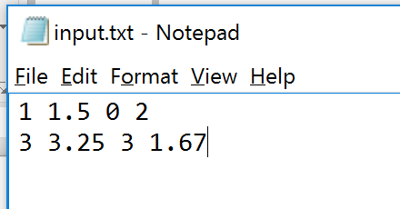

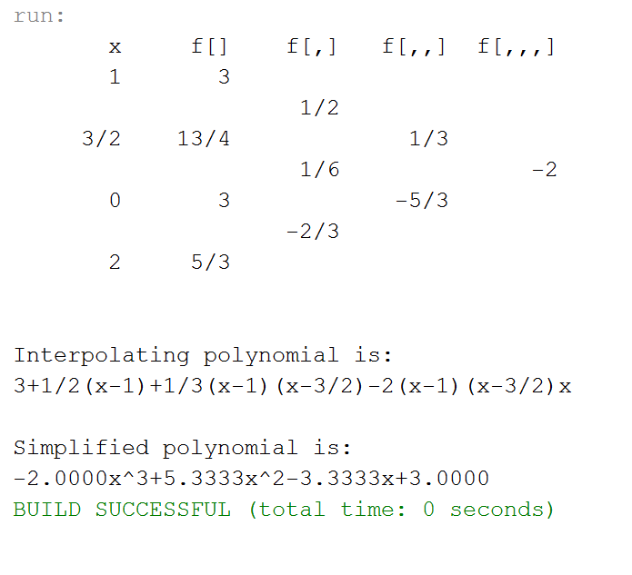

**Example 2: Exam 4 Problem 1**

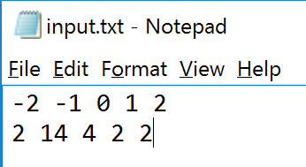

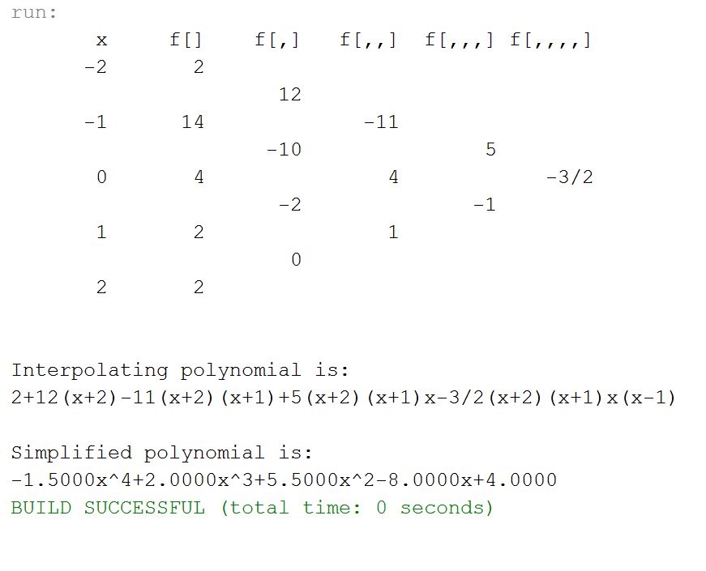

**Example 3: Exam 4 Problem 2**

