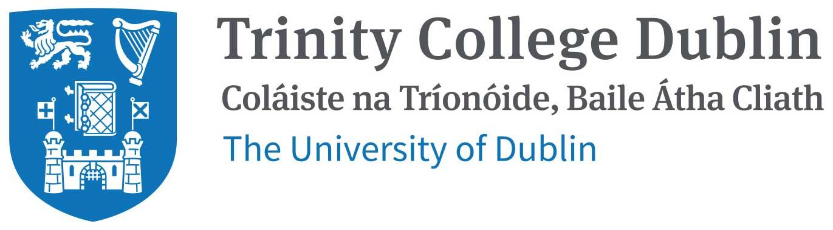

**Self-reflection report**

**Group F:**

Claire Farrell - 16319148

Joshua Cassidy - 20300057

Yifan Pei - 20303063

Siddhesh Kankekar - 20300810

CS7IS1- Knowledge and Data Engineering

December 3rd, 2020

### **Joshua Cassidy**

As the Lead on the ontology design for this project I designed the ontology using draw.io, I worked with Yifan to uplift the design using r2ml with the downloaded datasets, I also fixed up any inconsistencies within the ontology model throughout its development. I also worked with Yifan to generate the documentation of the ontology using Widico, I worked with Claire to develop the application code for the user interface. I worked with Siddhesh to ensure the correct data was being represented on the user interface from the competency questions that were developed.

I feel like the strengths of the team was communication, helping each other when we got blocked and producing high-quality work for the purpose of this project.

I feel like the weaknesses of the team was time management with regard to getting tasks completed on time and clearly defining the tasks of each team member.

### **Claire Farrell**

I was responsible for the data selection, query design and UI. The data selection process was very collaborative as we made sure that the datasets collected were suitable for our application and satisfied the various requirements. Upon agreement, Joshua and Yifan worked on modelling and uplifting the data, whilst Siddhesh designed questions. After deliberation, we refactored these questions as a team and Siddhesh and I worked on designing the queries for the user interface. Joshua and I proceeded to design and develop the UI for our ontology.

As a team, we were in constant communication and understood the value of us all being on the same page as our tasks were all highly dependent on each other. This created a very collaborative environment and made for an enjoyable project experience. Personally, a strength that has been highlighted to me through this project is group organisation, query design and presentation development.

Some areas we could work on in future are: spending less time thinking about an issue and posting our doubts in the clinic earlier, more effective time management, and outlining a clear definition of done for each task. I feel an area I could improve on for next time is gaining an understanding of the complexities of the ontology model first, before designing the queries as I had to duplicate my efforts at times.

### **Siddhesh Kankekar**

Contribution: Competency questions and SPARQL queries.

As we decided to distribute core elements among us, each of us was helpful to one another. I took responsibility for creating competency questions between our chosen datasets which were Tourists activities in Ireland and Accommodations(Airbnbs) in Ireland. We exchanged ideas and refined questions.

After feedback upon the first submission, I went through questions again and modified it by specifying datasets and data points utilized by each question.

Following up with competency questions further to work on SPARQL *queries* after uplifting of data and merging into one turtle file where we specified more competency questions and their respective *queries* for our ontology which requires to have content of both datasets.

After completion, we discussed and a very good suggestion was proposed by team members to add on these *queries* which with help I worked with Claire and Joshua and created a few more *queries* on it.

### **Yifan Pei**

As for the contribution to our project, I used Protégé to build my own ontology based on UML diagrams made before by Joshua. I also used WINDOCO to generate the electronic version for OWL ontology and test it.

For my group, I would like to do everything to help our team to get a satisfying result, but when I meet the difficulties and I find it is tough for me, I will not hesitate but directly tell the other group members although maybe it’s a little bit embarrassing, I know if I did not ask them to try to solve problems as fast as possible, our whole project will be influenced.