Splash Car Wash
Damage Claim Process
User Guide

Section 1 — Claim Form Links by Site
Each Splash location has its own claim form. Use the link for your site.
Site | Claim Form URL
Binghamton | https://splashcarwashes.info/claims/binghamton
Cicero | https://splashcarwashes.info/claims/cicero
Cortland | https://splashcarwashes.info/claims/cortland
Elmira Heights | https://splashcarwashes.info/claims/elmira_heights
Johnson City | https://splashcarwashes.info/claims/johnson_city
Leray | https://splashcarwashes.info/claims/leray
Oswego | https://splashcarwashes.info/claims/oswego
Vestal | https://splashcarwashes.info/claims/vestal
Watertown | https://splashcarwashes.info/claims/watertown

Section 2 — Opening the Claim Form in Chrome (Samsung Tablet)
- Unlock the tablet and tap the Chrome icon to open it.
- Tap the address bar at the top of the screen.
- Type your location's claim form address from Section 1 — for example: splashcarwashes.info/claims/johnson_city
- Tap Go (or the enter/arrow key) on the keyboard.
- The claim form loads with your site's name in the blue header. You're ready to start a claim.
Tip: Type the address carefully. The part after /claims/ is your site's slug (see Section 1) and must match exactly.

Section 3 — Saving the Shortcut to the Home Screen
Do this once so staff can open the form with a single tap in the future.
- Open Chrome on the tablet.
- Go to your location's claim form (the website from Section 2).
- To the right of the address bar, tap More ( ⋮ ) > Add to home screen > Create shortcut.
- In the dialog that appears, keep the default name or rename it to something clear like "Damage Claim - [Site]".
- Tap Add. The shortcut now appears on the home screen.
Tip: Shortcuts with the Chrome logo will open in Chrome.

Section 4 — Deleting the Old Damage Claims Shortcut
Remove the outdated shortcut so staff don't use the wrong link.
- Go to the home screen where the old damage claims shortcut sits.
- Press and hold the old icon until a menu or the Remove option appears.
- Tap Remove (or drag the icon up to Remove at the top of the screen) and confirm if asked.
- This only deletes the shortcut — it does not delete Chrome or any app or data.

Section 5 — Filling Out the Claim Form
The form has two parts on one page: Customer Information (filled by the customer) and Staff Assessment (filled by staff, behind a PIN).

Page 1: Customer Information — completed by the customer
The header shows the site name and "Vehicle Issue Report." Required fields are marked with an asterisk (*):
Your Name*, Phone Number*, Email Address* (a copy of the claim is emailed here), Mailing Address*, License Plate*, Vehicle Year*, Vehicle Make*, Vehicle Model*, Vehicle Color*, Description of Issue*.
Tap Continue to staff assessment →.
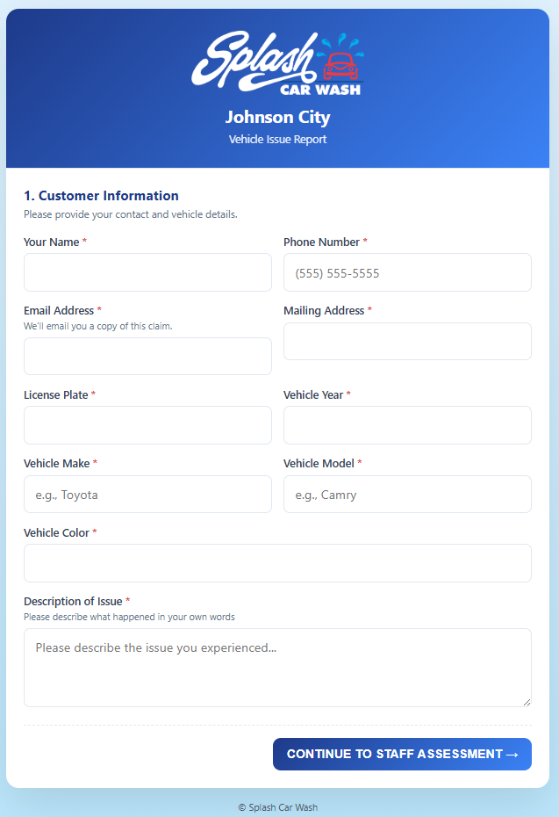
Customer Information page

Staff PIN gate
A "Staff PIN required" box appears: "Enter the staff PIN to continue with the assessment portion of this claim." Enter the staff PIN and tap Continue. (A wrong PIN shows "Incorrect PIN. Please try again.")
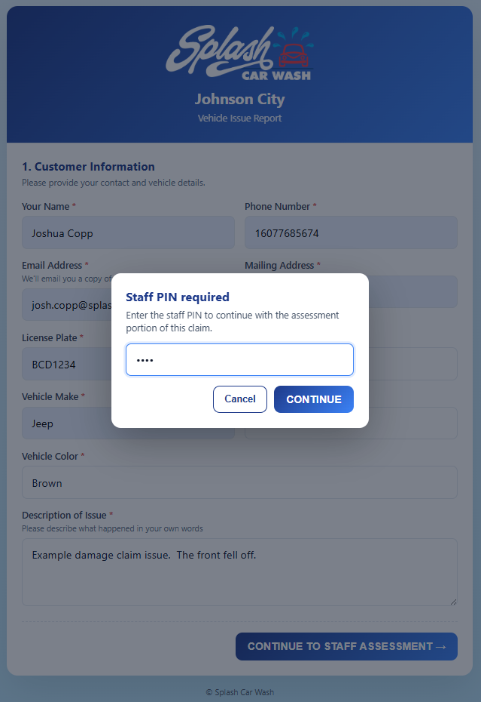
Staff PIN gate

Page 2: Staff Assessment — completed by staff
- Employee Name* and Membership / Barcode (optional).
- Photo sets, each added with + Add photo: Four-Corner / Full-Vehicle Photos*, VIN Photo*, Damage Photos*, License Plate Photo*.
- Pre-Existing Damage Noted (optional) — e.g. "Scratch on rear bumper, dent on driver door."
- Damage Type* dropdown: License Plate, Wiper, Collision, Roof Rack/Roof Accessory, PS Mirror, DS Mirror, Window, Paint Damage, Rims, Tires, Other. Choosing Other reveals a "Description of other*" box.
- Was the damage equipment related? No/Yes toggle (defaults to No). Selecting Yes reveals Equipment Involved*: Top Brush, Side Wraps, Conveyor, Dryer, Wheel Blaster, Other.
- Determination* (choose one): No Responsibility — damage is pre-existing or not caused by the wash; Requires GM Review — needs General Manager evaluation; Requested Customer Get Quote(s) — customer will obtain repair estimates.
- What Was the Customer Told? (optional) and Customer Interaction & Demeanor (optional).
- Tap Submit claim.
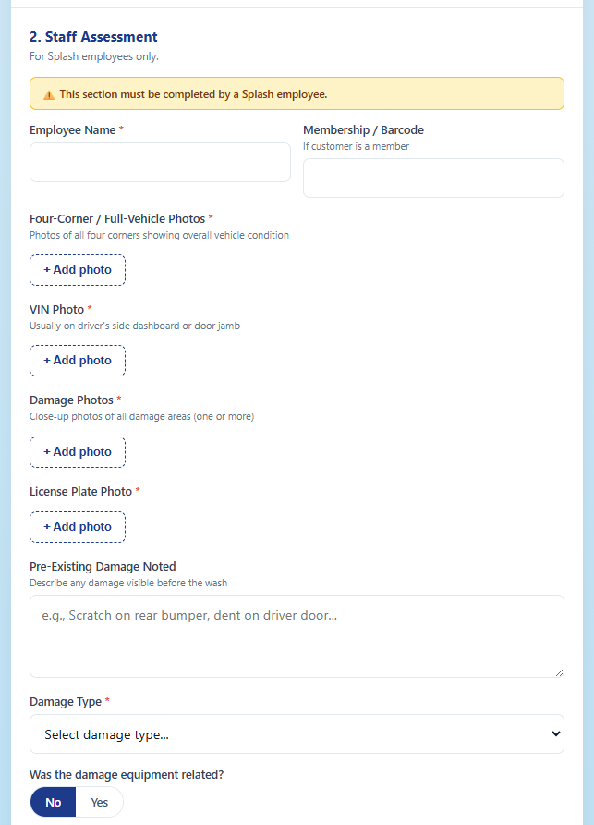
Staff Assessment — top
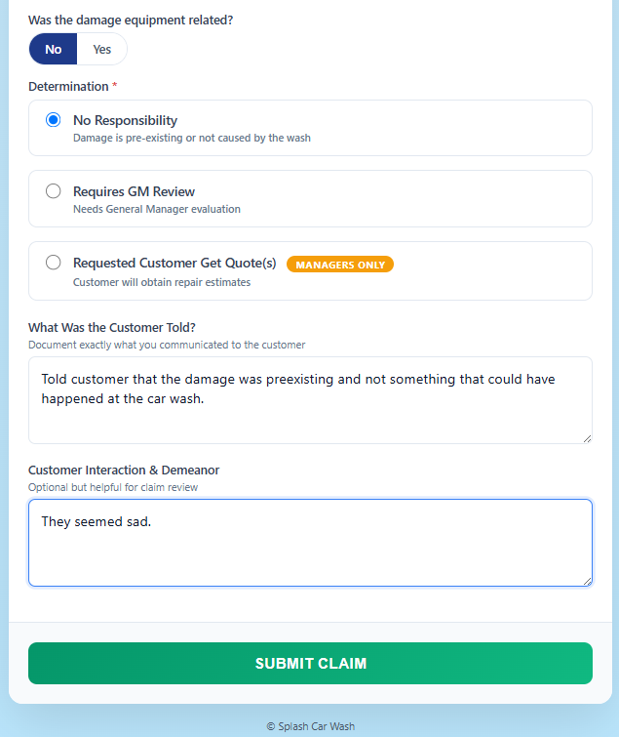
Staff Assessment — determination

Confirmation
"Claim submitted — Your claim for {Site} has been recorded." The screen shows the Claim ID. Buttons: Download a copy (PDF) and Submit another claim. Give the customer a copy or photo of the Claim ID; a manager will review and may follow up.
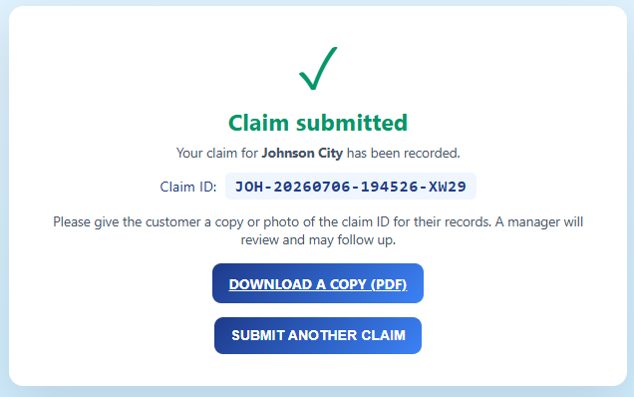
Submission confirmation with Claim ID

Section 6 — Reviewing and Resolving a Claim (GM / Manager)
Once a claim is submitted, a manager reviews it in the internal tools backend, sets the cause, uploads any quotes or receipts, and moves it toward a resolution (including submitting a check request when a payout is approved).

Step 1: Sign in
Open the internal tools site and sign in with your Splash account email and password. Tap Sign In.
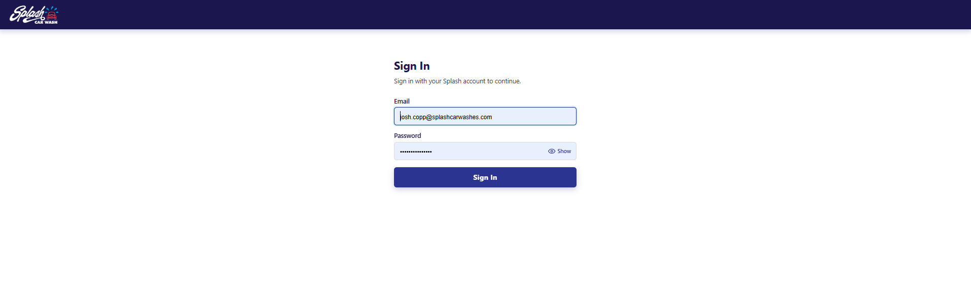
Sign-in screen

Step 2: Open Operations
On the Dashboard, find the three sections: Submissions, Operations, and Admin. Under Operations ("Damage claims, work orders, and performance tracking"), tap Open →.
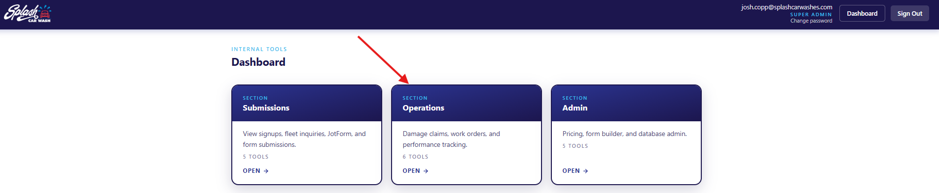
Dashboard — Operations section

Step 3: Open Damage Claims
In the Operations menu, tap Damage Claims ("Review and manage vehicle damage claims and resolutions") > Open →.
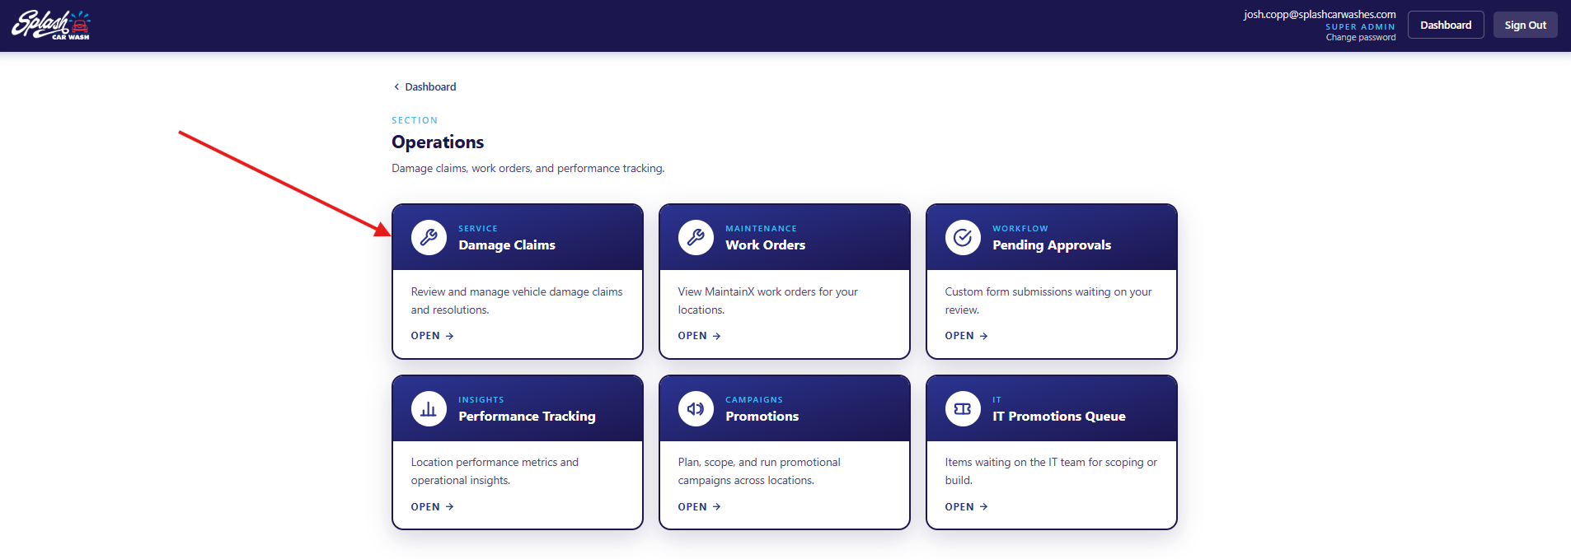
Operations — Damage Claims

Step 4: Find the claim
The Damage Claims list has filters across the top: Search (customer name), Location, Status, Lifecycle, Regional Director, Regional Manager, and a Submitted date range. Set any filters and tap Apply filters (or Reset to clear). Tap a claim row to open it. Export CSV downloads the current list.
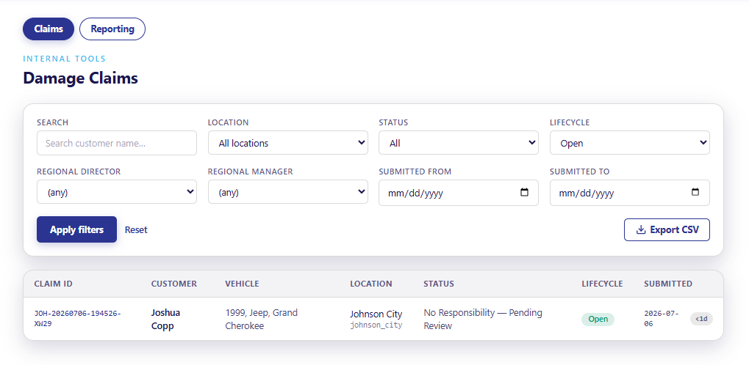
Damage Claims list with filters

Step 5: Review the claim details
The claim page shows everything the customer and staff submitted: customer contact info, vehicle, location, who submitted it, the staff Determination and Damage Type, plus Preexisting Damage and Staff Notes (what the customer was told and their demeanor). Use Add note to record follow-up, and Add document to attach a quote or receipt (see Step 8).
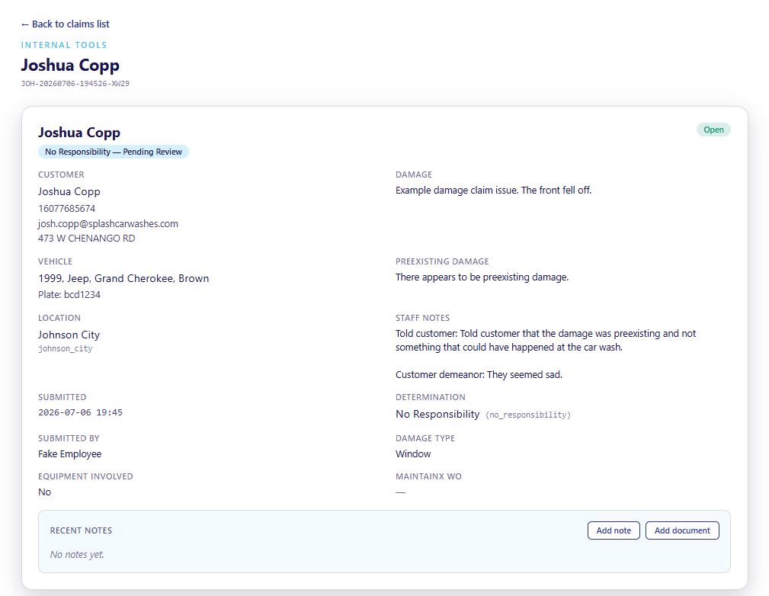
Claim overview

Step 6: Set the Cause (fault)
Scroll to the Cause section. Every claim defaults to Undetermined. Choose the cause from the dropdown, then tap Save cause:
- Undetermined — not sure yet
- Employee Error
- Equipment Malfunction
- Not Employee/Equipment
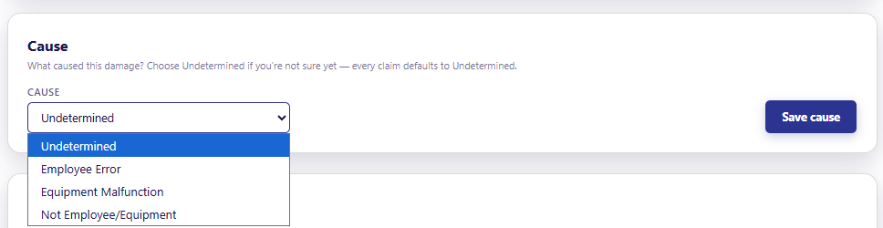
Cause selector

Step 7: Choose how to move forward
The Move forward section lists the resolution actions. Pick the one that fits:
- Approve - Pending Quotes — approve the claim; it now waits on quotes/estimates.
- Approve - In House (Parts Ordered) — handle the repair in house. Optional Parts and Vendor fields.
- Send to RM Review — escalate to the Regional Manager.
- Deny — close the claim as denied.
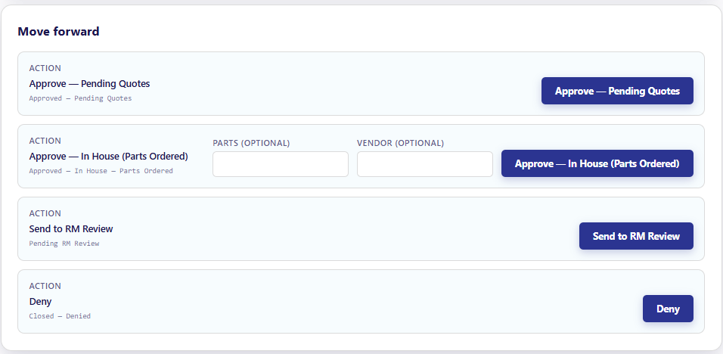
Move forward — resolution actions
Tip: The uploaded claim photos (Vehicle Overview, VIN, Damage, License Plate) appear on the claim page for reference while you decide.
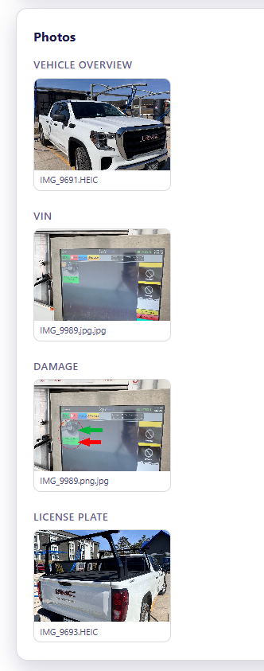
Claim photos on the claim page

Step 8: Upload a quote or receipt
To attach an estimate or receipt, use Add document. Attach a Quote or Receipt (PDF, JPG, PNG, or HEIC; up to 10 MB) and fill in the fields:
- Document Type — Quote or Receipt
- File — tap Choose File and select the document
- Vendor, Amount ($), Pay To (e.g. Customer or the vendor), Vendor Address, and Notes
Important: To generate a check-request PDF later, a Quote must include an Amount and a Pay To. If paying the vendor directly, also fill in the Vendor name and Vendor Address. Tap Upload document.
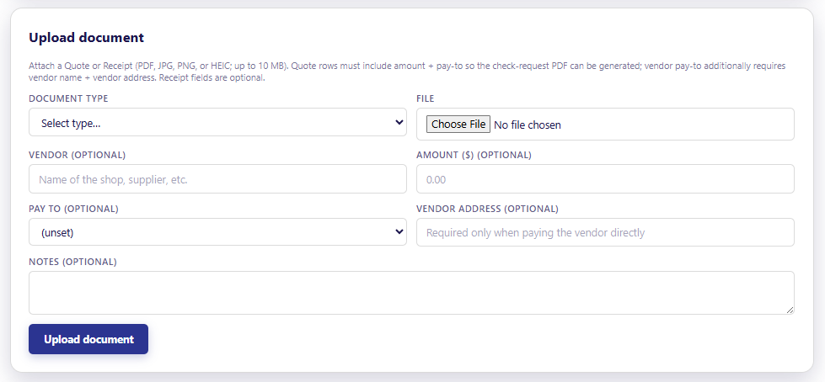
Add document form
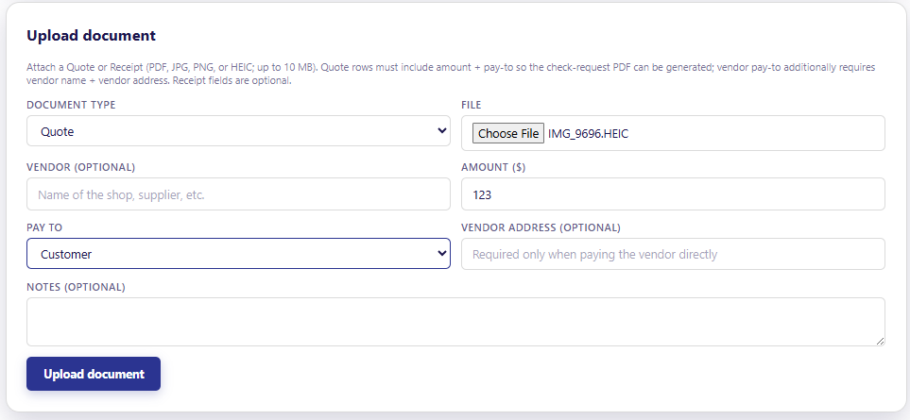
Add document — filled in

Step 9: Approve into Pending Quotes
When you approve a claim into Pending Quotes, a confirmation asks "Was this damage equipment related?" The employee's original answer is pre-filled, but you can override it. Choosing Yes creates a MaintainX work order assigned to maintenance. Tap Confirm - Approve - Pending Quotes.
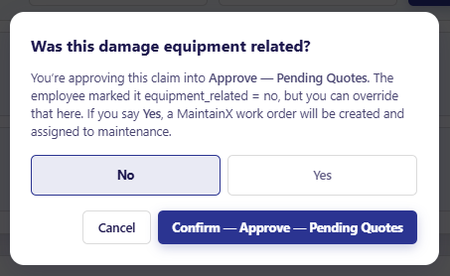
Equipment-related confirmation

Step 10: Approve the quote and submit the check request
After a quote is added, the Move forward section shows Approve Quote (submit Check Request). Pick the quote from the Quote to approve dropdown (each is listed as #ID - $Amount), then tap Approve Quote (submit Check Request). This submits the check request and moves the claim to Approved - Check Request Submitted.
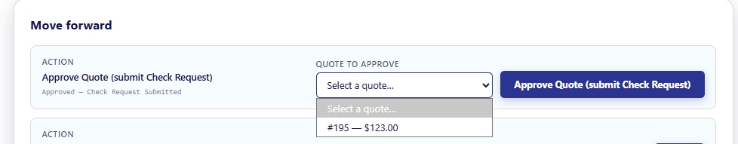
Approve quote and submit check request

