**LEGAL DOCUMENT SUMMARIZATION AND ANALYSIS**

**OBJECTIVE:**

To move forward the way Lawful Reports and Terms and Conditions contracts aredisplayed and analyzed. Give a comprehensive and simple to get it rundownof legitimate archives and analytics of the content, permitting a more profound knowledge into it forthe pursuer.

**PROJECT DESCRIPTION:**

Our arrangement is two overlap. We have fundamentally worked with Terms of Benefitrecords and Lawful Judgements. We hence give the taking after:a) Lawful Judgment - Arrangement of a web application where clients can transfer a.TXT record of their legitimate archive. We analyze the report and give:-> Comprehensible outline of content-> Imperative Watchwords to assist get it the content superior-> Certain informatics such as people included, areas, organizationsincluded etc.-> Arrangement of a bot which can be inquired questions to pick up way betterunderstanding of the reportb) Protection Report space - Arrangement ofa plugin which has the capacity todiscover the Terms and Conditions link for website and after that give aninvestigation of the complexity and coherence of the archive. It too extricatesthe foremost critical sentences from the reports for the user's examination.Hence, this item makes a difference a client be way better educated almost the conditions theyare concurring to.

**SINESS MODEL:**

Our arrangement is two overlap. We have fundamentally worked with Terms of Benefitrecords and Lawful Judgements. We hence give the taking after:a) Lawful Judgment - Arrangement of a web application where clients can transfer a.TXT record of their legitimate archive. We analyze the report and give:-> Comprehensible outline of content-> Imperative Watchwords to assist get it the content superior-> Certain informatics such as people included, areas, organizationsincluded etc.-> Arrangement of a bot which can be inquired questions to pick up way betterunderstanding of the reportb) Protection Report space - Arrangement ofa plugin which has the capacity todiscover the Terms and Conditions link for website and after that give aninvestigation of the complexity and coherence of the archive. It too extricatesthe foremost critical sentences from the reports for the user's examination.Hence, this item makes a difference a client be way better educated almost the conditions theyare concurring to.

**TECHNICAL SPECIFICATION:**

a) Legitimate Report SummarizerDataset Utilized: The dataset for deciding the category of the report wasgotten by slithering through the archives accessible inhttps://indiankanoon.org/browse which comprises of judgements and tribunaland court particular legitimate archives.**Calculation**: The strategy of summarization utilized here is extractive in nature.The summarization pipeline comprises of the taking after steps:i) preprocessing - part reports into sentences which are stemmed,lemmatized, case-normalized, and cleared of halt wordsii) scoring of sentence significance - Sentences are scored employing a TF*IDFlattice built from thousands of legitimate case reports, which checks termrecurrence utilizing T F * IDFt = T Ft * Vlog N DFt where N alludes to thenumber of documents, T Ft is the entire number of term t, and DFt is thenumber of archives in which t shows up. These scores are summed overeach sentence and normalized by the sentence length. This normalizationstep guarantees the framework does not predisposition long sentences.iii) space handling - In arrange to incorporate extra space data,we to begin with extricate a list of all substances from the content. Parties can be extricatedfrom case titles since of the record structure. Essentially, shortened formsof substance names are distinguished to aid the reader's understanding ofrundowns.We don't utilize particular prompt words or catchphrases, but alter sentence scoresutilizing events of known substances, dates, and nearness to segmentheadings. The alteration work is w(new) = w(old) + G(0.2d + 0.3e +1.5s), where is the standard deviation among sentence scores, d alludes tothe number of dates display, e is the number of substance notices, and s may be aboolean demonstrating the begin of a area. (Weights tentativelydecided)We utilize a multinomial Gullible Bayes demonstrate for the forecast of categorybased on the substance of the record. NLTK is utilized for preprocessing and otherextraction.bundle gives a pairwise comparison strategy forassessing candidate rundowns against human-provided ones. The ROUGEmetric has numerous variations and may be connected at the word, state, orsentence level. In this case, we utilized ROUGE-N, which measures the coverofn-grams between rundowns, with N = 1, 2, 3, and 4. We too computedthe ROUGE-L score, a metric comparative to an F-measure based onsentence-level similitude of two rundowns.

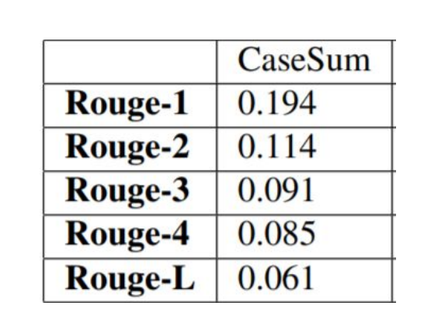

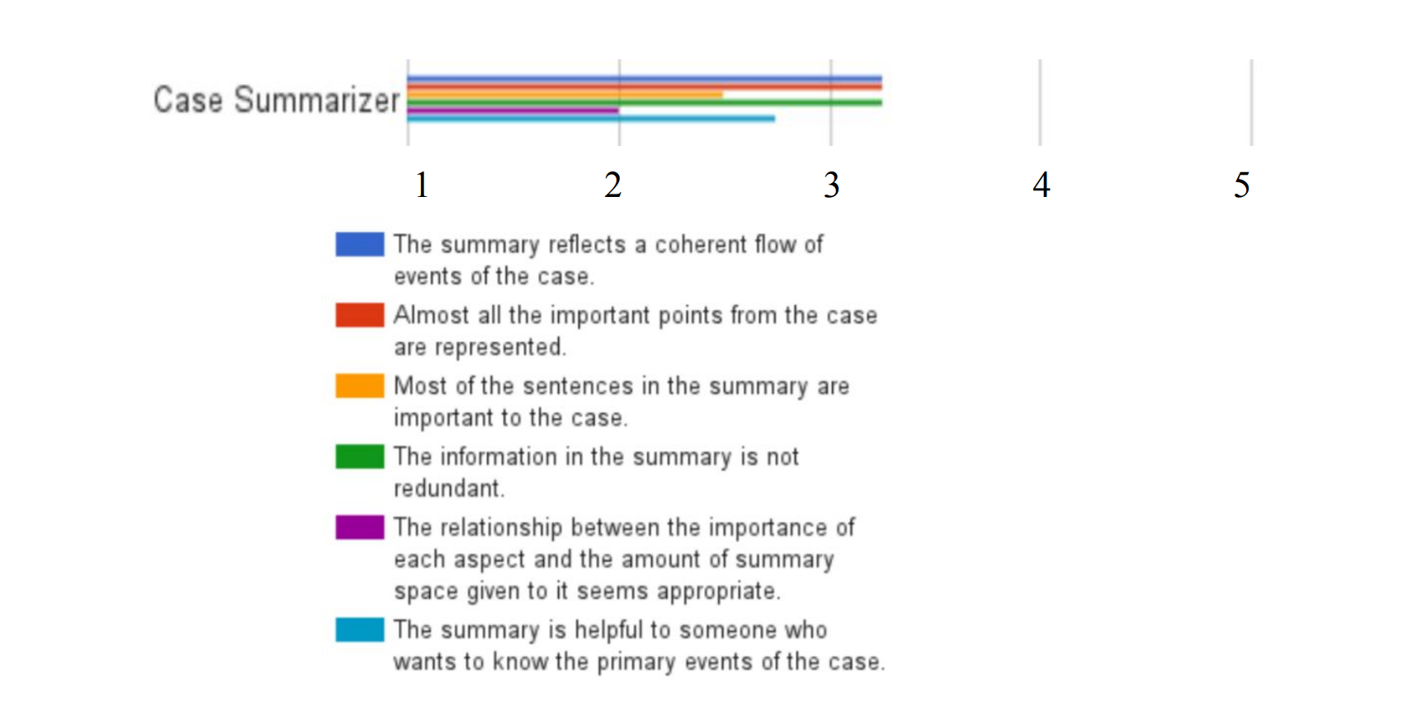

**User Interface:** We utilize the Django system to make a web application.Here clients can upload their record and it'll be examined to donate the specifiedrundown and informatics.The record is specifically handled and not put away on any server. For the bot, weutilize the Microsoft LUIS system, and we have as of now prepared the bot onleast data. Hence the client can inquiry the bot for theirprerequisites.

**Tech Stack:**

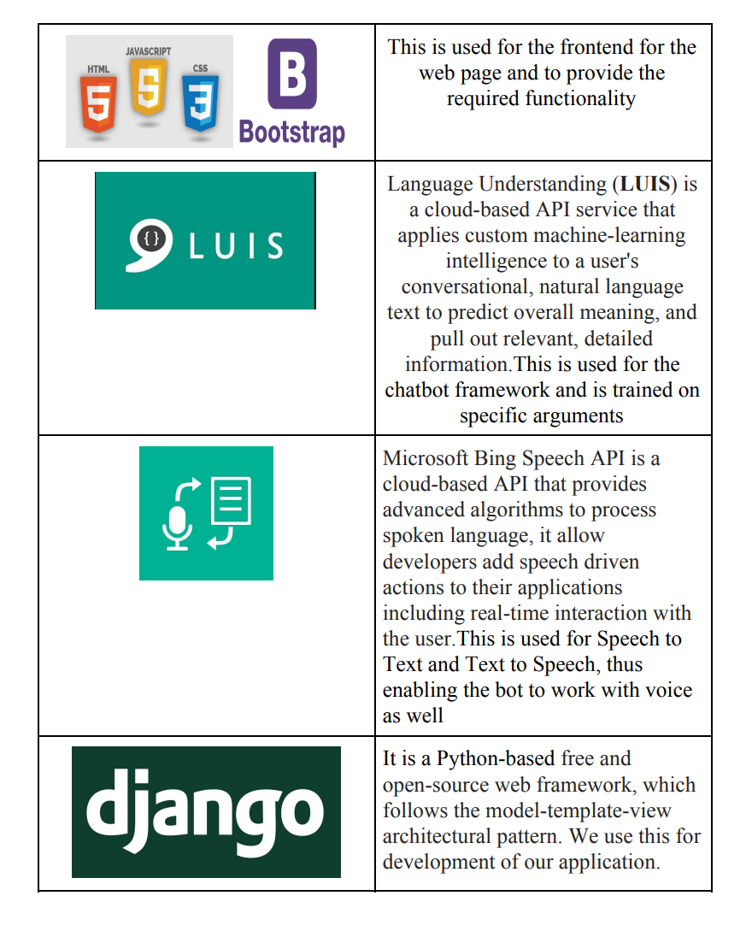

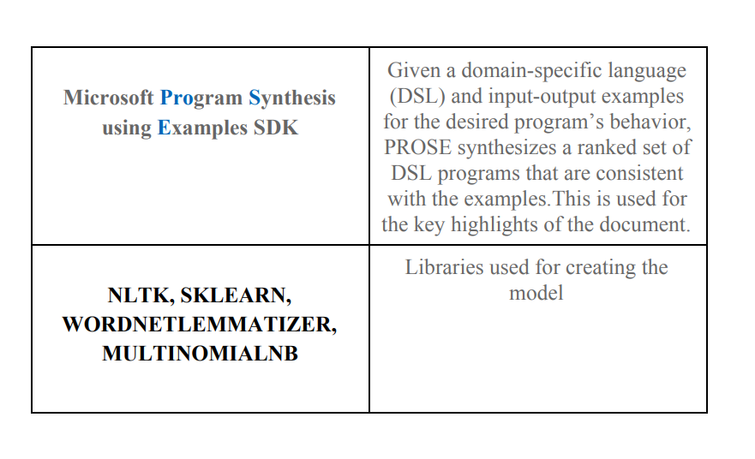

**Final product:**

**Further work:**

->We would like to expand the record groups backed to pdf etc->We would like to prepare the bot for particular client illustrations so it is able toreply any report inquiry->We would like to investigate the thought of employing a organize for abstractive legitimatesummarization->We would like to grow our preparing set so our demonstrate can handle distinctivesorts of information.b) Protection Report Analyzer:Dataset utilized: We have utilized the terms and conditions documents scrapedfrom the net for making commented on sets with the score for each express.**Calculation:**a) Extractive Summarization of the T&Cs and approaches is done utilizing theunsupervised TextRank summarization calculation to recognize the keysentences within the report.b) We too carry out Content Classification of the document's sentences,similar to Opinion Examination, to recognize the extremity ofa givensentence within the arrangement. This was done employing a Transformer demonstrate(BERT) with a calculated relapse head fine-tuned for ourdomain-specific task employing a named dataset.c) Meaningfulness and complexity scores of the report are calculated anddoled out employing a publicly accessible API which employments theFlesch—Kincaid Evaluating strategy.d) At last, we too utilized a pre-trained Named Substance Acknowledgment demonstrateto recognize key substances within the record that ought to be brought to theconsumer's consideration such as associations included and activities thatthe arrangement involves.Evaluation: After 8 ages, we get the taking after result:Preparing Precision: 96.5413544411051%Approval Misfortune: 0.22072744742035866Approval Exactness: 94.28571632930209%Approval execution moved forward... Sparing demonstrateClient Interface: The backend could be a Jar server which communicates to ourfront conclusion utilizing REST APL On the client side, a userscript utilizing jQuery wasmade for utilize in a supervisor such as Tampermonkey . A button is made inthe best right corner of the page which is, able when clicked, channel through allthe labels on the page to discover the connect to the protection approach page. Whenthe page is opened, the script will affirm that the client is on the proper pageand after that send an http GET ask to the backend with the page URL. Thereaction from the server will be parsed and shown to appear the outlinealong side a few evaluations for the approach through responsive plan.

**Tech stack:**

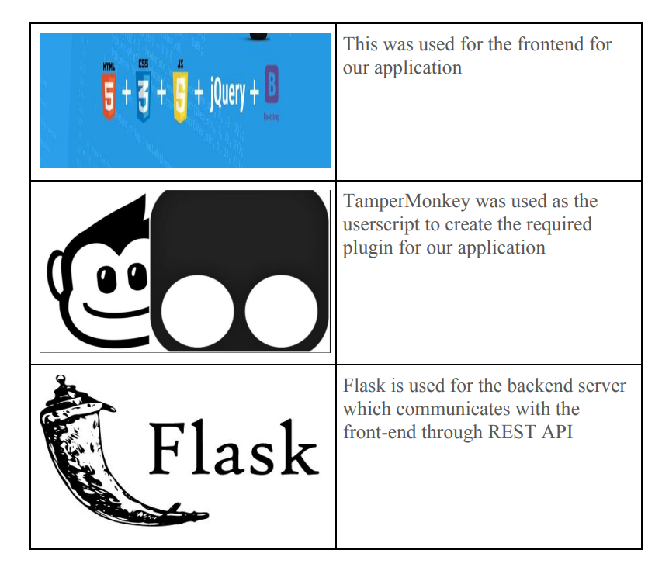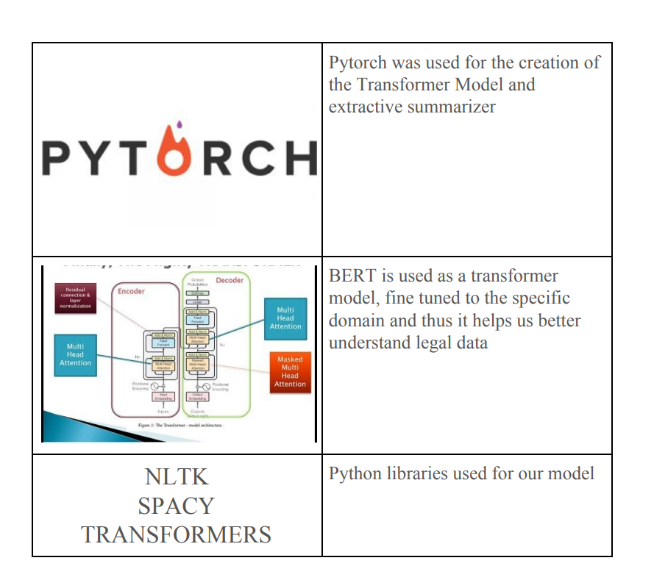

**Further work:**

-> Create a more nitty gritty dashboard which may offer assistance clients to way better visualizewhat happens to their information-> Abstractive Content Summarisation, which can precisely rewording complexlegalese into easy-to-read sentences-> Making utilize of more progressed NLP methods may refine our rundowns,utilizing commonly-used dictionary and indeed colloquialisms to create our rundownsexceptionally user-friendly.

**Conclusion:**

In summary, this project offers an innovative solution to simplify the analysis of legal documents, including Legal Judgments and Terms of Service, by providing clear summaries, identifying key information, and enhancing user understanding. With a robust technical foundation and future expansion plans, it promises to significantly improve accessibility and comprehension of legal content, ultimately making the legal system more approachable and user-friendly for a broader audience.