STAGE S0
Problem Definition & Need Identification
Consolidated Evidence — Steps 1 through 7, in working order

Team No. | 4
Theme No. | 5
Artefact Name: | Resource Packing & Allocation Optimization Engine
Team Members | - Sumanth Patil  - Neil Mascarenhas  - Dasari Joshua  - Akash Dani
Guide Name | Mr.Maheshgowda Patil

Foundational Courses
SI.No. | Course | Core Concepts
1. | Data Structures & Algorithms | Multidimensional bin-packing heuristics, priority queues, and dynamic programming for optimal resource placement.
2. | Operating Systems | Process scheduling, memory allocation, context switching overhead, and resource starvation avoidance.
3. | Computer Networks | Latency-aware placement, network bandwidth constraints, and inter-process communication (IPC) routing.
4. | Database Management Systems | Relational schema design for node state tracking, transaction logging, and time-series utilization metrics.
5. | Software Engineering | System architecture design, API development, and module integration for the optimization engine.

2. Existing Problem / Current Situation
Describe the real-world problem or gap as it exists today. What currently happens, and where does it fall short?
In containerized environments and cloud data centers, workload provisioning relies heavily on static resource requests and basic round-robin scheduling. This results in multi-dimensional resource fragmentation, a scenario where a server might have ample CPU but exhausted memory, rendering the remaining compute capacity unusable for new applications.

3. Who Is Affected
Briefly name the affected users/groups. (Full stakeholder detail belongs in the separate Stakeholder Analysis document.)
1.System and DevOps Administrators
2.Cloud Infrastructure Operations and FinOps Teams
3.Application Developers
4.End-Users experiencing service latency

4. Why the Existing Approach Is Inadequate
Explain specifically what is missing, slow, error-prone, manual, or unreliable about the current approach.
The current static approach lacks dynamic, multi-dimensional awareness during the scheduling phase. Human administrators cannot manually calculate complex 3D bin-packing equations in real time during traffic spikes. Relying on default orchestration schedulers without custom packing logic forces organizations to over-provision underlying server hardware to avoid workload crashes.

5. Evidence That This Problem Is Real
List observations, informal surveys, interviews, existing data, or references that support the problem's existence — not assumptions.
- The Flexera 2026 State of the Cloud Report identifies that organizations waste approximately 29% of their cloud infrastructure spend, largely driven by over-provisioned and poorly optimized compute resources.
- Industry container telemetry data indicates that over 65% of Kubernetes workloads utilize less than half of their requested CPU and memory, leading to severe cluster underutilization.
- Internal server environments typically average between 15% to 20% hardware utilization due to inefficient workload bin-packing.

6. Sources / References
Cite where your evidence came from (people consulted, documents reviewed, existing systems observed, etc.).
- Flexera. (2026). State of the Cloud Report.
https://share.google/kNuvS44K1gzMEK2vK
- Datadog. Container Report.
https://www.datadoghq.com/state-of-containers-and-serverless/
- Natural Resources Defense Council (NRDC) Data Center Efficiency Assessments.
https://jemtechgroup.com/wp-content/uploads/2016/09/data-center-efficiency-assessment-IP.pdf

💡 REMINDER: This document must be dated and completed BEFORE any requirements engineering (S1) work begins — Gate 0 checks this explicitly.
WHO IS INVOLVED
Step 2 of 7 — S0 Problem Definition & Need Identification
Stage S0 — Problem Definition & Need Identification │ General, Theme-Independent

1. Stakeholder Table
List every distinct group or role that interacts with, is affected by, or has an interest in this problem/system. Add rows as needed.
Stakeholder | Role / Description | Needs & Expectations | Current Pain Points | Influence (H/M/L)
System/DevOps Administrators | Manage infrastructure and monitor cluster health | Automated scaling and intelligent placement | Manual intervention required during sudden workload spikes; high operational overhead | High
Cloud FinOps Teams | Oversee infrastructure budget and resource ROI | Maximum hardware utilization and predictable billing | High percentage of wasted spend on idle but allocated server capacity | High
Application Developers | Deploy microservices and containerized applications. | Consistent environments without hardware constraints. | Applications fail to schedule due to localized resource exhaustion (e.g., OOM errors). | Medium
End-Users | Consume the deployed digital services. | Uninterrupted, low-latency application performance. | Dropped requests or lag when physical node limits are reached. | Low

2. Primary vs. Secondary Stakeholders
Primary: directly use or are directly affected by the system. Secondary: indirectly involved (e.g., administrators, oversight bodies).
Primary Stakeholders | Secondary Stakeholders
System/DevOps Administrators | Cloud FinOps Teams
Application Developers | End-Users

3. Key Insight Summary
In 3–5 sentences, summarize what the stakeholder analysis reveals about whose needs the system must prioritize.
The system must prioritize the operational needs of System Administrators by automating complex placement decisions. By optimizing how workloads are packed, the engine simultaneously satisfies FinOps teams (by reducing waste) and Developers (by ensuring reliable deployment), bridging the gap between hardware efficiency and application stability.

💡 REMINDER: Every stakeholder listed here should be traceable to at least one requirement in S1.

HOW IT WORKS TODAY
Step 3 of 7 — S0 Problem Definition & Need Identification
Stage S0 — Problem Definition & Need Identification │ General, Theme-Independent

1. Current Process — Narrative Summary
Describe, in plain language, how the process/task is currently carried out from start to finish.
A developer submits a deployment request for a new containerized application, specifying static CPU and memory limits. The system administrator or a default scheduler reviews the current cluster dashboard and assigns the workload to the first node that mathematically fits the static request. As real-time usage fluctuates, the node may experience resource contention. The administrator receives a retroactive alert and must manually intervene to migrate pods or spin up additional servers.

2. Step-by-Step Workflow Table
Break the current process into individual steps. Add or remove rows as needed.
Step No. | Actor / Role | Action Performed | Tool / System Used | Pain Point Observed
1. | Developer | Submits application manifest with estimated resource limits | CI/CD Pipeline | Resource limits are frequently guessed, leading to over-requesting.
2. | Default Scheduler / Admin | Identifies a node with sufficient unallocated space based on the manifest. | Orchestration Engine | Decision is linear/naive, causing fragmentation on the selected node.
3. | System Node | Executes the workload alongside existing applications | Server Hardware | Memory or CPU may spike independently, causing local contention.
4. | Admin | Receives a high-utilization alert when limits are breached. | Monitoring Dashboard | Alerts are reactive; performance degradation has already occurred.
5. | Admin | Manually reschedules workloads or scales the cluster to relieve pressure. | CLI / Admin Console | Manual migration is slow, stressful, and prone to human error.

3. Workflow Diagram
Attach or paste a flowchart / swim lane diagram of the AS-IS process here (insert image after printing/exporting, or paste into this space in the digital copy).
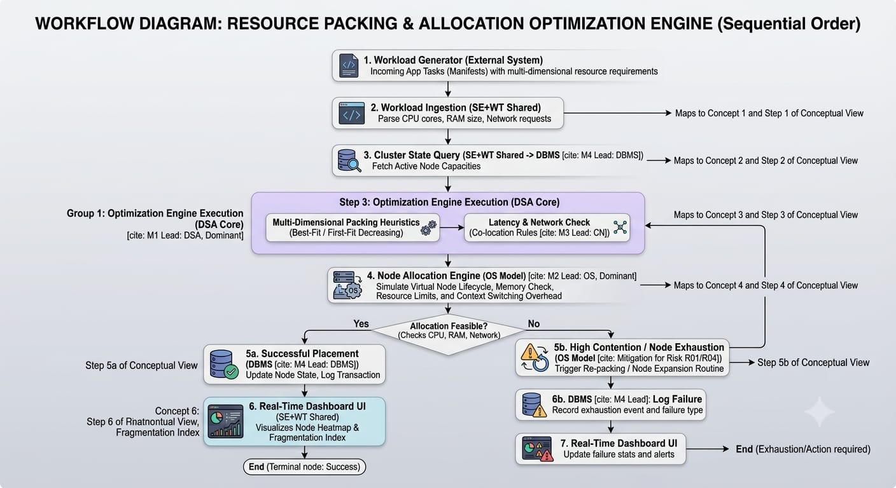

4. Bottlenecks & Inefficiencies Identified
Summarize the key weaknesses in the current workflow that the proposed system should address.
The core inefficiency is the reliance on rigid, single-dimensional provisioning. The existing workflow fails to dynamically analyze the entire cluster state to pack workloads complementary to one another (e.g., pairing a CPU-heavy task with a memory-heavy task on the same node).

💡 REMINDER: This document proves you understand the existing process before proposing a new one — required as Gate 0 evidence.

PROBLEM & GOALS
Step 4 of 7 — S0 Problem Definition & Need Identification
Stage S0 — Problem Definition & Need Identification │ General, Theme-Independent

1. Observed Problems → Underlying Needs
For every observed problem, state the evidence/source behind it, the underlying need it points to, and which stakeholder(s) it affects. Add rows as needed.
Observed Problem | Evidence / Source | Underlying Need | Linked Stakeholder(s)
29% of cloud spend is wasted due to underutilization. | Flexera 2026 Cloud Report | Algorithmic optimization of server node capacity. | FinOps Teams, Admins
Workloads fail to schedule despite total cluster capacity existing. | System fragmentation logs | Multi-dimensional bin-packing awareness. | Developers, Admins
Administrators manually migrate pods during traffic spikes. | Standard operational workflows | Automated, predictive placement engine. | System Administrators

2. Prioritization
Rank the needs above by importance/urgency, and briefly justify the ranking.
- Algorithmic Optimization: Must be addressed first as it is the mathematical core of reducing waste.
- Multi-dimensional Awareness: Essential for translating the algorithm into practical CPU/RAM metrics.
- Automated Placement: The final execution step to remove the manual administrative burden.

3. Problem Statement
State the single, concise computing problem this project solves — bounded, evidence-supported, and free of solution language.
Current static resource provisioning models in multi-node environments cause severe multi-dimensional resource fragmentation, resulting in an average of 20-30% wasted compute capacity and necessitating manual administrative intervention during workload spikes.

4. Project Objectives
State 4–6 clear, measurable objectives this project aims to achieve, based on the needs above. Each should be speci
fic enough to later map to a requirement or deliverable.
1. Develop an algorithmic bin-packing engine capable of evaluating 2D resource constraints (CPU and RAM).
2. Simulate a virtual node environment to test workload placement without requiring physical data center hardware.
3. Design a relational database schema to log real-time node state and historical allocation efficiency.
4. Implement a visualization dashboard to display cluster utilization and fragmentation metrics.
5. Reduce simulated resource fragmentation by at least 15% compared to naive round-robin scheduling algorithms.

💡 REMINDER: Every need and objective here should map forward into a Functional or Non-Functional Requirement in S1 — keep this page for your Requirements Traceability Matrix later.

WHAT'S INCLUDED
Step 5 of 7 — S0 Problem Definition & Need Identification
Stage S0 — Problem Definition & Need Identification │ General, Theme-Independent

1. In-Scope
List what the system WILL do / include within this semester's project.
# | In-Scope Item
1. | Implementation of multidimensional bin-packing heuristics (e.g., Best-Fit Decreasing) using Python or C++.
2. | Simulation of a localized cluster environment utilizing Minikube and Docker containers to represent nodes and workloads.
3. | A backend API facilitating communication between the packing engine and the cluster state database.
4. | A web-based frontend dashboard mapping real-time resource allocation and algorithmic efficiency.
5. | Detection of simulated localized resource exhaustion and network bandwidth thresholds.

2. Out-of-Scope
List what the system explicitly will NOT do / include — this prevents scope creep later.
# | Out-of-Scope Item | Reason for Exclusion
1. | Production-grade cloud billing or invoicing modules. | Exceeds the technical scope and timeline of the academic project.
2. | Physical hardware provisioning and bare-metal server configuration. | Unnecessary for demonstrating the algorithmic optimization problem.
3. | Internet-scale distributed peer-to-peer deployment. | Beyond the compute limitations of a local laboratory environment.

3. Assumptions
List anything assumed to be true for planning purposes (e.g., available data, user access, environment).
- Workload resource requests (CPU/RAM) are known and provided at the time of scheduling.
- The simulated nodes possess uniform baseline operating system overhead.

4. Constraints
List known limitations — time, team size, technology, data availability, etc.
- System testing is restricted to local development environments and student hardware.
- Execution timeline is strictly bound to the 15-week academic semester

💡 REMINDER: A clear Out-of-Scope list is just as important as In-Scope — reviewers will check both at Gate 0.

CAN WE DO THIS
Step 6 of 7 — S0 Problem Definition & Need Identification
Stage S0 — Problem Definition & Need Identification │ General, Theme-Independent

1. Technical Feasibility
Assess whether the team has (or can acquire) the technical skills, tools, and technology needed.
Aspect | Assessment | Justification
Algorithmic | High | Team possesses foundational DSA knowledge to adapt Knapsack and Bin-Packing algorithms.
Infrastructure | High | Container orchestration platforms like Minikube allow robust cluster simulation directly on local machines.
Integration | Medium | Connecting the C++/Python engine to the web dashboard requires strict API interface contracts.

2. Operational Feasibility
Assess whether the proposed system will realistically work within the target environment/users.
The proposed artefact operates completely within a controlled simulation, making it highly feasible to execute and evaluate without requiring enterprise user access or live production data.

3. Time Feasibility
Assess whether the scope is achievable within the semester timeline (15 weeks).
The project is achievable within the 15-week limit due to the explicit exclusion of physical hardware provisioning and production-grade security features.

4. Resource Feasibility
Assess team size, skill distribution, and access to any needed data/hardware/software.
The team of four provides sufficient bandwidth to divide responsibilities across Algorithm Design, OS Simulation, Database Management, and UI integration. Required software tools (Docker, Git, Python, MySQL) are open-source and readily available.

5. Overall Feasibility Conclusion
State a clear go / go-with-modifications / no-go conclusion, with reasoning.
Go. The project scope is tightly bounded to algorithmic optimization and software simulation. By leveraging existing local containerization setups, the team can effectively demonstrate the core computing problem and achieve the stated objectives within the semester timeframe.

💡 REMINDER: Feasibility must be realistic, not optimistic — reviewers will check this against your stated scope and timeline.

WHAT COULD GO WRONG
Step 7 of 7 — S0 Problem Definition & Need Identification
Stage S0 — Problem Definition & Need Identification │ General, Theme-Independent

1. Project-Level Risks
Identify risks that could affect the project at this early stage — technical, resource, scope, or timeline related. Add rows as needed.
Risk ID | Risk Description | Category | Likelihood (H/M/L) | Impact (H/M/L) | Mitigation Strategy
R01 | Algorithm execution time becomes a bottleneck during simulated high-volume traffic spikes. | Technical | M | H | Impose time-complexity bounds (e.g., $O(N \log N)$) and utilize greedy heuristics over exhaustive search.
R02 | Inconsistent data synchronization between the packing engine and the database state. | Integration | M | H | Enforce strict transaction locks and relational constraints within the DBMS schema.
R03 | Scope expansion into advanced predictive machine learning models for workload forecasting. | Scope | H | M | Strictly adhere to the In-Scope definition; defer predictive ML modeling to future iterations.
R04 | Simulated container node failures are difficult to accurately measure and reproduce. | Operational | L | M | Standardize the test workload manifests and execute benchmarks within an isolated Minikube environment.

2. Risk Owner Summary
For each risk above, note which team member is responsible for monitoring it (optional but recommended).
R01 (Algorithmic Overhead): Member 1 (Algorithmic Core Lead)
R02 (State Integrity): Member 4 (Data Infrastructure Lead)
R03 (Scope Creep): All Team Members
R04 (Simulation Accuracy): Member 2 (Systems & Simulation Lead)

💡 REMINDER: This is an INITIAL register — it will be revisited and expanded at later gates as the project matures.

