**Using the BAM Migration Utility**

In order to migrate data from Proteus to BAM without having to do everything manually, I wrote a migration utility to automate the workload. To use this utility, begin by opening up PowerShell ISE and opening the BAM_Migration_Utility.ps1 file or right-clicking on the aforementioned file and choosing “Open With” -> “Windows PowerShell”. If you chose to use the ISE, once the file has been opened, click the Green Arrow (or press “F5”) to run the script.

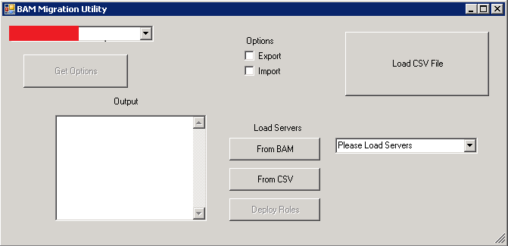

**Export Data from Proteus**:

To export data from Proteus, you first need a CSV file with subnets listed therein (Note: This file needs to have a field labeled “Subnets” in the first row in the column where the subnets are listed in subsequent rows). Begin by clicking the “Load CSV File” and navigate to your CSV file. Once the Output area shows the loaded subnets, select “(internal URL removed)” from the dropdown menu and check the “Export” checkbox. Next click the “Choose CSV Output File” button and choose a name and location for your output file. (Once the export is completed, the named file will be created with all of the DHCP Scope options listed therein.) Finally, click the “Get Options” button and enter your credentials when prompted.

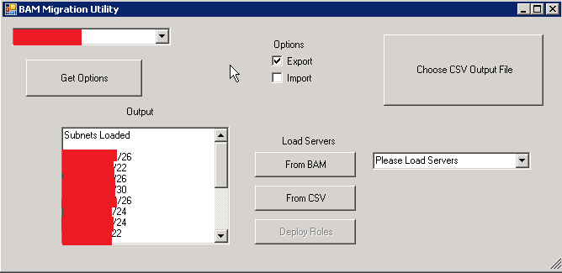

**Import Data to BAM:**

Once you have a CSV file with DHCP scope options listed therein, open the BAM Migration Utility (if it was previously used to export, close it and run it again) and click the “Load CSV File” button, and load your CSV file. Once the file has been loaded, check the “Import” box and then click the “Load Options” button. (Note: “bam.chs.net” should automatically be selected from the dropdown menu when the “Import” box is checked, but if that has been changed, make sure to select it prior to loading the options.) This will create the scope options (making on-the-fly conversions for options which need to be different on the two systems such as TFTP options since the Linux appliances require slightly different options from the Windows servers which are attached to Proteus) in BAM. Once all of the options have been copied, do not forget to run the “BlueCat-Migration-Tool-IP-Assignments” and “BlueCat-Migration-Tool-Scope-Splits” (selecting the same CSV file with a listing of the subnets therein) scripts so that all of the DHCP reservations and such are matched and the scope split which exists in Proteus is undone.

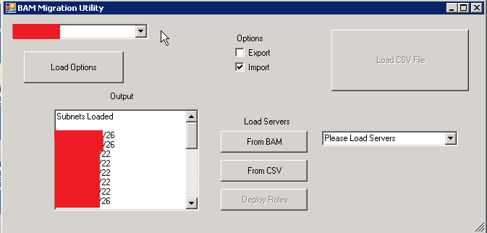

**Attaching Roles to DHCP appliances**

Multiple simultaneous role deployments can also be performed by using the migration utility as well. In order to do this, you must have a CSV file with a listing of the subnets to which you wish to attach the DHCP deployment roles. Begin by running the utility and clicking “Load CSV File”, and navigate to your CSV file so that it is loaded. Next, choose one of the options under “Load Servers”. If you have previously loaded servers from BAM, loading them from the CSV file* works much faster. If a new server has been added which you need to select, or if this is being run on a new machine, the server list will have to be loaded from BAM. (*Note: each time the servers are loaded from BAM, all servers are enumerated and saved to a CSV file at “C:\servers” so that they can be loaded from the CSV file on the next use instead of having to load them from BAM.) Once the servers have been loaded, select one of the two servers (from the DHCP failover pair) you wish to deploy DHCP roles to and click the “Deploy Roles” button. This will attach the DHCP roles to each of the subnets and perform a deployment to the servers in the failover pair automatically.

