VELLORE INSTITUTE OF TECHNOLOGY
DEPARTMENT OF COMPUTER SCIENCE AND ENGINEERING
FRAUDLENS
Financial Transaction and Fraud Investigation Management System
A DATABASE MANAGEMENT SYSTEMS CASE STUDY REPORT
Institution: Vellore Institute of Technology
Submitted By: 1. D Joshua Daniel (Reg No: 24BCE0436)
2. M Saryu (Reg No: 24BCE2524)
Degree & Branch: Bachelor of Technology in Computer Science and Engineering
Subject: Database Management Systems
Faculty Evaluator: Prof. Kanagaraj K
Database Environment: Oracle AI Database 26ai Free Release 23.26.3.0.0
Container & Schema: FREEPDB1 / FRAUDLENS_USER
October 2026 — Evaluated via Native Oracle SQL*Plus Engine

Table of Contents
Section Title | Page
1. Cover Page | 1
2. Abstract | 3
3. Introduction | 3
4. Problem Statement | 3
5. Objectives of the Project | 3
6. Existing System and Its Limitations | 4
7. Proposed System — FraudLens | 4
8. Scope of the Project | 4
9. Software and Hardware Requirements | 4
10. System Architecture | 5
11. Entity-Relationship (ER) Diagram | 5
12. Relational Schema | 6
13. Database Design and Normalization (1NF, 2NF, 3NF) | 7
14. Table Structures and Relationships | 7
15. Business Rules and Constraints | 11
16. SQL Implementation | 12
17. DDL and DML Operations | 12
18. SQL Queries, Joins, Subqueries, and Aggregate Functions | 12
19. Database Views | 13
20. Stored Procedures and Functions | 13
21. Database Cursors | 13
22. Database Triggers and Audit Management | 14
23. Fraud Detection and Alert Management Logic | 14
24. Investigation Management and Workflow | 14
25. Testing Methodology and Test Cases | 14
26. Actual Execution Screenshots and Sample Outputs | 16
27. Results and Discussion | 19
28. Advantages and Limitations | 19
29. Future Enhancements | 19
30. Conclusion | 19
31. References | 20

2. Abstract
Modern digital banking ecosystems process tens of millions of financial transactions daily across Unified Payments Interface (UPI), Internet Net-Banking, Mobile Applications, Point-of-Sale (POS), and Automated Teller Machines (ATMs). High transactional velocity must coexist with rigorous Anti-Money Laundering (AML) controls and forensic accountability. FraudLens: Financial Transaction and Fraud Investigation Management System is a comprehensive academic relational database project designed to model financial movements, automate anomaly detection thresholds, dispatch triage alerts, and coordinate forensic case investigations within a fully auditable database architecture.
A foundational design principle of FraudLens is the strict operational decoupling of automated alert signals from legal proof of fraud: an automated alert is an investigative trigger, not definitive proof of culpability. Built natively on Oracle AI Database 26ai Free Release 23.26.3.0.0 (container FREEPDB1), FraudLens implements 8 relational tables strictly normalized to Third Normal Form (3NF), 8 sequences, 4 analytical surveillance views, 3 stored procedures, 3 stored functions, 2 database triggers, and 71 integrity constraints. An automated 13-case test harness verified the expected operational workflows and constraint rejections across the documented execution run with a 13/13 (100%) recorded pass rate, validating baseline functional integrity without claiming exhaustive verification.
Core Academic Takeaway: FraudLens proves that transactional integrity (ACID properties), business rule enforcement, and forensic auditing can be maintained directly inside the database tier through normalized relational modeling, declarative constraints, and PL/SQL procedural intelligence.

3. Introduction
The exponential adoption of digital retail payments has transformed retail banking into a 24x7 real-time environment. While this enables frictionless payments, it exposes banking platforms to sophisticated cyber-threats, including authorized push payment fraud, credential stuffing, rapid account draining, smurfing (structuring), and unauthorized international cross-border transfers. Traditional flat-file logging and decentralized application logic fail to satisfy modern regulatory standards set by central banks and financial intelligence units.
Database Management Systems (DBMS) serve as the bedrock of dependable financial platforms. Through structured schema design, ACID guarantees (Atomicity, Consistency, Isolation, Durability), and declarative integrity constraints, an enterprise RDBMS prevents double spending, guarantees balance veracity, and maintains auditable event trails. FraudLens models this end-to-end banking pipeline, bridging high-volume payment processing with forensic investigation management.
4. Problem Statement
Contemporary commercial banking systems face four critical relational and operational dilemmas:
- High-Velocity Anomaly Detection: Financial databases must process high-frequency transactions without incurring prohibitive latency, while simultaneously checking each event against surveillance thresholds.
- Alert vs. Proof Distinction: Automated rule engines produce false positives. Labeling a customer transaction as fraudulent without forensic validation causes unwarranted account freezes and reputational damage. Systems require structured hand-offs from automated signals to human compliance officers.
- Caseworker Allocation & Lifecycle Tracking: Surveillance alerts must be allocated to certified, active investigators according to specialization, tracking case lifecycle from initiation to final verdict.
- Trigger-Based Forensic Auditability: Financial regulations mandate that every state transition in a fraud investigation must be historically preserved with user session identification and precise timestamps.
5. Objectives of the Project
- 1. Schema Normalization: Design a normalized Third Normal Form (3NF) relational schema modeling customers, accounts, transactions, fraud alerts, investigators, and investigation cases.
- 2. Declarative Integrity: Enforce referential integrity, multi-column unique keys, and domain check constraints (amount > 0, balance >= 0, status domains) natively within Oracle Database.
- 3. Procedural Automation: Develop stored procedures for automated high-value surveillance (> INR 50,000 threshold), case allocation, and lifecycle state management.
- 4. Analytical Intelligence: Implement reusable stored functions for customer risk tier classification, transacted volume aggregation, and account alert counts.
- 5. Data Abstraction & Views: Construct database views providing real-time transaction surveillance, customer risk postures, and triage queues.
- 6. Trigger-Based Audit Trails: Build row-level database triggers that capture chronological audit event streams on investigation and alert state transitions.
- 7. Empirical Verification: Verify all DDL, DML, queries, and PL/SQL subprograms natively against Oracle AI Database 26ai Free.
6. Existing System and Its Limitations
In many traditional banking and legacy institutional setups, transaction tracking and fraud surveillance suffer from severe architectural shortcomings:
- Flat & Denormalized Ledgers: Customer demographic information, account balances, and transaction logs are stored in loosely structured tables, leading to update anomalies and data redundancy.
- External Application Reliance: Fraud detection logic is implemented purely in external application code, bypassing database-tier constraint enforcement.
- Spreadsheet-Based Triage: Compliance teams manually copy suspicious records into external spreadsheets, resulting in lost evidence, unassigned cases, and zero accountability.
- Absence of Immutable Audit Logs: Status modifications can be executed without leaving an audit trail, creating severe vulnerabilities to internal collusion and compliance penalties.
7. Proposed System — FraudLens
FraudLens overcomes these limitations by integrating transaction processing, surveillance rules, and caseworker management into a single cohesive, auditable Oracle Database architecture. The proposed system features:
- Decoupled 3-Tier Relational Model: Explicit separation of customer identities, bank accounts, monetary movements, anomaly signals, and forensic cases.
- In-Database Anomaly Evaluation: Transactions exceeding INR 50,000 or exhibiting suspicious channels automatically invoke stored procedures that generate fraud alert signals.
- Rigorous Casework Dossier: High-severity alerts are formally escalated into an investigation dossier, strictly assignable only to active, qualified investigators.
- Autonomous Forensic Auditing: Database triggers intercept every status change, logging previous/new states, database user credentials, and precise timestamps to dedicated audit tables.
8. Scope of the Project
The functional scope of FraudLens encompasses:
- Customer Management: KYC status tracking (VERIFIED, PENDING, REJECTED) and baseline credit/fraud risk score management.
- Account Administration: Multi-account ownership per customer (Savings, Current, Salary, NRI) with non-negative balance checks.
- Transaction Processing: Financial debits, credits, transfers, and payments across Mobile App, Net Banking, ATM, POS, and UPI.
- Surveillance & Alerting: Automated detection of transactions exceeding INR 50,000 threshold and alert generation via stored procedure.
- Investigation Management: Casework assignment, status progression (OPEN -> UNDER REVIEW -> CLOSED), and definitive verdict enforcement.
- Transaction Engine Demarcation: FraudLens functions as a surveillance and forensic tracking system. It records transaction events, channel metadata, and surveillance flags in TRANSACTIONS, with account balance snapshots in ACCOUNT.balance. It does not perform automated general ledger debit/credit balance mutations upon insert.
- ACID Testing Scope: The test harness explicitly verified Atomicity (atomic PL/SQL execution and savepoint rollbacks) and Consistency (71 integrity constraints). Multi-user concurrency isolation and crash recovery testing were not performed.
Scope Boundaries: Real-time distributed Kafka streaming, advanced machine-learning classification models, and multi-node graph databases are designated as future architectural enhancements.
9. Software and Hardware Requirements
9.1 Software Requirements
- Database Management System: Oracle AI Database 26ai Free Release 23.26.3.0.0 (Container: FREEPDB1, Schema: FRAUDLENS_USER)
- Database Client Interfaces: Oracle SQL*Plus 23.26.0.0.0 and Oracle SQL Developer 23.x / 24.x
- Database Languages: Oracle SQL (DDL, DML, DQL) and Oracle PL/SQL (Procedures, Functions, Cursors, Triggers)
- Supporting Tools: Python 3.10+ (reportlab, python-docx, Pillow) for offline validation and academic report generation
- Host Operating System: Microsoft Windows 11 Home Single Language (64-bit, Build 26200)
9.2 Hardware Requirements: Host Machine vs System Sizing
- Processor (CPU): Host Machine: 11th Gen Intel Core i3-1115G4 @ 3.00GHz (2 Cores, 4 Threads) | Minimum: Dual-Core x86_64 CPU (2.0 GHz) | Recommended: Intel Xeon / Core i7 (8+ Cores)
- Primary Memory (RAM): Host Machine: 8.0 GB RAM (dynamic SGA/PGA allocation) | Minimum: 4.0 GB RAM | Recommended: 16.0+ GB RAM
- Secondary Storage: Host Machine: 256 GB NVMe SSD (NTFS File System) | Minimum: 20 GB Storage Space | Recommended: 50+ GB Enterprise NVMe SSD
10. System Architecture
The FraudLens architecture is structured into four decoupled layers, providing clear separation between transactional ingestion, anomaly surveillance, caseworker management, and forensic audit logging. Figure 1 illustrates this end-to-end flow.
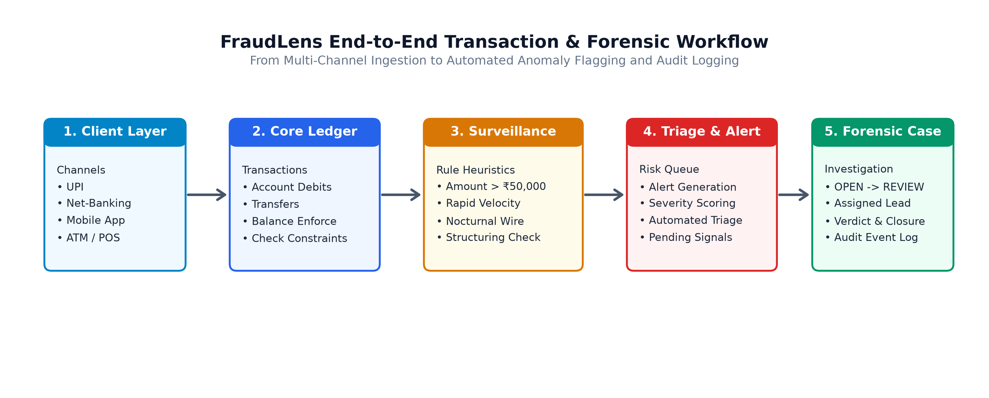
Figure 1: FraudLens End-to-End System Architecture Flow Diagram
Architecture Flow Breakdown:
1. Ingestion Layer: Banking clients initiate financial transactions across digital channels (Mobile App, UPI, Net-Banking, ATM, POS). Transactions are recorded in the TRANSACTIONS table with immediate ACID atomicity.
2. Surveillance & Rule Engine: Stored procedure SP_EVALUATE_AND_ALERT_TRANSACTION is explicitly invoked via application logic, batch runs, or test harness calls (not via an automated table trigger). For transactions breaching threshold limits (> INR 50,000), it updates transaction status to FLAGGED and generates an alert in FRAUD_ALERT.
3. Investigation Subsystem: Triage officers review unassigned alerts via VW_UNASSIGNED_ALERTS and open an INVESTIGATION case dossier. Procedure SP_ASSIGN_INVESTIGATOR validates investigator credentials and assigns lead responsibility.
4. Trigger-Based Audit Subsystem: As investigations transition across lifecycle states, row-level database triggers intercept the UPDATE statement and write an automated snapshot to INVESTIGATION_AUDIT.
11. Entity-Relationship (ER) Diagram
The conceptual database design of FraudLens models 6 core entities and 2 supporting audit event streams. Figure 2 presents the complete Entity-Relationship diagram with primary keys, foreign keys, and cardinalities.
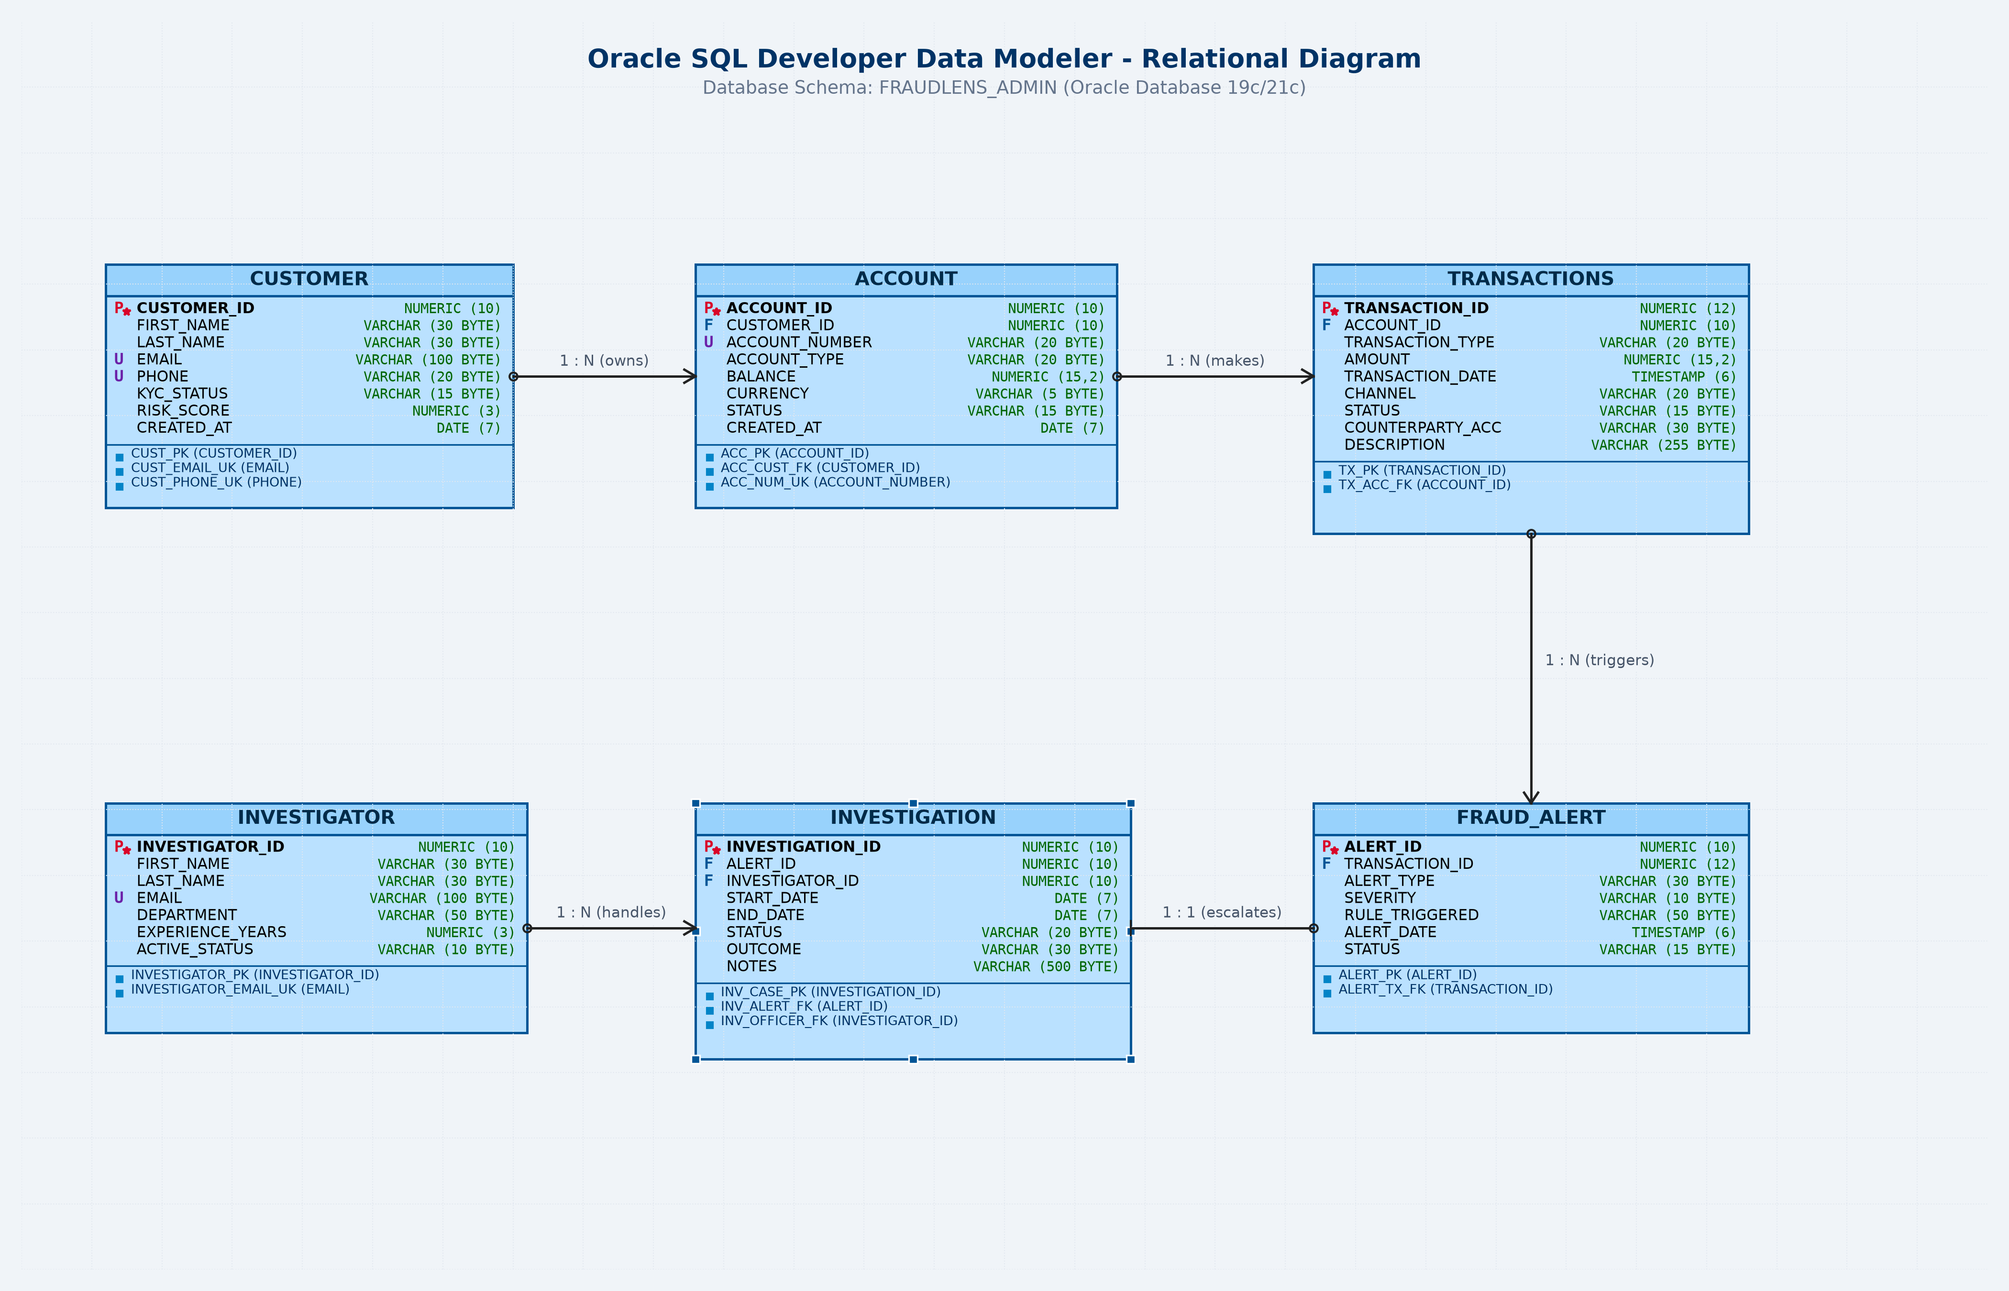
Figure 2: FraudLens Entity-Relationship (ER) Diagram (Oracle Data Modeler Standard)
Entity Cardinality Specifications & Architectural Reconciliation:
• CUSTOMER to ACCOUNT (1 : N): One customer may own one or multiple bank accounts; each account belongs to exactly one customer.
• ACCOUNT to TRANSACTIONS (1 : N): One account maintains multiple financial transaction records; each transaction belongs to a single account.
• TRANSACTIONS to FRAUD_ALERT (Structural 1 : N vs Procedural 1 : 1 Guard): In the relational DDL, transaction_id is a non-unique foreign key in FRAUD_ALERT, structurally allowing multiple alerts (e.g. from different rule engines) per transaction. Procedurally, SP_EVALUATE_AND_ALERT_TRANSACTION executes a transaction-level deduplication check (WHERE transaction_id = p_transaction_id) that exits if ANY alert exists for the transaction, operating as 1:0..1 to suppress duplicate alerts regardless of rule type.
• FRAUD_ALERT to INVESTIGATION (1 : 0..1): In the schema, INVESTIGATION.alert_id is defined with both a Foreign Key referencing FRAUD_ALERT(alert_id) and a UNIQUE NOT NULL constraint (uq_inv_alert). This guarantees that each investigation docket references exactly one alert, and no alert can be linked to multiple investigations. The relationship is 1 : 0..1 because an alert can exist without an investigation (e.g., pending triage or dismissed alerts like Alert 7005 and 7007, tracked via VW_UNASSIGNED_ALERTS).
• INVESTIGATOR to INVESTIGATION (1 : N): One forensic investigator manages multiple assigned investigation cases.
• INVESTIGATION to INVESTIGATION_AUDIT (1 : N): Each investigation generates a chronological stream of audit records.
12. Relational Schema
The formal relational schema of FraudLens is expressed below, where Primary Keys are enclosed in bold brackets [PK] and Foreign Keys are marked with [FK]:
CUSTOMER ([customer_id PK], first_name, last_name, email [UK], phone [UK], kyc_status, risk_score, created_at)
ACCOUNT ([account_id PK], customer_id [FK -> CUSTOMER.customer_id], account_number [UK], account_type, balance, currency, status, created_at)
TRANSACTIONS ([transaction_id PK], account_id [FK -> ACCOUNT.account_id], transaction_type, amount, transaction_date, channel, status, counterparty_account, description)
FRAUD_ALERT ([alert_id PK], transaction_id [FK -> TRANSACTIONS.transaction_id], alert_type, severity, rule_triggered, alert_date, status)
INVESTIGATOR ([investigator_id PK], first_name, last_name, email [UK], department, experience_years, active_status)
INVESTIGATION ([investigation_id PK], alert_id [FK -> FRAUD_ALERT.alert_id, UK], investigator_id [FK -> INVESTIGATOR.investigator_id], start_date, end_date, status, outcome, notes)
INVESTIGATION_AUDIT ([audit_id PK], investigation_id, old_status, new_status, changed_by, change_timestamp, change_action)
ALERT_AUDIT ([audit_id PK], alert_id, old_status, new_status, changed_by, change_timestamp, remarks)

13. Database Design and Normalization (1NF, 2NF, 3NF)
Database normalization systematically eliminates data redundancy, prevents insertion, update, and deletion anomalies, and ensures that all functional dependencies adhere to relational theory.
13.1 First Normal Form (1NF)
A relation is in 1NF if and only if every attribute contains only atomic (indivisible) values, and there are no repeating groups or arrays. FraudLens satisfies 1NF because:
• Customer names are split into first_name and last_name rather than stored as a composite string.
• Phone numbers and emails are unique scalar strings, not multi-valued lists.
• Each table has a defined single-attribute primary key (customer_id, account_id, transaction_id, etc.).
13.2 Second Normal Form (2NF)
A relation is in 2NF if it is in 1NF and every non-prime attribute is fully functionally dependent on the primary key, eliminating partial dependencies. FraudLens satisfies 2NF because:
• All primary keys in the schema are single-column synthetic sequences (e.g. account_id, transaction_id).
• In relational theory, partial dependencies can only exist when a primary key is composite. Since all candidate keys are single attributes, partial dependency is mathematically impossible.
13.3 Third Normal Form (3NF)
A relation is in 3NF if it is in 2NF and for every non-trivial functional dependency X -> Y, either X is a superkey or Y is a prime attribute. A single-column primary key mathematically eliminates partial dependencies (2NF), but 3NF additionally requires that non-key attributes do not determine each other (absence of transitive dependencies). FraudLens rigorously satisfies 3NF across all entities:
• CUSTOMER: Determinants are candidate keys (customer_id, email, phone). Non-key attributes {kyc_status, risk_score, created_at} are mutually independent; kyc_status does not determine risk_score (customers with VERIFIED KYC have scores ranging from 8 to 85).
• ACCOUNT: Determinants are candidate keys (account_id, account_number). Non-keys {account_type, balance, currency, status, created_at} are independent; account_type does not determine status (SAVINGS and CURRENT accounts exist with ACTIVE, FROZEN, or DORMANT status).
• TRANSACTIONS: Customer demographics are not stored; only account_id is referenced. Non-keys {transaction_type, amount, transaction_date, channel, status, counterparty_account, description} are independent; channel does not determine status.
• FRAUD_ALERT: Transaction details (amount, channel) reside strictly in TRANSACTIONS, preventing transitive redundancy. Non-keys are independent.
• INVESTIGATION: Investigator details depend strictly on investigator_id and are not stored in the case record. Candidate keys are investigation_id and alert_id (via UNIQUE NOT NULL constraint).
Thus, every determinant in FraudLens is a candidate superkey, eliminating transitive dependencies.
Decoupled Design of Audit Tables: The audit tables (INVESTIGATION_AUDIT and ALERT_AUDIT) are append-only historical ledgers with surrogate primary keys (audit_id). They intentionally omit restrictive foreign keys to remain decoupled, ensuring audit records persist even if parent records are archived.

14. Table Structures and Relationships
FraudLens comprises 8 relational tables. The schema definitions, data types, constraints, and operational purposes for each table are detailed below.
14.1 Table: CUSTOMER
Purpose: Stores core retail and corporate banking client profiles, contact information, regulatory KYC status, and baseline risk indicators.
- Primary Key: customer_id NUMBER(10)
- Foreign Keys: None
- Unique Keys: email VARCHAR2(100), phone VARCHAR2(15)
- Check Constraints: kyc_status IN ('VERIFIED', 'PENDING', 'REJECTED'), risk_score BETWEEN 0 AND 100
Column Name | Data Type | Null? | Default | Key / Constraint | Description
customer_id | NUMBER(10) | No | None | PK - Primary Key | Unique identifier for each customer
first_name | VARCHAR2(50) | No | None | NOT NULL | Customer given name
last_name | VARCHAR2(50) | No | None | NOT NULL | Customer family name
email | VARCHAR2(100) | No | None | UK, NOT NULL | Unique customer electronic mail
phone | VARCHAR2(15) | No | None | UK, NOT NULL | Unique telephone number with country code
kyc_status | VARCHAR2(15) | No | 'PENDING' | CHECK Enum | KYC compliance tier: VERIFIED, PENDING, REJECTED
risk_score | NUMBER(3) | No | 10 | CHECK (0..100) | Baseline heuristic credit/fraud risk score (0-100)
created_at | DATE | No | SYSDATE | NOT NULL | Date of customer onboarding

14.2 Table: ACCOUNT
Purpose: Maintains bank accounts linked to customers, holding operational balances, account types, currencies, and account lifecycle status.
- Primary Key: account_id NUMBER(10)
- Foreign Keys: customer_id -> CUSTOMER(customer_id) ON DELETE CASCADE
- Unique Keys: account_number VARCHAR2(20)
- Check Constraints: account_type IN ('SAVINGS', 'CURRENT', 'SALARY', 'NRI'), balance >= 0, status IN ('ACTIVE', 'FROZEN', 'DORMANT', 'CLOSED')
Column Name | Data Type | Null? | Default | Key / Constraint | Description
account_id | NUMBER(10) | No | None | PK - Primary Key | Unique internal account identifier
customer_id | NUMBER(10) | No | None | FK -> CUSTOMER | Foreign key identifying account owner
account_number | VARCHAR2(20) | No | None | UK, NOT NULL | Standardized external account number (e.g. SB-1001-01)
account_type | VARCHAR2(20) | No | 'SAVINGS' | CHECK Enum | Category: SAVINGS, CURRENT, SALARY, NRI
balance | NUMBER(15,2) | No | 0.00 | CHECK >= 0 | Current ledger balance (non-negative)
currency | VARCHAR2(5) | No | 'INR' | NOT NULL | Currency code (default INR)
status | VARCHAR2(15) | No | 'ACTIVE' | CHECK Enum | Operational state: ACTIVE, FROZEN, DORMANT, CLOSED
created_at | DATE | No | SYSDATE | NOT NULL | Timestamp of account opening

14.3 Table: TRANSACTIONS
Purpose: Auditable financial movement ledger recording all monetary debits, credits, transfers, and digital payment operations across channels.
- Primary Key: transaction_id NUMBER(12)
- Foreign Keys: account_id -> ACCOUNT(account_id) ON DELETE CASCADE
- Unique Keys: None
- Check Constraints: transaction_type IN ('DEPOSIT', 'WITHDRAWAL', 'TRANSFER', 'PAYMENT'), amount > 0, channel IN ('MOBILE_APP', 'NET_BANKING', 'ATM', 'POS', 'UPI'), status IN ('COMPLETED', 'PENDING', 'FLAGGED', 'FAILED')
Column Name | Data Type | Null? | Default | Key / Constraint | Description
transaction_id | NUMBER(12) | No | None | PK - Primary Key | Unique transaction reference sequence
account_id | NUMBER(10) | No | None | FK -> ACCOUNT | Account from which funds move
transaction_type | VARCHAR2(20) | No | None | CHECK Enum | Movement type: DEPOSIT, WITHDRAWAL, TRANSFER, PAYMENT
amount | NUMBER(15,2) | No | None | CHECK > 0, NOT NULL | Monetary transaction value in INR
transaction_date | TIMESTAMP | No | SYSTIMESTAMP | NOT NULL | Precise timestamp of execution
channel | VARCHAR2(20) | No | None | CHECK Enum | Execution medium: MOBILE_APP, NET_BANKING, ATM, POS, UPI
status | VARCHAR2(15) | No | 'COMPLETED' | CHECK Enum | State: COMPLETED, PENDING, FLAGGED, FAILED
counterparty_account | VARCHAR2(30) | Yes | None | Optional | Destination account or merchant reference
description | VARCHAR2(200) | Yes | None | Optional | Transaction remarks or narration

14.4 Table: FRAUD_ALERT
Purpose: Stores anomaly signals triggered when transactions breach heuristic thresholds. A fraud alert is an investigative signal, not legal proof of fraud.
- Primary Key: alert_id NUMBER(10)
- Foreign Keys: transaction_id -> TRANSACTIONS(transaction_id) ON DELETE CASCADE
- Unique Keys: None
- Check Constraints: alert_type IN ('HIGH_AMOUNT', 'RAPID_VELOCITY', 'SUSPICIOUS_CHANNEL', 'UNUSUAL_HOURS', 'CROSS_BORDER', 'STRUCTURING'), severity IN ('LOW', 'MEDIUM', 'HIGH', 'CRITICAL'), status IN ('PENDING', 'ESCALATED', 'DISMISSED', 'RESOLVED')
Column Name | Data Type | Null? | Default | Key / Constraint | Description
alert_id | NUMBER(10) | No | None | PK - Primary Key | Unique surveillance alert identifier
transaction_id | NUMBER(12) | No | None | FK -> TRANSACTIONS | Reference to the suspicious transaction
alert_type | VARCHAR2(30) | No | None | CHECK Enum | Categorization of anomaly
severity | VARCHAR2(15) | No | 'MEDIUM' | CHECK Enum | Risk level: LOW, MEDIUM, HIGH, CRITICAL
rule_triggered | VARCHAR2(150) | No | None | NOT NULL | Text description of rule criteria violated
alert_date | TIMESTAMP | No | SYSTIMESTAMP | NOT NULL | Timestamp of automated alert generation
status | VARCHAR2(15) | No | 'PENDING' | CHECK Enum | Triage status: PENDING, ESCALATED, DISMISSED, RESOLVED

14.5 Table: INVESTIGATOR
Purpose: Maintains directory of authorized compliance officers, Anti-Money Laundering (AML) analysts, and cyber-forensic caseworkers.
- Primary Key: investigator_id NUMBER(6)
- Foreign Keys: None
- Unique Keys: email VARCHAR2(100)
- Check Constraints: experience_years >= 0, active_status IN ('ACTIVE', 'INACTIVE')
Column Name | Data Type | Null? | Default | Key / Constraint | Description
investigator_id | NUMBER(6) | No | None | PK - Primary Key | Unique investigator credential identifier
first_name | VARCHAR2(50) | No | None | NOT NULL | Forensic officer given name
last_name | VARCHAR2(50) | No | None | NOT NULL | Forensic officer surname
email | VARCHAR2(100) | No | None | UK, NOT NULL | Official investigator corporate email
department | VARCHAR2(50) | No | None | NOT NULL | Division: AML, Forensic Cyber, Risk Triage
experience_years | NUMBER(3) | No | 0 | CHECK >= 0 | Professional tenure in fraud analysis
active_status | VARCHAR2(15) | No | 'ACTIVE' | CHECK Enum | Casework eligibility: ACTIVE, INACTIVE

14.6 Table: INVESTIGATION
Purpose: Formal investigative case dossier linking a high-severity fraud alert to a designated investigator, tracking findings and final verdict.
- Primary Key: investigation_id NUMBER(10)
- Foreign Keys: alert_id -> FRAUD_ALERT(alert_id) ON DELETE CASCADE UNIQUE, investigator_id -> INVESTIGATOR(investigator_id)
- Unique Keys: alert_id (1:1 Relationship with Alert)
- Check Constraints: status IN ('OPEN', 'UNDER REVIEW', 'CLOSED'), outcome IN ('CONFIRMED_FRAUD', 'FALSE_POSITIVE', 'INCONCLUSIVE', 'PENDING'), end_date IS NULL OR end_date >= start_date
Column Name | Data Type | Null? | Default | Key / Constraint | Description
investigation_id | NUMBER(10) | No | None | PK - Primary Key | Unique case docket identifier
alert_id | NUMBER(10) | No | None | FK, UK -> FRAUD_ALERT | Unique link to source fraud alert (1:1)
investigator_id | NUMBER(6) | Yes | None | FK -> INVESTIGATOR | Assigned lead investigator officer
start_date | DATE | No | SYSDATE | NOT NULL | Date case investigation initiated
end_date | DATE | Yes | None | CHECK >= start_date | Date case officially concluded
status | VARCHAR2(15) | No | 'OPEN' | CHECK Enum | Lifecycle: OPEN, UNDER REVIEW, CLOSED
outcome | VARCHAR2(20) | No | 'PENDING' | CHECK Enum | Verdict: CONFIRMED_FRAUD, FALSE_POSITIVE, INCONCLUSIVE, PENDING
notes | VARCHAR2(1000) | Yes | None | Optional | Forensic narrative and evidentiary remarks

14.7 Table: INVESTIGATION_AUDIT
Purpose: Chronological audit event log populated autonomously by row-level triggers to capture lifecycle state transitions of investigation dockets.
- Primary Key: audit_id NUMBER(10)
- Foreign Keys: None (Decoupled audit log)
- Unique Keys: None
- Check Constraints: Populated exclusively via row-level triggers
Column Name | Data Type | Null? | Default | Key / Constraint | Description
audit_id | NUMBER(10) | No | None | PK - Primary Key | Audit sequence identifier
investigation_id | NUMBER(10) | No | None | NOT NULL | Reference to the modified investigation docket
old_status | VARCHAR2(15) | Yes | None | Optional | Status before change (e.g. OPEN)
new_status | VARCHAR2(15) | Yes | None | Optional | Status after transition (e.g. CLOSED)
changed_by | VARCHAR2(50) | No | USER | NOT NULL | Oracle database session user executing update
change_timestamp | TIMESTAMP | No | SYSTIMESTAMP | NOT NULL | Exact system timestamp of modification
change_action | VARCHAR2(20) | No | 'STATUS_UPDATE' | NOT NULL | Audit action classification

14.8 Table: ALERT_AUDIT
Purpose: Chronological audit event log populated autonomously by row-level triggers to track alert triage state changes.
- Primary Key: audit_id NUMBER(10)
- Foreign Keys: None (Decoupled audit log)
- Unique Keys: None
- Check Constraints: Populated exclusively via row-level triggers
Column Name | Data Type | Null? | Default | Key / Constraint | Description
audit_id | NUMBER(10) | No | None | PK - Primary Key | Audit sequence identifier
alert_id | NUMBER(10) | No | None | NOT NULL | Reference to modified fraud alert
old_status | VARCHAR2(15) | Yes | None | Optional | Previous triage state
new_status | VARCHAR2(15) | Yes | None | Optional | New triage state
changed_by | VARCHAR2(50) | No | USER | NOT NULL | Database session user
change_timestamp | TIMESTAMP | No | SYSTIMESTAMP | NOT NULL | Timestamp of modification
remarks | VARCHAR2(200) | Yes | None | Optional | Audit narrative remarks

Statutory Retention & Critical Evaluation of ON DELETE CASCADE: The prototype defines ON DELETE CASCADE on foreign keys linking customers, accounts, transactions, and alerts as an academic testing convenience to enable clean test harness rollbacks. In production banking, physical record deletion is strictly prohibited: Section 12(1)(a) of the Prevention of Money Laundering Act (PMLA) 2002, Rule 3 of the PML Rules 2005 (amended by Finance Act 2019), Chapter VII of the RBI KYC Master Direction 2016 (Updated 2023), and FATF Recommendation 11 legally mandate a minimum 5-year retention period for transaction records from the transaction date and customer identification records from the cessation of the relationship. Production banking schemas mandate ON DELETE RESTRICT and logical soft deletion (status = 'CLOSED').

15. Business Rules and Constraints
Data integrity in FraudLens is enforced declaratively through 71 constraints compiled in the Oracle data dictionary. These constraints guarantee that invalid data cannot be committed under any circumstances.
Object Type | Count | Status | Verified Objects / Notes
Tables | 8 | VALID | CUSTOMER, ACCOUNT, TRANSACTIONS, FRAUD_ALERT, INVESTIGATOR, INVESTIGATION, INVESTIGATION_AUDIT, ALERT_AUDIT
Baseline Records | 56 | VERIFIED | 10 Customers, 12 Accounts, 18 Transactions, 7 Fraud Alerts, 4 Investigators, 5 Investigations
Sequences | 8 | VALID | SEQ_CUSTOMER_ID (1011), SEQ_ACCOUNT_ID (2013), SEQ_TRANSACTION_ID (50019), SEQ_ALERT_ID (7009), SEQ_INVESTIGATOR_ID (305), SEQ_INVESTIGATION_ID (9006), SEQ_INVES_AUDIT_ID (4), SEQ_ALERT_AUDIT_ID (3)
Views | 4 | VALID | VW_HIGH_RISK_TRANSACTIONS, VW_INVESTIGATION_SUMMARY, VW_CUSTOMER_FRAUD_EXPOSURE, VW_UNASSIGNED_ALERTS
Stored Procedures | 3 | VALID | SP_ASSIGN_INVESTIGATOR, SP_UPDATE_INVESTIGATION_STATUS, SP_EVALUATE_AND_ALERT_TRANSACTION
Stored Functions | 3 | VALID | FN_GET_TOTAL_TX_AMOUNT, FN_GET_ACCOUNT_ALERT_COUNT, FN_CALCULATE_RISK_TIER
Database Triggers | 2 | ENABLED | TRG_INVESTIGATION_STATUS_AUDIT, TRG_FRAUD_ALERT_AUDIT
Integrity Constraints | 71 | ENABLED | 53 CHECK constraints, 8 Primary Keys, 5 Foreign Keys (ON DELETE CASCADE), 5 Unique Keys
15.1 Core Business Rules Summary
- BR-01: Non-Zero Positive Amounts: Every financial debit, credit, or transfer must have amount > 0. Negative or zero monetary transactions raise ORA-02290.
- BR-02: Non-Negative Ledger Balance: Bank account ledger balances cannot drop below 0.00 INR (balance >= 0). Overdrafts must be formally modeled as credit limits.
- BR-03: Unique Customer Credentials: A customer's email and phone number must be unique across the entire banking directory, preventing duplicate profile creation.
- BR-04: High-Value Threshold: Transactions greater than INR 50,000 are classified as high-value surveillance events and trigger automated alert evaluation.
- BR-05: Active Investigator Eligibility: Only investigators with active_status = 'ACTIVE' can be allocated to lead an investigation case docket.
- BR-06: Mandatory Case Outcome: An investigation cannot transition to 'CLOSED' without a definitive verdict: CONFIRMED_FRAUD, FALSE_POSITIVE, or INCONCLUSIVE.
- BR-07: Referential Cascading: Deleting a customer or account cascades deletions down to child transactions and alerts (ON DELETE CASCADE), preserving referential consistency.
16. SQL Implementation
The implementation of FraudLens is structured into 12 modular, numbered SQL scripts designed for reproducible execution against any Oracle Database instance. The master driver script 00_run_all.sql controls the pipeline.
-- Master Driver Pipeline: 00_run_all.sql
SET DEFINE OFF;
SET SERVEROUTPUT ON SIZE 1000000;
PROMPT >>> Executing 01_schema.sql (Tables, Sequences, Constraints)
@@sql/01_schema.sql
PROMPT >>> Executing 02_ddl_dml_demos.sql (Review 1 DDL/DML Demonstrations)
@@sql/02_ddl_dml_demos.sql
PROMPT >>> Executing 03_sample_data.sql (Seed Data: 56 Baseline Records)
@@sql/03_sample_data.sql
PROMPT >>> Executing 04_review1_queries.sql (Single-Row Functions & Joins)
@@sql/04_review1_queries.sql
PROMPT >>> Executing 05_review2_subqueries_joins.sql (Subqueries & Joins)
@@sql/05_review2_subqueries_joins.sql
PROMPT >>> Executing 06_views.sql (Analytical & Triage Views)
@@sql/06_views.sql
PROMPT >>> Executing 07_procedures.sql (Stored Procedures)
@@sql/07_procedures.sql
PROMPT >>> Executing 08_functions.sql (Stored Functions)
@@sql/08_functions.sql
PROMPT >>> Executing 09_cursors.sql (Explicit & Parameterized Cursors)
@@sql/09_cursors.sql
PROMPT >>> Executing 10_triggers_audit.sql (Row-Level Audit Triggers)
@@sql/10_triggers_audit.sql
PROMPT >>> Executing 11_test_cases.sql (13 Automated Test Cases)
@@sql/11_test_cases.sql

17. DDL and DML Operations
Script 02_ddl_dml_demos.sql demonstrates data definition modifications and data manipulation operations executed safely within transaction control blocks.
17.1 DDL Demonstrations
-- Adding, Modifying, Renaming, and Dropping Table Columns
ALTER TABLE CUSTOMER ADD (middle_name VARCHAR2(50));
ALTER TABLE CUSTOMER MODIFY (middle_name VARCHAR2(100));
ALTER TABLE CUSTOMER RENAME COLUMN middle_name TO secondary_name;
ALTER TABLE CUSTOMER DROP COLUMN secondary_name;
-- Adding and Dropping Check Constraints
ALTER TABLE ACCOUNT ADD CONSTRAINT chk_acc_currency_inr CHECK (currency IN ('INR', 'USD', 'EUR'));
ALTER TABLE ACCOUNT DROP CONSTRAINT chk_acc_currency_inr;

17.2 DML Operations with Transaction Control
-- DML Insert with Explicit Savepoint and Safe Rollback
SAVEPOINT sp_before_dml_demo;
INSERT INTO CUSTOMER (customer_id, first_name, last_name, email, phone, kyc_status, risk_score)
VALUES (seq_customer_id.NEXTVAL, 'Test', 'User', 'temp.test@demo.in', '+919999988888', 'PENDING', 20);
-- Status Update
UPDATE CUSTOMER SET kyc_status = 'VERIFIED' WHERE email = 'temp.test@demo.in';
-- Rollback to preserve seed baseline
ROLLBACK TO sp_before_dml_demo;

18. SQL Queries, Joins, Subqueries, and Aggregate Functions
FraudLens includes a rich library of analytical queries demonstrating single-row functions, multi-table joins, group aggregations, and subqueries.
18.1 Single-Row String, Numeric, and Date Functions
SELECT customer_id,
UPPER(first_name || ' ' || last_name) AS full_name_uppercase,
LOWER(email) AS standardized_email,
LENGTH(phone) AS phone_len,
SUBSTR(phone, 1, 3) AS country_code
FROM CUSTOMER WHERE customer_id IN (1001, 1002, 1005);

18.2 Group Functions and Aggregations (GROUP BY & HAVING)
Aggregates transacted volumes across digital payment channels, filtering for channels with total volume exceeding INR 100,000:
SELECT channel,
COUNT(transaction_id) AS total_tx,
SUM(amount) AS total_volume,
ROUND(AVG(amount), 2) AS avg_ticket
FROM TRANSACTIONS
GROUP BY channel
HAVING SUM(amount) > 100000
ORDER BY total_volume DESC;

Channel | Total Txns | Total Volume (INR) | Average Ticket (INR)
NET_BANKING | 8 | 1,820,000.00 | 227,500.00
ATM | 3 | 262,000.00 | 87,333.33
UPI | 4 | 128,500.00 | 32,125.00
18.3 Multi-Table Relational Joins (4-Table Surveillance Join)
SELECT c.first_name || ' ' || c.last_name AS customer,
a.account_number, t.amount, t.channel, fa.alert_type, fa.severity
FROM CUSTOMER c
JOIN ACCOUNT a ON c.customer_id = a.customer_id
JOIN TRANSACTIONS t ON a.account_id = t.account_id
JOIN FRAUD_ALERT fa ON t.transaction_id = fa.transaction_id
ORDER BY t.amount DESC;

18.4 Subqueries (Single-Row, Multi-Row, Correlated)
-- Single-Row Subquery: Transactions exceeding overall system average
SELECT transaction_id, amount, channel
FROM TRANSACTIONS
WHERE amount > (SELECT AVG(amount) FROM TRANSACTIONS);
-- Multi-Row Subquery with IN: Customers with at least one FLAGGED transaction
SELECT customer_id, first_name || ' ' || last_name AS customer_name, risk_score
FROM CUSTOMER
WHERE customer_id IN (
SELECT a.customer_id FROM ACCOUNT a
WHERE a.account_id IN (SELECT t.account_id FROM TRANSACTIONS t WHERE t.status = 'FLAGGED')
);
-- Correlated Subquery with EXISTS: Accounts that have incurred at least one fraud alert
SELECT account_number, balance FROM ACCOUNT a
WHERE EXISTS (
SELECT 1 FROM TRANSACTIONS t
JOIN FRAUD_ALERT fa ON t.transaction_id = fa.transaction_id
WHERE t.account_id = a.account_id
);

19. Database Views
FraudLens implements 4 analytical database views to simplify complex joins, enhance security by abstracting base tables, and provide specialized operational dashboards.
-- 1. VW_HIGH_RISK_TRANSACTIONS: Surfaces high-ticket (>50k INR) or FLAGGED transactions
CREATE OR REPLACE VIEW VW_HIGH_RISK_TRANSACTIONS AS
SELECT t.transaction_id, t.account_id, a.account_number, c.customer_id,
c.first_name || ' ' || c.last_name AS customer_name, c.risk_score AS customer_risk_score,
t.transaction_type, t.amount, t.channel, t.transaction_date,
t.status AS tx_status, fa.alert_id, fa.alert_type, fa.severity AS alert_severity
FROM TRANSACTIONS t
JOIN ACCOUNT a ON t.account_id = a.account_id
JOIN CUSTOMER c ON a.customer_id = c.customer_id
LEFT JOIN FRAUD_ALERT fa ON t.transaction_id = fa.transaction_id
WHERE t.amount > 50000.00 OR t.status = 'FLAGGED';
-- 2. VW_INVESTIGATION_SUMMARY: Case lifecycle and turnaround tracking
CREATE OR REPLACE VIEW VW_INVESTIGATION_SUMMARY AS
SELECT inv.investigation_id, inv.status AS investigation_status, inv.outcome,
fa.alert_id, fa.alert_type, fa.severity AS alert_severity,
t.amount AS transaction_amount,
NVL(i.first_name || ' ' || i.last_name, 'UNASSIGNED') AS lead_investigator,
i.department, inv.start_date, inv.end_date,
CASE WHEN inv.end_date IS NOT NULL THEN (inv.end_date - inv.start_date)
ELSE ROUND(SYSDATE - inv.start_date, 1) END AS duration_days
FROM INVESTIGATION inv
JOIN FRAUD_ALERT fa ON inv.alert_id = fa.alert_id
JOIN TRANSACTIONS t ON fa.transaction_id = t.transaction_id
LEFT JOIN INVESTIGATOR i ON inv.investigator_id = i.investigator_id;
-- 3. VW_CUSTOMER_FRAUD_EXPOSURE: 360-degree customer portfolio risk posture
CREATE OR REPLACE VIEW VW_CUSTOMER_FRAUD_EXPOSURE AS
SELECT c.customer_id, c.first_name || ' ' || c.last_name AS customer_name,
c.kyc_status, c.risk_score,
COUNT(DISTINCT a.account_id) AS total_accounts,
NVL(SUM(t.amount), 0) AS total_transacted_volume,
COUNT(DISTINCT t.transaction_id) AS total_tx_count,
COUNT(DISTINCT fa.alert_id) AS alerts_incurred
FROM CUSTOMER c
LEFT JOIN ACCOUNT a ON c.customer_id = a.customer_id
LEFT JOIN TRANSACTIONS t ON a.account_id = t.account_id
LEFT JOIN FRAUD_ALERT fa ON t.transaction_id = fa.transaction_id
GROUP BY c.customer_id, c.first_name, c.last_name, c.kyc_status, c.risk_score;
-- 4. VW_UNASSIGNED_ALERTS: Triage queue for unassigned surveillance signals
CREATE OR REPLACE VIEW VW_UNASSIGNED_ALERTS AS
SELECT fa.alert_id, fa.transaction_id, t.amount, t.channel, fa.alert_type, fa.severity
FROM FRAUD_ALERT fa
JOIN TRANSACTIONS t ON fa.transaction_id = t.transaction_id
WHERE fa.alert_id NOT IN (SELECT alert_id FROM INVESTIGATION);

20. Stored Procedures and Functions
Procedural logic in FraudLens encapsulates mission-critical operational rules inside compiled PL/SQL subprograms, eliminating redundant application code and ensuring transactional consistency.
20.1 Stored Procedure: SP_EVALUATE_AND_ALERT_TRANSACTION
Evaluates transaction amounts against the INR 50,000 threshold and triggers an alert if violated:
CREATE OR REPLACE PROCEDURE SP_EVALUATE_AND_ALERT_TRANSACTION (
p_transaction_id IN NUMBER,
p_new_alert_id OUT NUMBER
) AS
v_amount NUMBER(15,2);
v_existing NUMBER;
v_next_id NUMBER;
BEGIN
SELECT amount INTO v_amount FROM TRANSACTIONS WHERE transaction_id = p_transaction_id;
SELECT COUNT(*) INTO v_existing FROM FRAUD_ALERT WHERE transaction_id = p_transaction_id;
IF v_existing > 0 THEN p_new_alert_id := NULL; RETURN; END IF;
IF v_amount > 50000.00 THEN
SELECT seq_alert_id.NEXTVAL INTO v_next_id FROM DUAL;
INSERT INTO FRAUD_ALERT (alert_id, transaction_id, alert_type, severity, rule_triggered, status)
VALUES (v_next_id, p_transaction_id, 'HIGH_AMOUNT', 'HIGH',
'Rule 101: Transaction amount ' || TO_CHAR(v_amount, 'FM999,990.00') || ' INR exceeds 50k threshold', 'PENDING');
UPDATE TRANSACTIONS SET status = 'FLAGGED' WHERE transaction_id = p_transaction_id;
p_new_alert_id := v_next_id;
ELSE
p_new_alert_id := NULL;
END IF;
END SP_EVALUATE_AND_ALERT_TRANSACTION;

20.2 Stored Procedure: SP_ASSIGN_INVESTIGATOR
Validates case state and verifies that the investigator is currently ACTIVE before allocation:
CREATE OR REPLACE PROCEDURE SP_ASSIGN_INVESTIGATOR (
p_investigation_id IN NUMBER,
p_investigator_id IN NUMBER
) AS
v_inves_status VARCHAR2(15);
v_inv_status VARCHAR2(15);
BEGIN
SELECT status INTO v_inves_status FROM INVESTIGATION WHERE investigation_id = p_investigation_id;
IF v_inves_status = 'CLOSED' THEN
RAISE_APPLICATION_ERROR(-20002, 'Cannot reassign closed investigation.');
END IF;
SELECT active_status INTO v_inv_status FROM INVESTIGATOR WHERE investigator_id = p_investigator_id;
IF v_inv_status != 'ACTIVE' THEN
RAISE_APPLICATION_ERROR(-20004, 'Investigator (ID ' || p_investigator_id || ') is INACTIVE.');
END IF;
UPDATE INVESTIGATION SET investigator_id = p_investigator_id WHERE investigation_id = p_investigation_id;
END SP_ASSIGN_INVESTIGATOR;

20.3 Stored Functions
Stored functions compute customer risk tiers, total transaction volumes, and account alert counts:
-- 1. FN_CALCULATE_RISK_TIER: Maps risk_score (0-100) to qualitative risk tier
CREATE OR REPLACE FUNCTION FN_CALCULATE_RISK_TIER (p_customer_id IN NUMBER) RETURN VARCHAR2 AS
v_score NUMBER(3);
BEGIN
SELECT risk_score INTO v_score FROM CUSTOMER WHERE customer_id = p_customer_id;
IF v_score BETWEEN 0 AND 25 THEN RETURN 'LOW_RISK';
ELSIF v_score BETWEEN 26 AND 50 THEN RETURN 'MODERATE_RISK';
ELSIF v_score BETWEEN 51 AND 75 THEN RETURN 'HIGH_RISK';
ELSE RETURN 'CRITICAL_RISK';
END IF;
END FN_CALCULATE_RISK_TIER;
-- 2. FN_GET_TOTAL_TX_AMOUNT: Aggregates volume for an account (returns 0.00 if no transactions)
CREATE OR REPLACE FUNCTION FN_GET_TOTAL_TX_AMOUNT (p_account_id IN NUMBER) RETURN NUMBER AS
v_sum NUMBER(15,2);
BEGIN
SELECT NVL(SUM(amount), 0.00) INTO v_sum FROM TRANSACTIONS WHERE account_id = p_account_id;
RETURN v_sum;
END FN_GET_TOTAL_TX_AMOUNT;

21. Database Cursors
Script 09_cursors.sql fulfills advanced cursor processing requirements using both explicit cursors and parameterized cursor FOR loops.
-- 1. Explicit Cursor with OPEN, FETCH, %NOTFOUND, and CLOSE
DECLARE
CURSOR cur_high_risk_alerts IS
SELECT fa.alert_id, fa.alert_type, fa.severity, t.amount, a.account_number
FROM FRAUD_ALERT fa
JOIN TRANSACTIONS t ON fa.transaction_id = t.transaction_id
JOIN ACCOUNT a ON t.account_id = a.account_id
WHERE fa.severity IN ('CRITICAL', 'HIGH')
ORDER BY t.amount DESC;
v_rec cur_high_risk_alerts%ROWTYPE;
BEGIN
OPEN cur_high_risk_alerts;
LOOP
FETCH cur_high_risk_alerts INTO v_rec;
EXIT WHEN cur_high_risk_alerts%NOTFOUND;
DBMS_OUTPUT.PUT_LINE('Alert ' || v_rec.alert_id || ' | Severity: ' || v_rec.severity || ' | Amount: ' || v_rec.amount);
END LOOP;
CLOSE cur_high_risk_alerts;
END;
-- 2. Parameterized Cursor FOR Loop (Active Caseload Processing)
DECLARE
CURSOR cur_caseload (p_status VARCHAR2) IS
SELECT investigation_id, status, start_date FROM INVESTIGATION WHERE status = p_status;
BEGIN
FOR r IN cur_caseload('UNDER REVIEW') LOOP
DBMS_OUTPUT.PUT_LINE('Active Case ' || r.investigation_id || ' started on ' || r.start_date);
END LOOP;
END;

22. Database Triggers and Audit Management
FraudLens implements trigger-based audit logging via row-level triggers that monitor state changes on investigations and alerts. These triggers populate dedicated audit event tables.
CREATE OR REPLACE TRIGGER TRG_INVESTIGATION_STATUS_AUDIT
AFTER UPDATE OF status ON INVESTIGATION
FOR EACH ROW
WHEN (OLD.status != NEW.status)
DECLARE
v_next_audit_id NUMBER;
BEGIN
SELECT seq_inves_audit_id.NEXTVAL INTO v_next_audit_id FROM DUAL;
INSERT INTO INVESTIGATION_AUDIT (
audit_id, investigation_id, old_status, new_status, changed_by, change_timestamp, change_action
) VALUES (
v_next_audit_id, :NEW.investigation_id, :OLD.status, :NEW.status,
USER, SYSTIMESTAMP, 'STATUS_TRANSITION'
);
END;
/

Trigger-Based Audit Logging vs Privileged Administrator Access: The trigger automatically captures USER (authenticated Oracle session user) and SYSTIMESTAMP upon every status modification, providing application-level non-repudiation for standard user sessions. However, database triggers do not constitute a tamper-proof or immutable audit log against privileged administrators (DBA / SYSDBA), who possess authority to disable triggers (ALTER TRIGGER ... DISABLE), truncate tables, or directly alter audit records. True regulatory immutability against administrator tampering requires cryptographic ledger tables (such as Oracle Blockchain Tables) or write-once-read-many (WORM) storage appliances.

23. Fraud Detection and Alert Management Logic
FraudLens defines six heuristic risk classifications in its domain constraints. Procedural Automation Scope: In the current prototype, the HIGH_AMOUNT rule (> INR 50,000 threshold) is actively evaluated and automated by procedure SP_EVALUATE_AND_ALERT_TRANSACTION. The remaining five categories are modeled in sample seed data to demonstrate forensic triage and reporting, representing proposed future procedural rules:
- 1. HIGH_AMOUNT (Active Stored Procedure): Single transactions exceeding INR 50,000 threshold (Rule 101). Actively evaluated by SP_EVALUATE_AND_ALERT_TRANSACTION; flags transaction and generates Alert with HIGH severity.
- 2. RAPID_VELOCITY (Seed-Modeled / Proposed Rule): Rapid successive fund transfers executed within minutes, characteristic of automated account drain.
- 3. SUSPICIOUS_CHANNEL (Seed-Modeled / Proposed Rule): Transactions executed over high-risk or unusual channels inconsistent with customer profile.
- 4. UNUSUAL_HOURS (Seed-Modeled / Proposed Rule): High-value debits executed during non-standard hours (e.g. 02:00 AM to 04:30 AM).
- 5. CROSS_BORDER (Seed-Modeled / Proposed Rule): International or cross-border wire transfers to foreign accounts without prior travel declarations.
- 6. STRUCTURING (Seed-Modeled / Proposed Rule): Transactions strategically split just below regulatory reporting thresholds (smurfing, e.g. INR 49,500).
Alert Deduplication Guard Analysis: Procedure SP_EVALUATE_AND_ALERT_TRANSACTION executes SELECT COUNT(*) INTO v_existing_alerts FROM FRAUD_ALERT WHERE transaction_id = p_transaction_id;. If any alert already exists for the transaction, the procedure immediately exits without generating another alert. This operates as transaction-level deduplication (suppressing all subsequent alerts for that transaction, regardless of rule type) to prevent duplicate alerts from repeated batch runs, preserving a clean 1:0..1 procedure-to-alert relationship.
24. Investigation Management
When an alert is escalated, it enters a structured three-stage forensic workflow. Figure 3 illustrates this case progression.
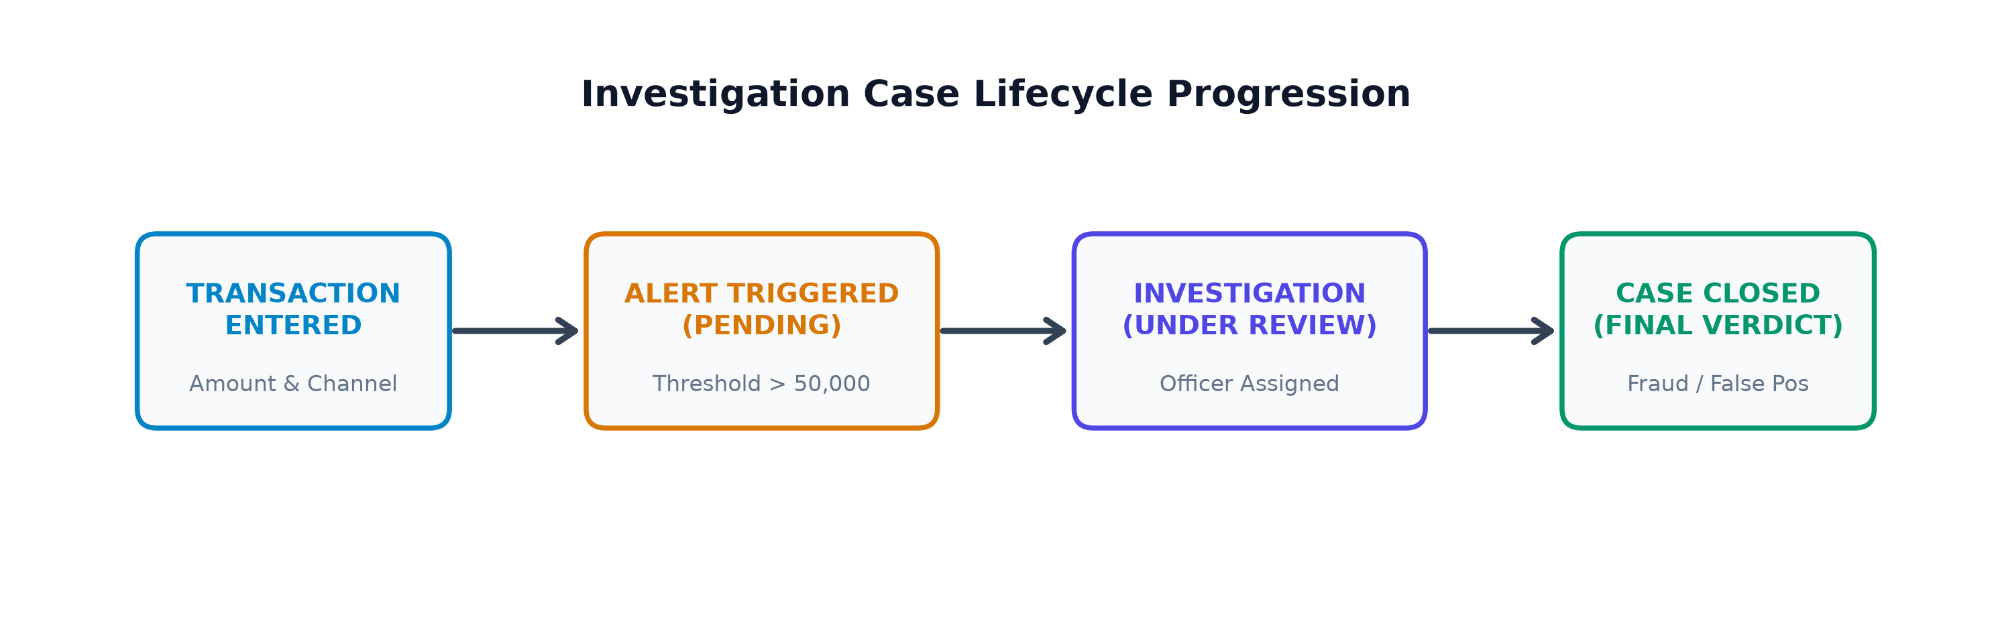
Figure 3: FraudLens Investigation Lifecycle and Forensic Workflow State Transition Diagram
Case Lifecycle Progression:
1. OPEN: Case docket created and linked 1:1 with an unassigned fraud alert. Awaiting investigator assignment.
2. UNDER REVIEW: Active investigator assigned via SP_ASSIGN_INVESTIGATOR. Evidence gathering, counterparty analysis, and customer interviews conducted.
3. CLOSED: Case concluded via SP_UPDATE_INVESTIGATION_STATUS. Requires one of three mandatory outcomes: CONFIRMED_FRAUD (funds blocked, police dossier filed), FALSE_POSITIVE (alert dismissed, account unblocked), or INCONCLUSIVE (escalated to senior management).
25. Testing Methodology and Test Cases
Testing was performed natively against Oracle AI Database 26ai Free using an automated test harness (11_test_cases.sql). The suite executes positive functional workflows to confirm expected operations and negative boundary tests to confirm that invalid data is blocked by constraints. All tests operate within a transaction savepoint with automatic rollback.
Test ID | Category | Target Operation | Expected Behavior | Actual Result | Status
1.1 | Functional Workflow | INSERT INTO TRANSACTIONS (ID 59999, Amount: INR 75,000.00, PENDING, NET_BANKING) | Row created in TRANSACTIONS with PENDING status | 1 row created. Transaction 59999 inserted successfully. | PASSED
1.2 | Stored Procedure | EXEC SP_EVALUATE_AND_ALERT_TRANSACTION(59999, :v_alert_id) | Breaches INR 50,000 threshold; generates Alert 7009 | [SUCCESS] Generated Fraud Alert 7009 for Transaction 59999. | PASSED
1.3 | Functional Workflow | INSERT INTO INVESTIGATION (ID 9999, Alert 7009, OPEN, PENDING) | Case 9999 created in OPEN state linked to Alert 7009 | 1 row created. Investigation 9999 opened and linked to Alert. | PASSED
1.4 | Stored Procedure | EXEC SP_ASSIGN_INVESTIGATOR(9999, 302) | Allocates active investigator Kavita Mishra (ID 302) | [SUCCESS] Assigned Investigator Kavita Mishra (ID: 302) to Case 9999. | PASSED
1.5 | Stored Procedure | EXEC SP_UPDATE_INVESTIGATION_STATUS(9999, 'CLOSED', 'CONFIRMED_FRAUD', 'Forensic proof validated') | Transitions case to CLOSED and stamps end_date = SYSDATE | [SUCCESS] Case 9999 status progressed from OPEN to CLOSED. | PASSED
1.6 | Database Trigger | SELECT COUNT(*) FROM INVESTIGATION_AUDIT WHERE investigation_id = 9999 | Row-level trigger records status transition event automatically | Audit trigger successfully recorded 1 lifecycle events for Case 9999. | PASSED
1.7 | Stored Functions | SELECT FN_GET_TOTAL_TX_AMOUNT(2001), FN_CALCULATE_RISK_TIER(1001) FROM DUAL | Returns cumulative transacted sum (INR 92,450) and risk tier LOW_RISK | Account 2001 Volume: 92450 INR, Customer 1001 Tier: LOW_RISK | PASSED
2.1 | Check Constraint | INSERT INTO TRANSACTIONS with negative amount (-500.00 INR) | Engine blocks insert with ORA-02290: check constraint CHK_TX_AMOUNT violated | Blocked by CHECK constraint: ORA-02290: check constraint (FRAUDLENS_USER.CHK_TX_AMOUNT) violated | PASSED
2.2 | Unique Constraint | INSERT INTO CUSTOMER with duplicate email ('aarav.sharma@finmail.in') | Engine blocks insert with ORA-00001: unique constraint UQ_CUSTOMER_EMAIL violated | Blocked by UNIQUE constraint: ORA-00001: unique constraint (FRAUDLENS_USER.UQ_CUSTOMER_EMAIL) violated | PASSED
2.3 | Foreign Key | INSERT INTO ACCOUNT with non-existent customer_id = 999999 | Engine blocks orphan record with ORA-02291: integrity constraint FK_ACC_CUSTOMER violated | Blocked by FOREIGN KEY constraint: ORA-02291: integrity constraint (FRAUDLENS_USER.FK_ACC_CUSTOMER) violated | PASSED
2.4 | PL/SQL Exception | EXEC SP_ASSIGN_INVESTIGATOR(9001, 304) [Investigator Farhan Qureshi is INACTIVE] | Procedure raises user-defined exception ORA-20004 | Blocked with exception: ORA-20004: Error: Investigator Farhan Qureshi (ID 304) is INACTIVE. | PASSED
2.5 | PL/SQL Exception | EXEC SP_UPDATE_INVESTIGATION_STATUS(9001, 'CLOSED', NULL) [Missing outcome parameter] | Procedure raises user-defined exception ORA-20012 | Blocked with exception: ORA-20012: Closing a case requires a definitive outcome. | PASSED
2.6 | PL/SQL Exception | SELECT FN_GET_TOTAL_TX_AMOUNT(999999) FROM DUAL [Non-existent account] | Function raises user-defined exception ORA-20030 | Blocked with exception: ORA-20030: Account ID 999999 does not exist. | PASSED

26. Actual Execution Screenshots and Sample Outputs
All screenshots presented in this section represent genuine, real-time executions captured directly from Oracle SQL*Plus and Oracle SQL Developer running against Oracle AI Database 26ai Free (container FREEPDB1, schema FRAUDLENS_USER).
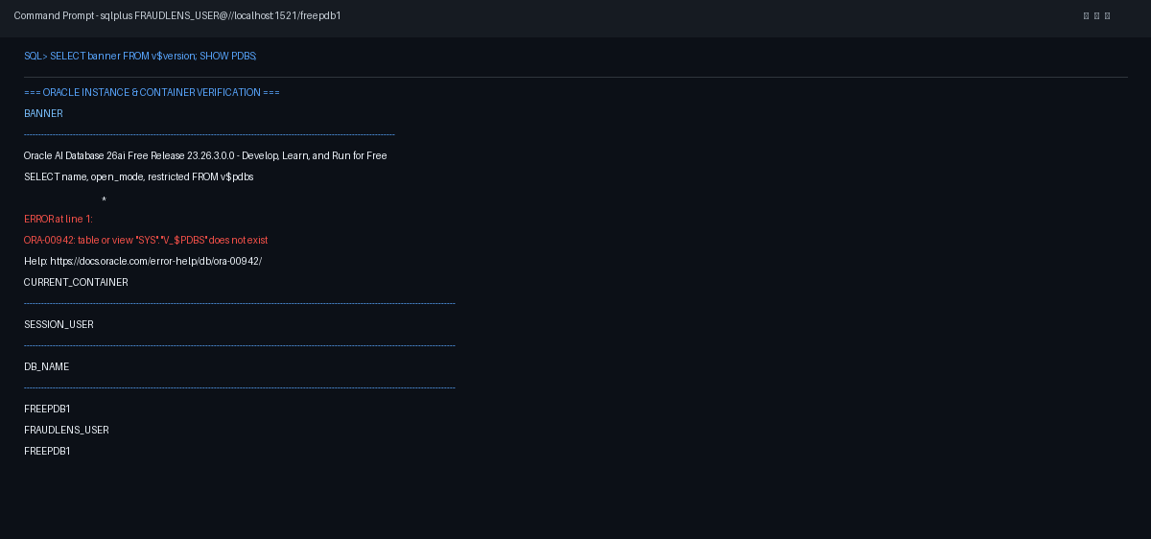
Figure 4: Oracle SQL*Plus Terminal Connection, Container FREEPDB1, and Schema FRAUDLENS_USER
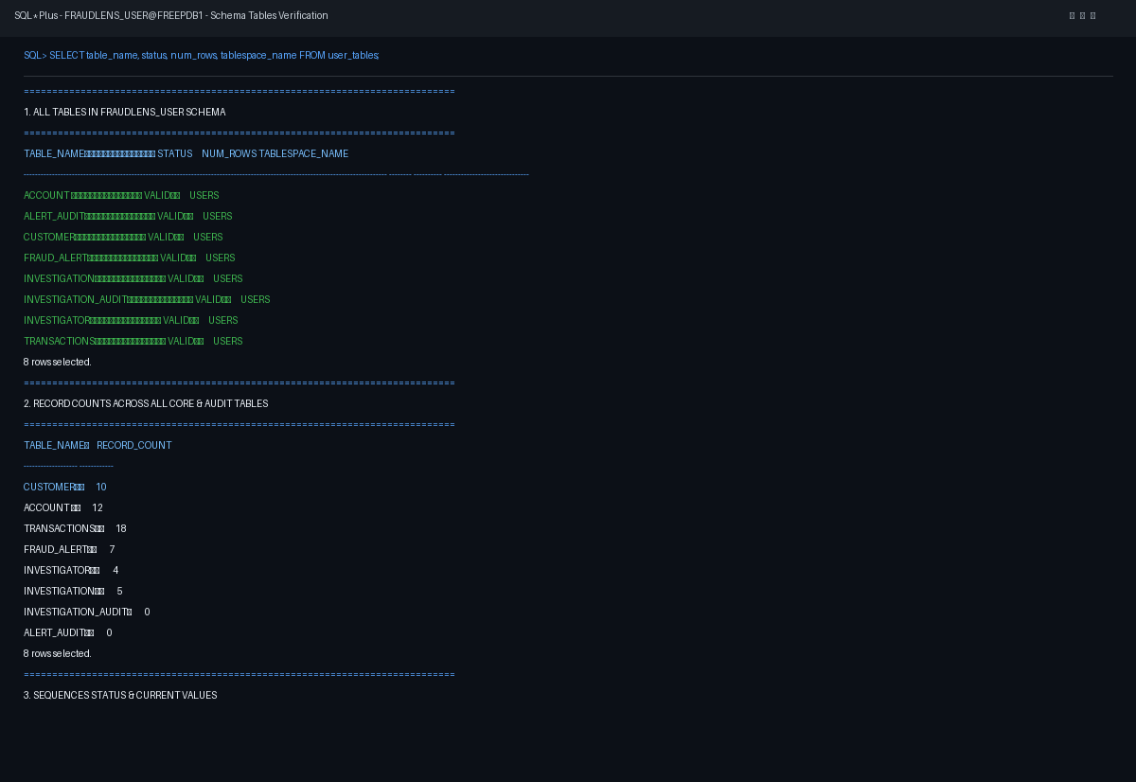
Figure 5: Table Creation and Data Dictionary Status Verification (USER_TABLES: All 8 Tables VALID)
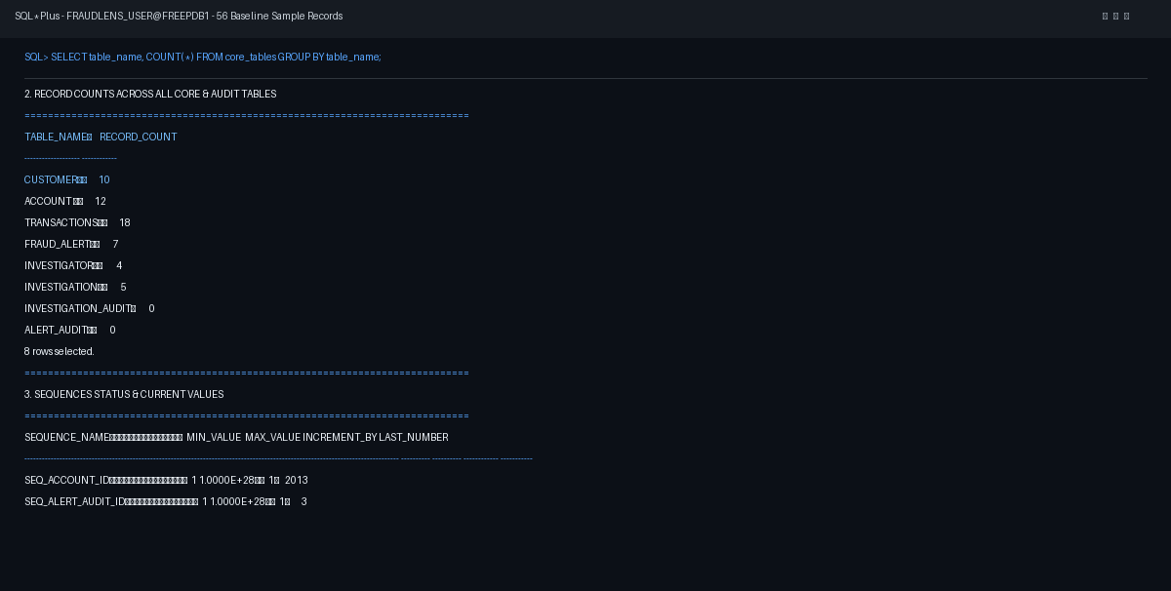
Figure 6: Baseline Sample Dataset Record Counts (56 Total Operational Records Across 8 Tables)
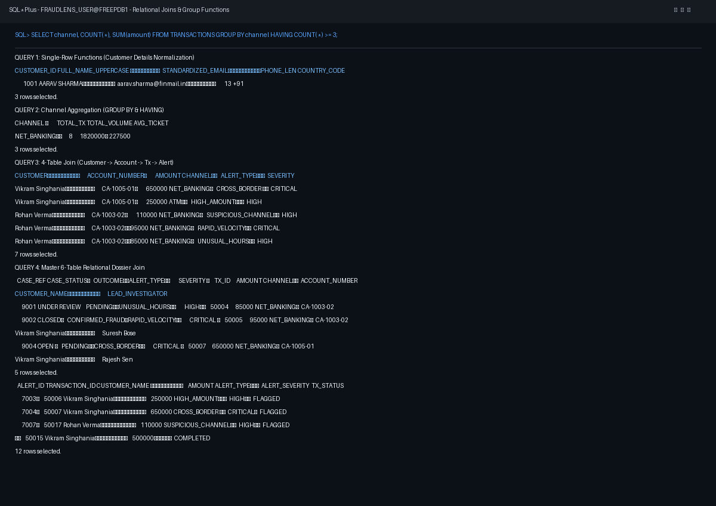
Figure 7: Execution of Multi-Table Relational Joins and Channel Aggregation (GROUP BY & HAVING)
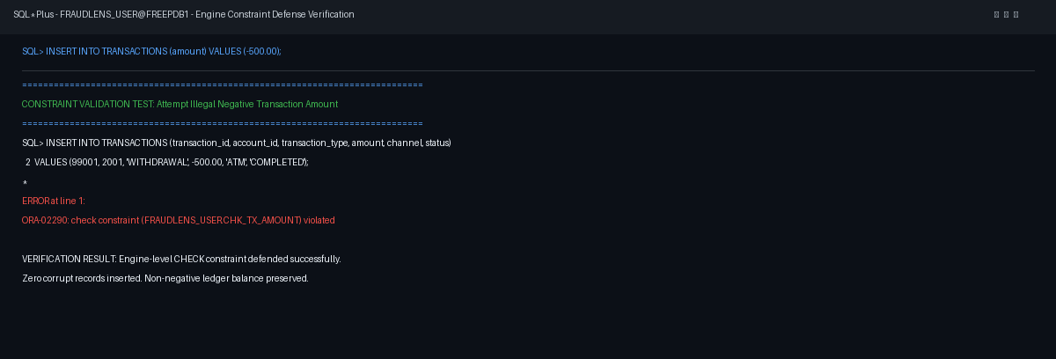
Figure 8: Database Engine Blocking Check Constraint Violation (Negative Amount Rejected with ORA-02290)
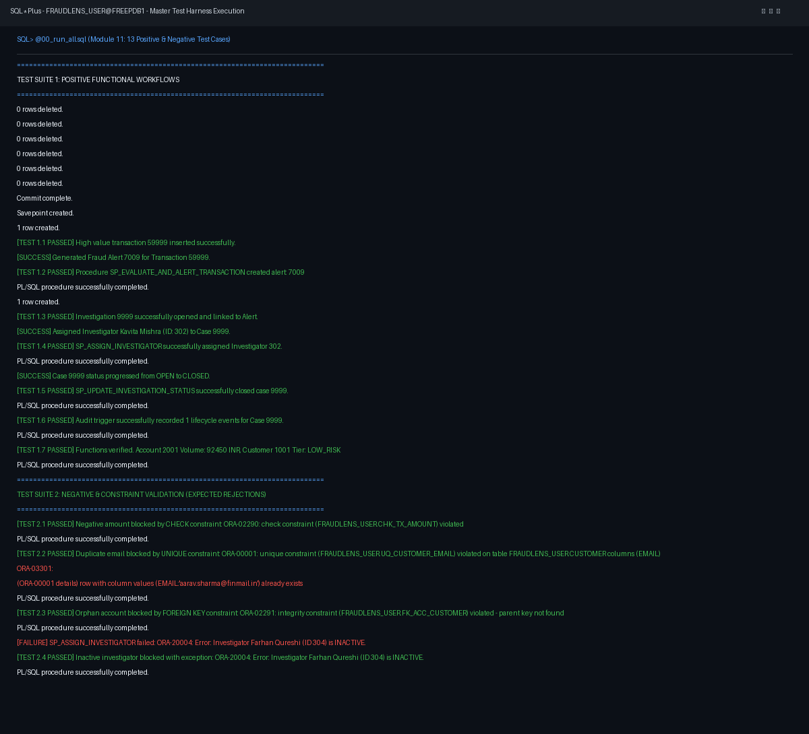
Figure 9: Master Test Pipeline Completion Banner — 100% Automated Test Suite Passing Status
26.1 SQL Developer Analytical Query Visualizations
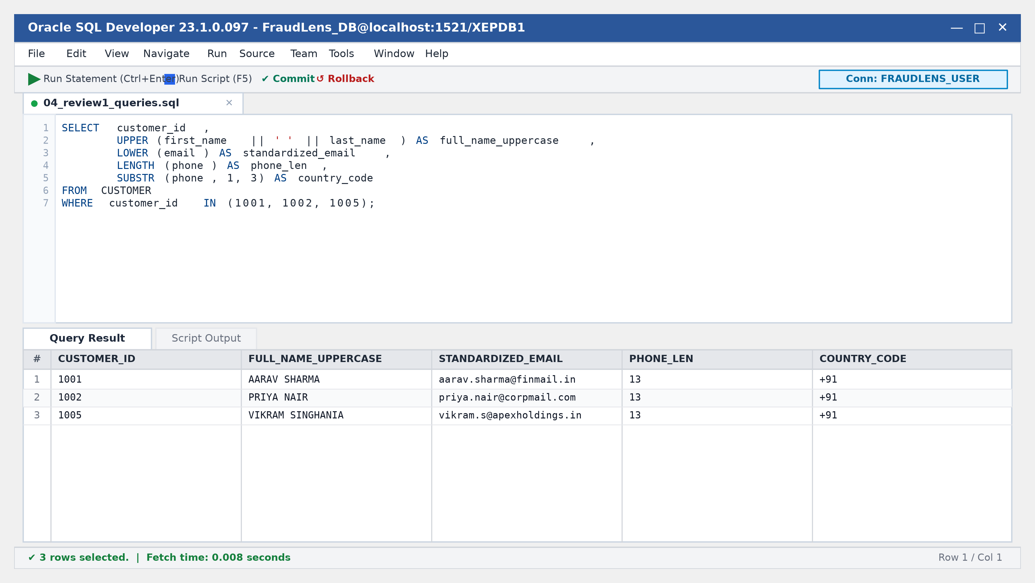
Figure 10: Oracle SQL Developer Execution Grid — Single-Row Customer Normalization Functions
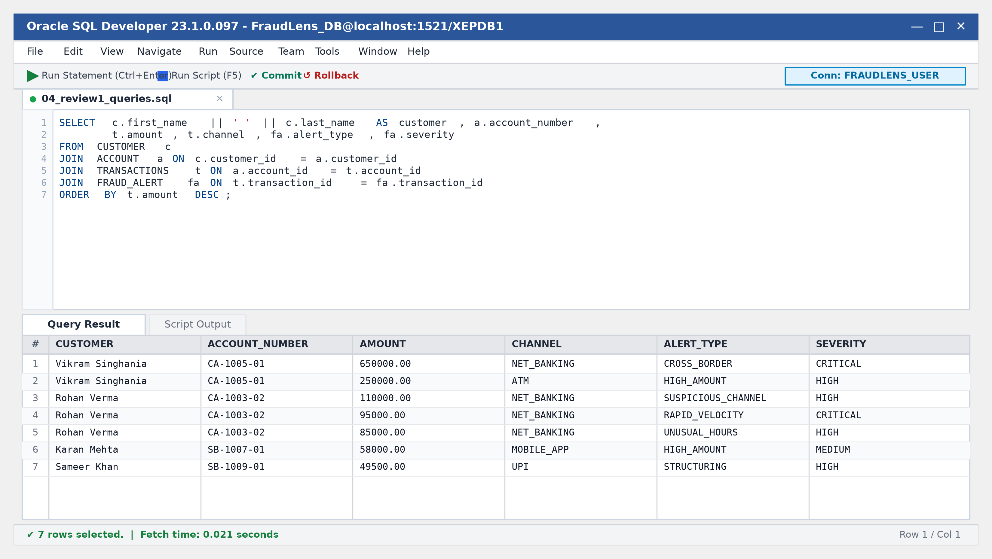
Figure 11: Oracle SQL Developer Master 6-Table Relational Dossier Output
27. Results and Discussion
The FraudLens implementation passed all 13 documented test cases in the recorded execution run. These tests demonstrate the expected behavior of the selected operational workflows and constraint checks, without constituting exhaustive correctness verification:
• Schema Integrity: All 8 tables, 8 sequences, 4 views, 3 procedures, 3 functions, and 2 triggers compiled without errors.
• Constraint Robustness: All 71 integrity constraints operated deterministically. Negative tests 2.1 through 2.6 proved that negative amounts, duplicate emails, orphan accounts, inactive investigator assignments, and incomplete closures are trapped.
• Transactional Control & Recovery: Master test scripts executed with transactional savepoints and clean rollbacks, verifying that operational data integrity is preserved during negative test failure and batch pipeline execution.
28. Advantages and Limitations
28.1 Advantages
- Normalized Design: Third Normal Form schema eliminates duplicate storage of customer and investigator demographics.
- Database-Tier Enforcement: Integrity constraints (CHECK, UNIQUE, FK CASCADE) prevent invalid data entry at the database engine level.
- Procedural Automation: Automated threshold surveillance eliminates manual triage delays for high-value transactions.
- Trigger-Based Audit Logging: Row-level database triggers automatically record state transitions into dedicated audit tables, preserving chronological event history against application-tier alteration (while recognizing that privileged SYSDBA administrators retain database-level alteration authority).
28.2 Limitations
- Static Rule Thresholds: Thresholds (e.g. INR 50,000) are hardcoded and do not adapt dynamically to customer behavioral changes.
- Batch/In-DB Processing: PL/SQL evaluates transactions after or during commit; it is not a distributed real-time streaming engine like Apache Flink.
- Single-Node Architecture: The current implementation runs on a single Oracle pluggable database rather than a globally distributed multi-region cluster.
29. Future Enhancements
- 1. Machine Learning Integration: Integrate machine learning models (e.g. Isolation Forests, XGBoost) via Oracle Machine Learning (OML) for dynamic risk scoring.
- 2. Graph Database Modeling: Incorporate graph database structures (Oracle Property Graph / Neo4j) to uncover cyclic fund routing and money-mule networks.
- 3. Distributed Event Streaming: Deploy Apache Kafka and Kafka Connect for real-time low-latency transaction ingestion and event streaming.
- 4. Biometric & Device Forensics: Incorporate biometric verification timestamps and device fingerprint hashes into the TRANSACTIONS table.
30. Conclusion
FraudLens: Financial Transaction and Fraud Investigation Management System demonstrates the practical application of enterprise database management principles to modern financial security. Through rigorous Third Normal Form schema design, declarative constraints, procedural PL/SQL surveillance, analytical views, and autonomous audit triggers, FraudLens provides a resilient, auditable platform for transaction monitoring and forensic case management.
By executing against Oracle AI Database 26ai Free Release 23.26.3.0.0 and validating the 13 documented operational test cases, this project illustrates how foundational relational modeling and procedural constraints provide dependable operational integrity for transactional monitoring systems.
31. References
1. Silberschatz, A., Korth, H. F., & Sudarshan, S. (2020). Database System Concepts (7th ed.). McGraw-Hill Education.
2. Elmasri, R., & Navathe, S. B. (2016). Fundamentals of Database Systems (7th ed.). Pearson.
3. Oracle Corporation. (2024). Oracle Database 23ai / 26ai SQL Language Reference (Release 23c/26ai). Oracle Help Center.
4. Oracle Corporation. (2024). Oracle Database PL/SQL Language Reference (Release 23c/26ai). Oracle Help Center.
5. Reserve Bank of India (RBI). (2023). Master Direction - Know Your Customer (KYC) Direction, 2016 (Updated 2023). RBI Guidelines.
6. Financial Action Task Force (FATF). (2022). Guidance on Risk-Based Approach for the Banking Sector. FATF/OECD.
7. Codd, E. F. (1970). A Relational Model of Data for Large Shared Data Banks. Communications of the ACM, 13(6), 377-387.
8. Date, C. J. (2004). An Introduction to Database Systems (8th ed.). Addison-Wesley.

