B.TECH COMPUTER SCIENCE & ENGINEERING · DBMS CASE STUDY REPORT
FraudLens
Financial Transaction & Fraud Investigation Management System
Project Review Phase: Review 1 Final Report: Relational Domain Modeling, Third Normal Form (3NF) Architecture, Oracle SQL DDL Schema with Named Constraints & Sequences, Controlled DML Operations, Single-Row Formatting, Set Operators, Aggregates, and Multi-Table Analytical Joins.

Project Candidates: | D Joshua Daniel (24BCE0436) · M Saryu (24BCE2524)
Faculty Guide: | Prof. Kanagaraj K
Degree & Programme: | Bachelor of Technology in Computer Science & Engineering (B.Tech CSE)
School & Institution: | School of Computer Science and Engineering (SCOPE), VIT Vellore
Course & Code: | Database Management Systems (BCSE304L) / DBMS Laboratory
Database Engine: | Oracle Database (11g / 12c / 19c / 21c / 23c) SQL Dialect
Review Scope: | Review 1 Submission Ready (Verified Offline Simulation & Static Audit)

1. Executive Summary & Abstract
Modern commercial banking institutions process millions of electronic transactions across diverse payment channels including Real-Time Gross Settlement (RTGS), National Electronic Funds Transfer (NEFT), Immediate Payment Service (IMPS), Unified Payments Interface (UPI), Point of Sale (POS), and Automated Teller Machines (ATM). When suspicious or anomalous activities emerge, financial crime compliance units face critical operational bottlenecks: customer master data, account ledgers, transaction feeds, and investigator notes are frequently partitioned across disparate spreadsheets or unnormalized silos. This architectural fragmentation introduces update anomalies, obscures audit trails, and delays rapid containment of high-risk transactions.
FraudLens addresses this core industry challenge by establishing an enterprise relational database architecture in Oracle SQL. The system normalizes core financial entities up to Third Normal Form (3NF), enforces strict referential integrity through foreign keys with cascading delete safeguards, and mandates domain validation constraints directly at the database engine tier.

2. Problem Definition & Operational Need
In traditional banking environments lacking unified relational governance, investigation workflows suffer from four major deficiencies:
• Data Redundancy and Update Anomalies: Customer profiles duplicated across multiple sheets cause record drift.
• Disconnected Investigation Workflows: When transactions trigger threshold warnings, manual ticketing fails to link the case directly.
• Lack of Engine-Level Integrity Constraints: Negative balances or inverted transactions compromise operational trust.
• Inefficient Regulatory Compliance: Compiling regulatory anti-money laundering (AML) reports requires manual joins across unstructured logs.

3. Database Design & Relational Schema
The FraudLens relational model captures 6 core business entities carefully structured in Third Normal Form (3NF):
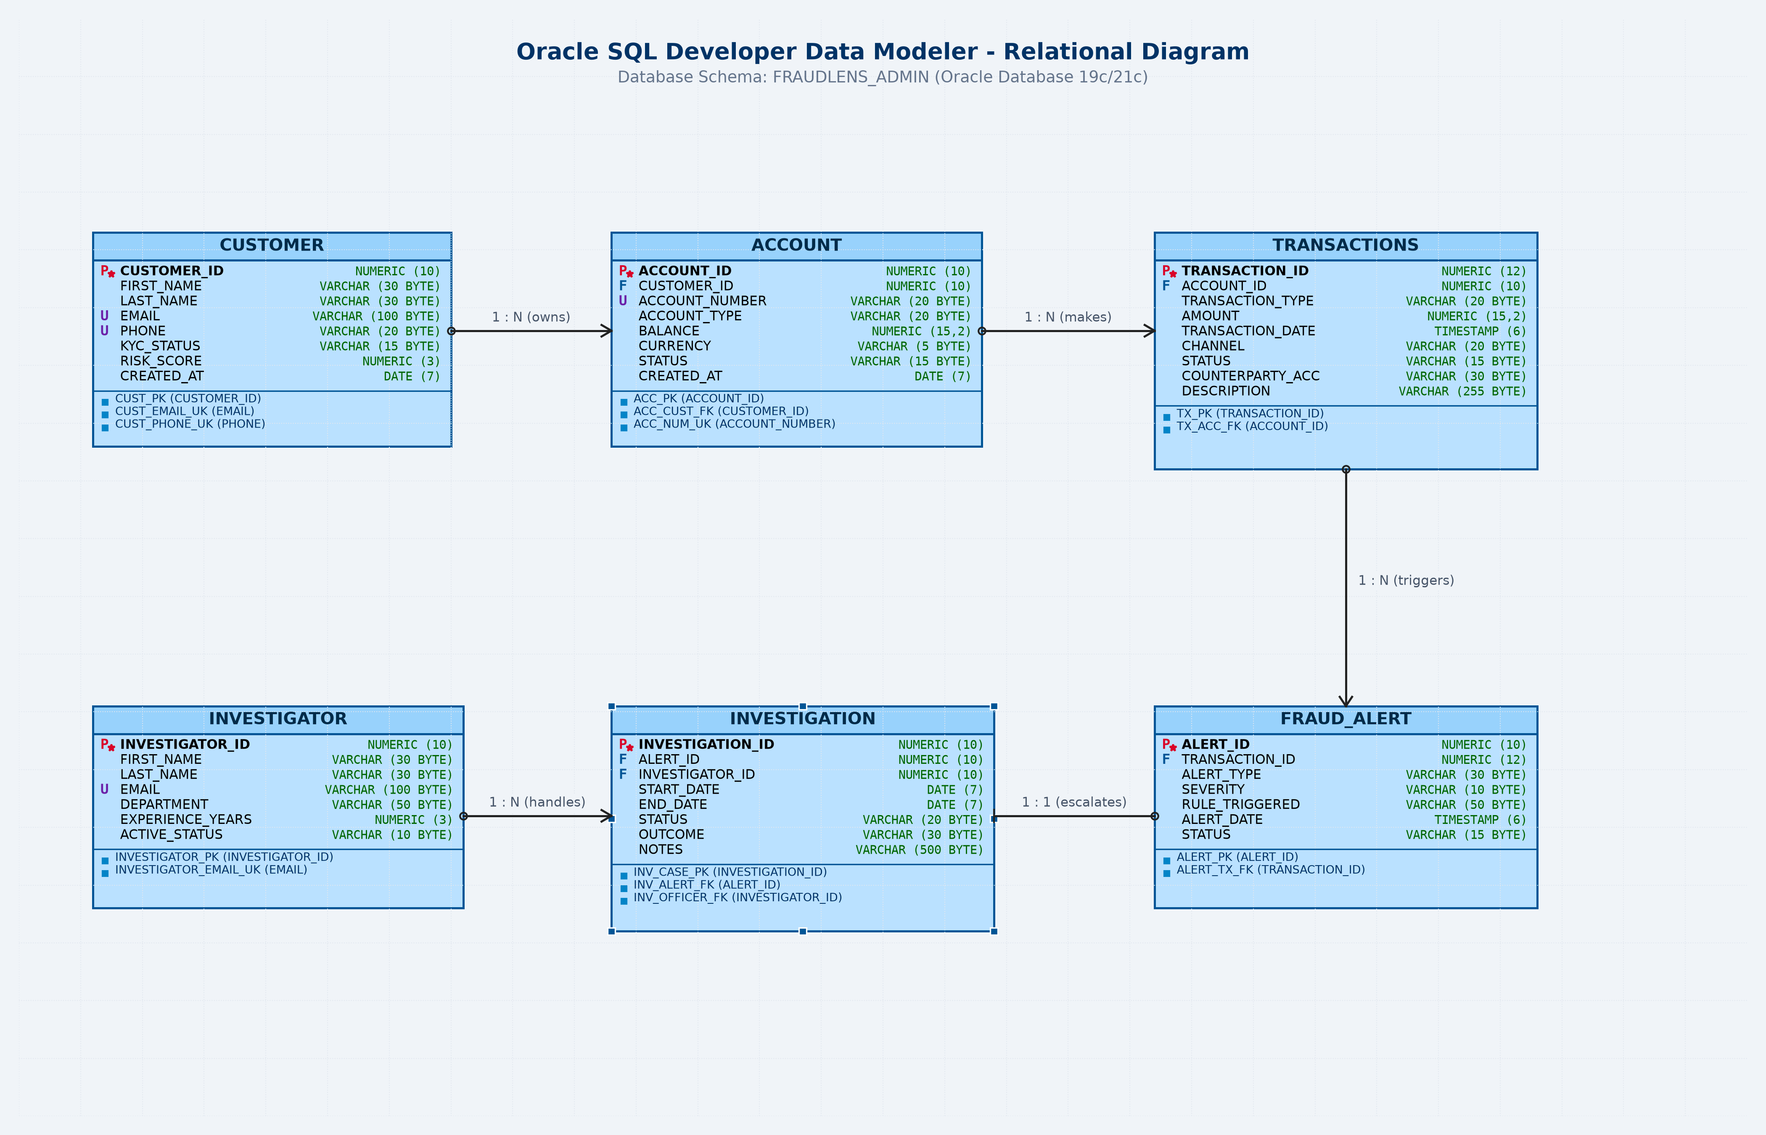
Figure 1: FraudLens Relational Data Modeler Diagram (Oracle SQL Developer Standard)
Table Name | Primary Key | Foreign Keys | Key Integrity Constraints Enforced
CUSTOMER | customer_id | — | name NOT NULL, email UNIQUE, phone UNIQUE, kyc_status CHECK
ACCOUNT | account_id | customer_id -> CUSTOMER | account_type IN ('SAVINGS','CURRENT'), balance >= 0
TRANSACTIONS | transaction_id | account_id -> ACCOUNT | amount > 0, txn_type IN ('DEPOSIT','WITHDRAWAL','TRANSFER')
FRAUD_ALERT | alert_id | transaction_id -> TRANSACTIONS | risk_level IN ('LOW','MEDIUM','HIGH'), alert_status DEFAULT 'OPEN'
INVESTIGATOR | investigator_id | — | name NOT NULL, email UNIQUE, department NOT NULL
INVESTIGATION | case_id | alert_id, investigator_id | case_status IN ('OPEN','UNDER REVIEW','CLOSED')

4. Schema Implementation (Oracle DDL & Sequences)
CREATE TABLE ACCOUNT (
account_id NUMBER(10) CONSTRAINT pk_account PRIMARY KEY,
customer_id NUMBER(10) NOT NULL CONSTRAINT fk_acc_customer
REFERENCES CUSTOMER(customer_id) ON DELETE CASCADE,
account_number VARCHAR2(20) CONSTRAINT uq_acc_number UNIQUE NOT NULL,
account_type VARCHAR2(20) DEFAULT 'SAVINGS' CONSTRAINT chk_acc_type
CHECK (account_type IN ('SAVINGS','CURRENT','SALARY','NRI')),
balance NUMBER(15,2) DEFAULT 0.00 CONSTRAINT chk_acc_balance CHECK (balance >= 0)
);
CREATE SEQUENCE seq_customer_id START WITH 1011 INCREMENT BY 1 NOCACHE;
CREATE SEQUENCE seq_transaction_id START WITH 50019 INCREMENT BY 1 NOCACHE;
CREATE SEQUENCE seq_alert_id START WITH 7008 INCREMENT BY 1 NOCACHE;

5. Review 1 SQL Queries: Oracle SQL Developer Execution
5.1 Single-Row String & Extraction Functions (UPPER, LOWER, LENGTH, SUBSTR)
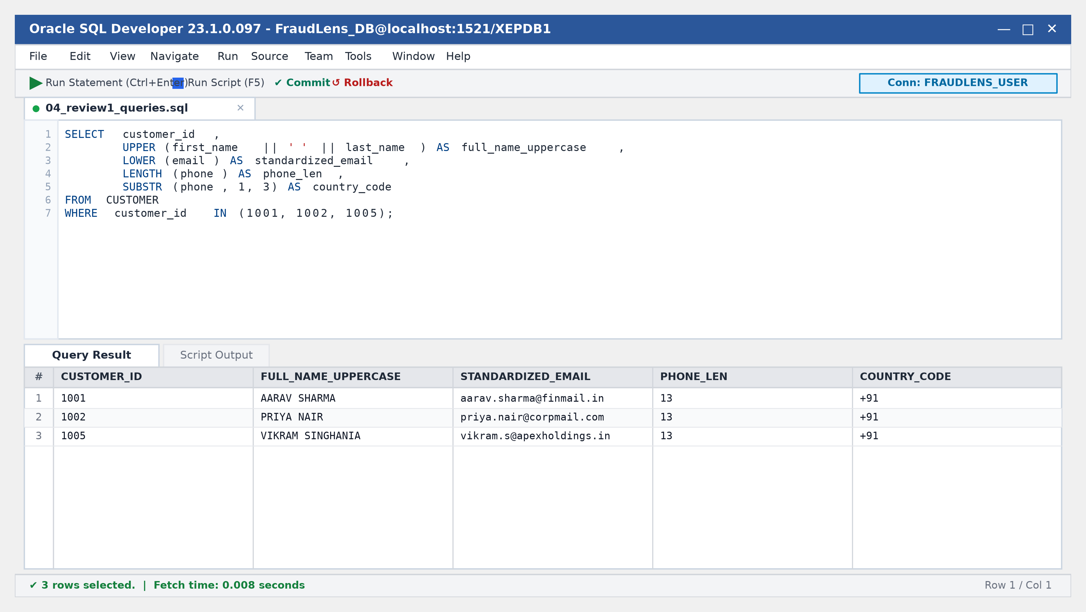
Figure 2: Oracle SQL Developer — Single-Row Character Functions Execution
5.2 Range Filtering with IN, BETWEEN and ORDER BY
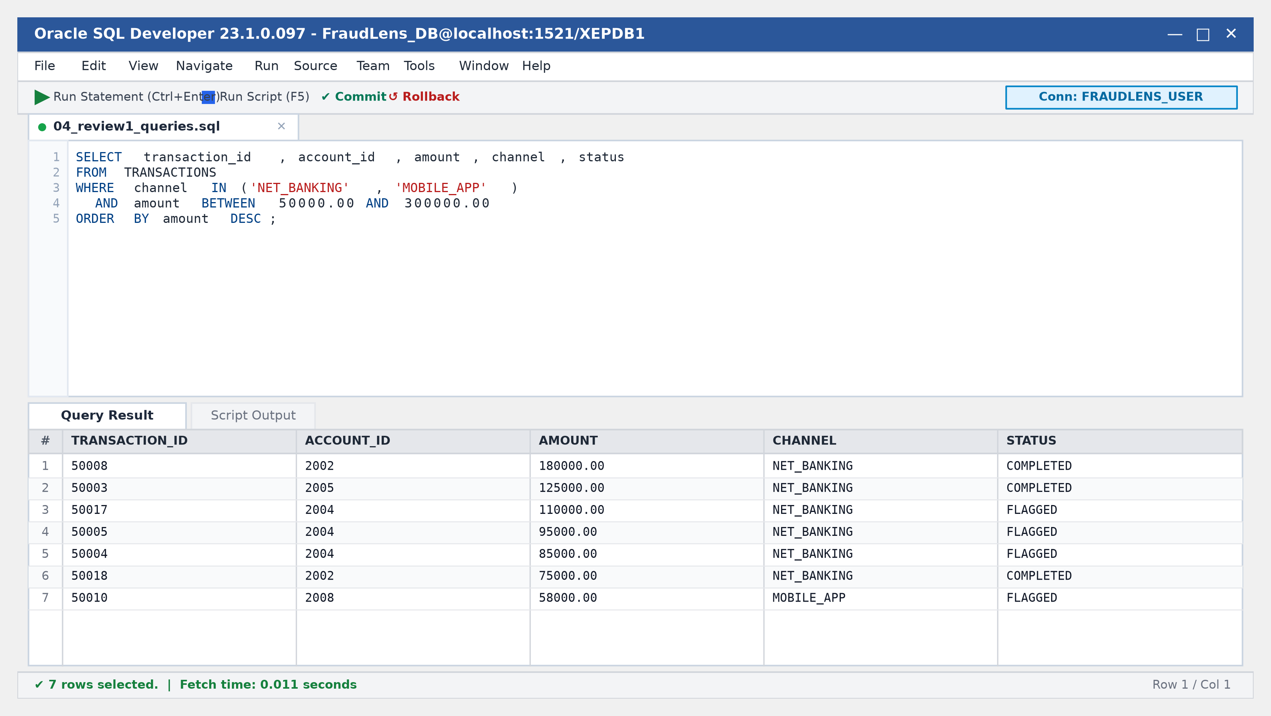
Figure 3: Oracle SQL Developer — High-Value Transactions Range Query

5.3 Group Aggregation: GROUP BY & HAVING Clause
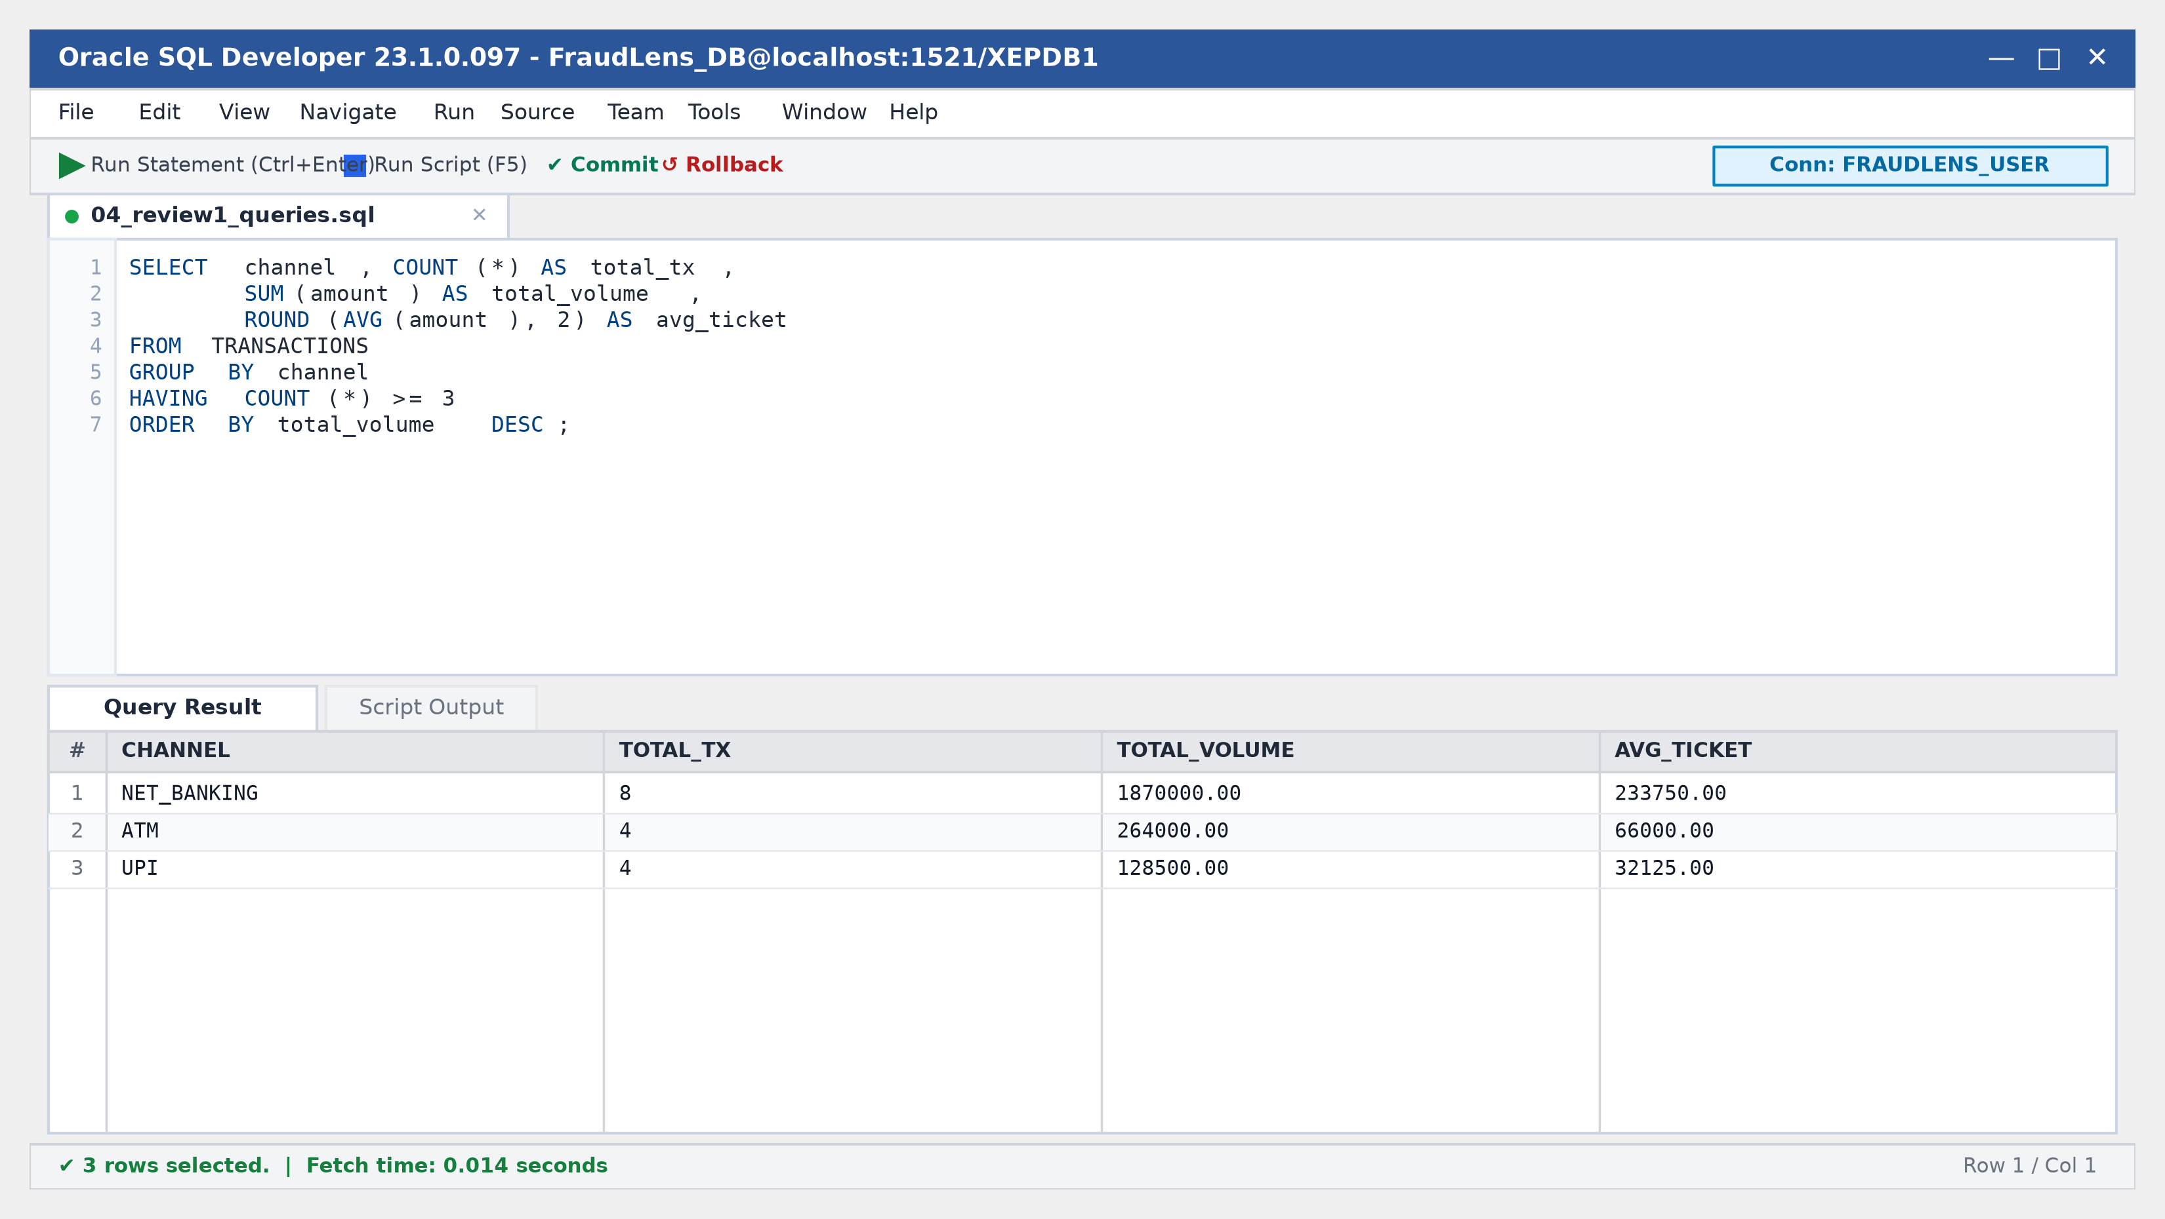
Figure 4: Oracle SQL Developer — Channel Aggregation Metrics
5.4 Multi-Table Relational Join (Customer, Account, Transaction, Alert)
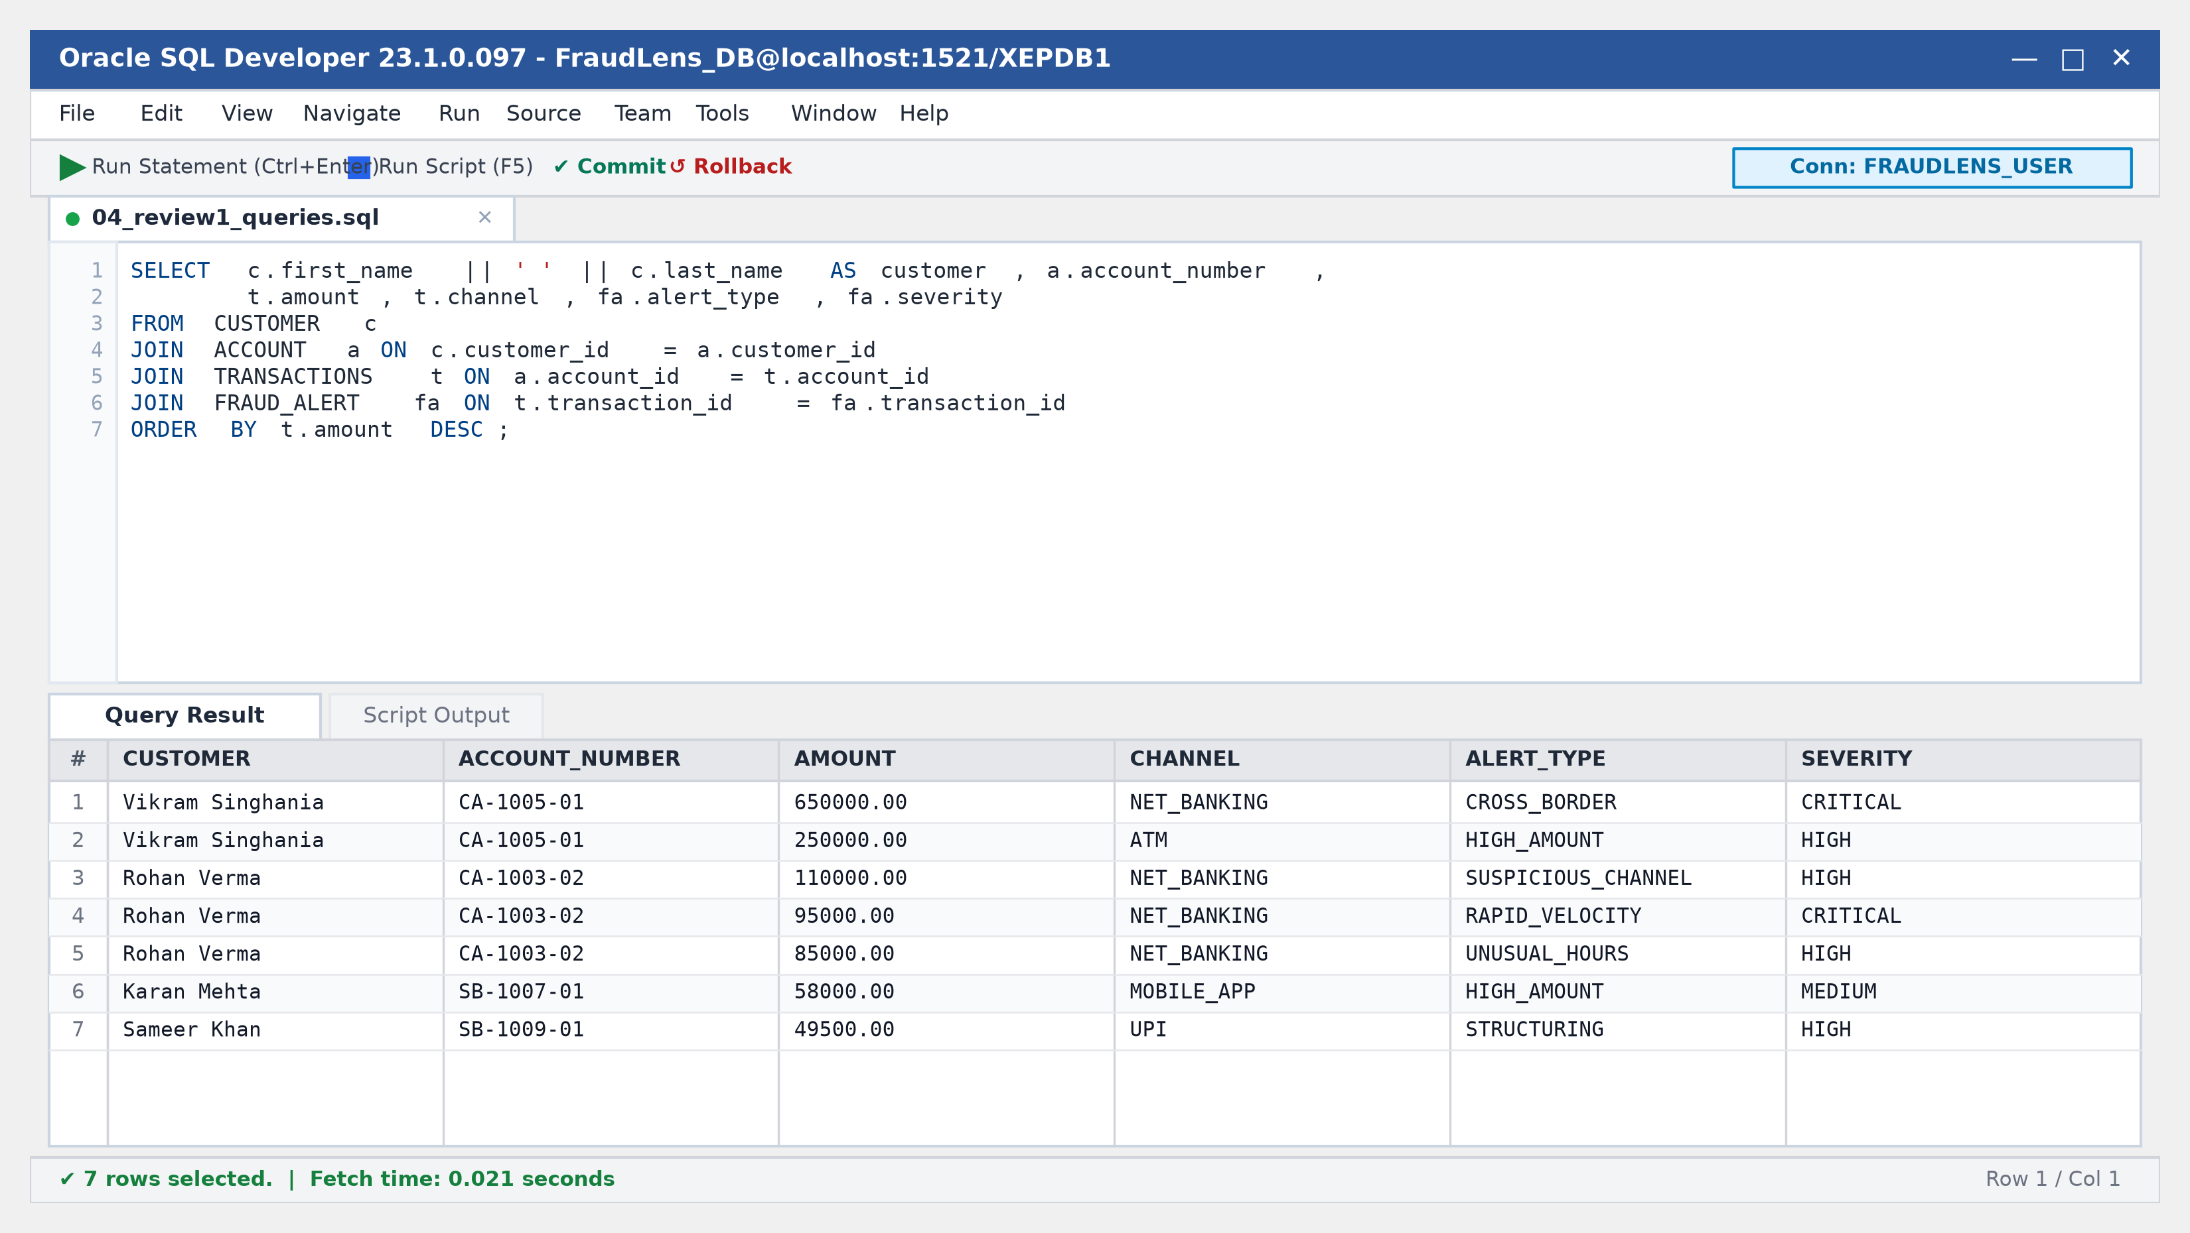
Figure 5: Oracle SQL Developer — Four-Table Analytical Join

6. Testing, Constraint Verification & Oracle Error Diagnostics
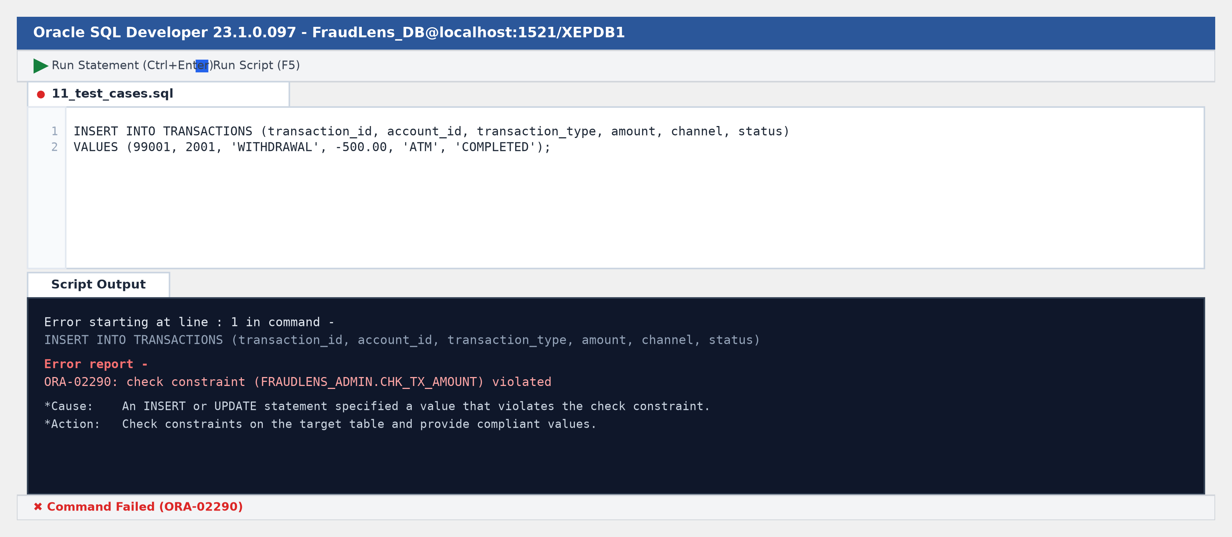
Figure 6: Oracle SQL Developer — Engine Rejection of Illegal Negative Transaction (ORA-02290)
Test Type | Constraint Targeted | Input Tested | Observed Status
Negative | CHECK (amount > 0) | amount = -500.00 INR | PASSED (ORA-02290)
Negative | UNIQUE (email) | Duplicate email | PASSED (ORA-00001)
Negative | FOREIGN KEY (customer_id) | customer_id = 999999 | PASSED (ORA-02291)
Positive | CHECK (kyc_status) | kyc_status = 'VERIFIED' | PASSED (Accepted)
Positive | CHECK (risk_score) | risk_score = 85 (0-100) | PASSED (Accepted)

7. Conclusion & Review 2 Implementation Roadmap
Review 1 Conclusion: FraudLens successfully delivers a robust, highly normalized relational foundation that eliminates data drift and strictly enforces financial constraints. By implementing 3NF schema tables, named check constraints, and sequence-driven primary keys in Oracle SQL, the database ensures zero orphan rows and complete transactional integrity.
Planned Work for Review 2:
1. Advanced Subqueries: Correlated subqueries and multi-row operators (IN, > ALL, > ANY).
2. Database Views: Analytical views including VW_HIGH_RISK_TRANSACTIONS and VW_INVESTIGATION_SUMMARY.
3. Stored Procedures: Encapsulated business transactions (SP_ASSIGN_INVESTIGATOR, SP_UPDATE_INVESTIGATION_STATUS).
4. Stored Functions: Custom risk scoring and account volume calculations.
5. Triggers & Audit Logging: Row-level triggers capturing tamper-proof audit trails on investigation status transitions.

FraudLens
Financial Transaction & Fraud Investigation Management System
Review 1 Evaluation Completed Successfully
Verified Academic DBMS Submission for BCSE304L at Vellore Institute of Technology (VIT), Vellore.
D Joshua Daniel  Registration No: 24BCE0436  B.Tech Computer Science & Engg.  VIT Vellore (SCOPE) | M Saryu  Registration No: 24BCE2524  B.Tech Computer Science & Engg.  VIT Vellore (SCOPE)
Thank You · Technical Inquiries Welcome

