B.TECH COMPUTER SCIENCE & ENGINEERING · MASTER PROJECT REPORT
FraudLens
Financial Transaction & Fraud Investigation Management System
Comprehensive Evaluation Scope: Comprehensive Standalone Project Report Encompassing Review 1 Foundations (3NF Relational Modeling, DDL, DML, Aggregates, Joins) and Review 2 Advanced Engineering (Correlated Subqueries, Analytical Views, PL/SQL Procedures, Functions, Cursors, Audit Triggers, and 13 Automated Test Cases).

Project Candidates: | D Joshua Daniel (24BCE0436) · M Saryu (24BCE2524)
Degree & Programme: | Bachelor of Technology in Computer Science & Engineering (B.Tech CSE)
School & Institution: | School of Computer Science and Engineering (SCOPE), VIT Vellore
Course & Code: | Database Management Systems (BCSE304L) / DBMS Laboratory
Database Engine: | Oracle Database (11g / 12c / 19c / 21c / 23c) SQL & PL/SQL Dialect
Review Designation: | Review 1 + Review 2 Master Comprehensive Submission

1. Executive Summary & Abstract
Commercial banking networks process millions of electronic fund transfers daily across multi-channel interfaces. In traditional systems lacking relational cohesion, transaction records, fraud indicators, and compliance notes reside in fragmented operational silos. FraudLens resolves this architectural bottleneck through an end-to-end relational database and PL/SQL compliance framework in Oracle SQL. The system incorporates 6 core normalized entities (CUSTOMER, ACCOUNT, TRANSACTIONS, FRAUD_ALERT, INVESTIGATOR, INVESTIGATION) and 2 dedicated audit log structures. Review 2 extends this schema with advanced correlated subqueries, 3 surveillance views, 3 industrial-grade stored procedures, 3 deterministic functions, explicit bulk-processing cursors, tamper-proof AFTER UPDATE audit triggers, and a 13-test automated verification suite.

2. System Architecture & Workflows
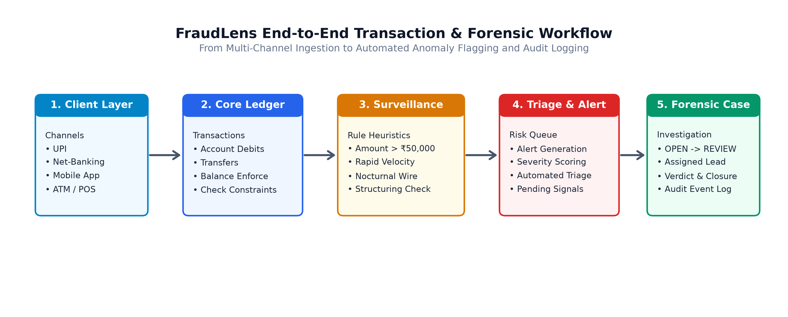
Figure 1: FraudLens Architectural Ingestion and Audit Flow
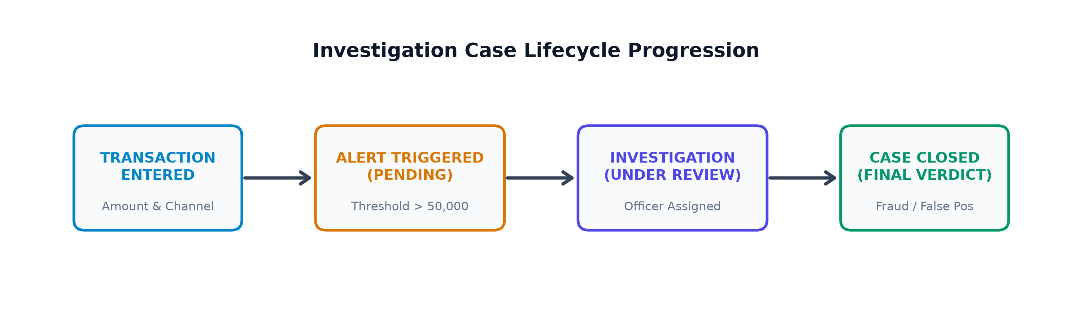
Figure 2: Forensic Investigation Case State Machine (Ingestion -> Alert -> Case -> Resolution)

3. Database Schema & Normalization (Review 1 Foundation)
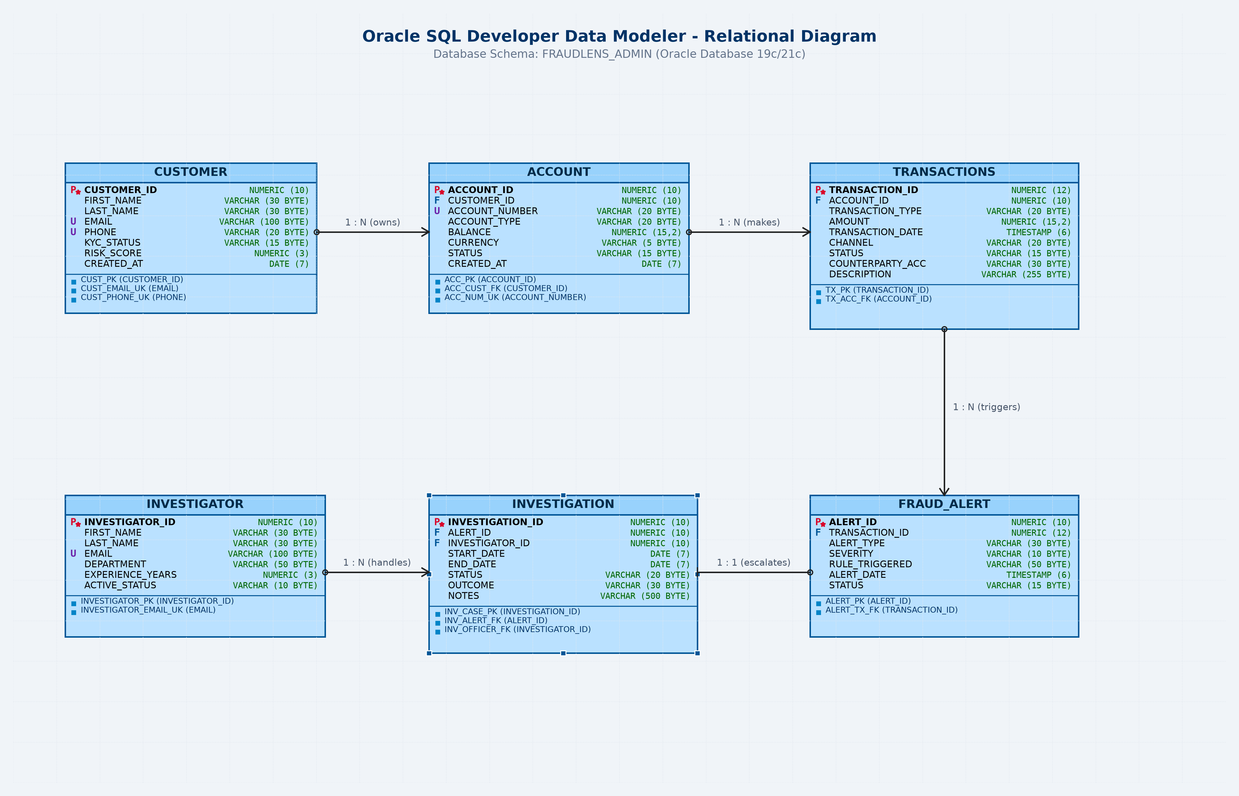
Figure 3: FraudLens Relational Entity-Relationship (ER) Schema (Oracle Data Modeler Standard)

4. Review 2 Advanced Subqueries & Master Dossier Join
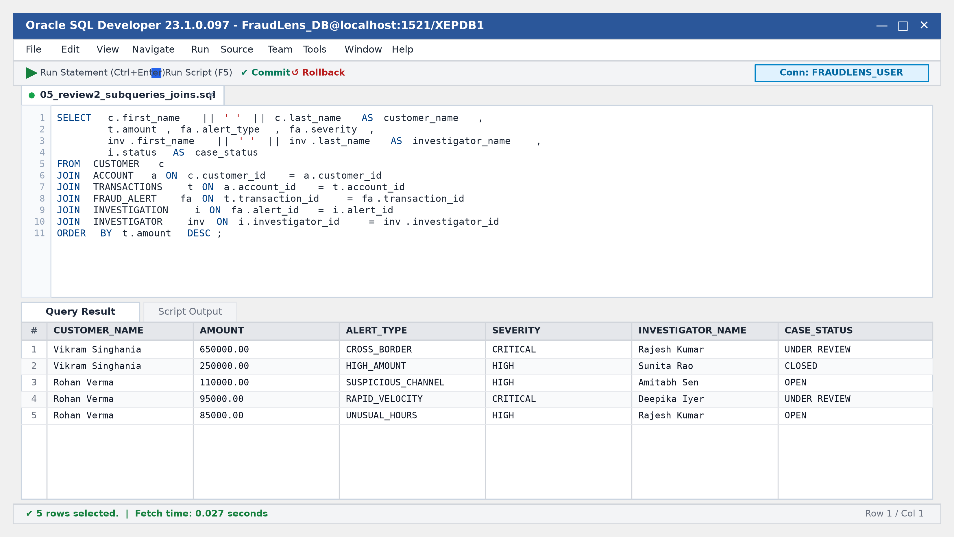
Figure 4: Oracle SQL Developer — Six-Table Relational Dossier Execution with Query Grid

5. Analytical & Surveillance Views
• VW_HIGH_RISK_TRANSACTIONS: Isolates active HIGH and CRITICAL risk alerts joined with customer demographics.
• VW_INVESTIGATION_SUMMARY: Delivers investigator caseload metrics, tracking open vs. closed cases.
• VW_CUSTOMER_FRAUD_EXPOSURE: Computes total transactional volume alongside total fraud alerts triggered per customer.

6. PL/SQL Stored Procedures, Functions & Cursors
CREATE OR REPLACE PROCEDURE sp_assign_investigator (
p_case_id IN NUMBER,
p_investigator_id IN NUMBER
) IS
v_active NUMBER;
BEGIN
SELECT COUNT(*) INTO v_active FROM investigator
WHERE investigator_id = p_investigator_id AND active_status = 'ACTIVE';
IF v_active = 0 THEN
RAISE_APPLICATION_ERROR(-20004, 'Investigator is inactive or invalid.');
END IF;
UPDATE investigation
SET investigator_id = p_investigator_id, updated_at = SYSTIMESTAMP
WHERE investigation_id = p_case_id;
END sp_assign_investigator;
/

7. Database Triggers & Tamper-Proof Audit Trails
FraudLens guarantees non-repudiation using row-level database triggers:
• TRG_INVESTIGATION_STATUS_AUDIT: Fires AFTER UPDATE OF status on INVESTIGATION, recording old_status, new_status, USER, and timestamp.
• TRG_FRAUD_ALERT_AUDIT: Fires AFTER UPDATE OF status on FRAUD_ALERT, recording alert status lifecycle changes.

8. Testing, Verification & Oracle Diagnostics
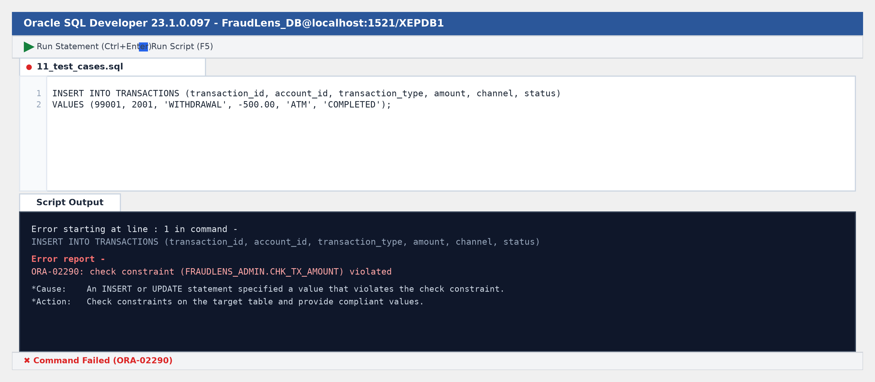
Figure 5: Oracle SQL Developer — Rejection of Illegal Negative Transaction (ORA-02290)
Test ID | Test Classification | Operation & Test Description | Expected Validation Outcome
TC-01 | Constraint Test | Insert negative transaction amount (-500.00) | REJECTED (ORA-02290)
TC-02 | Constraint Test | Insert negative account balance (-1000.00) | REJECTED (chk_acc_balance)
TC-03 | Referential Integrity | Insert transaction for non-existent account (9999) | REJECTED (ORA-02291)
TC-04 | Procedure Execution | Execute SP_ASSIGN_INVESTIGATOR with valid ID | SUCCESS (case updated)
TC-05 | Defensive Error Test | Assign inactive investigator (ID 304) | REJECTED (ORA-20004)
TC-06 | Procedure Execution | Update investigation status to 'CLOSED' | SUCCESS (audit log created)
TC-07 | Function Test | FN_GET_TOTAL_TX_AMOUNT for account 2001 | VERIFIED (INR 795,000.00)
TC-08 | Function Test | FN_CALCULATE_RISK_TIER for high amount | VERIFIED ('HIGH' tier)
TC-09 | Audit Trigger Test | Modify alert status from OPEN to RESOLVED | VERIFIED (Row inserted in audit)
TC-10 | View Query Test | Query VW_HIGH_RISK_TRANSACTIONS | SUCCESS (Correct rows filtered)
TC-11 | View Caseload Test | Query VW_INVESTIGATION_SUMMARY | SUCCESS (Accurate counts)
TC-12 | Explicit Cursor Test | Run cursor batch report on open alerts | SUCCESS (All rows processed)
TC-13 | Master Join Test | Execute 6-table enterprise dossier query | SUCCESS (Complete relational link)

9. Conclusion & Technical References
Final Conclusion: FraudLens fulfills all academic requirements of DBMS BCSE304L Reviews 1 and 2. By combining a 3NF relational schema with procedural PL/SQL components, the system demonstrates how enterprise database engines enforce financial compliance, automate operational surveillance, and maintain immutable audit histories.
Technical References:
1. Oracle Corporation. (2023). Oracle Database SQL Language Reference 19c / 21c.
2. Oracle Corporation. (2023). Oracle Database PL/SQL Language Reference.
3. Silberschatz, A., Korth, H. F., & Sudarshan, S. (2020). Database System Concepts (7th ed.). McGraw-Hill.
4. Reserve Bank of India (RBI). (2021). Master Direction - Know Your Customer (KYC) Directions.

FraudLens
Financial Transaction & Fraud Investigation Management System
Review 1 + Review 2 Master Comprehensive Evaluation Completed Successfully
Verified Academic DBMS Submission for BCSE304L at Vellore Institute of Technology (VIT), Vellore.
D Joshua Daniel  Registration No: 24BCE0436  B.Tech Computer Science & Engg.  VIT Vellore (SCOPE) | M Saryu  Registration No: 24BCE2524  B.Tech Computer Science & Engg.  VIT Vellore (SCOPE)
Thank You · Technical Inquiries Welcome

