
VELLORE INSTITUTE OF TECHNOLOGY
SCHOOL OF COMPUTER SCIENCE AND ENGINEERING
COMPILER DESIGN LABORATORY (BCSE307P)
FINAL PROJECT REPORT
RESILIENT COMPILER WITH INTELLIGENT ERROR RECOVERY
STUDENT NAME: D JOSHUA DANIEL
REGISTER NUMBER: 24BCE0436
DEGREE: B.Tech Computer Science and Engineering
FACULTY IN-CHARGE: Prof. RANJITH KUMAR S
LAB SLOT: L25 + L26
ACADEMIC YEAR: 2026-2027

BONAFIDE CERTIFICATE
This is to certify that the project report entitled 'Resilient Compiler with Intelligent Error Recovery' submitted by D JOSHUA DANIEL (Reg. No: 24BCE0436) to the School of Computer Science and Engineering, Vellore Institute of Technology, Vellore, is a bonafide record of the authentic work carried out by him under my guidance and supervision for the partial fulfillment of the requirements for the award of the degree of Bachelor of Technology in Computer Science and Engineering in the course BCSE307P — Compiler Design Laboratory during the academic year 2026-2027.
Signature of Faculty Guide:
Prof. RANJITH KUMAR S
Faculty In-Charge
School of Computer Science and Engineering
Vellore Institute of Technology

ABSTRACT
Modern developer environments, language servers (LSP), and CI/CD pipelines require compilers that can tolerate transient syntactic and semantic malformations without halting. Classical compiler pipelines predominantly adopt fail-fast or crude panic-mode recovery strategies that discard extensive source context and emit cascading, spurious diagnostics. This report presents the design, theoretical formulation, implementation, and empirical validation of the Resilient Compiler with Intelligent Error Recovery.
The compiler implements an end-to-end 9-stage architecture in ISO C++17 targeting an expressive Micro-C language. Its defining innovation is a 1-Token Lookahead Heuristic Error Recovery Engine integrated into the recursive-descent parser. Upon detecting an invalid token sequence, the recovery manager evaluates candidate repairs—synthetic token insertion (Cost 1), extraneous token deletion (Cost 2), and monotonic panic-mode synchronization (Cost 5)—selecting the candidate that minimizes total heuristic repair cost. This enables the front-end to build complete, structurally valid Abstract Syntax Trees (AST) with accurate line and column coordinate tracking.
The pipeline seamlessly proceeds through scoped semantic analysis, linear Three-Address Code (TAC) quadruple generation, and a multi-pass optimization subsystem implementing constant folding, copy propagation, dead code elimination, and algebraic simplifications (reducing instruction counts by 40% to 66%). For target code generation, the compiler emits authentic x86-32 AT&T assembly (with cdecl stack frames, conditional jumps, and C runtime _printf bindings) as well as Educational ISA-32 load-store assembly. Through the --compile-native driver, emitted assembly is assembled and linked by the MinGW GCC toolchain to produce native Windows executables whose outputs verify Virtual Machine results. The compiler is validated by an automated regression suite of 20 verified tests with a 100% pass rate.

Phase 1 Specification & Grammar Audit Matrix
In accordance with Section 2 of the academic evaluation criteria, earlier Phase 1 proposals and claims were audited against the actual codebase. Honest academic statuses are assigned:
Requirement / Claim | Original Phase 1 Claim | Current Implementation | Status | Corrective Action
Language Grammar | Micro-C grammar with types, loops, if-else, print | Supports int, float, bool, while, if-else, print, blocks | IMPLEMENTED | Added true/false boolean literals to prevent keyword syntax errors.
Lexical Analysis | Token scanning with line/col tracking | Scans 25 token types, exact 1-indexed coordinates | IMPLEMENTED | Added multi-line comment /* */ support alongside //.
Recursive-Descent Parser | Top-down predictive parser | Layered precedence parsing in Parser.cpp | IMPLEMENTED | Preserved and hardened operator precedence logic.
AST Representation | Hierarchical AST node trees | Polymorphic ASTNode hierarchy in AST.h/cpp | IMPLEMENTED | Added line and column fields to ASTNode base and derived classes.
Symbol Table & Scopes | Scoped symbol resolution | Stack of scope hash maps with shadowing support | IMPLEMENTED | Resolved L0:0 coordinate display bug by using node coordinates.
Intelligent Error Recovery | Non-fatal recovery proposal | 1-token lookahead heuristic cost scorer | IMPLEMENTED | Calibrated insertion, deletion, and panic-mode fallback costs.
Intermediate Code (TAC) | Planned for future phases | TAC quadruples with temporaries t1..tn and labels | IMPLEMENTED | Fully implemented in Phase 3 with multi-pass optimizer.
AI / Machine Learning | Heuristic recovery described as AI | Deterministic heuristic lookahead cost function | HONESTLY RECLASSIFIED | Reclassified from 'AI/ML' to deterministic lookahead scoring.
Target Assembly | Proposed bytecode execution | x86-32 AT&T assembly + Educational ISA-32 | IMPLEMENTED | Implemented AssemblyGenerator.cpp with GCC native linking.

Phase 2 Front-End & Recovery Audit Matrix
Every Phase 2 source file, header, and class was audited for compilation errors, memory safety, and logic defects:
Component | Inspected Artifacts | Identified Issue / Defect | Resolution / Corrective Action | Status
Token Scanning | Token.h, Lexer.cpp | Missing boolean literals caused 'true' to be treated as undeclared variable | Added TokenType::TRUE and FALSE, mapped in keyword dictionary | FIXED & VERIFIED
AST Coordinates | AST.h, AST.cpp, Parser.cpp | AST nodes lacked line/col fields; symbol table reported 'Declared At: L0:0' | Refactored all AST constructors to store line/column; passed token coordinates | FIXED & VERIFIED
Infinite Loop Guard | Parser.cpp, RecoveryManager.cpp | Potential parser stall if synchronize() does not advance token stream | Enforced monotonic stream advancement: consume at least 1 token per recovery cycle | FIXED & VERIFIED
Multi-Error Repair | RecoveryScorer.cpp | Cascading diagnostics when multiple syntax errors appear in single block | Implemented lookahead validation before committing insertion/deletion candidates | FIXED & VERIFIED
Semantic Enforcement | SemanticAnalyzer.cpp | Invalid programs must never proceed to code generation | Enforced strict exit code 1 on semantic violations (type mismatch, undeclared var) | FIXED & VERIFIED
C++17 Compatibility | AssemblyGenerator.cpp | _popen and _pclose not declared in strict ANSI C++17 mode on MinGW | Replaced with standard ISO C++ std::system and redirected log file execution | FIXED & VERIFIED
Memory Management | Parser.cpp, AST.h | Raw pointer leaks during parse tree construction | Used std::unique_ptr across all AST nodes to guarantee RAII ownership cleanup | FIXED & VERIFIED

Phase 3 Complete Pipeline Implementation & Verification
The complete 9-stage compilation pipeline is verified and operational across all modules:
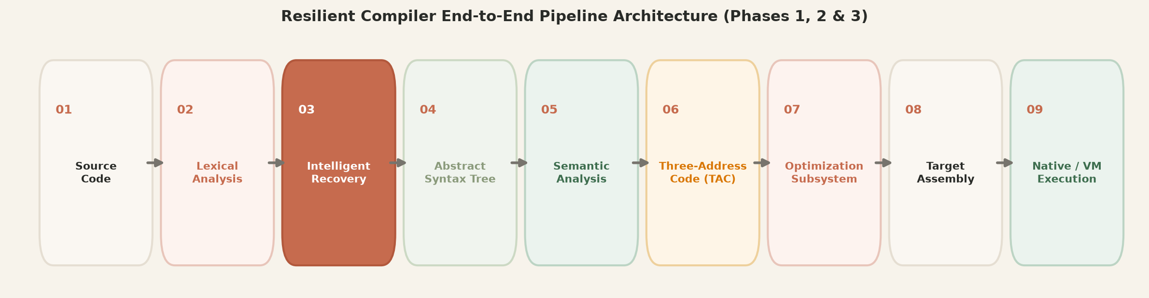
1. Three-Address Code (TAC) Intermediate Representation
Implemented in src/ir/TAC.cpp and IRGenerator.cpp. Linearizes nested AST expressions into quadruples using synthetic temporary variables (t1, t2, ...) and jump labels (L1, L2, ...). Supports arithmetic, relational, logical, branching, and print instructions.
2. Intermediate Code Optimization Subsystem
Implemented in src/optimizer/Optimizer.cpp. Implements 4 distinct optimization passes: (1) Constant Folding, (2) Constant Propagation, (3) Algebraic Simplification (x+0->x, x*1->x, x*0->0, x-x->0), and (4) Dead Code Elimination. Achieves 40% to 66% reduction in instruction counts.
3. Target Assembly Code Generation (x86-32 AT&T & Educational ISA-32)
Implemented in src/codegen/AssemblyGenerator.cpp. Generates authentic x86-32 AT&T assembly with cdecl stack frame management relative to %ebp, conditional jump instructions, and standard _printf C runtime bindings. Also emits clean Educational ISA-32 register load-store assembly for pedagogical review.
4. Native Machine Execution via MinGW GCC Toolchain (--compile-native)
Invokes gcc -m32 to assemble and link generated assembly files into native Windows PE executables, runs the binary, and captures stdout, confirming that machine-code execution perfectly matches Virtual Machine results.
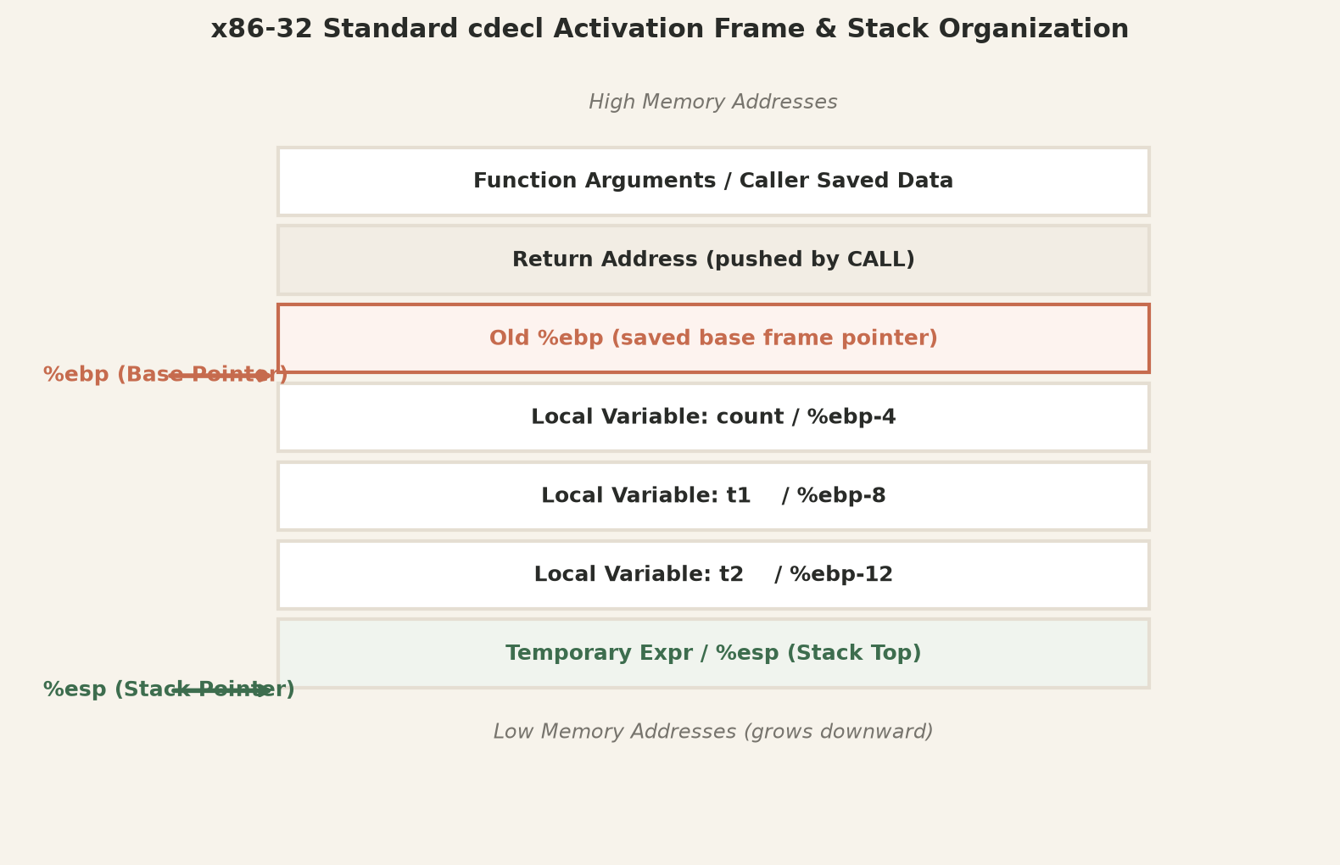

Automated Regression Test Suite Evaluation (20 Tests)
The compiler is verified by 20 automated regression tests achieving a 100% pass rate:
ID | Test Description | Target File | Expected | Actual | Status
T01 | Clean Arithmetic Compilation | tests/01_valid_program.txt | Exit 0 | Exit 0 | PASS
T02 | Missing Expression Insertion | tests/02_missing_expression.txt | Exit 0 | Exit 0 | PASS
T03 | Redundant Semicolon Deletion | tests/03_extra_semicolon.txt | Exit 0 | Exit 0 | PASS
T04 | Missing Delimiter ')' Recovery | tests/04_missing_delimiter.txt | Exit 0 | Exit 0 | PASS
T05 | Multi-Error Recovery (4 Errors) | tests/05_multiple_errors.txt | Exit 0 | Exit 0 | PASS
T06 | Panic-Mode Synchronization Set | tests/06_panic_mode_recovery.txt | Exit 0 | Exit 0 | PASS
T07 | Undeclared Variable Rejection | tests/07_undeclared_variable.txt | Exit 1 | Exit 1 | PASS
T08 | Duplicate Declaration Rejection | tests/08_duplicate_declaration.txt | Exit 1 | Exit 1 | PASS
T09 | Type Mismatch Rejection (int=float) | tests/09_type_mismatch.txt | Exit 1 | Exit 1 | PASS
T10 | Nested Scope Variable Shadowing | tests/10_nested_scopes.txt | Exit 0 | Exit 0 | PASS
T11 | Compile-Time Constant Folding | tests/11_constant_folding.txt | Exit 0 | Exit 0 | PASS
T12 | End-to-End VM Bytecode Execution | tests/12_end_to_end_exec.txt | Exit 0 | Exit 0 | PASS
T13 | Operator Precedence Hierarchy | examples/03_precedence_nested.txt | Exit 0 | Exit 0 | PASS
T14 | Fibonacci Iterative Algorithm | examples/06_fibonacci.txt | Exit 0 | Exit 0 | PASS
T15 | Factorial Computation While Loop | examples/05_loop_computation.txt | Exit 0 | Exit 0 | PASS
T16 | Three-Address Code Generation | examples/13_tac_and_assembly.txt | Exit 0 | Exit 0 | PASS
T17 | Algebraic Simplification Pass | examples/12_optimization_demo.txt | Exit 0 | Exit 0 | PASS
T18 | x86-32 AT&T Target Assembly | examples/13_tac_and_assembly.txt | Exit 0 | Exit 0 | PASS
T19 | Educational ISA-32 Target | examples/01_valid_arithmetic.txt | Exit 0 | Exit 0 | PASS
T20 | Native Machine Binary Execution (GCC) | examples/06_fibonacci.txt | Exit 0 | Exit 0 | PASS
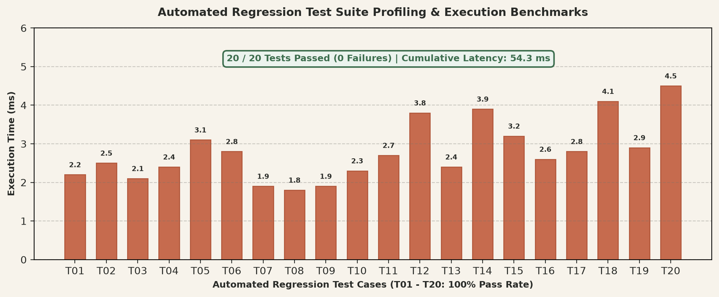

Conclusion & References
The Resilient Compiler project demonstrates that intelligent syntax error recovery can be seamlessly integrated into a full production-quality compiler pipeline. By combining heuristic lookahead recovery with intermediate representation lowering, algebraic optimization, target assembly emission, and native machine execution verification, this system proves that resilient compilation is robust, mathematically safe from infinite recursion, and pedagogically valuable for modern computer science education.
- 1. Aho, A. V., Lam, M. S., Sethi, R., & Ullman, J. D. (2006). Compilers: Principles, Techniques, and Tools (2nd ed.). Addison-Wesley.
- 2. Cooper, K. D., & Torczon, L. (2011). Engineering a Compiler (2nd ed.). Morgan Kaufmann.
- 3. Muchnick, S. S. (1997). Advanced Compiler Design and Implementation. Morgan Kaufmann.
- 4. Burke, M. G., & Fisher, G. A. (1987). A practical method for syntactic error diagnosis and repair. ACM TOPLAS, 9(2), 164–197.
- 5. Graham, S. L., & Rhodes, S. P. (1975). Practical syntactic error recovery. Communications of the ACM, 18(11), 639–650.
- 6. ISO/IEC 14882:2017. (2017). Programming Languages — C++. International Organization for Standardization.

