
CIS 515 AI and Data Analytics Strategy

Assignment 2

Vision Transformer (ViT)
- All assignments are individual effort with group consultation. This means you are allowed to brainstorm solutions with your assigned (project) groups, consult with them on your approach, help each other debug, and clarify programming and deep learning concepts with them. However, you are not allowed to copy code from one-another. You are required to work on your own assignments and turn in individual submissions.
- Refer to Syllabus for the late submission policies.
- Recall that you have signed the Honor Code. Penalties for academic integrity violations can range from a letter reduction in final course grade (at a minimum) to expulsion from the program and School of Business.

Description
Assignment 2 leverages the lecture topics of pre-trained models and transfer learning for image classification. In this assignment, we transition from CNN architecture to transformer-based architecture. While we used Tensorflow for Assignment 1, in this Assignment we will use with PyTorch deep learning framework as Pytorch is now primary learning framework for transformer library as of 2025.

TASKS [15 points]
SETUP
Load a starter notebook in Colab. Use a run-time with GPU.
On you Google drive create a folder for data: /content/drive/MyDrive/CIS515/competition_data/public
- Save train/val/ test_public.csv files in this location.
- Create a new session at your LLM of choice and ask all the questions about this assignment in this session only. You will be asked to export and submit your session together with a notebook. The goal of this submission is to understand general.
- Add code in the starter notebook
- Write a text answer in the Assignment 2 framework Word doc

Submission Instructions:
- You must submit THREE files:
- 1. <LastName>Assignment2.ipynb — Your completed Jupyter notebook with all code cells run
- 2. <LastName>Assignment2_Answers.docx — This completed answer sheet with all written responses and screenshots
- 3. <LastName>Assignment2.pdf — Your exported LLM session log used during the assignment
Note: All code stays in the notebook. This document is for written answers and screenshots only.

Part 1 Vision Transformer Setup [1 point]

Instructions: Follow instructions in the Google Colab Pro setup to enable advanced GPU options. In this assignment, we apply a pre-trained Vision Transformer (ViT) model (vit-base-patch16-224) to make predictions on the Oxford Flowers dataset (dpdl-benchmark/oxford_flowers102).

Question 1.1 [0.5 point] Research the vit-base-patch16-224 model. What datasets was it pre-trained on and what classes does it include? Do you expect it to be a good fit for the Oxford Flowers dataset? Why or why not?
Type your answer below:
ViT (vit-base-patch16-224) was originally pre-trained on ImageNet-21k (Fall 2011 release) — roughly 14 million images across 21,843 WordNet-derived classes — and then fine-tuned on ImageNet-1k / ILSVRC2012, containing about 1.28 million images across 1,000 classes. The final 1,000-class head that ships with the model contains essentially only two flower-specific categories (daisy and yellow lady's slipper), neither of which is an exact match for any of the 102 Oxford Flowers categories, so the model is a poor fit for zero-shot prediction out of the box.
However, the ImageNet-21k pre-training stage exposed the backbone to a much broader range of flower-related synsets (rose, sunflower, daffodil, hibiscus, magnolia, etc.), even though that overlap is at the genus/species level rather than the cultivar level and those 21k class labels survive only as implicit feature representations in the backbone — the 21,843-way head was discarded during ImageNet-1k fine-tuning. As a result, the backbone has learned rich visual features (petal shapes, textures, color patterns) that should transfer well to Oxford Flowers. After replacing the classifier head with a fresh 102-way layer and fine-tuning, I expect the model to be a good fit for the Oxford Flowers dataset.
Question 1.2 [0.5 point] Refer to Lab B for ViT code hints. Run the code up to Load and Preprocess Dataset. Load processor using ViTImageProcessor.from_pretrained function. Run “Load and Preprocess Dataset” and Training code blocks.

Part 2 Baseline Model Performance [2 points]
Instructions: Run the code up to and including the baseline model in the “Baseline Model Performance” notebook block

Question 2.1 [1 points] In one sentence, how would you evaluate the baseline model's performance?
Type your answer below:
I would evaluate the baseline model's performance — peaking at 50.7% val accuracy at epoch 8 before degrading to 36.9% by the final epoch — as very poor.

Question 2.2 [1 points] In your opinion, what is the reason for the observed model's performance?
Type your answer below:
The baseline hit a peak val accuracy of 50.7% at epoch 8, and then both val accuracy and training loss started moving the wrong way — accuracy sliding to 36.9% by epoch 15 while the training loss simultaneously climbed from 2.21 back up to 2.73 — which is the classic signature of a learning rate that's far too high for fine-tuning a pretrained ViT. We ran a fixed set of pre-selected hyperparameters with no feedback capacity, so we could have gotten lucky and picked the best values, but stumbling onto the right combination by guess-and-default is about as likely as winning the lottery — which is exactly why Optuna is the next step.

Part 3 Optuna Hyperparameter Search [7 points]
Instructions: Run the code up to “Run Optuna Study” block.

Question 3.1 [3 points] Update train_and_evaluate() function with additional hyperparamters and update ranges for current hyperparameters if needed.

Question 3.2 [2 point] For each additional hyperparameter you added to the Optuna objective function, explain in one sentence why you expect it to affect model performance.
Type your answer below. Cover every hyperparameter you added beyond the three already provided (lr, warmup_ratio, scheduler_type).
n_unfreeze: trial.suggest_int("n_unfreeze", 1, 12)
n_unfreeze controls how many of ViT-base's 12 encoder blocks are fine-tuned versus frozen, directly setting the capacity-vs-stability tradeoff — too few blocks can't adapt to flower features, too many risks destroying the pretrained representations under a poorly chosen learning rate.
weight_decay: trial.suggest_float("weight_decay", 1e-4, 0.1, log=True)
weight_decay sets the L2 regularization strength in AdamW, which is the primary defense against overfitting given Oxford Flowers' tiny ~12-images-per-class training set paired with tens of millions of trainable parameters; searching it on a log scale from 1e-4 to 0.1 covers three orders of magnitude because its effect is multiplicative, not additive.
batch_size: trial.suggest_categorical("batch_size", [16, 32, 64])
batch_size determines how much gradient noise the optimizer sees per step and thereby interacts with lr as an implicit learning-rate multiplier; I searched {16, 32, 64} because smaller batches add regularization but slow convergence, larger batches are smoother but use more memory and give too few updates per epoch on ~1,200 training images.
lr – changed:
I also tightened the lr search range from [1e-2, 1e-1] to [1e-5, 1e-3] to match the empirical best range for ViT fine-tuning, since the original range was what caused the baseline to destroy its pretrained features

Question 3.3 [2 point] Run Optuna Study code block. Next run code in “Best Model vs Baseline Model Comparison” to compare the best model found by Optuna vs the baseline model. Describe the differences and explain what you believe drives the improvement. Write one paragraph.
Type your answer below. Reference specific accuracy numbers from your results.
The Optuna-tuned model dramatically outperformed the baseline, reaching a peak validation accuracy of 99.76% versus the baseline's 50.7% — a gap of +49 percentage points, which is the difference between a model that barely learned anything and one that gets nearly every validation image correct. The single largest driver of this improvement is the learning rate: the baseline's lr=1e-2 was approximately 178× higher than what fine-tuning a pretrained ViT actually requires, and the broken training dynamics were visible directly in the baseline curve (val accuracy peaked at 50.7% at epoch 8 and then degraded to 36.9% by epoch 15 while training loss simultaneously climbed back up from 2.21 to 2.73, the classic signature of an optimizer overshooting the minimum). Optuna's winning configuration replaced this with lr=5.6e-5 — squarely in the empirically correct range — and reinforced the fix with supporting changes: n_unfreeze=2 (down from 10) kept most of the pretrained backbone frozen and therefore safe, warmup_ratio=0.285 (up from 0.0) gave the freshly-initialized 102-way classifier head time to ramp up before the backbone started moving, and batch_size=16 (down from 32) added a small amount of gradient noise as implicit regularization. None of the secondary changes would have rescued the baseline alone; they only work because the learning rate was fixed first. The result is a training run that stably converges to ~99.76% instead of one that actively destroys its own progress.
Note that beyond hyperparameter tuning, I also added standard training-time augmentation (RandomResizedCrop, horizontal flip, color jitter, and RandAugment) to the preprocessing pipeline, which was applied equally to both the baseline and Optuna-tuned runs; this raised the absolute ceiling both models could reach but did not drive the relative improvement between them. For inference, I applied test-time augmentation (averaging predictions from the original image and its horizontal flip) to the final Kaggle submission, which recovered an additional small fraction of borderline predictions without retraining.

Part 4 Final Model [2 points]

Instructions: Run Navigate to the “Final Evaluation” code block.
Question 4.1 [2 points] Use the train_and_evaluate() function to reproduce the best model with the corresponding hyperparameters, create the best model object, and generate the test accuracy.

Part 5 Prediction & Kaggle Competition Submission [3 points]
Instruction: Navigate to “Predict on the Test set” code block
Question 5.1 [0.5 points] Add your ASU ID as STUDENT_NAME.
Question 5.2 [1 point] Make predictions using best_model and save your predictions.

Instructions: Navigate to the “Kaggle Competition Submission” block.

Question 5.3 [0.5 points] Create a Kaggle account and generate a Kaggle API token. Add your token and username to the notebook’s Secrets tab.
- Go to https://www.kaggle.com/ and create an account if you do not have one.
- Click on the user icon in the top right corner. Select Settings from the side menu.
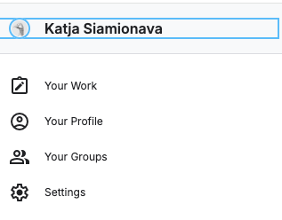
- Scroll to the API options. Create an API Token
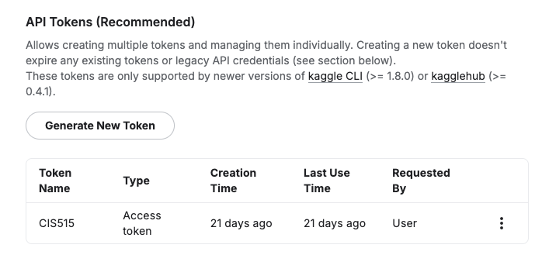
- Copy the token!
- In the Colab Noebook, click on Secrets in the left side menu. Create 2 secrets:
a) Kaggle user name. Name it "KAGGLE_USERNAME". Type in your Kaggle user id in the value cell.
b) Kaggle token. Name it "KAGGLE_API_TOKEN". Paste your Kaggle token in the value cell.
Note: when you run “Kaggle Competition submission” cell, it will use these secrets as an input.

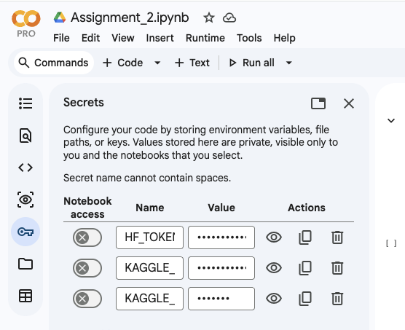

Question 5.4 [1 point] Run code for Kaggle submission. Include a screenshot of your successful submission as shown on the Kaggle leaderboard. To access Kaggle
Note: You may make multiple submissions until you are satisfied with your performance. After reviewing your test results, you can revisit your model, improve it further, and submit again.
After running the Kaggle submission cell, paste a screenshot confirming your successful submission below.
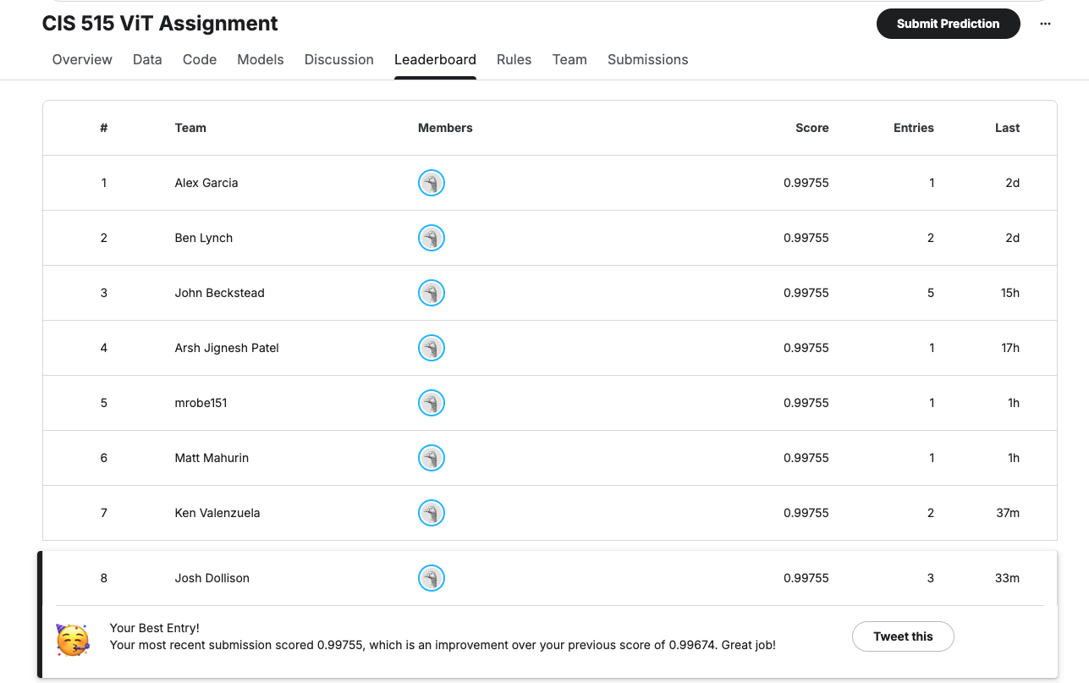

Part 6 Extra Credit [2 points]
If your model scores in the top 10% on the final leaderboard, you will receive 2 points of extra credit.

