Howard University
College of Engineering and Architecture
Department of Electrical Engineering & Computer Science

Large Scale Programming
Fall 2024

Midterm Exam – Part I
October 17, 2024

Part I: 50 pts. (essay questions)

Instructions:
- Submit completed exam to your github repository under package org.howard.edu.lsp.midterm

Verify that the commit(s) completed successfully

- OPEN BOOK, OPEN NOTES. THERE IS NO COLLABORATION ON THIS EXAM
- Site any and ALL references for anything obtained off the internet.

Question 1. (10 pts.)

You are reviewing the following class in a Fitness Tracking System. The class is intended to manage various aspects of a user’s fitness activities.

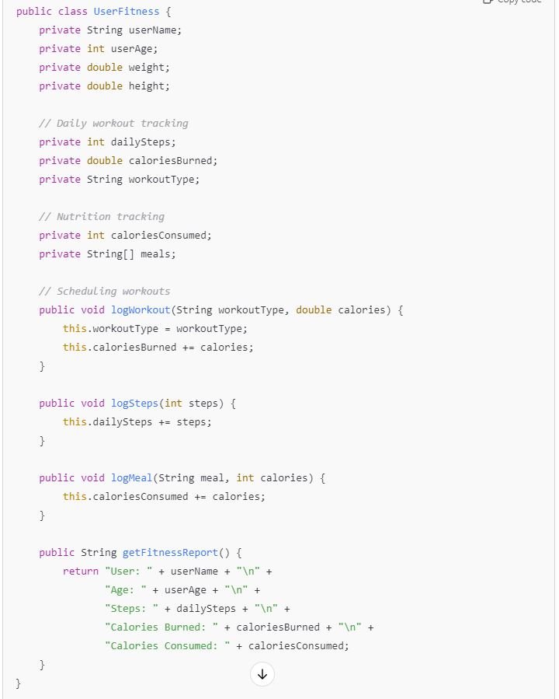

Tasks:
- Analyze the UserFitness class. Explain why this class has low cohesion. (5 pts.)
This class has low cohesion due to the “getFitnessReport()” class which has returns five loosely related variables.

- Describe, in general, how you would split the UserFitness class into more cohesive classes. Your answer should not be a complete design. (5 pts.)
In general I would separate the “User fitness” class into many different classes. For example, you could have a FitnessLogger class to handle logging data, a HealthMetrics class to calculate health-related data, and a UserInteraction class to manage user input/output. Each class would have a single responsibility.

Question 2. (5 pts.)
Given the following, answer the below questions.

A university manages its students using a program that has a class Student with subclasses FirstYear, SecondYear, and ThirdYear for year-specific state and behaviors. The program has a List that contains all Students.

Should Student be a class, an abstract class or an interface? Explain your answer
Students should be an abstract class because all students share common features, like names and IDs, but each subclass (FirstYear, SecondYear, ThirdYear) will have its own specific behaviors.

- At the end of each year, the third-year students graduate and must be removed. This is done by passing the list to the following method:

void removeThirdYears(List<Students> students) {
for (Student student : students) {
try {
ThirdYear = (ThirdYear) student;
students.remove(thirdyear);
}
}
}

Why is the above method flawed? Hint: Another Arthur Riel heuristic (5 pts.)
The method is flawed because removing items from a list while looping over it causes errors. You should use a separate list to store the items to remove and then remove them after the loop.

Question 3. (5 pts.)
Given the following, answer the below questions.

public class BankAccount {
public String accountHolderName;
public String accountNumber;
public double balance;
public double interestRate;

public BankAccount(
String accountHolderName,
String accountNumber,
double initialDeposit,
double interestRate) {
this.accountHolderName = accountHolderName;
this.accountNumber = accountNumber;
this.balance = initialDeposit;
this.interestRate = interestRate;
}

// Exposed implementation for adding interest
public void addInterest() {
double interest = balance * (interestRate / 100);
balance += interest;
}

// Exposed implementation for deposits
public void deposit(double amount) {
balance += amount;
}

// Exposed implementation for withdrawals
public void withdraw(double amount) {
balance -= amount;
}
}

- Is BankAccount well-encapsulated? Why or why not? If so, describe what changes you would make to the class. Otherwise, state nothing. (5 pts.)

No, the Bank Account class is not well-encapsulated because its fields are public, which means they can be changed directly from outside the class. You should make the fields private and use getters and setters to protect them.

Question 4. (10 pts.)
Given the following, answer the below questions.

Given:
A car manufacturer uses Java software to track current vehicles being built. The UML diagram below shows an excerpt of the current software structure. You should assume the presence of other appropriate fields and methods

Car
getTrimLevel()
Engine
accelerate()
getFuelLevel()
Base
Sports
Luxury
Electric
Petrol

Each car can be built to one of three trim levels: Base, Luxury or Sport. They can also be configured with an electric or petrol engine. At various points in the manufacturing process the customer can choose to change the trim level.

Task:
- Explain in detail why the current structure does not support this. (5 pts.)
The structure doesn't support trim-level changes because the car's trim is likely hardcoded. This means once a trim is set, it can't be changed dynamically.

- Describe how to refactor the structure to allow trim-level change for a car to dynamically change. Hint: How would you modify Car to use composition to solve the problem? (5 pts.)
Use composition by having the Car class contain a TrimLevel object, which can be changed at any time, allowing the car's trim to be updated during the manufacturing process.

Question 5. (5 pts.)
Suppose you are about to code a particular class and find that you have written another class with nearly the functionality that you now are developing. This means that the two classes in large parts contain the same code, but in smaller parts have different code. Explain in detail why this may be a problem and how to solve it. Give your answer in terms of Arthur Riel’s design heuristics.
Having two similar classes with shared code leads to code duplication, which violates the DRY (Don't Repeat Yourself) principle. This makes maintenance harder because changes must be made in multiple places. Solution: The solution is to abstract the shared functionality into a base class or utility class and allow the two similar classes to inherit or use the common functionality.
https://news.ycombinator.com/item?id=23607673

Question 6. (5 pts.)
Suppose we need to store instances of the classes Car and BankAccount in a database. To obtain low coupling it may seem as if the functionality to save an instance should be in precisely those classes, since they have the information that shall be saved. Why is it unwise to place the database calls there?
Placing database functionality in domain classes (like Car or BankAccount) results in high coupling between business logic and data access logic as they are heavily dependent on each other so changing ones code would heavily affect the other. This reduces flexibility and makes the code harder to test or maintain.

Question 7. (5 pts.)
Given a set of requirements, what conditions must be met to make it appropriate to create a new class hierarchy using inheritance? Neither superclass nor subclass exist before, the question is about designing a new class hierarchy.
You should use inheritance when there's a clear relationship where one class is a specialized version of another.

Question 8. (2.5 pts.)
Describe the difference between inheritance and composition why would you choose one over the other.
Inheritance: One class takes on the properties and behaviors of another class, Composition: A class is made up of objects from other classes.
Use inheritance when there is a subclass and super class relationship, use composition when one class needs to use features of another class without being tightly connected.

https://www.digitalocean.com/community/tutorials/composition-vs-inheritance

Question 9. (2.5 pts.)
Explain the meaning of cohesion and describe whether low or high cohesion is better.
Cohesion refers to how focused the code is to its specific responsibility. High cohesion is better because it is easier to maintain and very reusable

