**Programming Project1**

**EAS230 Engineering Computations**

**Spring 2018**

**Joshua Emerling 50104912**

**Drew Wentka 50110060**

NOTE: All provided fonts, font sizes, and spacing should remain unchanged in this document: Cambria, 12 pt, 1.15 spacing. Please replace all red text with the appropriate content.

**Table of Contents**

Add your table of contents including each section number, title, and corresponding page number

**List of Tables and Figures**

Add your list of tables and figures including each table number, title, and corresponding page number and each figure number, title, and corresponding page number

1. **Summary/Abstract**

Briefly describe the objective of the programming project, the problem in hand, how you handled it/your approach, your results, and conclusions. I would encourage you to write this section last as a brief description of what the rest of your report says.

NOTE: This section should be a maximum of ½ page

1. **Introduction**

Give a brief description of the problem to be solved, its importance (application), and if there are any other methods for solving it.

NOTE: This section should be a maximum of ½ page

1. **Deliverables**

3.1 **Part 1**

3.1.1 **Methods:**

Script Name: PP1P1.m

**Description:**

Values in () represent corresponding variable name in the script.

This script calculates the temperature of each node on a fin given the number of nodes (node_limit), an initial temperature (T0), T infinity (Tinf) ,length (L), coefficient of heat transfer (h), Thermal Conductivity (k) and the thickness of the base (base_thickness), by using both the numerical and analytical solutions. It then calculates the rate of heat transfer (Qfin) and fin efficiency(nfin) for both solutions.

**Pseudocode:**

Define all given constants

Calculate theata and delta_x by delta_x = L/(node_limit-1) and theta=atan((base_thickness/2)/L);

Initialize A to a node_limit X node_limit of all zeros

Initialize b to a column vector of length node_limit

Set values of row 1 of A and b

A(1,1) = 1;

b(1,1) = T0;

Set values of row node_limit of A and b

A(node_limit,node_limit-1) = 1;

delta_x_ex = delta_x;

A(node_limit,node_limit) = -1*(1+(h*delta_x/(k*sin(theta))));

b(node_limit,1) = -1*((h*delta_x_ex/(k*sin(theta)))) * Tinf;

for m =2 to m = node_limit -1

calculate the previous, current and next coefficients of T with the following formulas and assign the appropriate values of row m of A and b.

coff_T_prev = 1-(m-(1/2))*delta_x/L;

coff_T = -1*((2-2*m*delta_x/L) + h*delta_x^2/(k*L*sin(theta)));

coff_T_next = 1-((m+(1/2))*delta_x/L);

b(m,1) = -1*(h*delta_x^2/(k*L*sin(theta)))*Tinf;

Solve T values using rref([A b])

Calculate numerical Qfin and nfin

Create a vector of node locations using delta_x

%Analytical solution

Use given formulas to calculate T values, Qfin_Ana and nfin_Ana by the analytical solutions

Print out Qfin, nfin, Qfin_Ana and nfin_Ana

Plot the numerical T values and analytical values vs each node location.

3.1.2 **Results:**

**1)**

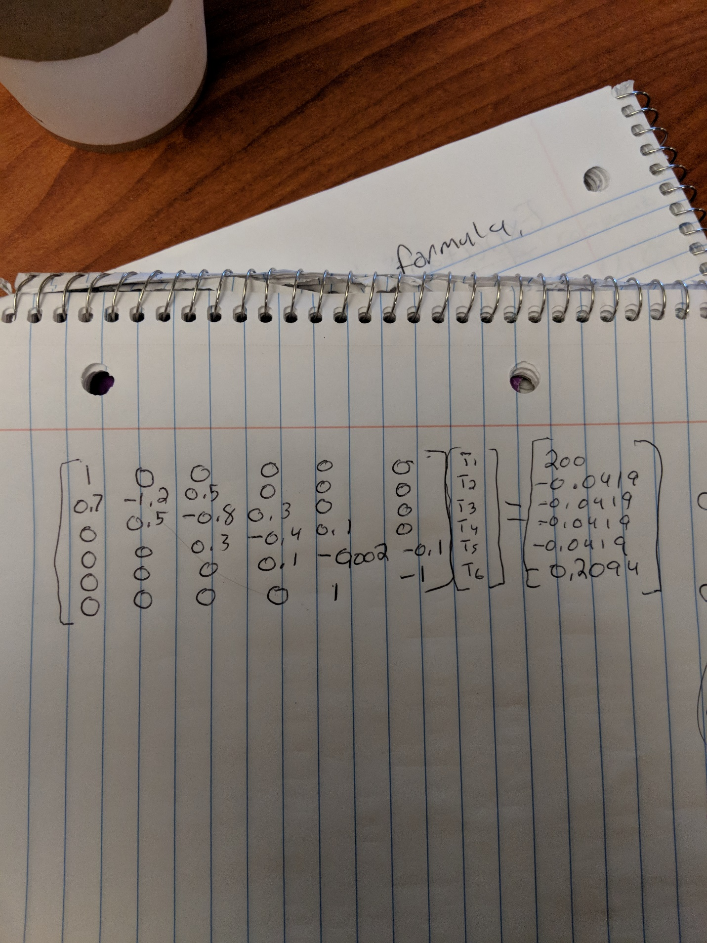

**2)**  Solved using rref([A b])

T_values =

200.0000

198.5602

197.1259

195.6964

194.2670

192.8612

**3)**

Qfin =

258.406437

nfin =

0.979520

**5)**

**e)**

>> PP1P1

node_limit =

11

T_values =

200.0000

199.2813

198.5641

197.8483

197.1340

196.4211

195.7097

194.9996

194.2907

193.5819

192.8789

>> PP1P1

node_limit =

21

T_values =

200.0000

199.6409

199.2821

198.9237

198.5657

198.2081

197.8508

197.4939

197.1374

196.7812

196.4254

196.0700

195.7149

195.3602

195.0059

194.6519

194.2983

193.9450

193.5921

193.2391

192.8876

>> PP1P1

node_limit =

101

T_values =

200.0000

199.9282

199.8564

199.7847

199.7129

199.6412

199.5695

199.4977

199.4261

199.3544

199.2827

199.2111

199.1394

199.0678

198.9962

198.9246

198.8531

198.7815

198.7100

198.6384

198.5669

198.4954

198.4240

198.3525

198.2810

198.2096

198.1382

198.0668

197.9954

197.9240

197.8526

197.7813

197.7100

197.6386

197.5673

197.4960

197.4248

197.3535

197.2823

197.2110

197.1398

197.0686

196.9974

196.9263

196.8551

196.7840

196.7129

196.6417

196.5706

196.4996

196.4285

196.3575

196.2864

196.2154

196.1444

196.0734

196.0024

195.9315

195.8605

195.7896

195.7187

195.6478

195.5769

195.5060

195.4351

195.3643

195.2935

195.2226

195.1518

195.0811

195.0103

194.9395

194.8688

194.7981

194.7274

194.6567

194.5860

194.5153

194.4447

194.3740

194.3034

194.2328

194.1622

194.0916

194.0211

193.9505

193.8800

193.8095

193.7390

193.6685

193.5980

193.5275

193.4571

193.3867

193.3162

193.2458

193.1754

193.1051

193.0347

192.9643

192.8940

**f)**



**g)**

>> PP1P1

Numerical : Rate of Heat Transfer 258.434578, Fin Efficiency 0.979627

Analytical : Rate of Heat Transfer 257.178930, Fin Efficiency 0.974867

**h)**



>> hold on

>> %Aluminum Alloy

>> PP1P1

Numerical : Rate of Heat Transfer 258.434578, Fin Efficiency 0.979627

Analytical : Rate of Heat Transfer 257.178930, Fin Efficiency 0.974867

>> %Copper

>> PP1P1

Numerical : Rate of Heat Transfer 261.226747, Fin Efficiency 0.990211

Analytical : Rate of Heat Transfer 259.943168, Fin Efficiency 0.985345

>> %Steel

>> PP1P1

Numerical : Rate of Heat Transfer 248.507640, Fin Efficiency 0.941997

Analytical : Rate of Heat Transfer 247.352785, Fin Efficiency 0.937620

>> legend('Al Numerical T','Al Analytical T','Cu Numerical T','Cu Analytical T','St Numerical T','St Analytical T')

>> hold off

3.1.3 **Conclusions:**

Our numerical and analytical solutions were almost the same with Rate of heat transfer differing by less than 1 and Fin Efficiency differing by less than 0.05. This may be due to rounding error.

Out of the 3 metals Copper has the Highest Rate of Heat Transfer and the best Fin Efficiency, followed by Aluminum Alloy. Steel has the lowest Rate of Heat Transfer and the worst Fin Efficiency.

3.2 **Part 2**

3.2.1 **Methods:**

Script Names: ThCond.m PP1P2.m

**Description:**

Created a function that will determine the thermal conductivity given a temperature value and alloy name. Temperature may be a scalar, a vector or a matrix. If the alloy name is invalid or the temperature is outside of the range of the given alloy name the function will error. PP1P2 will call ThCond for each metal type and the temperature range they are defined on. Then plot the return k for each metal vs their respective temperatures.

**Pseudocode:**

ThCond:

In a case statement have a case for each alloy name then check if the given temperature is within that alloys range, if its then calculate thermal conductivity (k) with the respective formula for the alloy. Else error.

In the otherwise clause of the case statement error.

PP1P2: For each alloy call ThCond for the correct temperature range then plot result vs temperature range.

3.2.2 **Results:**

**I**

>> ThCond(400,'Pl1')

Error using ThCond (line 173)

Not a valid Alloy

>> ThCond(300,'St1')

Error using ThCond (line 128)

Temperature out of Range for Alloy

**II**



3.3 **Part 3**

3.3.1 **Methods:**

Script Names: PP1P3.m

**Description:**

This scripts is similar to the numerical solution of Part 1 except that it is using the ThCond function to recalculate thermal conductivity(k) and with that k value recalculate the value of T using the same solution as in Part 1. It continues to do this until either the difference between the previous T values and the new ones is less than or equal to 1E-8 or 100 iterations have passed. Then it calculates rate of heat transfer and fin efficiency. Lastly it saves the determined values of T and node location to the PP1P3.dat file. Finally using the command line these values are loaded and plotted for each alloy.

**Pseudocode:**

Ask user for an alloy name

Initilize all constant values from part 1 except for k.

Initialize Told to a vector of T0’s.

Set a counter variable equal to 0.

Set error to 1 to ensure the loop can be entered the first time

While error>1E-8 and counter less than or equal to 100

Calculate k using ThCond with the alloy name and Told

Solve using the numerical solution of part one and the new k value for Tnew

Find the difference between Told and Tnew and assign that to error

Calculate node locations

Save node locations and Tnew to PP1P3.dat

Calculate Qfin and nfin using same method as in Part 1.

3.3.2 **Results:**

**e)**

>> data = load('PP1P3.dat','-ascii');

>> Al_x = data(1:101);

>> Al_T = data(102:202);

>> Cu_x = data(203:303);

>> Cu_T = data(304:404);

>> St_x = data(405:505);

>> St_T = data(506:606);

>> hold on

>> plot(Al_x,Al_T,'k');

>> plot(Cu_x,Cu_T,'r:');

>> plot(St_x,St_T,'m--');

>> title('Node Temperature vs Node Location');

>> ylabel('Temperature (C)');

>> xlabel('Location (m)');

>> legend('Al1','Cu1','St1');

>> grid on

>> hold off



**f)**

>> PP1P3

Enter an Alloy Name 'Al1'

Rate of Heat Transfer 257.982891, Fin Efficiency 0.977915

>> PP1P3

Enter an Alloy Name 'Cu1'

Rate of Heat Transfer 261.379897, Fin Efficiency 0.990791

>> PP1P3

Enter an Alloy Name 'St1'

Rate of Heat Transfer 247.387577, Fin Efficiency 0.937752

3.3.3 **Conclusions:**

Al1

Rate of Heat Transfer 257.982891, Fin Efficiency 0.977915

Cu1

Rate of Heat Transfer 261.379897, Fin Efficiency 0.990791

St1

Rate of Heat Transfer 247.387577, Fin Efficiency 0.937752

1. **Conclusion**

Briefly state your conclusions about the programming aspects of the project. For example: What did you gain from writing this solution with MATLAB versus by hand? What are the good programming practices that you used in developing your scripts/functions? How did these improve your scripts/functions? Why were user-defined functions useful in calculating the thermal conductivity? Etc.

NOTE: This section should be a maximum of ½ page