B: 20221205_0630

All bold terms represent terms for further research.

My first move today is to read the wikepedia page for JavaScript, then start its documentation.

Sections of JavaScript code are called scripts.

Scripts are embedded in or included from HTML documents interact with the DOM (Document Object Model).

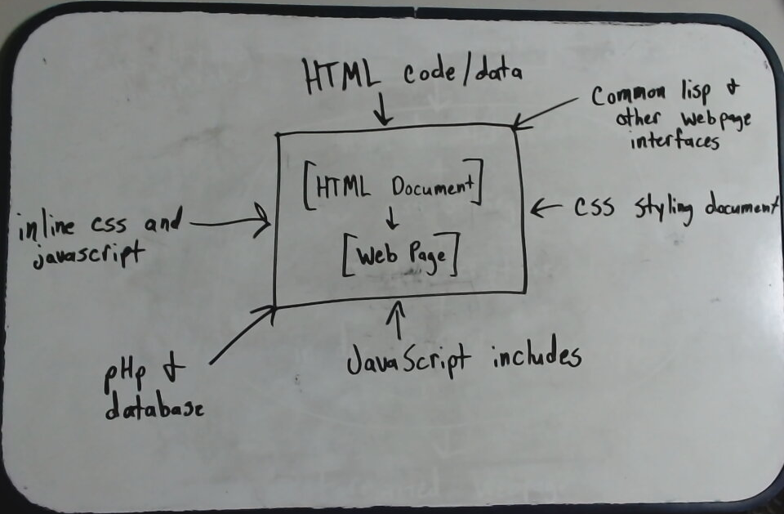

Important additional research topics from the wiki page:

- Ajax
- WebSocket
- Validating web forms
- Node.js
- jQuery library
- React library
- web framework
- Angular
- Vanilla JS

JavaScript is imperative and structured.

- Many structured programming techniques which appear
in JavaScript are derived from C syntax.

- if statements
- while loops
- switch statements
- do while loops

- block scoping is supported with keywords let and const

- Like C, JavaScript makes a distinction between
expressions and statements.

- an expression can be evaluated to determine its
value.
- a statement expresses some action to be carried
out, but has no value.

- JavaScript has automatic semicolon insertion, which
allows the omission of semicolons which terminate
statements

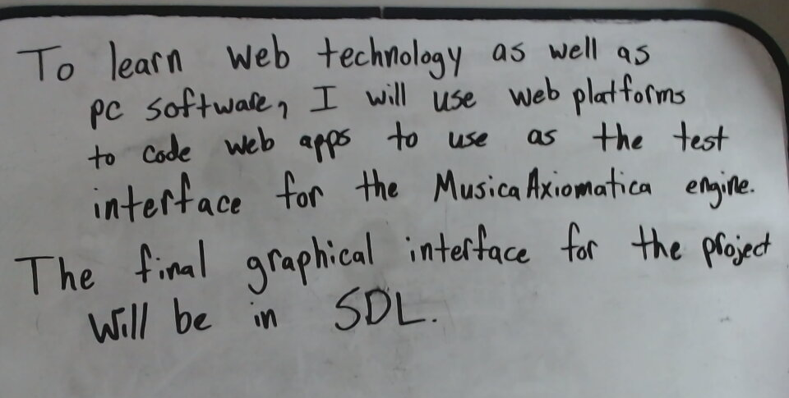

JavaScript is weakly typed.

- Certain types are implied by the operation being used.

- The binary operator + casts both operands to a
a string unless both operands are numbers.
That is, the addition operator doubles as the
concatenation operator.

- The binary operator – always casts both operands
to a number.

- Both unary operators (+, -) always cast the
operand to a number.

- Values are cast to strings:

- Strings are left as-is

- Numbers are converted to string representation

- Arrays have their elements cast to strings,
joined by commas.

- Other objects are converted to the string
[object Object] where Object is the name of the
constructor of the object.

JavaScript uses prototypes for inheritance rather than classes.

Functions double as object constructors. Prefixing a function call with new will create an instance of a prototype, inheriting properties and methods from the constructor (including properties from the Object prototype).

The Object.create method allows explicit creation of an instance without automatically inheriting from the Object prototype.

The constructor’s prototype property determines the object used for the new object’s internal prototype.

New methods can be added by modifying the prototype of the function used as a constructor.

Unlike many object-oriented languages, there is no distinction between a function definition and a method definition. Rather, the distinction occurs during function calling.

When a function is called as a method of an object, the function’s local this keyword is bound to that object for that invocation.

JavaScript functions are first-class.

- That is, a function is considered an object.

JavaScript supports implicit and explicit delegation.

JavaScript is a zero-index language.

JavaScript typically relies on a run-time environment (e.g., a web browser) to provide objects and methods by which scripts can interact with the environment (e.g., a web page DOM).

JavaScript also relies on the run-time environment to provide the ability to include/import scripts.

JavaScript processes messages from a queue one at a time.

JavaScript calls a function associated with each new message, creating a call stack frame with the function’s arguments and local variables.

When the call stack is empty upon function completion, JavaScript proceeds to the next message in the queue. This is called the event loop (also called “run to completion”).

JavaScript’s concurrency model requires that the event loop is non-blocking. Thus, input/output is performed using events and callback functions. Therefore, JavaScript can process a mouse click while waiting for a database query to return information.

