**Introduction to Open-Source Software**

B. Tech Integrated /Computer / Sem IV

**(PART - B)**

(TO BE COMPLETED BY STUDENTS)

(Students must submit the soft copy as per following segments within two hours of the practical.

The soft copy must be uploaded on the Blackboard or emailed to the concerned lab in charge faculties at the end of the practical in case there is no Black board access available)

|  |  |
| --- | --- |
| Roll.No. : C107 | Name: Joshua Ferreira |
| Sem/Year : IV/2 | Batch: C2 |
| Date of Experiment : 25/2/2022 | Date of Submission: 25/2/2022 |
| Grade -- |  |

# B.1: Procedure of performed experiment

1. Task 1:
   1. Adding Style –
      1. Navigate to the Styles option on the right side of the application screen

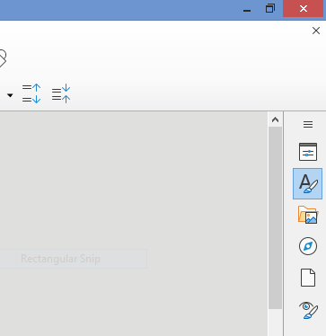

* + 1. A new section will appear. Navigate to the Headings option and expand it by clicking on the + icon.

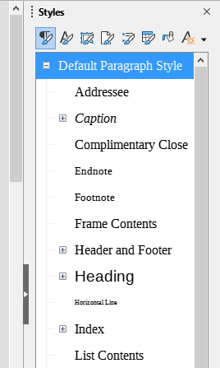

* + 1. Under Headings select Heading 2 and then right click on the mouse. Select ‘New..’ option

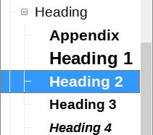

* + 1. This window should appear.

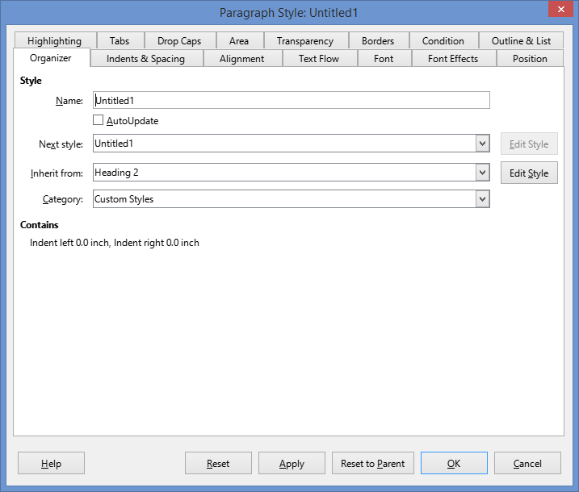

We enter the required name in the ‘Name’ field and then go to the Font and Font Effects Section.

* + 1. Make required Changes in these sections.
  1. For changing the style of text, just select required text and then double click on required style from the styles section.

1. Task 2:
   1. Inserting table of contents
      1. Go to the insert drop down list on top of the application

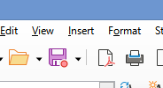

* + 1. Select table of contents from the drop down list. This window should appear

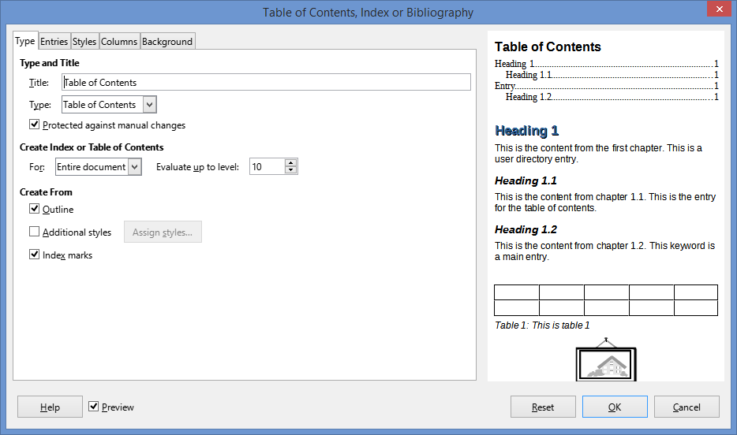

Simply click on OK

# B.2: Observations and Learning’s:

Learnt the basic functions of LibreOffice writer. Learnt how to apply styles to text, add Table of Contents as well as create new styles.

Final ODT Files –

1. [Task1](Climate_Change.odt)
2. [Task2](Freedom_Struggle.odt)

# B.3: Conclusion:

LibreOffice Writer can be used to edit word files with efficiency. LibreOffice writer is a part of the open source initiative, so you can modify how it looks, works and feels according to one’s personal requirements. It has a lot of features (,along with being free) and can rival even proprietary software like Microsoft Word.