111年度工程科技中堅躍升研究計畫-期中考評作業
Sub-report by Joshua Oon Soo Goh, PhD

1. 計畫執行進度掌握
We are continuing our work on machine theory of mind (ToM) that seeks to enhance human-machine interactions (HMI). The hypothesis is that machines can better interact with humans if they have the capacity to use representations of the hidden conceptual graphs that drive or cause observed human behaviors. To this end, the ToMNet-plus model (from the previous grant MOST 107-2634-F-002-018) was developed and successfully shown to behave in manner that reflected the possession of representations of hidden social networks of an agent’s social preferences toward four other agents (Fig. 1A). This work has been published with the code made publicly available on Github (https://github.com/NTUBMLab/tomnet-plus). Present work is ongoing on ToMNet 2.0, which is capable of representing five agents’ inter-relational social preferences for each other (Fig. 1B), a more complex case that ToMNet-plus was not designed to handle. ToMNet 2.0 simulations are completed, the manuscript is in preparation and work on model validation with human data are ongoing. Importantly, work is completed in acquiring a database comprising of audiovisual recordings human verbal and facial expressions during social interactions involving taking on different social relationships (Fig. 1C). This database will be used to validate the ToMNet 2.0 model and is hosted on a private repository. It is also available for sharing upon reasonable request.

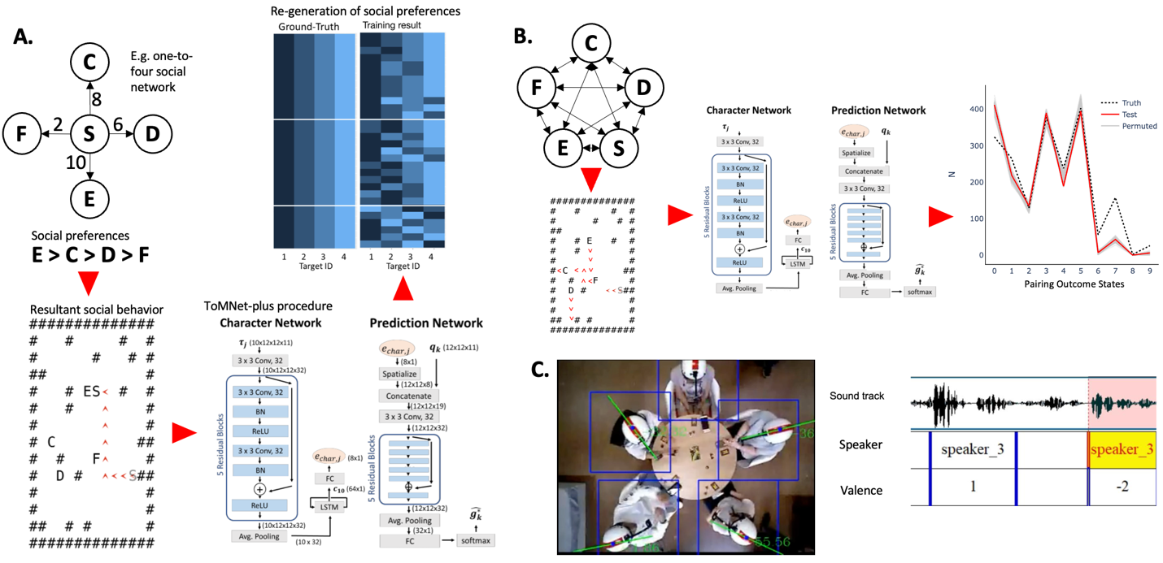
Fig. 1. A. Schematic showing an example social network with agent S’s preferences for the other four agents, which drives the agent’s approach behavior in Gridworld. ToMNet-plus observes the Gridworld trajectories and learns character embeddings for S, which are then used to predict behaviors in new Gridworld scenariors (published in Chuang et al., 2020, 29th IEEE RO-MAN, pp 1013). B. ToMNet 2.0 advances from ToMNet-plus by being able to handle social networks that include 5-way preferences that drive more dynamic Gridworld behaviors. ToMNet 2.0 predicts pairing outcome state vectors which are the prediction cases where a given pair of agents spatially converge (10 possible pairings in a 5-way social network). The manuscript for this work is in preparation. C. Sample human social preference behavior data. A top-down view is shown of 5 human participants socially engaging during a role-playing game (Avalon). The video tracks head orientation angles along with eye movements and facial expressions (not shown), and speech sound tracks. Information on behavioral expression target agent, valence in facial expression, and valence in speech is then obtained using human ratings and machine learning applications (data available upon reasonable request). NOTE: Top-down view is a playable video in PPT slide mode.

2. 人才培養研究團隊
N/A. At present, my lab has not used our allotted funding for personnel hire or training.

3. 學術成就與表現
N/A. ToMNet 2.0 paper is still in preparation with target for SCI journals.

4. 社會影響力
We are presently conducting a cognitive intervention for older adults that involves having older adults sampled from the local community interact with and programming Lego robots. The hypothesis is that interactive programming of Lego robots to perform tasks will drive older adults to engage neural circuits involved in inferential processing and should be protective against age-related cognitive decline. This study also seeks to engage the older adult public in learning about human-robot interaction, and also to apply practical cognitive health benefits to the community sample via training and social engagement. This intervention study is a clinical trial (no. NCT05341232, https://clinicaltrials.gov/ct2/show/NCT05341232?term=Lego&draw=2&rank=2) implemented at the National Taiwan Science Education Center (NTSEC, Taipei) in the form of a 12-week training course on programming Lego robots (Fig. 2A). The target sample size is 80 older adult participants (aged > 59 yrs old; with random assignment to experimental and control groups). In the training course for the experimental group, participants are taught basic programming codes and implement them in the robots to achieve goals in an interactive manner (e.g. maze navigation, object movement, simple audiovisual recognition/production) (Fig. 2B). In the control group, participants do not engage interactively but follow pre-set instructions on programming steps that similarly task the robot to achieve the goals. Importantly, participants undergo various pre- and post-training assessments involving brain and behavioral outcomes that evaluate efficacy of the human-robot interaction intervention approach in modulating human older adult cognition and brain status (Fig. 2C). This intervention is also jointly supported by MOST grant nos. 110-2511-H-002-005-MY3, 110-2410-H-002-126-MY3, 110-2511-H-002-006-MY3, 110-2511-H-002-003-MY3, 111-2321-B-006-004, and 111-2321-B-006-008, with data collection expected to be completed in 2024.

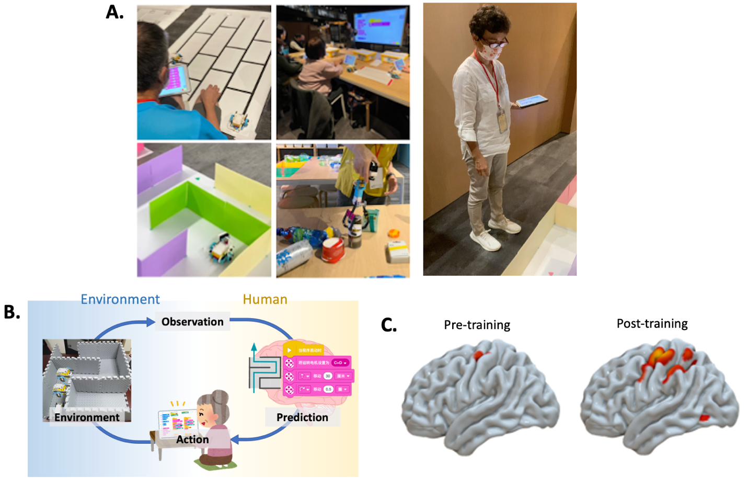
Fig. 2. A. Sample photographs showing older adult participants interacting with machines in the Lego Robot Programming training course conducted at the National Taiwan Science Education Center. Participants are shown learning the Scratch programming interface to instruct robots to follow environmental cues, navigate mazes, and to manipulate objects. NOTE: the left panel is a playable video in PPT slide mode (please do not publicly share this slide due to participant identity privacy issues). B. Schematic illustrating our hypothesis about how robot programming stimulates older adults to update their inferences about environmental causes by updating their programming codes in response to observations of the environment in relation to their actions (program codes). C. Preliminary results showing brain activity during inferential processing in a sub-set of participants before and after undergoing the 12-week Lego Robot Programming training course.

5. 國際合作與鏈結
We are presently running the Taiwan site of the international BrainHack School 2023 course (https://school-brainhack.github.io/). This is a highly inter-disciplinary, collaborative, international hybrid online/in-person course involving learning and using applications in advanced data analytic methods (e.g. machine learning, artificial intelligence applications) for working with neurophysiological data such as brain magnetic resonance imaging (MRI), electro-encephalographs (EEG), and magneto-encephalographs (MEG). The course started with a local hub in Feb 2023 and will join the main international hub in May for one month. The course consists of self-paced learning from online modules with implemention of practical projects individually or as groups, with local and international Teaching Assistants and Faculty instructors advising and discussions. The projects involve using various methods to work on existing neurophysiological data either acquired through the students’ own labs or from open databases. The main organizers of BrainHack School are from the University of Montreal, with international sites including Taiwan, Canada, Argentina, France, Uruguay, and Germany.

