Sub-Project 6: ToMNet 2.0

(一) AI技術突破
（研究目的、國際文獻回顧、方法創新性、資料集與實驗結果）
（可用圖表說明，請提供參考文獻）

The principal aim of the ToMNet 2.0 sub-project was to design a machine Theory of Mind (ToM) model that infers hidden information structures behind observed agent social interaction behaviors. In humans, ToM refers to the ability to maintain a representation of the mental states of others, and is classically tested in humans using the Sally Anne Test (Wimmer & Perner, 1983). In this test, participants are asked about their beliefs about another participant’s belief. Critically, human ToM is necessary for everyday communication in that we choose appropriate interactive behaviors based on our beliefs about what others think and how they would react (Wang et al., 2021). Specifically, ToM operations in the brain model other’s beliefs, which are information structures hidden to us that drive their behaviors we observe. Thus, in work on artificial intelligence using neural networks modeled based on the human brain, it is a standing challenge to imbue machines with ToM. That is, to design a neural network model that is able to represent the hidden beliefs underlying the behaviors of human agents, and use these representations to interact with humans. Based on the theoretical implications from previous behavioral and also neuroimaging studies on human ToM studies (Schaafsma et al., 2015; Schurz et al., 2014), we expect machine ToM to confer at least three key advantages to artificial intelligence technology. First, because the machine ToM primary approach learns interaction derivatives from pre-parsed objects (outputs from other algorithms), its operation does not require big data. Second, the very nature of ToM models enables them to generalize from a subset of data to make robust predictions from variable novel inputs including inputs that contain occlusions or overt conflicts. Finally, because of the more accurate hidden state representation of real world causes and the fact that effective human interactions rely on ToM, implementation of such models in machines will enhance human-machine-interaction experience.

Google Deepmind introduced an approach to instantiate machine ToM by implementing an artificial intelligence model (ToMNet) consisting of a spatial convolutional neural network feeding into a long short-term memory that parsed how simulated gridworld agents moved over time using character embeddings (Rabinowitz et al., 2018). Character embeddings were then used in predictive outputs of subsequent agent positions based on initial start locations. Rabinowitz et al. (2018) showed that with just the simple spatiotemporal integration instantiated in ToMNet, machines could predict agent subsequent movements even when some movement trajectories were partially occluded. That is, ToMNet appeared to represent a belief about agents’ beliefs for how they should move even when it could not “see” the movements.
In previous project years, we applied a critical advancement in usage of the ToMNet model (Fig. 1). Specifically, we imposed fixed social network structures that governed how agents behavioral interacted in gridworld. For instance, we simulated simple social networks of inter-agent valences, which formed the basis for how they moved with respect to other agents when in gridworld (Fig. 1A, B). Thus, we were able to systematically evaluate how ToMNet models represented different variations in hidden social network information based purely on its observations of how agents behaved in gridworld. As such, we modified the original ToMNet to our ToMNet+ (which handles 1-to-4-body social networks; Chuang et al., 2020), to now ToMNet 2.0 (which handles 5-to-5-body social networks; reported in this project’s previous year; Lai, 2023; Lai et al., in preparation; Fig. 1C). The leap from ToMNet+ to ToMNet 2.0 is not trivial as the latter has to effectively solve dynamic simultaneous influences in motion interactions between 5 agents. Our experiments show that ToMNet 2.0 is able to predict the final settling state of 5 agents very closely to actual states (Fig. 1D). To date, we have completed troubleshooting of the ToMNet 2.0 model and can now apply it with relative confidence about its input and output operations for validation and scaling. We have now packaged the model source code as an importable module in the python environment (https://gitlab.com/brain-and-mind-lab/research-projects/tomnet/tomnet2; currently a private repository available on reasonable request).

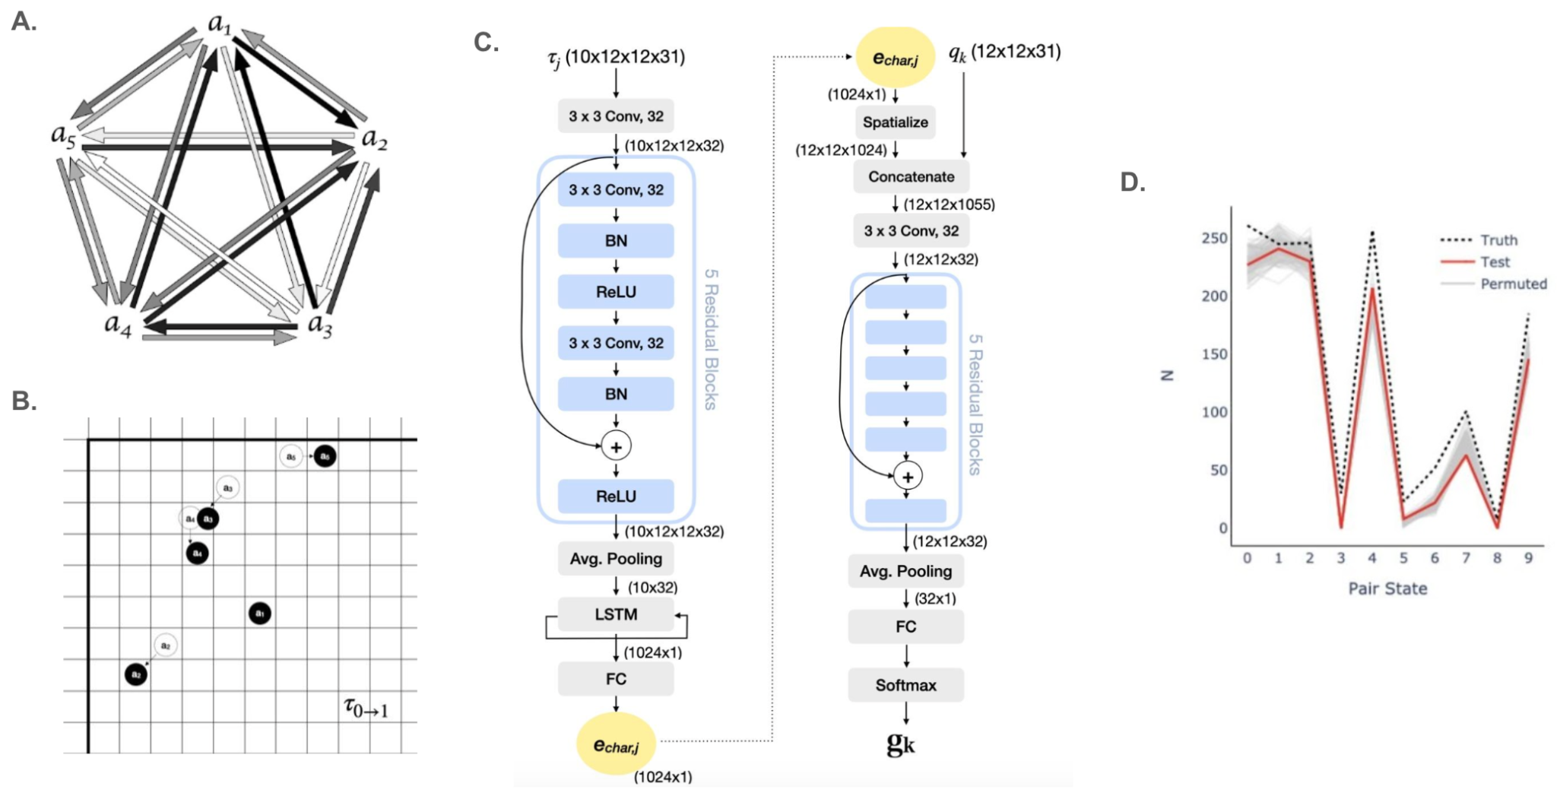
Fig. 1. A. A simulated 5-way social network. Intensity of arrows represent valences of the social associations between agents. B. Sample agent gridworld movements from a previous time point (unfilled circles) to the next time point (filled) based on the valences in the 5-way social network. C. ToMNet 2.0 architecture. Briefly, gridworld states are fed into a convolutional neural network and LSTM integrating over space and time to result in character embeddings. Character embeddings are then used to predict agent positions from novel query start states. D. Frequencies of various ToMNet 2.0 predicted (test) and actual (truth) states of agent settling positions (as 10-bit words).

(二) 實際場域驗證
（真實受試者之實驗設計、問卷結果等）

As previously reported, in an effort to validate ToMNet 2.0 using human social interaction data, we collected audiovisual recordings of 5 human participants interacting in a context of a multiplayer role playing game (Avalon; https://gitlab.com/brain-and-mind-lab/research-projects/tomnet/TOMAV; currently currently a private repository available on reasonable request; Fig. 2). These data afforded a means to evaluate if the ToMNet 2.0 framework can decode hidden game social motivations driving real-time human social behaviors towards each other as observed in their facial emotional expressions and speech valences. In this project year, analyses of the parsing of these human audiovisual data into a format suitable for entry into the ToMNet 2.0 framework is still ongoing. The key difficulties include the general lack of dynamism in normative human expressions and the lack of reliable target attribution indicators for a given expression (i.e., who a given expression is directed at). These inherent natures of the variances and complexities in human communication behavior require significant further examination before such audiovisual data can be effectively used to train artificial intelligence models for real life applications.

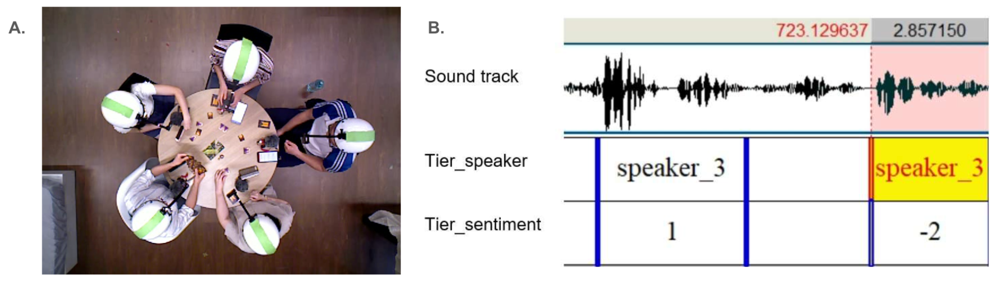
Fig. 2. A. Top-down view of 5 human participants playing a multiplayer role-playing game (Avalon) in which they have friend-foe associations with each other. Cameras mounted on helmets with directional bands provided information on facial expressions, eye gaze, head orientations, and speech, as participants interacted during the game. B. Sample sound track used to rate the valence or sentiment of a given participant during a time window.

(三) 可信任的AI
（模型是否有線索可幫助理解其決策過程與結果）

Critically, recent advances in machine ToM have raised the issue of how ToM might be evaluated appropriately in artificial intelligence. We propose that our work on ToMNet+ and ToMNet 2.0 might be a solution path in that we objectively define the capacity of ToM of any intelligent behavior as the degree to which the system’s predictions align with the hidden information structure. This provides a more quantifiable and scalable metric to evaluate machine ToM performance, as opposed to evaluation of more propositional errors as used in Strachan et al. (2024) to evaluate chatGPT. Further, we highlight that our ToMNet approach is configured so that the model predictions reflect hidden ground truths (which we design in the social networks) driving observations of agent interaction behavior. As such, this approach might reasonably be applied to use observations of object interactive phenomena to derive “ground truths” in physical causal mechanisms for which we are as yet unaware of.

We are currently considering recent compelling machine ToM capabilities exhibited by chatGPT 4.0 (Strachan et al., 2024), which is a large language model approach distinct from ToMNet’s architecture. Overall, our ongoing works are thus to continue to integrate ToMNet 2.0’s capability to work on real human audiovisual data, and to compare the performances of ToMNet vs. other machine ToM approaches such as evinced by chatGPT. One possible integration which we are considering is to train and use chatGPT (or other vision-capable LLMs) to parse and interpret the human audiovisual data for valences which can then be more easily transformed into a format that ToMNet 2.0 can operate on.

(四) 參考文獻
Chuang, Y.-S., Hung, H.-Y., Gamborino, E., Goh, J. O. S., Huang, T.-R., Chang, Y.-L., Yeh S.-L., Fu, L.-C. (2020). Using Machine Theory of Mind to Learn Agent Social Network Structures from Observed Interactive Behaviors with Targets. In the 29th IEEE International Conference on Robot and Human Interactive Communication (RO-MAN) (pp. 1013–1019). IEEE. https://doi.org/10.1109/RO-MAN47096.2020.9223453.
Lai, Y.-L. (2023). A Machine Theory of Mind for Processing Complex Social Networks (Master thesis). Graduate Institute of Brain and Mind Sciences, National Taiwan University.
Lai, Y.-L., Le, J., Chen, C.-Y., Chuang, Y.-S., Fu, L.-C., & Goh, J. O. S. (in prep.). A Machine Theory of Mind for Processing 5-way Social Networks.
Rabinowitz, N., Perbet, F., Song, F., Zhang, C., Eslami, S.M.A., Botvinick, M.. (2018). Machine Theory of Mind. Proceedings of the 35th International Conference on Machine Learning, in Proceedings of Machine Learning Research 80:4218-4227
Schaafsma, S. M., Pfaff, D. W., Spunt, R. P., & Adolphs, R. (2015). Deconstructing and reconstructing theory of mind. Trends in Cognitive Sciences, 19(2), 65–72. https://doi.org/10.1016/j.tics.2014.11.007
Schurz, M., Radua, J., Aichhorn, M., Richlan, F., & Perner, J. (2014). Fractionating theory of mind: A meta-analysis of functional brain imaging studies. Neuroscience and Biobehavioral Reviews, 42, 9–34. https://doi.org/10.1016/j.neubiorev.2014.01.009
Strachan, J. W. A., Albergo, D., Borghini, G., Pansardi, O., Scaliti, E., Gupta, S., … Becchio, C. (2024). Testing theory of mind in large language models and humans. Nature Human Behaviour. https://doi.org/10.1038/s41562-024-01882-z
Wang, Y., Zhong, F., Xu, J., & Wang, Y. (2021). ToM2C: Target-oriented Multi-agent Communication and Cooperation with Theory of Mind. ArXiv. https://doi.org/10.48550/arXiv.2111.09189
Wimmer, H., & Perner, J. (1983). Beliefs about beliefs: representation and constraining function of wrong beliefs in young children’s understanding of deception. Cognition, 13(1), 103–128. https://doi.org/10.1016/0010-0277(83)90004-5

執行率

(1) 學術成就(必要項目)
- 論文待完全; Lai et al. (in preparation). A Machine Theory of Mind for Processing 5-way Social Networks.

(2) 技術創新(必要項目)
- 無

(3) 經濟效益
- 無

(4) 社會影響
- 無

(5) 國際合作(必要項目)
- 無

(6) 人才培育(必要項目)
- 陳庭萱, 113/08/01~113/07/31
- 王力陞, 113/08/01~113/07/31

