|  |
| --- |
| kings college london |
| Database Systems |
| Coursework Part 1 : Design |
|  |
| **Joshua Harris 19008090** |
|  |

|  |
| --- |
|  |

# Database Systems Coursework part 1: Design

1.1)

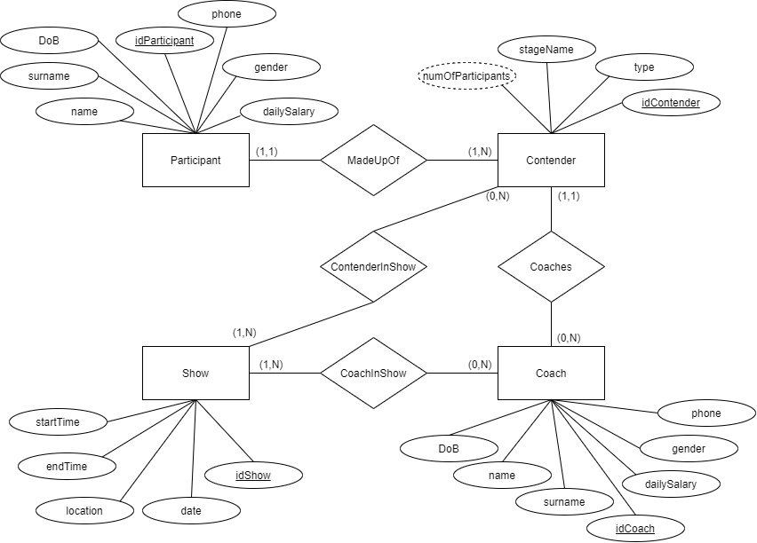Entity Relationship Diagram for TheVoiceLondon

1.2)

After designing the entity relationship diagram from the requirements and the relational schema, I decided on the following assumptions:

* A coach does not have to attend every show;
* A contender does not have to attend every show;
* Each show must have at least one contender taking part in the show;
* A participant can only be part of one contender, as a participant should not be able to be a part of two or more contenders;
* Each contender is coached by a single coach.

1.3)

Constraints:

Key: PK – Primary Key, FK – Foreign Key

Coach(name, surname, DoB, **idCoach(PK)**, phone, dailySalary, gender)

Contender(stageName, type, **idContender(PK)**, **coach(FK)**)

Participant(name, surname, DoB, **idParticipant(PK)**, phone, dailySalary, gender, **contender(FK)**)

TvShow(location, date, **idShow(PK)**, startTime, endTime)

CoachInShow(**coach(PK)(FK)**, **show(PK)(FK)**)

ContenderInShow(**contender(PK)(FK)**, **show(PK)(FK)**)

