20 Feb 2018



KAS ELECTRONIC LOCKING SYSTEM

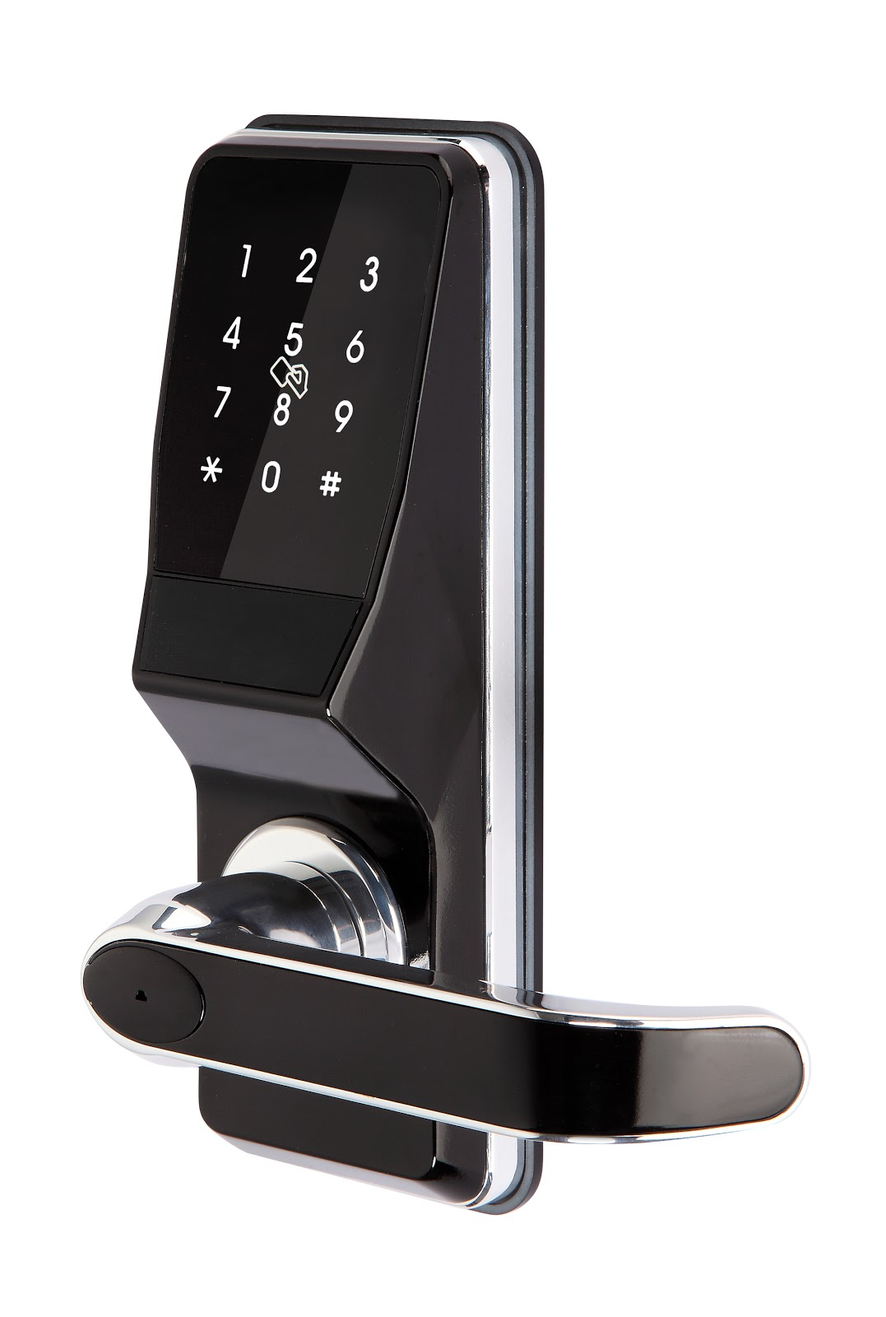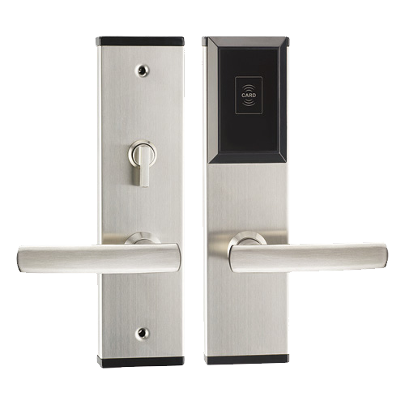

**NEO PLATINUM**

Bluetooth Lock System Theory

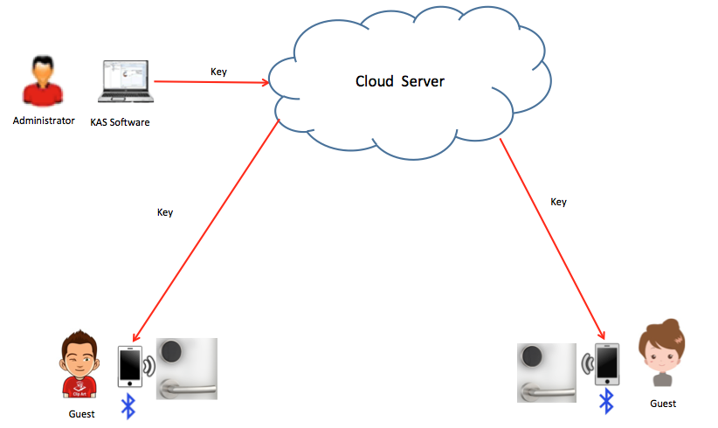

Features of KAS Bluetooth Lock System

* Send Bluetooth Key to client smartphone for room access
* Smartphone sends unique BLE packet to door lock for access
* Smartphone does not need to validate key time constraints (if bluetooth key is out of date, the door lock will not accept Bluetooth packet)
* Each time key is used to open the door, the server can store the unlocking record. Server and software could store persistent unlocking record of each user
* Lock Keeper app is the Bluetooth Management app which integrates with the KAS Lock System. This app is used to setup the Bluetooth interface and door locks with the locking software.
* Lock Keeper Smartphone app validates for internet access each time a key is used.
* If no internet access (or clients tries to disabled mobile data to open door) the app will allow access 1 time. Afterwards, access is restricted and requires internet network to open the door.  This is an advanced feature, in case client does not have internet, they can still obtain door access once. Afterwards, they must re-sync to the server to re-validate their key.
* Bluetooth Key SDK available. Third party must host their own server to store the keys and run their own local SQL server to run the locking software.
* Developers can use Lock Keeper app as a guide app during development

Product Information

Platinum - RFID + Bluetooth



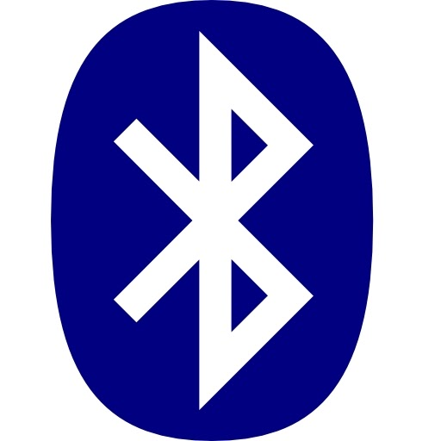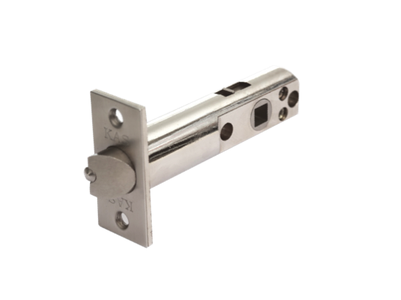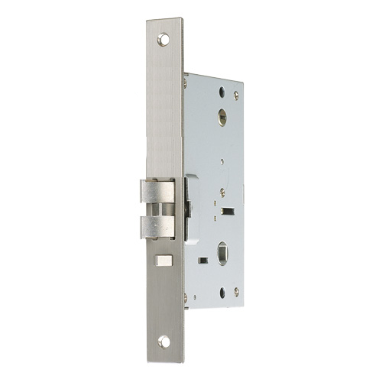

* 2 Opening methods:
  + RFID key card - issued by USB encoder from lock software
  + Bluetooth key - issued by lock software, client download Lock Keeper App to retrieve key details to open door
* Front and rear handle supplied per 1 door
* Latch supplied separately
* Powered by 3 x AA batteries
* Unlocking records; unlimited if using Bluetooth Key, 820 records using RFID key card by PDA
* Mechanical key - 2 per lock only used as emergency backup only

Neo-Blue - RFID + Bluetooth + Password

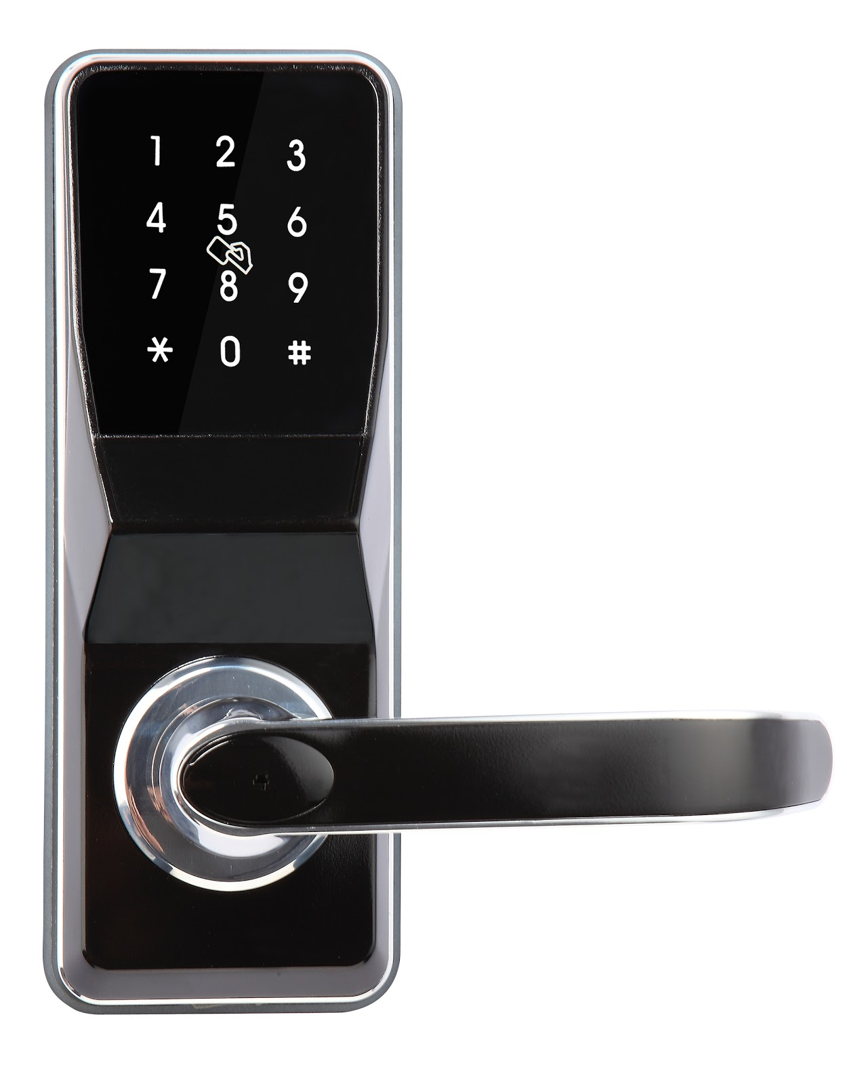



* 3 opening methods:
  + RFID key card - issued by USB encoder from lock software
  + Bluetooth key - issued by lock software, client download Lock Keeper App to retrieve key details to open door
  + Password - issued by lock software, one-time dynamic codes expire after check-out time (no SDK available for password yet - coming soon!)
* Front and rear handles supplied per 1 door
* Latch supplied separately
* Powered by 4 x AA batteries
* Unlocking records; unlimited if using Bluetooth Key, 820 records using RFID key card by PDA
* Reversible handle for easy onsite installation - HIGHLY RECOMMENDED
* Mechanical key - 2 per lock only used as emergency backup only

Bluetooth Wall Reader - RFID + BLE

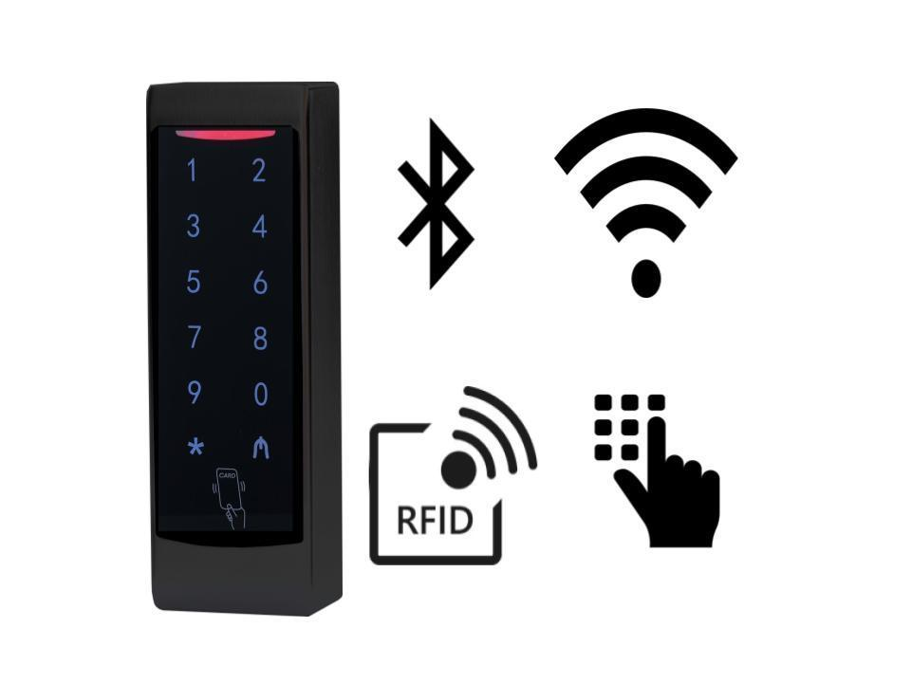

* 1 wall reader per 1 door
* Powered by 12V DC
* Unlocking records: unlimited if using Bluetooth Key
* Can assigned ‘auto opening times’. Free access during the day, bluetooth key or RFID key card after hours access for example.
* Glass doors/Swinging door may require electromagnetic lock or electric strike system
* Mechanical key - not applicable
* Bluetooth wall reader not available yet - coming soon

Electronic Lock Software

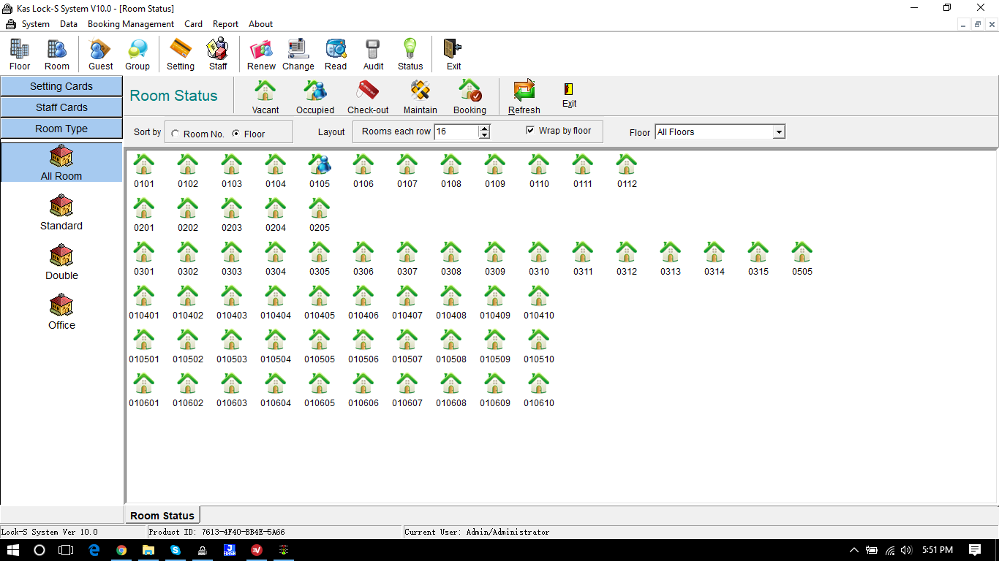

KAS Lock-S Software

* Software is setup with SQL server / Windows XP and above.
* Used to define the layout of door locks and program RFID key cards or issue BT keys
* Multi networking software client softwares can be linked with the SQL server
* This creates a centralised access system which can be controlled from different computers
* Software has powerful customer user roles and feature restrictions
* Up to 1 million rooms per software - in theory
* Up to 60 common wall readers
* No limit on RFID key cards or Bluetooth keys in theory. Note: this may differ during development
* Suitable for multiple keys for 1 room. I.e the same door can have many bluetooth keys with different time check-out constraints.
* USB encoder used to program RFID cards - optional for the guest or if they lose their mobile phone
* Integration and SDK available:
  + Opera/Fidelio Integration available
  + DLL interface for RFID card integration: C#, Delphi, PB, VB samples available
  + TCP/IP interface for bluetooth key creation from lock software
  + Bluetooth packet structure definition SDK available

Example User Stories

User opens door with app

* User receives bluetooth key by mobile app
* User approaches the broadcasting door lock (up to 5-15m range, depends on interference)
* Mobile app detects the Bluetooth door lock peripheral and displays UI button for action
* User taps UI button to ‘Unlock door’
* Bluetooth packet is sent to door lock
* Door lock responses with ACK packet
* Door lock opens

User misplaces mobile phone

* Lock software generates password
* Reception staff have to manually SMS or provide password string by TXT
* User receives welcome TXT with the password
* User walks to door lock
* After the check-out time, the 10 digit password is automatically invalidated.
* If user tries to enter same password, the door will NOT unlock.

User misplaces mobile phone

* Reception desk can issue RFID key card temporarily

Reception wants to block user

* Remove the Bluetooth Key from the hosted server
* The app UI will automatically remove the ability to discover BT device and send packet data which means mobile access is removed.

User needs to open room door and common door

* User receives **2 x bluetooth keys** by mobile app
* User approaches the broadcasting door lock **(or common door)**
* Mobile app detects the Bluetooth door lock peripheral and displays UI button for action
* User taps UI Button to ‘Unlock door’
* Bluetooth packet is sent to door lock
* Door lock responses with ACK packet
* Door lock opens