**Introduction**

The purpose of this document is to report on the results that I got from analyzing a supersonic airfoil. I focused on two theories to find the aerodynamic coefficients of the airfoil: thin airfoil theory and shock-expansion theory. I then compared the results between the two theories as well as discussed some of the differences between supersonic and subsonic thin airfoil theory.

**5.2 Supersonic Airfoils**

**Introduction**

P3U

P2U

The problem stated that the airfoil was diamond-shaped and had a maximum thickness-to-chord ratio of 5% with a freestream Mach number of $M_{∞}=2.0$ (see Fig. 1). This problem was split into four parts:

P1

P3L

P2L

1. Compare the lift coefficient, drag coefficient, and moment coefficient about the leading edge versus the angle of attack for both the thin airfoil theory and shock-expansion theory across a reasonable operating range.

Figure 1: Sketch of the diamond-shaped airfoil. Different sections of the airfoil are labeled.

1. Find the predicted lift curve slope of the supersonic airfoil and compare it to the subsonic thin airfoil theory.
2. Find the predicted aerodynamic center of the supersonic airfoil and compare it to the subsonic thin airfoil theory.
3. Discuss any differences between supersonic thin airfoil theory and shockwave theory.

The majority of the work consisted of finding the aerodynamic coefficients of the airfoil using the two different methods. I generated plots to show a comparison between these two theories. Parts b-c are answered in the Results and Discussion section of this report. The code used to find the aerodynamics coefficients and generate the plots are found in Appendix A.

**Methods**

I defined the range of angles of attacks to be from -2 degrees to 2 degrees. I first found the aerodynamic coefficients of the airfoil by using the supersonic Thin Airfoil Theory. To do this, I used the following process:

$$c_{n}=\frac{4α}{\sqrt{M_{∞}^{2}-1}}$$

$$c_{a}=\frac{4}{\sqrt{M_{∞}^{2}-1}}\left({\left(\overline{\frac{dy_{c}}{dx}}\right)}^{2}+{\left(\overline{\frac{dy_{t}}{dx}}\right)}^{2}\right)$$

$$c_{l}=c_{n}\cos{α}-c_{a}\sin{α}$$

$$c_{d}=c_{n}\sin{α}+c_{a}\cos{α}$$

where $y_{t}$ is the thickness of the airfoil.

$$y_{t}= ±x\tan{θ}$$

$${\left(\frac{\overline{dy_{t}}}{ⅆx}\right)}^{2}={\left(\frac{t}{c}\right)}^{2}$$

Since this airfoil is diamond-shaped, there is no camber. The moment coefficient about the leading edge can be found using

$$c_{mle}=-\frac{2}{\sqrt{M_{∞}^{2}-1}}\left[α+\frac{{\overline{y}}_{c}}{c}\right]$$

Then, I found the aerodynamic coefficients using the Shock-Expansion Theory. There were two main formulas that I used in order to find the pressure ratio at various angles of attack: oblique shocks and Prandtl-Meyer expansion fans. I used oblique shocks when the value of *θ* was positive and expansion fans when it was negative at the leading edge. Once I got to the middle of the airfoil, I only used expansion fans due to the geometry of the airfoil.

I used the *θ – β – M* relationship in order to find the wave angle, $β$.

$$\tan{θ= }\frac{2\cot{β}\left(M_{1}^{2}\sin^{2}β-1\right)}{M_{1}^{2}(γ+\cos{(2β))+2}}$$

where *θ* is the turn angle and $M_{1}$ is the freestream Mach number. Once I had the wave angle, I was able to solve for the pressure coefficients

$$M_{n_{1}}= M_{1}\sin{β}$$

$$M_{n_{2}}^{2}= \frac{1+ \frac{γ-1}{2} M_{n_{1}}^{2}}{γM_{n_{1}}^{2}- \frac{γ-1}{2}}$$

$$M_{2}= \frac{M_{n_{2}}}{sin⁡(β- θ)}$$

$$\frac{p_{2}}{p_{1}}=1+ \frac{2γ}{γ+1}(M_{n_{1}}^{2}-1)$$

where $γ=1.4$ (thermodynamic coefficient).

To find the pressure ratios when there is an expansion fan, I used the Prandtl-Meyer function:

$$ν\left(M\right)=\sqrt{\frac{γ+1}{γ-1}}\tan^{-1}{\sqrt{\frac{γ-1}{γ+1}\left(M^{2}-1\right)}}-\tan^{-1}{\sqrt{M^{2}-1}}$$

$$θ= ν\left(M_{2}\right)- ν\left(M_{1}\right)$$

$$\frac{p_{2}}{p_{1}}={\left(\frac{1+\left(\frac{γ-1}{2}\right)M_{1}^{2}}{1+\left(\frac{γ-1}{2}\right)M_{2}^{2}}\right)}^{\frac{γ}{γ-1}}$$

Once I calculated the pressure ratios, I was able to find the aerodynamic coefficients using the following equations (see Fig.1 to reference location of pressures):

$$c_{n}= \frac{1}{{γM}_{1}^{2}} \left(\frac{p_{2L}}{p_{1}}+ \frac{p_{3L}}{p_{1}}- \frac{p_{2U}}{p_{1}}- \frac{p_{3U}}{p_{1}}\right)$$

$$c_{a}= \frac{\left(\frac{t}{c}\right)}{{γM}_{1}^{2}} \left(\frac{p_{2U}}{p_{1}}- \frac{p_{3U}}{p_{1}}+ \frac{p_{2L}}{p_{1}}- \frac{p_{3L}}{p_{1}}\right)$$

$$c_{mle}= \frac{1}{{4γM}_{1}^{2}} \left(\frac{p_{2U}}{p_{1}}- \frac{p_{2L}}{p_{1}}+ 3\frac{p_{3U}}{p_{1}}- 3\frac{p_{3L}}{p_{1}}\right) + \frac{\left(\frac{t}{c}\right)}{{4γM}_{1}^{2}} \left(\frac{p_{2U}}{p_{1}}- \frac{p_{2L}}{p_{1}} - \frac{p_{3U}}{p_{1}}+ \frac{p_{3L}}{p_{1}}\right)$$

$$c_{l}=c_{n}\cos{α}-c_{a}\sin{α}$$

$$c_{d}=c_{n}\sin{α}+c_{a}\cos{α}$$

where $\frac{t}{c}=0.05$.

**Results and Discussion**

Figures 2, 3, and 4 show plots of moment coefficient, lift coefficient, and drag coefficient as a function of angle of attack respectively. It compares the two theories (supersonic thin airfoil theory and shock-expansion theory) that were mentioned before.

The predicted lift curve slope for the subsonic thin airfoil theory that we previously calculated was 2π; the Shock-Expansion Theory showed that it was about 2.32 and the supersonic thin airfoil theory was about 2.31 (see Fig. 3). This means that the lift for the supersonic airfoil does not change as much with respect to the angle of attack compared to the subsonic airfoil. Furthermore, the predicted aerodynamic center was found to be at the quarter chord using the subsonic thin airfoil theory. However, in the Shock-Expansion Theory, it is located at about 0.47 times the chord and is located at the half chord for supersonic thin airfoil theory. The aerodynamic center can be found using the following relationship:

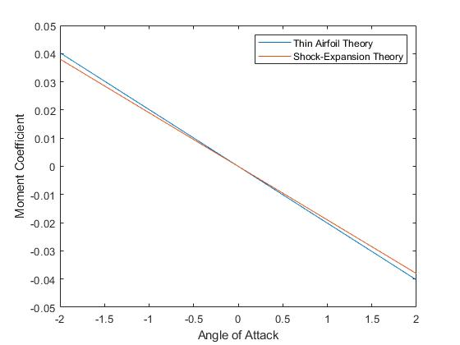

Figure 2: Moment coefficient vs. angle of attack.

$$x_{ac}= \frac{-dc_{mle}/dα}{{dc}_{l}/dα}$$

where ${dc}_{mle}/dα$ and ${dc}_{l}/dα$ are the slopes of the moment coefficient and lift coefficient respectively. (Note: I used the polyfit function in MATLAB to find the slopes for the lift coefficient and moment coefficient.)

As can be seen from these plots, the results for the two theories are very similar. In fact, the only plot where we see slight deviations is the moment coefficient. Unlike the thin airfoil theory, shock-expansion theory is more accurate because it doesn’t rely on the small disturbances assumption.

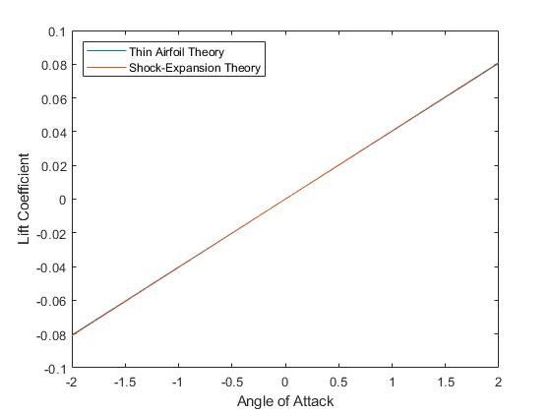

Figure 4: Lift coefficient vs. angle of attack.

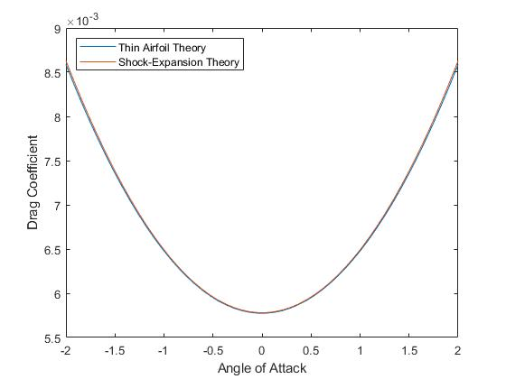

Figure 4: Drag coefficient vs. angle of attack.

**Appendix A**

Code for Supersonic Thin Airfoil Theory and Shock-Expansion Theory:

clc

clear all

N = 50;

t_c = 0.05;

alpha = linspace(-2, 2, N);

alpha = alpha .* (pi / 180); % radians

M_1 = 2.0;

theta_up = atan(t_c) - alpha; % radians

theta_low = atan(t_c) + alpha;

gamma = 1.4;

% supersonic thin airfoil theory

c_n_taf = 4 * alpha ./ (sqrt(M_1^2 - 1));

c_a_taf = (4 / (sqrt(M_1^2 - 1))) * (t_c)^2;

c_l_taf = c_n_taf;

c_d_taf = c_n_taf .* alpha + c_a_taf;

c_mle_taf = -2 .* alpha ./ (sqrt(M_1^2 - 1));

% shock-expansion theory

for R = 1:length(alpha)

% First shockwave

if theta_up(R) < 0 % Prandtl-Meyer

fun = @(x) f_fan(x, gamma, M_1, -theta_up(R));

x0 = [1 5];

M_2_up = fzero(fun, x0);

P2_P1_up(R) = ((1+((gamma-1)/2)*M_1^2) / ...

(1+((gamma-1)/2)*M_2_up^2))^(gamma/(gamma-1));

else % Shock-Exp

fun = @(x) f_shock(x, gamma, M_1, theta_up(R));

x0 = pi/4; % initial guess

beta_up = fzero(fun, x0); % radians

% upper surface

Mn_1_up = M_1 * sin(beta_up);

Mn_2_up = sqrt((1+((gamma-1)*Mn_1_up^2)/2) ./ ...

(gamma*Mn_1_up^2 - (gamma-1)/2));

M_2_up = Mn_2_up / sin(beta_up-theta_up(R));

P2_P1_up(R) = 1 + 2*gamma*(Mn_1_up^2 - 1) / (gamma+1);

end

fun = @(x) f_shock(x, gamma, M_1, theta_low(R));

x0 = pi/4; % initial guess

beta_low = fzero(fun, x0); % radians

% lower surface

Mn_1_low = M_1 * sin(beta_low);

Mn_2_low = sqrt((1+((gamma-1)*Mn_1_low^2)/2) ./ ...

(gamma*Mn_1_low.^2 - (gamma-1)/2));

M_2_low = Mn_2_low / sin(beta_low-theta_low(R));

P2_P1_low(R) = 1 + 2*gamma*(Mn_1_low^2 - 1) ./ (gamma+1);

% Second wave (Prandtl-Meyer: fan expansion)

theta = 2 * atan(t_c);

% upper surface

fun = @(x) f_fan(x, gamma, M_2_up, theta);

x0 = [1 5];

M_3_up = fzero(fun, x0);

P3_P2_up(R) = ((1+((gamma-1)/2)*M_2_up^2) / ...

(1+((gamma-1)/2)*M_3_up^2))^(gamma/(gamma-1));

% lower surface

fun = @(x) f_fan(x, gamma, M_2_low, theta);

x0 = [1 5];

M_3_low = fzero(fun, x0);

P3_P2_low(R) = ((1+((gamma-1)/2)*M_2_low^2) / ...

(1+((gamma-1)/2)*M_3_low^2))^(gamma/(gamma-1));

end

P3_P1_up = P3_P2_up .* P2_P1_up;

P3_P1_low = P3_P2_low .* P2_P1_low;

c_mle_shock = (1/(4*gamma*M_1^2)) .* (P2_P1_up - P2_P1_low + ...

3 .* P3_P1_up - 3 .* P3_P1_low) + (t_c^2/(4*gamma*M_1^2)) .* ...

(P2_P1_up - P2_P1_low - P3_P1_up + P3_P1_low);

c_n_shock = (1/(gamma*M_1^2)) .* (P2_P1_low + P3_P1_low - ...

P2_P1_up - P3_P1_up);

c_a_shock = (t_c/(gamma*M_1^2)) .* (P2_P1_up - P3_P1_up + ...

P2_P1_low - P3_P1_low);

c_l_shock = c_n_shock .* cos(alpha) - c_a_shock .* sin(alpha);

c_d_shock = c_n_shock .* sin(alpha) + c_a_shock .* cos(alpha);

figure(1)

plot(alpha .* (180/pi), c_mle_taf, alpha .* (180/pi), c_mle_shock)

legend("Thin Airfoil Theory", "Shock-Expansion Theory")

xlabel("Angle of Attack")

ylabel("Moment Coefficient")

figure(2)

plot(alpha .* (180/pi), c_l_taf, alpha .* (180/pi), c_l_shock)

legend("Thin Airfoil Theory", "Shock-Expansion Theory", "Location", "northwest")

xlabel("Angle of Attack")

ylabel("Lift Coefficient")

figure(3)

plot(alpha .* (180/pi), c_d_taf, alpha .* (180/pi), c_d_shock)

legend("Thin Airfoil Theory", "Shock-Expansion Theory", "Location", "northwest")

xlabel("Angle of Attack")

ylabel("Drag Coefficient")

function y = f_fan(x, gamma, M, theta)

nu_M = sqrt((gamma+1)/(gamma-1)) * ...

atan(sqrt((gamma-1)*(M^2-1)/(gamma+1))) - ...

atan(sqrt(M^2-1));

y = sqrt((gamma+1)/(gamma-1)) * ...

atan(sqrt((gamma-1)*(x^2-1)/(gamma+1))) - ...

atan(sqrt(x^2-1)) - nu_M - theta;

end

function y = f_shock(x, gamma, M, theta)

y = (2*cot(x)*(M^2*(sin(x))^2 - 1)) / ...

(M^2 * (gamma+cos(2*x)) + 2) - ...

tan(theta); % function

end