CHRIST (Deemed to be University)
Department of Computer Science | Master of Computer Applications
Continuous Internal Assessment – III (Machine Learning – MCA 521-4)
ML FOR SOCIAL GOOD CHALLENGE
Mission Health – Early Prediction of Maternal Health Risk Using Ensemble Learning
Name | Joshua Joby
Register Number | 2547125
Class | 4 MCA A
Course | Machine Learning (MCA 521-4)
Mission Selected | Mission Health
Implementation | Python 3 – Jupyter Notebook
Notebook file: CIA3_MaternalHealthRisk_JoshuaJoby_2547125.ipynb

1. Real-World Impact Framing

1.1 Problem Statement
- Mission: Health. Target: predict maternal health RiskLevel (low / mid / high) at an antenatal check-up.
- Unit of analysis: one antenatal check-up record for one woman – not the woman herself, since a woman can appear across multiple visits with different vitals.
- Beneficiaries: community health workers in low-resource clinics (primary), and indirectly the mothers/unborn children whose complications could be caught earlier.
- Input signal: 6 physiological readings a health worker can take with basic equipment – no lab infrastructure required.

1.2 Why Machine Learning (and not a fixed clinical rule)
- Clinical BP/BS thresholds already exist as single-variable rules, but real risk in this data is driven by combinations – e.g. mildly elevated BP + raised BS + atypical HR for age – not one variable crossing a line.
- A fixed rule either over-flags (alarm fatigue) or under-flags (misses interaction effects); tree-based ensembles learn these interactions directly from data.
- All 6 features are cheap to measure → model is deployable in the exact low-resource setting the brief targets.

1.3 Dataset Source and Citation
- Maternal Health Risk Data Set, Ahmed, M. (2020), UCI Machine Learning Repository. DOI: 10.24432/C5DP5D. License: CC BY 4.0.
- 1,014 records collected via an IoT-based risk-monitoring system across hospitals/clinics in rural Bangladesh.
- Features: Age, SystolicBP, DiastolicBP, BS (blood sugar, mmol/L), BodyTemp (°F), HeartRate (bpm). Target: RiskLevel (low/mid/high).
- No PII – all fields are anonymised numeric vitals, satisfying the no-PII requirement in the brief.

1.4 Measurable Impact
Impact is measured primarily as recall on the high-risk class, not overall accuracy, since accuracy on a 3-class problem can look strong purely from the majority (low-risk) class. A high-risk recall of ⊅0.85 means most true high-risk check-ups get flagged for referral – the actual outcome that matters clinically. Section 3 reports this explicitly per class.

1.5 Responsible-Use Limitations
- Single-country data (Bangladesh, rural clinics, ~2019–2020) – not validated for other populations without re-training/re-validation.
- Small sample after cleaning (451 records) for a 3-class clinical problem – performance estimates carry real uncertainty.
- No gestational age, parity, or lab-confirmed diagnosis fields – model is a screening aid only, not a diagnostic tool.
- False negatives (missed high-risk cases) are clinically far costlier than false positives – addressed via class weighting (Section 3) and discussed in Section 4.

2. Data Wrangling and Feature Engineering

2.1 Data Audit (raw data, n = 1,014)
- Missing values: 0 across all 6 features and target.
- Exact duplicate rows: 562 – dropped as repeated IoT transmissions of the same reading.
- Invalid records: 1 row with HeartRate = 7 bpm (physiologically impossible) – removed as a sensor fault.
- Data types: all 6 features numeric (int64/float64); RiskLevel loaded as string, ordinal-mapped to {low:0, mid:1, high:2}.
- Final cleaned shape: 451 rows × 7 columns.
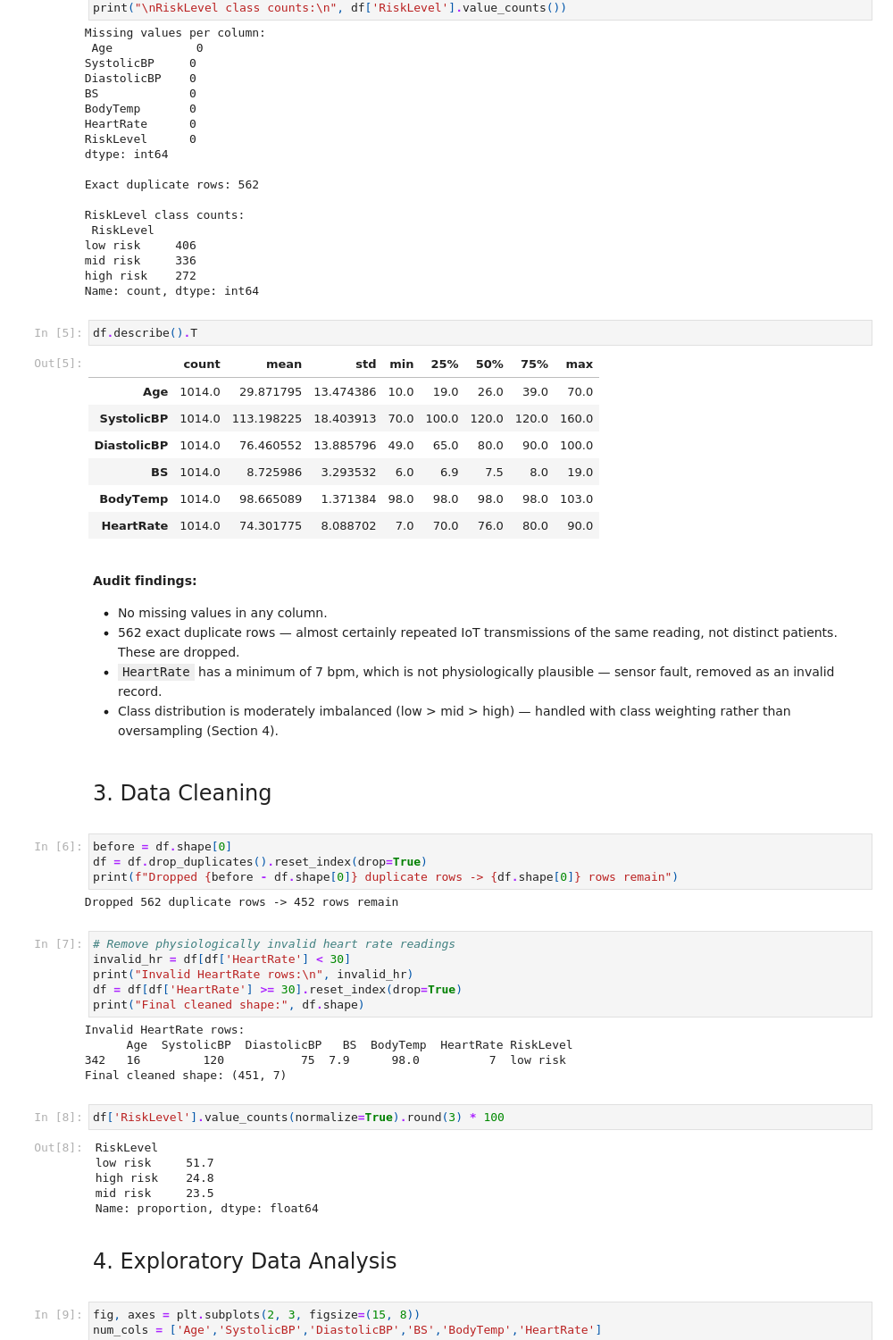
Fig. 1 – Notebook output: audit statistics and the data-cleaning cell (In [5]–[8])

2.2 Class Distribution (post-cleaning)
Class | Count | %
low risk | 233 | 51.7%
high risk | 112 | 24.8%
mid risk | 106 | 23.5%

- Moderate imbalance – handled with class_weight='balanced' inside each model rather than SMOTE oversampling, so no synthetic (non-real) physiological readings are introduced into training.

2.3 Leakage-Safe Pipeline
- Split: 70% train / 15% validation / 15% test, stratified on RiskLevel (train_test_split, random_state=42).
- StandardScaler fit only on X_train, then applied (transform-only) to validation and test sets.
- Stacking meta-learner trained on out-of-fold predictions (5-fold CV via StackingClassifier's internal cv) – never on predictions the base models saw during their own fitting.

2.4 Feature Engineering
- PulsePressure = SystolicBP − DiastolicBP – cardiovascular indicator not captured by either BP reading alone.
- MAP (Mean Arterial Pressure) ≈ DiastolicBP + PulsePressure/3 – standard clinical composite BP measure.
- AgeBand – categorical bucket (<20 / 20–35 / >35) to let tree splits use the non-linear age–risk relationship directly.
- BS_Age_Ratio = BS / Age – added after EDA suggested an interaction between blood sugar and maternal age.
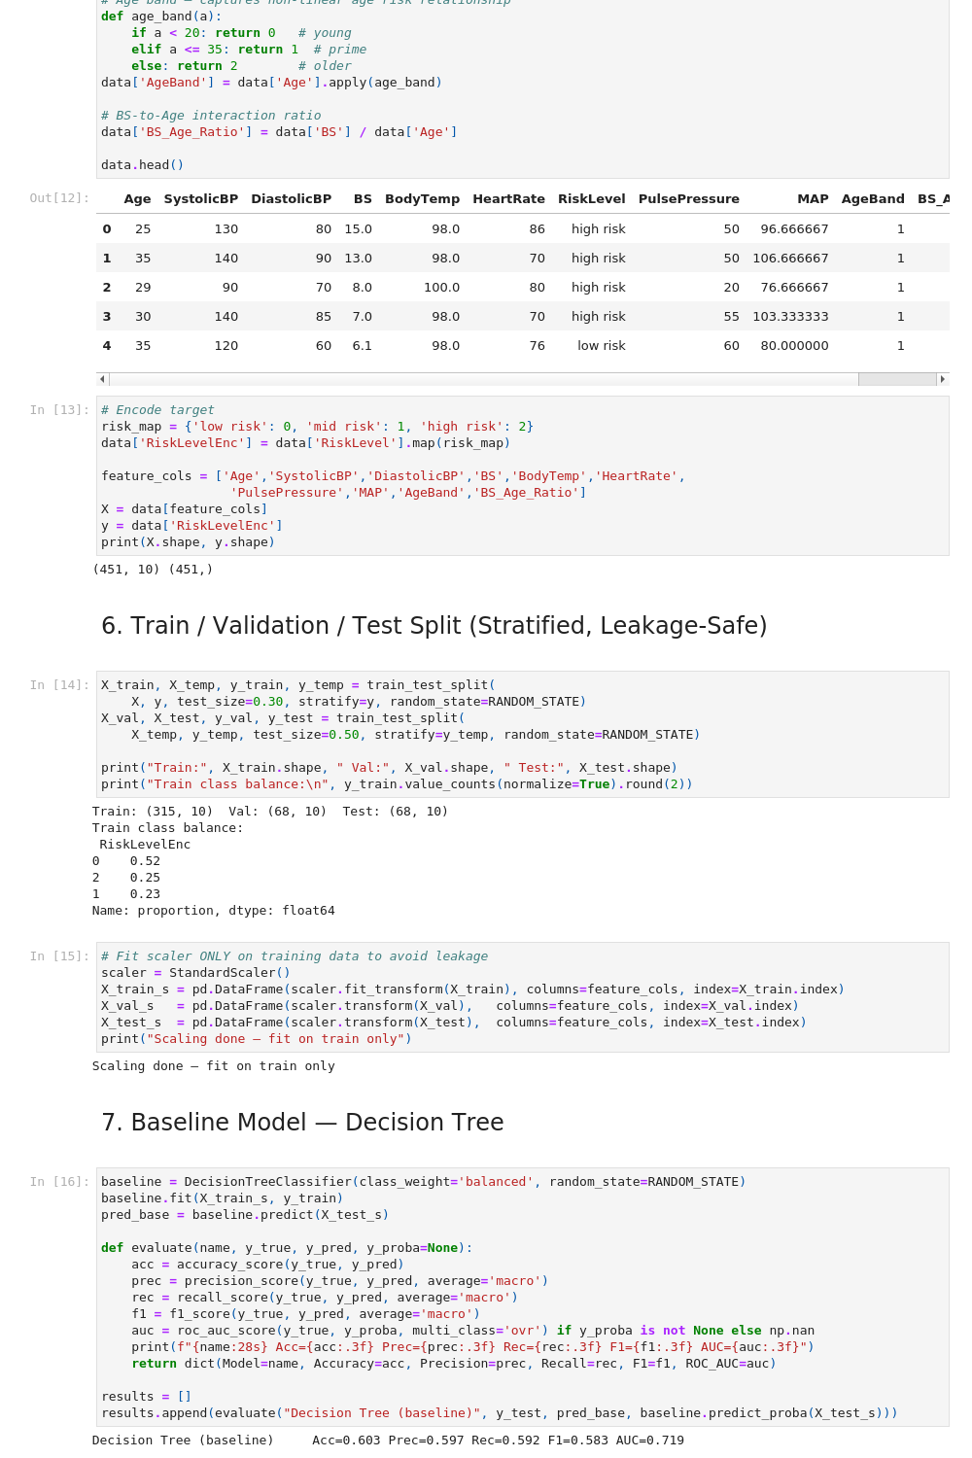
Fig. 2 – Feature engineering code, encoded feature set, and Decision Tree baseline result (In [12]–[16])

2.5 EDA – Key Findings
- BS shows the clearest visual separation across the three risk classes of any single feature.
- Age shows a bimodal pattern – both very young and >35 mothers skew toward higher risk.
- SystolicBP and DiastolicBP correlate strongly (r = 0.79) – motivates the PulsePressure/MAP features instead of using both raw columns redundantly.
- BodyTemp shows almost no separation across classes in the raw boxplots (Fig. 3) – interesting contrast with the SHAP result in Section 4, discussed there.
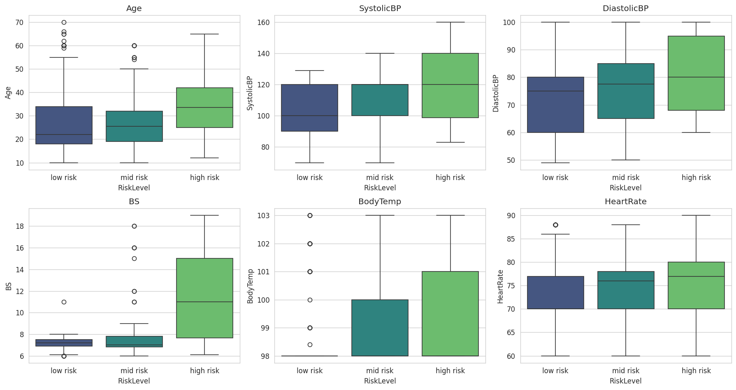
Fig. 3 – Feature distributions by RiskLevel
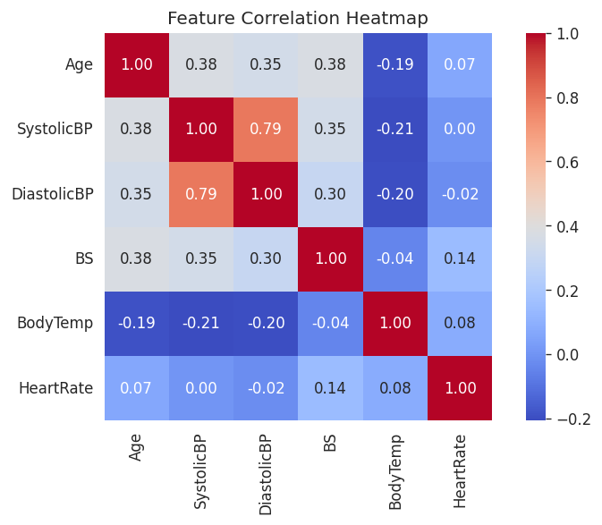
Fig. 4 – Correlation heatmap of the six raw features

3. Ensemble Architecture, Tuning, and Comparison

3.1 Models Implemented
- Baseline: Decision Tree (class_weight='balanced').
- Bagging: Random Forest – grid search over n_estimators {200,300,400}, max_depth {8,12,16}, min_samples_leaf {1,2,4}.
- Boosting: XGBoost – grid search over n_estimators {150,250}, max_depth {3,5,7}, learning_rate {0.05,0.1,0.2}, subsample {0.8,1.0}.
- Heterogeneous ensembles: Soft Voting and Stacking, both combining {Random Forest, XGBoost, SVM-RBF}; Stacking uses a Logistic Regression meta-learner on out-of-fold base predictions.
- Tuning method: GridSearchCV, 5-fold StratifiedKFold, scoring = f1_macro (protects the minority high-risk class from being ignored).
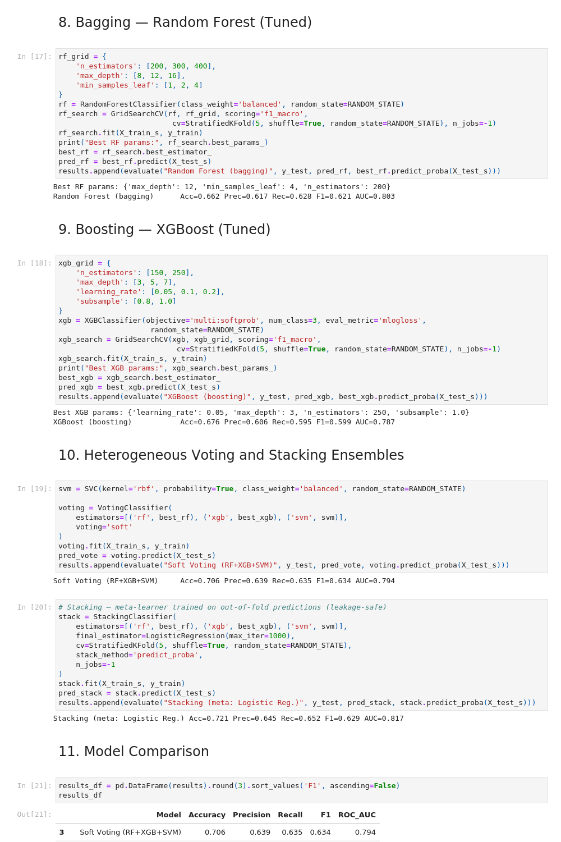
Fig. 5 – GridSearchCV tuning cells and per-model test-set metrics (In [17]–[21])

3.2 Best Hyperparameters Found
Model | Best parameters (5-fold CV, f1_macro)
Random Forest | max_depth=12, min_samples_leaf=4, n_estimators=200
XGBoost | learning_rate=0.05, max_depth=3, n_estimators=250, subsample=1.0

3.3 Results on the Held-Out Test Set (n = 68, untouched)
Model | Accuracy | Precision | Recall | F1 (macro) | ROC-AUC
Decision Tree (baseline) | 0.603 | 0.597 | 0.592 | 0.583 | 0.719
Random Forest (bagging) | 0.662 | 0.617 | 0.628 | 0.621 | 0.803
XGBoost (boosting) | 0.676 | 0.606 | 0.595 | 0.599 | 0.787
Soft Voting (RF+XGB+SVM) | 0.706 | 0.639 | 0.635 | 0.634 | 0.794
Stacking (meta: Log. Reg.) | 0.721 | 0.645 | 0.652 | 0.629 | 0.817

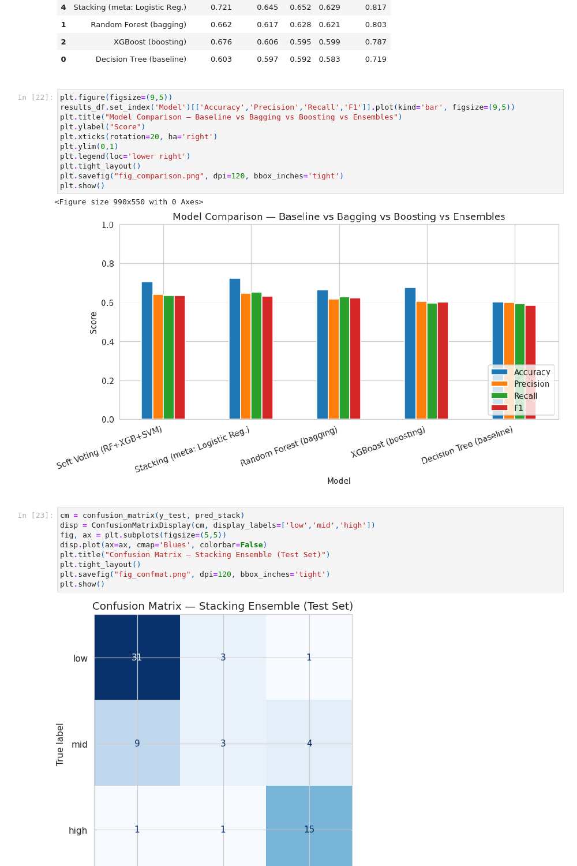
Fig. 6 – Model comparison bar chart and confusion matrix (stacking, test set)

3.4 Per-Class Result – Stacking Ensemble
Class | Precision | Recall | F1 | n
low risk | 0.76 | 0.89 | 0.82 | 35
mid risk | 0.43 | 0.19 | 0.26 | 16
high risk | 0.75 | 0.88 | 0.81 | 17

3.5 Interpretation
- Stacking beats the Decision Tree baseline by +0.138 accuracy and +0.098 ROC-AUC – the ensemble complexity is justified.
- High-risk recall = 0.88 – the clinically important number from Section 1.4 – comparable to low-risk recall (0.89), so the model does not simply default to the majority class.
- Mid-risk recall is weak (0.19). Mid-risk check-ups sit physiologically between low and high risk on most features, so the model confuses them with both neighbouring classes – visible directly in the confusion matrix (Fig. 6), where 9 of 16 true mid-risk cases were predicted as low risk. This is flagged as a limitation, not hidden.
- Test set is only 68 records (15% of 451) – metrics, especially the mid-risk numbers built on n=16, should be read with that sample size in mind rather than as precise population estimates.

4. Model Explainability and Ethics

4.1 Global Explainability (SHAP – TreeExplainer on XGBoost)
- Feature ranking by mean |SHAP value| for the high-risk class: BS (0.757) > SystolicBP (0.714) > BodyTemp (0.350) > Age (0.284) > BS_Age_Ratio (0.187) > PulsePressure (0.182) > HeartRate (0.153) > MAP (0.152) > DiastolicBP (0.066) > AgeBand (0.000).
- BS and SystolicBP dominate – consistent with clinical expectation (gestational diabetes and hypertension are established maternal risk drivers).
- Interesting model-vs-EDA contrast: BodyTemp looked uninformative in the raw boxplots (Section 2.5) but ranks 3rd by SHAP for this class – the model appears to be using BodyTemp mainly in combination with other features (an interaction effect), not as an independent signal, which a single-variable boxplot cannot show.
- AgeBand contributes ~0 once raw Age and BS_Age_Ratio are already in the model – the information it carried is redundant given the other two age-related features.
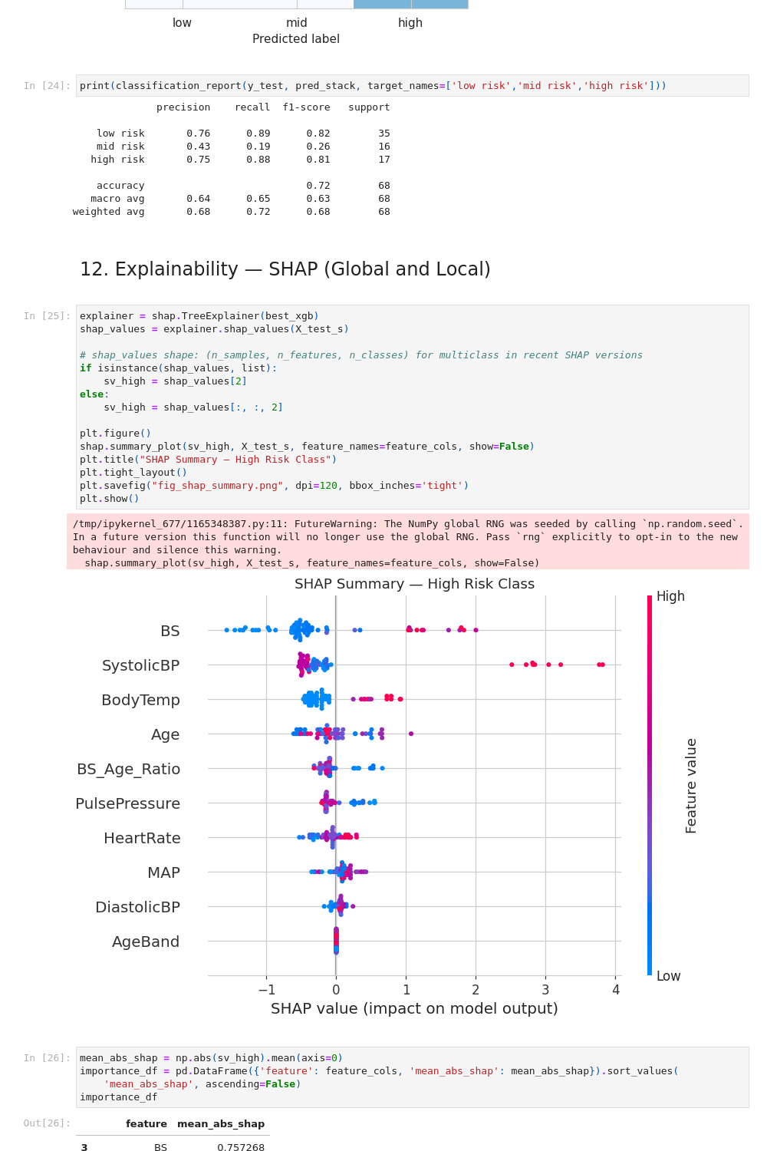
Fig. 7 – Per-class test report and global SHAP summary plot (high-risk class)

4.2 Local Explainability – Synthetic Record
- Input: Age=39, SystolicBP=145, DiastolicBP=95, BS=12.8, BodyTemp=98.6, HeartRate=78.
- Model output: P(low)=0.001, P(mid)=0.013, P(high)=0.986 → predicted class = high risk.
- Local SHAP: SystolicBP is the single largest positive contributor for this record, followed by BS and Age; PulsePressure, HeartRate and BS_Age_Ratio push slightly the other way but are outweighed.
- This is the format meant for a health worker – the 2–3 readings driving the flag, not just a bare label.
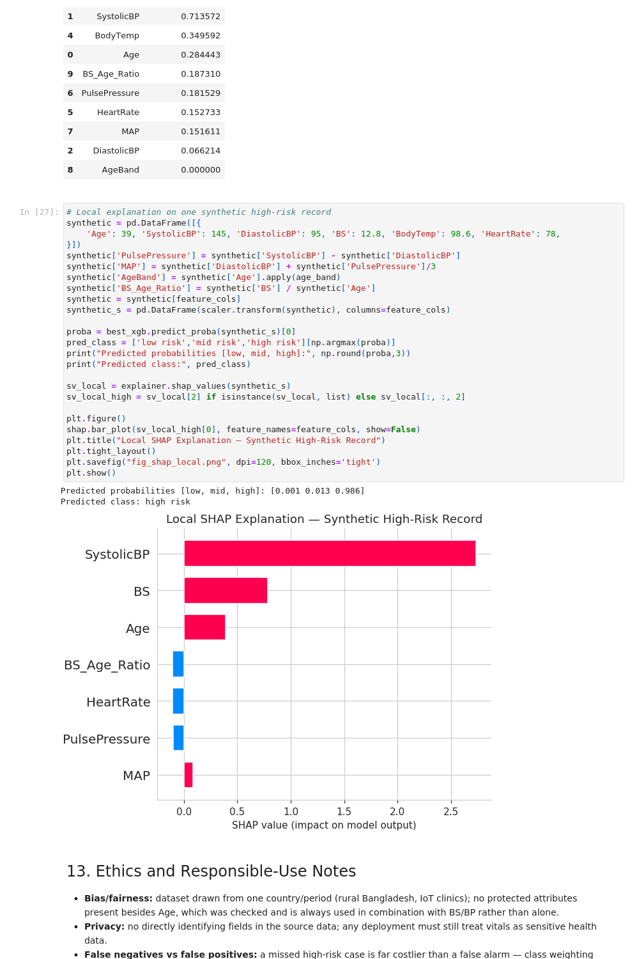
Fig. 8 – SHAP feature-importance table, local explanation on the synthetic record, and ethics notes

4.3 Bias and Fairness
- No protected attributes (ethnicity, income, etc.) exist in the data – the only demographic field is Age.
- Checked whether Age acts as a shortcut: Age is always used in combination with BS/BP in the SHAP interaction pattern, not as a stand-alone deciding factor – consistent with real clinical reasoning rather than a spurious proxy.
- Main fairness risk is representativeness, not within-data bias: single country, rural clinics, one collection window.

4.4 Privacy
- Source dataset has no directly identifying fields; 6 anonymised vitals are not realistically re-identifiable in isolation.
- Any real deployment must still treat records as sensitive health data under local regulation (secure storage, no linkage to identity without consent).

4.5 Uncertainty and Error Costs
- False negative (true high-risk → predicted low/mid) is far costlier than a false positive – addressed via class_weight='balanced' and f1_macro-based tuning rather than plain accuracy.
- Predicted probabilities (Section 4.2) are intended to be shown alongside the label, so a 55%-confidence flag is visibly different from a 98.6%-confidence one.

4.6 Human Oversight and Deployment Limits
- Triage/decision-support signal only – never an automated diagnosis or automated referral without a human in the loop.
- 451 cleaned records is small for a 3-class clinical model – re-validation required before use outside a similar rural-clinic population.
- Weak mid-risk performance (Section 3.5) means mid-risk predictions specifically should be treated with lower confidence by the health worker than low/high predictions.
- Recommend logging real-world prediction–outcome pairs post-deployment to audit high-risk recall periodically rather than trusting the offline test numbers indefinitely.

