**YOLO Set-up Instructions**

**1. Requirements**

* System Requirements
  + Windows 10
  + Nvidia GPU GTX 1050 or better
* Download and install the following
  + Anaconda – Python 3.6 or greater
  + <https://github.com/reigngt09/yolov3workflow>
  + <https://github.com/ayooshkathuria/pytorch-yolo-v3>
  + **Get the weights:**
    - **wget https://pjreddie.com/media/files/****yolov3.weights**
  + CUDA Toolkit – V9.0
    - <https://developer.nvidia.com/cuda-90-download-archive>
    - OR in Anaconda Prompt call the command
      * **conda install -c anaconda cudatoolkit**
  + CuDNN – V 7.05
    - <https://developer.nvidia.com/rdp/cudnn-archive>
    - OR in Anaconda Prompt call the command
      * **conda install -c anaconda cudnn**

**2. Set-up**

* After downloading everything on the requirements, you must access the yolov3workflow folder and navigate to the following:
  + C:\**yolov3workflow\2_YoloV3_Execute\**
    - In this directory you should see **yolo.yml** copy that file and navigate to **C:\**
    - **In C:\** , make a **directory** call it **yolo** (for conventions) and **paste in yolo.yml** in the **yolo** directory
    - Once all of that is done you should the following
      * **Open Anaconda prompt and Navigate to “C:\yolo”**
      * **In “C:\yolo”**
        + **Run** the following command:

**conda env create -f yolo.yml**

* + - **Once all is done correctly you’re pretty much good on this part**
* **To set up cuda and cudnn do the following**
  + In **cudnn-8.0-windows10-x64-v7** you should see the following
    - A directory called **“cuda”**
  + **Take** the **directory “cuda”** and **copy and paste it to “C:\”**
  + Once that is done do the following
    - **Open Control panel** and **Navigate to this:**
      * Control Panel 🡪System and Security 🡪System
    - **In System** **click** **Advance system settings and click Environment Variables** on the left panel **and add the following**:

**ADD the following directories “cuda”, “cuda/lib”, and “cuda/bin”** **in the “Path” environment variable**

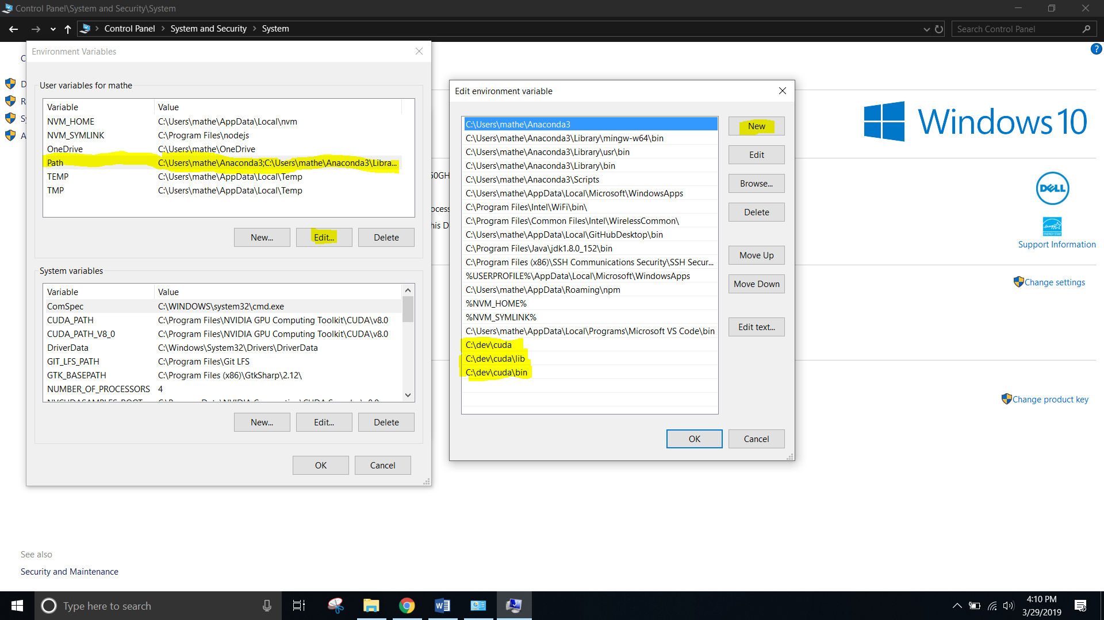

**NOTE: ADD the following directories “cuda” “cuda/lib” and “cuda/bin”** **in the “Path” environment variable**

* + **ONCE this is all done correctly, you’re pretty much good on this part**
* **To set up the “pytorch-yolo-v3” folder** 
  + You first take the **“yolov3.weights”** file and move it into **“pytorch-yolo-v3” folder**
  + Then you **move** the **“pytorch-yolo-v3” folder** to **“C:\yolo\” folder**
  + **ONCE this is all done correctly, you’re pretty much set up and ready YOLO it 😊**

**3. Let’s get wanging**

**BEFORE YOU START: replace the “cam_demo.py” with the one I gave you**

* **Open Anaconda Prompt**
* **Navigate to “C:\yolo\ pytorch-yolo-v3”**
* **Activate yolov3** by doing the **command** 
  + **conda activate yolov3**
* **And once everything is good you can do the following in Anaconda prompt** 
  + **python video_demo --[Insert video here]**
  + **python cam_demo.py**