# Comparison of stream morphological metrics that may be influenced by elevated water yield in reference and managed catchments in Western Montana and Northern Idaho.

Craig N Kendall[1], Joshua L Erickson[2], James A (Andy) Efta[3], Eric Archer[4]

## Introduction:

The history of research on forest management and water yield is extensive, beginning with the Wagon Wheel Gap paired watershed experiment in 1910 (Bates and Henry 1928). Numerous experiments have documented the effects of forest canopy removal on water yield and peak flows in the Pacific Northwest (e.g. Tonina et al 2008, Hubbart et al. 2007, Kuras et al. 2012, Beschta et al. 2000, Jones and Grant 1996, Thomas and Megahan 1998). Historically, increase in water yield and/or peak flows was a fundamental assertion associated with forest canopy removal (Hibbert 1967, Bosch and Hewlett 1982, Troendle and King 1985). More recently, studies and reviews have debunked this assertion with documentation of water yield reductions, increases, and no change following forest harvest and/or disturbance (e.g. Goeking and Tarboton 2020). Primary implicated processes include changes in evapotranspirative demand and snowpack redistribution.

Few have focused on indirect channel response from changes in water yield and/or peak flows associated with forest harvest. Grant et al. (2008) conducted a comprehensive literature review and determined no field studies have made a direct link between peak flow increases and channel response. Schnakenberg and MacDonald (1998) found no correlation between equivalent clearcut area (ECA) and stream channel characteristics in forested catchments in Colorado. MacDonald et al. (1995) studied the relationship between model-predicted water yield/peak flow increases and channel characteristics on the Kootenai National Forest in northwest Montana. None of the channel types (pool riffle or colluvial step-pool) showed any increase in bankfull width or width/depth ratio with more intensive management. In addition, there was no apparent correlation between the amount of timber harvest and the magnitude of peak flows, and climatic differences are the dominant control on the size of peak flows in the study area (MacDonald et al. 1995). Tonina et al. (2008) used hydrologic models and sediment transport equations to estimate how increased magnitude and frequency of low to moderate peak flow events combined with the alteration of timing of these events may cause scour of bull trout spawning sites in Idaho. While this study was not supported by pre-treatment and post-treatment measurements of channel morphology and spawning gravels, it demonstrates (conceptually) that a cause-and-effect relationship may exist.

Grant et al. (2008) concluded that the effects of peak flow increases are relatively minor in comparison to other anthropogenic changes to streams and watersheds. In general, channel impacts associated with peak flow increases alone are likely to be much less significant than other impacts associated with forest management activities. In addition, management-induced increases in peak flow diminish with the percentage of watershed affected and increasing recurrence interval of storms. Management influence on peaks over a 6-year recurrence interval is highly speculative (Grant et al. 2008). However, peak flow changes and associated effects are more likely to be measurable in smaller catchment sizes (Hubbart et al. 2007). It is important to note that Grant’s conclusions are based on numerous experiments in rain-dominated and transient systems in the Cascades. Snow-dominated systems are likely more sensitive to water yield increases because of canopy interception of snow (MacDonald and Hoffman 1995).

US Forest Service hydrologists in the Northern Region have been using water balance models for decades to determine how timber harvest may increase water yield and peak flows. Analysis of potential water quantity change following forest harvest remains a near-ubiquitous issue evaluated for regulatory compliance in environmental effects analysis documents required by the National Environmental Policy Act and other authorities such as the Clean Water Act. In general, analyses focus on the indirect water quality implications associated with water quantity changes, namely channel destabilization and the potential for water quality impairment associated with these changes. These analyses are based on the potential for potential changes (per Tonina 2008, as noted above) and past anecdotal evidence of channel destabilization following harvest, not peer-reviewed documentation of these occurrences. Of note is that this anecdotal evidence largely originated from past decades where forest harvest levels were much greater than those currently undertaken in north Idaho and western Montana on NFS lands.

New management direction for the Forest Service’s Northern Region directing an increase in harvest volume (and likely acreage) over the next ten years, interest from forest units in pursuing larger clearcut openings in the name of forest restoration, and public attention within project objections have all brought this issue back into clear relief. Understanding the relationship between channel morphology and forest management has direct implications for the Forest Service’s vegetation management program of work. To that end, this project sought to validate whether there is direct link between management-induced hydrologic changes and stream channel morphology. More specifically, the objective of this analysis is to determine if channel geometry (bankfull width, bankfull width/depth, bank stability, and/or bank angle) are affected by forest management (primarily roads and timber harvest).

## Materials and Methods

### Study area and management history

Sample sites are located west of the Continental Divide within the Bitterroot, Flathead, Lolo, and Kootenai National Forests in Montana, and the Idaho Panhandle and Nez Perce-Clearwater National Forests in Idaho (Figure 1). Forests within this study area span from the Canadian border to the north to the Salmon River basin divide to the south, to the Palouse prairie on the west edge and, as noted above the Continental Divide to the east. The study domain spans Five Level IV Ecoregions (i.e. Ecological Sections) (EPA 2013): Bitterroot Mountains, Flathead Valley, Idaho Batholith, Northern Rockies, and Okanogan Highland. Drainage patterns are relicts of eroded glacial (glacial drift, moraines, till, etc.), fluvialglacial (spillover, braided rivers, deltas, etc.), volcanics (ash material, breccia, etc) and residual bedrock landtypes that were shaped through time by several glacial advances, alpine glaciation and structural processes (e.g. faulting, thrusting, etc.).

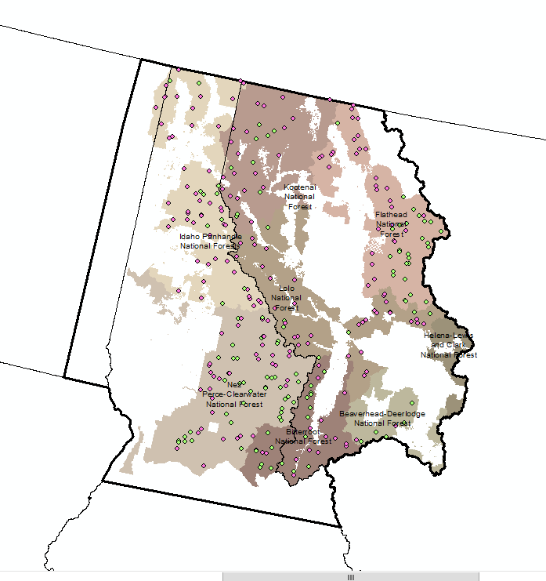

Figure 1. Study area.

The climate in the study area is considered inland maritime and generally snow-dominated. Average annual precipitation varies significantly depending on which part of the sample domain you are in. In short, the areas range from 580 and 2,125 (mm) annually (Daly 1997). While minor peak flows resulting from snowmelt are common around all of the domain, short duration high intensity precipitation events (e.g. rain on snow) can produce substantial peak flow events in subwatersheds (e.g., Hydrological Unit Codes 12 & 14).

The managed catchments in the sample domain have histories of road construction, timber harvest, and mining that began in the early twentieth century. Reference sites in the sample domain have little to no recent history of timber harvest, road construction, or mining in their catchments. Harvest levels have declined since the 1970s, and this trend is reflected in the amount of harvest that has occurred in the managed catchments within our sample (Table 2). Of the 189 managed catchments, one has high intensity harvest that covers more than 36% of its catchment area, and 16 catchments have greater than 20% high intensity harvest. For total harvest (high and intermediate) in the last 30 years, 21 catchments have greater than 30%, and 45 have greater than 20%. The average percent catchment area for high and intermediate harvest is 5.8 and 6.0 percent, respectively. For road density, ten (5%) of them have road densities greater than 3 km/km2 (4.8 mi/mi2) and 40 (21%) have greater than 2 km/km2 (3.2 mi/mi2).

To facilitate more efficient analysis, harvested area was binned into three “harvest impact” categories based on area harvested under high to moderate intensity silvicultural prescriptions (outlined at XX location): low (less than five percent catchment area), moderate (5-18 percent catchment area) and high (greater than 18 percent catchment area).

**Table 2. Potential covariates and dependent variables for reference and managed sites, and their associated summary statistics.**

|  |  |  |  |  |
| --- | --- | --- | --- | --- |
| **Geoclimatic Variables** | **Reference (n=116)** | | **Managed (n=189)** | |
|  | **Mean** | **SD** | **Mean** | **SD** |
| Catchment Area (km2)* | 38.7 | 27.2 | 36.0 | 29.6 |
| Mean Annual Precipitation (mm)* | 1,277 | 249 | 1,141 | 271 |
| Mean Annual Climatic Deficit (mm) | 327 | 58 | 330 | 76 |
| Mean Basin Elevation (m) | 1,844 | 300 | 1,570 | 299 |
| Drainage Density (km/km2) | 1.2 | 0.4 | 1.6 | 1.1 |
| Reach Gradient (%) | 1.6 | 0.9 | 1.9 | 0.8 |
| Median Particle Size (mm) | 64 | 47 | 58 | 40 |
|  |  |  |  |  |
| **Management and Fire** | **Mean** | **SD** | **Mean** | **SD** |
| Road Density (km/km2) | 0.07 | 0.14 | 1.12 | 1.07 |
| High Intensity Harvest in last 30 years (Percent of watershed area) | 0.1 | 0.3 | 5.8 | 7.6 |
| Moderate Intensity Harvest in last 30 years (Percent of watershed area) | 0.1 | 1.0 | 6.0 | 8.8 |
| Total Harvest in last 30 years (Percent of watershed area) | 0.2 | 1.1 | 11.8 | 13.9 |
| High Severity Fire in last 10 years (Percent of watershed area) | 4.1 | 8.7 | 2.5 | 7.7 |
| Moderate Severity Fire in last 10 years (Percent of watershed area) | 4.0 | 6.7 | 2.2 | 5.8 |
| Total Fire in last 10 years (Percent of watershed area) | 8.1 | 14.3 | 4.7 | 12.8 |
|  |  |  |  |  |
| **Stream Dependent Variables** | **Mean** | **SD** | **Mean** | **SD** |
| Mean Bankfull Width (m) | 8.9 | 3.4 | 7.6 | 3.9 |
| Mean Bank Angle (Percent) | 106 | 17 | 106 | 14 |
| Mean bank stability (Percent) | 97.3 | 2.6 | 97.3 | 2.8 |

### Field data

We used physical habitat data acquired at the reach scale (160–500-m stream length) through the PACFISH/INFISH Biological Opinion (PIBO) Effectiveness Monitoring Program (Kershner et al. 2004a and Heitke et al. 2007). The study area contains 116 reference and 189 managed reaches, respectively (Table 2). Measurements have been taken at each site in the study area at least three times (PIBO protocol recommends revisiting sites on a five year basis) for a total of 472 observations for reference and 654 observations for managed. Sample sites contain at least 95 percent Forest Service ownership upstream and have stream gradients less than 4 percent. Sites within grazing allotments were omitted to eliminate variability associated with direct streambank impacts.

### Exploratory and statistical analysis

Dependent variables chosen for analysis were bankfull width, bankfull width to depth ratio, bank stability, and bank angle. Data were stratified between managed and reference conditions as discussed by Roper and others (2019). Exploratory data analysis evaluated the managed and reference populations independently as well as in concert.

For statistical analysis, we explored application of both Analysis of Covariance (ANCOVA) and Linear Mixed Effects Regression Model (LMER) techniques. We ultimately decided on carrying the LMER modeling forward for multiple reasons. With repeated measures in the PIBO sample pool, LMER modeling provides the ability to leverage all data rather than aggregate it as required in ANCOVA. Further, potential effects between dependent variables and multi-level dependence structures (ex. ecoregions, sites, multiple visits over time) are most likely correlated, which can impact the error variance (over- or underfitting). LMER techniques, in this instance, help avoid bias error by pooling across dependence structures and help balance the potential for model overfit/underfit.

Free and open-source U.S. Geological Survey (USGS) Climatic and Physical Continuous Parameter Grids (CPG) (Sando et al. 2018) were used to capture climatic conditions and static physiographic characteristics at a 30-m spatial resolution. In contrast to zonal statistics calculated only for specific basins, CPGs provide information for all points of interest (grid cells) along a specified flow path by accumulating a variable of interest at each grid cell and dividing by total upstream area (normalizing). This allows for easier application of model results when predicting to a spatially continuous grid. Table 2 provides a summary of the potential covariates within reference and managed catchments. Management-related variables (road density, harvest amount, road length, etc) were explored (similar to Kershner et al. 2004) but were excluded because they lacked correlation across the independent variable levels (managed and reference).

Bank stability was also dropped due to a lack of correlation with other variables and techniques used may not be applicable for a treatment/control analysis. Bankfull width/depth was kept; however, due to changes in data collection methods during the sampling period only measurements from 2009 to present were used, i.e. mean and repeated measures. Bankfull width, bankfull width/depth and bank angle were then selected as the final dependent variables (DV). Before we started any statistical testing, we performed a Pearson Two-Sided Correlation test on each of the DVs by using statistical software R (R Core Team (2022)). We then filtered out any potential covariate that was above the predetermined 0.05 alpha threshold (p value). This gave use six potential covariates for mean bankfull (FA Catchment Area, FA Mean Annual Precipitation (1981-2010), FA Basin Slope %, FA Temperature Max (1981-2010), FA Average SWE March and FA Clay %), seven potential covariates for mean width/depth (FA Catchment Area, FA Mean Annual Precipitation (1981-2010), Mean Annual Climatic Deficit, FA Basin Slope %, FA TWI (Topographic Wetness Index), FA Average SWE March and FA Clay %), as well as five potential covariates for mean bank angle (FA Catchment Area, Mean Basin Elevation, FA Silt %, FA Stream Slope % and FA TWI (Topographic Wetness Index)). Level IV ecoregions were also added to the model to help reduce potential error at fixed and random effects.

We used the lme4 (Bates et al. 2015) package in R to test different LMER models. For each DV we tested whether a varying intercept model among ecoregion and site within ecoregion (Model A) was a better fit at explaining the variance against a varying intercept among sites only model (Model B) and a correlated random slope and intercept model fixed by year (Model C). We compared the models using the anova (stats package; R Core Team (2022) function in R by comparing the Chi-Square model results from which we selected the appropriate model.

## Results

Average annual precipitation and drainage area were established via preliminary ANCOVA analysis as being significant covariates (see plots in Figure 2; statistical tests not shown).

Attempts to disentangle relationships between dependent variables, independent variables, and covariates using exploratory graphical data analysis proved challenging. Using relationships with bankfull width as an illustrative example, simple boxplots of harvest impact against mean bankfull width (not shown) suggested that catchments displaying high harvest impact have mean bankfull widths lower than catchments with lower harvest impact (i.e. less area subjected to high to moderate intensity harvest).

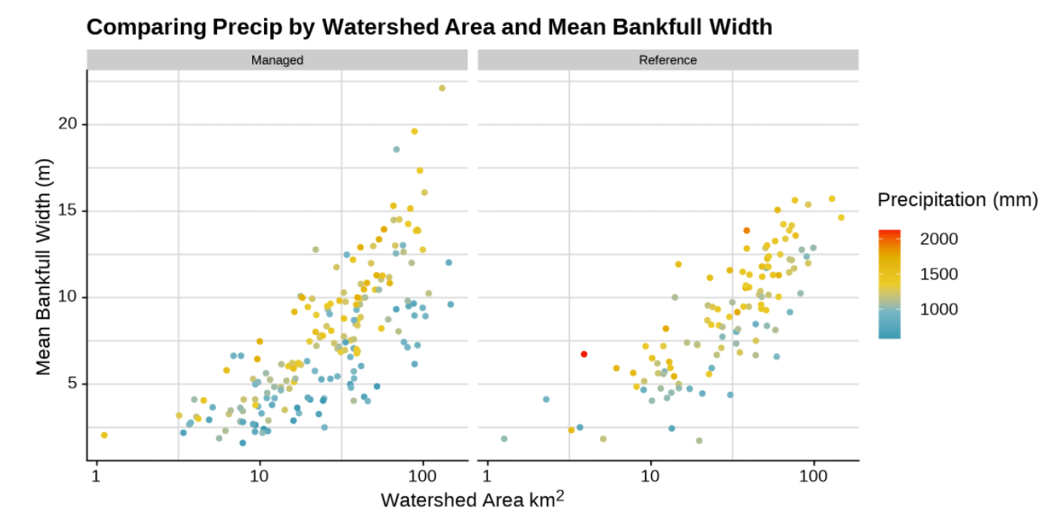

Figure 2. Mean bankfull width plotted for managed and reference catchments plotted against watershed area and faceted by precipitation.

Plotting those same data against watershed area provided more nuance, with mean bankfull widths being quite similar between catchments subjected to moderate and high harvest impact where catchments are smaller and diverging as catchments increase in size, with bankfull widths becoming more similar between moderately impacted catchments and catchments with low impact as catchment area increased (Figure 3a). Normalizing bankfull width using average annual precipitation ultimately collapsed the trend differences (Figure 3b). It is acknowledged that normalizing bankfull width in this way will inherently shrink variability between groups.

Trendlines comparing referenced and managed sample pools for bankfull width to depth ratio and bank angle suggested minor differences between sample means across the covariate (x axis domain) that varied depending on the covariate. Plotted data suggested slightly greater mean bank angles in the managed sample pool than the reference sample pool (Figures 5a and 5b) and slightly lower mean bankfull width to depth ratios, at least when evaluated against watershed area as a covariate (Figures 6a and 6b).

Time series plots did not suggest any dramatic shifts in bankfull width for much of the sample population. While a portion of the sites may have been affected by the historic 2011 water year, no specific pattern related to harvest impact was discernible. See Appendix A for time series figures.

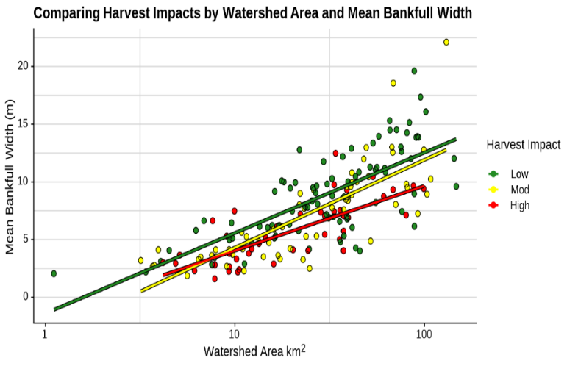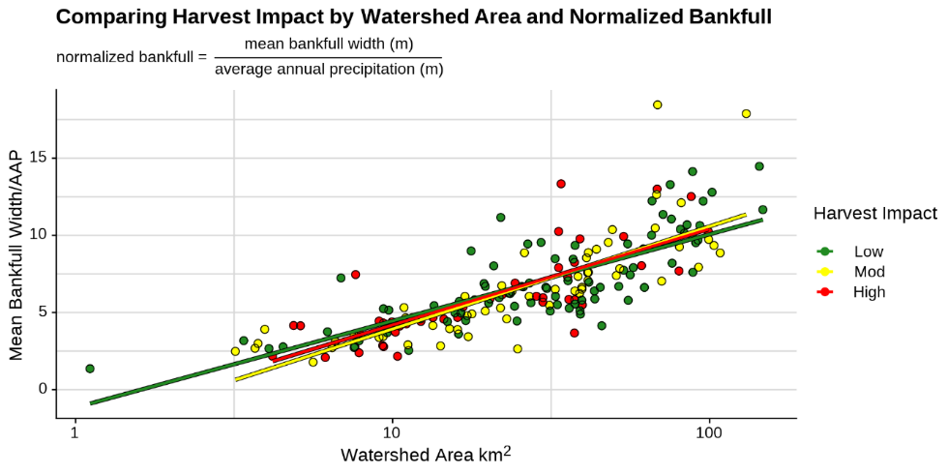

Figure 3a and b. Bankfull width plotted against watershed area, faceted by harvest impact. Figure b) normalizing the data plotted in Figure a by dividing by average annual precipitation.

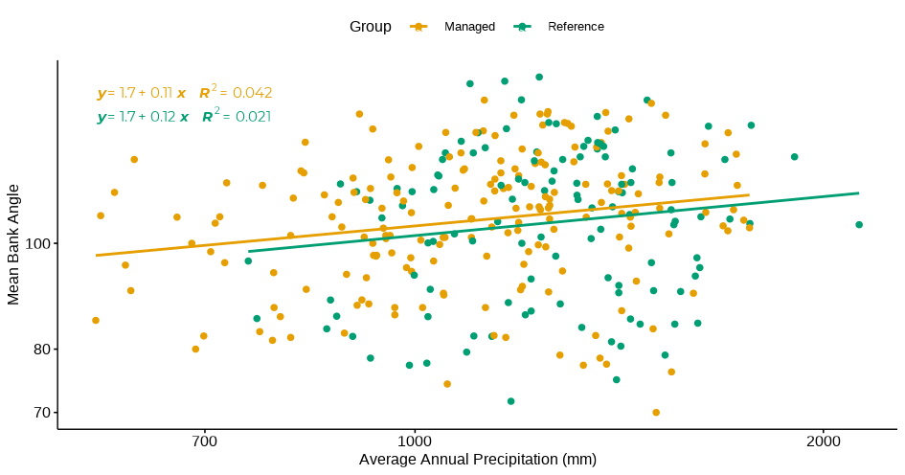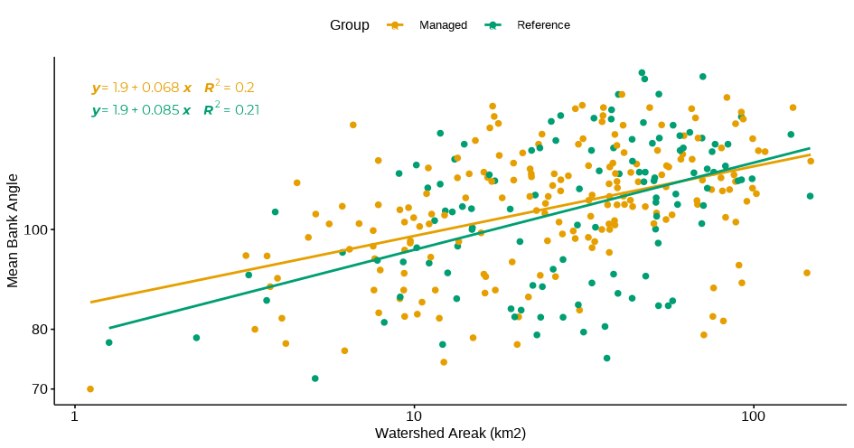

Figure 4a and b. Mean bank angle for managed and reference sites plotted against average annual precipitation (a, left) and catchment area (b, right).

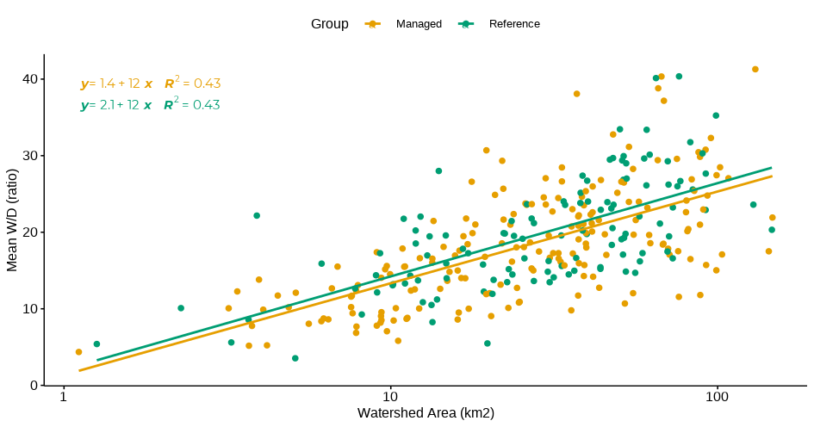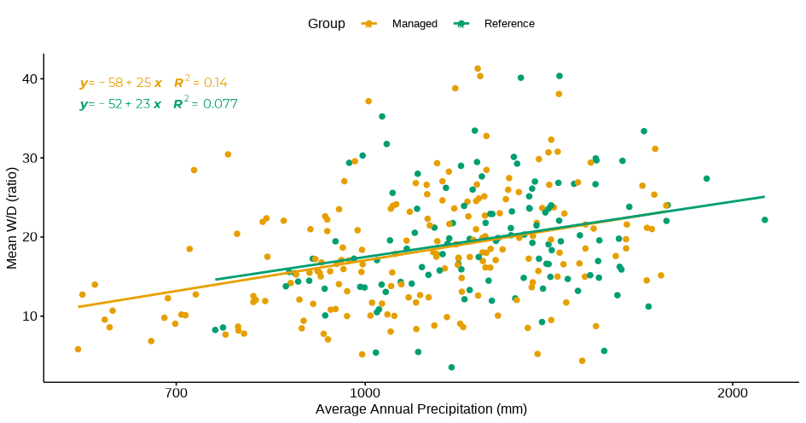

Figure 5a and b. Mean width to depth ratio for managed and reference sites plotted against average annual precipitation (a, left) and catchment area (b, right).

### Statistical analysis

### LMER

#### Bankfull Width

We performed three different LMER models using bankfull width as the dependent variable. The model that was selected was the random intercept and slopes model fixed on year. Model C (sites, within Ecological Section, random slopes by year) was a better fit than the Model B (varying among sites only) ( ) and the site within Ecological Section nested model , (Model A) ( ). The final model (Model C) residuals of normality and heteroscedasticity were violated via tests but after visually inspecting it was deemed fine, e.g. no fanning of or significant skewness of residuals.

We found that there was no statistically significant difference between Reference and Managed sites at an alpha level of 0.05, i.e. p value was 0.59. Similar to the ANCOVA model, the overall percent difference between Reference and Managed for a 1% increase in the DV was 1.7%. Thus, the LMER model was able to explain a little more of the variance by including more data and partially pooling by year. The ICC among individual sites was high (0.75) which means that it was appropriate and very useful to include sites as a level. This compared to Model A (site within Ecological Section = 0.65 and Ecological Section = 0.07) and Model B (site = 0.71) shows a 3-4% increase in variability explained when using time as an effect (random and fixed). See Appendix A for statistical model outputs.

#### Bank Angle

We performed three different LMER models using bank angle as the dependent variable. The model that was selected was the random intercept among site and Ecological Sections within Ecological Section (Model A) because it was the less complex model of the two, i.e. no real difference p = 1. Model A (sites, within Ecological Sections, varying intercept/fixed slopes) was a better fit than the Model B (varying among sites only) ( ) and the same as sites within Ecological Sections, random slopes by year, (Model C) ( ). Assumptions on normality and heteroscedastic were violated but after visually inspecting the residuals it was deemed fine, e.g. no fanning of or significant skewness of residuals. We found that there was no statistically significant difference between Reference and Managed sites at an alpha level of 0.05, i.e. p value was 0.74. The ICC among individual sites was moderate (0.48) with Ecological Sites at (0.10) which means that it was appropriate and very useful to include sites and Ecological Section as levels. This compared to Model B (site within year = 0.67) and Model C (site = 0.56) shows a 1% increase in variability explained when using site and Ecological Section but is less effective than site over time (year) (19% increase). See Appendix A for statistical model outputs.

#### Width/Depth Ratio

We performed three different LMER models using bank angle as the dependent variable. The model that was selected was the random intercept among site and Ecological Sections within Ecological Section (Model A) because it was the less complex model of the two, i.e. no real difference p = 1. Model A (sites, within Ecological Sections, varying intercept/fixed slopes) was a better fit than the Model B (varying among sites only) ( ) and the same as sites within Ecological Sections, random slopes by year, (Model C) ( ). Assumptions on normality and heteroscedastic were violated but after visually inspecting the residuals it was deemed fine, e.g. no fanning of or significant skewness of residuals. We found that there was no statistically significant difference between Reference and Managed sites at an alpha level of 0.05, i.e. p value was 0.19. The ICC among individual sites was moderate (0.59) with Ecological Sites at (0.11) which means that it was appropriate and very useful to include sites and Ecological Section as levels. This compared to Model B (site within year = 0.78) and Model C (site = 0.69) shows a 1% increase in variability explained when using site and Ecological Section but is less effective than site over time (year) (8% increase). See Appendix B for statistical model outputs.

## Discussion

Our analysis failed to detect any statistically significant management-induced morphologic shifts associated with altered hydrology from forest management. Exploratory data analysis provided some evidence that channels in managed channels have adjusted vertically (i.e. downcut), but those trends diminished when covariance was accounted for. If any management influenced-morphologic shifts associated with past management and subsequent hydrograph changes have occurred, our results suggest they cannot be detected within the bounds of inherent ecoregional variability. There are multiple limitations, however, to this study that are outlined below.

This analysis is constrained by the limited number of harvested acres found within managed catchments. Harvest levels have declined substantially in the study area during the past 30 years along with the proportion of regeneration harvest. Between 1989-1999 and 2009-2019, green harvest declined by 70% (19,256 ha to 5,702 ha) within the study area. Only 58 of the 305 PIBO sites within the study area (19%) fell within ‘high impact’ harvest catchments. The Forest Service has been deliberately constraining harvest acreages over the past twenty years or so, per peer-reviewed research findings discussed above and regulations and policy stemming from those findings.

The study domain encompassed a substantial range of drainage areas, hydroclimatic variation, and range of management characteristics. This is in part demonstrated within Table 1. While every effort was made to address inherent landscape variability, differing hydrologic and geomorphic drivers have influence at differing scales, which may have hampered our ability to detect a management-induced changes in channel morphology.

While this study did not find evidence of management-induced changes to elevated water yield and/or peak flows, this does not mean that such impacts do not or cannot occur. There is ample anecdotal evidence that such impacts occurred in the past across the study area. This evidence is in the form of personal communications with hydrologists and fisheries biologists that worked in the study area during the 1970s through the 1990s, along with old files, photos, and other documentation. When water yield and channel stability models were first developed, they were in direct response to severe impacts caused by timber harvest and road construction. It is likely that streams were destabilized not only through changes in hydrology, but also through removal of riparian vegetation and elevated sediment delivery.

Threads of evidence, albeit limited, suggesting vertical channel adjustment associated with forest management-induced hydrologic changes were not expected given the range of channel gradients within the sample pool. All sample sites, by design, fall squarely within the gradient range associated with response reaches (*sensu* Montgomery and Buffington 1997). Mean channel gradient is slightly lower in reference reaches than managed reaches (1.4 percent v. 1.8 percent), but likely not enough to dramatically affect transport processes differently between the two populations. Further investigation may be warranted.

In absence of a field-based paired watershed experimental design directly catering to channel morphologic detection resulting from harvest and road building-induced hydrograph changes, at best only correlation between management and channel morphology can be achieved. In this instance, we were unable to achieve that. Nonetheless, the findings of this study have shed further light on not only the level of detectability of management-induced channel changes resulting from hydrograph shifts as well as the applicability of various techniques for attempting to detect that signal.

Future analysis of in-stream channel habitat metrics would shed further light on the degree to which upstream and upslope forest management may be indirectly influencing channel conditions via hydrograph alteration.

## References

Bates, C.G. and A.J. Henry. 1928. Forest and streamflow experiment at Wagon Wheel Gap, Colorado. Final report upon completion of second phase of the experiment. USDA Monthly Weather Rev. Supply. No. 30.

Beschta, R.L., Pyles, M.R., Skaugset, A.E., Surfleet, C.G. 2000. Peak flow responses to forest practices in the western Cascades of Oregon. Oregon State University. Corvallis, OR.

Bosch, J., and J. Hewlett. 1982. A review of catchment experiments to determine the effect of vegetation changes on water yield and evapotranspiration. J. Hydrol. 55:3–23.

Goeking, S.A. and D.G. Tarboton. 2020. Forests and water yield: A synthesis of disturbance effects on streamflow and snowpack in western coniferous forests. Journal of Forestry. Volume 118, No. 2.

Grant, Gordon E.; Lewis, Sarah L.; Swanson, Frederick J.; Cissel, John H.; McDonnell, Jeffrey J. 2008. Effects of forest practices on peak flows and consequent channel response: a state-of-science report for western Oregon and Washington. Gen. Tech. Rep. PNW-GTR-760. Portland, OR: U.S. Department of Agriculture, Forest Service, Pacific Northwest Research Station. 76 p.

Hibbert, A. 1967. Forest treatment effects on water yield. P. 527–543 in International symposium on forest hydrology, Sopper, W.A.L.H. (ed.). Pergamon, Oxford.

Hietke et al. 2007.

Hubbart, J.A., T.E. Link, J.A. Gravelle, and W.J. Elliot. 2007. Timber harvest impacts on water yield in the continental/maritime hydroclimatic region or the United States. Forest Science 53(2): 169-180.

Jones, J.A. and Grant, GE. 1996. Peak flow responses to clear-cutting and roads in small and large basins, western Cascades, Oregon. Water Resources Research. 32 (1996), pp. 959–974

Kershner, J.L., Roper, B.B., Bouwes, N., Henderson, R., Archer, E. 2004. An analysis of stream habitat conditions in reference and managed watersheds on some federal lands within the Columbia River Basin. North American Journal of Fisheries Management. 24:1363-1375.

MacDonald, L.H., and Hoffman, J.A. 1995. Causes of peak flows in northwestern Montana and northeastern Idaho. Water Resources Bulletin 31: 79-95.

MacDonald, L.H., Wohl, E.E., Madsen, S.W., 1995. Validation of Water Yield Thresholds on the Kootenai National Forest. Department of Earth Resources, Colorado State University, Fort Collins, CO. 197 p.

Montgomery, D.R., and Buffington, J.M. 1997. Channel-reach morphology in mountain drainage basins. GSA Bulletin 109(5): 596-611.

Roper, B.B., Saunders, C.W., Ojala, J.V. 2019. Did changes in western federal land management policies improve salmonid habitat in streams on public lands within the Interior Columbia River Basin? Environmental Monitoring and Assessment. 2019. 191:574.

Sando et al. 2018.

Thomas, R.B. and W.F Megahan. 1998. Peak flow responses to clear-cutting and roads in small and large basins, western Cascades, Oregon: a second opinion. Water Resources Research. 34 (1998). pp. 3393–3403

Troendle, C., and R. King. 1985. The effect of timber harvest on the Fool Creek watershed, 30 years later. Water Resour. Res. 21:1915–1922.

Tonina, D., C.H. Luce, B. Rieman, J.M. Buffington, P. Goodwin, S.R. Clayton, S.M. Ali, J.J. Barry, and C. Berenbrock. 2008. Hydrological response to timber harvest in northern Idaho: implications for channel scour and persistence of salmonids. Hydrological Processes 22(7):3223-3235.

Kuras, P.K., Y. Alila, and M. Weiler. 2012. Forest harvesting effects on the magnitude and frequency of peak flows can increase with return period. Water Resources Research, 48:1-19.

## Appendix A. Time series figures

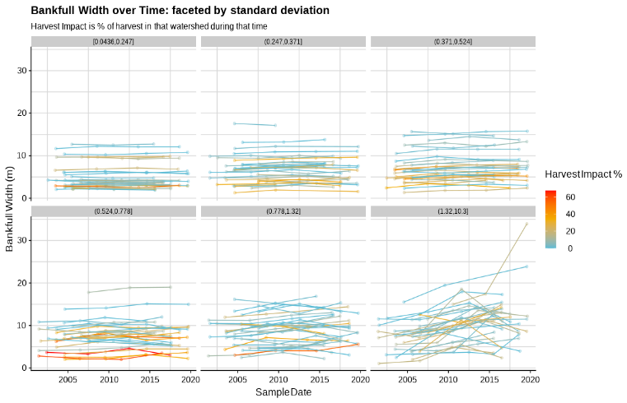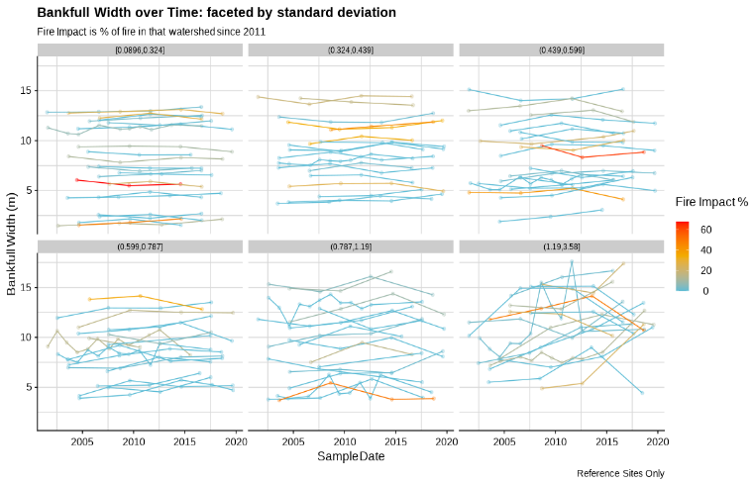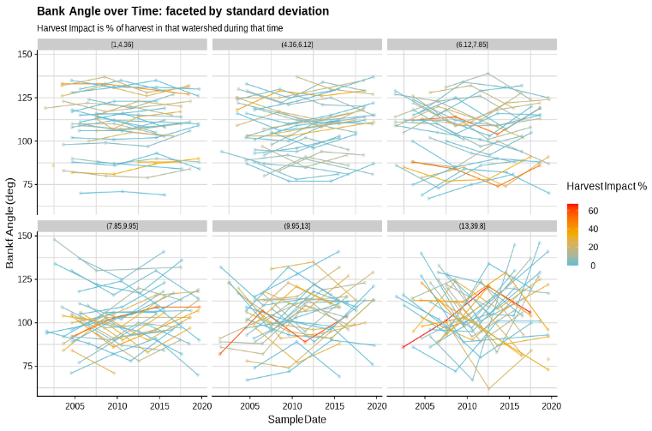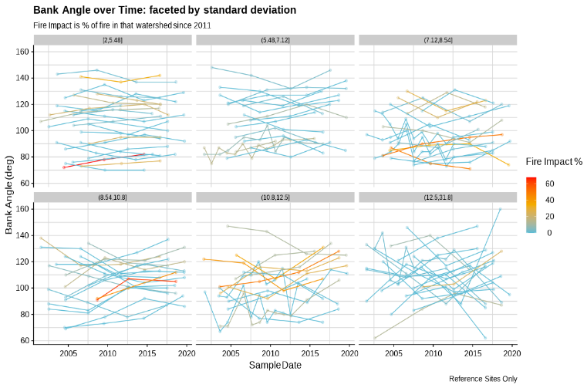

## Appendix B. LMER model outputs

1. Hydrologist. USDA Forest Service, Flathead National Forest. Kalispell, MT.
2. Hydrologist, USDA Forest Service, Kootenai National Forest.
3. Regional Hydrologist. USDA Forest Service, Northern Region. Missoula, MT.
4. Fisheries Biologist, USDA Forest Service, Helena-Lewis and Clark National Forest.