AttenuationRelationShip Application

AttenuationRelationship application can be downloaded from “Applications” link on http://www.OpenSHA.org . User has option of either running this application in web-browser or downloading a version that can run on his own system without a web-browser (standalone application).

This application allows the testing for following AttenuationRelationships:
May provide references to these Attenuation Relationships (?????)

- Sadigh et al (1997)
- SEA (Spudich et al., 1999)
- Campbell (1997) w/ erratum (2000) changes
- Abrahamson (2000)
- Abrahamson & Silva (1997)
- Boore, Joyner, & Fumal (1997)
- Campbell & Bozorgnia (2003)
- Field (2000)
- ShakeMap (2003)

You can plot the standard deviation, mean, and exceedence probability by setting all independent parameters values except the one chosen for the x-axis. The x-axis is generated by the constraints of the chosen independent variable for the x-axis. This applet doesn't require a Site or a Potential Earthquake, which are normally necessary to calculate all the independent parameters. The purpose of the Application is to test implemented AttenuationRelationships at its simplest level.

This application tries to implement the above attenuations in a simple possible manner. It provides user with elaborative and friendly messages if parameter settings goes outside the scope of the model. It allows user to adjust parameters supported by the selected attenuation relationship, using which varied results can be compared. This application tries to provide user with as many adjustable parameters as the attenuation relationhship supports.

This application allows user to plot linear and log plots by adjusting the parameters supported by attenuation relationship.
In Fig – 1, attenuation relationship application when it launched, user can select the attenuation relationship where it says “Choose Model”. Once user has selected the model, adjustable parameters for that model gets listed in panel listed as “Graph Panel” and “Independent Variables”.

In “Graph Panel” the Y-Axis listings are not dependent on any of the chosen model. Currently this application supports the following Y axis values:

1)Median
2)Standard Deviation
3)Exceed Probability
4)IML at exceed Prob.

Values listed for X-Axis depends on the selected attenuation relationship and selected “Intensity Measure Type”.
Similarly values listed for Intensity Measure Type are dependent on the chosen attenuation model. Following are the Intensity Measure Type enabled in our application:

1)SA
2)PGA
3)PGV
4)MMI

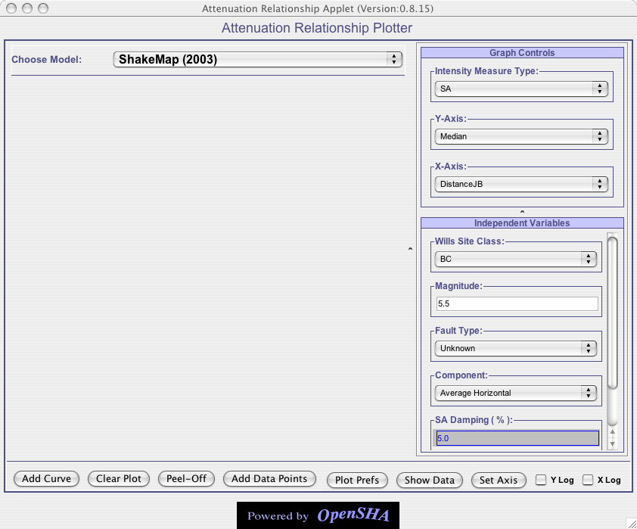

Fig –1 : AttenuationRelationship application when it is launched

Parameters defined in “Graph Controls” panel are known as Dependent Parameters, because based on what user sets the value for Intensity Measure Type; Y-Axis and X-Axis, the parameters in the “Independent Variables” panel are displayed. Parameters displayed in “Independent Variables” panel are known as Independent Parameters because no parameter is dependent on their values.

User can view parameters info by hovering the mouse cursor over the parameter name.

Once user has adjusted all the parameters, he/she can click on the “Add Curve” button to create XY curve. Users can add multiple curves to the same plot, as shown in Fig – 2, but X and Y axis for these curves should be the same. In the Fig – 2 , if user tries to plot Median Vs Magnitude for Abrahamson & Silva (1997), all the earlier curves will be erased and new curve will be added. More on this has explained in section: Plotting multiple curves in the same window.

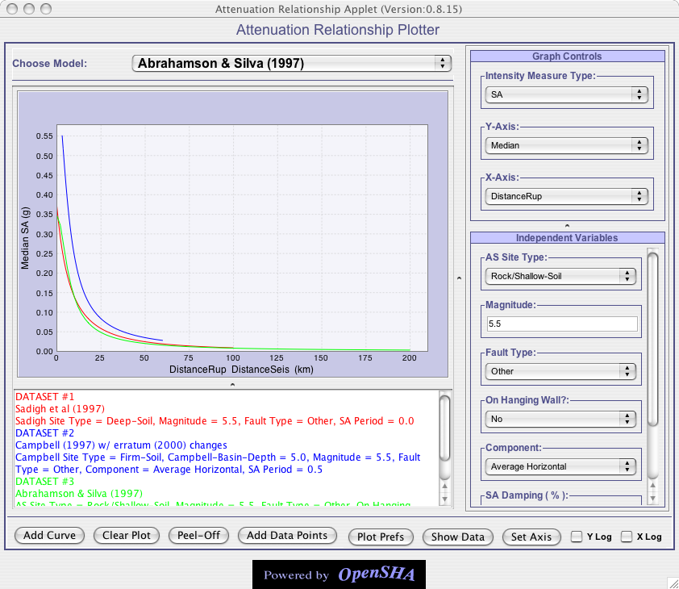
Fig – 2: Shows multiple curves in the plot, see metadata has been color coded with the same color as their corresponding curve.

Panel below in the application that displays buttons is known as the Button Panel. It provides user with all the capability of adjusting the XY plot once plotted.
Each button functionality is explained briefly down below:

- Add Curve : This button allows user to plot the XY curve once parameter have been adjusted. See the Example in Fig – 3.

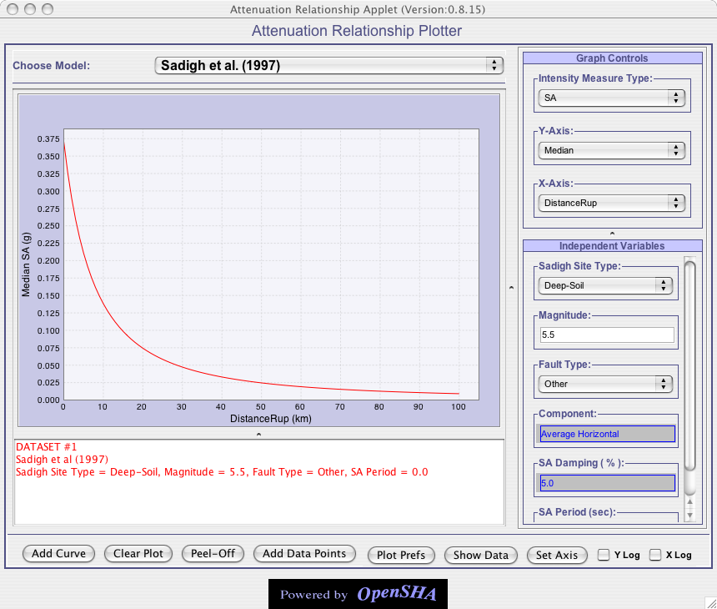
Fig – 3: Once user has set the values for adjustable parameters ,clicking on “Add Curve” will plot the graph. See that in this fig we are plotting Median Vs DistanceRup for Sadigh et al. (1997). Also see in the fig once curve has been added to the plot, a panel just below the plot panel shows the independent parameters values of the adjustable parameters. Curve and metadata for this curve are color coded in the same color.

- Clear Plot : This button will remove all the curves from the plot as well as metadata associated with the plots as shown in Fig – 4.

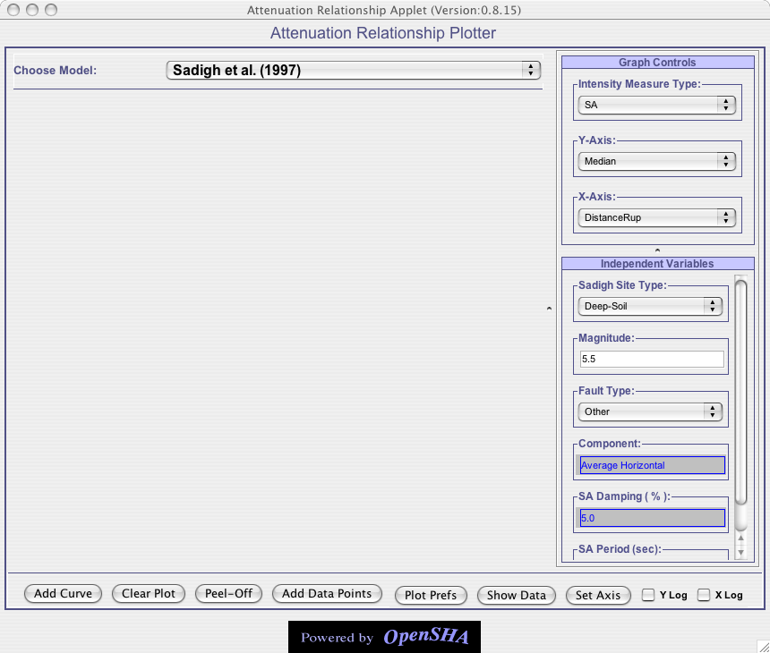
Fig – 4: This is how application looks when user has clicked on “Clear Plot”, similar to when application is launched. It removes all the curves and the metadata associated with those curves. This figure is in sequence from Fig – 3. Once user has plotted the curve as shown in Fig-3, then click “Clear Plot” button, this is how the application will look like.

- Peel – Off : This button allows user to peel the curves from main application window to some other window as shown in Fig – 5. This feature allows user to separate the curves from the main application window and be shown in a separate window. Every time user clicks this button a separate window will pop up that will remove the curves from the main application window and add those to the new window. This also allows user to preserve the earlier curves and make comparison if need be.
Once curves have been peeled off from the main application, user cannot add those back to the main application window. Also user cannot add new curves to the peeled off window. For example in Fig – 5, user cannot add more curves to the peel – off window titled as “Plot Window – 2”, though curves can still be added to the main application window.
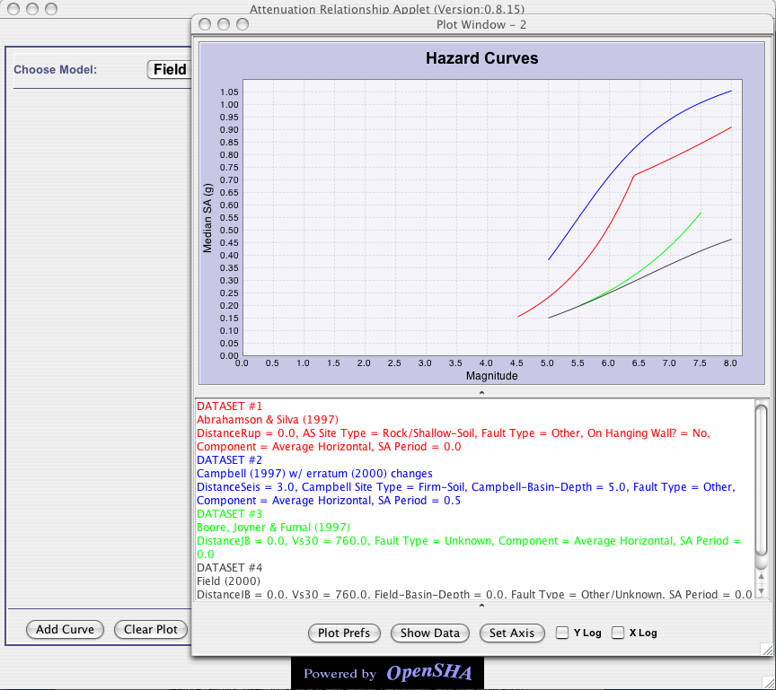
Fig – 5: Showing the curves in a new window after they have been peeled off from the main application window.

- Add Data Points: This button allows user to specify his XY dataset and metadata for this dataset. This new dataset will be plotted in black color crosses and same color of metadata. Fig – 6 and 7 shows the sequence, how user can add custom XY data.
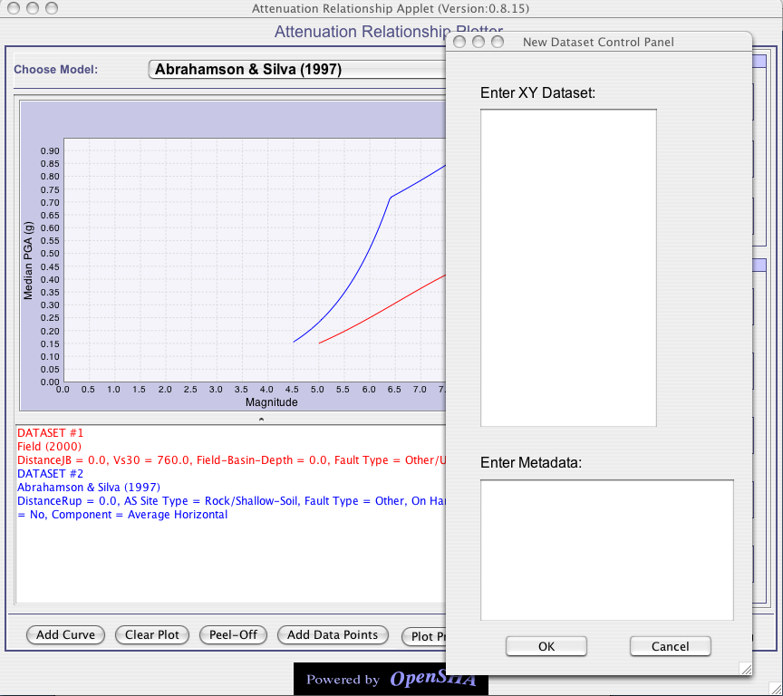
Fig – 6: Clicking on “Add Data Points” will pop up the window as shown in this figure. User needs to enter XY data and metadata in this window and then click on “OK” button, if wants to add this new data to the set of curves. When user is entering XY data in the window, it must be entered the following format:
Each line must have only one X and one Y value and they must be space separated. Example can be:
0.3 0.1
0.6 0.2
0.9 0.3
1.2 0.4
1.5 0.5
1.8 0.6
2.1 0.7
2.4 0.8
2.7 0.9
3.0 1
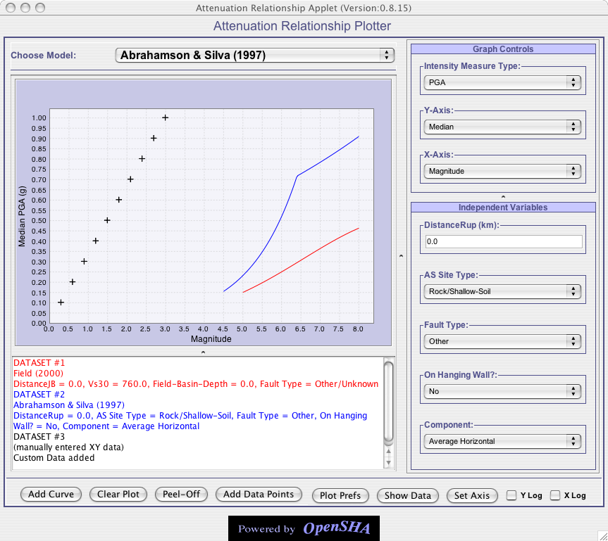
Fig – 7: After custom data has been added to the application as Dataset #3. See how curve for custom data appears is displayed in black color crosses. Similarly, metadata for this custom is color coded to be black.

- Plot Prefs: This button allows user of the application to change the color , thickness of the curve and also allowed to change the plot curve style as shown in Fig – 8.
Note user can change plot preferences of the curves that are currently visible in the application. Once the plot preferences of the curves are changed and then we peel-off these curves by clicking on “Peel – Off” button, the new window maintains the new plot preferences of the curves and shows the curves with changed plot preferences in the new window, example Fig – 9.
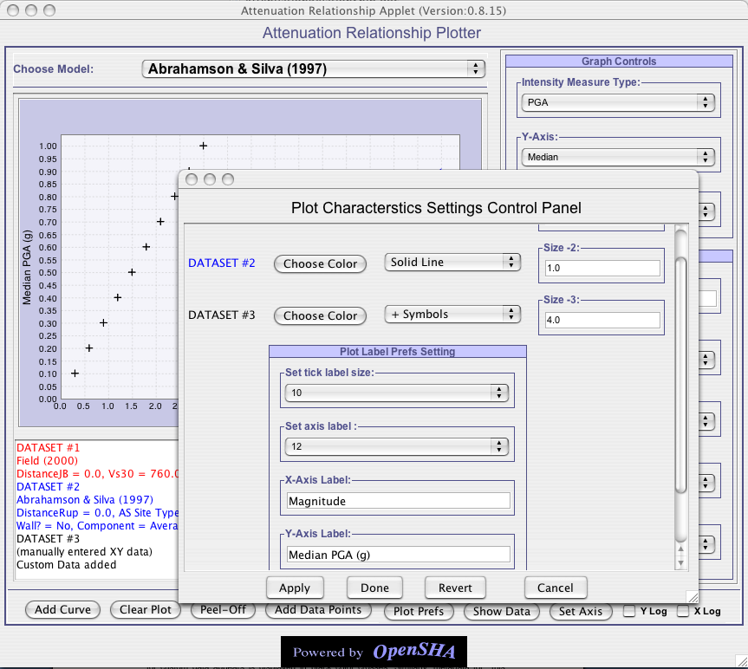
Fig – 8: This figure shows the plot preferences that user can adjust to plot curves with different color, line size or style. User can also change the plot label size, axis labels and label sizes. Note that user can change the plot preferences of curves that have already been drawn.

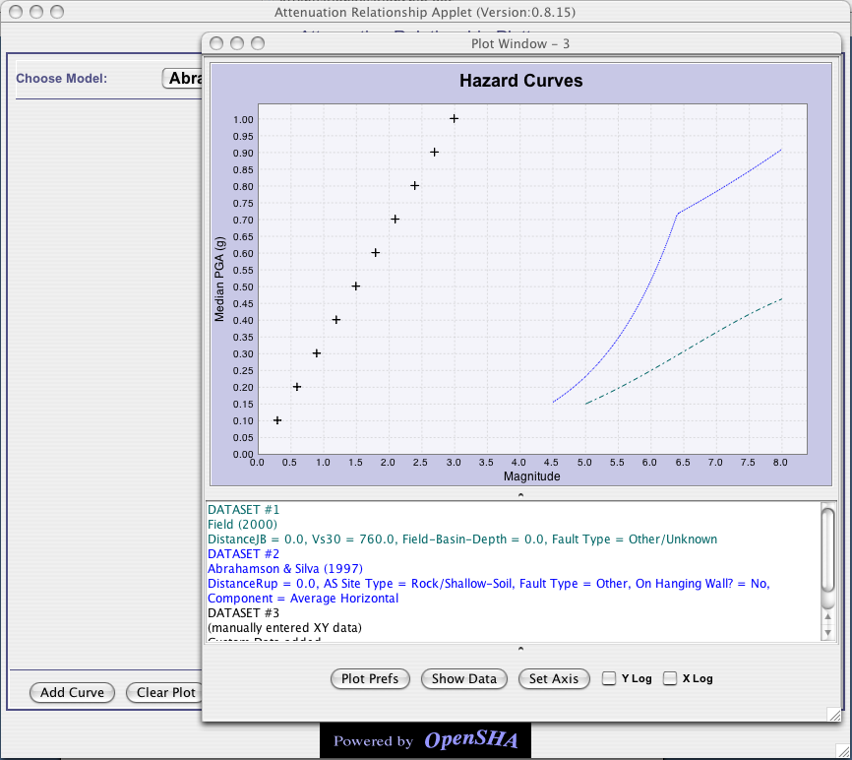
Fig – 9: Changing plot preferences for dataset #1 and #2, then peel-off the curves in Fig – 8, will result in saving of those plot preferences when showing in a separate peeled off window.

- Show Data: This button allows user to visualize or save the actual plot metadata with XY values for all curves in the plot, as shown in Fig – 10. This provides toggle between plot window and data window.

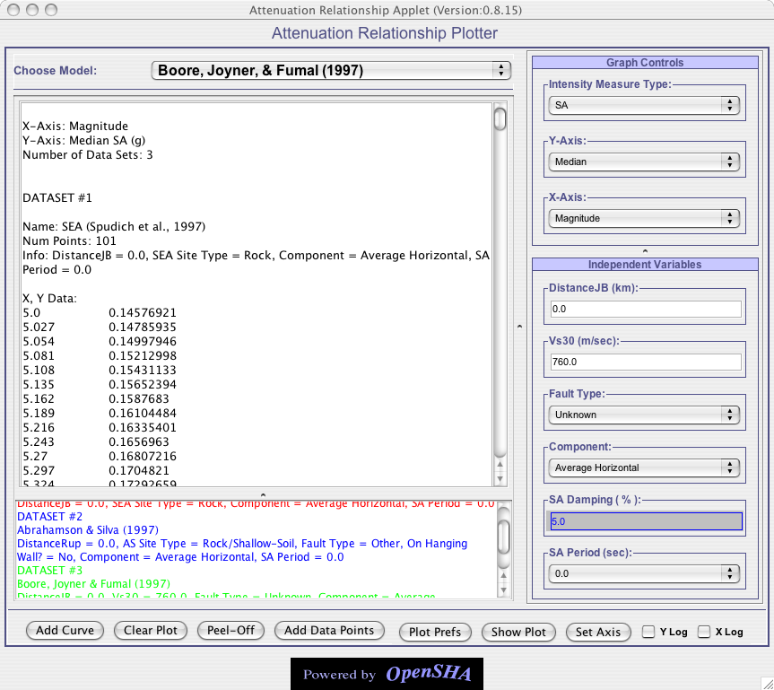
Fig – 10: After plotting curve(s), if user clicks on “Show Data” button, firstly it will change the text on the “Show Data” to “Show Plot”. Secondly, it will replace the plot window with a data window, describing all the data and metadata associated with each curve plotted. Each plotted curve is also known as Dataset.

- Set Axis: This button allows setting the plot axis range. When user clicks on this button, a window labeled “Axis Control Panel” pops up. This window allows user to define his own custom axis range, by selecting “Custom Scale” in “Axis Scale” choices, as shown in Fig - 11. Once user has defined his own axis scale, pressing “OK” button will set the axis range in the application.

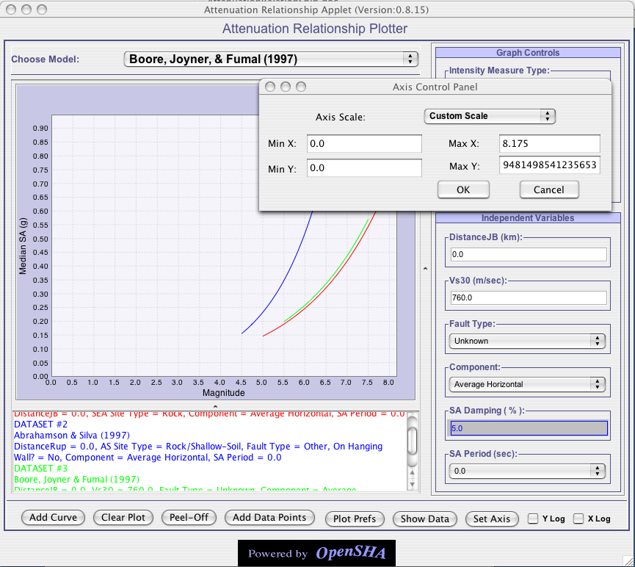
Fig – 11: When user click the “Set Axis” button , a window titled “Axis Control Panel” pops up that allows user to set X and Y axis range.

After setting the custom axis for the plot, if user peels off the curve to be shown in the new window then plot in the new window will be shown with custom axis range that user has set in the main application window, as shown in Fig –12.
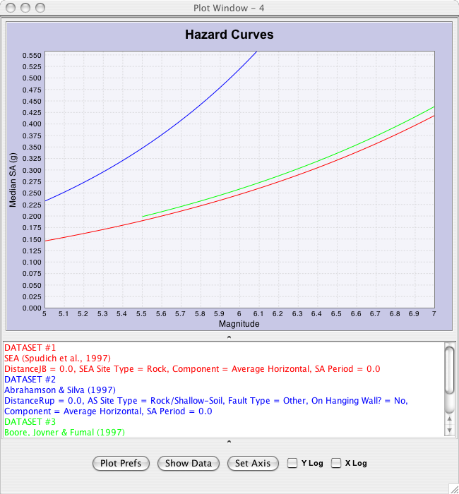
Fig – 12: From Fig – 11 user sets the custom axis range in the main application then clicks on the “Peel – Off” button. This results in a new plot window with axis scale limits being what user set in the main application window.

- Y Log: This checkbox allows user to toggle between log and linear plot for Y axis. If Y Log checkbox is selected then it converts the linear Y axis to log scale, else if unselected then plots Y axis in linear scale, as shown in Fig – 13.

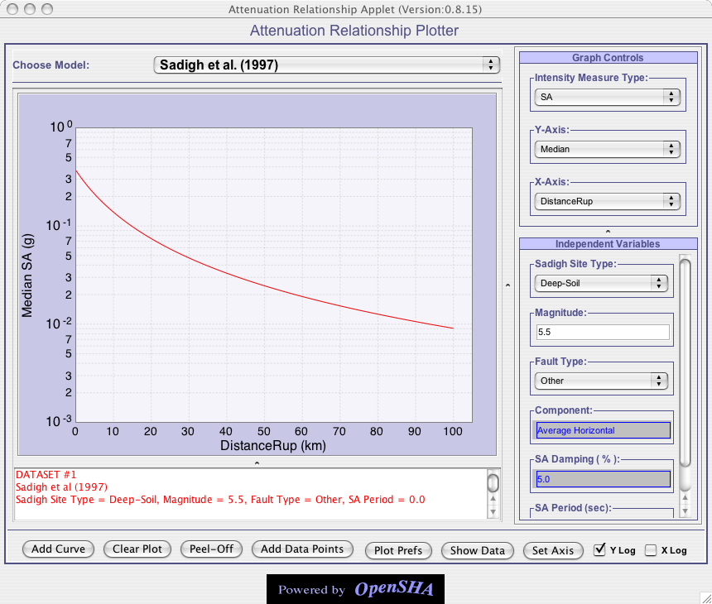
Fig – 13: Plot showing Y axis being log and X axis being linear. See only YLog is selected so Y-axis is displayed in log. In log scale only the major axis gets labeled as power of 10 and minor axis being labeled simply as numbers from 2 to 9.

- X Log: This checkbox allows user to toggle between log and linear plot for X axis. If X Log checkbox is selected then it converts the linear X Axis to log scale, else if unselected then plots X axis in linear scale, as shown in Fig – 14.

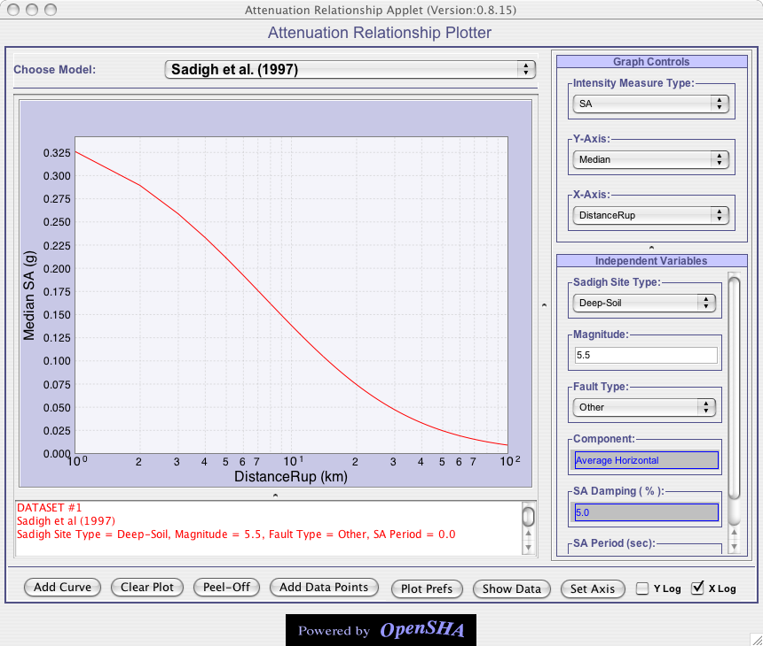
Fig – 13: Plot showing X-axis being log and X-axis being linear. See only Y-Log is selected so Y-axis is displayed in log. In log scale only the major axis gets labeled as power of 10 and minor axis being labeled simply as numbers from 2 to 9.

User can select both axes to be log scale as shown in Fig – 14. Axes scale will be maintain if user peels – off the curve to a new window. So curves status will be maintained whenever user decides to peel off the plotted curves to a new window.
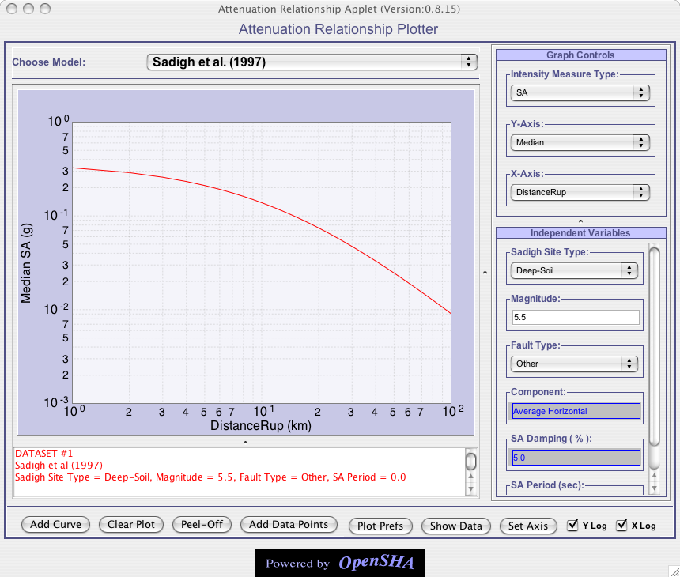
Fig – 14: Plot showing both X and Y axis in log scale.

Setting values for adjustable parameters

There are different types of adjustable parameters in the application.

- Where user can enter numeric value, most of these parameters have defined min and max values constraints on them. Constraints for these parameters are visible by hovering the mouse over them.
- User can make selection from a list of choices provided to him. These type of parameters don’t allow user to enter any value, choice has to be made from list of choices provided to him.

Once user set the parameter in the GUI, parameter value automatically gets set.

Constraints on the parameters can be 2 types:

- Absolute constraints: If user goes outside this range, exception message will be shown to the user and value of the parameter will be reverted back to the old value. For example see Fig – 16.
- Recommended constraints: If user goes outside this range, window is popped-up asking user if he/she really wants to go with entered value, even though it is not recommended for the model. For example see Fig – 15.

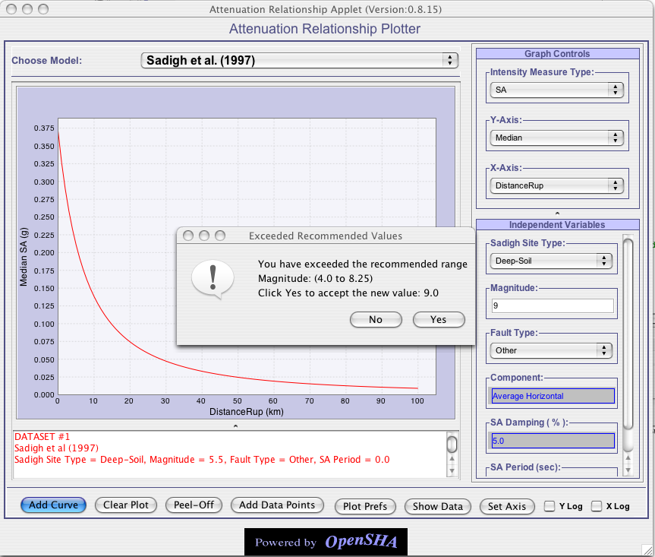
Fig – 15: For Sadigh et al. model user to exceed the range of magnitude defined by model by giving it a value of 9.0 . A window pops up asking user if he/she really wants to violate the recommended range of magnitude defined by this model. If user clicks “Yes” the value will be set inside the parameter.

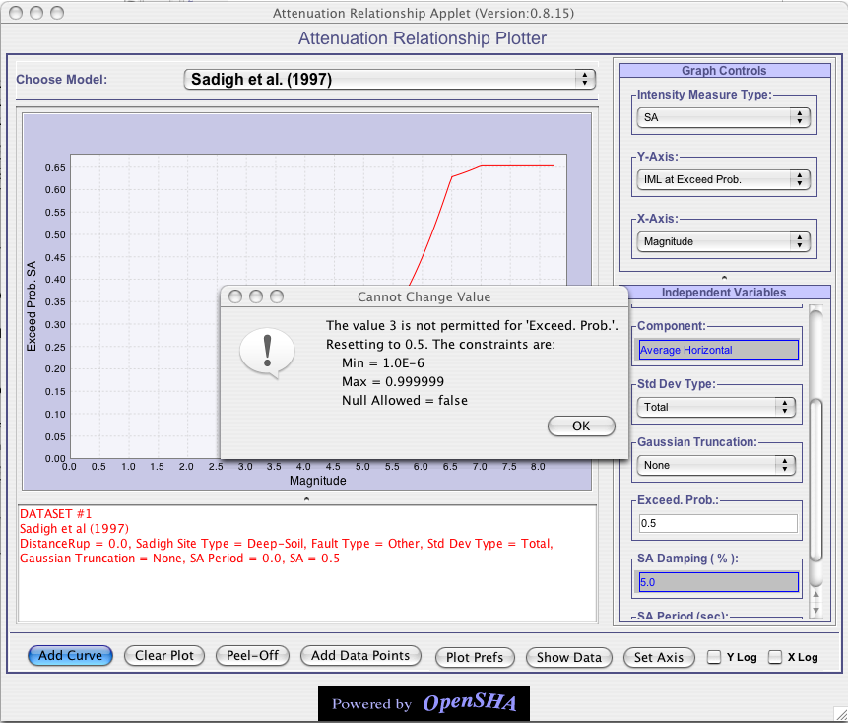Fig – 16: For Sadigh et al. Model user tries to give independent parameter “Exceed Prob.” a value of 3 , which is violating the absolute constraints on the parameter, thus reverts back the parameter value to original.

Plotting for individual values for Y-Axis

If for some Y-axis parameter user wants to just wants a single individual value rather then the whole plot, then he/she needs to make selection in Y-Axis listing for which individual value needs to be computed. Then in the X-Axis make the selection for “Individual Value”. Once this has been done, application will list all the adjustable independent parameters in “Independent Variables” panel. User can adjust whatever parameters he wants and then click on “Add Curve”. For example see Fig – 17.

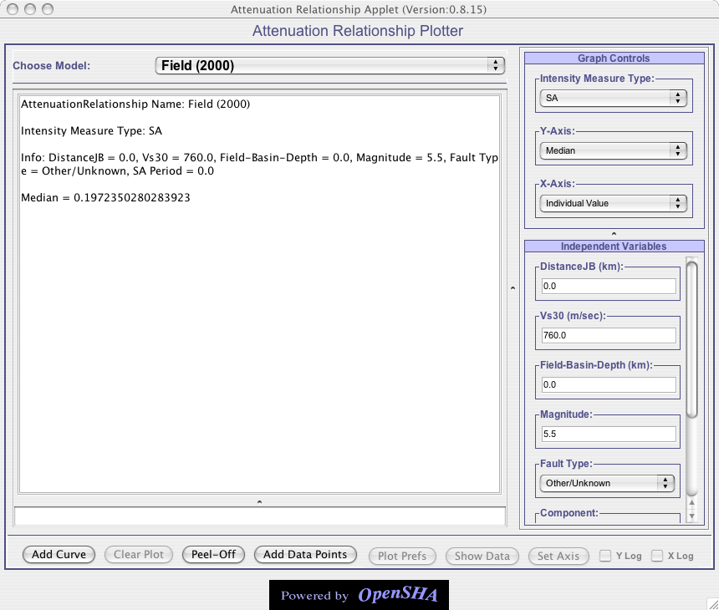
Fig – 17: Plotting Individual Value for Median. See instead of showing the plot screen, user is shown individual value for Median with the values chosen for adjustable parameters.
Note : User can only plot one individual value at a time.

Plotting multiple curves in the same window

User can plot multiple curves, i.e., keep adding one curve after another to the same application window as long following rules are followed:

- Intensity Measure type for multiple curves remain the same.
- Y-Axis for these multiple curves remains the same.
- X-Axis values for these multiple curves have at least same units. For example: DistanceSeis and DistanceRup both units in Kms, so curves can either DistanceSeis or DistanceRup as X-Axis value.

Peel – Off window

As explained in peel-off section, when user clicks on the “Peel – Off” button, a separate window is launched that will remove the curves from main application window and add these curves to this new window. Once a window has been peeled off user cannot add any more curves to this new window, though he/she can keep adding to main application window.
This peeled – off window maintains the state and plot preferences of the main application window. This window allows user with the following functionality:

- Change the Plot Preferences using the “Plot Prefs” button.
- Change the Axis scale using the “Set Axis” button.
- See the Metadata and XY data for the plots using the “Show Data” button.
- Set X-Log and Y-Log to change axis scale from linear to log.

