ScenarioShakeMap Application

ScenarioShakeMap application can be downloaded from “Applications” link on http://www.OpenSHA.org. User can download the application and run on his own system without a web-browser (standalone application).

This application provides user with capability of plotting Scenario-Shake-Map for a given potential earthquake rupture in selected region. This rupture gets inputted inside the selected attenuation relationship(s). Plotting of map is done using GMT. More to be added, may be Ned can do that ????.

May provide references to these Attenuation Relationships (?????)

- Sadigh et al (1997)
- SEA (Spudich et al., 1999)
- Campbell (1997) w/ erratum (2000) changes
- Abrahamson (2000)
- Abrahamson & Silva (1997)
- Boore, Joyner, & Fumal (1997)
- Campbell & Bozorgnia (2003)
- Field (2000)
- ShakeMap (2003)

User has option of either selecting the single attenuation a time or selecting multiple attenuations at any given time (refer section ????).

It provides user with elaborative and friendly messages if parameter settings goes outside the scope of the model. This application tries to provide user with as many adjustable parameters that allows comparing the varied results based on different parameters.

This application allows user to plot linear and log map by adjusting the parameters for Map attributes, which is basically the data that is sent to the GMT.

In Fig – 1, Scenario-ShakeMap application when it launched. This application allows user to adjust the following:
- Intensity Measure Relationship parameters: Allowing the user to select multiple attenuation relationships or single attenuation and some of their adjustable parameters.

- Region and Site Parameters: Allowing user to set Region lats and lons (in degree). Also allowing to set the site parameters for this region. User has choice of either applying same site effects to all sites or setting the site effects using the Wills Site Class and Basin Depth.
- Earthquake Rupture Parameters: Allowing user to define his/her own rupture or select one from already existing Earthquake Rupture Forecast models like Step ERF, USGS-2002 ERF model, etc.

- Exceedance Level/Probablity: Setting up what to create the map for?

  - Prob@IML : Finds what is the probability of exceeding the given intensity measure level for each site in the region.
  - IML@Prob : Finds what is the intensity measure level that will be exceeding the given probability for each site in the region.

IML : Intensity Measure Level
Prob : Probability

- Map attributes Parameters: Setting up the parameters for map attributes that allows user to vary GMT plotting parameters.

Similarly values listed for supported attenuations relationships are dependent on the chosen Intensity Measure Type. Following are the Intensity Measure Type enabled in our application:

- SA
- PGA
- PGV
- MMI

Based on what user has selected as IMT, only those Attenuations Relationships that support the chosen IMT are provided as choices to for user to select from.

User can view parameters info by hovering the mouse cursor over the parameter name.

This is a very lightweight application that has no dependency on the users machine. This application just assumes that user must be having internet access when running this application, otherwise shows user with the message that there are problems connecting with the server. Otherwise this application does not hog the client machine for performing the computation. User has choice of either performing the computation on his own machine or on the server (By default calculation are performed on the server). Once user has adjusted all the parameters for which map has to be computed, he/she can click on the “Make Map” button that will create map using the GMT on the server.
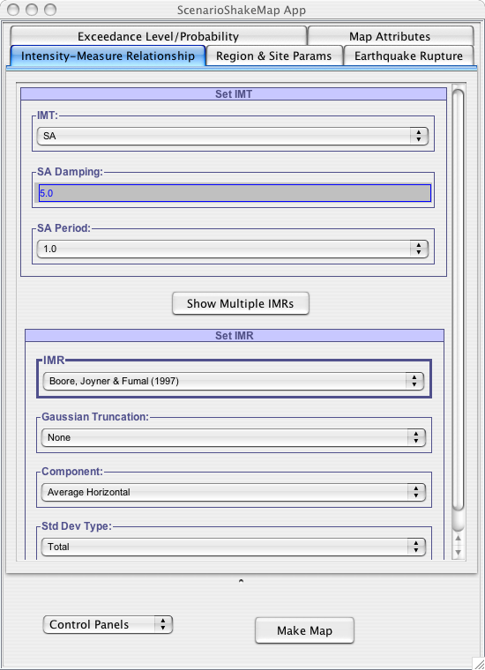

Fig –1: ScenarioShakeMap application when it is launched

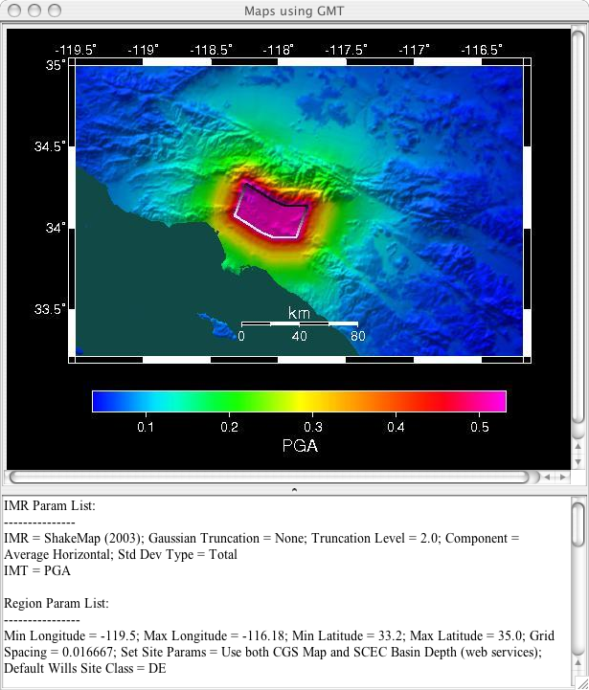
Fig – 2: Shows Scenario ShakeMap for Puente Hills Region. Map generated using the GMT.
User can produce the same by selecting “Set Params for Puente Hills Scenario” from “Control Panel“ list and then hitting the “Map Map” button.

As explained briefly, this application provides user with set of 5 tabbed panels for adjusting parameters before creating a scenarioshake map. Each of these panel is explained below:

- Intensity Measure Relationship: As shown in Fig –1, this is the first panel visible to the user when application is first launched. Based on what user selects as the choice for Intensity Measure Type (IMT), only those Attenuation Relationships that support this selected IMT are listed for user to make his selection, as shown in Fig –3.
User has option of either generating ScenarioShakeMaps using single attenuation relationship or multiple attenuation relationships. User can select multiple attenuation relationships by clicking on button “Show Multiple IMRs”, as shown in Fig – 4. If multiple attenuation relationships are being used for calculation, then final Scenario ShakeMap data is the weighted average of the selected attenuation relationships. User can set parameters for each Attenuation Relationship individually by clicking on “Set IMR Params”. As shown in Fig – 4 each selected AttenuationRelationship is associated with some weight. In this application computation for Scenario Shakemap data is done using the weighted average, in which case once user has provided weight for each selected AttenuationRelationships, our application computes relative weight of each selected Attenuation model out of 1.0, using which we compute the ScenarioShakeMap data.
The button in the middle of the panel is a toggle between selection of single attenuation relationship and multiple attenuation relationships. It allows the user to toggle between the 2 modes of attenuation relationship selection.
If user has chosen to work with multiple attenuation relationships models by clicking on the button “Show Multiple IMRs”, he/she can change the selected Attenuation Relationships models adjustable parameters by clicking on the “Show IMR Params”, as shown in Fig – 4(a). A pop up window will open up that allows user to adjust parameters for the attenuation relationship for which this button was clicked. So in case of Fig – 4 , user can adjust parameters for both ShakeMap-2003 and USGS Combined(2004) by clicking on their corresponding “Set IMR Params” button.

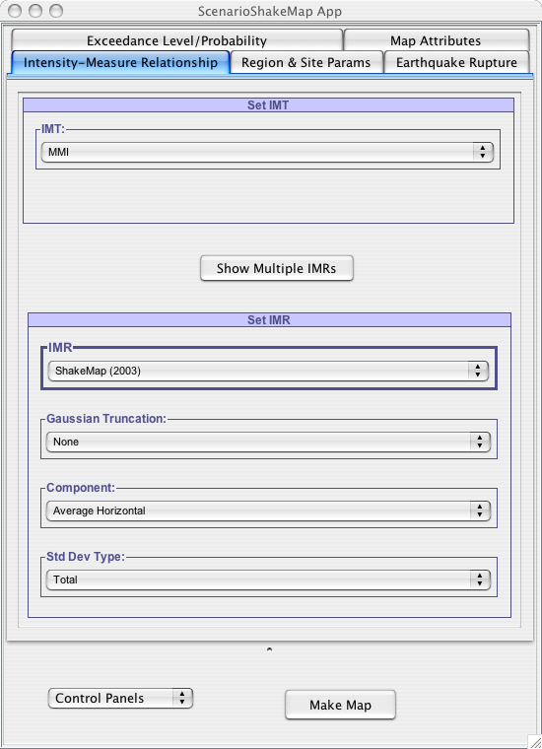
Fig – 3: Changing the IMT to “MMI” will allow user to select from only 2 choices of attenuation relationships (IMR Label) : ShakeMap (2003) and USGS Combined (2004).

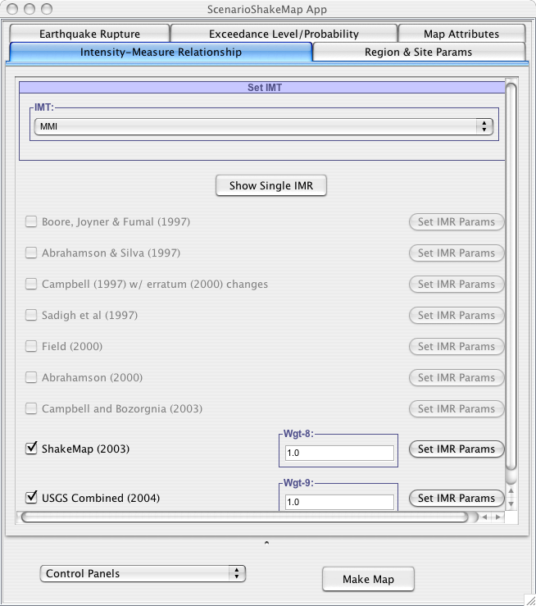
Fig – 4: Once IMT has been selected to “MMI” and “Show Multiple IMRs” button is clicked, it shows only 2 Attenuation Relationships to the user to choose from. User has choice of either selecting one or both attenuations for scenario shakemap. See now the button on this panel says “Show Single IMR”, which if clicked will revert back to the single attenuation selection. If user decides to work with multiple attenuation relationships then he/she can set parameters for each selected attenuation relationship by clicking on “Set IMR Params”.

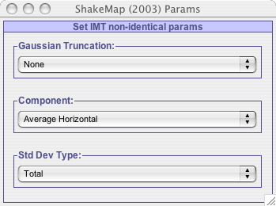
Fig – 4(a): This figures shows the adjustable parameters for the ShakeMap – 2003
Attenuation Relationship. This window pops up when user clicks on the
“Set IMR Params” for choice “ShakeMap-2003 “ if he/she has chosen to work with
multiple attenuation relationship models.

- Region and Site Params: This panel gets visible if user clicks on the “Regions and Site Params” tab on the top of the application. This panel allows user to enter the latitudes and longitudes for the region of interest. Based on the chosen attenuation relationship model(s) this panel shows all the site parameters for selected attenuation relationship model as shown in Fig – 5 and 6. As you can see from figures, apart from allowing user to fill in the latitudes, longitudes and grid-spacing for the region, it also allows user in applying site conditions to the region. User has following options when setting the site conditions for the region:
  - Apply all sites in the region with same site type.
  - Apply site effects to all locations in the region using the Wills Site Class.
  - Apply site effects to all locations in the region using the Wills Site Class and SCEC Basin Depth.

When user chooses to get the site effects using the Will Site Class Values and/or SCEC Basin Depth, then each site within the region get translated to Site Effect Parameter for selected AttenuationRelationship(s). Within this application scope Wills Site Class value are only defined for California Region and Basin Depth values for Southern California region. So if user gives region where sites are outside the bound of California or in water or for any reason our application is not able to apply site effects to location(s) within this region then it apply default value for Site parameter for the selected AttenuationRelationship(s) model, as shown in Fig-6.

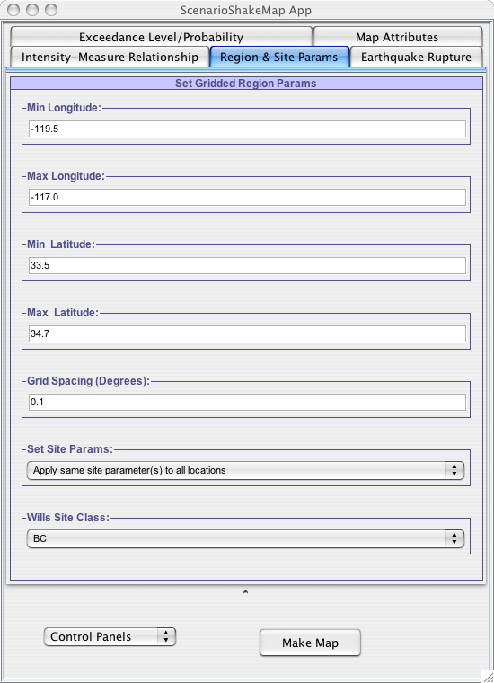
Fig – 5: Allows user to set the latitudes and longitude (in degrees) for the region. It also allows user to specify if similar site parameters are to be applied to all locations in the region or each location will be having its own site parameters.

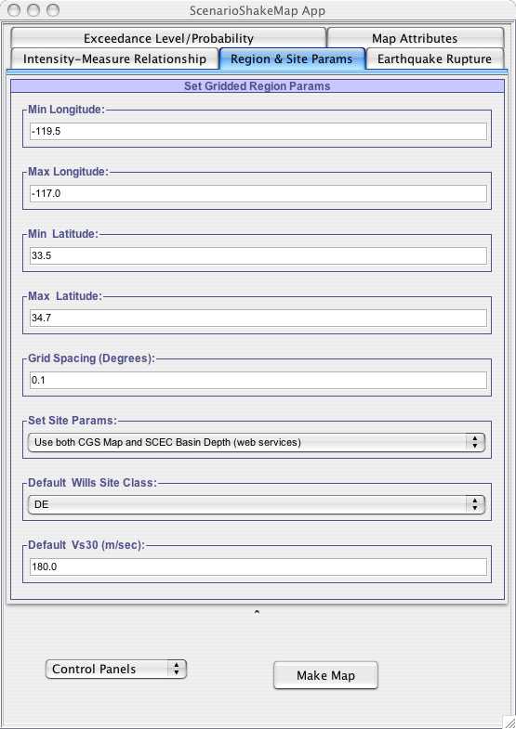
Fig – 6: This figures shows Multiple Site Parameters corresponding to selected Attenuation Relationships (in this case ShakeMap (2003) and USGS Combined (2004)). In figure , it chooses to set the site effects for each location in the region using the Wills CGS map and SCEC basin Depth. If application is not able to get the site effect for location(s) then it apply default value to the Site parameter, which in this case is “DE” for ShakeMap (2003) and “180” for USGS Combined(2004).

- Earthquake Rupture : This panel gets visible when user clicks on the “Earthquake Rupture” tab as shown in Fig – 6.
This panel allows user to either define their own custom rupture or choose a one already existing in the Earthquake Rupture Model. Depending on the choice made by the user, this panel will allow user to adjust parameters correspondingly, as shown in Fig-7 and 8.

Selecting rupture from ERF

As Fig-7 shows, user can select a rupture from already existing ERF models. Currently this application supports following ERF models:

  - Poisson Fault ERF
  - USGS/CGS 1996 Adj. Cal. ERF
  - STEP ERF
  - Floating Poisson Fault ERF
  - USGS/CGS 2002 Adj. Cal. ERF
  - WG02 Eqk Rup Forecast

User can configure these ERF models by adjusting the parameters for these ERF’s by clicking on “Set Eqk Rup Forecast Params”, which will pop up a window as shown in Fig – 7(a). Once this window pops up user can adjust parameters for the ERF model. For example in the case of Fig–7, when user clicks on “Set Eqk Rup Forecast Params”, window pops up as shown in Fig – 7(a), which allows user adjust parameters for the “Poisson Fault ERF”. It also helps user define the Fault Surface and Magnitude Frequency Distribution for the Poisson Fault ERF as shown in Fig –7(a)(a) and Fig – 7(a)(b).
Now once user is done adjusting all the parameters for the ERF model, he/she can click on “Update Forecast” button as shown in Fig – 7(a). This will update the ERF model with new parameter values that user has inputted. While ERF is updated user will be shown a progress bar that keeps him/her updated, because updating can take a while depending on ERF model chosen by user. Once the ERF model is updated it will update the number of sources within this forecast model. User can select a source from the “Source Index” and correspondingly select a rupture from “Rupture Index” as shown in Fig – 7. In the case Fig – 7, Poisson Fault ERF supports just single source, so user is not given any choice to select source. But this source supports 84 ruptures. “Rupture Index” parameter in Fig – 7 is restricted by number of ruptures supported by the selected source. When user hovers mouse over the “Rupture Index” parameter, user can see number of ruptures within the selected source. If user scroll-down the window in Fig – 7, he/she can see information about all ruptures within the selected Source Index.

User can set the hypocenter location for the selected rupture by “Checking” the “Set Hypocenter Location” checkbox. Once this is selected, list of hypocenter locations will appear, from which user can pick one location as hypocenter location.

Note: If user has chosen the Intensity Measure Relationship model to be of Abrahamson-2000, it requires that earthquake rupture must have a hypocenter location, so user will need to set the Hypocenter location in its case. Even if user forgets to do so, he/she will prompted to do so via a user friendly message by the application.
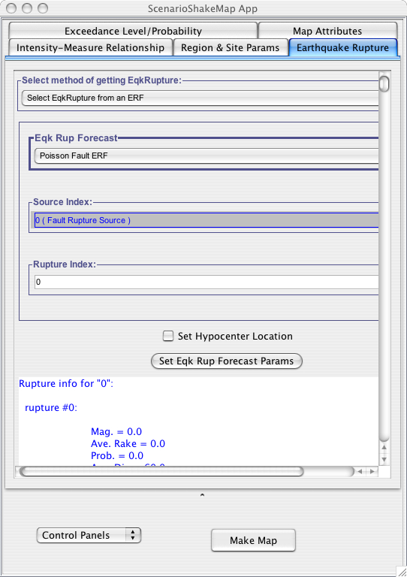
Fig – 7: Figure shows user can select rupture from already existing EarthquakeRupture Forecast. Label “Eqk Rup Forecast” presents user with list of supported Earthquake Rupture Forecast models supported in our framework.
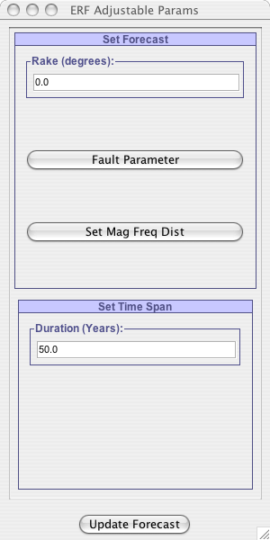
Fig – 7(a) : Figure shows Adjustable Parameters for Poisson Fault ERF.
It also allows user to set the Timespan for the selected earthquake rupture
forecast model.

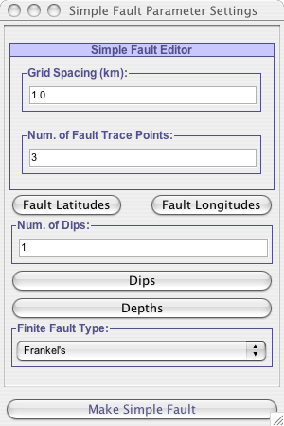
Fig – 7(a)(a): Figures shows how user can define the fault surface for the
ERF. Clicking on the “Fault Latitudes”, “Fault Longitude” will allow user to
specify the locations of fault trace. Similarly, “Dips” and “Depths” will allow
user to enter the dip and depths for the fault trace. Once user is done adjusting
parameters to create a fault surface, he/she can click “Make Simple Fault” which
will set this fault surface for the ERF model.

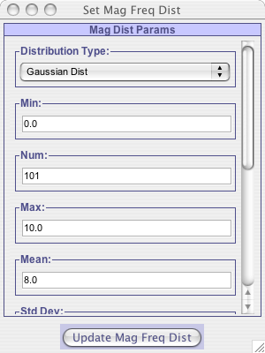
Fig – 7(a)(b): Mag Dist Params window that pops up when user clicks
on “Set Mag Dist Params” in Fig – 7. This window allows to adjust
parameters for Magnitude Frequency Distribution.

Defining Custom Earthquake Rupture
If user wants to define his own custom rupture, he/she can do so by selecting “Custom Eqk Rupture” from “Select method of getting EqkRupture”. Once user has done this he/she has the option of either working with “Point Source Rupture” or “Finite Source Rupture”.

Finite Source Rupture
As shown in Fig – 8, user can define his own Finite source rupture by setting the values for magnitude, rake and fault surface. When user clicks on “Set Fault Surface” , window pops up as shown in Fig – 7(a)(a), which allows user to define fault surface for the earthquake rupture. User can also set the Hypocenter location for the earthquake rupture by “Checking” the “Set Hypocenter Location” which allows user to select a hypocenter location.

Point Source Rupture
As shown in Fig – 9, user can define his own Point source rupture by setting the values for Magnitude, Rake, dip and Location of this rupture. When user clicks on “Location” button, a window will pop up, as shown in Fig – 9 (a), which allows user to input the location for this point source rupture. Though it provides user with the option of setting the Hypocenter Location but it will be same as Point source rupture location.
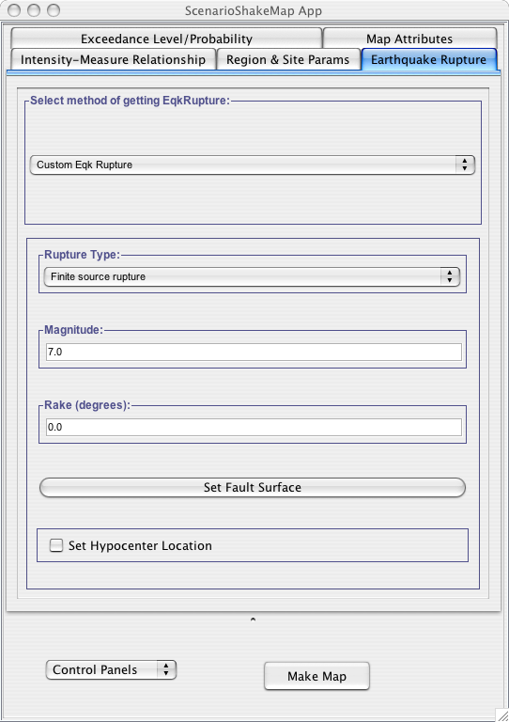
Fig – 8: Figures shows how user can define his own custom rupture. User can choose to create either a “Point source rupture” or “Finite source rupture” by making his selection from “Rupture Type”.
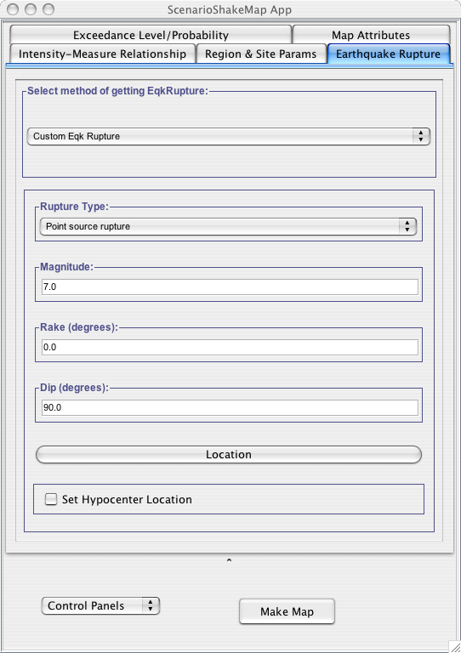
Fig – 9: Defining a point source rupture for Custom Eqk Rupture.

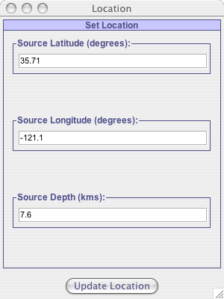
Fig 9(a): This window gets popped up when user clicks on the Location
Button in Fig – 9. This window allows user to input the location for the
Point source rupture.

- Exceedance Level/Probability: This panel becomes visible when user clicks on the Exceedance Level/Probability tab in the application. This provides the user with option of generating Scenario Shakemaps for either of following:

  - IML@Prob: It will generate shakemap for Intensity Measure Level for selected region which will be exceeding the probability of 50% if this earthquake rupture occurs, as shown in Fig – 10.
  - Prob@IML: It will generate probability scenario shakemap after finding the probability of each site in the region that will exceed the given intensity measure level, as shown in Fig – 11.

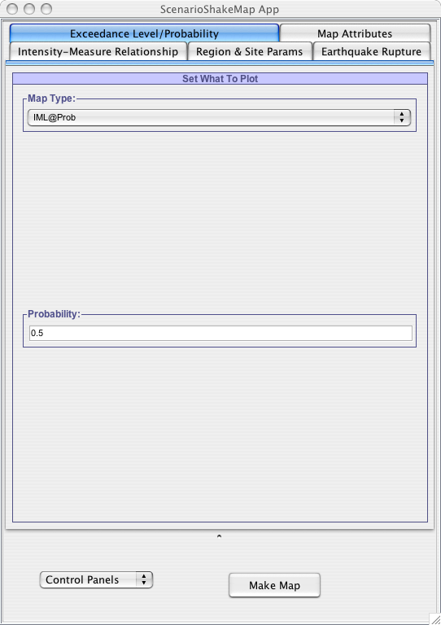
Fig – 10: Choosing to generate Scenario Shakemap for Intensity Measure Level that exceeds the probability of 50%.

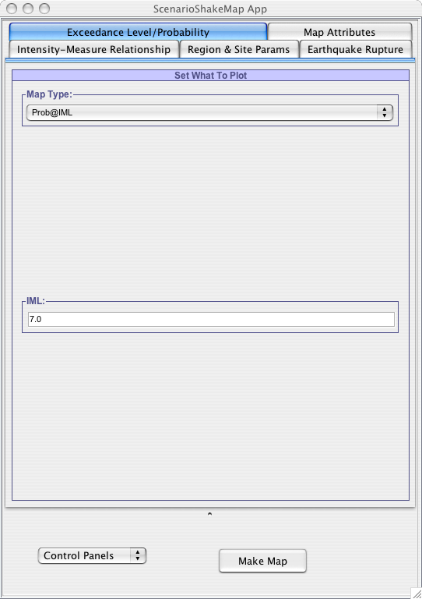
Fig – 11: Choosing to plot probabilistic Scenario Shakemap for what probability the intensity measure level will exceed 7.

- Map Attributes: This panel becomes visible when user clicks on the “Map Attributes” tab in the main application. Parameters within this panel help the user in specifying the map image setting which is produced using the GMT(Geographic Mapping toolkit) script.
As shown in Fig – 12, user can set the Color Scheme for the map image. Following are the color schemes supported in our framework :

- MaxSpectrum :???? (Color range)
- STEP : ???? (Color range)
- Shakemap : ???? (Color range)

User can specify color scale limits either from the data itself or can set it manually by making choice from “Color Scale Limits” parameter.

He/she can also specify which topographic file to use(3 sec grid spacing, 6 sec gridspacing, 18 sec grid spacing, etc). Currently we only have topographic data for California region. User can make his/her choice about the topographic file by selecting from parameter “Topo Resolution (arc-sec)”.
If user wants to plot Highways in his Scenario shakemap, he/she can make that choice from “Highways in plot” parameter.
He/she can specify how coastline to be shown in the map image by selecting from parameter “Coast”.
Image width can be specified using “Image Width(inches)” parameter.
User can choose to add the Rupture surface in the map image by selecting from “Rupture-Surface Plotting” parameter. This will create a discrete boundary in the region for the earthquake rupture surface.

Above specified parameter values are used in creating the GMT script that will eventually create the map image.

Apart from above specified parameters user has the option of either generating the Scenario shakemap of the linear values or log values. If user chooses to generate the Log Plot then “Plot Log” parameter must be “Checked”, it will then convert convert all the data values to Natural Log values, then create the Scenario shakemap of these log values.

“Use GMT WebService” parameter should always be checked so that application can use GMT on the server, else it will try to find on the local machine where this application is running. User does not have to worry about this parameter, as long “Select Map Calculation Method” from “Controls Panels” at the bottom of the application has be set to “Use Server”. As long as it is selected all the computation and map generation will be performed on the server. Refer to section - ????

Using this application user can generate Hazus Shape files that goes inside the Hazus software for loss estimation. If the parameter “Generate Hazus Shape Files” parameter is checked then application will generate Hazus shape files for the selected IMT(Intensity Measure Type).

Note : This application generate Hazus shapefiles which cannot be imported directed to Hazus-MH. They have to be first converted to files that Hazus-MH can accept using Arc-GIS. But shapefiles generated using this application can be imported directly to earlier version of Hazus, it is just these files have to converted to format that Hazus-MH understands.

If user has chosen to generate the shapefiles for Hazus then “Plot Log” option must be unchecked because shape files can only be generated for the linear data values. So if both “Plot Log” and “Generate Hazus Shape Files” options are checked user application will throw Error Message back to user saying that “You cannot make Hazus Shapefiles with log-plot selected! ”.

This application provides very user-friendly error messages so user understands what went wrong in the application. Even after user has provided some incorrect inputs in the application, he/she will be prompted with error message, describing the nature of the error. Once user is notified with the error, he/she can correct the input and redo the calculations. Once an error message is thrown by the application, it will remain in the same state until user fixes the error. But if application does crash due to some reason, a window (Bug Report window) will launched that will allow user to send email to the OpenSHA group describing the problem and what was user trying to do when the exception occurred.
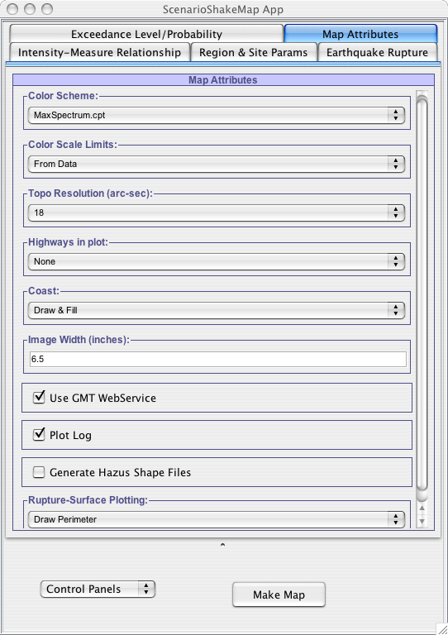
Fig – 12: Setting the values for the parameters that are needed to create the GMT (Geographic Mapping Toolkit) script using which Scenario Shakemaps are produced.

Control Panels

This allows user to specify some extra settings in the application. This provides user with options that are not the direct part of SHA but helps in making choices that can reduce the calculation time or automatically set some parameter values in the application. For example: Setting all parameters for “Puente Hills Scenario” by single click.

Following are the control panel that we currently support in our framework:

- Region Of Interest: Fills in the latitudes and longitudes parameter automatically when user select a region of interest from the window as shown in Fig-13.

Though user can enter latitude and longitude range for a region by hand. But this control panel provides user the option of selecting a region of interest from given choices, which will automatically fill in latitude and longitude range, thus saving user from entering region range by hand.

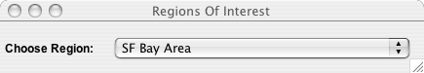
Fig –13: Window that allows to select a region from the given choices.

- Map Calculation Mode: When user chooses the option “Select Map Calculation Option” from the control panels then he/she can decide whether to do the ScenarioShakeMap calculations on the server or on the user’s own local machine, as shown in Fig – 14.
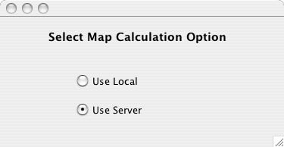
Fig – 14 : Window that allows user to choose if Scenario shakemap calculations have
to be done on server or on user’s own local machine.

- Puente Hills Scenario Settings:

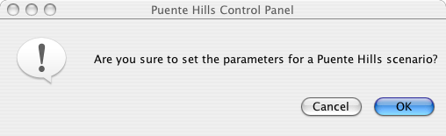
Fig – 15 :

- Calculation Settings:

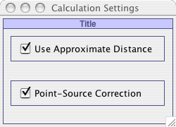
Fig – 15:

- Generating Hazus Shapefiles:

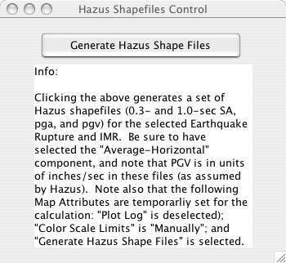
Fig – 16:

Setting values for adjustable parameters

There are different types of adjustable parameters in the application.

- Where user can enter numeric value, most of these parameters have defined min and max values constraints on them. Constraints for these parameters are visible by hovering the mouse over them.
- User can make selection from a list of choices provided to him. These type of parameters don’t allow user to enter any value, choice has to be made from list of choices provided to him.

Once user set the parameter in the GUI, parameter value automatically gets set.

Constraints on the parameters can be 2 types:

- Absolute constraints: If user goes outside this range, exception message will be shown to the user and value of the parameter will be reverted back to the old value. For example see Fig – 16.
- Recommended constraints: If user goes outside this range, window is popped-up asking user if he/she really wants to go with entered value, even though it is not recommended for the model. For example see Fig – 15.

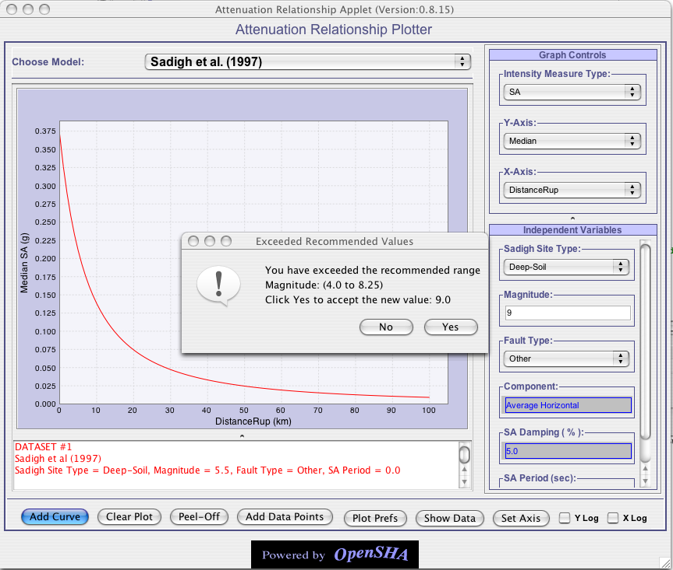
Fig – 15: For Sadigh et al. model user to exceed the range of magnitude defined by model by giving it a value of 9.0 . A window pops up asking user if he/she really wants to violate the recommended range of magnitude defined by this model. If user clicks “Yes” the value will be set inside the parameter.

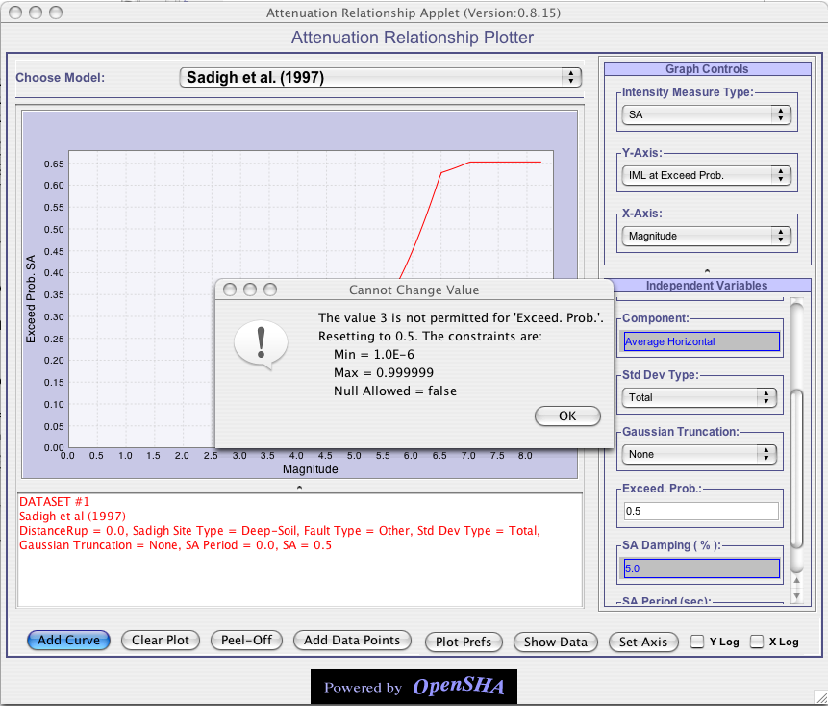Fig – 16: For Sadigh et al. Model user tries to give independent parameter “Exceed Prob.” a value of 3 , which is violating the absolute constraints on the parameter, thus reverts back the parameter value to original.

