SOLUTIONS ARCHITECTURE DOCUMENT
Appian Cloud Platform
Digital Forms & Workflow Automation for a Regulated Enterprise

Focus areas: SSO • Email Relay • Access & Custom Domain • Observability & Splunk • Reporting • Patching • CI/CD

Version 9.0 (Draft for Review)
Prepared: 22 July 2026
Classification: Internal — Confidential

Document Control

Version history
Version | Date | Author | Summary of change
0.1 | 2026-07-18 | Solution Architect | Initial skeleton and scope
1.0 | 2026-07-22 | Solution Architect | First complete draft (SSO, email, network, security)
2.0 | 2026-07-22 | Solution Architect | Added observability/Splunk, reporting, patching & testing, CI/CD
3.0 | 2026-07-22 | Solution Architect | Added end-user access model (VPN postures) and custom domain requirements
4.0 | 2026-07-22 | Solution Architect | Added architecture diagram, user personas, GitLab CI/CD, and Appian documentation references
5.0 | 2026-07-22 | Solution Architect | Added CI/CD deployment service account and Splunk HEC ingestion option
6.0 | 2026-07-22 | Solution Architect | Added Concept Primers appendix (SPF/DKIM/DMARC, DNS resolution, DDAA/DDSS) with explanatory figures
7.0 | 2026-07-22 | Solution Architect | Revised long-term retention for no-S3 constraint: network-drive options by Splunk edition (Cloud & Enterprise)
8.0 | 2026-07-22 | Solution Architect | Decoupled long-term archive from Splunk (90-day tier only); archive fed from the Appian stream to NAS at the receiver
9.0 | 2026-07-22 | Solution Architect | Added §9.2.2 customer-hosted receiver options/resilience (platform-agnostic) and Figure 2; renumbered appendix figures

Reviewers & approvers (to be completed)
Role | Name | Responsibility | Status
Enterprise Architect | «TBD» | Architecture assurance | Pending
Security / GRC Lead | «TBD» | Security & compliance sign-off | Pending
Network Engineering | «TBD» | VPN & connectivity approval | Pending
Messaging / Email Admin | «TBD» | Relay configuration approval | Pending
Observability / SecOps | «TBD» | Splunk integration & retention approval | Pending
Appian Platform Owner | «TBD» | Product, patching & CI/CD owner | Pending

Placeholder convention
Text shown as «TBD» or «placeholder» must be replaced with organisation-specific values (domains, IP ranges, IdP, index names, repository URLs) before this document is baselined.

Contents
Document Control 2
Version history 2
Reviewers & approvers (to be completed) 2
Contents 4
1. Executive Summary 6
2. Scope, Assumptions & Constraints 6
2.1 In scope 6
2.2 Out of scope 7
2.3 Assumptions 7
2.4 Constraints 7
3. Solution Context 7
3.1 User personas 7
3.2 System actors 8
3.3 Conceptual integrations 8
4. Logical Architecture 9
4.1 Architecture diagram 9
4.2 Component / flow view 9
5. Identity & Access — SAML Single Sign-On 10
5.1 Authentication flow (SP-initiated) 10
5.2 Configuration summary 10
5.3 Design considerations 11
6. Email Architecture — Corporate Relay Integration 12
6.1 Option A — Appian Cloud email-as-a-service (default) 12
6.2 Option B — Corporate email relay via custom SMTP (recommended) 12
6.2.1 End-to-end message flow 12
6.2.2 Domain authentication (SPF / DKIM / DMARC) 12
6.3 Inbound email (if required) 13
7. Network & Connectivity 13
7.1 Backend connectivity — site-to-site VPN 13
7.2 End-user access model 14
7.3 Custom domain name 14
7.3.1 Requirements 14
7.3.2 DNS resolution patterns 15
8. Security & Compliance 15
9. Observability, Logging & Monitoring 16
9.1 Log aggregation into Splunk 16
9.1.1 Integration pattern 16
9.1.2 Ingestion methods: syslog streaming and HTTP Event Collector (HEC) 16
9.2 Retaining logs beyond 90 days 17
9.2.1 The decoupled archival flow 17
9.2.2 Customer-hosted receiver — options and resilience 18
9.3 Dashboarding 20
9.4 Alerting on service-level metrics (availability, etc.) 20
9.5 Operational runbooks 21
10. Reporting 22
10.1 How Appian supports reporting 22
11. Platform Maintenance — Patching & Testing 22
11.1 Appian's patching model 22
11.2 Shared responsibility 23
11.3 Testing approach 23
12. CI/CD & Environment Promotion 24
12.1 Environment strategy 24
12.2 Appian deployment mechanisms 24
12.3 Defining configuration in Dev/Test and promoting to Production 24
12.4 Pipeline orchestration 25
12.5 Deployment authentication (service account) 25
13. Risks & Mitigations 27
14. Design Decision Log 27
15. Appendix 28
15.1 Glossary 28
15.2 Open items to confirm before baseline 28
15.3 Appian documentation references 30
Supplementary references (Splunk) 31
16. Concept Primers 32
16.1 Email authentication — SPF, DKIM and DMARC 32
16.2 DNS resolution and the custom domain 33
16.3 Splunk long-term retention — the decoupled model 33

1. Executive Summary
This document defines the target solution architecture for adopting Appian Cloud as the enterprise platform for digital forms and workflow automation within a tightly controlled, regulated IT environment. It describes how Appian Cloud integrates with the organisation's identity, email, network, observability and delivery controls, and records the design decisions and risks that underpin those integrations.
User authentication is delegated to the corporate identity provider using SAML 2.0 single sign-on. All notification and approval email generated by Appian workflows is routed through the corporate email relay over a site-to-site VPN, so that outbound mail is subject to the same data-loss-prevention, anti-malware, journaling/archiving and domain-authentication controls as any other corporate email.
Beyond those integrations, this version adds the operational architecture required to run Appian in a regulated setting: log aggregation and dashboarding in the enterprise Splunk platform (with options to retain logs beyond the standard 90-day window), alerting on service-level metrics such as availability, common reporting scenarios and how Appian meets them, the platform's patching and testing model, and a customer-owned CI/CD approach for promoting configuration from development through test to production.
Key architectural decisions at a glance
SSO: SAML 2.0 (SP-initiated); Appian is Service Provider, corporate IdP is Identity Provider; signed assertions, SHA-256.
Email: Outbound routed to the corporate relay via custom SMTP over a site-to-site VPN tunnel (set up with Appian Support).
Access & URL: end-user access posture selected (public+SSO / trusted-IP / inbound-over-VPN); custom domain forms.corporate-domain.com resolved via corporate DNS.
Observability: Appian Cloud Log Streaming pushes logs to a syslog receiver feeding Splunk (with HEC for application events); dashboards and alerts built there.
Log retention: Splunk = 90-day searchable tier only; long-term archive decoupled onto a network drive (NAS), fed from the Appian log stream at the receiver (AWS S3 excluded).
Patching: Appian patches the platform, OS and Java via hotfixes and quarterly upgrades in scheduled maintenance windows; customer owns application regression testing.
CI/CD: Customer-owned GitLab pipeline using Appian's Deployment REST API, Compare & Deploy and version control, promoting packages Dev → Test → Prod; authenticated by a per-environment Appian service account (API key / mTLS).

2. Scope, Assumptions & Constraints

2.1 In scope
- Logical and integration architecture for Appian Cloud (SaaS) within the regulated environment.
- SAML-based single sign-on with the corporate identity provider.
- Outbound email design: routing of task, notification and approval email through the corporate email relay.
- Network connectivity required to support secure email relay and platform access.
- Observability: log aggregation and dashboarding in Splunk, long-term log retention, and alerting on service-level metrics.
- Reporting scenarios and how Appian addresses them.
- Platform patching and testing, and a customer-owned CI/CD and environment-promotion approach.
- Security, compliance and operational considerations relevant to a regulated industry.

2.2 Out of scope
- Detailed application/process design of individual Appian solutions (forms, records, process models).
- Data model and integration design for line-of-business systems beyond email, identity and logging.
- Procurement, licensing and commercial terms with Appian and Splunk.
- End-user training and organisational change management.

2.3 Assumptions
- Appian Cloud is licensed and provisioned by Appian, hosted on Appian's cloud infrastructure with a customer-selected region.
- A corporate SAML 2.0 identity provider (e.g. Microsoft Entra ID, Okta, PingFederate or ADFS) is available.
- A corporate email relay (smart host) can accept, inspect and forward mail from an internal source.
- An enterprise Splunk platform exists with a standard 90-day searchable retention policy and a syslog ingestion path.
- The organisation can establish a site-to-site IPSec VPN with the Appian Cloud environment via Appian Support.
- GitLab is available as the corporate source-control and CI/CD pipeline platform.
- Corporate DNS (internal and/or external) can publish the records required for email authentication and for the Appian custom domain.

2.4 Constraints
- As SaaS, certain low-level configuration (custom SMTP, VPN, log streaming) is applied by Appian Support rather than self-service.
- Regulatory obligations require outbound communications and audit logs to be retained, inspectable and, in some cases, held well beyond 90 days.
- Public exposure of internal messaging, logging or delivery infrastructure is not permitted; private connectivity is mandated.

3. Solution Context
Appian Cloud is a low-code process automation platform delivered as managed SaaS. In a regulated enterprise it must behave as a well-governed tenant of the corporate control plane: authenticating through corporate SSO, sending mail through corporate messaging, forwarding its logs into corporate observability, and being changed only through governed, auditable pipelines.

3.1 User personas
Four human personas interact with the platform. Their numbers and duties drive the access model, the SSO group design and the permissions applied to each Appian role.
Persona | Population | Responsibilities | Appian touchpoints
Platform Administrator | 1–2, whole platform | Administer the platform: SSO, environments, configuration, deployments | Admin Console; deployment governance
Functional Administrator | 2–3 per functional area | Define forms and workflows; extract reports | Designer; record/report tooling
Business Operations User | Few, whole platform | Review form templates, check for sensitive data elements, and publish templates | Template review & publishing; governance views
End User | Many | Receive tasks; approve/reject actions | Task list / records via SSO; email notifications

3.2 System actors
Actor | Role
Corporate IdP | Authenticates users, enforces MFA/policy, issues signed SAML assertions
Corporate email relay | Inspects, signs and forwards outbound mail
Splunk platform | Aggregates streamed logs; dashboards, alerting and retention
GitLab | Source control and CI/CD pipeline for versioned application packages
Appian deployment service account | Non-human Appian account (per environment) the GitLab pipeline uses to call the Deployment API via API key / OAuth / mTLS; outside SAML SSO

3.3 Conceptual integrations
User → Appian Cloud ↔ Corporate IdP (SAML SSO)
Appian Cloud → Corporate Email Relay → Recipients (SMTP over VPN)
Appian Cloud → Syslog receiver → Splunk (Log Streaming; dashboards & alerts)
GitLab source control + CI/CD → Appian Dev → Test → Prod (Deployment REST API / Compare & Deploy)

4. Logical Architecture

4.1 Architecture diagram
The diagram below shows the user personas, the Appian Cloud tenant and its subsystems, the corporate environment (identity, email relay, Splunk and GitLab), and the connectors between them. Cross-boundary email and log traffic is carried over the site-to-site VPN; SSO and CI/CD deployment calls are over HTTPS. The relay delivers DKIM-signed mail onward to recipient mailboxes.
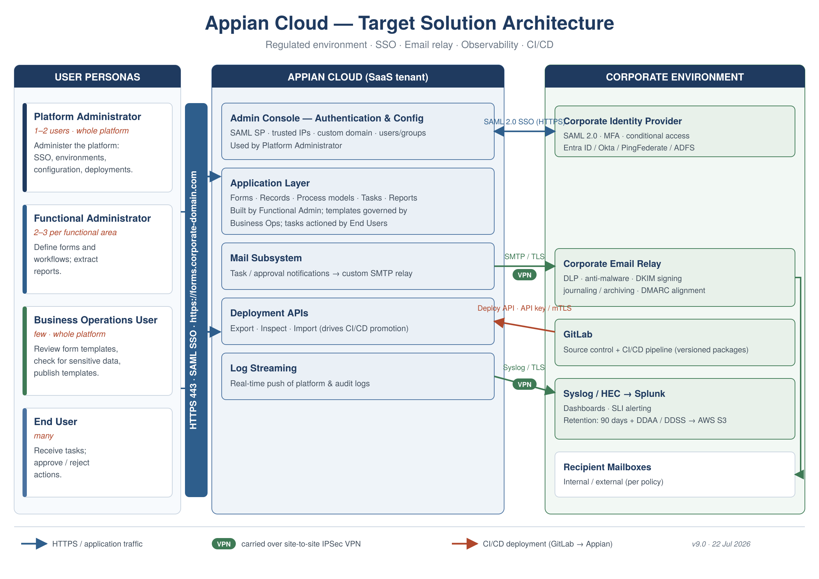
Figure 1 — Appian Cloud target solution architecture

4.2 Component / flow view
The table below sets out the major logical components and the trust boundaries between the Appian Cloud tenant and the corporate environment.
Zone | Component | Role
Appian Cloud (SaaS) | Appian application layer | Forms, records, process models, task assignment
Appian Cloud (SaaS) | Appian mail subsystem | Generates outbound notifications; routes SMTP
Appian Cloud (SaaS) | Admin Console — Authentication | SAML SP config, group sync, attribute mapping
Appian Cloud (SaaS) | Deployment APIs / Log Streaming | CI/CD automation endpoints; log push to syslog
Boundary | Site-to-site IPSec VPN | Private, encrypted path for SMTP and (optionally) logs
Corporate | Email relay / smart host | DLP, AV, DKIM signing, journaling, delivery
Corporate | Identity provider (IdP) | Authentication, MFA, SAML issuance
Corporate | Syslog receiver + Splunk | Log aggregation, dashboards, alerting, retention
Corporate | GitLab (source control + CI/CD) | Version control and promotion pipeline

Trust boundary principle
Appian Cloud is an external trusted tenant. It authenticates against — but never becomes — the identity source of truth, hands every outbound message to corporate messaging, forwards its logs into corporate observability, and is changed only through governed pipelines. All cross-boundary traffic is encrypted.

5. Identity & Access — SAML Single Sign-On
Authentication is delegated to the corporate identity provider using SAML 2.0. The user is the Principal, Appian is the Service Provider (SP) and the corporate IdP is the Identity Provider. Appian supports SAML 2.0 with the SHA-256 signature algorithm and requires signed assertions — an unsigned assertion is rejected. [R4]

5.1 Authentication flow (SP-initiated)
- The user navigates to the Appian Cloud URL and is unauthenticated.
- Appian (SP) generates a signed SAML request and redirects the browser to the corporate IdP.
- The IdP authenticates the user, applying MFA and conditional-access policy.
- The IdP returns a signed SAML assertion to Appian's Assertion Consumer Service (ACS) URL.
- Appian validates the signature, maps attributes to an Appian user, and establishes the session.
- Single logout can be configured so sign-out is coordinated with the IdP.

5.2 Configuration summary
Setting | Value / approach
Protocol | SAML 2.0, SP-initiated SSO
Service Provider | Appian Cloud environment (per environment)
Identity Provider | Corporate IdP — «Entra ID / Okta / PingFederate / ADFS»
Signature algorithm | SHA-256; signed assertions mandatory
SP signing certificate | PEM certificate uploaded to Appian; trusted by the IdP
Metadata exchange | Appian SP metadata to IdP; IdP metadata to Appian
Attribute mapping | IdP attributes mapped to Appian identity attributes
Group synchronisation | Optional group-membership sync for authorisation
Multiple IdPs | Supported; per-IdP settings can differ
Validation | Use Admin Console 'Test This Configuration' before enabling

5.3 Design considerations
- Configure SSO independently per environment (Dev / Test / Prod), each with its own SP metadata and certificate.
- Prefer IdP-driven provisioning/de-provisioning so joiner/mover/leaver processes govern Appian access.
- Do not manually edit IdP metadata before uploading, as this can lock users out.
- Retain a secured, audited break-glass administrator path in case SSO is misconfigured or the IdP is unavailable.
- Track SP and IdP certificate expiry and build renewal into operational runbooks.

6. Email Architecture — Corporate Relay Integration
Appian workflows generate outbound email for task assignment, notifications and approval requests. Appian Cloud offers two outbound-mail modes; the recommended design for this regulated environment uses the second.

6.1 Option A — Appian Cloud email-as-a-service (default)
By default, Appian Cloud sends mail directly from its own email-as-a-service infrastructure. DKIM signing is configured for Appian-owned domains (such as appiancloud.com) by default. For a custom sending domain, DKIM signing can be configured from the Administration Console. Appian's sending IP addresses are published in Appian's SPF records and are subject to change. [R2, R3]
Why Option A is not recommended here
Mail bypasses corporate DLP, anti-malware, journaling and archiving controls required in a regulated context.
Sender reputation and IP space are Appian's, not the organisation's; SPF depends on Appian-published (changeable) IPs.
Limited corporate visibility and control over message content leaving the enterprise.

6.2 Option B — Corporate email relay via custom SMTP (recommended)
Appian is configured to route all outbound SMTP to a nominated smart host — the corporate relay. Appian is given the IP, hostname or FQDN of the SMTP server; multiple servers may be listed comma-separated and are tried in order, with mail sent via the first available (failover). The connection supports SMTP authentication and TLS: STARTTLS can be enabled (with fallback) or required, and SMTPS is supported. [R1]
Crucially for a cloud tenant, Appian Cloud supports routing outbound email over a VPN tunnel between the Appian Cloud environment and the SMTP server. Because this is managed SaaS, the custom SMTP host and VPN are configured in coordination with Appian Support. [R1, R6]

6.2.1 End-to-end message flow
- An Appian process sends mail (task notification or Send E-Mail smart service) with a From address on the corporate domain.
- Appian opens an authenticated, TLS-protected SMTP session to the corporate relay across the VPN tunnel.
- The relay applies corporate controls: anti-malware, DLP, content policy, journaling/archiving.
- The relay DKIM-signs with the corporate domain and ensures SPF/DMARC alignment.
- The relay delivers to internal and, where permitted, external recipients.
- The recipient clicks the task link, driving an SP-initiated SAML login back into Appian.

6.2.2 Domain authentication (SPF / DKIM / DMARC)
Mechanism |  | Where anchored (Option B) | Action
From domain |  | Corporate sending domain | Set Appian From address to a corporate-domain address
SPF |  | Corporate DNS | Authorise the corporate relay/egress hosts
DKIM |  | Corporate relay | Relay signs with corporate domain key in DNS
DMARC |  | Corporate DNS | Publish/observe policy; ensure alignment via relay signing
Why Option B fits a regulated environment
Every outbound message passes through corporate DLP, AV, journaling and archiving.
Mail is sent from, and DKIM-signed by, the corporate domain, aligning cleanly under DMARC.
The relay is never exposed publicly; Appian reaches it only over the encrypted VPN tunnel.
Failover is built in via multiple comma-separated SMTP hosts.

6.3 Inbound email (if required)
If a workflow must be triggered by inbound email, note that inbound routing works differently on Appian Cloud and the cloud infrastructure polls only a single mailbox; additional mailbox polling requires a custom mail server. Confirm inbound design with Appian Support if in scope. [R6]

7. Network & Connectivity
Two distinct connectivity concerns are addressed here: the backend, server-to-server paths between Appian Cloud and corporate infrastructure, and the way normal end users reach the platform. They use different mechanisms and should not be conflated — the site-to-site VPN is a backend path, not the route ordinary users take.

7.1 Backend connectivity — site-to-site VPN
A site-to-site IPSec VPN is the recommended mechanism for private connectivity between Appian Cloud and corporate infrastructure (the email relay and, where chosen, the syslog receiver), established via Appian Support. This tunnel carries server-to-server traffic only. [R13]
Source |  | Destination | Port / protocol | Purpose
Appian Cloud |  | Corporate relay (via VPN) | 587/465/25 TCP, TLS | Outbound workflow email
Appian Cloud |  | Syslog receiver (via VPN) | 514/6514 TCP (TLS) | Log streaming to Splunk pipeline
User browser |  | Appian Cloud (HTTPS) | 443 TCP | Application access (see 7.2)
CI/CD tooling |  | Appian deployment APIs | 443 TCP | Automated deployments
Appian Cloud |  | Corporate IdP endpoints | 443 TCP | SAML exchange (browser redirects)
Reachability note
Over the VPN, corporate endpoints are presented to Appian by private addresses resolvable within the tunnel. Agree routing, DNS and any NAT with network engineering and Appian Support during setup. HA conversion with VPN is typically staged across two maintenance windows so connectivity is validated before nodes are enabled.

7.2 End-user access model
Normal end users reach Appian Cloud with a browser over HTTPS (443); they do not traverse the site-to-site VPN. Whether a user-facing VPN is involved is a deliberate hardening decision. Three postures are available and combine with the custom domain in 7.3. [R12, R13]
Posture |  | How users reach Appian | VPN for users? | Notes
Public, SSO-gated (default) |  | HTTPS to the environment URL; secured by SAML SSO, MFA and conditional access | No | Simplest; environment reachable from the internet (authentication-gated)
Trusted-IP allowlisting |  | HTTPS, but only from nominated corporate IP ranges; other sources are refused | Usually yes | Appian Support enables trusted IPs; off-network users connect the corporate VPN to egress from an allowlisted IP
Inbound access over VPN (private) |  | HTTPS to the FQDN, which resolves to the environment's private IP over the tunnel | Yes | Not reachable from the public internet; users must be on the corporate network/VPN
Choosing a posture
Public + SSO is easiest but exposes the environment to the internet (still authentication-gated).
Trusted-IP allowlisting keeps public reachability but restricts source IPs — users off-network need the corporate VPN.
Inbound-over-VPN removes public reachability entirely — strongest, but external approvers, mobile and BYOD become harder and must be planned for.
Regulated deployments commonly choose allowlisting or inbound-over-VPN; record the choice as decision D9.

7.3 Custom domain name
Appian Cloud supports a custom (vanity) domain, so the environment can be reached at an address such as https://forms.corporate-domain.com instead of the default appiancloud.com URL. This is enabled by Appian Support and requires a matching TLS certificate and DNS records; the DNS pattern depends on the access posture chosen in 7.2. [R14, R15]

7.3.1 Requirements
- TLS certificate: a certificate covering the custom FQDN(s). Appian Support provides a CSR covering your environments; you have it signed by your CA and upload the signed certificate and chain of trust, which Appian deploys. Renewals can be handled through MyAppian self-service certificate management, and adding an FQDN later means a new certificate covering the existing plus new names.
- DNS records: created in your DNS infrastructure to resolve the FQDN — the record type and target depend on the access mode (see 7.3.2).
- Maintenance window: configuring a new or changed custom domain requires Appian to restart the environment in a scheduled window; certificate-only renewals with no domain change need no downtime.
- SSO & email alignment: the SAML SP entity ID / ACS URL and the links embedded in workflow emails should use the custom domain, so SSO configuration and the email From/links stay consistent with forms.corporate-domain.com.

7.3.2 DNS resolution patterns
Access mode (from 7.2) |  | DNS record | Resolves to
Public access |  | CNAME in external/public DNS for the FQDN | Appian Cloud load balancer DNS name provided by Appian Support
Inbound over VPN (private) |  | Host record in your internal corporate DNS | Private IP assigned to the environment during VPN configuration
Dual access |  | Split-horizon: external DNS + internal DNS | Public load balancer externally; private IP internally
Reverse-proxy (optional) |  | CNAME to your CDN/WAF | Your service, which proxies to the Appian Cloud load balancer
Custom domain with internal DNS (this environment)
Where corporate-domain.com is maintained on the corporate internal DNS servers and access is private (inbound-over-VPN), internal DNS holds a host record resolving forms.corporate-domain.com to the environment's private IP over the tunnel. Users on the corporate network/VPN reach the friendly URL and the environment is not published to the public internet.
For dual access, use split-horizon DNS: the same FQDN resolves to the public load balancer for external users and to the private IP for internal users.
If a custom mail server is used, CNAME expansion must be disabled in the environment (per Appian KB-1394).

8. Security & Compliance
Domain | Control in this design
Authentication | Corporate SSO via SAML 2.0; MFA and conditional access at the IdP; signed assertions only
Authorisation | Group-based access driven from the IdP; least-privilege Appian roles
Data in transit | TLS/HTTPS for access; TLS SMTP and TLS syslog over IPSec VPN
Email governance | All outbound mail inspected by corporate DLP/AV and journaled/archived at the relay
Observability | Platform logs aggregated in Splunk for monitoring, alerting and forensic retention
Auditability | IdP sign-in logs, Appian audit logs and relay/message logs give end-to-end traceability
Change control | Governed CI/CD with versioned packages and approvals across environments
Data residency | Appian Cloud region selected to meet residency obligations
- Confirm Appian Cloud's applicable attestations (e.g. SOC 2, ISO 27001, industry-specific programmes) against regulatory needs.
- Ensure email journaling and log archive retention meet records-management and e-discovery obligations.
- Apply DLP to email and monitor logs for regulated or personal data leaving the platform.

9. Observability, Logging & Monitoring
Appian Cloud platform and application logs are aggregated into the enterprise Splunk platform for search, dashboarding, alerting and retention. This section covers how logs reach Splunk, how to retain them beyond the standard 90-day window, how dashboards are built, and how service-level metrics such as availability are alerted on.

9.1 Log aggregation into Splunk
Appian Cloud provides a Log Streaming service that operates on a push model: the Appian Cloud environment streams supported logs in real time to a syslog receiver in the customer's network. From that central point the logs are indexed and correlated by the organisation's SIEM/log-management tooling — Splunk in this case (Appian explicitly lists Splunk, LogRhythm and the ELK stack as downstream targets). Logs are also viewable in-product at ENVIRONMENT_URL/suite/logs. [R5, R6]

9.1.1 Integration pattern
- Request Log Streaming for each Appian environment via an Appian Support Case, specifying the syslog receiver details and the log set to stream.
- Appian pushes logs to the corporate syslog receiver (e.g. a syslog server or Splunk Connect for Syslog / a heavy forwarder) in real time.
- The receiver forwards into Splunk indexes; alternatively an HTTP Event Collector (HEC) or the Appian Splunk connected system can be used for specific event flows.
- Splunk parses, indexes and makes the data searchable for dashboards and alerts.
Aspect |  | Detail
Model |  | Push-based real-time streaming from Appian Cloud
Transport |  | Syslog to a customer-hosted receiver (TLS recommended; carry over VPN where required)
Enablement |  | Per environment, via Appian Support Case; changes to the streamed log set also via Support
Availability |  | Requires a supported success plan and version; certain RDBMS audit logs only stream in single-node or standard 3-node HA topologies
In-product access |  | ENVIRONMENT_URL/suite/logs for direct viewing
Design note — connectivity for logs
Where corporate policy prohibits log egress over the public internet, stream syslog over the same private VPN used for email, or to an internal receiver reachable only within the tunnel. Confirm the receiver address, port and TLS posture with Appian Support at enablement.

9.1.2 Ingestion methods: syslog streaming and HTTP Event Collector (HEC)
Two complementary paths carry Appian data into Splunk. They serve different purposes and can be used together — syslog streaming for platform-level logs and HEC for application-level events. [R5, R6, S3]
Path | What it carries | How it works | Best for
Log Streaming (syslog) | Platform, server and audit logs from the Appian environment | Native Appian Cloud push over syslog to a customer receiver feeding Splunk; enabled via Support | Infrastructure health, security and audit logging
HTTP Event Collector (HEC) | Application / business and process events chosen by the designer | Appian process models / integrations POST JSON events to Splunk's HEC endpoint over HTTPS using a token; no forwarder required | Structured workflow events (e.g. form submitted, approval granted, SLA breach, deployment markers)
HEC uses token-based authentication to an endpoint of the form https://<splunk-host>:8088/services/collector, with the token supplied in an Authorization header and the payload sent as JSON. In Appian this is implemented with an HTTP connected system / integration object (or the Appian Splunk connected system from the AppMarket), so no Splunk credentials are stored in the application. The HEC token is held as an Appian secure/credential value, and — where log egress must stay private — the HEC endpoint is reached over the same site-to-site VPN. [S3]
Choosing syslog vs HEC
Use Log Streaming (syslog) as the baseline for platform and audit logs — it is native, comprehensive and requires no application code.
Add HEC where you want specific, structured business events indexed in Splunk with your own sourcetype/index for dashboards and SLI alerting.
HEC events are application-driven, so they can carry business context (process, case ID, functional area) that platform logs do not.
Both can be carried over the VPN and land in per-environment Splunk indexes.

9.2 Retaining logs beyond 90 days
Splunk is used purely as the 90-day searchable tier; long-term log archival is decoupled from Splunk and fed directly from the Appian log stream. This keeps Splunk's licensing and retention out of the archival question entirely, and avoids AWS S3 (which is not available here) and the Splunk self-storage feature (DDSS), which can only target object storage.
A crucial constraint drives the design: Appian Cloud does not retain its own logs for long. Appian rotates and purges platform logs aggressively — most keep only a handful of old versions, older files are removed within minutes, and the cloud database audit logs are retained only about a week. Appian therefore cannot be treated as an archive that is exported on a schedule; whatever archives the logs must capture the stream as it is produced. Appian's real-time export mechanism is Log Streaming (the syslog push, §9.1), and because Appian Cloud is SaaS there is no filesystem access to write logs to a network drive directly — the customer-hosted receiver is the capture and fan-out point. [R5, R6, R16]

9.2.1 The decoupled archival flow
- Appian streams platform and audit logs (and, optionally, HEC business events) to the customer-hosted receiver in real time.
- The receiver forwards to Splunk, where retention is set to 90 days — the searchable tier for dashboards, alerting and investigations.
- In parallel, the receiver writes a compressed copy of the raw stream to the network drive (NAS); this is the system of record for long-term logs, with its own retention, and is where tamper-evidence (hashing/signing) is applied.
- The NAS archive is independent of Splunk: Splunk can roll data off at 90 days without affecting long-term retention. Archived data is reviewed by loading it into a Splunk instance if search is needed.
Concern |  | Approach in this design
Searchable window |  | Splunk, 90 days only (searchable tier)
Long-term archive |  | Compressed raw logs on the NAS, written by the receiver from the Appian stream
Capture point |  | At ingest on the receiver — required, because Appian purges its own logs quickly
Path to the NAS |  | Receiver → NAS (Appian Cloud is SaaS; no direct filesystem push for platform logs)
Business events (optional) |  | Appian may also POST selected events directly to an archive endpoint via HEC / HTTP
Splunk-side archive |  | Not required; if additionally wanted: DDAA (Cloud) or coldToFrozen-to-NAS (Enterprise). DDSS needs S3 — excluded
Recommendation
Set Splunk index retention to 90 days and treat Splunk as the searchable tier only.
Make the receiver-fed NAS archive the system of record for long-term logs; capture at ingest, compress, and hash/sign for tamper-evidence.
Keep the receiver resilient (buffering, redundancy) and monitor stream continuity — because Appian purges quickly, a capture gap is not recoverable from Appian later.
A Splunk-side archive (DDAA on Cloud, coldToFrozen-to-NAS on Enterprise) is optional and only needed if you also want a Splunk-managed copy; it is not part of the baseline here.
See Figure 5 in §16.3 for a visual of this decoupled flow.

9.2.2 Customer-hosted receiver — options and resilience
The receiver is the capture and fan-out point of the decoupled design: it terminates the TLS syslog stream (and any HEC events) from Appian, buffers it, and delivers to two destinations — Splunk for the 90-day searchable tier and the NAS for the long-term archive. It is a lightweight component and is deliberately platform-agnostic: it can run on a virtual machine (for example on VMware vSphere), on a physical server, or as a container, to match the hosting environment's standards rather than any particular cloud or OS.
Receiver option | Type | Splunk leg | Notes
rsyslog | Syslog daemon | Forward via HEC or a Splunk forwarder | Ships with most Linux; writes compressed files to the NAS via file output; disk-assisted queues; lowest cost, full control
syslog-ng (OSE / PE) | Syslog daemon | Native Splunk HEC destination | File destination to the NAS; PE and the syslog-ng Store Box appliance add vendor support and log-lifecycle management
SC4S (Splunk Connect for Syslog) | Splunk-supported, containerised syslog-ng | HEC (built in) | Splunk-recommended for the Splunk leg; runtime-agnostic (any OCI runtime) and can also run as a VM; add a parallel disk/NAS archive path
Cribl Stream | Observability pipeline / router | Splunk HEC or S2S | Receives once and clones/routes to Splunk and a filesystem/NAS sink; persistent queues, compression, reduction, replay; GUI
Vector | Observability pipeline | Splunk HEC sink | Single efficient binary; syslog source, Splunk + file/NAS sinks, disk buffering; easy to containerise or run on a VM
Fluentd / Fluent Bit | CNCF collectors | Splunk HEC output | File output to the NAS; natural fit in container / Kubernetes estates
NXLog (Enterprise) | Log collector | Splunk output | Windows-friendly and appliance-like; useful where the receiver host is Windows-centric
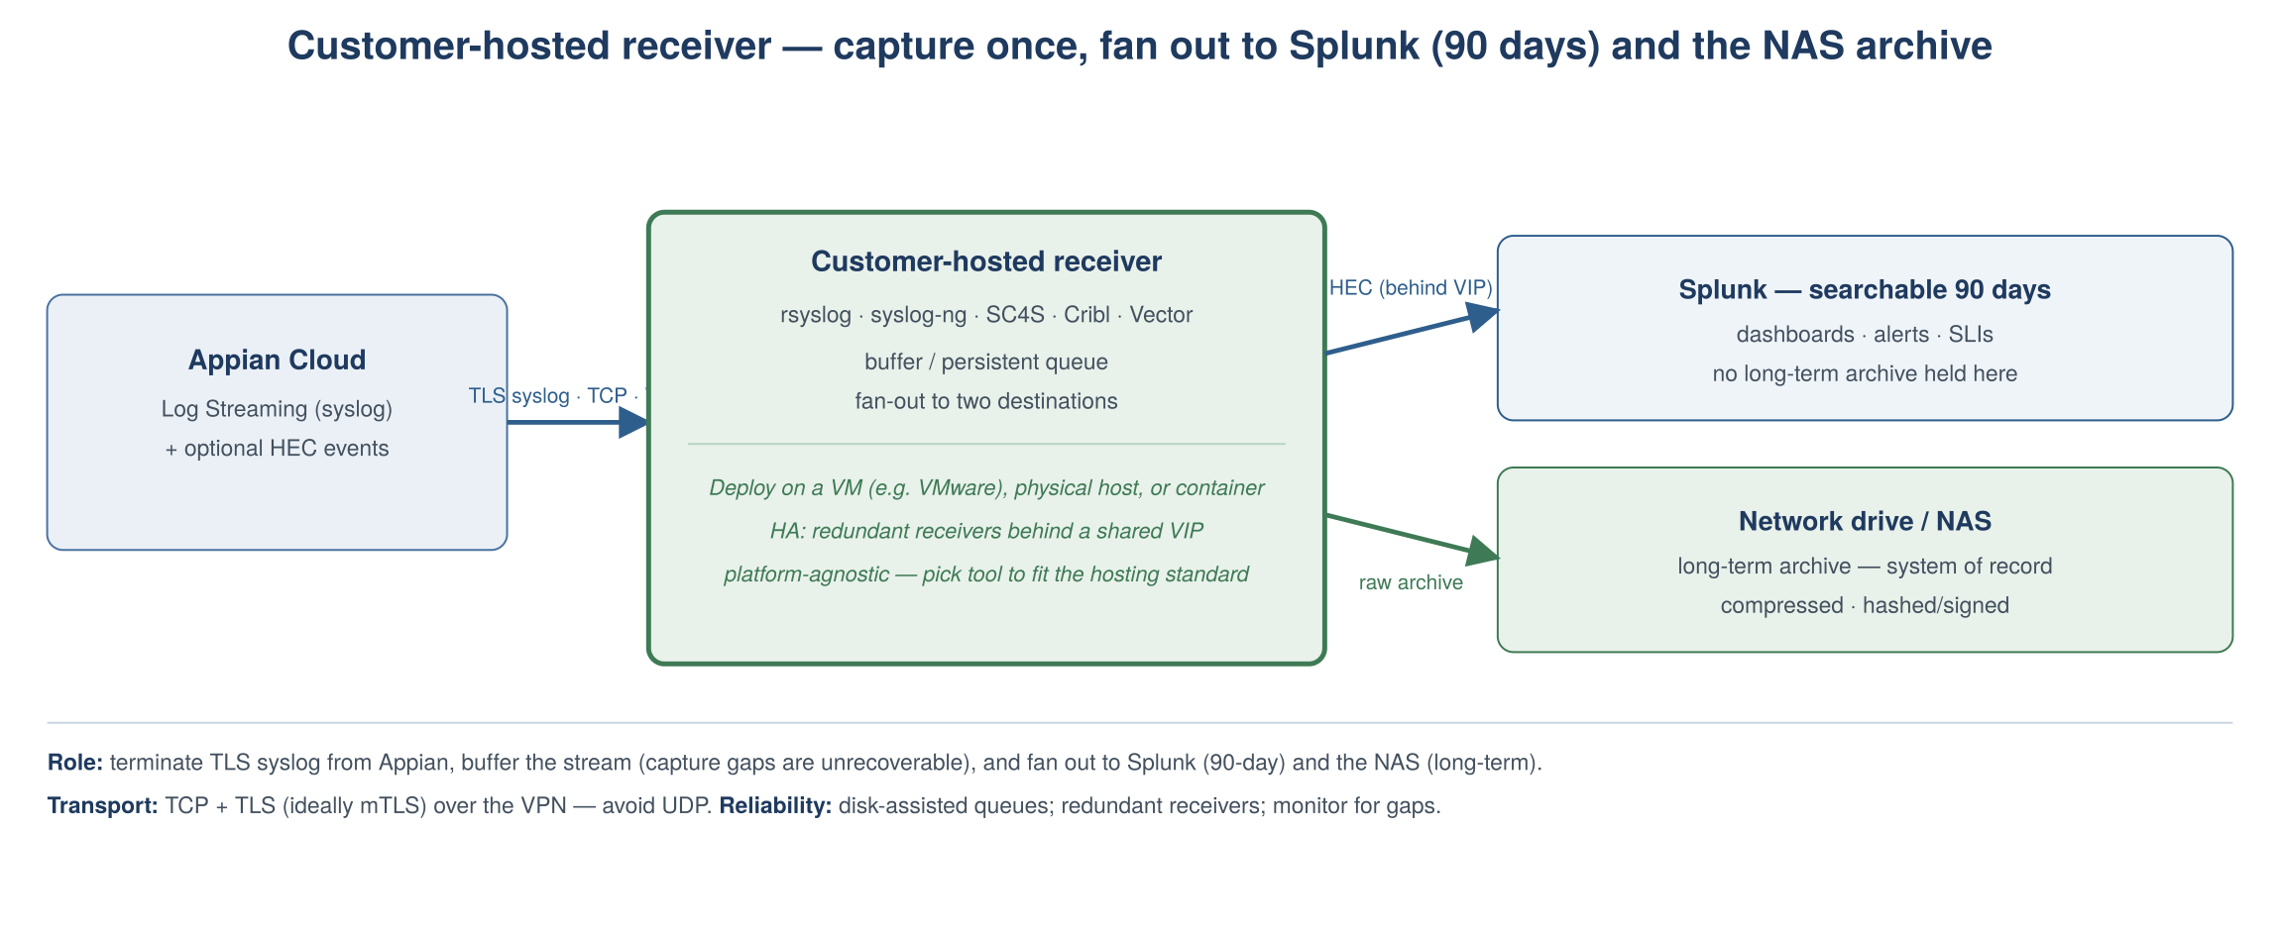
Figure 2 — Customer-hosted receiver: capture once, fan out to Splunk (90 days) and the NAS archive
Deployment & resilience
- Host platform: VM (e.g. VMware vSphere), physical server, or container — chosen to fit the environment's standards. For VMware, VM-level HA (vSphere HA) plus a load balancer / shared VIP is a common pattern.
- Transport: accept TCP syslog with TLS (RFC 5425), ideally mutual TLS, from Appian over the VPN. Avoid UDP — loss is unrecoverable because Appian purges its own logs quickly.
- Buffering: enable disk-assisted / persistent queues sized for expected downstream outages, so a Splunk or NAS blip does not drop data at capture.
- High availability: front redundant receivers with a shared IP / VIP. Note syslog HA is only “mostly available” (no application-level ACK), so keep the scheme simple — OS/VM clustering or a shared IP — and monitor for gaps.
- Splunk leg: prefer HEC behind a load-balanced VIP (round-robin, no sticky sessions).
- Archive leg: compress and hash/sign on write to the NAS for tamper-evidence; apply the archive's own retention policy there.
Recommendation (platform-agnostic)
Pick the receiver tool to fit the hosting standard, not a specific cloud/OS: rsyslog or syslog-ng on a VM is the simplest, lowest-cost option and does both legs natively.
SC4S is the Splunk-blessed choice for the Splunk leg (containerised, or on a VM) with a parallel NAS archive.
Cribl Stream or Vector are strong single-tool routers when you want queues, compression and replay across both destinations.
Whatever the tool, make buffering and gap-monitoring first-class — the receiver is the one place a capture gap cannot be recovered from Appian.

9.3 Dashboarding
Splunk dashboards provide the single pane of glass over Appian. Typical panels include environment availability and error rates, authentication (SAML) successes/failures, email send outcomes and bounces, deployment events from the CI/CD pipeline, and process/integration error trends. Dashboards are built from saved searches over the streamed Appian logs and can be scoped per environment (Dev/Test/Prod) and per application.
- Operational health: uptime, HTTP error rates, response latency, node/HA status signals.
- Security & access: SAML authentication outcomes, admin actions, anomalous access patterns.
- Workflow & email: task volumes, email delivery/bounce outcomes, integration failures.
- Change & delivery: deployment successes/failures and post-deployment process results.

9.4 Alerting on service-level metrics (availability, etc.)
Service-level indicators are alerted through a combination of external synthetic monitoring, Splunk alerting on streamed logs, and Appian's own platform notifications. No single source covers availability fully, so they are layered.
Mechanism |  | What it detects | How alerts fire
Synthetic / uptime monitoring |  | Availability & response time of the Appian URL (best proxy for user-facing uptime) | External prober (e.g. AWS CloudWatch Synthetics canary or corporate uptime tool) triggers on failed probes → email/PagerDuty/ServiceNow
Splunk saved-search alerts |  | Error-rate spikes, auth failures, email bounces, deployment failures in streamed logs | Scheduled/real-time saved searches with threshold conditions → alert actions (email, webhook, ITSM ticket)
Appian platform notifications |  | Scheduled maintenance, upgrades and incidents | Appian emails Authorized Technical Support Contacts in advance / on incidents
Appian Health Check |  | Application-level design & performance health | Periodic health report reviewed by the platform team (advisory, not real-time)
SLI/SLO guidance
Define SLOs for availability (e.g. 99.x% of successful synthetic probes per month) and for key workflow error rates.
Alert on the synthetic signal for user-facing availability; alert on Splunk log signals for internal error conditions.
Route alerts into the corporate on-call/ITSM tool so response is tracked and auditable.

9.5 Operational runbooks
- Certificate lifecycle: monitor and renew SAML SP/IdP certificates and SMTP/syslog TLS certificates ahead of expiry.
- Email deliverability: monitor relay logs, bounce handling and DMARC reports; the mail step cannot itself auto-handle bounce-backs.
- VPN & streaming health: monitor tunnel status and log-stream continuity; alert on gaps; define escalation with Appian Support.
- Deliverability guardrail: excessive spam or high-volume undeliverable mail can cause Appian to apply environment limits (notified via support case).

10. Reporting
Reporting spans two layers: operational/business reporting produced inside Appian from workflow data, and platform/observability reporting produced in Splunk from streamed logs. The table sets out common scenarios and how each is addressed.
Reporting scenario | Typical questions | How Appian (and Splunk) addresses it
Operational process reporting | Task backlog, cycle time, approval turnaround, SLA breaches | Appian Records and record-backed reports; process reports/analytics; interactive dashboards on Appian sites/portals
Management / executive KPIs | Volumes, throughput, trend over time by team/region | Appian dashboards with charts and grids, driven from records and the Appian data store
Compliance & audit reporting | Who did what, when, and with what outcome | Appian process history and audit trails, plus streamed logs retained in Splunk (DDAA/DDSS) for the required period
Availability / service-level reporting | Uptime %, error rates, deployment frequency/success | Splunk dashboards over streamed logs and synthetic-monitoring results; SLO reporting
Ad-hoc & cross-system analytics | Blended analysis across Appian and other systems | Surface Appian data via records/data fabric or export to a data warehouse/BI tool; long-term store for multi-year trends
Regulatory / periodic submissions | Scheduled extracts and formatted outputs | Appian scheduled processes generating documents/exports (e.g. Excel/PDF) delivered via the governed email path

10.1 How Appian supports reporting
- Records & record-backed reports: a governed, secured view over process and business data for self-service reporting.
- Process analytics / process reports: operational metrics on tasks and process instances (cycle time, backlog, SLA).
- Dashboards & sites: interactive charts and grids surfaced to users with role-based security.
- Scheduled generation & export: timer-driven processes produce documents or data extracts, delivered through the corporate email relay.
- Observability reporting in Splunk: availability, error and delivery reporting from streamed logs, retained per policy for audit.

11. Platform Maintenance — Patching & Testing
As a managed SaaS platform, Appian patches the underlying software, operating system and Java runtime; the customer owns testing of its own applications against those changes. This is a shared-responsibility model. [R6, R7, R8, R9]

11.1 Appian's patching model
- Quarterly releases: Appian issues new platform versions quarterly; Cloud customers are upgraded, typically within ~30 days of a release, and each release is supported for about six months.
- Hotfixes: OS security patches, Java updates and defect fixes are delivered as hotfixes applied on restart during maintenance windows. Hotfixes reach non-production first and production roughly a week later; critical fixes can be expedited.
- Maintenance windows: scheduled outside business hours for the hosting region. Authorized Technical Support Contacts are notified in advance (upgrade notifications at least two weeks out).
- Self-managed scheduling: upgrade dates can be viewed and rescheduled via the Cloud Installations site (per Appian KB-1403) or a support case; shared-infrastructure maintenance cannot be rescheduled.

11.2 Shared responsibility
Responsibility | Appian | Customer
Platform / OS / Java patching | Yes | —
Version upgrades & hotfixes | Yes (scheduled) | Approve/reschedule window; monitor notifications
Application regression testing | — | Yes
Environment upgrade sequencing | Yes | Confirm non-prod validated before prod
Custom plug-in compatibility | Cloud-approved plug-in list | Validate plug-ins against new versions

11.3 Testing approach
- Appian applies the upgrade/hotfix to non-production first, giving a window to validate before production.
- The customer runs regression tests against Dev/Test — automated unit tests for rules/expressions, integration tests for process models and integrations, and UI tests for critical flows where warranted.
- Deployment and post-deployment processes are validated (see Section 12) so the pipeline itself is confirmed against the new version.
- On successful non-prod validation, the production maintenance window proceeds; issues are raised with Appian Support and, if needed, the window rescheduled.
Note on data movement
Appian keeps each site's data isolated and does not transfer data between sites; applications move between environments only via application import/export (and the deployment APIs). Test data is therefore managed per environment, not copied from production wholesale.

12. CI/CD & Environment Promotion
The organisation, as the Appian tenant, owns a CI/CD pipeline that promotes application configuration from development through test to production in a governed, auditable way. Appian provides the deployment mechanisms; corporate source control and pipeline tooling orchestrate them. [R10, R11]

12.1 Environment strategy
Environment | Purpose | SSO | Email | Logs
Development | Build & unit test | Dedicated SP config | Relay (test) or sink; non-prod From | Streamed to Dev index
Test / UAT | Integration & acceptance | Dedicated SP config | Relay (test); restricted recipients | Streamed to Test index
Production | Live workflows | Dedicated SP config | Corporate relay via VPN; prod From | Streamed to Prod index

12.2 Appian deployment mechanisms
- Packages: application changes are assembled into a package of objects plus application configuration; related objects are added explicitly or must already exist in the target.
- Compare & Deploy: compares a source and target environment and deploys the differences directly between connected environments.
- Deployment REST API: six endpoints — export, inspect, get inspection results, import, get deployment results, get deployment log — allow a pipeline to fully automate exports, inspections and imports. Enabled on the Admin Console infrastructure page.
- Automated Version Manager (AVM): integrates with a version control system to store and retrieve package files, giving versioning and audit history.
- Post-deployment process: an Appian process that runs automatically after a deployment to perform follow-up tasks or notify external tooling.

12.3 Defining configuration in Dev/Test and promoting to Production
Environment-specific values must not be hard-coded. Appian's import customization file supplies per-environment values (such as connected-system credentials, data source references and constants) at import time, so the same package promotes cleanly across Dev, Test and Production with the correct configuration applied to each.
- Build and unit-test changes in Development; capture environment-specific values as constants / connected systems rather than literals.
- Export the package (via the API or Compare & Deploy) and commit it to source control through AVM for versioning and audit.
- Import into Test/UAT, supplying the Test import customization file so Test-specific endpoints and credentials are applied; run automated and user-acceptance tests.
- Use the inspect endpoint to validate the package against the target before import, catching missing precedents or conflicts early.
- Promote the same versioned package to Production with the Production import customization file, gated by change approval; a post-deployment process handles follow-up and notification.
Concern | Mechanism
Environment-specific config | Import customization file per environment (credentials, data sources, constants)
Versioning & audit trail | Package files stored in source control via AVM
Pre-import validation | Inspect endpoint / inspection results before import
Promotion | Same package Dev → Test → Prod; no rebuild between environments
Governance | Change approval gates production import; deployment logs retained

12.4 Pipeline orchestration
A GitLab CI/CD pipeline (with pipeline artefacts and logs retained per corporate standards) can orchestrate the Appian deployment APIs: on merge to a release branch, the pipeline exports/retrieves the versioned package, calls inspect against the target, imports on success applying the environment customization file, runs post-deployment checks, and records results. Deployment events are streamed to Splunk (Section 9) so releases are visible on the same dashboards as operational health.
- Trigger: merge/tag in GitLab starts the pipeline.
- Stages: export/retrieve package → inspect target → import with env customization → automated tests → post-deployment process.
- Gates: automated test pass + change approval required before the production stage.
- Evidence: deployment logs and results captured and forwarded to Splunk for audit.

12.5 Deployment authentication (service account)
The GitLab pipeline cannot authenticate interactively through SAML SSO, so it uses a dedicated Appian service account rather than a human identity. Appian's deployment endpoints are authenticated with an API key linked to a service account — the same mechanism Appian uses to secure Web API objects — created in the Admin Console and configured to secure external deployments. [R11]
- Per-environment service accounts: a dedicated non-human account (e.g. svc-gitlab-deploy) in each target environment. It authenticates by API key rather than the corporate IdP, so it is outside SAML SSO by design — which is what allows an unattended pipeline to call Appian.
- Admin Console setup: create the service account and generate its API key under Web Authentication; then, under Infrastructure, enable External Deployments and assign the account to the “Authenticate As” and “Deploy As” fields. “Deploy As” is the identity the import runs under, so its rights bound what the pipeline can change.
- Request auth: the key is sent on each call in the appian-api-key header; newer Appian versions also support an OAuth client configuration and mutual TLS (mTLS) with trusted server certificates uploaded to the Admin Console — mTLS is recommended for this regulated environment. [R11]
- Secret handling in GitLab: store each environment's key as a masked, protected CI/CD variable (or fetch it from a secrets manager/vault at run time), scoped so the production key is only available on protected branches.
- Governance: apply least privilege to the “Deploy As” account, rotate API keys on a schedule, and treat the key as the primary control since the account bypasses SSO/MFA. Deployments are attributable to the service account in Appian's deployment logs and streamed to Splunk.
Service account at a glance
One Appian service account + credential per environment (Dev / Test / Prod), used only by the GitLab pipeline.
Auth options: API key (appian-api-key header), OAuth client, or mTLS — prefer mTLS and/or short-lived rotation here.
Keys/certs stored as protected GitLab CI/CD variables or in a vault; never committed to the repository.
Scope 'Deploy As' to least privilege; all deployments are logged under the service-account identity.

13. Risks & Mitigations
# | Risk | Impact | Mitigation
R1 | VPN tunnel outage stops workflow email (and log egress if routed over it) | High | Redundant tunnels/relay hosts (comma-separated failover); monitoring & escalation runbook
R2 | SAML/SP certificate expiry causes login outage | High | Expiry monitoring; renewal runbook; break-glass admin access
R3 | Mail flagged as spam / DMARC failure | Medium | From on corporate domain; DKIM at relay; aligned SPF/DMARC; monitor DMARC reports
R4 | Regulated data leaked via email or logs | High | DLP at the relay; log content review; least-privilege access to Splunk indexes
R5 | Logs exceed 90 days needed for audit but not retained | High | Archive to a network drive (S3 excluded): DDAA + collector tee (Cloud) or coldToFrozen-to-NAS (Enterprise); align archive retention to the compliance requirement
R6 | Log-stream gap loses observability and long-term archive continuity | High | Appian purges its own logs quickly, so a capture gap is unrecoverable; buffer/queue at the receiver, run redundant collectors, monitor stream continuity, and alert on gaps
R7 | Platform upgrade breaks an application | Medium | Non-prod-first upgrades; automated regression tests; reschedule window via Cloud Installations if needed
R8 | Manual/ad-hoc deployments cause config drift | Medium | Automated CI/CD with versioned packages and import customization; no manual prod changes

14. Design Decision Log
ID | Decision | Rationale
D1 | SAML 2.0 SSO with corporate IdP | Centralises authentication, MFA and lifecycle
D2 | Outbound email via corporate relay (custom SMTP over VPN) | Subjects all mail to corporate controls and domain authentication
D3 | Appian Log Streaming into Splunk | Reuses enterprise observability; central dashboards and alerting
D4 | Decouple long-term archive from Splunk; Splunk = 90-day searchable tier only | Long-term logs archived to NAS from the Appian stream at the receiver; keeps Splunk licensing/retention out of archival and avoids S3
D5 | Layered availability alerting (synthetic + Splunk + platform) | No single source covers user-facing uptime; layering closes gaps
D6 | Customer-owned CI/CD via deployment APIs + AVM | Governed, auditable, repeatable promotion with versioned packages
D7 | Import customization files for env-specific config | Same package promotes Dev → Test → Prod without rebuilds or drift
D8 | Non-prod-first testing aligned to Appian's patch model | Validates applications before production upgrades
D9 | «Select» end-user access posture (public+SSO / trusted-IP / inbound-over-VPN) | Balances reachability against regulated-environment exposure requirements
D10 | Custom domain forms.corporate-domain.com via corporate DNS | Branded, stable URL; supports private (VPN) access through internal DNS resolution
D11 | Per-environment Appian service account (API key / OAuth / mTLS) for CI/CD | Lets the GitLab pipeline authenticate outside SAML SSO with least-privilege, auditable identity
D12 | Splunk ingestion via syslog streaming, with HEC for application events | Native platform logging plus structured business/process events, no forwarder
D13 | Capture logs at ingest on the receiver; Splunk-side archive optional | Appian Cloud purges its own logs quickly, so the archive must capture the stream; DDAA (Cloud)/coldToFrozen (Enterprise) only if a Splunk-managed copy is also wanted

15. Appendix

15.1 Glossary
Term | Meaning
SAML / SP / IdP | SSO standard; Service Provider (Appian) / Identity Provider (corporate)
Smart host / relay | Mail server that accepts and forwards outbound mail
SPF / DKIM / DMARC | Email domain-authentication mechanisms
Log Streaming | Appian Cloud push of logs to a customer syslog receiver
DDAA / DDSS | Splunk Dynamic Data Active Archive / Self-Storage (long-term retention)
SmartStore | Splunk index storage backed by an object store (e.g. S3)
AVM | Automated Version Manager — Appian's version-control integration
Compare & Deploy | Appian direct environment-to-environment deployment tool
Import customization file | Per-environment values applied to a package at import
Custom domain / vanity URL | A branded FQDN (e.g. forms.corporate-domain.com) for the environment
Split-horizon DNS | Same FQDN resolving differently for internal vs external clients

15.2 Open items to confirm before baseline
- Confirm corporate IdP product and SAML endpoints.
- Confirm relay hostname(s), ports, TLS mode and authorisation method.
- Confirm sending domain and DNS ownership for SPF/DKIM/DMARC.
- Confirm syslog receiver, transport (TLS/VPN) and target Splunk indexes per environment.
- Confirm the receiver's dual-write (Splunk 90-day + NAS archive), the archive format/compression, tamper-evidence (hashing/signing), NAS retention periods, and receiver resilience/monitoring so no stream data is lost at capture.
- Select the receiver software (rsyslog / syslog-ng / SC4S / Cribl / Vector) and its host platform (VM — e.g. VMware, physical, or container) to fit the target environment's standards.
- Confirm availability SLOs and the synthetic-monitoring and alert-routing tools.
- Confirm source-control platform, pipeline tooling and change-approval gates.
- Decide the end-user access posture (public+SSO, trusted-IP allowlisting, or inbound-over-VPN).
- Confirm the custom domain FQDN(s), certificate authority, and internal/external DNS ownership and records.
- Define per-environment Appian deployment service accounts, their auth method (API key / OAuth / mTLS) and 'Deploy As' rights; agree GitLab secret storage and rotation.
- Decide the split between syslog Log Streaming and HEC, and which business/process events HEC should carry (sourcetype/index per environment).
- Engage Appian Support to schedule SMTP, VPN, custom domain and log-streaming configuration.

15.3 Appian documentation references
The following Appian documentation informed this design. The reference markers [R#] appear inline in the sections above where the corresponding capability is described. Documentation versions may differ from the version deployed; confirm against the release in use.
Ref | Appian documentation (title and URL)
R1 | Mail Server Setup  https://docs.appian.com/suite/help/25.4/Mail_Server_Setup.html
R2 | Email on Appian Cloud  https://docs.appian.com/suite/help/24.4/Email_on_Appian_Cloud.html
R3 | Configuring Custom Email Senders  https://docs.appian.com/suite/help/25.4/Configuring_Custom_Email_Senders.html
R4 | SAML for Single Sign-On  https://docs.appian.com/suite/help/25.4/SAML_for_Single_Sign-On.html
R5 | Log Streaming for Appian Cloud  https://docs.appian.com/suite/help/26.5/Log_Streaming_for_Appian_Cloud.html
R6 | Appian Cloud FAQ  https://docs.appian.com/suite/help/26.6/Appian_Cloud_FAQ.html
R7 | Appian Cloud Environment / Site Maintenance  https://docs.appian.com/suite/help/25.3/Appian_Cloud_Site_Maintenance.html
R8 | Cloud Support (release & upgrade cadence)  https://docs.appian.com/suite/help/25.4/cloud-support.html
R9 | High Availability for Appian Cloud  https://docs.appian.com/suite/help/24.4/High_Availability_for_Appian_Cloud.html
R10 | Deploying Applications  https://docs.appian.com/suite/help/25.4/deploying-applications.html
R11 | Deployment REST API  https://docs.appian.com/suite/help/26.6/Deployment_Rest_API.html
R12 | Configuring Trusted IP Addresses for Appian Cloud  https://docs.appian.com/suite/help/26.1/Configuring_Trusted_IP_Addresses_for_Appian_Cloud.html
R13 | Configuring Inbound Access Over VPN  https://docs.appian.com/suite/help/26.1/Configuring_Inbound_Access_Over_VPN.html
R14 | Using a Custom Domain in Appian Cloud  https://docs.appian.com/suite/help/26.6/Using_a_Custom_Domain_in_Appian_Cloud.html
R15 | Self-Service Certificate Management for Appian Cloud  https://docs.appian.com/suite/help/26.4/Self_Service_Certificate_Management_for_Appian_Cloud.html
R16 | Managing Log Files (Appian log rotation & retention)  https://docs.appian.com/suite/help/25.4/managing-log-files.html

Supplementary references (Splunk)
Ref | Splunk documentation (title and URL)
S1 | Dynamic Data: Data Retention Options in Splunk Cloud (DDAA / DDSS)  https://www.splunk.com/en_us/blog/platform/dynamic-data-data-retention-options-in-splunk-cloud.html
S2 | Setting data retention rules in Splunk Cloud Platform (Splunk Lantern)  https://lantern.splunk.com/Platform_Data_Management/Optimize_Data/Setting_data_retention_rules_in_Splunk_Cloud_Platform
S3 | Set up and use HTTP Event Collector (HEC) in Splunk Web  https://docs.splunk.com/Documentation/Splunk/latest/Data/UsetheHTTPEventCollector
S4 | Store expired Splunk Cloud data in your private archive (DDSS — S3/GCS)  https://help.splunk.com/en/splunk-cloud-platform/administer/admin-manual/latest/manage-your-indexes-and-data-in-splunk-cloud-platform/store-expired-splunk-cloud-platform-data-in-your-private-archive
S5 | Archive indexed data (Splunk Enterprise — coldToFrozenDir)  https://help.splunk.com/en/splunk-enterprise/administer/manage-indexers-and-indexer-clusters/9.2/back-up-and-archive-your-indexes/archive-indexed-data
S6 | Splunk Connect for Syslog (SC4S) documentation  https://splunk.github.io/splunk-connect-for-syslog/main/
S7 | Cribl Stream documentation  https://docs.cribl.io/stream/
S8 | Vector (observability pipeline) documentation  https://vector.dev/docs/

16. Concept Primers
This appendix explains, in plain language, three concepts referenced elsewhere in the document: email authentication (SPF/DKIM/DMARC) as it applies to the relay, DNS resolution for the custom domain, and Splunk's long-term retention tiers (DDAA/DDSS). It is background material for readers who are new to these specifics.

16.1 Email authentication — SPF, DKIM and DMARC
When Appian sends a notification, it hands the message to the corporate relay, which sends it as a corporate-domain address. The receiving mail server has never met your relay, so it needs a way to decide whether the message is genuinely from your domain and was not tampered with. Three DNS-published mechanisms provide that assurance, and they work together.
SPF (Sender Policy Framework) answers “is this server allowed to send for the domain?”. Your DNS holds a list of authorised sending hosts; the receiver compares the actual sending server against that list. Because all Appian mail now leaves through the corporate relay, the relay (not Appian) is what SPF needs to authorise.
DKIM (DomainKeys Identified Mail) answers “was this message really signed by the domain, and unchanged in transit?”. The relay signs each message with a private key; the receiver fetches the matching public key from your DNS and verifies the signature. A valid signature proves origin and integrity.
DMARC (Domain-based Message Authentication, Reporting and Conformance) ties the two together. It tells receivers: require SPF and/or DKIM to pass and to align with the visible From domain, and here is what to do if they do not (do nothing, quarantine, or reject). It also asks receivers to send back aggregate reports, so you can see who is sending as your domain. Routing all Appian mail through the relay is what makes this clean: the message is sent from, and DKIM-signed by, the corporate domain, so it aligns under DMARC.
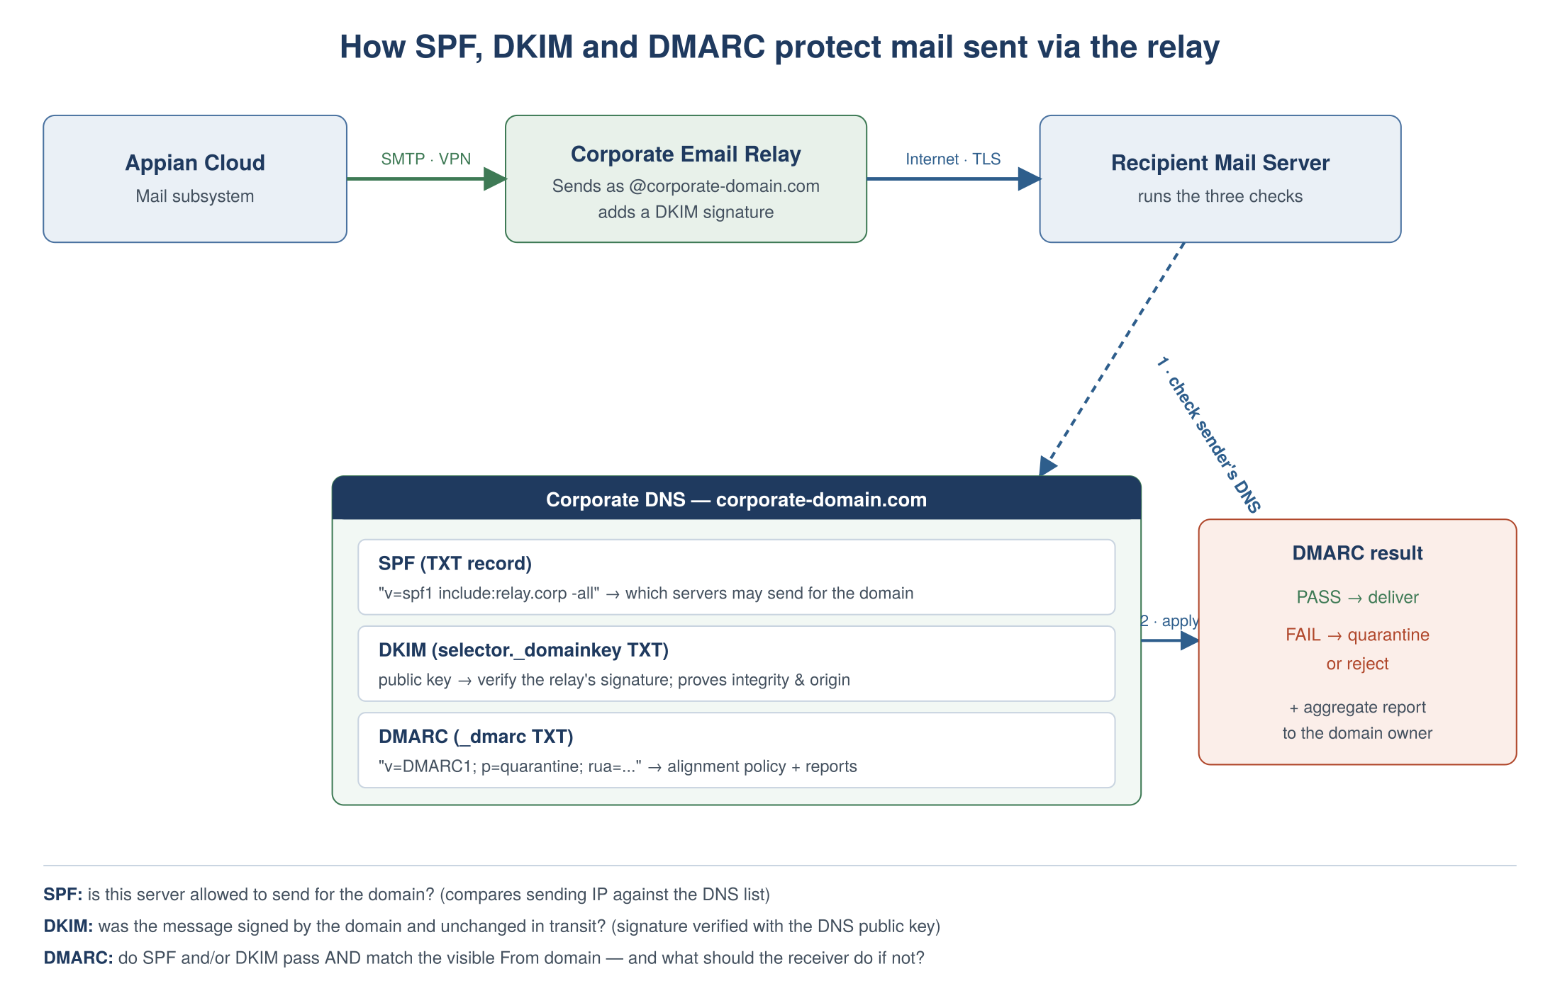
Figure 3 — SPF, DKIM and DMARC checks applied to relayed mail
How it applies here
The relay is the sending host SPF must authorise, and the identity that DKIM-signs — so domain authentication is anchored on the corporate domain and relay, not on Appian. (See §6 and §6.2.2.)

16.2 DNS resolution and the custom domain
DNS is the address book of the internet: it turns a name a person types, such as forms.corporate-domain.com, into the network address a browser actually connects to. For the Appian custom domain, the answer DNS gives depends on how you have chosen to let users reach the platform (§7.2–§7.3).
For public access, a record in your external/public DNS (a CNAME) points the name at the Appian Cloud load balancer, and users connect over the internet with HTTPS. For private access (inbound-over-VPN), a record in your internal corporate DNS points the same name at the private IP assigned to the environment during VPN configuration, and users reach it over the VPN tunnel. When you want both, split-horizon DNS returns the public address to external clients and the private address to internal clients — the same name, answered differently depending on where the request comes from. Because your corporate domain is maintained on internal DNS servers, the private answer is fully under your control.
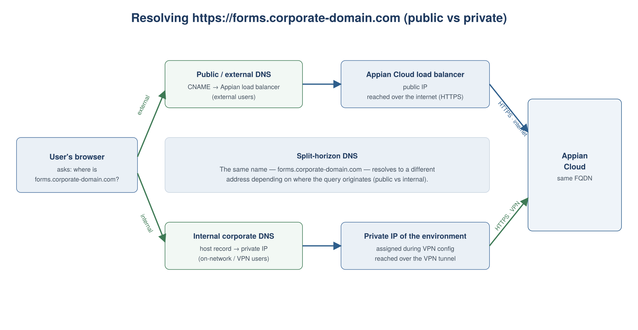
Figure 4 — Public vs private (split-horizon) resolution of the custom domain
How it applies here
In a private (inbound-over-VPN) deployment, your internal DNS resolves forms.corporate-domain.com to the environment's private IP, so the friendly URL works for on-network / VPN users and the environment is never published publicly. (See §7.3.2.)

16.3 Splunk long-term retention — the decoupled model
The enterprise Splunk platform keeps logs searchable for 90 days. Regulated retention usually needs much longer, so the design separates the two jobs: Splunk provides the searchable window, and a separate archive holds logs for the long term. In this environment that archive is a network drive (NAS), because AWS S3 — and therefore Splunk's S3-only self-storage feature (DDSS) — is not available.
The key point is where the archive is fed from. Appian Cloud does not keep its own logs for long: it rotates and purges them quickly (older files within minutes; cloud database audit logs after about a week), so you cannot let logs sit in Appian and collect them later — they must be captured from the stream as they are produced. Appian's real-time export is Log Streaming (the syslog push), and because Appian Cloud is SaaS there is no way to write its platform logs straight onto a network drive; the customer-hosted receiver is the capture point.
So the archive is decoupled from Splunk and fed from the Appian stream: the receiver forwards to Splunk (retention set to 90 days) and, in parallel, writes a compressed copy of the raw logs to the NAS as the long-term system of record. Splunk can then roll data off at 90 days with no effect on the archive. If long-term data ever needs searching, it is loaded back into a Splunk instance.
A Splunk-side archive is optional and not part of this baseline. If you also wanted a Splunk-managed copy, DDAA (Splunk Cloud) keeps a restorable archive with no S3, and coldToFrozen (Splunk Enterprise) can write frozen buckets to the NAS; DDSS is excluded because it needs S3. Application/business events can additionally be sent straight from Appian to an archive endpoint via HEC or an HTTP integration, bypassing Splunk entirely.
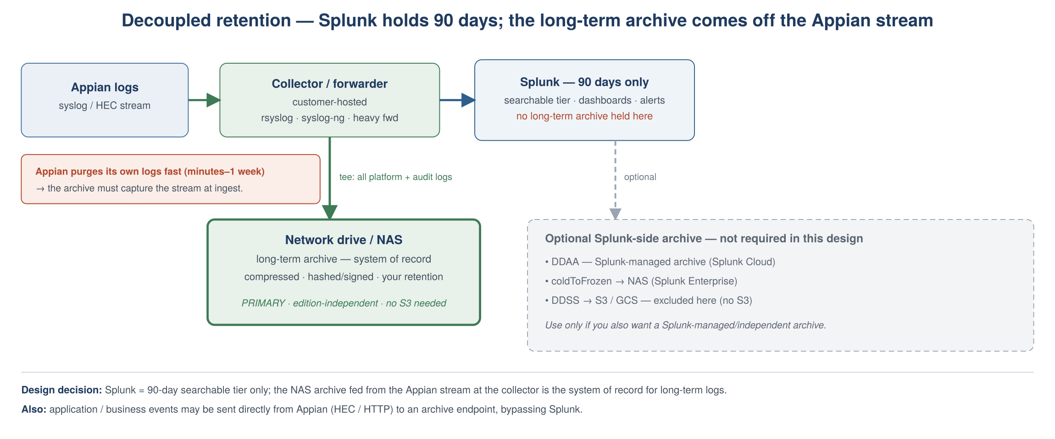
Figure 5 — Decoupled retention: Splunk holds 90 days; the NAS archive is fed from the Appian stream at the receiver
How it applies here
Set Splunk retention to 90 days (searchable tier). Make the receiver-fed NAS archive the system of record for long-term logs, capturing at ingest because Appian purges its own logs quickly. A Splunk-side archive (DDAA / coldToFrozen) is optional. (See §9.2.)

End of document — Appian Cloud Solutions Architecture v9.0 (Draft)

