Running Fortran Through Python
  - Documentation for execution of Fortran hip replacement models through Python
Simulations of joint replacements are computationally expensive. Many phenomena need to be modelled and integrated. This computational expense makes more efficient models desirables.
First released in 1954, Fortran is still used due it’s inherent simplicity (and therefore extreme speed). As an older programming language, Fortran lacks many of the quality-of-life improvements of more modern programming languages. Put simply, it is not easy to use. This means that these efficient models written in Fortran can be made inaccessible.
For these reasons, this work package has been commissioned to build a Python wrapper around the Fortran model. This wrapper is documented in this text. Critically, this is not a development log, but instructions on how to get the code running.
If you run into an error/ problem that is not documented here, please contact Dr Joshua Montgomery (jm26774@essex.ac.uk).
This document assumes some basic knowledge of Python but provides extensive guidance on interfacing Fortran and Python. Substantial portions can likely be skipped if the reader has previous experience with command prompt execution of Python.
This documentation was created using a Windows PC. Linux or Mac setup will be similar, but not the same.

Table of Contents
1 Installing Software 3
1.1 Installing Anaconda 3
1.1.1 Miniconda? 3
1.2 Installing Codeblocks 3
1.2.1 Installing a Fortan compiler 4
1.2.2 Debugging 4
2 Conda Tutorial 6
2.1 Note on Command Line Execution of Python 6
2.2 Setup the Environment 7
2.2.1 Debugging 7
2.3 Building a Basic F2PY Module 7
2.4 Using a F2PY Module 8
3 Compiling the Hip Model 9
4 Running A Gui 9
5 Compiling App 10

Installing Software
This section exclusively covers the installation of the core software. Whilst installing the software is easy, getting the different pieces of software working together is difficult. Please follow along closely.

Installing Anaconda
Anaconda Navigator can be easily installed via the Essex Software Hub or the Anaconda website.
- If you are a student or staff at the University of Essex – Please download Anaconda 3 via the Essex Software Hub (also known as Apps Anywhere). The website link: https://software.essex.ac.uk
- Nottingham Trent?
- If you are anyone else – Download Anaconda Navigator from the website link: https://www.anaconda.com/download You may be required to create an account. Make sure you download the right version for your PC. Generally, this means 64bit, Windows and using a GUI.
Anaconda is fantastic for managing packages within Python and will drastically reduce the hassle of building an environment.

Miniconda?
Anaconda Navigator requires a rather substantial amount of space on your PC to install. Most of the downloaded packages will not be used. If the readers local PC is getting rather short on storage, they may consider downloading Miniconda instead. This is a barebones version of Anaconda. Whilst it contains everything needed, it will require manually installing a few packages.
This document was written under the assumption that the reader prioritises convenience over a few GB and hence will assume the download of Anaconda Navigator.

Installing Codeblocks
This document explains how to use Python to run Fortran models. For the sake of comparison, it’s worth having Codeblocks installed to run Fortran natively. Codeblocks will not see much use in this document, but for the sake of completeness an installation guide is provided here.
From the following link, download a 64bit Windows version of Codeblocks: https://www.codeblocks.org/downloads/binaries The author recommends downloading a version with setup included. As the name suggests, the software will then autoconfigure.
At the time of writing, Codeblocks allows downloads through several common software download platforms. SourceForge is recommended.
Codeblocks offer a version with MingGW (and a Fortran compiler) built in. Superficially this sounds ideal, but the included package is not sufficient for this work. Save computer memory and take the default version of Codeblocks.

Installing a Fortan compiler
The Codeblocks installation does not come with the required Fortran compiler. It (GFortran) will need to be downloaded separately.
This can be done manually, but the versioning is very tricky, so using a dedicated manager is recommended. Without going into unnecessary detail, Python is not built the same on all platforms. On Windows it generally requires Microsoft Visual Studios (MCVS), but on Linux it is standard to use MingGW in the backend. The versions are not compatible. As several essential packages use MingGW, all of the packages must use MingGW. If the GFortran compiler is manually added, it is very easy to get the wrong version. This is an extremely frustrating issue to debug, so the author strongly recommends following the procedure outlined herein.
MSYS2 will handle the necessary versioning. Download it from:
https://www.msys2.org Making sure to get the correct version for your computer. At time of writing there is only two, so if one doesn’t work, download the other.
After the software has been installed, the MSYS2 terminal should automatically start. If not, simply run the MSYS2 app. This command window operates with Linux commands, so standard Windows key bindings and commands will not work.
In this MSYS2 terminal two commands must be executed to download the required compiler and ensure that it is properly configured. Firstly, execute the below command to download the compiler
 | pacman -S mingw-w64-x86_64-gcc-fortran | (1)
Upon execution, this command will ask for confirmation to install. Submit Y for yes. Then execute the following command.
 | pacman -S mingw-w64-x86_64-toolchain | (2)
If the system asks what packages you would like to install, select all. This is generally the default, so submitting enter immediately selects them all.

Debugging
Sometimes Codeblocks has difficulty finding GFortran. This can be resolved by specifying the location within the compiler options. Simply go to Settings> Compiler> Toolchain and then specify the location.
The toolchain executables may also start with incorrect compiler location names. They should look as seen in Figure 1. If not, adjust.
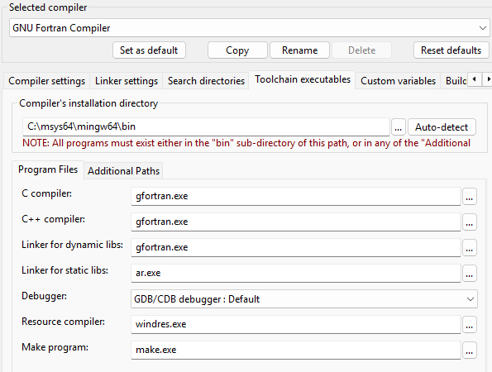
Figure 1. Correct compiler paths

Conda Tutorial
Package managers like Conda are useful for creating reproduceable environments. It can be tricky to ensure that all the various libraries and add-ons are compatible. For this reason, a pre-built package has been developed that the reader can simply install. This section will walk the reader through the various steps required to setup Conda and get started.
Make sure that terminal opened is the Anaconda Prompt. The standard Command Prompt functions differently.

Note on Command Line Execution of Python
This section covers some of the basics of using terminal commands. If the reader is already familiar with these techniques, skip to the following section.
The Anaconda prompt must be told that the following command is in Python. This can be achieved through two separate techniques.
- Input the command as a string to be executed within Python (Python -s “Whatever you want Python to do formatted as Python code”). The -c simply indicates that the code in the following string should be executed as code.
- Specify a Python instance, then write the Python code. Simply type in Python and execute the command. The command prompt will now execute all subsequent commands as lines of Python code. When you wish to return to standard command prompt operation, execute exit().
There are additional ways to do this, but for the sake of brevity only two are employed in this work.
The differences are subtle, so Figure 2 is presented to give additional guidance.
(a)
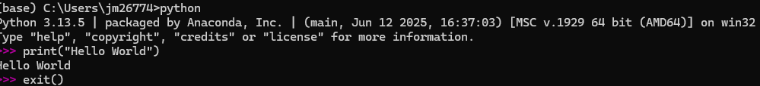
(b)
Figure 2. Different ways to execute command prompt Python commands. (a) requires multiple lines but is less verbose, (b) has a more complicated syntax, but allows all the code to be in a single line.
Pay attention to the different indents/ prefixes between the approaches. When using the command prompt normally, the left most text (after the environment) specifies the working directory and then has a single > symbol. When operating within a Python instance, the file directory is gone and there is only three > symbols.
This document will primarily use the first method to keep the code contained (easy to copy and paste) and to ensure that the file directory remains clear.

Setup the Environment
An environment has been prepared for both F2PY and the PYQT GUI environment. The file ‘combined_environment.yml’ is likely already saved in the in all downloaded folders by default. For completeness, the contents are also state below. This will aid in developing a new environment, should this one depreciate in the coming years.
 | name: HipEHL_ENV  channels:  - conda-forge  - pypi  dependencies:  - python=3.11  - pyside6  - pyqt6  - pandas  - pip  - matplotlib  - numpy  - gfortran=16.1  - meson  - ninja  - pyinstaller | (3)
Ensure that the environment file created above is in the working directory, then execute the following command, replacing the filename with whatever you chose. This will create an environment named HipEHL_env.
 | conda env create -f combined_environment.yml | (4)
The environment can be activated and deactivated with the following commands.
 | conda activate HipEHL_env | (5)
 | conda deactivate | (6)
Remember that the active environment is listed at the far left of the terminal in brackets. Make sure that Demo is active!

Debugging
It is easy to accidentally create a file called something like ‘demo_environment.yml.txt’ if created in the notepad. Make sure that the file type is not ‘.txt’.

Building a Basic F2PY Module
This script has nothing to do with hip simulations but is simple and serves to demonstrate that the Anaconda prompt has been properly configured.
Create a file called ‘square.f90’ containing the following code.
 | subroutine square(x, y, n)  implicit none  integer, intent(in) :: n  real(8), intent(in) :: x(n)  real(8), intent(out) :: y(n)  integer :: i  do i = 1, n  y(i) = x(i) * x(i)  end do  end subroutine square | (7)
Make sure that the file is in the working directory and the Demo environment is active, then execute the following code. Squaremod is the name of the module that will be created.
 | python -m numpy.f2py -c square.f90 -m squaremod --backend meson | (8)
It’s important to pass the ‘--backend meson’ handle as that ensures that the type of Python (MinGW) is used and that communication with numpy.f2py is possible.
The above code will have created a ‘.pyd’ file with a name something like ‘squaremod.cp39-win_amd64.pyd’. It may not have an identical name.

Using a F2PY Module
Make sure that correct environment is active and that the module file is in the working directory then run the following code. This code must be run within a Python instance. Simply enter python on the Anaconda prompt. If the only symbols on the left of the prompt line are ‘>>>’ the Python instance is active. It can be escaped with the ‘exit()’ command.
 | import numpy as np  import squaremod  x = np.array([1.0, 2.0, 3.0, 4.0])  y = squaremod.square_array(x)  print(y) | (9)
This will result in an array of the squared numbers being printed. Figure 3 depicts the expected output.
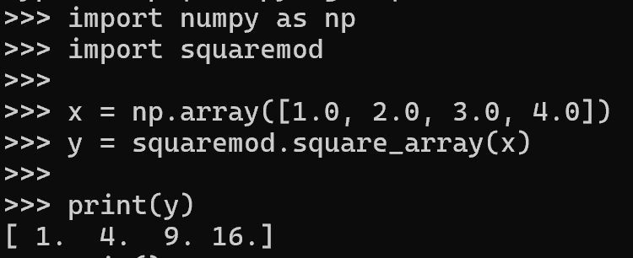
Figure 3. Terminal outputs when the square module is successfully used.
If this output can be seen on the readers terminal, a Python wrapper has successfully been used to run a Fortran script.

Compiling the Hip Model
The following code is used on the command line to compile the Fortran module. Execute it on the anaconda prompt.
The following code is used on the command line to compile the Fortran module. Execute it on the anaconda prompt to rebuild the Python wrapper. This will likely need to be done on every new PC. Make sure that the working directory is correct.
 | python -m numpy.f2py -c modules.f90 input.f90 COEF.f90 ELMLMI.f90 wear_wrapper.f90 wear_model.f90 -m HipEHL --backend meson --f90flags="-O2 -Wno-unused-dummy-argument -Wno-unused-label -Wno-surprising" | (9)

Running A Gui
Running the GUI should be a simple as using the below command. Again, make sure that the working directory is correct.
 | python HipEHL.py | (11)

Useful Commands
pyinstaller --name HipEHL_GUI --windowed --noconfirm HipEHL.py
pyinstaller HipEHL_GUI.spec
pmax, hmin, p_array = HipEHL.wear_wrapper.wear_run(1,1,300.0,-2.0,0.2,1.0,1.0,1.0,20.0,20.0,30.0,0.01,0.05,0.01,0.05,0.05,100,50E-6,0.016,660E6,1e-16,1e6,1,2,50)
pyqt6-tools designer

