**Name:** Moore, Joshua

**Major:** Software Engineering

**Faculty Advisor Name, Affiliation:** Dr. Vuk Marojevic, Electrical Engineering

**Project Category:** Physical Sciences and Engineering

**Co-Author(s):** Bhandari, Ankit

**REU/Research Program:** AERPAW

**Title:** SISO (Single Input Single Output) Vs MIMO (Multi input Multi Output) in 4G LTE using Software Defined Radios (SDRs)

**Description:** MIMO and SISO are antenna technologies used by wireless networks. SISO (Single Input Single Output) uses one antenna at the transmitter, and one at the receiver.MIMO (Multiple Input Multiple Output) uses multiple antenna elements at the transmitter and the receiver. While SISO is the most straightforward configuration for wireless networks, the added antennas used in MIMO can help when adverse channel conditions are present,and achieve higher data rates due to techniques such as spatial multiplexing and beamforming. MIMO is used in wireless networks such as 4G LTE, 5G NR and WiFi6. This abstract will focus on the results gathered from testing SISO and MIMO, and gathering relevant performance metrics (throughput for uplink and downlink). These results will show the current expected performance in 4G LTE using a COTS (Cheap off the shelf) SDR enabled network. The SDR’s used were b210s connected through USB3.0.

**Test 1**: SISO using UHD (physical SDRs)

Software Needed: Docker, Ubuntu 18.04 container with full privileges,UHD,SRSRAN

additional apt packages required: iproute2,ping,iperf3

Description of test: Using physical SDRs, one on the transmitter and one on the receiver, a link is established and tests are performed which follow.

IPERF Results:

*Time is in seconds for all data collected*

AVG Upload in Mbps: 21.9 Mbps

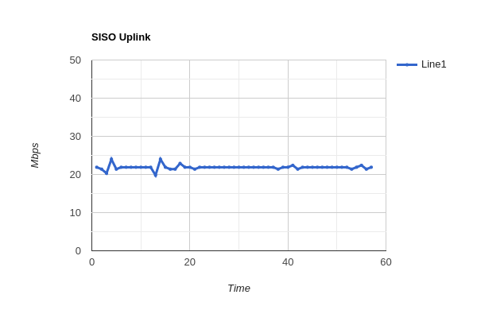

AVG Download in Mbps: 35 Mbps

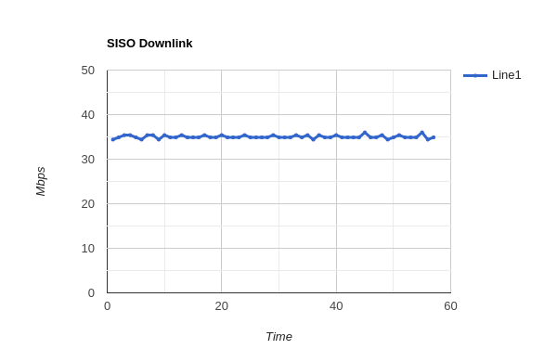

**Test 2**: MIMO using UHD (physical SDRs)

Software Needed: Docker, Ubuntu 18.04 container with full privileges,UHD,SRSRAN

additional apt packages required: iproute2,ping,iperf3

Description of test: Using physical SDRs, one on the transmitter and one on the receiver two links are established and tests are performed which follow. All testing was done with 2 antennas in mode 4 for lte.

IPERF Results

*Time is in seconds for all data collected*

AVG Upload in Mbps: 21.9 mbps

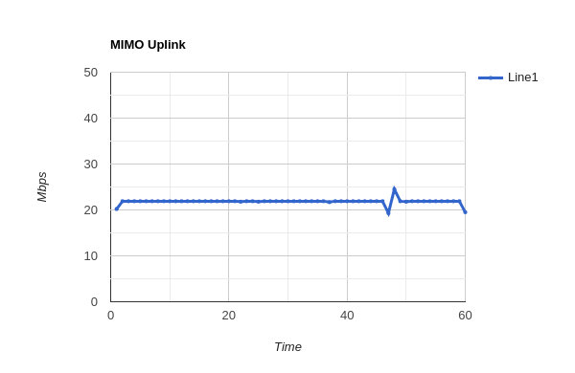

AVG Download in Mbps: 70 mbps

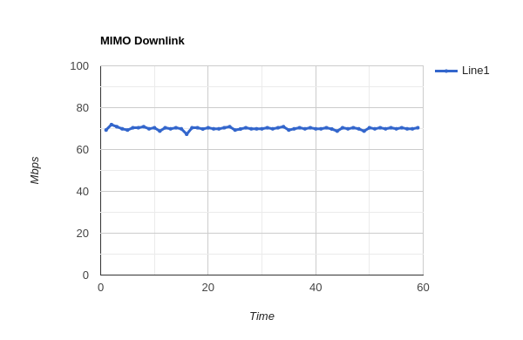

**Conclusion:** While SISO offers the easiest setup, using MIMO can positively impact data rates for downlink.