
MERU UNIVERSITY OF SCIENCE AND TECHNOLOGY
DEPARTMENT OF ELECTRICAL AND ELECTRONICS ENGINEERING
BACHELOR OF TECHNOLOGY IN ELECTRICTRAL AND ELECTRONIS ENGINEERING
UNIT CODE: EET 3422
UNIT DESCRIPTION: ANTENNA THEORY AND PRACTICE
Github link: https://github.com/joshuamuthenya/antenna.git
TITLE: LAB 1 REPORT: REFLECTOR ANTENNAS
GROUP 3 MEMBERS
- JOSHUA WAMBUA EG209/109705/22
- WILKISTER KWAMBOKA EG209/109739/22
- AKALA DALVAN EG209/109726/22
- NASON ALFRED EG209/111030/22
- WAYNE FAVOUR EG209/109708/22
Date: 30/10/25
INSTRUCTOR: VICTOR MUTAI

TABLE OF CONTENTS
1.0 Objectives 3
2.0 Background Theory 3
2.1 Cylindrical Reflector Antennas 3
2.2 Spherical Reflector Antennas 3
2.3 Parabolic Reflector Antennas 3
2.4 Radiation Patterns 4
3.0 Procedure 4
4.0 Results 4
4.1 Cylindrical Reflector Antenna 4
Question 1 5
4.2 Spherical Reflector Antenna 6
4.3 Azimuth Radiation Patterns of Rectangular and Cylindrical Reflectors 7
Question 2 9
4.4 Elevation Plots of Spherical and Parabolic Reflectors 9
Question 3 11
5.0 Discussion 11
6.0 Conclusions 12
7.0 References 12

1.0 Objectives
The main objectives of this experiment are:
- To design and analyze curved reflector antennas using MATLAB R2021b or later.
- To model cylindrical and spherical reflector antennas and study their radiation characteristics.
- To compare the azimuth patterns of cylindrical and rectangular reflector antennas.
- To evaluate the elevation patterns of spherical and parabolic reflector antennas.
- To determine and interpret radiation parameters such as maximum gain, minimum gain, and pattern shape.
- To understand the effect of reflector curvature on antenna performance.

2.0 Background Theory
Reflector antennas use reflective surfaces to redirect electromagnetic waves from an exciter (usually a dipole or horn) into a highly directional beam. Curved reflector antennas extend the concept of flat or rectangular reflectors and include cylindrical, spherical, or parabolic surfaces.

2.1 Cylindrical Reflector Antennas
A cylindrical reflector has curvature in one plane only. It focuses energy in one direction, producing a beam with high gain and narrow beamwidth in that axis. Applications include:
- Radar systems
- Satellite communication
- Radio astronomy

2.2 Spherical Reflector Antennas
A spherical reflector has curvature in both principal planes. Unlike parabolic reflectors, spherical reflectors are capable of wide-angle scanning without mechanically moving the main reflector surface. Applications include:
- Adaptive beamforming
- Tracking radar
- Wide-area scanning systems

2.3 Parabolic Reflector Antennas
Parabolic reflectors focus all incoming parallel rays to a single focal point. They are widely used for long-distance and high-gain systems such as:
- Satellite dishes
- Deep space communication
- Radio telescopes

2.4 Radiation Patterns
Radiation patterns describe how the antenna radiates energy in space. Key measurements include:
- Maximum gain (dBi)
- Minimum gain (dBi)
- Side lobes
- Beamwidth

3.0 Procedure
- MATLAB R2021b was launched, and a MATLAB Live Script was created.
- Code for designing cylindrical, spherical, rectangular, and parabolic reflectors was written section by section.
- Each section was executed to generate the antenna models and radiation patterns.
- Plots were inserted directly into the Live Script under each code block.
- The results were analyzed to answer the given questions.

4.0 Results

4.1 Cylindrical Reflector Antenna

MATLAB Code
GL = 0.3;
GW = 0.3;
D = 0.075;
cref = reflectorCylindrical(GroundPlaneLength=GL, GroundPlaneWidth=GW, Depth=D);
cref.Tilt = 90;
cref.Exciter.TiltAxis = [1 0 0];
cref.Exciter.Tilt = 90;
show(cref)

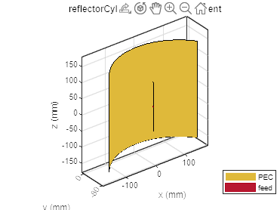

Radiation Pattern at 1 GHz
pattern(cref,1e9)
view(-26,39)

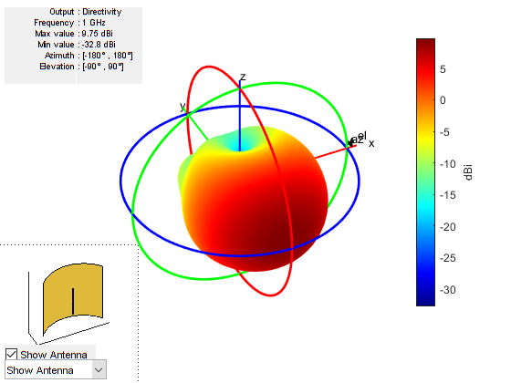

Question 1
Indicate the maximum and minimum values of the radiation pattern.

4.2 Spherical Reflector Antenna

MATLAB Code
R = 0.15;
D = 0.15;
sref = reflectorSpherical(Radius=R, Depth=D);
show(sref)

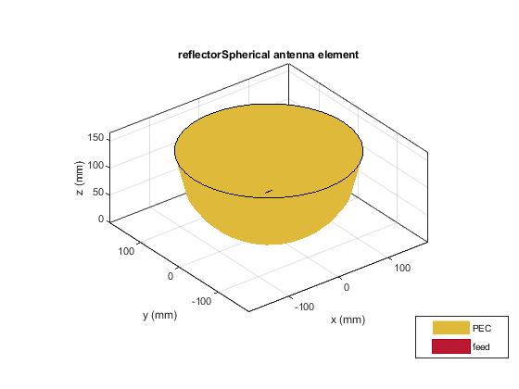Radiation Pattern at 10 GHz
pattern(sref,10e9)
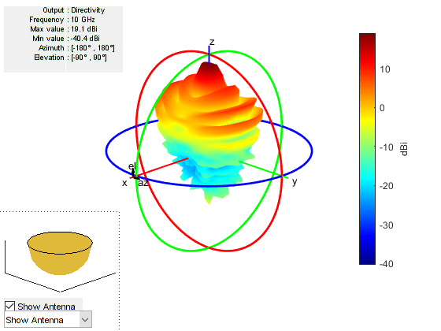

4.3 Azimuth Radiation Patterns of Rectangular and Cylindrical Reflectors

Create Rectangular Reflector
antR = reflector;
antR.Tilt = 90;
antR.Exciter.TiltAxis = [1 0 0];
antR.Exciter.Tilt = 90;
show(antR)

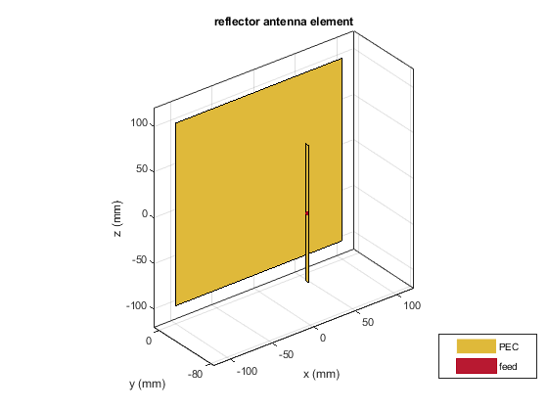Plot Azimuth Patterns
pa1 = patternAzimuth(antR,1e9,0,"Azimuth",0:-1:-360);
pa2 = patternAzimuth(cref,1e9,0,"Azimuth",0:-1:-360);
figure
polarpattern(pa1);
hold on;
polarpattern(pa2);
hold off;
l = legend("Rectangular Reflector","Cylindrical Reflector");
l.Position = [0.6 0.8877 0.2996 0.0869];

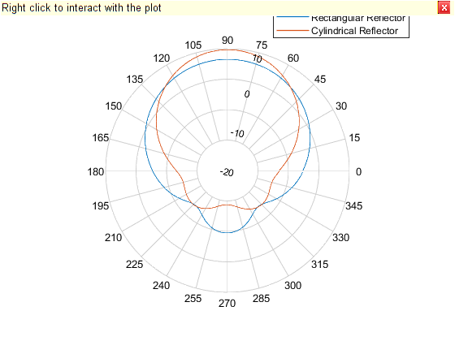

Question 2
Which reflector (cylindrical or rectangular) offers higher gain?
Cylindrical reflector offers higher gain because its curvature focuses energy in one direction, unlike the rectangular reflector which spreads energy more uniformly.

4.4 Elevation Plots of Spherical and Parabolic Reflectors

Create Parabolic Reflector
pref = reflectorParabolic;
show(pref)
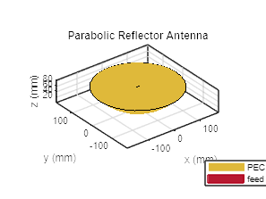

Plot Elevation Patterns
pe1 = patternElevation(pref,10e9,0,Elevation=0:360);
pe2 = patternElevation(sref,10e9,0,Elevation=0:360);
figure
polarpattern(pe1)
hold on;
polarpattern(pe2)
l = legend("Parabolic Reflector","Spherical Reflector");
l.Position = [0.6 0.8877 0.2996 0.0869];
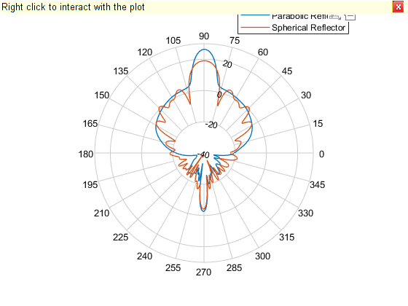

Question 3
Compare the spherical and parabolic reflectors in terms of peaks and scanning suitability.
- Parabolic reflector
  - Exhibits one dominant main lobe
  - High gain
  - Narrow beam
  - Not suitable for wide-angle scanning
- Spherical reflector
  - Has multiple peaks due to curvature
  - Beam can scan over wide angles without mechanical movement
  - Best for wide-area scanning

5.0 Discussion
- Cylindrical Reflector Radiation Pattern
The cylindrical reflector showed a focused radiation pattern with a clear main lobe, indicating its capability of producing high gain in a single direction. The maximum and minimum gains depend on frequency and reflector geometry.
- Spherical Reflector Output
At 10 GHz, the spherical reflector exhibited broader radiation characteristics with more evenly distributed sidelobes. This behavior supports its suitability for scanning applications.
- Cylindrical vs. Rectangular Reflector
The cylindrical reflector had a higher gain because curvature enhances focusing, unlike the rectangular reflector which is planar and produces a wider, less focused beam.
- Parabolic vs. Spherical Reflector
The parabolic reflector had a clean, sharp main lobe ideal for long-distance communication. The spherical reflector produced a multi-lobe pattern, meaning it can support radiation over a wider range, reducing the need for mechanical steering.
- Applications of Curved Reflector Antennas
  - Radar systems
  - Radio astronomy
  - Satellite uplink/downlink
  - Deep-space telemetry
  - Weather radar
  - Long-range point-to-point microwave links

6.0 Conclusions
In this experiment, curved reflector antennas were successfully designed and analyzed using MATLAB R2021b. Cylindrical and spherical reflector antennas were modeled, and their radiation patterns were generated and studied. Comparisons among rectangular, cylindrical, parabolic, and spherical reflectors revealed the following:
- Cylindrical reflectors yield higher gain due to curvature focusing.
- Spherical reflectors support wide-angle scanning with multiple peaks.
- Parabolic reflectors are best for high-gain, narrow-beam applications.
Overall, curved reflectors offer improved antenna performance, and MATLAB provides an efficient simulation environment for evaluating antenna behavior before physical fabrication.

7.0 References
- Balanis, C. A. Antenna Theory: Analysis and Design. Wiley, 2016.
- MATLAB Documentation, “Reflector Antennas,” MathWorks, 2024.
- Kraus, J. D., & Marhefka, R. J. Antennas: For All Applications. McGraw-Hill, 2002.
- Stutzman, W., & Thiele, G. Antenna Theory and Design. John Wiley & Sons, 2012.
- Mailloux, R. J. Phased Array Antenna Handbook. Artech House, 2018.

