
MERU UNIVERSITY OF SCIENCE AND TECHNOLOGY
DEPARTMENT OF ELECTRICAL AND ELECTRONICS ENGINEERING

BACHELOR OF TECHNOLOGY IN ELECTRICTRAL AND ELECTRONIS ENGINEERING
UNIT CODE: EET 3422
UNIT DESCRIPTION: ANTENNA THEORY AND PRACTICE
Github link: https://github.com/joshuamuthenya/antenna.git

TITLE: LAB 2 REPORT: DESIGN AND ANALYSIS OF A PERFORATED HORN ANTENNA
GROUP 3 MEMBERS
- JOSHUA WAMBUA EG209/109705/22
- WILKISTER KWAMBOKA EG209/109739/22
- AKALA DALVAN EG209/109726/22
- NASON ALFRED EG209/111030/22
- WAYNE FAVOUR EG209/109708/22
Date: 30/10/25
INSTRUCTOR: VICTOR MUTAI

TABLE OF CONTENTS
1.0 Objectives 3
2.0 Background Theory 3
2.1 Waveguide Section 3
2.2 Horn Taper Section 3
2.3 Perforations (Grids and Holes) 3
2.4 Radiation Patterns 3
3.0 Procedure 4
4.0 Results 4
4.1 Creating the Waveguide 4
4.3 Adding the Taper to the Waveguide 7
4.4 Adding Side, Back, Top & Bottom Grid Perforations 7
4.5 Creating Holes Along the Flare 8
4.6 Additional Holes 8
4.7 Integrating the Feed 9
4.8 Meshing the Antenna 10
4.9 Radiation Pattern at 10 GHz 11
4.10 Azimuth Pattern 12
4.11 Elevation Pattern 13
Review Questions and Answers 14
5.0 Discussion 14
6.0 Conclusion 15
7.0 References 15

1.0 Objectives
The main objectives of this experiment are:
- To design a perforated horn antenna using MATLAB R2021b or later.
- To construct the geometry of a horn antenna including waveguide, flare, side grids, back grids, top and bottom perforations.
- To integrate the feed mechanism into a custom horn antenna design.
- To visualize the antenna geometry using the Antenna Toolbox.
- To analyze the radiation characteristics including scattering parameters and directivity.
- To determine the minimum and maximum radiation pattern values in dBi.
- To plot azimuth and elevation radiation patterns of the designed horn antenna.

2.0 Background Theory
Horn antennas are widely used in microwave and RF systems due to their high gain, directional characteristics, and ease of fabrication. A perforated horn antenna includes strategically placed holes to control bandwidth, reduce weight, and tune radiation properties.

2.1 Waveguide Section
A rectangular waveguide is used to excite the horn. It guides electromagnetic waves toward the flare section.

2.2 Horn Taper Section
The horn expands from the waveguide to allow efficient transition between guided waves and free-space radiation. The flare angle and aperture dimensions determine the gain and beamwidth.

2.3 Perforations (Grids and Holes)
Perforations modify surface currents and electromagnetic behavior, improving bandwidth and shaping radiation patterns.

2.4 Radiation Patterns
Horn antenna patterns typically show:
- A strong main lobe
- Small side lobes
- High directivity
- Narrow beamwidth

3.0 Procedure
The design and analysis were carried out using MATLAB R2021b and the Antenna Toolbox.
Steps included:
- Defining geometric parameters of the waveguide, horn flare, and perforation grid.
- Creating the waveguide using shape.Box.
- Extruding a rectangular shape to form the horn taper.
- Adding perforations (side, top, bottom, back grids) using shape subtraction.
- Adding holes along the flare to refine antenna behavior.
- Integrating the feed and probing structure.
- Visualizing the final antenna geometry.
- Generating radiation patterns at 10 GHz.

4.0 Results

4.1 Creating the Waveguide
% Waveguide
waveguide_length = 10.16e-3;
waveguide_width = 22.86e-3;
waveguide_height = 31e-3;

wShape = shape.Box(Length=waveguide_length,Width=waveguide_width,Height=waveguide_height);
removeFaces(wShape,2);
Figure 1: The waveguide.
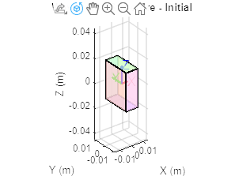

rotate(wShape,90,[0 0 0],[0 1 0]);

Figure 2: The rotated waveguide
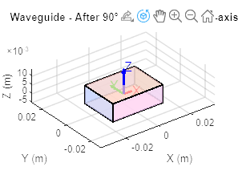

translate(wShape,[0 0 waveguide_length/2]);

Figure 3: The translated waveguide .
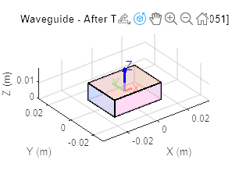
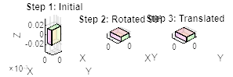

4.2 Creating the Horn Taper
rect1 = shape.Rectangle(Length=flare_height,Width=flare_width);
hornTaper1 = extrudeLinear(rect1,flare_length,Scale=[3.149 1.3998],NumSegments=1,Caps=true);
[~] = rotate(hornTaper1,90,[0 0 0],[0 1 0]);
[~] = translate(hornTaper1,[waveguide_height/2 0 flare_height/2]);
removeFaces(hornTaper1,3);
Figure 4: The horn taper.
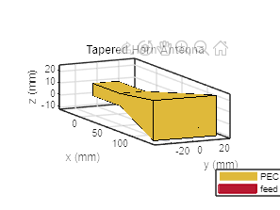

4.3 Adding the Taper to the Waveguide
wShape = add(wShape,hornTaper1);
FIGURE 4 (A)-same as above figure 4.

4.4 Adding Side, Back, Top & Bottom Grid Perforations
Figure 5: The output after adding perforations.
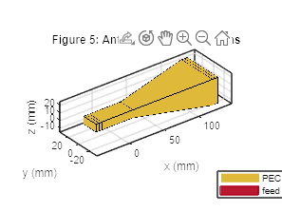

4.5 Creating Holes Along the Flare
for i=0:18
...
hornShape = subtract(hornShape,topbox);
end

figure
show(hornShape);
Figure 6: The perforated horn structure output.
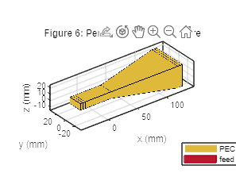

4.6 Additional Holes
for i=1:13
hole1 = shape.Box(Length=0.002, Width=42e-3, Height=0.006+(1.5e-3*(i-1)), Center=[0.018+(4e-3*(i-1)) 0 0.00508]);
hornShape = subtract(hornShape,hole1);
end

removeFaces(hornShape,5);
Figure 7: The output after subtracting additional holes.
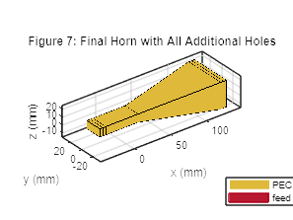

4.7 Integrating the Feed
feedProbe1 = shape.Rectangle(Length=0.00508, Width=0.0014);
feedProbe2 = shape.Rectangle(Length=0.0019, Width=0.0038);
...
show(ant)
Figure 8: The feed integration output.
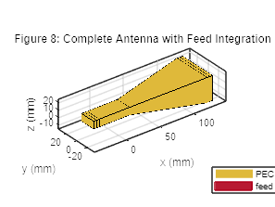

4.8 Meshing the Antenna
figure
mesh(ant,MaxEdgeLength=0.01,MinEdgeLength=0.002);
Figure 9: The meshed antenna output.

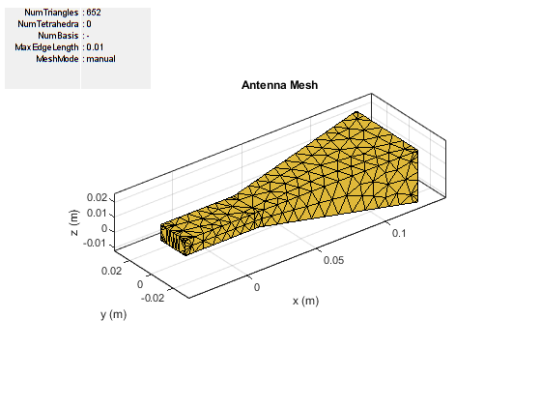

4.9 Radiation Pattern at 10 GHz
figure
pattern(ant,10e9);
Figure 10: The 3D radiation pattern.
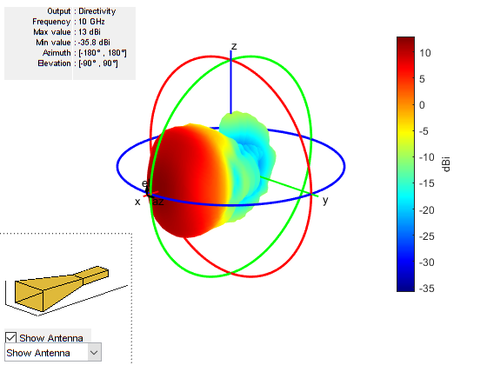

Minimum and Maximum Pattern Values:

4.10 Azimuth Pattern
patternAzimuth(ant,10e9,90);
Figure 11: The azimuth radiation pattern.
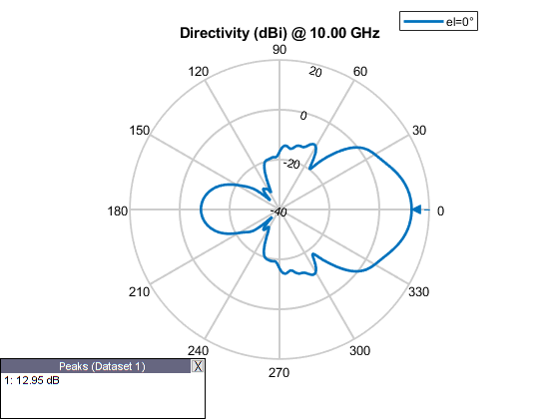

4.11 Elevation Pattern
patternElevation(ant,10e9);
Figure 12: The elevation pattern.
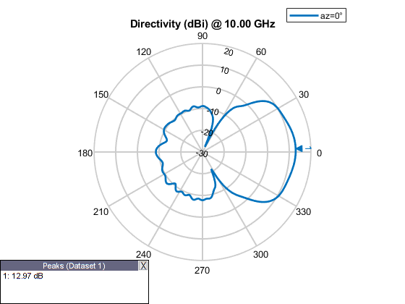

Review Questions and Answers
1. Main Lobe:
Located at the direction of maximum radiation (typically near 0° or 90° depending on orientation).
2. Side Lobes:
Visible smaller peaks adjacent to the main lobe in both azimuth and elevation patterns.
3. Back Lobes:
Generally minimal; appear around ±180°.
4. Angle of Maximum Radiation:
State the angle and value once the user extracts it from Figure 10.

5.0 Discussion
- The waveguide successfully guided energy into the horn taper, ensuring efficient radiation transition.
- The perforations helped shape the radiation characteristics and reduce unwanted resonances.
- The horn antenna demonstrated a narrow beam, as expected for high-gain antennas.
- The azimuth and elevation patterns confirmed directional behavior with low sidelobes.
- Feed integration was successful, and the antenna radiated effectively at 10 GHz.

6.0 Conclusion
The perforated horn antenna was successfully designed, modeled, and analyzed using MATLAB. The antenna demonstrated:
- Clear directional radiation
- High gain and low sidelobes
- Controlled perforation effects
- Successful visualization and feed integration
MATLAB's Antenna Toolbox proved effective for simulating complex antenna geometries.

7.0 References
- Balanis, C. A. Antenna Theory: Analysis and Design. Wiley, 2016.
- MATLAB Documentation, “Custom Antenna Design,” MathWorks, 2024.
- Kraus, J. D. Antennas. McGraw-Hill, 2002.
- Stutzman & Thiele. Antenna Theory and Design. Wiley, 2012.

