
MERU UNIVERSITY OF SCIENCE TECHNOLOGY

DEPARTMENT OF ELECTRICAL AND ELECTRONICS ENGINEERING

IoT-Based Air Quality Monitoring System
Joshua Muthenya Wambua
EG209/109705/22

A proposal submitted in partial fulfillment of the requirements for the award of the Degree of Bachelor of Technology in Electrical and Electronics Engineering in the Department of Electrical and Electronics Engineering at Meru University of Science and Technology.
January, 2026

DECLARATION
I hereby declare that this project proposal is my original work except as cited in the references and has not been presented for the award of a degree in any other University.

Sign: .........................................Date: ...........................................
Joshua Muthenya Wambua
EG209/109705/22

This proposal has been submitted for examination with my approval as the University supervisor.
Sign: ....................................... Date……...................................
Supervisor: ……………………………………………………......................................

ABSTRACT
Air quality degradation and hazardous gas emissions represent critical challenges to public health, safety, and environmental sustainability. Urbanization and industrialization have intensified the release of pollutants, including carbon oxides, methane, and particulate matter (PM2.5 and PM10), while domestic environments remain vulnerable to leaks of liquefied petroleum gas (LPG) and other combustible gases. These pollutants are linked to respiratory illnesses, cardiovascular diseases, climate change, and fire outbreaks. However, existing monitoring approaches are often centralized, costly, and inaccessible to individuals for real-time decision-making. This project proposes an IoT-based air quality monitoring system designed to provide real-time data acquisition, cloud-based storage, and predictive analytics. The system integrates low-cost MQ gas sensors, particulate matter sensors, and environmental sensors with an ESP32 microcontroller for data collection and analysis. Data are transmitted to Firebase for secure storage, visualization, and alert dissemination through a web application. Furthermore, predictive models are employed to forecast pollution levels, detect anomalies, and assess potential fire hazards. Actuation and safety response system is also included. The proposed system contributes to environmental health research by offering a scalable and resource-efficient solution for continuous monitoring, early warning, and risk mitigation in urban, domestic, agricultural, and healthcare settings.

CHAPTER 1: INTRODUCTION

1.1 Background of the Study
Air quality degradation has become a pressing environmental and public health concern globally. Rapid urbanization, increased industrial activities, transportation, and population growth have significantly elevated the release of harmful pollutants such as particulate matter (PM2.5 and PM10), methane, carbon oxides and volatile organic and inorganic compounds. These pollutants are directly associated with respiratory illnesses, cardiovascular diseases, allergies, and climate impacts. In addition to outdoor pollution, domestic environments face risks of hazardous gas leaks such as liquefied petroleum gas (LPG) and methane, which can lead to poisoning, fire outbreaks, and explosions.
Although government-operated monitoring stations exist in major cities, current air quality monitoring approaches remain centralized, expensive, and inaccessible to individuals at the household level. This creates a gap in real-time localized monitoring that can help mitigate risks.
Recent advancements in Internet of Things (IoT), cloud computing, and machine learning present a promising opportunity to develop affordable and scalable monitoring systems. The proposed IoT-Based Air Quality Monitoring System integrates low-cost sensors with cloud-based storage and real-time data visualization to deliver accessible environmental insights. By leveraging MQ-series gas sensors, particulate matter sensors, temperature and humidity sensor (DHT11) and ESP32 microcontrollers, the system offers continuous surveillance of air pollutants and hazardous gases. The integration of predictive analytics further enhances the capability to detect anomalies and forecast pollution trends. The integration of the actuation and safety response system makes the system more vital in today’s world.
The system, therefore, represents a timely initiative toward improving environmental health, public safety, and awareness by bridging the gap between centralized air quality monitoring and household-level accessibility.

1.2 Problem Statement
Air pollution and hazardous gas exposure remain persistent problems in urban and domestic environments due to increased industrial activity, vehicle exhausts, and the use of gas-powered appliances. In many residential areas and small business premises, exposure to pollutants such as carbon monoxide and combustible gases often goes undetected until health symptoms, fires, or explosions occur. This delayed detection significantly increases the risk of injury, property damage, and loss of life.
Existing air quality and gas monitoring systems are largely centralized, expensive, and designed for regulatory or industrial use rather than individual households or small enterprises. Consequently, they are inaccessible to most users and fail to provide continuous, real-time, and location-specific information at the point of exposure. Consequently, individuals lack timely awareness and early warning of deteriorating air quality or gas leakages within their immediate surrounding.
The absence of a resource-efficient, real-time, and localized monitoring solution creates a critical safety and public health gap. Without such a system, communities remain reactive rather than preventive in managing air pollution and gas-related hazards. Addressing this gap requires an economical, scalable, and accessible monitoring solution capable of detecting air pollutants and hazardous gases in real time and providing timely alerts to users, and enabling preventive measures through actuators. The solution is the proposed IoT-Based Air Quality Monitoring System.

1.3 Main Objective
To design a scalable IoT-Based Air Quality Monitoring System with real-time detection, prediction, alerts, and actuation.

1.4 Specific Objectives
- To monitor air pollutants such as particulate matter (PM2.5, PM10) and harmful gases (CO, LPG) in real time.
- To measure environmental parameters like temperature and humidity.
- To enable remote monitoring through a cloud–connected web application.
- To provide instant alerts when air quality exceeds safe thresholds.
- To implement a safety response system.

1.5 Justification
Air quality monitoring solutions are often limited to government-operated or industrial-scale systems, making them inaccessible to households and small businesses. As a result, individuals remain exposed to invisible yet harmful pollutants and gas hazards. An economical and scalable IoT-Based Air Quality Monitoring System helps bridge this gap by:
- Enhancing public safety through early detection and alerts.
- Providing accessible real-time data for informed decision-making.
- Reducing environmental health risks.
- Aiding in community-level awareness and mitigation.
- Integrating modern IoT and machine learning technologies for proactive monitoring.
The system thus offers a practical and research-driven solution to promote environmental health and public safety.

1.6 Scope of the Study
This project focuses on designing and implementing an IoT-based air quality monitoring system using low-cost gas sensors, particulate matter sensors, environmental sensors, actuators, and ESP32 microcontrollers. The scope includes real-time data collection, wireless transmission to a cloud platform (Firebase), web-based data visualization, safety response, and predictive modeling for anomaly detection and forecasting.
The project will cover; hardware integration, firmware development, cloud connectivity, web application interface, alert systems, and evaluation of system performance.
This project, however, does not cover nationwide monitoring or industrial certification standards. Instead, the focus remains on household, urban, agricultural, and healthcare environments where feasible and cost-effective deployment is needed.

CHAPTER 3: METHODOLOGY
This chapter describes the methodology used in the design and implementation of the IoT-Based Air Quality Monitoring System. The approach follows a systematic framework consisting of hardware integration, data acquisition, cloud connectivity, predictive analytics, and visualization. The methodology ensures that the proposed system delivers real-time monitoring, alerts, and environmental data insights using low-cost IoT components and machine learning techniques.

3.1Research Design
The project adopts an experimental and design-based research methodology, where a functional IoT prototype is developed, tested, and evaluated under both controlled and real-world conditions. This approach is appropriate because the study aims to design, implement, and validate a practical engineering system rather than purely analyze theoretical models.
The system is designed to continuously sense air pollutants and environmental parameters, process the data locally at the edge device, transmit the data to a cloud platform, and present actionable insights to end users. Experimental testing is conducted to evaluate sensor accuracy, alert latency, and system reliability. The design emphasizes low-cost implementation, scalability, real-time communication, and end-user accessibility to ensure suitability for household and urban environments.

3.2 System Requirements

Hardware Requirements
- ESP32 microcontroller
- MQ-series gas sensors (MQ7, MQ-8, MQ-5,MQ-9,MQ-153)
- PM sensors (Nova PM Sensor)
- DHT11
- LEDs/buzzer (alert interface)
- Breadboard/stripboard
- 12V Battery
- Wi-Fi access point.
- Jumper wires and enclosure

Software Requirements
- Firebase backend
- Web application framework
- Programming language (Arduino C++ / MicroPython)
- Machine learning libraries
- Data visualization tools

3.3 System Development Approach
The system development follows a four-phase incremental approach, allowing each subsystem to be developed, tested, and validated before full integration. This minimizes system-level errors and improves reliability.

Phase 1: Sensor Integration
This phase focuses on selecting, interfacing, and calibrating sensing components responsible for detecting air pollutants and environmental conditions. MQ-series gas sensors (MQ-2, MQ-5, MQ-7, MQ-8, MQ-9, and MQ-135) are used to detect combustible gases, carbon monoxide, methane, and general air contaminants. A particulate matter sensor is employed to measure PM₂.₅ and PM₁₀ concentrations, while a DHT11 sensor measures ambient temperature and humidity.
Sensors are electrically interfaced with the ESP32 microcontroller using analog and digital input pins. Voltage divider circuits are used where necessary to ensure signal levels are compatible with the ESP32’s ADC. Initial calibration is performed by exposing sensors to known or simulated pollutant conditions and recording baseline readings. This calibration process establishes threshold values and improves measurement consistency before deployment.

Phase 2: Edge Processing and Data Acquisition
In this phase, the ESP32 microcontroller is programmed to function as an intelligent edge device. The firmware continuously samples sensor data at predefined intervals. Raw analog readings are converted into digital values using the ESP32’s built-in ADC and preprocessed to reduce noise and fluctuations.
Edge-level processing includes normalization of sensor values, application of calibration correction factors, threshold comparison, and timestamping of readings. Threshold-based logic is implemented to detect hazardous conditions locally, enabling rapid activation of alerts and actuators without relying on cloud processing. The ESP32 transmits processed data to the cloud via Wi-Fi, ensuring low-latency and energy-efficient communication.
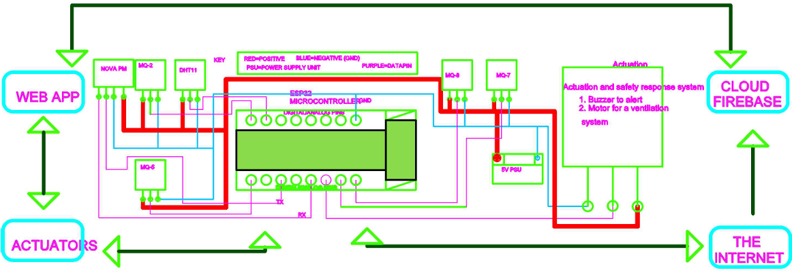

Fig 3.1 IoT-Based Air Quality Monitoring System hardware.

Phase 3: Cloud Storage and Backend Integration
Firebase is selected as the cloud backend due to its real-time database capabilities, scalability, and ease of integration with IoT applications. In this phase, a secure communication channel is established between the ESP32 and Firebase using authentication keys.
Sensor data are structured into organized database fields representing gas concentrations, particulate matter levels, temperature, humidity, timestamps, and alert states. Firebase functions are configured to trigger notifications when pollutant levels exceed predefined safety thresholds. This cloud-based approach enables remote access to both real-time and historical air quality data, supporting long-term analysis and visualization.

Phase 4: Web Application and User Interface
A web-based application is developed to provide users with intuitive access to air quality information. The interface displays real-time sensor readings, historical trends, and alert notifications using charts and graphical indicators. The application allows users to interpret air quality conditions easily and respond appropriately to hazardous events.
The web application is designed to be responsive and accessible from smartphones, tablets, and personal computers. User experience considerations such as clarity, readability, and responsiveness are prioritized to ensure effective communication of environmental data to non-technical users.
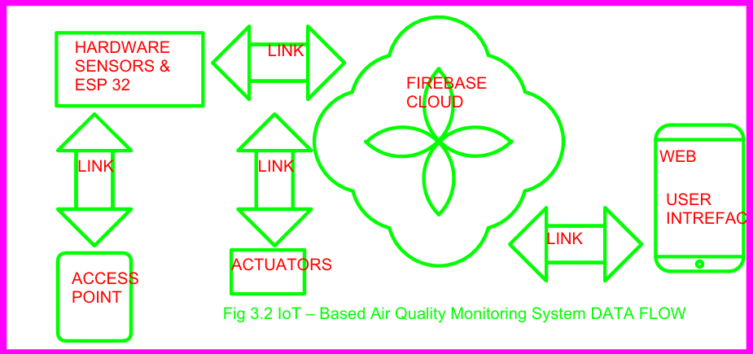

Fig 3.2 IoT-Based Air Quality Monitoring System Data Flow.

CHAPTER 5: WORK PLAN AND BUDGET
This chapter presents the proposed implementation schedule and financial requirements for the successful execution of the IoT-Based Air Quality Monitoring System project. The work plan outlines the project phases and timelines, while the budget details the estimated costs of hardware, software, and miscellaneous resources.

5.1 Work Plan
The project will be implemented in a phased approach to ensure systematic development, testing, and validation of the IoT-based air quality monitoring system. Each phase is designed to build upon the outcomes of the previous stage.

Phase 1: Project Planning and Literature Review
This phase involves refining the project scope, reviewing related literature, and finalizing system requirements. It establishes the theoretical and technical foundation of the project.

Phase 2: Hardware Design and Sensor Integration
This phase focuses on the selection, wiring, and calibration of gas sensors, particulate matter sensors, and environmental sensors with the ESP32 microcontroller. Initial hardware testing is conducted to ensure accurate sensing.

Phase 3: Firmware Development and Data Acquisition
Firmware is developed to enable sensor data acquisition, preprocessing, threshold detection, and wireless transmission. This phase ensures stable communication between the ESP32 and the cloud backend.

Phase 4: Cloud Integration and Database Design
In this phase, Firebase is configured to store and manage real-time sensor data. Cloud-based triggers and alert mechanisms are implemented to support remote monitoring.

Phase 5: Web/App Application Development
A web-based user interface is developed to visualize real-time data, historical trends, and alerts. Emphasis is placed on usability and accessibility.

Phase 6: Machine Learning Integration and Data Analysis
Predictive models are trained and integrated to forecast pollution levels, detect anomalies, and enhance system intelligence.

Phase 7: System Testing and Validation
The complete system is tested under controlled and real-world conditions to evaluate accuracy, responsiveness, and reliability.

Phase 8: Documentation and Final Submission
This final phase involves compiling project documentation, analyzing results, and preparing the final project report for submission.

5.2 Project Schedule

Table 5.1: timeline
The project is expected to span two academic semesters (approximately 8 months). A summarized timeline is presented below.
Activity | Start Month | Duration (Months)
Planning & Literature Review | 1 | 1
Hardware Design & Integration | 2 | 1
Firmware Development | 3 | 1
Cloud Integration | 4 | 1
Web Application Development | 5 | 1
Machine Learning Integration | 6 | 1
System Testing & Validation | 7 | 1
Documentation & Submission | 8 | 1

A Gantt chart is provided in Appendix A.

5.3 Budget

Table 5.2: Estimated Project Budget
Serial No | Component | Total
1 | ESP 32 | 2000
2 | MQ-SERIES | 3500
3 | NOVA PM | 2300
4 | BATTERY | 2500
5 | BATTERY CHARGER | 1800
6 | PSU | 400
7 | JUMPERS | 750
8 | STRIP BOARD | 240
9 | BREAD BOARD | 400
10 | ENCLOSURE | 1500
11 | INTERNET | 2000
12 | DHT11 | 700
13 | ACCESS POINT | 2500
14 | POWERBANK | 2000
15 | Miscellaneous | 1000
16 | LEDS | 100
17 | BUZZER | 40
18 | PUSH BUTTON | 100
19 | RESISTORS | 200
20 | CAPACITORS | 300
 | TOTAL | 24330

A detailed cost breakdown is provided in Appendix B.

CONCLUSION
The IoT-based air quality monitoring system is a feasible, resource-saving and scalable solution for the increasing problem of air pollution and dangerous gas leaks in home and urban areas. With the use of IoT sensing technologies, cloud-based data storage and predictive analytics, the system provides a practical solution for real-time environmental monitoring and early warning alerts. Unlike conventional centralized monitoring stations, this initiative seeks to provide household, small industry, and community-based air quality data in a way that is accessible, economical and actionable. The technology is in line with contemporary developments and is directed toward pressing health and safety needs, especially in areas with limited or expensive access to reliable monitoring infrastructure. The system can promote environmental awareness, lower pollution risks, improve public health and safety, and uses a modular system and easy-to-use UI. This proposal showcases the capability of and importance to implement an IoT-based monitoring solution that enables individuals and communities with effective and up-to-date environmental insights. Accordingly, the project could be considered relevant and impactful, in terms of measurable benefits in research, innovation and real-world application.

APPENDICES

APPENDIX A: Project Gantt Chart
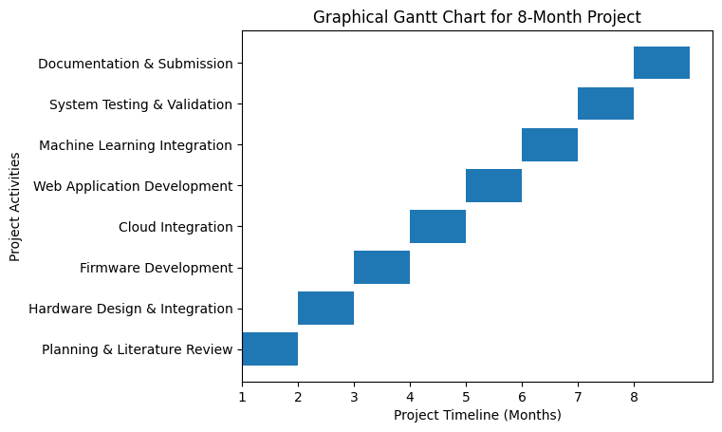

APPENDIX B: Detailed Budget Breakdown

Serial No | Component | DESCRIPTION | Unit cost | Quantity | Total
1 | ESP 32 | DOIT ESP32 DEVKIT V1 | 2000 | 1 | 2000
2 | MQ-SERIES | MQ-135 / MQ-7 gas sensors (analog modules) | 700 | 5 | 3500
3 | NOVA PM | SDS011 PM2.5/PM10 particulate sensor (UART) | 2300 | 1 | 2300
4 | BATTERY | 12 V Li-ion / lead-acid battery, 2–5 Ah typical | 2500 | 1 | 2500
5 | BATTERY CHARGER | TP4056 Li-ion charger module | 1800 | 1 | 1800
6 | PSU | AMS1117-3.3 voltage regulator (3.3 V output). | 400 | 1 | 400
7 | JUMPERS | 20 cm male-to-male jumper wires. (common prototyping set) | 250 | 3 | 750
8 | STRIP BOARD | Standard perfboard, proto assembly | 120 | 2 | 240
9 | BREAD BOARD | Standard 830-tie point breadboard. | 200 | 2 | 400
10 | ENCLOSURE | ABS plastic project box (project size dependent). | 1500 | 1 | 1500
11 | INTERNET | Wi-Fi data connection plan (monthly) | 1000 | 2 | 2000
12 | DHT11 | Temp/humidity sensor module (5 V) | 700 | 1 | 700
13 | ACCESS POINT | Wi-Fi router | 2500 | 1 | 2500
14 | POWERBANK | 10 000 mAh USB power bank | 2000 | 1 | 2000
15 | Miscellaneous | Screws, headers, mounts. | 1000 | 1 | 1000
16 | LEDS | 5 mm LEDs (e.g., red, green, blue). | 10 | 10 | 100
17 | BUZZER | 5 V active piezo buzzer. | 2 | 20 | 40
18 | PUSH BUTTON | Standard tactile push button | 5 | 20 | 100
19 | RESISTORS | Assorted: 10 kΩ, 4.7 kΩ, 1 kΩ, 220 Ω | 10 | 20 | 200
20 | CAPACITORS | Decoupling and bulk: 100 µF, 10 µF, 0.1 µF | 30 | 10 | 300
 |  |  |  | TOTAL | 24330

APPENDIX C: System Block Diagram

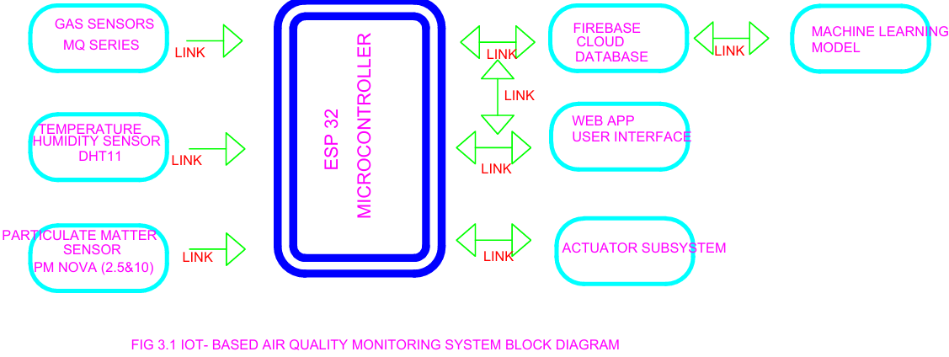

APPENDIX D: GITHUB REPOSITORY FOR THE PROJECT

https://github.com/joshuamuthenya/finalyearproject_all_content.git

