MERU UNIVERSITY OF SCIENCE TECHNOLOGY


DEPARTMENT OF ELECTRICAL AND ELECTRONICS ENGINEERING

Title: IoT – Based Air Quality Monitoring System

Name: Joshua Muthenya Wambua
Reg No: EG209/109705/22

A proposal submitted in partial fulfillment of the requirements for the award of the Degree of Bachelor of Technology in Electrical and Electronics Engineering in the Department of Electrical and Electronics Engineering at Meru University of Science and Technology.

Date:23/12/2025

DECLARATION
I hereby declare that this project proposal is my original work except as cited in the references and has not been presented for the award of a degree in any other University.

Sign: .........................................Date: ............................................
Name: Joshua Muthenya Wambua
Registration Number: EG209/109705/22

This proposal has been submitted for examination with my approval as the University supervisor.
Sign: ....................................... Date……...................................
Supervisor: ……………………………………………………......................................

Dedication
I dedicate this project proposal to my family, whose unwavering support, encouragement, and belief in my academic journey have continually inspired me. Their patience and motivation have been my greatest source of strength throughout this pursuit.

Acknowledgement
I wish to sincerely acknowledge the invaluable guidance and support provided by my supervisor, Eng. Job Kerosi, whose expertise and mentorship played a significant role in shaping this project idea. I also extend my appreciation to the Department of Electrical Engineering at Meru University of Science and Technology for providing the academic foundation and resources necessary for the development of this proposal. Lastly, I am grateful to my colleagues and friends for their constructive insights and encouragement, which contributed to the refinement and clarity of this work.

Table of contents
DECLARATION i
Dedication ii
Acknowledgement ii
Abstract v
CHAPTER 1: INTRODUCTION 1
1.1 Background of the Study 1
1.2 Problem Statement 1
1.3 Main Objective 2
1.4 Specific Objectives 2
1.5 Justification 2
1.6 Scope of the Study 2
CHAPTER TWO: LITERATURE REVIEW 3
2.1 Traditional Air Quality Monitoring Systems 3
2.2 Emergence of Low-Cost and Distributed Sensor Networks 3
2.3 Regional Studies and Local Initiatives 4
2.4 IoT-Based Monitoring and Real-Time Analytics 4
2.5 Machine Learning and Predictive Modeling in Air Quality 4
2.6 Summary of Literature Gaps 5
CHAPTER 3: METHODOLOGY 5
3.1 Research Design 5
3.2 System Development Approach 6
Phase 1: Sensor Integration 6
Phase 2: Edge Processing and Data Acquisition 6
Phase 3: Cloud Storage and Backend Integration 7
Phase 4: Web Application and User Interface 7
3.3 Machine Learning and Data Analysis Methods 7
Data Preprocessing 7
Exploratory Data Analysis 8
Predictive Modeling 8
Classification and Anomaly Detection 8
Evaluation Metrics 8
3.4 System Requirements 9
Hardware Requirements 9
Software Requirements 9
3.5 Prototype Testing 9
3.6 Ethical and Safety Considerations 10
3.7 Methodology Summary 10
CHAPTER 4: EXPECTED OUTCOMES 10
4.1 Real-Time Monitoring of Air Pollutants 10
4.2 Detection of Hazardous Gas Leaks and Fire Risks 11
4.3 Automated Alerts and User Notifications 11
4.4 Data Visualization and Accessibility 11
4.5 Predictive Analytics and Anomaly Detection 11
4.6 Enhanced Awareness and Safety Practices 11
4.7 Affordability and Scalability 12
4.8 Validation of IoT-Based Environmental Monitoring 12
4.9 Summary 12
Conclusion 13

Abstract
Air quality degradation and hazardous gas emissions represent critical challenges to public health, safety, and environmental sustainability. Urbanization and industrialization have intensified the release of pollutants, including carbon monoxide, methane, nitrogen oxides, and particulate matter (PM2.5 and PM10), while domestic environments remain vulnerable to leaks of liquefied petroleum gas (LPG) and other combustible gases. These pollutants are linked to respiratory illnesses, cardiovascular diseases, climate change, and fire outbreaks. However, existing monitoring approaches are often centralized, costly, and inaccessible to individuals for real-time decision-making. This project proposes an IoT-based air quality monitoring system designed to provide real-time data acquisition, cloud-based storage, and predictive analytics. The system integrates low-cost MQ gas sensors, particulate matter sensors, and environmental sensors with an ESP32 microcontroller for data collection and analysis. Data are transmitted to Firebase for secure storage, visualization, and alert dissemination through a web application. Furthermore, predictive models are employed to forecast pollution levels, detect anomalies, and assess potential fire hazards. The proposed system contributes to environmental health research by offering a scalable and resource-efficient solution for continuous monitoring, early warning, and risk mitigation in urban, domestic, agricultural, and healthcare settings.

CHAPTER 1: INTRODUCTION

1.1 Background of the Study
Air quality degradation has become a pressing environmental and public health concern globally. Rapid urbanization, increased industrial activities, transportation, and population growth have significantly elevated the release of harmful pollutants such as particulate matter (PM2.5 and PM10), carbon monoxide, methane, nitrogen oxides, carbon oxides and volatile organic compounds. These pollutants are directly associated with respiratory illnesses, cardiovascular diseases, allergies, and climate impacts. In addition to outdoor pollution, domestic environments face risks of hazardous gas leaks such as liquefied petroleum gas (LPG) and methane, which can lead to poisoning, fire outbreaks, and explosions.
Although government-operated monitoring stations exist in major cities, current air quality monitoring approaches remain centralized, expensive, and inaccessible to individuals at the household level. This creates a gap in real-time localized monitoring that can help mitigate risks promptly.
Recent advancements in Internet of Things (IoT), cloud computing, and machine learning present a promising opportunity to develop affordable and scalable monitoring systems. The proposed IoT – Based Air Quality Monitoring System integrates low-cost sensors with cloud-based storage and real-time data visualization to deliver accessible environmental insights. By leveraging MQ-series gas sensors, particulate matter sensors, and ESP32 microcontrollers, the system offers continuous surveillance of air pollutants and hazardous gases. The integration of predictive analytics further enhances the capability to detect anomalies and forecast pollution trends.
The IoT – Based Air Quality Monitoring System, therefore, represents a timely initiative toward improving environmental health, public safety, and awareness by bridging the gap between centralized air quality monitoring and household-level accessibility.

1.2 Problem Statement
Air pollution and hazardous gas exposure remain persistent problems in urban and domestic environments due to increased industrial activity, vehicular emissions, and the widespread use of gas-powered appliances. In many residential areas and small business premises, exposure to pollutants such as carbon monoxide, ammonia, and combustible gases often goes undetected until health symptoms, fires, or explosions occur. This delayed detection significantly increases the risk of injury, property damage, and loss of life.
Existing air quality and gas monitoring systems are largely centralized, expensive, and designed for regulatory or industrial use rather than individual households or small enterprises. Consequently, they are inaccessible to most users and fail to provide continuous, real-time, and location-specific information at the point of exposure. As a result, individuals lack timely awareness and early warning of deteriorating air quality or gas leakages within their immediate environment.
The absence of a resource-efficient, real-time, and localized monitoring solution creates a critical safety and public health gap. Without such a system, communities remain reactive rather than preventive in managing air pollution and gas-related hazards. Addressing this gap requires a low-cost, scalable, and accessible monitoring solution capable of detecting air pollutants and hazardous gases in real time and providing timely alerts to users.

1.3 Main Objective
To design a scalable IoT air quality monitor with real-time detection, prediction, and alerts.

1.4 Specific Objectives
- To monitor air pollutants such as particulate matter (PM2.5, PM10) and harmful gases (CO, LPG) in real time.
- To measure environmental parameters like temperature and humidity.
- To enable remote monitoring through a cloud–connected web application.
- To provide instant alerts when air quality exceeds safe thresholds.

1.5 Justification
Air quality monitoring solutions are often limited to government-operated or industrial-scale systems, making them inaccessible to households and small businesses. As a result, individuals remain exposed to invisible yet harmful pollutants and gas hazards. An economical and scalable IoT – Based Air Quality Monitoring System helps bridge this gap by:
- enhancing public safety through early detection and alerts,
- providing accessible real-time data for informed decision-making,
- reducing environmental health risks,
- aiding in community-level awareness and mitigation,
- integrating modern IoT and machine learning technologies for proactive monitoring.
The system thus offers a practical and research-driven solution to promote environmental health and public safety.

1.6 Scope of the Study
This project focuses on designing and implementing an IoT-based air quality monitoring system using low-cost gas sensors, particulate matter sensors, environmental sensors, and ESP32 microcontrollers. The scope includes real-time data collection, wireless transmission to a cloud platform (Firebase), web-based data visualization, and predictive modeling for anomaly detection and forecasting.
The project will cover:
- hardware integration,
- firmware development,
- cloud connectivity,
- web application interface,
- alert systems,
- and evaluation of system performance.
However, it does not cover nationwide monitoring or industrial certification standards. Instead, the focus remains on household, urban, agricultural, and healthcare environments where feasible and cost-effective deployment is needed.

CHAPTER TWO: LITERATURE REVIEW
Air quality monitoring has increasingly become a central topic in environmental research due to rising pollutant levels linked to urbanization, industrialization, and increasing population density. Traditional monitoring networks, while recognized for their accuracy, remain limited in spatial coverage and accessibility. Recent advances in low-cost sensing technologies, IoT platforms, and machine learning have introduced scalable solutions for broadening environmental surveillance. This chapter reviews developments in traditional monitoring systems, low-cost sensor deployment, regional monitoring initiatives, IoT-based systems, and predictive analytics.

2.1 Traditional Air Quality Monitoring Systems
Historically, government-operated and reference-grade monitoring stations have served as the foundational infrastructure for environmental air surveillance in major cities. These fixed stations rely on highly accurate instruments; however, they are expensive to deploy and maintain, leading to sparse coverage and limited real-time public accessibility [1]. Reference monitoring systems also struggle to capture localized variations in pollutant concentration due to their centralized nature [2]. This limited flexibility has driven researchers to explore complementary systems capable of expanding coverage while maintaining high levels of measurement reliability [3].

2.2 Emergence of Low-Cost and Distributed Sensor Networks
The limitations associated with traditional monitoring networks have catalyzed the development of distributed, low-cost sensor systems. Recent literature highlights that sensors such as MQ-series gas sensors and optical PM sensors have demonstrated strong potential for community-level monitoring due to their small form factor and deployability [2]. Studies further show that while low-cost sensors may experience drift and require calibration, cloud-based and algorithmic techniques significantly enhance their accuracy [4]. Case studies examining low-cost sensor deployment emphasize the ability of distributed networks to offer high-resolution spatial data not captured by fixed government stations [6]. Researchers conclude that such networks can complement traditional monitoring by expanding spatial resolution and enabling continuous monitoring in areas previously underserved by reference systems [7].

2.3 Regional Studies and Local Initiatives
In Africa, and Kenya specifically, research indicates heightened exposure to particulate matter and gaseous pollutants due to traffic, industrial activity, and domestic fuel combustion. Localized studies in Nairobi demonstrate that calibrated low-cost sensors can provide pollutant data that aligns closely with reference instruments [5]. Citizen-science deployments in informal settlements have shown the feasibility and social value of community-integrated monitoring approaches [4]. Reports from networks operating in cities such as Mombasa show that PM2.5 levels frequently exceed established safety guidelines, indicating the practicality and urgency of scalable monitoring solutions [6]. Additionally, governmental and research organizations, including national meteorological agencies, acknowledge the growing need for distributed environmental sensing. The literature clearly supports the implementation of affordable, scalable sensors tailored for domestic and urban environments within developing regions.

2.4 IoT-Based Monitoring and Real-Time Analytics
Advancements in IoT systems have enabled remote environmental monitoring through real-time data acquisition, wireless communication, and cloud storage. Microcontrollers such as ESP32 facilitate continuous sensing and low-power wireless transmission, eliminating manual data collection requirements [7]. Research demonstrates that cloud platforms enhance data availability, support alert systems, and simplify user access. Further, IoT-enabled monitoring systems are recognized for their capacity to scale across networks and integrate heterogeneous sensors, making them highly suitable for both indoor and outdoor environments. Studies confirm that IoT-based monitoring architectures significantly improve responsiveness to pollution episodes, gas leaks, and hazardous air quality events .

2.5 Machine Learning and Predictive Modeling in Air Quality
Machine learning (ML) has emerged as a transformative component of air quality surveillance, enhancing both data interpretation and predictive capability. Algorithms such as regression models, Random Forest, Support Vector Machines, and deep learning are commonly employed to improve sensor accuracy and generate pollutant forecasts [8]. Literature further demonstrates that ML calibration significantly reduces error and drift from low-cost sensor measurements, making them suitable for long-term operation [9]. Additional studies explore the integration of mobile and fixed monitoring systems with ML to create high-resolution spatial pollutant maps [10]. These advancements shift monitoring frameworks from passive data collection to proactive pollution management, enabling anomaly detection and early warnings [11].

2.6 Literature Gaps
Although substantial research exists on centralized and distributed air quality monitoring systems, notable gaps persist, including:
- limited household-level access to reliable monitoring systems,
- insufficient real-time alerts for hazardous pollutant events,
- challenges in integrating predictive analytics at scale,
- and the need for cost-effective, scalable sensor frameworks.
The reviewed literature suggests that a solution leveraging distributed sensors, IoT communication, cloud storage, and machine learning can address existing system limitations by improving accessibility, enhancing responsiveness, and providing actionable environmental data for communities and households.

CHAPTER 3: METHODOLOGY
This chapter describes the methodology used in the design and implementation of the IoT – Based Air Quality Monitoring System. The approach follows a systematic framework consisting of hardware integration, data acquisition, cloud connectivity, predictive analytics, and visualization. The methodology ensures that the proposed system delivers real-time monitoring, alerts, and environmental data insights using low-cost IoT components and machine learning techniques.

3.1 Research Design
The project adopts an experimental and design-based research methodology. An IoT-driven prototype is developed to demonstrate real-time detection of pollutants and hazardous gases. The system integrates sensors with an ESP32 microcontroller to collect air quality data, which is transmitted to a cloud database for storage and visualization. Predictive analytics and anomaly detection models are incorporated to enhance system intelligence.
The research design emphasizes:
- low-cost implementation,
- scalability,
- real-time communication,
- and end-user accessibility.

3.2 System Development Approach
The methodology consists of four major development phases:

Phase 1: Sensor Integration
This phase involves selecting and interfacing appropriate sensing components with the ESP32 microcontroller.
Key components include:
- MQ-series gas sensors (MQ-2, MQ-7, MQ-9,MQ-8,MQ-5, MQ-135)
- PM2.5 and PM10 particulate matter sensors
- DHT11 environmental sensor for temperature and humidity
Activities:
- wiring and assembling sensors on a stripboard/breadboard,
- testing detection ranges,
- calibrating sensor responses.
The purpose of this phase is to enable accurate measurement of gaseous pollutants and particulate matter.

Phase 2: Edge Processing and Data Acquisition
The ESP32 microcontroller is programmed to:
- capture sensor readings,
- filter noise,
- convert analog signals to digital values,
- and preprocess raw data.
Processing tasks include:
- normalization,
- threshold checks,
- timestamping,
- and packaging of readings.
Wireless communication via built-in Wi-Fi enables seamless transmission without additional networking modules.
The microcontroller acts as an intelligent edge device, reducing the cloud processing load.
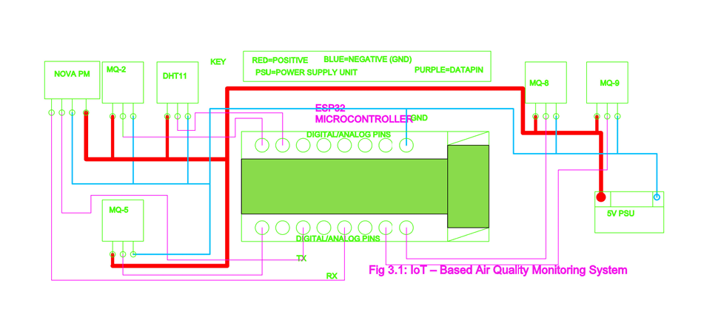

Phase 3: Cloud Storage and Backend Integration
Firebase is used as the cloud backend due to its:
- real-time database functionality,
- secure data storage,
- and scalable architecture.
Core activities include:
- establishing a connection between ESP32 and Firebase,
- structuring cloud database fields for pollutants,
- implementing triggers for threshold-based alerts.
This allows remote access to sensor data, historical records, and system performance metrics.

Phase 4: Web Application and User Interface
A web application is developed to allow end-users to visualize and interact with data.
Functionalities include:
- viewing real-time air quality indices,
- accessing historical pollutant trends,
- receiving notifications and warnings,
- interpreting visual charts.
The interface enhances usability by enabling monitoring from smartphones, PCs, or tablets.
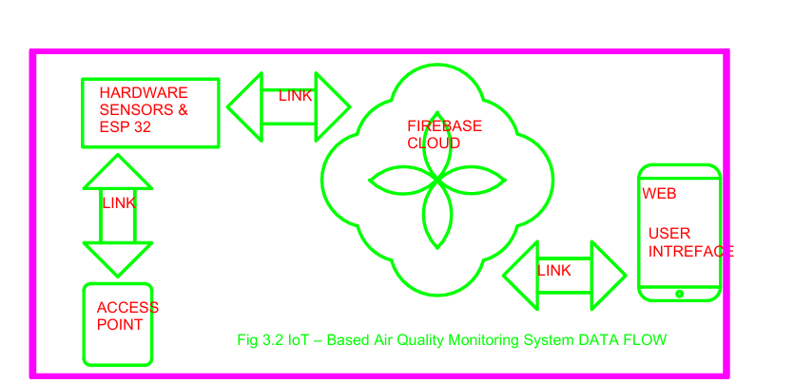

3.3 Machine Learning and Data Analysis Methods
To improve system intelligence, predictive and analytical methods are employed.

Data Preprocessing
Involves:
- cleaning anomalous readings,
- calibration corrections,
- normalizing values,
- and managing missing data.

Exploratory Data Analysis
Used to:
- observe patterns and time-series trends,
- visualize pollution spikes,
- Identify seasonal or hourly variations.

Predictive Modeling
Methods include:
- Regression (Linear Regression, Random Forest)
- Deep Learning (LSTM)
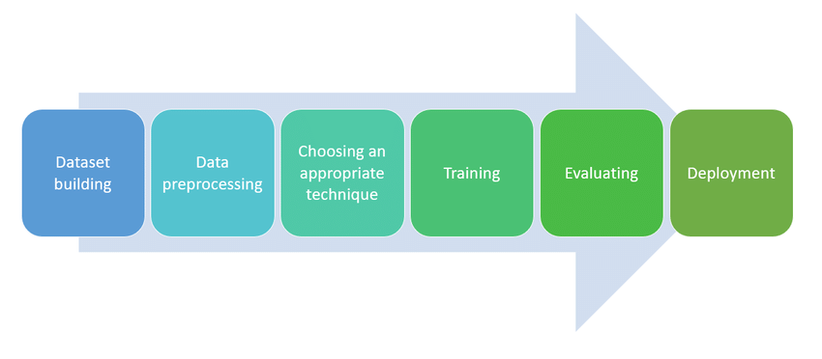
Purpose:
- forecasting short-term pollutant levels,
- predicting hazardous events.

Classification and Anomaly Detection
Models include:
- Support Vector Machines,
- Isolation Forests.
Used to:
- detect gas leaks,
- flag abnormal pollution patterns,
- activate alerts.

Evaluation Metrics
System performance is validated using:
- RMSE and MAE (forecasting accuracy),
- confusion matrices (classification),
- and accuracy scores.

3.4 System Requirements

Hardware Requirements
- ESP32 microcontroller
- MQ-series gas sensors (MQ7, MQ-8, MQ-5,MQ-9,MQ-153)
- PM sensors (Nova PM Sensor)
- DHT11
- LEDs/buzzer (alert interface)
- Breadboard/stripboard
- 12V Battery
- Wi-Fi access point.
- Jumper wires and enclosure

Software Requirements
- Firebase backend
- Web application framework
- Programming language (Arduino C++ / MicroPython)
- Machine learning libraries
- Data visualization tools

3.5 Prototype Testing
Testing is performed in two contexts:
- Controlled environment testing
  - use simulated pollutant sources
  - validate sensor response and calibration
- Real-world deployment
  - Monitor air quality in domestic or urban environments.
  - Evaluate performance under actual conditions.
Testing measures:
- accuracy of readings,
- latency of alerts,
- cloud update performance,
- and user interface usability.

3.6 Ethical and Safety Considerations
- safe handling of gas sources during testing,
- ensuring no exposure risks to people,
- data privacy for logged sensor information.

CHAPTER 4: EXPECTED OUTCOMES

The EcoSphere Monitor project is designed to deliver a practical, affordable, and scalable air quality monitoring system capable of real-time detection, analysis, and reporting of environmental pollutants. Upon completion, the system is expected to provide measurable improvements in environmental awareness, hazard prevention, and data accessibility. The following section outlines the anticipated outcomes of the proposed system.


4.1 Real-Time Monitoring of Air Pollutants
The system is expected to successfully monitor key pollutants such as particulate matter (PM2.5 and PM10), carbon monoxide, methane, and other hazardous gases. Continuous sensing through MQ-series gas sensors and PM sensors will enable immediate detection of fluctuations in pollutant levels. This real-time visibility will support individuals and households in understanding the quality of air in their immediate surroundings.

4.2 Detection of Hazardous Gas Leaks and Fire Risks
With integrated sensors like MQ-2, MQ-7, and MQ-135, the system is expected to detect combustible and toxic gases associated with fire outbreaks, poisoning, and explosions. By setting threshold values, the prototype should be capable of issuing warnings when gas concentrations exceed safety limits. This outcome minimizes risks and enables timely intervention, especially in kitchens, industries, laboratories, and fuel storage facilities.

4.3 Automated Alerts and User Notifications
Through Firebase integration and web application support, the system is expected to provide instant alerts to users via cloud-based notifications or interface warnings. These alerts will allow rapid response to hazardous environmental conditions, helping prevent accidents or prolonged exposure to pollution.

4.4 Data Visualization and Accessibility
The project is expected to deliver a user-friendly web application that displays real-time readings, historical trends, and pollution analysis. This ensures accessibility through mobile devices, laptops, and other internet-enabled platforms. The outcome democratizes environmental data by making it available to users who traditionally lack access to professional monitoring systems.

4.5 Predictive Analytics and Anomaly Detection
Machine learning models integrated into the system are expected to:
- forecast pollutant levels,
- detect abnormal pollution patterns,
- identify gas leak anomalies,
- and provide proactive insights.
This transforms the system from a purely reactive tool into a predictive decision-making platform.

4.6 Enhanced Awareness and Safety Practices
The project is expected to contribute significantly to public awareness by:
- educating users about pollutant risks,
- promoting safe practices,
- and encouraging environmental responsibility.
This outcome supports households, schools, healthcare facilities, and small industries in adopting safety-driven behavior.

4.7 Affordability and Scalability
By using low-cost sensing modules and open-source platforms, the system is expected to demonstrate that effective air quality monitoring can be achieved without high-cost equipment. The modular design ensures scalability for:
- household use,
- small businesses,
- urban communities,
- agricultural facilities,
- and healthcare environments.

4.8 Validation of IoT-Based Environmental Monitoring
Finally, the system is expected to validate that IoT-enabled monitoring can bridge the gap between centralized government monitoring systems and individual consumer needs. Success will confirm the feasibility of:
- decentralized sensing,
- cloud-based analytics,
- and low-cost environmental intelligence.

4.9 Summary
In summary, EcoSphere Monitor is expected to:
- enable real-time pollutant monitoring,
- detect hazardous gas leaks,
- provide timely alerts,
- support predictive analysis,
- improve environmental awareness,
- and offer a low-cost, scalable alternative to centralized monitoring systems.
Collectively, these outcomes position the system as an impactful solution to environmental health and safety challenges in both domestic and urban contexts.

CHAPTER 5: WORK PLAN AND BUDGET
This chapter presents the proposed implementation schedule and financial requirements for the successful execution of the IoT – Based Air Quality Monitoring System project. The work plan outlines the project phases and timelines, while the budget details the estimated costs of hardware, software, and miscellaneous resources.

5.1 Work Plan
The project will be implemented in a phased approach to ensure systematic development, testing, and validation of the IoT-based air quality monitoring system. Each phase is designed to build upon the outcomes of the previous stage.

Phase 1: Project Planning and Literature Review
This phase involves refining the project scope, reviewing related literature, and finalizing system requirements. It establishes the theoretical and technical foundation of the project.

Phase 2: Hardware Design and Sensor Integration
This phase focuses on the selection, wiring, and calibration of gas sensors, particulate matter sensors, and environmental sensors with the ESP32 microcontroller. Initial hardware testing is conducted to ensure accurate sensing.

Phase 3: Firmware Development and Data Acquisition
Firmware is developed to enable sensor data acquisition, preprocessing, threshold detection, and wireless transmission. This phase ensures stable communication between the ESP32 and the cloud backend.

Phase 4: Cloud Integration and Database Design
In this phase, Firebase is configured to store and manage real-time sensor data. Cloud-based triggers and alert mechanisms are implemented to support remote monitoring.

Phase 5: Web/App Application Development
A web-based user interface is developed to visualize real-time data, historical trends, and alerts. Emphasis is placed on usability and accessibility.

Phase 6: Machine Learning Integration and Data Analysis
Predictive models are trained and integrated to forecast pollution levels, detect anomalies, and enhance system intelligence.

Phase 7: System Testing and Validation
The complete system is tested under controlled and real-world conditions to evaluate accuracy, responsiveness, and reliability.

Phase 8: Documentation and Final Submission
This final phase involves compiling project documentation, analyzing results, and preparing the final project report for submission.

5.2 Project Schedule
The project is expected to span two academic semesters (approximately 8 months). A summarized timeline is presented below.
Activity | Duration
Planning & Literature Review | Month 1
Hardware Design & Integration | Month 2
Firmware Development | Month 3
Cloud Integration | Month 4
Web Application Development | Month 5
Machine Learning Integration | Month 6
System Testing & Validation | Month 7
Documentation & Submission | Month 8
A detailed Gantt chart is provided in Appendix A.

5.3 Budget
The estimated budget for the project is summarized in Table 5.1. All costs are in Kenya Shillings (KES).

Table 5.1: Estimated Project Budget

Serial No | Component | Total
1 | ESP 32 | 2000
2 | MQ-SERIES | 3500
3 | NOVA PM | 2300
4 | BATTERY | 2500
5 | BATTERY CHARGER | 1800
6 | PSU | 400
7 | JUMPERS | 750
8 | STRIP BOARD | 240
9 | BREAD BOARD | 400
10 | ENCLOSURE | 1500
11 | INTERNET | 2000
12 | DHT11 | 700
13 | ACCESS POINT | 2500
14 | POWERBANK | 2000
15 | Miscellaneous | 1000
16 | LEDS | 100
17 | BUZZER | 40
18 | PUSH BUTTON | 100
19 | RESISTORS | 200
20 | CAPACITORS | 300
 | TOTAL | KSH: 24330

A detailed cost breakdown is provided in Appendix B.

Conclusion
The IoT – Based Air Quality Monitoring System proposes an innovative, resource-efficient, and scalable approach to addressing the growing challenge of air pollution and hazardous gas leaks in domestic and urban environments. By integrating IoT sensing technologies, cloud-based data storage, and predictive analytics, the system offers a practical solution for real-time environmental monitoring and early warning alerts. Unlike traditional centralized monitoring stations, this project aims to make air quality data accessible, affordable, and actionable for households, small industries, and community settings.
The proposed system aligns with current technological trends and responds to an urgent health and safety need, particularly in regions where access to reliable monitoring infrastructure is limited or costly. Through its modular design and user-friendly interface, EcoSphere Monitor has the potential to enhance environmental awareness, reduce pollution-related risks, and contribute to public health and safety.
Overall, this proposal demonstrates the feasibility and significance of developing an IoT-based monitoring system that empowers individuals and communities with timely and accurate environmental insights. The project is therefore justified as both relevant and impactful, with measurable benefits in research, innovation, and real-world application.
References

[1] | E. Bagkis , . A. Hassani, P. Schneider, P. DeSouza, S. Shetty, T. Kassandros and J. Khan, "Evolving trends in application of low-cost air quality sensor networks: challenges and future directions:challenges and future directions," npj Climate and Atmospheric Science, vol. 8, no. 1, p. 335, 2025.
[2] | F. Concas, J. Mineraud, E. Lagerspetz, S. Varjonen, X. Liu, S. Tarkoma and K. Puolamäki, "Low-cost outdoor air quality monitoring and sensor calibration: A survey and critical analysis.," ACM Transactions on Sensor Networks (TOSN), vol. 17, no. 2, pp. 1-44, 2021.
[3] | A. Garcia, Y. Saez, I. Harris, X. Huang and E. Collado, "Advancements in air quality monitoring: a systematic review of IoT-based air quality monitoring and AI technologies," Artificial Intelligence Review, vol. 58, no. 9, p. 275, 2025.
[4] | T. Manshur, C. Luiu, W. R. Avis, V. Bukachi, F. D. Pope, J. Mulligan and M. Gatari, "A citizen science approach for air quality monitoring in a Kenyan informal development.," City and Environment Interactions, vol. 19, p. 100105, 2023.
[5] | M. J. Gatari, F. D. Pope, D. Ng'ang'a , A. Poynter and R. Blake, "Airborne particulate matter monitoring in Kenya using calibrated low-cost sensors.," Atmospheric Chemistry and Physics, vol. 18, no. 20, pp. 15403-15418., 2018.
[6] | M. N. Njeru, E. Mwangi, M. J. Gatari, M. I. Kaniu, J. Kanyeria, G. Raheja and D. M. Westervelt, "First results from a calibrated network of low‐cost PM2. 5 monitors in Mombasa, Kenya show exceedance of healthy guidelines," GeoHealth, vol. 8, no. 9, p. e2024GH001049, 2024.
[7] | M. Zaid, P. Nawale, V. Kumar, V. Malyan and M. Sahu, "Investigating IoT-Based Low-cost Sensor Network for Real-Time Hyper-Local Air Quality Monitoring and Exposure Assessment.," Atmospheric Pollution Research, p. 102749, 2025.
[8] | M. Tastan, " Machine Learning–Based Calibration and Performance Evaluation of Low-Cost Internet of Things Air Quality Sensors.," Sensors, vol. 25, no. 10, p. 3183, 2025.
[9] | K. Yong-Hyuk and M. Seung-Hyun, "Machine Learning-Based Quality Control for Low-Cost Air Quality Monitoring: A Comprehensive Review of the Past Decade," Atmosphere, vol. 16, no. 10, p. 1136, 2025.
[10] | Y. M. Idir, O. Orfila, P. Chatellier, V. Judalet and V. Guaffre, "Idir, Y.M., Orfila, O., Chatellier, P., Judalet, V. and Guaffre, V., 2025. Mapping urban air quality using mobile and fixed low cost sensors: a model comparison.," arXiv preprint arXiv, vol. 2511.22550., 2025.
[11] | R. Ramesh, . H. Vallabhu, A. Unni and . S. Nalinakshan, "IoT-Enabled Air Quality Monitoring: Advancements, Applications, and Challenges.," In 2024 9th International Conference on Communication and Electronics Systems (ICCES), pp. 561-567, 2024.
[12] | H. Othman, R. Azari and T. Guimarães , "Low-Cost IoT-based Indoor Air Quality Monitoring.," Technology| Architecture+ Design, vol. 8, no. 2, pp. 250-270, 2024.

APPENDICES

APPENDIX A: Project Gantt Chart
(Insert graphical Gantt chart)

APPENDIX B: Detailed Budget Breakdown
(
Serial No | Component | DESCRIPTION | Unit cost | Quantity | Total
1 | ESP 32 | DOIT ESP32 DEVKIT V1 | 2000 | 1 | 2000
2 | MQ-SERIES | MQ-135 / MQ-7 gas sensors (analog modules) | 700 | 5 | 3500
3 | NOVA PM | SDS011 PM2.5/PM10 particulate sensor (UART) | 2300 | 1 | 2300
4 | BATTERY | 12 V Li-ion / lead-acid battery, 2–5 Ah typical | 2500 | 1 | 2500
5 | BATTERY CHARGER | TP4056 Li-ion charger module | 1800 | 1 | 1800
6 | PSU | AMS1117-3.3 voltage regulator (3.3 V output). | 400 | 1 | 400
7 | JUMPERS | 20 cm male-to-male jumper wires. (common prototyping set) | 250 | 3 | 750
8 | STRIP BOARD | Standard perfboard, proto assembly | 120 | 2 | 240
9 | BREAD BOARD | Standard 830-tie point breadboard. | 200 | 2 | 400
10 | ENCLOSURE | ABS plastic project box (project size dependent). | 1500 | 1 | 1500
11 | INTERNET | Wi-Fi data connection plan (monthly) | 1000 | 2 | 2000
12 | DHT11 | Temp/humidity sensor module (5 V) | 700 | 1 | 700
13 | ACCESS POINT | Wi-Fi router | 2500 | 1 | 2500
14 | POWERBANK | 10 000 mAh USB power bank | 2000 | 1 | 2000
15 | Miscellaneous | Screws, headers, mounts. | 1000 | 1 | 1000
16 | LEDS | 5 mm LEDs (e.g., red, green, blue). | 10 | 10 | 100
17 | BUZZER | 5 V active piezo buzzer. | 2 | 20 | 40
18 | PUSH BUTTON | Standard tactile push button | 5 | 20 | 100
19 | RESISTORS | Assorted: 10 kΩ, 4.7 kΩ, 1 kΩ, 220 Ω | 10 | 20 | 200
20 | CAPACITORS | Decoupling and bulk: 100 µF, 10 µF, 0.1 µF | 30 | 10 | 300
 |  |  |  | TOTAL | 24330

APPENDIX C: System Block Diagram
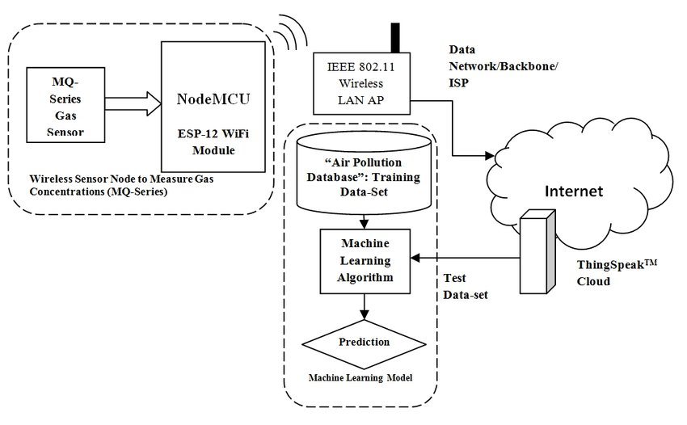

APPENDIX D: GITHUB REPOSITORY FOR THE PROJECT

https://github.com/joshuamuthenya/finalyearproject_all_content.git

