IOT-BASED AIR QUALITY MONITORING SYSTEM

School of Engineering and Architecture
Department of Electrical and Electronics Engineering
Bachelor of Technology in Electrical and Electronics Engineering
Joshua Muthenya Wambua
EG209/109705/22
A proposal submitted in partial fulfillment of the requirements for the award of the Degree of Bachelor of Technology in Electrical and Electronics Engineering in the Department of Electrical and Electronics Engineering at Meru University of Science and Technology.
January, 2026

DECLARATION
I hereby declare that this project proposal is my original work except as cited in the references and has not been presented for the award of a degree in any other University.

Sign: .........................................Date: ...........................................
Joshua Muthenya Wambua
EG209/109705/22

This proposal has been submitted for examination with my approval as the University supervisor.
Sign: ....................................... Date……...................................
Supervisor: Mr. Job Kerosi, COD Electrical and Electronics Department

ABSTRACT
Air quality degradation and hazardous gas emissions present critical challenges to public health, safety, and environmental sustainability. Urbanization and industrialization have intensified the release of pollutants, including carbon oxides, methane, and particulate matter (PM2.5 and PM10), while domestic environments remain vulnerable to leaks of liquefied petroleum gas (LPG) and other combustible gases. These pollutants are linked to respiratory illnesses, cardiovascular diseases, climate change, and fire outbreaks. However, existing monitoring approaches are often centralized, costly, and inaccessible to individuals for real-time decision-making. This project proposes an IoT-based air quality monitoring system designed to provide real-time data acquisition, cloud-based storage, and predictive analytics. The system integrates low-cost MQ gas sensors, particulate matter sensors, and environmental sensors with an ESP32 microcontroller for data collection and analysis. Data are transmitted to Firebase for secure storage, visualization, and alert dissemination through a web application. Furthermore, predictive models are employed to forecast pollution levels, detect anomalies, and assess potential fire hazards. Actuation and safety response system is also included. The proposed system contributes to environmental health research by offering a scalable and resource-efficient solution for continuous monitoring, early warning, and risk mitigation in urban, domestic, agricultural, and healthcare settings.

TABLE OF CONTENTS
DECLARATION ii
ABSTRACT iii
TABLE OF CONTENTS iv
LIST OF ABBREVIATIONS v
LIST OF FIGURES vi
LIST OF TABLES vi
CHAPTER 1: INTRODUCTION 1
1.1 Background of the Study 1
1.2 Problem Statement 2
1.3 Main Objective 2
1.4 Specific Objectives 2
1.5 Justification 3
1.6 Scope of the Study 3
CHAPTER TWO: LITERATURE REVIEW 4
Introduction 4
2.1 Traditional Air Quality Monitoring Systems 4
2.2 Emergence of Low-Cost and Distributed Sensor Networks 4
2.3 Regional Studies and Local Initiatives 5
2.4 IoT-Based Monitoring and Real-Time Analytics 5
2.5 Machine Learning and Predictive Modeling in Air Quality 6
2.6 Safety Response Systems in Air Quality Monitoring 6
2.7 Effects of Temperature and Humidity on Air Pollutant Concentration and Sensor Performance 7
2.8 Literature Gaps 7
CHAPTER 3: METHODOLOGY 8
3.1 Research Design 8
3.2 System Requirements 8
3.3 System Development Approach 10
Phase 1: Sensor Integration 10
Phase 2: Edge Processing and Data Acquisition 11
Phase 3: Cloud Storage and Backend Integration 11
Phase 4: Web Application and User Interface 13
3.4 Machine Learning and Data Analysis Methods 13
3.5 Prototype Testing 16
3.6 Ethical and Safety Considerations 16
CHAPTER 4: EXPECTED OUTCOMES 17
4.1 Real-Time Monitoring of Air Pollutants 17
4.2 Detection of Hazardous Gas Leaks and Fire Risks 18
4.3 Automated Alerts and User Notifications 18
4.4 Data Visualization and Accessibility 18
4.5 Predictive Analytics and Anomaly Detection 18
4.6 Enhanced Awareness and Safety Practices 19
4.7 Affordability and Scalability 19
4.8 Validation of IoT-Based Environmental Monitoring 19
CHAPTER 5: WORK PLAN AND BUDGET 19
5.1 Project Schedule 19
5.2 Budget 20
CONCLUSION 21
REFERENCES 22
APPENDICES 24
Appendix A: Project Gantt Chart 24
Appendix B: System Block Diagram 25
Appendix C: GitHub Repository for The Project 25
Appendix D: Logical Flow Chart 26

LIST OF ABBREVIATIONS
- ESP32 – Espressif 32-bit Microcontroller
- DHT11 – Digital Humidity and Temperature Sensor
- LPG – Liquefied Petroleum Gas
- MQ – Metal Oxide Semiconductor Gas Sensor Series
- MQ7 – Carbon Monoxide Gas Sensor
- PM – Particulate Matter
- PM₂ – Particulate Matter with diameter ≤ 2.5 micrometers
- PM₁₀ – Particulate Matter with diameter ≤ 10 micrometers
- ML – Machine Learning
- CO – Carbon Monoxide
- RMSE – Root Mean Square Error

LIST OF FIGURES
Figure 1:DHT11 Sensor 8
Figure 2: PM sensor 9
Figure 3: MQ-2 Sensor 9
Figure 4: MQ-7 Sensor 9
Figure 5: MQ-5 Sensor 9
Figure 6: MQ-8 Sensor 10
Figure 7:ESP 32 Module 10
Figure 8: IoT-Based Air Quality Monitoring System Hardware 12
Figure 9:IoT-Based Air Quality Monitoring System Data Flow 13
Figure 10:IoT-Based Air Quality Monitoring System ML subsystem 15
Figure 11:illustrates the enclosure of the IoT-Based Air Quality Monitoring System 17
Figure 12:Gantt chart 24
Figure 13: System Block Diagram 25
Figure 14: logical flow chart 26

LIST OF TABLES
Table 1: Project timeline 20
Table 2: Project budget 20

CHAPTER 1: INTRODUCTION

1.1 Background of the Study
Air quality degradation has become a pressing environmental and public health concern globally. Rapid urbanization, increased industrial activities, transportation, and population growth have significantly elevated the release of harmful pollutants such as particulate matter (PM2.5 and PM10), methane, carbon oxides and volatile organic and inorganic compounds. These pollutants are directly associated with respiratory illnesses, cardiovascular diseases, allergies, and climate impacts. In addition to outdoor pollution, domestic environments face risks of hazardous gas leaks such as liquefied petroleum gas (LPG) and methane, which can lead to poisoning, fire outbreaks, and explosions.
Although government-operated monitoring stations exist in major cities, current air quality monitoring approaches remain centralized, expensive, and inaccessible to individuals at the household level. This creates a gap in real-time localized monitoring that can help mitigate risks.
Recent advancements in Internet of Things (IoT), cloud computing, and machine learning present a promising opportunity to develop affordable and scalable monitoring systems. The proposed IoT-Based Air Quality Monitoring System integrates low-cost sensors with cloud-based storage and real-time data visualization to deliver accessible environmental insights. By leveraging MQ-series gas sensors, particulate matter sensors, temperature and humidity sensor (DHT11) and ESP32 microcontrollers, the system offers continuous surveillance of air pollutants and hazardous gases. The integration of predictive analytics further enhances the capability to detect anomalies and forecast pollution trends. The integration of the actuation and safety response system makes the system more vital in today’s world.
The system, therefore, represents a timely initiative toward improving environmental health, public safety, and awareness by bridging the gap between centralized air quality monitoring and household-level accessibility.

1.2 Problem Statement
Air pollution and hazardous gas exposure remain persistent problems in urban and domestic environments due to increased industrial activity, vehicle exhausts, and the use of gas-powered appliances. In many residential areas and small business premises, exposure to pollutants such as carbon monoxide and combustible gases often goes undetected until health symptoms, fires, or explosions occur. This delayed detection significantly increases the risk of injury, property damage, and loss of life.
Existing air quality and gas monitoring systems are largely centralized, expensive, and designed for regulatory or industrial use rather than individual households or small enterprises. Consequently, they are inaccessible to most users and fail to provide continuous, real-time, and location-specific information at the point of exposure. Consequently, individuals lack timely awareness and early warning of deteriorating air quality or gas leakages within their immediate surrounding.
The absence of a resource-efficient, real-time, and localized monitoring solution creates a critical safety and public health gap. Without such a system, communities remain reactive rather than preventive in managing air pollution and gas-related hazards. Addressing this gap requires an economical, scalable, and accessible monitoring solution capable of detecting air pollutants and hazardous gases in real time and providing timely alerts to users, and enabling preventive measures through actuators. The solution is the proposed IoT-Based Air Quality Monitoring System.

1.3 Main Objective
To design a scalable IoT-Based Air Quality Monitoring System with real-time detection, prediction, alerts, and actuation.

1.4 Specific Objectives
- To monitor air pollutants such as particulate matter (PM_{2.5}, PM₁₀) and harmful gases (CO, LPG) in real time.
- To measure environmental parameters like temperature and humidity.
- To enable remote monitoring through a cloud–connected web application.
- To provide instant alerts when air quality exceeds safe thresholds.
- To implement a safety response system.

1.5 Justification
Air quality monitoring solutions are often limited to government-operated or industrial-scale systems, making them inaccessible to households and small businesses. As a result, individuals remain exposed to invisible yet harmful pollutants and gas hazards. An economical and scalable IoT-Based Air Quality Monitoring System helps bridge this gap by:
- Enhancing public safety through early detection and alerts.
- Providing accessible real-time data for informed decision-making.
- Reducing environmental health risks.
- Aiding in community-level awareness and mitigation.
- Integrating modern IoT and machine learning technologies for proactive monitoring.
The system thus offers a practical and research-driven solution to promote environmental health and public safety.

1.6 Scope of the Study
This project focuses on designing and implementing an IoT-based air quality monitoring system using low-cost gas sensors, particulate matter sensors, environmental sensors, actuators, and ESP32 microcontrollers. The scope includes real-time data collection, wireless transmission to a cloud platform (Firebase), web-based data visualization, safety response, and predictive modeling for anomaly detection and forecasting.
The project will cover; hardware integration, firmware development, cloud connectivity, web application interface, alert systems, and evaluation of system performance.
This project, however, does not cover nationwide monitoring or industrial certification standards. Instead, the focus remains on household, urban, agricultural, and healthcare environments where feasible and cost-effective deployment is needed.

CHAPTER TWO: LITERATURE REVIEW

Introduction
Bagkis et al. (2025) reviewed evolving trends in air quality monitoring and identified rising pollutant levels linked to urbanization, industrialization, and population growth as a major global concern [1]. Garcia et al. (2025) further emphasized that while reference-grade monitoring systems provide high accuracy, their high cost and limited spatial coverage restrict accessibility, particularly in developing regions [3]. Concas et al. (2021) noted that these limitations have driven increasing research interest in low-cost sensors, IoT platforms, and data-driven techniques as scalable alternatives for environmental surveillance [2]. Guided by these findings, this chapter reviews traditional air quality monitoring systems, low-cost and distributed sensor networks, regional and local initiatives, IoT-based monitoring systems, machine learning and predictive analytics, safety response systems, and the effects of temperature and humidity on air quality and sensor performance.

2.1 Traditional Air Quality Monitoring Systems
Concas et al. (2021) described traditional air quality monitoring systems as government-operated, reference-grade stations that employ highly accurate and standardized instruments for regulatory compliance and long-term assessment [2]. Garcia et al. (2025) reported that despite their accuracy, such stations are expensive to deploy and maintain, resulting in sparse spatial coverage and limited real-time accessibility for the public [3]. Bagkis et al. (2025) further demonstrated that the centralized nature of reference stations limits their ability to capture localized pollution variations caused by traffic density, land-use patterns, and microclimatic effects [1]. These observations collectively support the need for complementary monitoring approaches capable of extending coverage while maintaining acceptable measurement reliability.

2.2 Emergence of Low-Cost and Distributed Sensor Networks
Bagkis et al. (2025) identified low-cost and distributed sensor networks as a promising solution to the spatial and economic limitations of traditional monitoring systems [1]. Concas et al. (2021) analyzed commonly used low-cost sensors, including MQ-series gas sensors and optical particulate matter sensors, and highlighted their affordability, compact size, and suitability for large-scale deployment [2]. Othman et al. (2024) demonstrated that such sensors are particularly effective for indoor and household air quality monitoring due to their low power requirements and ease of integration into IoT systems [15]. Concas et al. (2021) also reported that low-cost sensors are prone to drift, cross-sensitivity, and environmental interference, which can degrade measurement accuracy over time [2]. Tastan (2025) showed that cloud-based calibration and machine learning techniques significantly reduce these errors, improving long-term sensor reliability [8]. Bagkis et al. (2025) concluded that dense networks of calibrated low-cost sensors provide high-resolution spatial and temporal data that complement sparse reference-grade stations [1].

2.3 Regional Studies and Local Initiatives
Gatari et al. (2018) conducted one of the earliest calibrated low-cost particulate matter monitoring studies in Kenya and demonstrated strong agreement between low-cost sensors and reference instruments [5]. Manshur et al. (2023) implemented a citizen-science air quality monitoring project in a Kenyan informal settlement and showed that community-integrated monitoring systems are both technically feasible and socially valuable [4]. Njeru et al. (2024) deployed a calibrated network of low-cost PM2.5 sensors in Mombasa and reported frequent exceedance of health-based air quality guidelines, indicating elevated exposure risks in coastal urban environments [6]. Garcia et al. (2025) noted that such regional studies highlight the importance of scalable and affordable monitoring systems in developing regions where conventional monitoring infrastructure is limited [3]. Collectively, these studies support the deployment of low-cost air quality monitoring solutions tailored to domestic and urban environments in Kenya and similar contexts.

2.4 IoT-Based Monitoring and Real-Time Analytics
Zaid et al. (2025) developed an IoT-based low-cost sensor network for real-time, hyper-local air quality monitoring and demonstrated reliable wireless data transmission using microcontroller-based platforms [7]. Ramesh et al. (2024) reported that IoT integration enables continuous data acquisition, remote access, and cloud-based storage, eliminating the need for manual data collection [11]. Garcia et al. (2025) emphasized that IoT-based monitoring architectures are highly scalable and capable of integrating heterogeneous sensors across both indoor and outdoor environments [3]. Zaid et al. (2025) further showed that real-time analytics and cloud dashboards enhance responsiveness to pollution episodes and hazardous air quality events, making IoT-based systems suitable for both environmental monitoring and safety-critical applications [7].

2.5 Machine Learning and Predictive Modeling in Air Quality
Tastan (2025) applied machine learning–based calibration techniques to low-cost IoT air quality sensors and demonstrated significant improvements in measurement accuracy and stability [8]. Kim and Seung-Hyun (2025) reviewed a decade of machine learning–based quality control methods and reported that algorithms such as Random Forests, Support Vector Machines, and deep learning models effectively mitigate sensor drift and noise [9]. Idir et al. (2025) compared predictive models for mapping urban air quality using mobile and fixed low-cost sensors and showed that data fusion techniques improve spatial resolution and forecasting performance [10]. Garcia et al. (2025) concluded that integrating machine learning into air quality monitoring systems shifts monitoring from passive data collection to proactive pollution management through anomaly detection and early warning capabilities [3].

2.6 Safety Response Systems in Air Quality Monitoring
Ramesh et al. (2024) identified safety response mechanisms as a critical extension of air quality monitoring systems, particularly for real-time hazard mitigation [11]. Kumar et al. (2023) developed an IoT-based gas leakage detection system capable of generating real-time alerts and automatically triggering safety actions such as alarms and ventilation controls [12]. Ramesh et al. (2024) further emphasized that embedding decision-making logic at the edge device level reduces response latency and ensures system functionality during network or cloud disruptions [11]. These findings support the integration of automated safety response features into modern IoT-based air quality monitoring systems, especially for indoor and household environments.

2.7 Effects of Temperature and Humidity on Air Pollutant Concentration and Sensor Performance
Kim and Seung-Hyun (2025) reported that ambient temperature influences atmospheric chemical reactions and pollutant dispersion, while temperature inversions can trap pollutants near ground level and increase exposure risks [9]. Casari and Po (2023) investigated the effects of high humidity on low-cost PM sensors and demonstrated that hygroscopic growth of particulate matter leads to inflated measurements due to enhanced light scattering [13]. Spinelle et al. (2014) showed that temperature and humidity variations alter the sensitivity and resistance characteristics of low-cost gas sensors, affecting measurement stability [14]. Tastan (2025) demonstrated that incorporating environmental parameters into machine learning–based calibration models significantly reduces sensor drift and improves long-term accuracy [8]. These studies collectively highlight the importance of environmental compensation techniques in achieving reliable IoT-based air quality monitoring.

2.8 Literature Gaps
Bagkis et al. (2025) identified limited household-level access to reliable air quality monitoring systems as a persistent challenge [1]. Garcia et al. (2025) reported insufficient real-time alert mechanisms and limited integration of predictive analytics in many existing monitoring frameworks [3]. Ramesh et al. (2024) further highlighted challenges related to scalability, resource efficiency, and real-time responsiveness in IoT-based systems [11]. Based on these gaps, the reviewed literature supports the development of an integrated solution that combines distributed low-cost sensors, IoT communication, cloud-based data management, machine learning–driven analytics, and safety response mechanisms to improve accessibility, responsiveness, and actionable air quality information for households and communities.

CHAPTER 3: METHODOLOGY

3.1 Research Design
The project adopts an experimental and design-based research methodology, where a functional IoT prototype is developed, tested, and evaluated under both controlled and real-world conditions. This approach is appropriate because the study aims to design, implement, and validate a practical engineering system rather than purely analyze theoretical models. The system is designed to continuously sense air pollutants and environmental parameters, process the data locally at the edge device, transmit the data to a cloud platform, and present actionable insights to end users. Experimental testing is conducted to evaluate sensor accuracy, alert latency, and system reliability. The design emphasizes low-cost implementation, scalability, real-time communication, and end-user accessibility to ensure suitability for household and urban environments.

3.2 System Requirements
Hardware Requirements
ESP32 microcontroller, MQ-series gas sensors (MQ7, MQ-8, MQ-5, MQ-2), PM sensors (Nova PM Sensor), DHT11, LEDs/buzzer (alert interface), Breadboard/stripboard, 12V Battery, Wi-Fi access point, and Jumper wires and enclosure.
Temperature and humidity measurements. 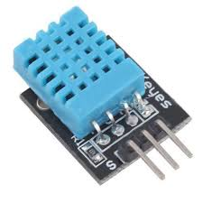
Figure 1:DHT11 Sensor
Particulate matter measurements (DUST). 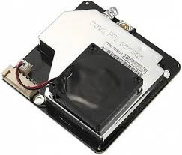
Figure 2: PM sensor

Smoke detection. 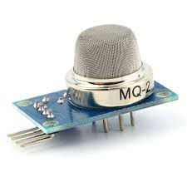
Figure 3: MQ-2 Sensor
Carbon monoxide detection. 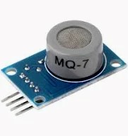
Figure 4: MQ-7 Sensor

LPG and natural gas detection. 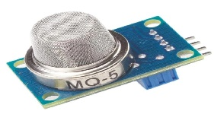
Figure 5: MQ-5 Sensor
Hydrogen detection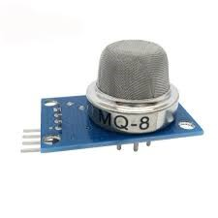
Figure 6: MQ-8 Sensor

The microcontroller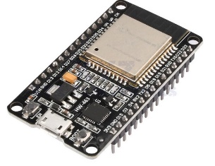
Figure 7:ESP 32 Module
Software Requirements
Firebase backend, Web application framework, Programming language (Arduino C++), Machine learning libraries, and Data visualization tools.

3.3 System Development Approach
The system development follows a four-phase incremental approach, allowing each subsystem to be developed, tested, and validated before full integration. This minimizes system-level errors and improves reliability.

Phase 1: Sensor Integration
This phase focuses on selecting, interfacing, and calibrating sensing components responsible for detecting air pollutants and environmental conditions. MQ-series gas sensors (MQ-2, MQ-5, MQ-7, MQ-8) are used to detect combustible gases, carbon monoxide, methane, and general air contaminants. A particulate matter sensor is employed to measure PM_{2.5} and PM₁₀ concentrations, while a DHT11 sensor measures ambient temperature and humidity. Sensors are electrically interfaced with the ESP32 microcontroller using analog and digital input pins. Voltage divider circuits are used where necessary to ensure signal levels are compatible with the ESP32’s ADC. Initial calibration is performed by exposing sensors to known or simulated pollutant conditions and recording baseline readings. This calibration process establishes threshold values and improves measurement consistency before deployment.

Phase 2: Edge Processing and Data Acquisition
In this phase, the ESP32 microcontroller is programmed to function as an intelligent edge device. The firmware continuously samples sensor data at predefined intervals. Raw analog readings are converted into digital values using the ESP32’s built-in ADC and preprocessed to reduce noise and fluctuations. Edge-level processing includes normalization of sensor values, application of calibration correction factors, threshold comparison, and timestamping of readings. Threshold-based logic is implemented to detect hazardous conditions locally, enabling rapid activation of alerts and actuators without relying on cloud processing. The ESP32 transmits processed data to the cloud via Wi-Fi, ensuring low-latency and energy-efficient communication.

Phase 3: Cloud Storage and Backend Integration
Firebase is selected as the cloud backend due to its real-time database capabilities, scalability, and ease of integration with IoT applications. In this phase, a secure communication channel is established between the ESP32 and Firebase using authentication keys. Sensor data are structured into organized database fields representing gas concentrations, particulate matter levels, temperature, humidity, timestamps, and alert states. Firebase functions are configured to trigger notifications when pollutant levels exceed predefined safety thresholds. This cloud-based approach enables remote access to both real-time and historical air quality data, supporting long-term analysis and visualization.

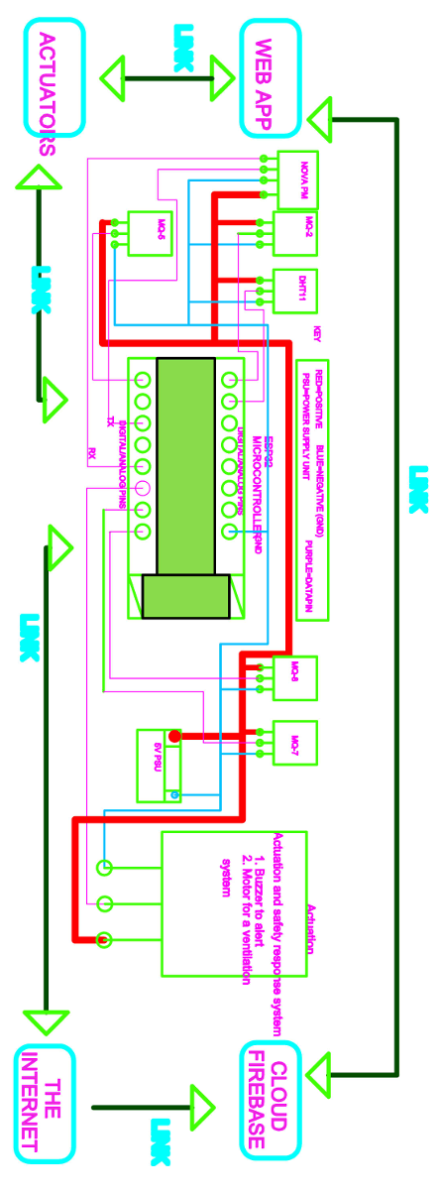
Figure 8: IoT-Based Air Quality Monitoring System Hardware

Phase 4: Web Application and User Interface
A web-based application is developed to provide users with intuitive access to air quality information. The interface displays real-time sensor readings, historical trends, and alert notifications using charts and graphical indicators. The application allows users to interpret air quality conditions easily and respond appropriately to hazardous events. The web application is designed to be responsive and accessible from smartphones, tablets, and personal computers. User experience considerations such as clarity, readability, and responsiveness are prioritized to ensure effective communication of environmental data to non-technical users.
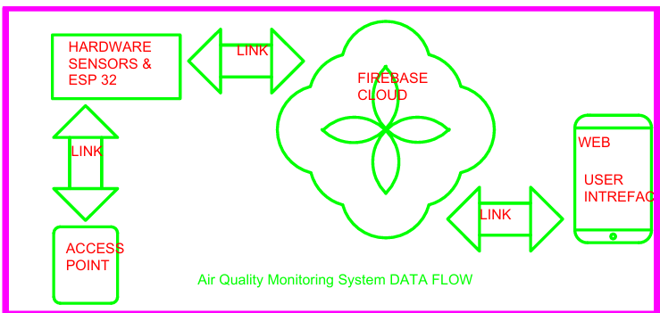
Figure 9:IoT-Based Air Quality Monitoring System Data Flow

3.4 Machine Learning and Data Analysis Methods
To enhance the intelligence of the proposed air quality monitoring system, this study employs classical machine learning and data analysis techniques for pollutant prediction and anomaly detection. The selected methods are intentionally kept simple, interpretable, and computationally efficient to suit embedded and sensor-based environmental monitoring applications. The analysis focuses on sensor measurements of carbon monoxide, dust concentration, temperature, humidity, hydrogen, liquefied petroleum gas (LPG), and smoke. The adopted approach enables the system to analyze historical pollution data, identify abnormal environmental conditions, and provide short-term forecasts that support early warning and safety decision-making.

Data Preprocessing
Raw sensor data collected from the monitoring nodes is first subjected to preprocessing to improve reliability and analytical value. Environmental sensor data is often affected by noise, drift, and missing values due to environmental interference, power fluctuations, or communication losses. Outliers and inconsistent readings are identified and removed using statistical thresholding and range-based validation, particularly for gas concentration sensors such as carbon monoxide, hydrogen, LPG, and smoke. Calibration correction factors are applied to compensate for sensor drift and manufacturing variability. To ensure that no single variable dominates model training due to scale differences, all sensor variables are normalized to a common range. Missing or incomplete observations are handled through interpolation and statistical imputation, preserving temporal continuity in the dataset. These preprocessing steps ensure that the machine learning models operate on clean, consistent, and representative data.

Exploratory Data Analysis
Exploratory Data Analysis (EDA) is conducted to understand the underlying behavior of the monitored pollutants and their relationships with environmental factors. Temporal analysis is performed to examine hourly and daily variations in carbon monoxide, dust, hydrogen, LPG, and smoke concentrations. Temperature and humidity are analyzed as influencing variables due to their impact on gas dispersion and sensor response. Visualization techniques are used to reveal pollutant trends, periodic fluctuations, and sudden concentration spikes that may indicate hazardous conditions such as gas leakage or poor air circulation. Correlation analysis is performed to assess interdependencies between pollutants and environmental parameters, supporting informed feature selection for predictive modeling. EDA provides critical insights that guide model choice and help validate the practical relevance of the collected data.

Predictive Modeling
Predictive modeling is employed to estimate short-term pollutant concentrations based on historical sensor readings. Several classical regression and tree-based models are implemented to balance prediction accuracy and interpretability. Linear Regression is used as a baseline predictive model to establish linear relationships between input variables, including temperature, humidity, and gas concentrations. Despite its simplicity, linear regression provides a useful reference for evaluating more advanced models. Decision Tree Regression is applied to capture non-linear relationships between sensor variables and pollutant levels. Decision trees are particularly suitable for environmental data, as they generate rule-based predictions that can be easily interpreted and translated into system logic. Random Forest Regression extends the decision tree approach by aggregating multiple trees trained on different data subsets. This ensemble method improves prediction robustness, reduces overfitting, and performs well in the presence of noisy sensor measurements commonly observed in real-world environments. Gradient Boosting Regression is implemented to further enhance predictive performance by sequentially correcting errors made by previous models. This technique is effective in capturing complex interactions among pollutants such as carbon monoxide, hydrogen, LPG, and smoke, while still maintaining manageable computational complexity. Together, these models enable accurate forecasting of pollutant concentrations and support early identification of potentially hazardous air quality conditions.
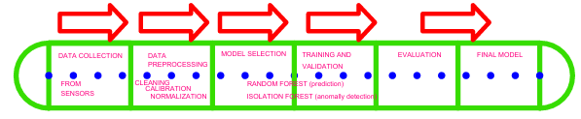
Figure 10:IoT-Based Air Quality Monitoring System ML subsystem

Anomaly Detection
Anomaly detection is incorporated to identify unusual pollution events that deviate significantly from normal environmental behavior. The Isolation Forest algorithm is selected for this task due to its efficiency and suitability for unlabeled environmental data. Isolation Forest works by isolating observations that differ markedly from typical sensor patterns. In this system, it is used to detect sudden spikes in carbon monoxide, hydrogen, LPG, dust, or smoke levels that may indicate gas leakage, fire hazards, or abnormal indoor air conditions. Detected anomalies trigger alert mechanisms and safety responses, enhancing system reliability and user protection.

Evaluation Metrics
Model performance is evaluated using standard quantitative metrics. Root Mean Square Error (RMSE) and Mean Absolute Error (MAE) are used to assess the accuracy of pollutant concentration predictions. These metrics quantify the deviation between predicted and actual sensor values. For anomaly detection, classification accuracy and confusion matrix analysis are used to evaluate the system’s ability to correctly identify abnormal pollution events. These evaluation measures provide an objective assessment of model effectiveness and support performance comparison across different algorithms.

3.5 Prototype Testing
System testing is conducted under controlled conditions and real-world deployment scenarios. Controlled testing involves simulated pollutant sources to evaluate sensor response, calibration accuracy, and alert functionality. Real-world testing is performed in domestic and urban environments to assess robustness under varying environmental conditions. Performance metrics include sensor accuracy, alert latency, cloud data update reliability, and user interface usability. These evaluations ensure that the system meets functional, reliability, and usability requirements.

3.6 Ethical and Safety Considerations
- Gas sources used during testing are handled safely in controlled and well-ventilated environments to prevent accidental exposure.
- System testing is conducted without exposing individuals to hazardous gas concentrations, ensuring no health risks to people.
- Sensor data is collected strictly for research and system evaluation purposes. No personal data is recorded, and access to logged information is restricted to authorized users only.

CHAPTER 4: EXPECTED OUTCOMES
The IoT-Based Air Quality Monitoring System project is designed to deliver a practical, resource-efficient, and scalable air quality monitoring system capable of real-time detection, analysis, and reporting of environmental pollutants. Upon completion, the system is expected to provide measurable improvements in environmental awareness, hazard prevention, and data accessibility. The following section outlines the anticipated outcomes of the proposed system.
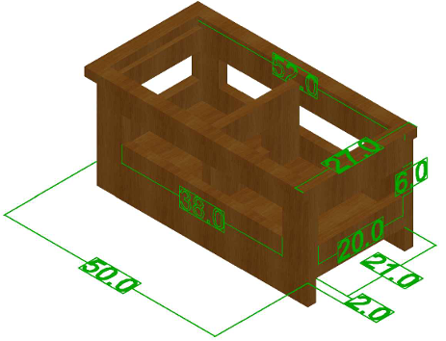
Figure 11:illustrates the enclosure of the IoT-Based Air Quality Monitoring System

4.1 Real-Time Monitoring of Air Pollutants
The system is expected to provide continuous real-time monitoring of key air quality parameters, including particulate matter (PM2.5 and PM10), carbon monoxide, methane, and other hazardous gases. Using MQ-series gas sensors and particulate matter sensors, the system should detect fluctuations in pollutant concentrations as they occur. This real-time capability enables users to understand and respond promptly to changes in air quality within their immediate environment.

4.2 Detection of Hazardous Gas Leaks and Fire Risks
Through the integration of sensors such as MQ-2, MQ-7, and MQ-135, the system is expected to detect combustible and toxic gases associated with gas leaks, fire outbreaks, and poisoning risks. By applying predefined threshold values, the prototype should generate warnings when gas concentrations exceed safe limits. This outcome enhances safety by enabling early detection and timely intervention in environments such as kitchens, laboratories, industrial spaces, and fuel storage areas.

4.3 Automated Alerts and User Notifications
The system is expected to provide automated alerts through Firebase and a web-based application interface. When hazardous conditions are detected, notifications should be delivered instantly to users, allowing rapid response and minimizing prolonged exposure to unsafe air conditions. This outcome strengthens the system’s role as an active safety tool rather than a passive monitoring device.

4.4 Data Visualization and Accessibility
The project is expected to deliver an intuitive web application that presents real-time sensor readings, historical trends, and basic pollution analysis. The platform should be accessible through mobile devices, laptops, and other internet-enabled systems. This outcome improves accessibility to environmental data and empowers users who lack access to professional or centralized monitoring infrastructure.

4.5 Predictive Analytics and Anomaly Detection
The integration of machine learning techniques is expected to enhance system intelligence by enabling predictive and analytical capabilities. Specifically, the system should be able to forecast short-term pollutant levels, detect abnormal pollution patterns, identify potential gas leak anomalies, and provide early warnings based on observed trends. This outcome shifts the system from a reactive monitoring tool to a proactive decision-support platform.

4.6 Enhanced Awareness and Safety Practices
The project is expected to contribute to increased environmental and safety awareness among users. By providing timely information and alerts, the system should educate users on pollution risks, promote safer practices, and encourage responsible environmental behavior. This outcome is particularly relevant for households, schools, healthcare facilities, and small-scale industrial environments.

4.7 Affordability and Scalability
By utilizing low-cost sensors and open-source hardware and software platforms, the system is expected to demonstrate that effective air quality monitoring can be achieved at an affordable cost. The modular design supports scalability and adaptability for deployment in households, small businesses, urban communities, agricultural facilities, and healthcare environments.

4.8 Validation of IoT-Based Environmental Monitoring
The successful implementation of the system is expected to validate the feasibility of IoT-based environmental monitoring as a practical alternative to centralized monitoring systems. The project should demonstrate the effectiveness of decentralized sensing, cloud-based data analytics, and low-cost environmental intelligence in addressing localized air quality monitoring needs.

CHAPTER 5: WORK PLAN AND BUDGET

5.1 Project Schedule
The project is expected to span two academic semesters (approximately 8 months). A summarized timeline is presented below.

Table 1: Project timeline
Activity | Project Lead | Start Date | End Date | Days | weeks
Project Topic choice | JOSHUA WAMBUA | 01-Sep-2025 | 14-Sep-2025 | 13 | 2
Introduction and Background Study | JOSHUA WAMBUA | 15-Sep-2025 | 05-Oct-2025 | 20 | 3
Literature Review | JOSHUA WAMBUA | 06-Oct-2025 | 09-Nov-2025 | 34 | 5
Problem Definition | JOSHUA WAMBUA | 10-Nov-2025 | 16-Nov-2025 | 7 | 1
Objectives Finalization | JOSHUA WAMBUA | 17-Nov-2025 | 23-Nov-2025 | 7 | 1
Methodology Development | JOSHUA WAMBUA | 24-Nov-2025 | 30-Nov-2025 | 7 | 1
Proposal Writing and Submission | JOSHUA WAMBUA | 01-Dec-2025 | 14-Dec-2025 | 14 | 2
Proposal Presentation | JOSHUA WAMBUA | 15-Dec-2025 | 21-Dec-2025 | 6 | 1
System Architecture & Design | JOSHUA WAMBUA | 05-Jan-2026 | 25-Jan-2026 | 20 | 3
Hardware Design & Integration | JOSHUA WAMBUA | 26-Jan-2026 | 16-Feb-2026 | 21 | 4
Firmware Development | JOSHUA WAMBUA | 10-Feb-2026 | 10-Mar-2026 | 28 | 5
Cloud and Database Integration | JOSHUA WAMBUA | 01-Mar-2026 | 22-Mar-2026 | 21 | 4
Web Application Development | JOSHUA WAMBUA | 10-Mar-2026 | 05-Apr-2026 | 26 | 4
Machine Learning Integration | JOSHUA WAMBUA | 23-Mar-2026 | 05-Apr-2026 | 14 | 2
Testing & Documentation | JOSHUA WAMBUA | 06-Apr-2026 | 25-Apr-2026 | 19 | 3
Presentation & Submission | JOSHUA WAMBUA | 26-Apr-2026 | 30-Apr-2026 | 4 | 1
A Gantt chart is provided in Appendix A.

5.2 Budget
Table 2: Project budget
Serial No | Component | DESCRIPTION | Unit cost | Quantity | Total
1 | ESP 32 | DOIT ESP32 DEVKIT V1 | 1500 | 1 | 1500
2 | MQ-SERIES | MQ-135 / MQ-7 gas sensors (analog modules) | 400 | 4 | 1600
3 | NOVA PM | SDS011 PM2.5/PM10 particulate sensor (UART) | 2300 | 1 | 2300
4 | BATTERY | 12 V Li-ion / lead-acid battery, 2–5 Ah typical | 1800 | 1 | 1800
5 | BATTERY CHARGER | TP4056 Li-ion charger module | 1200 | 1 | 1200
6 | PSU | AMS1117-3.3 voltage regulator (3.3 V output). | 400 | 1 | 400
7 | JUMPERS | 20 cm male-to-male jumper wires. (common prototyping set) | 250 | 2 | 500
8 | STRIP BOARD | Standard perfboard, proto assembly | 100 | 2 | 200
9 | BREAD BOARD | Standard 830-tie point breadboard. | 200 | 1 | 200
10 | ENCLOSURE | wooden box | 1000 | 1 | 1000
11 | INTERNET | Wi-Fi data connection plan (monthly) | 1000 | 2 | 2000
12 | DHT11 | Temp/humidity sensor module (5 V) | 500 | 1 | 500
13 | ACCESS POINT | Wi-Fi router | 2500 | 1 | 2500
14 | POWERBANK | 10 000 mAh USB power bank | 1200 | 1 | 1200
15 | Miscellaneous | Screws, headers, mounts. | 400 | 1 | 400
16 | LEDS | 5 mm LEDs (e.g., red, green, blue). | 10 | 10 | 100
17 | BUZZER | 5 V active piezo buzzer. | 2 | 20 | 40
18 | PUSH BUTTON | Standard tactile push button/switch | 1 | 20 | 20
19 | RESISTORS | Assorted: 10 kΩ, 4.7 kΩ, 1 kΩ, 220 Ω | 10 | 20 | 200
20 | CAPACITORS | Decoupling and bulk: 100 µF, 10 µF, 0.1 µF | 20 | 10 | 200
 |  |  |  | TOTAL | 17860

CONCLUSION
The IoT-based air quality monitoring system is a feasible, resource-saving and scalable solution for the increasing problem of air pollution and dangerous gas leaks in home and urban areas. With the use of IoT sensing technologies, cloud-based data storage and predictive analytics, the system provides a practical solution for real-time environmental monitoring and early warning alerts. Unlike conventional centralized monitoring stations, this initiative seeks to provide household, small industry, and community-based air quality data in a way that is accessible, economical and actionable. The technology is in line with contemporary developments and is directed toward pressing health and safety needs, especially in areas with limited or expensive access to reliable monitoring infrastructure. The system can promote environmental awareness, lower pollution risks, improve public health and safety, and uses a modular system and easy-to-use UI. This proposal showcases the capability of and importance to implement an IoT-based monitoring solution that enables individuals and communities with effective and up-to-date environmental insights. Accordingly, the project could be considered relevant and impactful, in terms of measurable benefits in research, innovation and real-world application.

REFERENCES

[1] | E. Bagkis , . A. Hassani, P. Schneider, P. DeSouza, S. Shetty, T. Kassandros and J. Khan, "Evolving trends in application of low-cost air quality sensor networks: challenges and future directions:challenges and future directions," npj Climate and Atmospheric Science, vol. 8, no. 1, p. 335, 2025.
[2] | F. Concas, J. Mineraud, E. Lagerspetz, S. Varjonen, X. Liu, S. Tarkoma and K. Puolamäki, "Low-cost outdoor air quality monitoring and sensor calibration: A survey and critical analysis.," ACM Transactions on Sensor Networks (TOSN), vol. 17, no. 2, pp. 1-44, 2021.
[3] | A. Garcia, Y. Saez, I. Harris, X. Huang and E. Collado, "Advancements in air quality monitoring: a systematic review of IoT-based air quality monitoring and AI technologies," Artificial Intelligence Review, vol. 58, no. 9, p. 275, 2025.
[4] | T. Manshur, C. Luiu, W. R. Avis, V. Bukachi, F. D. Pope, J. Mulligan and M. Gatari, "A citizen science approach for air quality monitoring in a Kenyan informal development.," City and Environment Interactions, vol. 19, p. 100105, 2023.
[5] | M. J. Gatari, F. D. Pope, D. Ng'ang'a , A. Poynter and R. Blake, "Airborne particulate matter monitoring in Kenya using calibrated low-cost sensors.," Atmospheric Chemistry and Physics, vol. 18, no. 20, pp. 15403-15418., 2018.
[6] | M. N. Njeru, E. Mwangi, M. J. Gatari, M. I. Kaniu, J. Kanyeria, G. Raheja and D. M. Westervelt, "First results from a calibrated network of low‐cost PM2. 5 monitors in Mombasa, Kenya show exceedance of healthy guidelines," GeoHealth, vol. 8, no. 9, p. e2024GH001049, 2024.
[7] | M. Zaid, P. Nawale, V. Kumar, V. Malyan and M. Sahu, "Investigating IoT-Based Low-cost Sensor Network for Real-Time Hyper-Local Air Quality Monitoring and Exposure Assessment.," Atmospheric Pollution Research, p. 102749, 2025.
[8] | M. Tastan, " Machine Learning–Based Calibration and Performance Evaluation of Low-Cost Internet of Things Air Quality Sensors.," Sensors, vol. 25, no. 10, p. 3183, 2025.
[9] | K. Yong-Hyuk and M. Seung-Hyun, "Machine Learning-Based Quality Control for Low-Cost Air Quality Monitoring: A Comprehensive Review of the Past Decade," Atmosphere, vol. 16, no. 10, p. 1136, 2025.
[10] | Y. M. Idir, O. Orfila, P. Chatellier, V. Judalet and V. Guaffre, "Idir, Y.M., Orfila, O., Chatellier, P., Judalet, V. and Guaffre, V., 2025. Mapping urban air quality using mobile and fixed low cost sensors: a model comparison.," arXiv preprint arXiv, vol. 2511.22550., 2025.
[11] | R. Ramesh, . H. Vallabhu, A. Unni and . S. Nalinakshan, "IoT-Enabled Air Quality Monitoring: Advancements, Applications, and Challenges.," In 2024 9th International Conference on Communication and Electronics Systems (ICCES), pp. 561-567, 2024.
[12] | . R. Kumar, R. Khan , R. Singh, A. Singh, R. Vijay and D. Ather, "Development and Evaluation of an IoT-Based Gas Leakage Detection System Using Arduino Uno. In International Conference on Cyber Intelligence and Information Retrieval," Singapore: Springer Nature Singapore, pp. 307-319, 2023.
[13] | M. Casari and . L. Po, "Mitigating the Impact of Humidity on Low-Cost PM Sensors," In CEUR WORKSHOP PROCEEDINGS, vol. Vol. 3489, pp. 599-604, 2023.
[14] | . L. Spinelle, . M. Gerboles, . M. G. Villani, . M. Aleixandre and . F. Bonavitacola, " Calibration of a cluster of low-cost sensors for the measurement of air pollution in ambient air," In SENSORS, 2014 IEEE, pp. 21-24, 2014.
[15] | H. Othman, R. Azari and T. Guimarães , "Low-Cost IoT-based Indoor Air Quality Monitoring.," Technology| Architecture+ Design, vol. 8, no. 2, pp. 250-270, 2024.

APPENDICES

Appendix A: Project Gantt Chart

ACTIVITY | SEP | OCT | NOV | DEC | JAN | FEB | MAR | APR
Project topic choice
Introduction and background study on the topic
Literature review and proposal writing
Proposal presentation and submission
Component procurement and prototype building
Web, database, and firmware development.
Prototype deployment, data collection, processing, analysis and machine learning modelling
Project presentation and submission

Figure 12:Gantt chart

Appendix B: System Block Diagram
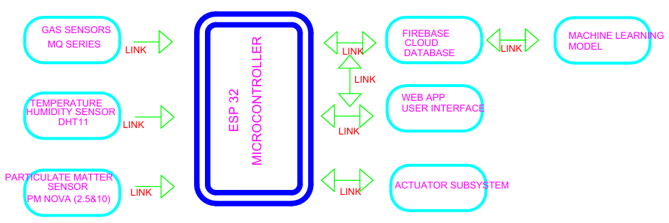
Figure 13: System Block Diagram

Appendix C: GitHub Repository for The Project
https://github.com/joshuamuthenya/finalyearproject_all_content.git

Appendix D: Logical Flow Chart

Figure 14: logical flow chart

