CHAPTER 4: EXPECTED OUTCOMES
4.1 Real-time monitoring of air poluttants

4.2 Anomaly detection and short term prediction.
4.3 automated alerts and user notifications
4.4 Enhanced Awareness

Reduce the content below to the the above mentioned key topics that can actually be achieved don’t use the ambiguous languged ,just be a techie like me and use necessary language,talk like a btech eee student doing a Fiona;l yea project not like a mmaboga

CHAPTER 4: EXPECTED OUTCOMES
The IoT-Based Air Quality Monitoring System project is designed to deliver a practical, resource-efficient, and scalable air quality monitoring system capable of real-time detection, analysis, and reporting of environmental pollutants. Upon completion, the system is expected to provide measurable improvements in environmental awareness, hazard prevention, and data accessibility. The following section outlines the anticipated outcomes of the proposed system.
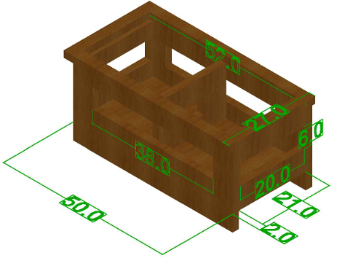
Figure 11:illustrates the enclosure of the IoT-Based Air Quality Monitoring System

4.1 Real-Time Monitoring of Air Pollutants
The system is expected to provide continuous real-time monitoring of key air quality parameters, including particulate matter (PM2.5 and PM10), carbon monoxide, methane, and other hazardous gases. Using MQ-series gas sensors and particulate matter sensors, the system should detect fluctuations in pollutant concentrations as they occur. This real-time capability enables users to understand and respond promptly to changes in air quality within their immediate environment.

4.2 Detection of Hazardous Gas Leaks and Fire Risks
Through the integration of sensors such as MQ-2, MQ-7, and MQ-135, the system is expected to detect combustible and toxic gases associated with gas leaks, fire outbreaks, and poisoning risks. By applying predefined threshold values, the prototype should generate warnings when gas concentrations exceed safe limits. This outcome enhances safety by enabling early detection and timely intervention in environments such as kitchens, laboratories, industrial spaces, and fuel storage areas.

4.3 Automated Alerts and User Notifications
The system is expected to provide automated alerts through Firebase and a web-based application interface. When hazardous conditions are detected, notifications should be delivered instantly to users, allowing rapid response and minimizing prolonged exposure to unsafe air conditions. This outcome strengthens the system’s role as an active safety tool rather than a passive monitoring device.

4.4 Data Visualization and Accessibility
The project is expected to deliver an intuitive web application that presents real-time sensor readings, historical trends, and basic pollution analysis. The platform should be accessible through mobile devices, laptops, and other internet-enabled systems. This outcome improves accessibility to environmental data and empowers users who lack access to professional or centralized monitoring infrastructure.

4.5 Predictive Analytics and Anomaly Detection
The integration of machine learning techniques is expected to enhance system intelligence by enabling predictive and analytical capabilities. Specifically, the system should be able to forecast short-term pollutant levels, detect abnormal pollution patterns, identify potential gas leak anomalies, and provide early warnings based on observed trends. This outcome shifts the system from a reactive monitoring tool to a proactive decision-support platform.

4.6 Enhanced Awareness and Safety Practices
The project is expected to contribute to increased environmental and safety awareness among users. By providing timely information and alerts, the system should educate users on pollution risks, promote safer practices, and encourage responsible environmental behavior. This outcome is particularly relevant for households, schools, healthcare facilities, and small-scale industrial environments.

4.7 Affordability and Scalability
By utilizing low-cost sensors and open-source hardware and software platforms, the system is expected to demonstrate that effective air quality monitoring can be achieved at an affordable cost. The modular design supports scalability and adaptability for deployment in households, small businesses, urban communities, agricultural facilities, and healthcare environments.

4.8 Validation of IoT-Based Environmental Monitoring
The successful implementation of the system is expected to validate the feasibility of IoT-based environmental monitoring as a practical alternative to centralized monitoring systems. The project should demonstrate the effectiveness of decentralized sensing, cloud-based data analytics, and low-cost environmental intelligence in addressing localized air quality monitoring needs.

