CHAPTER ONE

INTRODUCTION

1.1 BACKGROUND OF THE STUDY

Virtual library learning systems are online platforms that provide a user interface for both creators (instructors) and information users to share resources conveniently via the internet. VLPs can vary in complexity depending on the functionalities they provide and the target audience. An example of such systems are Institutional Repositories; “An institutional repository is an archive for collecting, preserving, and disseminating digital copies of the intellectual output of an institution, particularly a research institution” (Crow, 2002). Institutional repositories focus more on the preservation and dissemination of research information resources. This project focuses on the design and implementation of a digital learning platform that aids effective storage and dissemination of information from the instructor to the learner and provides an effective means of communication between users of the system.

A virtual learning environment refers to a system that offers educators digitally-based solutions aimed at creating interactive, active learning environments. VLEs can help professors create, store and disseminate content, plan courses and lessons, and foster communication between student and professor (in the form of e-mails and discussions), even in real-time. Virtual learning environments are often part of a higher education institution’s wider learning management system (LMS) (Tophatmonocle Corporation, 2021).

A virtual learning environment (VLE) in educational technology is a web-based platform for the digital aspects of courses of study, usually within educational institutions. They present resources, activities, and interactions within a course structure and provide for the different stages of assessment. VLEs also usually report on participation; and have some level of integration with other institutional systems. (Liber, 1999). A virtual learning environment is an online-based platform that offers students and professors digital solutions that enhance the learning experience. Unlike a virtual classroom, which is meant to replicate and replace the physical classroom environment for distance learners, a virtual learning environment (or VLE) harnesses technology to supplement an in-class experience, with, for example, digital communication, interaction and quizzes or polls run through the VLE (Tophatmonocle Corporation, 2021).

Learning is the process of acquiring new understanding, knowledge, behaviors, skills, values, attitudes, and preferences. The ability to learn is possessed by humans, animals, and some machines; there is also evidence for some kind of learning in certain plants (Karban, 2015). Some learning is immediate, induced by a single event (e.g. being burned by a hot stove), but much skill and knowledge accumulate from repeated experiences. The changes induced by learning often last a lifetime, and it is hard to distinguish learned material that seems to be "lost" from that which cannot be retrieved (Daniel, Daniel & Daniel, 2011). The process of learning is employed by humans in various levels of development; from childhood to adulthood. Students in academic institutions learn to acquire certain academic qualifications. They employ various tools and learning styles to reach their goal of learning a thing or acquiring a skill.

The world today is faced with so much development in various spheres of life; all works of life managed by man must see to it that they move with the trend and see how various developments can be made adaptable where necessary. The growth of the internet and technology in the world today has brought about several changes to how things are done. When it comes to the way knowledge is being transferred and acquired by individuals, technology has brought about a massive change. We see this when we consider the rise in online platforms making available course resources that people can access to acquire knowledge. An issue arises when we consider the opportunities and advantages made available by these online learning platforms as people tend to see them as competition to physical learning environments.

Students and Lecturers are faced with several opportunities to facilitate and ease the processes involved in knowledge transfer and acquisition considering the potentials embedded in technology. This could be seen in the way students and instructors communicate and share information. Instructors now put to use various technological tools to communicate with their students; We see the increase in the use of emails for communication, hosting of lecture videos on the internet on platforms such as YouTube, we see instructors harnessing the powers of Google classroom; a software that facilitates learning. “Google Classroom uses the standard Google office software tools such as Google Docs as well as spreadsheet and presentation applications, audio and video conferencing, not to mention Google Drive for online storage. Additionally, there are administrative tools to make it easier for teachers to manage their classes” (Tech Radar, 2021). Considering the multiple tools available for use by both instructors and students, we see that a problem is introduced as there would be a need to properly select what is usable and would be effective on the long run.

A library is a collection of materials, books, or media that are easily accessible for use and not just for display purposes. It is responsible for housing updated information to meet the user's needs daily. Libraries may provide physical or digital access to material and maybe a physical location or a virtual space, or both. A library's collection can include books, periodicals, newspapers, manuscripts, films, maps, prints, documents, microform, CDs, cassettes, videotapes, DVDs, Blu-ray Discs, e-books, audiobooks, databases, table games, video games, and other formats. Libraries range widely in size, up to millions of items (Lalrohlui, 2021). According to Lankes, Newman, Kowalski, Tench, Gould, & Silk (2016), a library is a mandated and facilitated space supported by the community, stewarded by librarians, and dedicated to knowledge creation.

A library is a collection of resources in a variety of formats that is organized by information professionals or other experts who provide convenient physical, digital, bibliographic, or intellectual access and offer targeted services and programs with the mission of educating, informing, or entertaining a variety of audiences and the goal of stimulating individual learning and advancing society as a whole (Robert, 2003). One of the benefits and advantages of libraries to learners is that they ensure access to materials through indexes, catalogs, and other information tools that allow learners to locate items appropriate to their needs.

E-learning (Electronic learning) which is also known as Virtual Learning refers to learning that is carried out electronically. Learners employ various electronic tools to acquire knowledge easily which exposes them to more opportunities to access knowledge irrespective of location constraints and other limiting factors.

E-learning unites two main areas, learning, and technology. Learning is a cognitive process for achieving knowledge, and technology is an enabler of the learning process meaning that technology is used like any other tool in the education practice, as is a pencil or a notebook, for example. E-learning systems aggregate various tools, such as writing technologies, communication technologies, visualization, and storage. For these reasons, researchers and scientists have sought to transform e-learning systems into the technically transparent tool, like pencil or notebook (Aparicio, Fernando & Tiago, 2016). Moore (1989) purported that three core types of interaction are necessary for quality, effective online learning:

1. Learner–learner (communication between and among peers with or without the teacher present),
2. Learner–instructor (student-teacher communication)
3. Learner–content (intellectually interacting with content that results in changes in learners' understanding, perceptions, and cognitive structures).

According to Stephen (1998), Information sources accessed via the internet are ingredients of a digital library. Today, the network connects some information sources that are a mixture of publicly available (with or without change) information and private information shared by collaborators. They include reference volumes, books, journals, newspapers, national phone directories, sound and voice recordings, images, video clips, scientific data (raw data streams from instruments and processed information), and private information services such as stock market reports and private newsletters. These information sources, when connected electronically through a network, represent important components of an emerging universally accessible, digital library.

The advantages of virtual libraries as a means of easily and rapidly accessing books, archives, and images of various types are now widely recognized by commercial interests and public bodies alike.

Advantages of virtual-learning-environments includes:

* Teachers can track if learners are engaging with internet-based communication and related materials by submitting evaluations online and providing quick feedback.
* The message services can inspire teamwork and communication both between instructor and learner and learner and learner.
* Teachers and learners can also involve more enthusiastically in a course at a time and place that is suitable for both (British Educational Communications and Technology Agency, 2005).
* Course information such as past exam papers, timetables, and administrative information can all be found in one place, and are accessible from one authoritative source.
* Careful signposting (such as including links with course material) can provide extra care for learners, or inspire learners to study at an intensive level.
* With a VLE, it is possible to save time for teachers by dropping the time required for photocopying, course material delivery, and updating course material (British Educational Communications and Technology Agency, 2005).
* The main benefit of virtual learning environments appears to be that they can present information at a variety of scales and present images from a variety of perspectives at once (for example aerial views, cross-sectional views, animated rotating block diagrams, etc.).
* The apparent and most thoughtful shortcoming of VLEs is that they are less effective at informing merely based skills than the actual world (Schlosser & Simonson. 2006).
* The material presented on a computer is only an abstraction of the real thing’ and ‘being on a VLE does not have the same impact as a real-world or face-to-face education

The project aims to develop a virtual library learning system made available via a website and mobile application. The basics are to build a space that aids the process of learning and makes it possible for learners and instructors to share knowledge and communicate virtually. Instructors would be provided various tools which they could use to reach out to students better; share lesson resources in various formats, a custom forum for every course created/managed by instructors, and many more functionalities that aid instructors in teaching and communicating easily. This proposed project is more of a virtual library for learning purposes, it is structured to facilitate easy access to resources needed for a particular topic to which students are subscribed.

The Faculty of Management science which was previously a department under the Faculty of Social Sciences has undergone some changes over the years. It was initially known as the Department of Management Studies and later the Department of Accounting and Management Sciences. Although the University of Jos Senate gave formal recognition to the separation of the Departments of Accounting and Management Sciences in 2004 and took up formally in August, 2004. After the separation, the Department was called Management Sciences.

With the creation of the Faculty of Management Sciences in December, 2010, the Department of Management Sciences was renamed as Business Administration. (University of Jos, n.d).

Faculty of Management Sciences is one of the faculties in the University of Jos. The Faculty is made up of three Departments which are the Department of Accounting, Department of Actuarial Science and Department of Business Administration.

The 300 level students of Management Science were selected to be used as a case study for this project as the platform would be first tested on them. These students currently employ the traditional means of learning which includes;

1. Instructor to student (One to One).
2. Instructor to students (One to many).
3. Group discussions (Many to many).
4. Learning using lecture notes and handouts.

1.2 STATEMENT OF THE PROBLEM

In University of Jos, students and instructors employ the traditional means of learning and teaching. Instructors often engage in physical lecture sessions where they avail themselves in a lecture hall to pass knowledge to students physically. They create lecture materials that are being distributed to students as photocopies by course representatives. The traditional method of knowledge transfer from instructor to students used in the university when compared to the opportunities posed by ICT is outdated and needs to be improved on. Some of the problems of the current system used by instructors in the University of Jos are;

1. Instructors must be available physically for lecture sessions to take place, they need to depend on course representatives to pass information across to learners.
2. Instructors need to redistribute learning materials every session.
3. Instructors depend on course representatives to quickly pass information across to learners.
4. There is no central repository for information resources to be stored and accessed easily by learners.

All these are some of the problems associated with traditional methods of teaching and learning.

The need for a virtual library learning platform (VLP) in 21st-century universities cannot be overemphasized as we see the opportunities made available by digital technologies and the internet. A functional VLP makes it possible for the information to be shared easily with a set audience and also provides a means for instructors to communicate with learners. Instructors can use these platforms to easily host a collection of information resources accessible by their students. A virtual library learning platform goes beyond the functionality provided by virtual libraries as it makes room for instructors and learners to interact actively while providing access to information resources uploaded.

1.3 OBJECTIVES OF STUDY

The aims and objectives of this research were to design and implement a virtual library learning platform for instructors and learners. The proposed platform aims to meet the key objectives outlined below.

1. Design of Virtual Library Learning Platform (VLLP) for learners and instructors for Faculty of Management Sciences.
2. Design and implementation of a Login Module for learners and instructors to access the functions of the Virtual Library Learning Platform (VLLP) which includes, course creation and management, course enrollment and access to course resources, and information resource upload and browsing.
3. Design of Course Management and Accessibility Module on the platform for learners and instructors.
4. Identification of the effectiveness and efficiency of the platform in granting the learners access to personalized data such as, courses enrolled in and related resources, information resources (e.g Articles, PDFs and Webpage links), and chat functionalities with other users of the system.
5. Identification of the effectiveness and efficiency of the platform in granting the lecturers/instructors access to virtual course and information resource management functionality and online interaction with learners.

**1.4 METHODOLOGY**

This project brings about the development of an online virtual learning platform that instructors and learners could easily access (via a website and custom mobile application) to utilize the functionalities provided. This platform runs on several software and hardware components at the back-end which ensures user access to the platform via the front end (Website and mobile application).

The online platform is built on three areas outlined.

MongoDB is a source-available cross-platform document-oriented database program. Classified as a NoSQL database program, MongoDB uses JSON-like documents with optional schemas. MongoDB is developed by MongoDB Inc. and licensed under the Server Side Public License (SSPL). (Wikipedia, 2021). MongoDB was chosen to be used as the primary database for this platform considering that it provides a flexible database schema that supports growth in the long run and has fast data retrial capabilities.

The mobile application which learners can install on mobile phones to access information resources on the platform is built on the flutter framework. Flutter is an open-source UI software development kit created by Google. It is used to develop cross-platform applications for Android, iOS, Linux, Mac, Windows, Google Fuchsia, and the web from a single codebase. (Amadeo, R, 2018).

For the development of this platform, several programming and scripting languages were used which include TypeScript, Dart, HTML, CSS, Javascript, and OpenAPI sepecification.

**1.5** **SIGNIFICANCE OF THE STUDY**

This project brings about web and mobile applications instructors could use to easily manage information resources and courses effectively, communicate with learners easily via chat functionality and electronic mail, view course participants' discussions in custom forums, and manage learner access to courses managed. Instructors no longer need to manually distribute course materials every session as the platform automatically distributes resources to eligible members in real-time as they are published.

This project makes it possible for learners to easily manage and access courses resources, interact with fellow course-mates online in the course forums, access information resources published by instructors, and easily reach out to instructors via chat functionality. This project is valuable to students and instructors in general but is targeted for use by students and instructors in the Department of Management Science in University of Jos. It’s of high value to academic institutions. The project uses a combinations of various IT components (databases, online servers, mobile development frameworks, and more) and online third-party resources to run effectively.

**1.6 SCOPE/DELIMITATION OF THE STUDY**

The proposed product is targeted for the attainment of effective communication between learners and instructors. This implies the ability for instructors to easily communicate knowledge with learners; store information resources for easy use and accessibility by learners; Aside from the basic functionality of making it possible for instructors to easily communicate with the learner, the system provides other tools that foster learning, a forum for students of a course to easily communicate with each other, a virtual store where instructors can make information resources available for free/sell, the possibility of learners to subscribe to multiple courses created by instructors (free/paid).  
 The system makes it possible for instructors to share and make available information resources to learners by providing an interface through a website or mobile application where courses can be created and learning resources for such courses can be uploaded periodically. This includes the upload of videos, documents, pictures, and audio recordings. Students automatically gain access to these resources on a real-time basis immediately they are uploaded, students are only required to sign in to their accounts to get access to these resources.  Accessibility to the platform is limited to computers and mobile devices with internet connection and a browser software through which the platform website can be accessed.

**1.7 OPERATIONAL DEFINATION OF TERMS   
Design:** A design is a plan or specification for the construction of an object or system or for the implementation of an activity or process, or the result of that plan or specification in the form of a prototype, product or process.

**Implementation:** Implementation is the realization of an application, or execution of a plan, idea, model, design, specification, standard, algorithm, or policy.  
**Virtual :** Virtual is a digitally replicated version of something real.   
**Library:** A library is a place that houses print and non-print materials useful for study and research and for preservation of man’s intellectual activities for potential users. The collections could be books, journals, periodicals, theses & dissertations, etc.  
**Learning:** Learning is the process of acquiring new understanding, knowledge, behaviors, skills, values, attitudes, and preferences.  
**Platform:** A computing platform or digital platform is the environment in which a piece of software is executed.  
**Virtual Library Learning Platform:** A platform that provides learning, teaching and information searching and accessibility functionalities to its users digitally.  
**University of Jos:** The University of Jos, abbreviated as Unijos, is a Federal University in Jos, Plateau State, central Nigeria.  
**300 Level Management Science Student :** Students who are formally engaged or enrolled in courses under the Faculty of Management Sciences in the University of Jos.

**CHAPTER TWO**

**LITERATURE REVIEW**

**2.0 Introduction**

The purpose of this literature review is to provide the reader with a general overview of the Virtual Library Learning Platforms, the current Learning System currently used by students of the Faculty of Management Science, and the Effectiveness of the proposed system to both instructors and students.

**2.1 Review of Existing System**

Currently the Faculty of Management Sciences 300 Level students and instructors engage the traditional method of Learning and Lecturing respectively. Students are expected to avail themselves to lecture sessions where they listen to lectures passed by courses lectures. During lecture sessions, instructors share information to students in various forms.

According to Alison (2021), Communication within the classroom is important in order for students to learn effectively and should be put in place from an early stage of learning. Classroom communication exists in three categories: verbal, nonverbal, and written.

1. Verbal communication refers to sending or receiving a message through sounds and languages. Teachers can address one student or the whole classroom through verbal communication. For example, a teacher may ask a student to stand up which is verbal communication.
2. Non-verbal communication refers to communicating without words through body language, gestures, facial expressions, the tone and pitch of the voice, and posture. For example, if a teacher is nodding their head while a student is speaking, this can be encouraging or show that they agree with the student.
3. Written communication is sending or receiving information through writing. For example, a teacher may arrange a written assignment for students to test their knowledge or present lecture slides or notes for complicated information.

A lecture (from the Greek *lecture*, meaning reading) is an oral presentation intended to present information or teach people about a particular subject, for example by a university or college teacher. (GreyNet International, 2021). Many university courses relying on lectures supplement them with smaller discussion sections, tutorials, or laboratory experiment sessions as a means of further actively involving students. Often ,these supplemental sections are led by graduate students, tutors, teaching assistants, or teaching fellows rather than senior faculty. Those other forms of academic teaching include discussion (recitation if conducted by a teaching assistant), seminars, workshops, observation, practical application, case examples/case study, experiential learning/active learning, computer-based instruction, and tutorials (Gaskell's Compendium, 2008).

Current 300 Level students of the Faculty of Management science currently employ the traditional means of learning which includes;

* Instructor to student (One to One): Students are given the opportunity to interact with lectures one on one, this could be during lecture sessions and school hours, but at the convenience of the lecturer.
* Instructor to students (One to many): One to many lecture session is mostly used by instructors to communicate information to students at scheduled periods usually in a semesters timetable for a course.
* Group discussions (Many to many): Group discussions could be carried out by students when the need to learn from themselves or when instructors give group assignments, in this case group members are required to work closely to solve the assignment given.
* Learning using lecture notes and handouts: The use of lecture notes and handouts is anther effective way lecturers in the Faculty of Management Science use to complicate information to students, students are expected to go through this notes at their pace.

**2.2 Design of Virtual Library Learning Platform (VLLP) for learners and instructors for  
Faculty of Management Sciences.**

A Learning Management System (LMS) delivers and manages all types of content, including video, courses, and documents. In the education and higher education markets, an LMS will include a variety of functionality that is similar to corporate but will have features such as teacher and instructor-facilitated learning, a discussion board, and often the use of a syllabus. A syllabus is rarely a feature in a corporate Learning Management System although courses may start with heading-level index to give learners an overview of topics covered (Ellis, 2009). The development of E-learning technology is very rapid and this is one of the reasons why this concept is important to be implemented and developed massively. The urgency factors are class limitations, boredom in learning, and limited interactions. Online learning is cooperative in nature. It requires high levels of interaction and collaboration to be successful (Naveh, 2010).

According to Victoria (N.d), Creating a custom system can be a daunting task, and without the right planning, a simple project can turn into a big headache. Here are the four things I recommend considering when designing or adopting a Learning Management System.

1. Focus on data–for both instructors and students.
2. Design for usability–make it ‘pleasurable’ to use
3. Plan for mobile from the very beginning
4. Design curriculum and instruction with the strengths of your specific LMS in mind

Opportunity Network’s student portal organizes content into courses that students can enroll in. Each course is self-paced and covers a host of content, and completing a course unlocks more courses. Therefore they have agency and a clear path for leveling up at the same time (Mike, 2021).

According to Balogh (2011), the figure below depicts a basics Virtual Learning Management system.

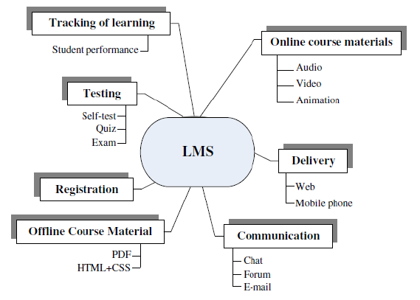

**2.3** **Design and implementation of a Login Module for learners and instructors to access the functions of the Virtual Library Learning Platform (VLLP)**

In computer security, logging in (or logging on, signing in, or signing on) is the process by which an individual gains access to a computer system by identifying and authenticating themselves. The user credentials are typically some form of username and a matching password, (The Linux Information Project, 2021). These credentials themselves are sometimes referred to as *a* login (or logon, sign-in, sign-on). In practice, modern secure systems often require a second factor such as email or SMS confirmation for extra security. (Oxford Dictionary, 2021). When access is no longer needed, the user can log out (log off, sign out or sign off).

According to Memari (2021), some of the advantages of a Login module for Learning platforms are:

1. Single Sign On (SSO) enables users to easily and quickly switch between corporate systems, portals, and applications, without the need to login each time. Learners can instantly access their LMS whenever they need to complete training or access resources to supplement their learning. They also save time and effort from having to deal with password reset requests and waiting on IT support if they end up getting locked out of their account.
2. Having a fast and uncomplicated way for users to login to their LMS will provide them with training resources and materials right at their fingertips whenever they need it. Making it simple to access lecture materials will increase user adoption and encourage them to supplement their learning to build knowledge on a topic or use it as support if they are struggling in a particular area.
3. When offering a new course or training program for dozens to thousands of users, it is inevitable that some of them will forget their passwords and require IT support to help them regain access. Employing Login module for your LMS greatly reduces the amount of password support tickets as users only need one login credential instead of having many different usernames and passwords.

VLLP supports single sign-on by automatically allowing learners to sign in to the training platform using only the login information of their existing cloud accounts (Memari, 2021).

**2.4 Design of Course Management and Accessibility Module on the platform for learners and instructors.**

A Course Management System (CMS) is a platform of educational software in post-secondary education allowing instructors and institutions to manage a variety of courses with a large number of students and multiple instructional materials. Course management systems, such as Blackboard, Canvas, Desire2Learn (D2L) and Moodle (Open-source Learning Platform) provide a single online environment for teaching and learning materials to be shared between instructors and students. (Tophatmonocle Corporation, 2021).

It is a web-based tool that allows instructors, universities, and corporations to develop and support online education. Course Management System software allows instructors to manage materials distribution, assignments, communications and other aspects of instruction for their courses. An example is Blackboard. (IGIglobal, N.d). According to Vanderbilt University (2021), a Course Management System (CMS) is a collection of software tools providing an online environment for course interactions. A CMS typically includes a variety of online tools and environments, such as:

1. An area for student posting of papers and other assignments
2. A gradebook where faculty can record grades and each student can view his or her grades
3. An integrated email tool allowing participants to send announcement email messages to the entire class or to a subset of the entire class
4. A chat tool allowing synchronous communication among class participants
5. A threaded discussion board allowing asynchronous communication among participants
6. An area for faculty posting of class materials such as course syllabus and handouts

The Course Management System is made to optimize the efficiency and effectiveness of your instructor-led training. There are many great course management software features that make it a core layer in the learning tech stack and a key complement to the Learning Management System (LMS) (Monica, 2020). According to Monica (2020), The main features to look for when considering training course management software are those focused on course management and scheduling, resource management, interaction with students, and resources sharing functionalities.

**2.5 Identification of the effectiveness and efficiency of the platform in granting the learners access to personalized data such as, courses enrolled in and related resources, information resources (e.g Articles, PDFs and Webpage links), and chat functionalities with other users of the system.**

1. Access to information anytime and anywhere: Students can get access to study materials from anywhere and at any time. Most modern LMSs have mobile apps that allow students to engage with e-learning content on any device (Harvey, 2021).
2. Centralized information: All lecture resources are hosted in one location which makes it possible for students to quickly access and put to use various information resource when needed.
3. Increased communication: Virtual Learning Platforms provide chat functionalities for participants of a course to effectively communicate. This makes it possible for students and instructors to stay up-to-date with latest information (Harvey, 2021).
4. Studying becomes more enjoyable: Students have the leverage of studying at their own pace which makes learning more interesting and fun.
5. Time saving: Virtual Learning Platforms make it possible for students to access learning resources in less time. (Sander, 2020)

2.6 **Identification of the effectiveness and efficiency of the platform in granting the lecturers/instructors access to virtual course and information resource management functionality and online interaction with learners.**

1. Effective course resource management: Virtual Learning Platform makes it possible for instructors to manage course resources in one place and grant access to this resources as at when needed. This eliminates the need to share lecture resources manually to students (Innovative Learning Solutions, 2020).
2. Increased communication: Instructors are provided with a tool whereby they gain fast access to their students and share information with less effort. Without such platforms, instructors would need to depend mostly on course representatives to communicate information to students (Innovative Learning Solutions, 2020).
3. Consistency of learning: Delivering your course through an LMS keeps the content centralized so all the students have a single source of content, instructions and questions. No excuses of old books or last years material. Everybody is up-to-date. (EasyLMS, 2021).
4. Organizes Learning in A Single Location: It becomes easier for instructors to store and manage course resources which could be accessed by students remotely without having to be physically present. Currently most Virtual Learning Platforms are stored in cloud-based environment (Innovative Learning Solution, 2020).

**2.7.**1 **SUMMARY**

A Virtual Library Learning platform is a web-based platform built to support virtual learning on the internet. This is made possible by providing various digital tools, applications and interfaces instructors use to interact with the platform in accessing various functionalities; Some of the functionalities provided by a typical VLLP are authentication, courses management, interaction, enrollment and search modules. All this are made available for users which includes learners and instructors to effectively interact seamlessly.

2.7.2 **Existing gap to be filled**

1. Development of an online platform for instructors to manage course resources effectively
2. Development of course forums where students and instructors for particular courses can effectively communicate.
3. Development of resources search module for students to search for information based on keywords inputted.
4. Development of online courses enrollment module, when students can enroll for courses offered and automatically gain access to course resources uploaded.

**CHAPTER THREE**

**DESIGN OF A VIRTUAL LIBRARY LEARNING PLATFORM FOR 300 LEVEL MANAGEMNET SCIENCE STUDENTS OF UNIVERSITY OF JOS**

**3.0 INTRODUCTION**

This chapter describes the structure and components of the application, programming languages used in development and justification for the use of those languages. The Virtual Library Learning Platform is built to make it possible for both instructors and learners to communicae and share information virtually. It also states the requirement and system design of the platform.

**3.1 STRUCTURE OF THE PROPOSED SYSTEM**

The Virtual Library Learning Platform is developed following Microservices Artitecture. According to Wolff (2016), Services in a Microservice Architecture are often processes that communicate over a network to fulfill a goal using technology-agnostic protocols such as HTTP. Services can be implemented using different programming languages, databases, hardware and software environments, depending on what fits best (Chen, 2018). The diagram below gives an overview of the Systems Architecture.

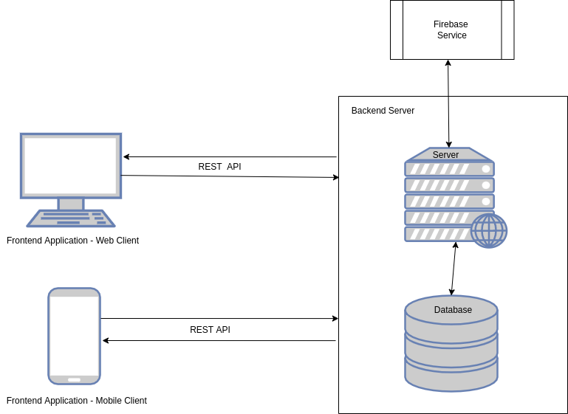Figure 3.1: System Architecture

Using the Microservices Architecture, the Virtual Library Learning platform was broken down into functional services. For this services to communicate effectively, a Representational State Transfer (REST) Application Programming Interface (API) is used as the basis for communication between these services.

The VLLP mobile application provides an interface for users to interact with the Virtual Learning Platform System seamlessly. The image below shows what users see after successfull installation of the Mobile Application on an Android device.

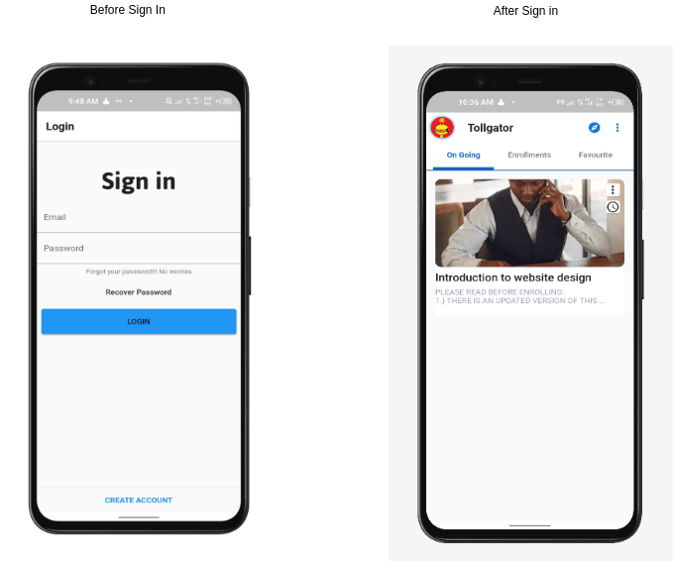*Figure 3.2: Authentication and Home Screens*

**Interaction between User and Mobile Application Hardware**

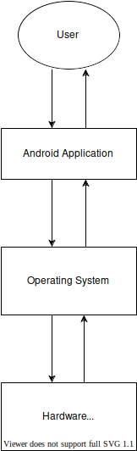*Figure 3.3: Interaction between User and Application Hardware*

The major modules of this system are outlined below

1. **Backend module**This service serves the purpose of providing all required back-end functionalities for the effective running of the system. This includes; Course management, user data management, user registration, and information resource management. Its functionality is made available through a well-defined API accessible via HTTPS.
2. **Firebase authentication module**This service is based on the Google Firebase toolkit for mobile application development. It is used to handle all user authentication data and provide user-specific customization and real-time notifications.
3. **Student Front-end module**This module presents an interface users can interact with to access functionalities provided by the platform. This includes browsing a collection of courses uploaded by instructors, accessing freely available information resources uploaded, account creation and login functionalities. The Frontend module is available for desktop and mobile devices.
4. **Instructor Front-end module**This module presents an interface instructors interact with to access functionalities provided by the platform. This includes courses management, information resources upload, account creation and login functionalities. The Frontend module is available for desktop and mobile devices.

**System Data flowchart**

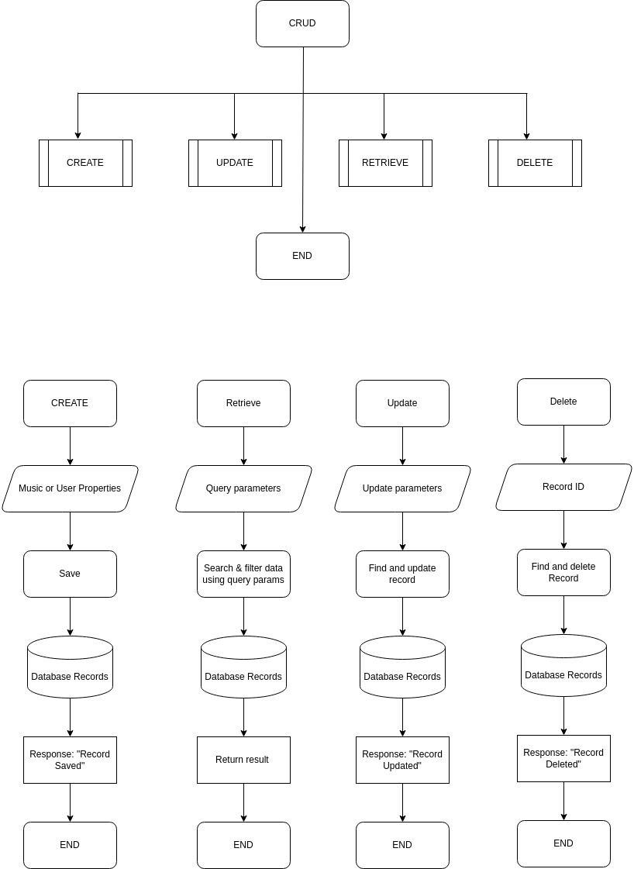*Figure 3.4: System Data flowchart*

**3.2 HARDWARE DESIGN MODEL**

The proposed Virtual Library Learning Platform can be grouped into two parts. The server and the client. The server component of the platform is responsible for handling all business login that makes it possible for users to interact with the platform. The server component of the platform is hosted on an online server accessble via the internet. The client component of the platform are user managed devices which are personal computers and mobile devices. These clients communicate with the server via the internet.

To run the backend application on the Server-side. The following are the minimum hardware requirement:

1. RAM: 512 MB
2. NodeJs Server Software
3. Heroku ephemeral storage

To run the frontend application on the Client-side The following are the minimum hardware requirement:

1. RAM: Minimim of 512 MB
2. Android, Windows, or Linux Operating System
3. Mobile or Computer Device

**Hardware Diagram**

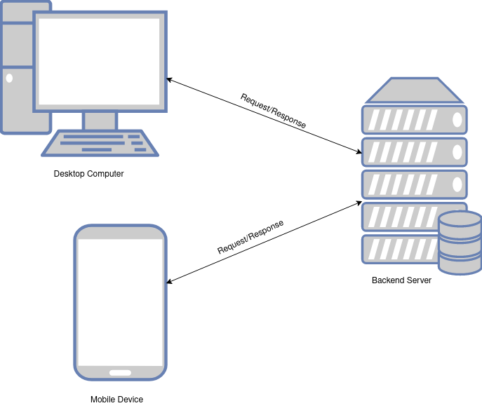*Figure 3.5: Hardware Design Model*

**3.3 GUI (MOBILE APPLICATION) DESIGN MODEL**

The Model-View-Controller design pattern was used in the development of the mobile application. Model–view–controller(MVC) is a software design pattern; commonly used for developing user interfacesthat divide the related program logic into three interconnected elements. This is done to separate internal representations of information from the ways information is presented to and accepted from the user (Reenskaug, 2019). The VVLP Mobile Application is made up of pages, models and controllers which work together to appropriately represent data and provide a functional interface.

**Mobile Application Screens**

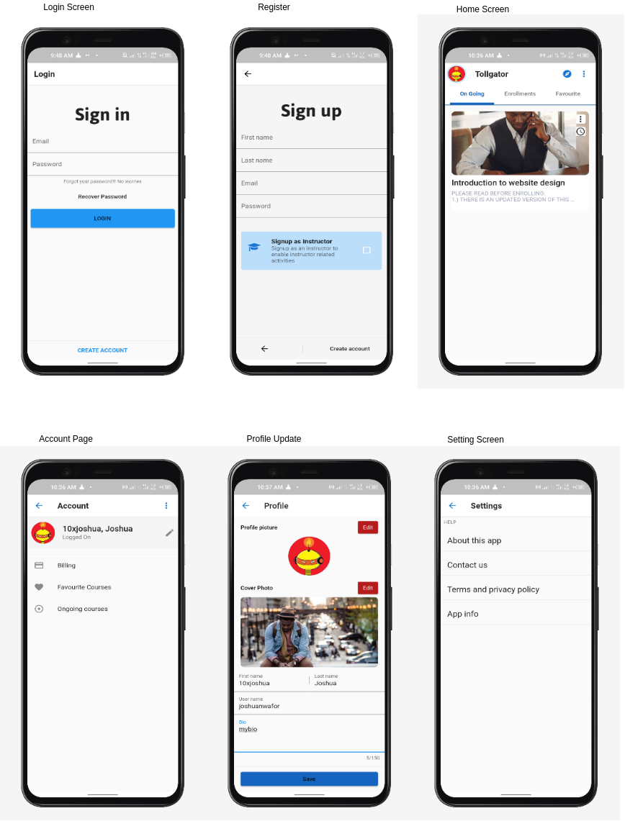

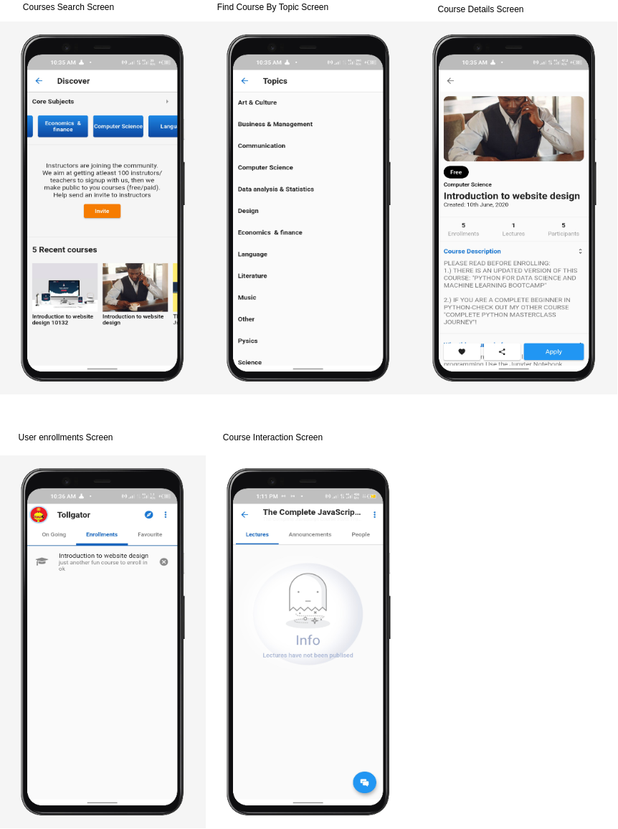*Figure 3.6: Mobile Application Screens*

**Entity Relationship Diagram**

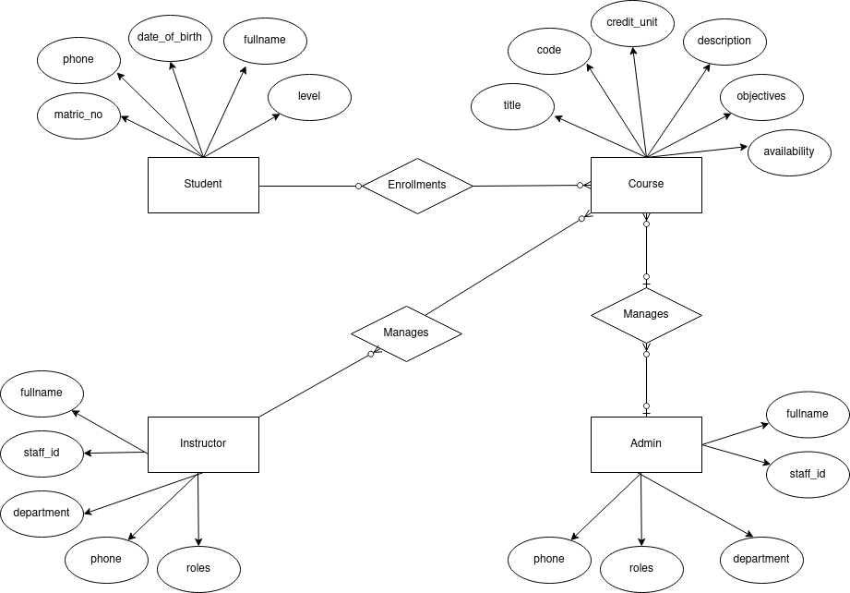*Figure 3.7: Entity Relationship Diagram*

**3.3.1 MOBILE APPLICATION COMPONENTS DESCRIPTION**

The VLLP mobile application is made up of modules that work together to properly represent information to the user.

* **Authentication module**: The authentication module is responsible for authentication users in to the application, for users to be properly authenticated, they must create an account on the application. Account creation and management is handled by the Firebase authentication service. This module provides the login and registeration screen that makes it possible for users to get authenticated.
* **User home module**: The user home view provides a single entry point into other parts of the application. From this view, users can navigate to other routes in the application.
* **User courses module**: The user courses view is responsible for loading all courses which an authenticated user has enrolled in.
* **Course search module**: The course search module provides an interface for authenticated users to search courses available in the system and view information on those course.
* **Course module**: This module is responsible for presenting an interface to user to have access to course resoures, this includes course members, forums, and lessons.
* **Course lesson module**: The presents a view to users to intereact and make use of course resources. This could be a video, audio, or digital file resource.
* **Course forum module:** This module provides a view for users to interact with and access course forum resources. Resources in a course forum are messages published by members of a course.
* **User profile module**: The user profile module provides an interface where users can update and view their profile.

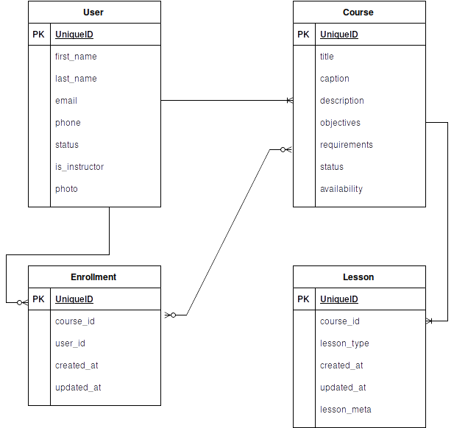**Entity Relationship Diagram**

*Figure 3.8: Entity Relationship Diagram*

**3.4 OPERATION OF THE PROPOSED SYSTEM**

**Representation of User roles and actions interacting with the system**

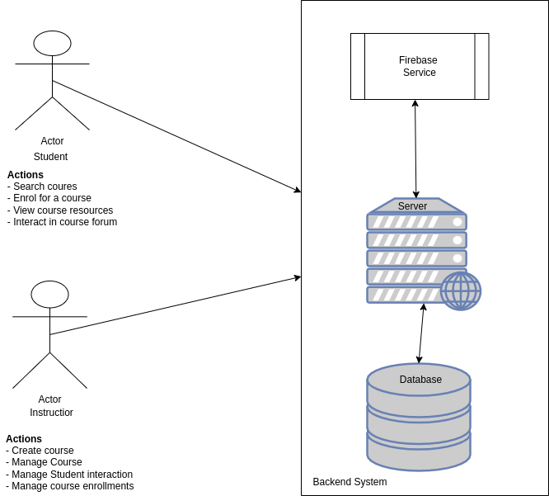*Figure 3.9: User interaction with system*

**Student Mobile Application Authentication Flow**

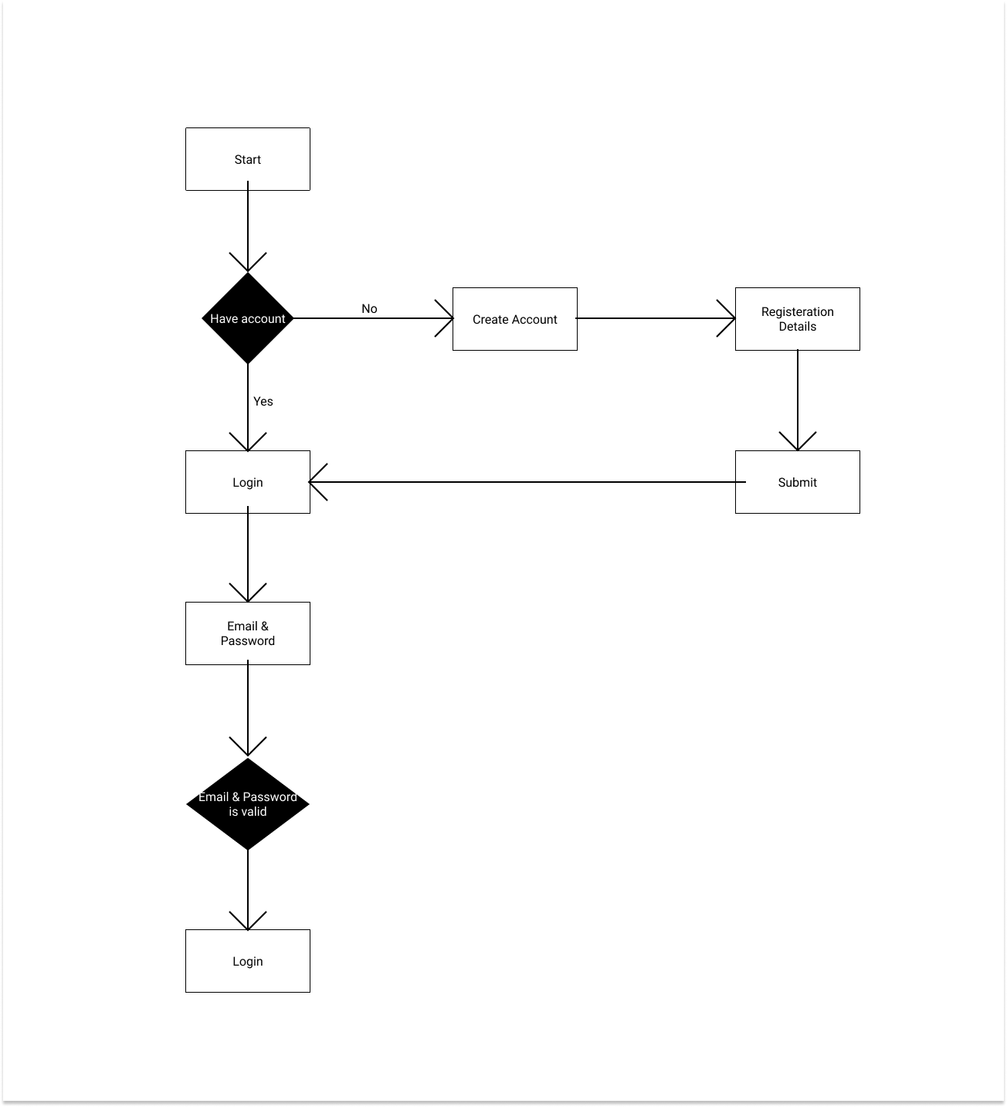*Figure 3.10: Student Authentication Flow*

**I****nstructor Mobile Application Authentication Flow**

*Figure 3.11: Instructor Authentication Flow*

**Representation of User interaction with mobile application**

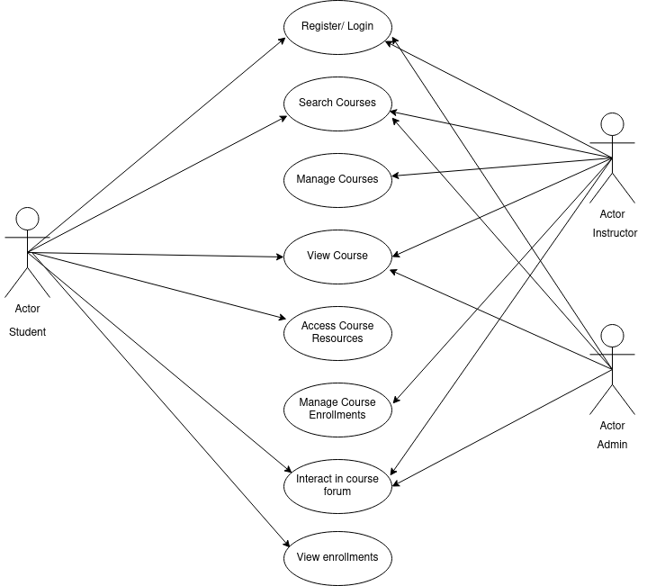*Figure 3.12: User interaction with mobile application*

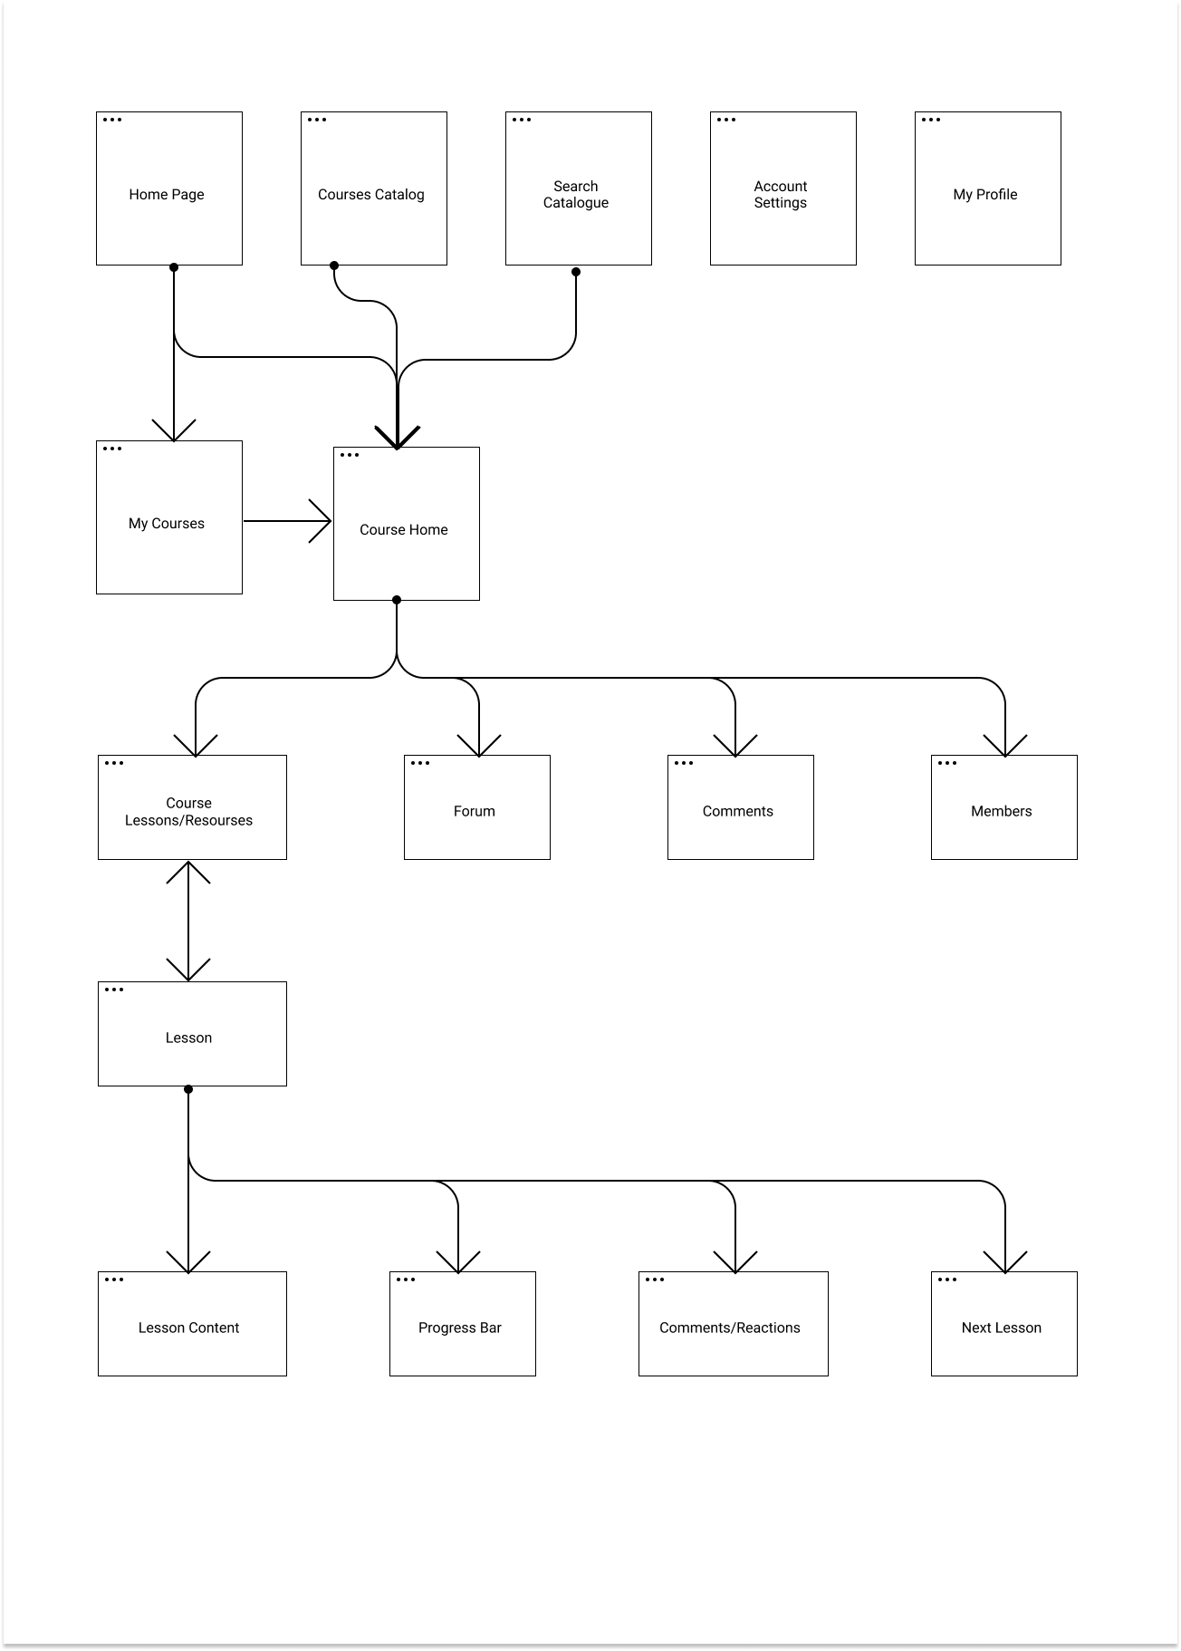**Authenticated User Dashboard flow**

*Figure 3.13: Authenticated user flowchart*

**3.5 ADVANTAGES OF THE PROPOSED PLATFORM**

1. Learners can easily access course resources from the comfort of their phones.
2. Course forum makes it possible for learners to as questions virtually and have answered buy fellow learners or the instructor realtime
3. Instructors can easily manage resources and course enrollments.
4. Instructors can reuse course resources for other sessions they would handle in the feature, this saves them the stress of publishing resources at the beginning of semesters
5. Instructors can track the knowledge of learners by monitoring interaction on the course forum.
6. The proposed system makes it possible for lecture sessions to hold irrective of wheather there’s an unforseen circumstance that hinders learners and instructors from being available physically.

**3.6 PROGRAMMING LANGUAGE**

Programming languages used are listed below;

**JavaScript Programming language;** According to Flanagan (2021), JavaScript is high-level, often just-in-time compiled and multi-paradigm. It has dynamic typing, prototype-based object-orientation and first-class functions. Alongside HTML and CSS, JavaScript is one of the core technologies of the World Wide Web. Over 97% of websites use it client-side for web page behavior; Javascript was choosen as the primary programming language for both frontend and backend development.

**Dart Programming Language** is a language developed and maintained by google; this language was created for the pupose of developing mobile friendly applications which can be compiled for both the Android and IOS operating systems. This makes it possible for developers to build applications for several operating systems using just one language; this increases development time and developers efficiency.

**HyperText Markup Language (HTML)** is the standard language every website is made up of. It is usually used alongside CSS and Javascript progamming language to produce more functionalies. HTML was choosed as the primary language to be used in building the website aspect of the system as it provides all that is needed to build a website.

**Cascading Style Sheets (CSS)** is the language used to style web pages; CSS was choosen as the primary language to be used in styleing basic components of the VLLP website.

**3.7 LANGUAGE JUSTIFICATION**

JavaScrript was choosed as the primary programming language for this project as it brings about somany advantagees. Looking at the fact that JavaScript can be used for backend and frontend development, it makes development faster as one langauge is being used accross major application modules. The Dart programming language was choosed to develop the mobile application as it poses several advanges. According to dart.dev (2021), Dart is a programming language designed for client development, such as for the web and mobile apps. It is developed by Google and can also be used to build server and desktop applications. HTML as the standard language for developing websites was used to build the platforms website.

According to Lozinski (2021), Uber Technologies uses JavaScript for frontend development including other programming languages such as Python, Go and Java. According to Ironhack (2021), LinkedIn relies on NodeJS for its mobile site; LinkedIn switched over to NodeJS to solve its scaling problems as the previous technology stack used (Rails application) was slow and hardly scalable.

**3.8 CONCLUSION**

This chapter summarised the structure and components of the Virtual Library Learning Platform, described the variouse languages used and justification for use and stated the requirement for systme use.

**CHAPTER FOUR**

**IMPLEMENTATION AND EVALUATION/TESTING**

**4.0 INTRODUCTION**

System implementation is the process of defining the user requirements and designing a system to meet such requirements. This is the stage of systems development in which hardware and software are acquired, developed and installed. This section provides details of the various modules in the platform, how this modules work and how they can be tested (Grady, 1994).

**4.1 IMPLEMENTATION OF THE PROPOSED SYSTEM**

This section describes how the proposed platform works and how it is structured. The platform is structured in such a way that each module in the system is loosely coupled to each other. The platform can be grouped into two parts generally which are the backend module and client side module.

**Backend Module**

The server component of the platform is responsible for handling all business login that makes it possible for users to interact with the platform. The server component of the platform is hosted on an online server accessible via the internet. This module provides several functions from user authentication to course management functionalities.

**Frontend Module**

This frontend module of the platform is responsible for providing an interface to users making it possible for them to access functionalities. The frontend module of the platform  is accessible via a website and a mobile application; the website can be accessed on https://tollgator.vercel.app/ and the mobile application can be downloaded on https://play.google.com/store/apps/details?id=com.devcircus.teogate

**4.1.1 HARDWARE COMPONENT**

The proposed system runs primarily on computer devices with access to the internet. The backend server which is the major module of is based on a nodeJs server and hosted on a heroku dyno server which can be accessed on the internet. Users of the platform make use of computers and mobile phones to access its functionalities.

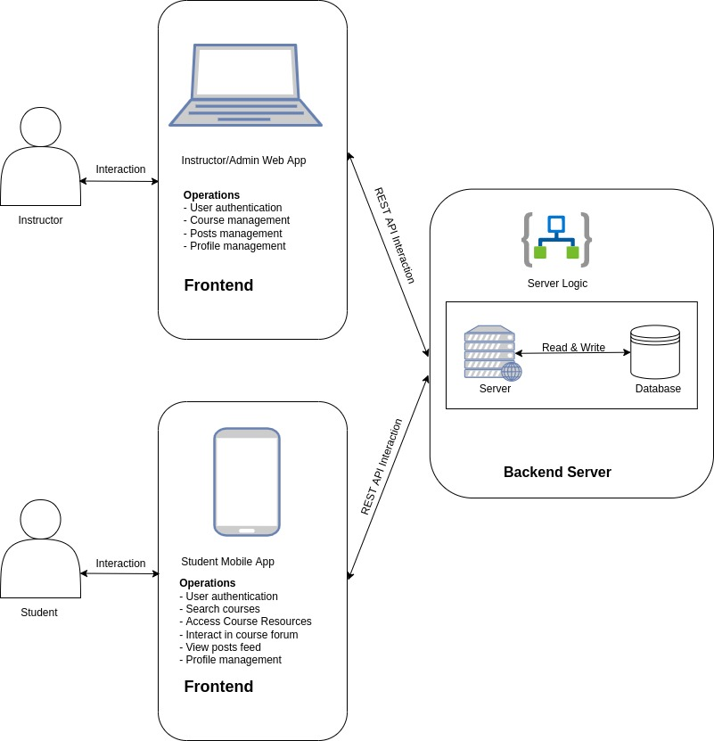*Figure 4.1: User interaction with Virtual Library Learning Platform*

**4.1.2 SOFTWARE COMPONENT**

The proposed platform runs on a backend remote server and exposed REST endpoints making it possible for clients to access several functionalities from authentication to course resource management. The software component of the platform is divided into two parts; the backend software and client side software which is made available to the users of the system. The client side software can be accessed via a website and mobile application.

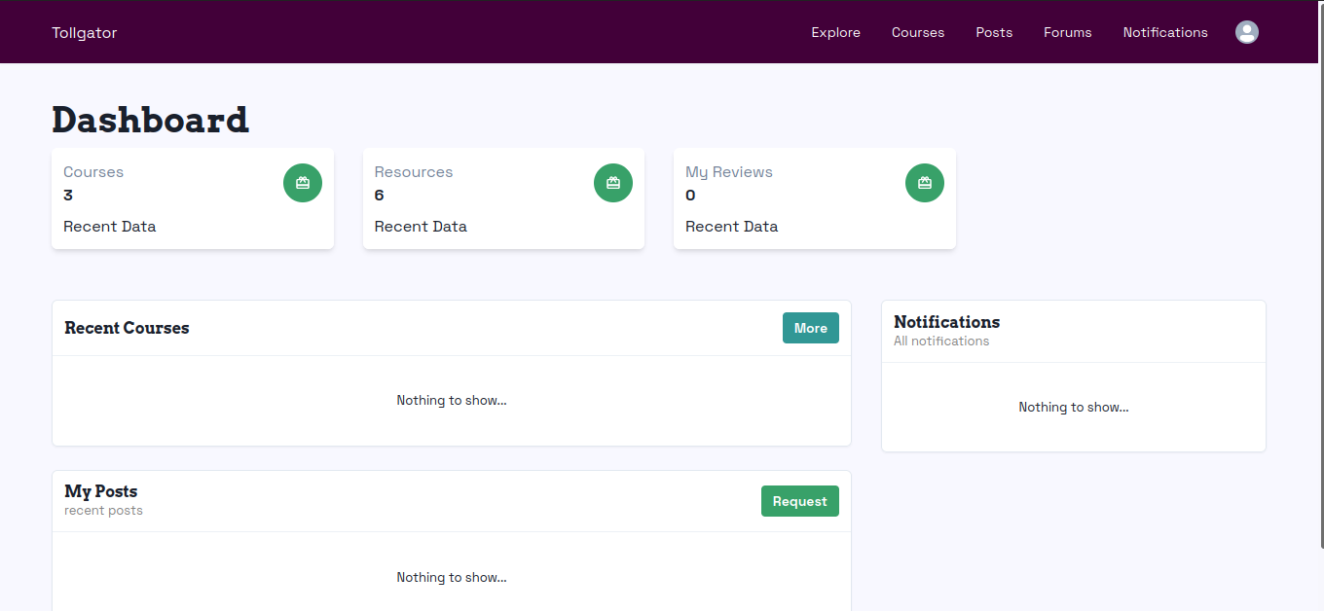*Figure 4.2: Instructor/Admin Dashboard*

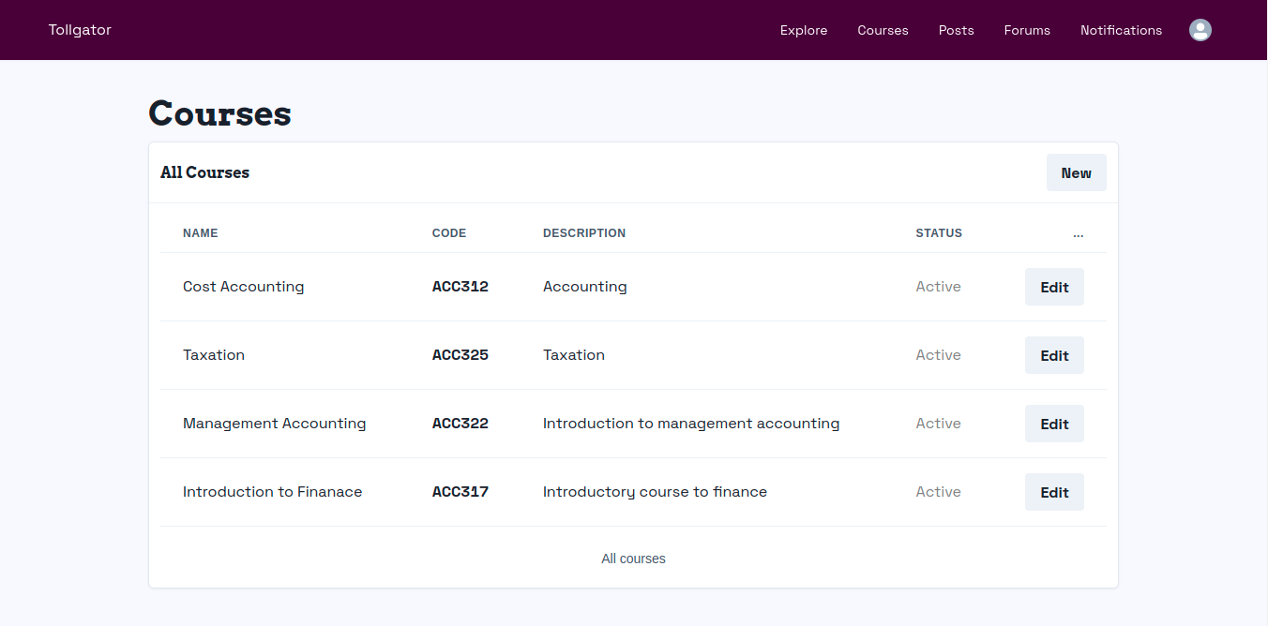*Figure 4.3: Instructor/Admin Course Management Screen*

*Figure 4.4: Student Authentication and Account Management Screens*

*Figure 4.5: Other relevant screens on Student Mobile Application*

**4.2 HARDWARE REQUIREMENTS**

Below are the hardware requirements of the platform

* RAM: 512 MB Heroku ephemeral storage
* Heroku Web Server
* Operating System Disk
* Processor
* Mobile or Computer Device

**4.3 SOFTWARE REQUIREMENTS**

Below are the software requirements of the platform

* Android, Windows, or Linux Operating System
* NodeJs Server Software
* Mobile application software
* Web Browser
* HTML
* CSS
* JavaScript Programming Language
* React - Website development framework
* React Native - Mobile application development framework

**4.4 OTHER NEEDED REQUIREMENTS**

Below are other requirements needed  to effectively use to platform

* Data Bundle
* Internet Connectivity

**4.5 SYSTEM TESTING**

The main importance of system testing is to ensure that the program performance is as intended and meets the defined objectives of the project. The researcher chose to test the software first to discover all the faults and defects as well as the general functionalities in the software.

**4.5.1 INSTALLATION TESTING**

Most software systems have installation procedures that are needed before they can be used for their main purpose. Testing these procedures to achieve an installed software system that may be used is known as installation testing (Myers, 2004).  So far, the various modules have been tested to meet the requirements of the platform. The installation test ensures that when every module in the system is integrated they produce the desired result. According to Kaner &  Pettichord  (2001), Installation testing may also be considered as an activity-based approach to how to test something. For example, install the software in the various ways.. Check which files are added or changed on disk. Does the installed software work? What happens when you uninstall?

**Below are outlines test cases to be followed for successful installation and testing of the Tollgator mobile application;**

**Application Installation**

* Users should be able to search and install the mobile application from Google Playstore
* Application should be able to install successfully without any error.
* Application should be able to create their icon properly into menu tray & on Home screen.
* Users should be able to create and login successfully after installation
* Learners should be manage profile settings
* Learners should be able to browse and access course resources

**Application Uninstallation**

* Application should be able to uninstall successfully without any error.
* Application icon should not be present on the device where you would expect to see the application icon after successful uninstallation.
* After application uninstallation, correlated files & folders should be able to remove properly from the Phone ROM.

**4.5.2 FUNCTIONALITY TESTING**

Functional testing is the process through which QAs determine if a piece of software is acting in accordance with predetermined requirements. It uses black-box testing techniques, in which the tester has no knowledge of the internal system logic. Functional testing is only concerned with validating if a system works as intended. (Browserstack, 2021).

**Authentication and Profile management Test**

**Description:** User should be able to successfully create an account

**Preconditions:** The user should not have an already existing account on the platform and must have an active email address

**Steps:**

1. User should create an account using mobile application
2. User should update profile details including profile picture
3. User should be able to browse courses available on the mobile application

**Expected result:** On successful registration, the user should be redirected to the mobile application dashboard and have access to a list of courses and navigation options. On successfully update of profile picture, the user should see the recent profile picture update on the profile page.

**Course Accessibility Test**

**Description:** User should be able to successfully search and subscribe to a course

**Preconditions:** The user should have an account already created on the platform

**Steps:**

1. User should login existing account.
2. User should browser for any course of interest.
3. User should be able to view the details of a course and enroll for the course in question.
4. Users should be able to view course resources and forum.

**Expected result:** On successful login, user should be presented with a list of courses from which he can view the details of any of the courses listed. On successful enrollment to a course, user should gain access to course resources.

**4.5.3 USABILITY TESTING**

Usability testing is a technique used in user-centered interaction design to evaluate a product by testing it on users. This can be seen as an irreplaceable usability practice, since it gives direct input on how real users use the system. (Nielsen, 1994).

**Mobile Application Usability Test Script**

User is expected to download and install the mobile application from Google Playstore and perform the tasks outlined below:

**Tasks**

* Begin by downloading the app to your device.
* Create and login to your account
* Update account profile on the profile screen
* Update profile picture on the profile screen
* Browse through courses in the courses screen
* View course details of any course of your choice by clicking on the course card
* User should enroll to a course by clicking on the enroll button on the course details page
* On successful enrollment, user should access course resources on the course resource screen

**Survey Questions**

1. What was the worst thing about your experience?
2. What other aspects of the experience could be improved?
3. What did you like about the mobile application?
4. What other comments do you have on the mobile application?

**4.6 CONCLUSION**

This chapter provided information on how the platform is being implemented, how it is being structured, the various components required to effectively use the platform and how it is tested to ensure it meets the specified requirements.

**CHAPTER FIVE**

**CONCLUSION AND FUTURE WORK**

**5.0 SUMMARY**

The project was aimed to develop a platform that makes it possible for instructors and learners to communicate seamlessly via the internet, this was done in consideration of how course resources are being communicated to learners. The platform provides a mobile application which could be used by learners to easily browse and access course resources. The system was developed using the React.js (Javascript library for creating user interfaces), Firebase development toolkit, Heroku server, Node.js (run-time environment for JavaScript) and MongoDB as the database management software of the system. The project requirement analysis was conducted in a systematic manner using the fact-finding techniques described in chapter three to fully understand the current system.

Further developments that could be made to the platform are real time video lesson sessions between students  and instructors, payments for course enrollments and sell of PDF resources on the platform.

Chapter one of this project focused on giving the reader an overview of Virtual learning applications, how they work, and some of they components that make up a Virtual learning application. The project went further to state the goal of developming a Virtual Learning Platform for the Faculture of Management Science 300 Level students, pointed out the current problem in the method of teaching used by lecurers and stated the objectives of the project.

Chapter two of this project provided more details on Virtual Learning Applications, the current Learning System currently used by students of the Faculty of Management Science, and the Effectiveness of the proposed system to both instructors and students.

Chaper three of the project described the structure and components of the application, programming languages used in development and justification for the use of those languages. The Virtual Library Learning Platform is built to make it possible for both instructors and learners to communicae and share information virtually. It also stated the requirements and system design of the platform.

Chapter four of the project provided information on how the platform is being implemented, how it is structured, the various components required to effectively use the platform and how it is tested to ensure it meets the specified requirements.

**5.1 CONCLUSION**

Generally, this research is based on the need for course resources to be made available on the internet and the need for effective interaction between learners and instructors.. The developed system can help  university instructors communicate course resources and materials effectively and speedily to students through an easy to use interface.

I was able to build a platform that makes it easy for instructors and students to share information, interact and access information easily.

The platforms mobile application was built and customised for students primarily making it possible for them to easily access resources publised by instructors from their mobile devices.

Instructors interact with the platform using a customised and easily-to-use dashboard making it possible for them to manage various courses, share resources for their courses and publish other resources which is made availble to students.

**References**

Amadeo, R. (2018). Google starts a push for cross-platform app development with Flutter SDK.  
  
Aparicio, M., Fernando B. & Tiago O. (2016). An e-learning theoretical framework. *Journal of Educational Technology & Society, 19*(1), 292-307. Available at: <http://www.jstor.org/stable/jeductechsoci.19.1.292>.

Alison. (2021). Types of Classroom Communication. Available at: https://alison.com/learning/courses/245/topic-types-of-classroom-communication

Balogh, Zoltan & Turčáni, Milan. (2011). *Possibilities of modelling web-based education using IF- THEN rules and fuzzy petri nets in LMS. Communications in Computer and Information Science*. 251. 93-106. 10.1007/978-3-642-25327-0_9.   
  
British Educational Communications and Technology Agency (BECTA). (2005). *Virtual Learning   
 Environments*. Available at <http://www.iadt.ie/vle/whatisvle/section2.htm>

BrowserStack. (2022). *Functional Testing : A Detailed Guide.* Available at: <https://www.browserstack.com/guide/functional-testing>.

Crow, R. (2002). *The Case for Institutional Repositories: A SPARC Position Paper. Association of Research Libraries, 40*(223), 1–4.

Chen, L (2018). *Microservices: Architecting for Continuous Delivery and DevOps.* Available at: https://www.researchgate.net/publication/323944215.  
  
Chris, R. (2020). What are microservices?. Available at: https://microservices.io/  
  
Daniel, L.S., Daniel T.G. & Daniel M.W. (2011). *Psychology, 2nd edition*. Worth Publishers. p. 264. ISBN 978-1-4292-3719-2.  
  
Doug, S. (2018). What is Firebase? The complete story, abridged. Available at: https://medium.com/firebase-developers/what-is-firebase-the-complete-story-abridged- bcc730c5f2c0

Dart.dev, (2021). Dart overview. Available at: https://dart.dev/overview.html

EasyLMS. (2021). Why use a learning management system (LMS)? Available at: https://www.easy- lms.com/knowledge-center/lms-knowledge-center/why-use-a- learning-management-system/item10131

Ellis, R. K. (2009). Field Guide to Learning Management. Available at: <https://web.archive.org/web/20140824102458/http://www.astd.org/~/media/Files/> Publications/ LMS_fieldguide_20091

Flanagan, D. (2021). *JavaScript the definitive guide.* Available at: https://www.worldcat.org/title/javascript-the-definitive-guide/oclc/64313259

Gaskell's Compendium. (2008). The Whole Forming a Complete Encyclopedia of Reference. Available at: <https://web.archive.org/web/20081202172539/http://people.virginia.edu/> ~rmf8a/gaskell/ EveningP.htm

GreyNet International. (2021). Document Types in Grey Literature. Available at: <http://greynet.org/greysourceindex/documenttypes.html>

Grady, J.O. 1994. *System integration.* Boca Raton, FL, USA: CRC Press, Inc.

Harvey, S. (2021). Benefits Of eLearning For Learners. Available at: https://elearningindustry.com/top- benefits-of-elearning-for-learners.

IGI Global(N.d). Course Management System CMS. Available at: https://binbiriz.com/en/blog/advantages-and-disadvantages-e-learning-platforms

IronHack. (2021). How 10 Major Companies Are Using JavaScript. Available at: https://www.ironhack.com/en/web-development/10-major-companies-avascript

Kaner, C., Bach, J. & Pettichord, B. (2001). *Lessons Learned in Software Testing: A Context-Driven Approach*. Wiley. p. 41.

Karban, R. (2015). *Plant Learning and Memory. In: Plant Sensing and Communication.* Chicago and London: The University of Chicago Press, pp. 31–44.  
  
Krill, P. (2014). React: Making faster, smoother UIs for data-driven Web apps.   
  
Lalrohlui, R. (2021). *Application of Information And Communication Techology in Special Libraries in Aizawl: A Study*. Mizoram University – via Digital Repository of Mizoram University.  
  
Lankes, R., Newman, W., Kowalski, S., Tench, B. Gould, C. & Silk, K. (2016). What Is a Library? In The New Librarianship Field Guide (pp. 95-102). Cambridge, Massachusetts; London, England: The MIT Press. Available at: http://www.jstor.org/stable/j.ctt1c2cqjm.14  
  
Lexico Dictionaries. (2020). Definition of Student by Oxford Dictionary on Lexico.com. Available at: https://www.lexico.com/definition/student  
  
Liber, O. & Britain, S. (1999). *A Framework for Pedagogical Evaluation of Virtual Learning Environments.* Available at: https://hal.archive-ouvertes.fr/hal-00696234

Lozinski, L. (2016). Engineering Tech Stack, Part II: The Edge and Beyond. Available at: https://eng.uber.com/uber-tech-stack-part-two/

Mazlum, K. (2020). Advantages and Disadvantages of E-Learning Platforms. Available at: https://binbiriz.com/en/blog/advantages-and-disadvantages-e-learning-platforms

Memri, E. (2021) The Importance of Using Single Sign-On for Your Learning Management System. Available at: https://skyprep.com/2019/11/18/the-importance-of-using-single-sign-on-for- your-learning- management-system

Mike, R. (2021) 5 considerations for designing a Learning Management System. Available at: <https://www.causelabs.com/post/5-considerations-for-designing-a-learning-management-> system  
  
Myers, G., Sandler, C., Badgett, T. & Thomas, M. (2004). *The Art of Software Testing (2ed.)*. Wiley.

Monica, K. (2020). *The Course Management System Explained: Your Ultimate Guide.* Available at: https://trainingorchestra.com/course-management-system-explained/

Moore, M. (1989). Three types of interaction. *American Journal of Distance Education*. 3 (2), 1–6.

Naveh, G., Tubin, D., & N. Pliskin. (2010 ) *Student LMS use and satisfaction in academic institutions: The organizational perspective, Internet High. Educ.*, vol. 13, no. 3, pp. 127– 133.   
  
Nick, K., (2021). Introduction to Mongoose for MongoDB. Available at: https://www.freecodecamp.org/news/introduction-to-mongoose-for-mongodb- d2a7aa593c57/

Nielsen,J.(1994). *Usability Engineering*. Academic Press Inc.

Reenskaug, T. & Coplien, J.O. (20 March 2009). The DCI Architecture: A New Vision of Object- Oriented Programming.  Available at: https://web.archive.org/web/20090323032904/https://www.artima.com/articles/ dci_vision.html

Wolff, E (2016). Microservices: Flexible Software Architectures. ISBN 978-0134602417. Available at: https://en.wikipedia.org/wiki/Special:BookSources/978-0134602417The Uber

Robert S. M. (2003). *Libraries and Learners in the Twenty-First Century*, Cora Paul Bomar Lecture, University of North Carolina at Greensboro.

Sander, T. (2020). Advantages of E-Learning. Available at: https://e-student.org/advantages-of-e- learning

Schatz, B. (1997). Information Retrieval in Digital Libraries: Bringing Search to the Net. Science.  
  
Stephen M. G. (1998). NSF/DARPA/NASA Digital Libraries Initiative.  
 Available at: http://www.dlib.org/dlib/july98/07griffin.html

Schlosser, L. A., & Simonson, M. R. (2006). Distance Education: Definition and Glossary of Terms (2nd Ed.). Greenwich, CT: IAP/Information Age Pub.

Smartbear. (2021). What is Microservices?. Available at: https://smartbear.com/solutions/microservices/  
  
Tech Radar. (2021). Best online learning platforms. Available at: https://www.techradar.com/best/best- online-learning-platforms

Tophatmonocle Corporation. (2021). *Virtual Learning Environment*. Available at: https://tophat.com/glossary/v/virtual- learning-environment/

The Linux Information Project. Login Definition. Available at: http://linfo.org/login_def.html

Tophatmonocle Corporation. (2021). Course Management System. Available at: https://tophat.com/glossary/v/virtual-learning-environment/

University of Jos. (n.d). *A Brief History of Department of Business Administration*. Available at https://www.unijos.edu.ng/faculty/management_sciences/business-administration

Victoria, R. (N.d). 4 Learning Management System Design Tips For Better eLearning. Available at: https://www.teachthought.com/technology/designing-a-learning-management-system-3-tips- to- make-it-better

Vanderbilt University. Course Management Systems. Available at: https://cft.vanderbilt.edu/guides- sub- pages/course-management-systems/  
  
Videoblocks. (2021). *Best 8 Online Learning Platforms 2021 To Jumpstart Your Careers.* Available at:<https://sites.google.com/site/videoblocksreview/online-learning-platforms>  
  
Witten, I. H., Bainbridge & David, N. (2009). *How to Build a Digital Library (2nd ed.)*. Morgan Kaufman.  
  
Wikipedia. (2021). *MongoDB*. Available at: https://en.wikipedia.org/wiki/MongoDB. Retrieved on July 6, 2021.