# CHAPTER ONE

## INTRODUCTION

### 1.0 INTRODUCTION

This work presents the background of the study, problem statement, scope/limitation and aim of the research.Likewise contained in this chapter is the aim of the research, the research objectives and the research methodology that will be pursued to accomplish the said goal.

### 1.1 BACKGROUND INFORMATION

E-learning is the delivery of learning, training or education program by electronic mean using computer or electronic device (e.g. a mobile phone) in order to provide training, educational or learning material. (Derek, 2003).

At the initial stage e-learning was not an acceptable form of learning, training or for educating students globally but due to the advancement in technology – e-learning is now warmly received globally as a means of knowledge delivery and two among many of the e-learning system that is predominantly used by teenagers globally include TOEFL iBT (Test of English in Foreign Language Internet Based Test) and, the Cisco Networking Academy Technology enabled learning program. This two prominent elearning system is popular among teenagers because it has gone through various trials process in order to find the teaching mechanics that appeals to k-6 because naturally teenagers are competitive (the like tasks that give them immediate feedback, such as giving them immediate score, or placing them on a real scoreboard and also the have high expectations (Choi, 2018)).

According to Nhu-Hien (2014) “Adolescence is recognized around the world as aperiod of human development that involves significant physical, cognitive, emotional, social and behaviouralchanges”.

The aforementioned e-learning tool have merit that is making adolescent to use the tool to practice, prepare and write exams which include; teacher and teaching method as well as facilitator and delegator style of teaching(Nhu-Hien Luong-Phan, 2014)**.**

In this study we will be considering an aspect of social media which is the privacy and security of social media and to develop a tutorial system using a Mobile Augmented Reality technology to educate and train students between the age of 10 – 17 on the menace of Online Social Media Sites.

Social media is a term that refers to a number of internet-based packages through which users interact with each other. Interactivity is what distinguishes social networking websites from conventional (or “static”) web sites. Social media packages inspire users to share their stories, critiques, understanding, and now and again their places. these connections can make contributions to a experience of engagement or loyalty among social media users. Figure 2 compares the traits of conventional media and social media. because the figure indicates, traditional media techniques are centralized and attention on handing over one or greater messages to customers. Social media methods are collaborative and depend on sharing statistics and soliciting remarks for his or her effectiveness. using traditional media—distributing press releases, granting interviews, and so on. The enterprise tries to control the message. the usage of social media, consisting of YouTube and Twitter, agencies can submit information that individuals can share, comment on, and every now and then regulate (Bregman, 2012).

In this study we are trying to get parents out of the side-line and to get involve in their children use of online social media sites because it behoves on parent to protect their children online activities by giving them proper guidance and to be aware of what goes around in the world in order to be able to investigate and adjust the privacy settings of your children. Also, to educate and train teenagers between the age of 10 – 18 on the adverse effects of using social media without a sense of knowing what privacy and security is all about (Bregman, 2012).

Blogs, or web logs, wherein individuals or corporations submit remark or news, often on a specific subject matter, and regularly invite remarks and feedback. The Los Angeles County Metropolitan Transportation Authority (l. a. Metro) publishes an everyday weblog called the source to offer information and tales of hobby to its riders; El Pasajero is the company’s companion Spanish-language blog.

* Social and expert networking web sites that encourage individuals to connect with one another, inclusive of fb, MySpace, LinkedIn, and GovLoop. Many transit residences hold a fb page to offer service facts and updates, including LANTA, DART, and community Transit in Everett, Washington.
* Micro-blogging websites, in the main Twitter, which permit customers to publish comments and internet links in a layout limited to a hundred and forty characters. some transit groups, such as the Washington Metropolitan vicinity Transit Authority (WMATA), fnd Twitter especially nicely acceptable for supplying actual-time provider updates, even as Vancouver’s TransLink makes use of the platform to provide customer service.
* Media- and record-sharing websites where members post and proportion video clips (YouTube), documents (Scribd), and pictures (Flickr). DART makes great use of YouTube to build network help for its offerings, while MTA keeps an image library on
* Flickr for media use. los angeles Metro’s Dorothy Peyton greyTransportation Library and Archive continues a set of historical making plans files on Scribd.
* Geolocation applications, which includes Foursquare, enable customers to percentage their area with other individuals of their social network and to earn digital “badges” for checking into sites. both BART and TransLink have collaborated with Foursquare to develop transit-specifc badges for their riders (Bregman, 2012).

## 1.2 PROBLEM AREA

Social media can sometimes do more harm than good such as cyber stalking, cyber bullying, pornography, isolation, sexual obsession etc., hence the need to create an online social media mobile application on privacy and security on online social media network.

## 1.3 PROBLEM STATEMENT

To make teenagers understand why they must consider their intended audience before the post anything online such as friends, family members, class mate and a possible unintended audience that can have access to the personal information of teenagers due to the open access that is provided to users' personal information on the online social media sites.

## 1.4 AIM OF RESEARCH

The aim of this research is to design and implement a tutorial-based application using Mobile Augmented Reality technology that teenagers can use in order to create awareness on the dangers that is lurk behind the screen of portable devices.

**1.5 RESEARCH QUESTION**

***PRIMARY QUESTION***

How to minimize exposure on social media?

## *SECONDARY QUESTIONS*

1. How can a teenager overcome the adverse health risk of social media addictions?
2. How do I avoid catfishing and cyberstalking in order to get rid of imposters?
3. How will a teenager guide against the legal, social, psychological risks of sexting, consequence exposure to online pornography as well as online dating? IV. How do I prevent live location broadcast to the world of my whereabout?

V. How do I prevent a third-party company from sharing my data this is within the walls of social networking sites?

**1.6 RESEARCH OBJECTIVE**

## PRIMARY OBJECTIVE

Teach your child on the adverse effects of using social media the wrong way. At whatever point they visit a site, share content, post something on a blog or transfer data, they are adding to their 'advanced impression'. This can be assembled under their genuine name and gotten to be invested individuals, for example, future bosses or promoting divisions. This may happen without you or your kid's assent or learning.

# SECONDARY OBJECTIVE

1. How to identify sexual predators that can lurk behind the screen of portable devices anonymously under false pretense through the wormholes of cyberspace.
2. To be aware of the dangers of cyber stalking and how not to fall victim of cyber stalking
3. To make teenagers know that one in five employers search online social media sites for potential candidates
4. To make teenagers aware that social networking sites owns all the content post on their social networking sites

## 1.7 RESEARCH METHODOLOGY

Different techniques used for data capturing and fact finding will be employed to gather information concerning the use of Augmented Reality Application by teenagers between the age of 10 – 17. And the use of interviews for data analysis, hence satisfying secondary objective II.

The data gathered are then employed in the design and building of a prototype of the system thereby achieving secondary objective III.

The Chapter 2, 3 and 4 of this work will be focused towards accomplishing the auxiliary goals as expressed previously.

Through literature review of different related works, the qualities of an effective Increased Reality Application would be distinguished to address optional objective I.

Distinctive methods utilized for information capturing and actuality finding will be utilized to accumulate data concerning the utilization of an Augmented Reality Application by Young people between the age of 10 - 16. Also, the utilization of interviews for information examination, subsequently fulfilling auxiliary objective II.

The information accumulated are then utilized in the plan and working of a model of the framework subsequently accomplishing auxiliary objective III.

## 1.8 SCOPE/LIMITATION

This study is focused mainly on the development of an Augmented Reality Application for students in primary school within Jos Metropolis and environs. The Augmented Reality Mobile Application can only run on smartphone devices that run on Android Operating System with a minimum API level of 15 which has the latest version of google play services installed.

The Augmented Reality section of the mobile application requires a target (A book cover stored in the database of Vuforia) in order to activate the functionality of the application such as the interface of the application for users to be able to interact with the application.

## 1.9 PROJECT OUTLINE

### 1.9.1 CHAPTER 1: INTRODUCTION

This chapter contains a brief introduction to the research work, the background of the study, problem statement, scope/limitation and aim of the research. Also contain in this chapter is the research objectives and the research methodology that will be followed to achieve the objectives.

### 1.9.2 CHAPTER 2: LITERATURE REVIEW

This chapter contains a brief introduction to the review work, then goes further to exploring the various technologies that is required for an Augmented Reality Application followed by a review of existing online social networking sites Augmented Reality Application and finally identifying the characteristics of these mobile application.

### 1.9.3 CHAPTER 3: PROPOSED SOLUTION

This chapter contains the techniques used for data capturing and fact finding in the development of the mobile Augmented Reality Application.

### 1.9.4 CHAPTER 4: DESIGN AND IMPLEMENTATION

In agreement with chapter 2 and the findings established in chapter 3, a model of the Mobile Augmented Reality Application System will be established in this chapter. The model will then be used to solve the problem stated at the start of this work.

In agreement with chapter 2 and the finding established in chapter 3, a model of the Mobile Augmented Reality Application System will be established in this chapter. The model will then be used to solve the problem stated at the start of this work.

### 1.9.5 CHAPTER 5: PROGRAM EVALUATION AND TESTING

This chapter contains activities aimed at evaluating the distinctive traits and capacities of the framework to decide whether they meet prior specifications.

### 1.9.6 CHAPTER 6: CONCLUSION

This chapter provides the summary of the entire research work, recommendations for further works and a brief conclusion.

## 1.10 CONCLUSION

This chapter started by introducing the research work and discussing the background of the study. The problem statement and the primary aim of the project was set. Objectives for the research work were defined together with the methodology for achieving the objectives. The scope and limitation of the project was ascertained and the outlines for all the six chapters were highlighted.

The next chapter will focus on related literature works on mobile Augmented Reality Application, other types of Augmented Reality Application and the characteristics of an efficient Augmented Reality Application.

# CHAPTER 2

# LITERATURE REVIEW

**2.0 INTRODUCTION**

This project work examines discussion on related technologies and devices, identifying their characteristics and features. The purpose of this literature review is to provide the reader with a general overview of privacy and security of online social media as it pertains to teenagers using Mobile Augmented Reality technology and to educate and train them on the dangers lurking behind the screen of laptops, phones and tablet.

## 2.1 WHAT IS AUGMENTED REALITY

“Augmented Reality (AR) refers to a live view of physical real-world environment whose elements are merged with augmented computer-generated images creating a mixed reality. The augmentation is typically done in real time and in semantic context with environmental elements. By using the latest AR techniques and technologies, the information about the surrounding real world becomes interactive and digitally usable” (Furh & Borko, 2011).

Augmented Reality goes for rearranging the client's life by bringing virtual data not exclusively to his prompt environment, yet additionally to any circuitous view of this present reality condition, for example, live-video stream. AR improves the client’s impression of and collaboration with this present reality.

While Virtual Reality (VR) innovation or Virtual Environment as called by Milgram, totally drenches clients in a manufactured world without seeing this present reality, AR innovation increases the feeling of reality by superimposing virtual items and signs upon this present reality progressively (Baillot,, Simon, Brown & Livingston, 2017).

From the above definition as well as an overview explanation of the important role of mobile Augmented Reality tends to play in this new media age.

Even though, virtually all Augmented reality system use tracking system to capture motion of an object in reality and map them into the computer-generated environment. This research work is focus on how augmented reality can make learning very cheap, engaging and interesting while creating an authentic learning environment for students between the age of 10 – 17 years of age by leveraging on the technology to create awareness in the privacy and security of online social networks. On a larger scale Augmented Reality is a developing field of innovation where reality is changed and upgraded by sights and sounds created by a computer system. AR makes the current reality progressively significant on the grounds that it permits user to connect with it through interaction. Augmented reality has an incredible potential to be utilized in the study hall since it changes the manner in which teenagers interact with this present reality, upgrades the level of student engagement, and makes the learning of their subject substance a good time. When incorporated into our education system most especially in Nigeria, Augmented Reality propels teenagers to investigate and, along these lines, learn. It extends teenagers to points of view and fosters their inventiveness and creative energy (Kaushik, 2018).

## 2.2 REVIEW OF RELATED WORK

Launched in 2015, the easy to-utilize application offers guardians apparatuses to stay aware of the consistently changing virtual scene kids are creating in. It investigates each instant message and post for harassing, substance abuse, self-destructive thoughts, gloom, sexting, and the sky is the limit from there. At the point when the product distinguishes a potential issue, it cautions you so you can see the hailed content, email, post, or picture. Alongside each alarm, Bark sends recommendations on how you can draw in with your kid in profitable, significant ways dependent on the kind of conduct that was hailed (Tross, 2018).

TeenSafe is a web software program application intended in particular for mother and father who need to discreetly display their teenager's cell phone area, phone calls, texts, social media interactions, and greater. there may be no need to jailbreak or root their gadgets. This application has been utilized by more than 500,000 mother and father within the united states of America to empower themselves with knowledge, and to offer their children with protection. for that reason, the transition of a baby into a grownup is a whole lot easier, and also you don't should worry approximately who your teen is speaking to, what conversations they're having and what they may be watching online. The cutting-edge generation has furnished plenty of recent opportunities, however can also open the door for threat. thankfully, TeenSafe can preserve children more secure. let us test how this system works in truth. well, it may work well with all Android and Apple gadgets, such as iPod Touches, iPhone, and iPads. in keeping with the organisation, the program is the primary tracker for iPhone (harrygould, 2018).

|  |  |  |  |
| --- | --- | --- | --- |
| SN | FEATURES | BARK APP | TEENSAFE |
| 1 | Unlimited  Children | ✓ | ✓ |
| 2 | Unlimited  Apps | ✓ | ✓ |
| 3 | 24/7  Monitoring | ✓ | ✓ |
| 4 | Cost | $14 per month | $9 per month |
| 5 | World Class  Security | ✓ | ✓ |
| 6 | Proactive  Support | ✓ | ✓ |

Table 1 shows a summary of comparison between TeenSafe and Bark

Augment is a 3D augmented reality application that is use for educational purposes for crossing over any barrier between the virtual and physical universes, Augment unites a multi layer learning background for students and instructors through augmented reality. Basically, Augment enables you to imagine 3D models in the genuine condition from the accommodation of your cell phone/tablet (iOS and Android).

Use Augment to: present difficult concept in 3D for visual and tactile learners create interactive scannable handouts that will display a supplementary 3D learning model or link to a educational webpage showcase and present the 3D models you and your students created, in and out of the classroom Augment gives free instruction memberships to students, instructors, and schools. This incorporates specialized help and backing in coordinating Augment all through the study hall and additionally schools (Lazzarini & Marcos, 2016).

Word Lens is an augmented reality application that Instantly translate printed words from one language to another with your built-in video camera, in real time! And Word Lens can be use by teenagers and adult alike during vacation, business travel, and just for fun.

### 2.2.1 Unity3D

“Unity 3DUnity was chosen as the main implementation tool for this project, since it supports both 2-dimensional and three-dimensional as well as augmented and virtual reality application development. Furthermore, the ability to build onto any platform from the same C++ codebase allows for prototyping of different operating system. For this project, an Android OS. Unity’s built-in UI tools allow for quick prototyping, since the Unity Editor is a visually-based interface with drag and drop functionality and its component add-on system allows for objects to receive properties of UI elements such as buttons without the need to code from scratch. Unity also allows unlimited customization of the Editor and provides an asset store with both Unity and community-made free and paid extensions, add-ons and resources. The assets used for this project are android studio SDK for Unity by android” (Amir Dirin, 2018).

### 2.2.2 Vuforia

Vuforia is a computer vision platform used for the development of Augmented Reality Application and the Vuforia plugins is integrated into newer versions of Unity3D. There are other AR platforms such as ARKit and ARCore, however, they are only for iOS and Android, respectively. Vuforia support the development of both iOS and Android, and to some extent, can be used alongside ARKit and ARCore as needed, therefore, ideal for rapid development as it uses the same code for both operating systems (Amir Dirin, 2018).

### 2.2.3 Microsoft HoloLens 2

Microsoft HoloLens is a Microsoft technological innovation, that made it possible for hologram to be displayed in our physical space making learning engaging and entertaining by making hologram objects look and sound as if they actually around the user. The features of Microsoft HoloLens are listed below.

1. The only holographic device that can display 47 pixels per degree of field of view which means it can display more information on screen
2. Slender glass panels that reflect holographic projections to your eyes
3. Retina scanning login feature
4. Time of flight depth sensors

Table 2 shows features of Microsoft HoloLens

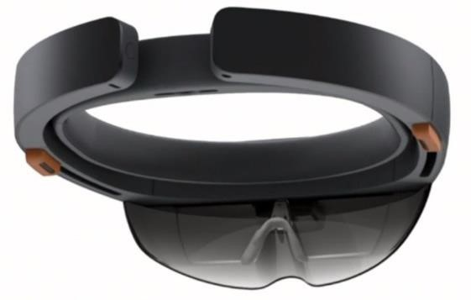

Figure 1Vuzix M3000

Vuzix M3000 developed by a South African startup utilizes mobile technology to save lives in the event of a car accident, being an android application that runs on smart phone devices. It has the following features/characteristics.

|  |  |
| --- | --- |
| I | **Latest Vuzix 1.4 mm thin waveguide optics** |
| II | It has custom WVGA linear DLP “Cobra” display engine for delivering the same hands-free digital world as the M300 processor |
| III | It operates on both Android and iOS platforms |
| IV | Intel inside 2.1 GHZ 64GB + Android 6.0 |
| V | Touch pad and physical Buttons |
| VI | Wi-fi 2.4/5.0 mimo and Bluetooth 4.1 |
| VII | USB an GPS |
| VII | Dual noise cancelling microphones |

Table 3 shows features of Microsoft HoloLens

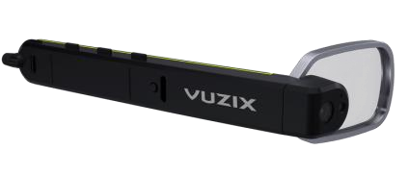

Figure 2 shows the Vuzix M3000.

### 2.2.5 AiR Glasses

|  |  |
| --- | --- |
| I | **2D Depth sensor** |
| II | Two see-through displays |
| III | Microphone |
| IV | Axis motion sensor |
| X | Replaceable lens |
| VI | External processing unit: Nvidia K1 Processor and GPU |
| vII | USB, HDMI and Debug ports |

Table 4shows features of AiR Glasses

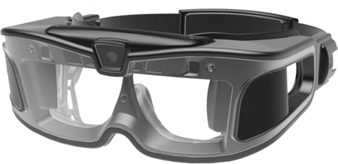

Figure 3 show AiR Glasses

### 2.2.6 Meta 2

Is a second-generation headset offers one of the best augmented reality experiences around. Think of it like Microsoft’s HoloLens, but at half the price and with a better Augmented Reality display and more comfortable design. The Meta 2 can project high-quality holograms using 3D imaging with a 90-degree field of view and a 2560 x 1440 resolution. It has the following features/characteristics

I

p front camera

720

II

Tinted screens

III

90

-

degree field of view

IV

Windows based operating system

V

2560

x

1440

-

pixel resolution

Table 5shows features of Meta 2 Glass

Figure 4 Shows an image of Meta 2

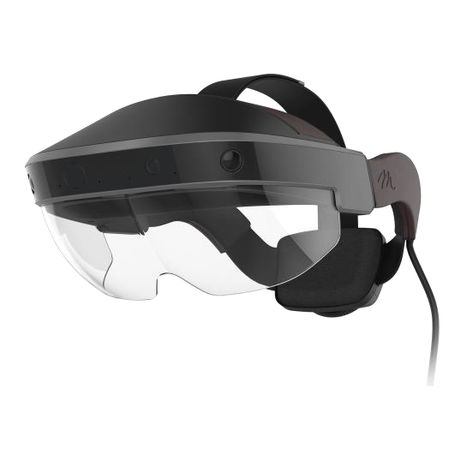

### 2.2.7 Studierstube

Is a software program framework Studierstube ES is a 2nd popular handheld AR platform. Written from scratch in mid of 2006 it represents an intensive new way of doing Augmented fact (AR) on hand held gadgets. other than previous tries it makes no compromises by using using software program that turned into basically written for other structures. Studierstube ES was designed from floor up to make exceptional use of the handheld platforms.

Studierstube ES operates go-platform (windows, home windows CE and Symbian) and addresses pix, video, tracking, multimedia, chronic garage, multi-consumer synchronisation and alertness authoring tools (Dimitris Chatzopoulos, 2017).

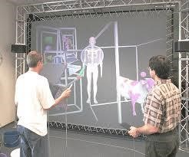

Figure 5 shows an image of Studierstube

**2.2.8 ARTiFiCe:** It is a software platform used to develop distributed and collaborative MAR applications. It allows multiple user collaboration, for example, multiple users can focus on the same physical area or sthe AR content is rendered on different physical scenarios. ARTiFiCe is implemented in several desktop and mobile platforms (Dimitris, Carlos, Zhanpeng & Pan, 2017).

### 2.2.9 SUMMARY OF FEATURES OF MOBILE AUGMENTED REALITY DEVICES

Table 2.1 provides the summary of features the analysed emergency response software and systems discussed in the previous section above offers.

|  |  |  |  |  |  |
| --- | --- | --- | --- | --- | --- |
|  | Depth  Sensor | Retina  Scanning  System | Wifi  Capabilities | WaveGuide  Optics | Bluetooth  Device |
| Microsoft  HoloLens | ✓ | ✓ | ✓ | ✓ | ✓ |
| Meta 2 | ✓ |  | ✓ | ✓ | ✓ |
| AirGlass |  |  | ✓ | ✓ | ✓ |
| Vuzix  M3000 | ✓ |  | ✓ | ✓ | ✓ |

Table 6 Summary of features of Augmented Reality Devices

## 2.3 PROBLEMS AND CONTEMPORARY ISSUES CURRENT IN MOBILE AUGMENTED REALITY

There are pretty some challenges within the implementation of Augmented Reality notwithstanding the advances in studies and development place.

The demanding situations are because of troubles associated with context-awareness, usability, navigation, visualization and interaction layout (Stan et al, 2012). **Navigation and Tracking**: AR system utilize GPS for out of doors navigation because of its accuracy and excessive availability. but in urban environments the GPS reception and accuracy can deteriorate, in which the GPS sign can be reflected and shadowed by using the encircling homes. Magnetometers available in cell gadgets can be used for the cause of navigation and tracking, but, they can be laid low with the nearby magnetic fields (Stan et al, 2012).

AR indoor navigation systems cannot use the GPS answer, as the GPS sign are unavailable or too weak interior. high Sensitivity GPS (HSGPS) or extremely-extensive Band (UWB) vicinity sensors may be used to hit upon indoor navigation, however currently no sensor technology is able to presenting particular navigation monitoring indoor (Stan et al, 2012).

**Content Management:** Many AR packages are restricted inside the manner new content material is to be brought to them. Programming skills are required for linking statistics sources to a current machine. everyday users must be able to upload their personal content material with minimal technical attempt (Stan et al, 2012).

**Usability:** A person’s position and orientation may be very vital for an Augmented Reality software to behave as predicted. Based totally on the place of the user, the digital 3D item is rendered into the actual reality. GPS sensors on smartphones have an accuracy of best 20 meters and the magnetometer compass orientation is most effective approximately 20 ranges. this will have an effect on at the same time as calculating the sector of view for the software, which will lead to digital items and the actual world no longer aligning with each different (Stan et al, 2012).

3D object is rendered into the real world. GPS sensors on smartphones have an accuracy of only 20 meters and the magnetometer compass orientation is only about 20 degrees. This will affect while calculating the field of view for the application, which will lead to digital objects and the real world not aligning with each other (Stan el al, 2012). despite the fact that present smartphones have excessive decision digital camera they provide a confined field of view. therefore, most effective a small portion of the person’s cellular field of view can be augmented. figuring out the focal point to view the Augmented truth items is an undertaking the user ought to face. The person might must rotate around at the same time as retaining the device to find the focal point (Stan et al, 2012).

**Visualization:** The small display, brightness, decision, assessment and discipline of view publish as a task in Augmented reality programs. The complete Augmented truth application might not fit in the small display. the proper use of the tool is vital for a sensible view if the digital object is to rendered into the real-world space (Bhutta, Umme-Hani & Tariq, 2012).

**Interaction Design:** The user interface and interplay of the user with an Augmented reality utility continues to be a hassle, because of the small show of the mobile device. there are numerous challenges in achieving interaction of the user with the virtual item (Bhutta, Umm-e-Hani & Tariq, 2012).

**Hardware problems:** The hardware used ought to be light weight and small so that it's might easily be portable. The trouble with having a small device is its computational strength. The battery life may be low and digicam high-quality might not be accurate in maximum gadgets to show the augmented reality items (Bhutta et al, 2012).

**Environmental issues:** The environment wishes to be installation with markings to discover the places for an AR utility (Bhutta et al, 2012).

## 2.4 KEY TECHNOLOGY

in this segment we will talk about the important thing technology is in need of for growing an Augmented reality software. the primary technology are monitoring and Registration era, object detection and recognition, calibration, rendering of models and display interaction technology.

### 2.4.1 TRACKING AND REGISTRATION TECHNOLOGY

monitoring and registration is the maximum hard technology as it calls for specific and corr ect orientation tracking to align the virtual items into the physical world. In a perfect scenario the tracking and registration era should go back to the accurate digital camera position so that the rendered digital objects can be placed in the precise function. When the camera role and orientation changes, the digital object also ought to get superimposed on the changed function to make it perceive love it’s a actual scene (Junwei, Fang & Lu, 2016).

There are steps concerned in the tracking and Registration generation.

1. Registration system: the digital object should completely align itself to the accurate role within the actual global to acquire accurate superposition.
2. monitoring procedure: whilst the observer position modifications, the appropriate function among the digital object and the real scene needs to be reconstructed (Junwei et al, 2016).

There are 3 varieties of monitoring and registration techniques

* 1. hardware-based totally tracking and registration method: This method specifically involves calculating the orientation and the spatial position of the item, based at the sensor statistics and signal resources acquired (Junwei et al, 2016).
  2. Imaginative and prescient-primarily based tracking and registration approach: The facts generated in the monitoring section, compares with saved facts. Then it calculates the current orientation and position. it is rapid easier and has extra scalability (Junwei et al, 2016).
  3. Hybrid monitoring and registration method: it is the maximum promising method to deal with the indoor and outdoor environment difficulties (Junwei Yu, 2016). it's far steeply-priced and tough to transplant (Junwei et al, 2016).

**2.4.2 Item Detection and Recognition Technology:**

The main reason of an item detection and recognition technology is to find out the scene and find the target. it's far divided into two components. the first component is to emphasize on superior supplementary information to get a better angle on the detection and classification. For instance, in an Augmented reality software after detecting the face, gender, call and age is displayed. the second element is picture matching, the photograph features and corresponding information are saved inside the database at the MAR server. In an Augmented Reality system, the digital camera of the mobile device is used to capture the present-day picture scene.

Recognition technology is used to process the photograph, matches with respect to characteristic value. ultimately shows the corresponding picture within the digital camera area of view (Junwei et al, 2016).

### 2.4.3 Calibration

Calibration technology utilizes the pixels of the image by using the camera and restores the items in actual space. It's far accountable for detecting the location and orientation and reporting the result facts to the machine. The calibration measured values are: the scope of vision, camera parameters, sensor offset, deformation and item localization (Junwei et al, 2016).

### 2.4.4 Model Rendering

The Model rendering method is a technique which utilizes 3D facts to generate 2D pictures. The ensuing image is typically saved in a body buffer. OpenGL ES rendering technology is utilized in mobile gadgets to gain rendering in Augmented truth packages. it's miles a 2D/3D lightweight pictures library, particularly designed for embedded and mobile gadgets (Junwei et al, 2016).

APPLICATION

OPENGL ES CLIENT

OPENGL ES SERVER

OPEN ES FRAMEWORK

GRAPHICS HARDWARE

RUNS ON CPU

RUNS ON CPU

RUNS ON CPU

Figure 6 OpenGL ES rendering process

### 2.4.5 Display interaction technology

This technology offers with how to show and engage with mobile AR results easily and efficiently on the mobile device. To obtain efficient user interface and interplay with MAR is still a task. The mobile gadgets have a small show display, no mouse, no keyboard and poor facts computing power. Interaction is just decreased to touch and swipe gestures.(Junwei Yu, 2016).

**2.4.6 SYSTEM ALGORITHM (FLOWCHART)**



Figure 7Augmented Reality application flow chart

## 2.5 CONCLUSION

Mobile Augmented Reality ranges from smartphone software to portable devices worn by individuals which transmits info to command centers automatically or through a button press by the individual. Other systems provide an easy to remember dial code through which emergency services could be sought for during emergency situations. it appears that evidently many groups default to making headsets and merchandise that cross immediately on to the person – within the hopes to create a tool for "regular" use. however, clients are simply no longer ready be seen out in public with those styles of wearables. further to social stigmas, the bulkiness and function (AR vs. VR, for example) of these gadgets limit whilst, wherein and in what context they can be used. Human factors are major drawbacks to Mobile Augmented Technology such as comfort, contextual awareness, ease of use and overload etc.

Our main focus was centred on identifying certain functionality, features and the privacy and security involve in using online social media such as Facebook, Twitter and Snapchat etc. That these systems possess and employ them in the development of an Mobile Augmented Reality application for the larger portion of teenagers using online social media application.

This chapter explored various Mobile Augmented Reality, hardware devices, software solutions and also produced a summarized table of features identified form those systems which will be used as a basis for our future chapter in the development of our software application. Lastly the influence of technology on these systems was discussed, identifying the technologies involved in this system.

The next chapter focuses on identifying the necessary requirements that would constitute our Mobile Augmented Reality Application.

# CHAPTER THREE

## DATA COLLECTION AND FINDINGS

## 3.0 INTRODUCTION

In the previous chapter, the characteristics associated with mobile augmented reality were identified, which formed the base knowledge needed to understand this research. this chapter focuses on addressing the second subjective which is gathering all necessary requirements for the mobile augmented reality.

In order to get the current way of reporting emergency cases, a detailed study of the current process is carried out. The key observations about this current process thus lead to specification of the new system.

This chapter begins with a brief description of the case study and current process of reporting emergency situations. Next, method of data collection will be addressed and data collected will be analysed and results will be generated. The result will lead to several key findings, which will be the basis for establishment of the user requirements for the new system.

## 3.1 CASE STUDY DESCRIPTION

The University of Jos Primary School is a well renowned school which provides education that is locally competitive. It provides a wide range of facilities and this constitutes of several units. One of such units is the Emergency response unit which is the primary object if this study.

There are a lot of risks that online social media is laden with that parents and teachers of teenagers need to take into cognizant that could proof detrimental and possibly endanger the lives of teenagers if adequate measure is not put in place - these dangers include:

Posting of inappropriate images online for family, acquaintance, foe and prospective future employers to view because most times teenagers care less about their future rather, they are more concern with the flamboyant life style of what today brings as well as the attention they will receive.

Teenagers build an image that is fake in order to make their life look more appealing to others thereby the focus their attention on creating a fantasy instead of embracing who they truly are.

Teenagers lack the tenacity and discipline to regulate their newly found sexuality instead of acting maturely the venture into act of manipulating the minds of their fellow online audience mostly boys as we as use it to gain unnecessary attention.

Some of the videos posted online can ruin the life and integrity of both teenagers and adult alike if proper care is not taken.

## 3.2 HOW PARENTS AND GUARDIAN CAN REDUCE THE NEGATIVE EFFECT OF SOCIAL MEDIA ON THE WELL-BEING OF TEENAGERS

Despite the prominent role social media tends to play in online communities the technology can have a negative impact on the self-esteem of teenagers among other list of negative impact of social media.

Here are the possible ways parent or guardian can reduce or possibly eliminate the risk involve in the use of social media.

1. As parent or guardian try as much as possible to know the kind of subscription your wards opt out for on online social media site such as YouTube to be able to track the kind of videos, they are feeding their minds with.
2. Have fun with your children online by creating your own favourite music, skit, movies etc., playlist online while you watch them create their playlist from doing that you will know the kind of videos your children are fun off.
3. Make them to understand that surfing the net is not anonymous hence educate your wards on the dangers of digital reputation by making them know about digital footprint which will be enforce they moment the share content, post a video and visit a website. iv. Teach them how to block cyber bullies by reporting any inappropriate behaviour to the social media platform.

## 3.3 DATA COLLECTION

The task of data collection commences as soon as research problem has been identified. Data collection can be defined as the method of taking measurement, collection of data and analysing information on a variable in a manner that is systematic in order to be able to answer relevant questions as well as evaluation of outcomes. Two types of research methods exist known as qualitative and quantitative. According to Defranzo (2011) explains that quantitative research such as Kiosk surveys, face-to-face interviews, telephone interviews, longitudinal studies provides a measure to quantify the problem by generating numerical data. It is used to measure behaviours, attitudes, opinions, feelings, and other defined variables and generalized from a larger sample population.

Qualitative method of data collection provides insight into the problem in order to come up with ideas or hypothesises for potential quantitative research. Methods of qualitative research techniques include: group discussions, individual interviews, observation and participation. The sample size is usually smaller than quantitative research method of collecting data. Qualitative research is also used to unravel trends in thought and suggestions, and dive deep into the problem at hand.

### 3.3.1 POPULATION OF STUDY

The study population is made of students between the age of 10 – 17 that are in primary school, few others in secondary school and university of Jos depending on the age bracket.

### 3.3.2 SAMPLING

The interview comprised of twelve individuals, an expert in digital marketing and a social media consultant, House on the Rock Jos, parent that is enthusiastic about social media and teachers of West Wood Park Primary School. 6 individuals were selected at random from the population with criteria that 2 of these individuals must be staying on the university campus(hostel), 2 must be staying off the university campus and 2 must be student of West Wood Park Secondary School.

### 3.3.3 INSTRUMENT DESIGN

An interview is a planned meeting during which you obtain information from another person was the major source of data for this research. Open ended questions were used. In this research two type of interview questions were generated:

**Type A (For parents, guardian and Teachers):** For parents and teachers who are concern on the privacy and security settings of their children or students on the dangers online social media tends to posed due their careless activities that can be avoided such as posting their address online which can endanger the lives of family members, use of online social media sites without using password, which can lead to identity theft by using the Mobile Augmented Reality on the privacy and security of online social media sites for teenagers. The purpose was to ascertain teenagers are educated appropriately on the negative and positive effects of using the Mobile Augmenting Reality Application, also to determine the functional requirement for the mobile application.

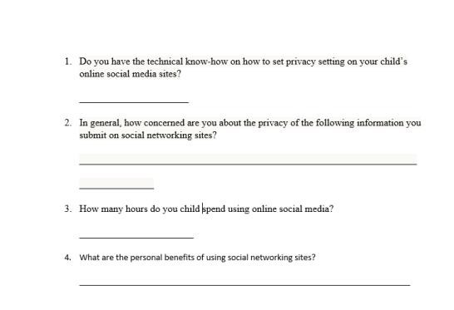

Figure 8 Type A interview question snippet

**Type B (For Teenagers who are somewhat addicted to use of online social media):** For school children between the ages of 10 - 17 years’ old who uses online social media platform such as Facebook, YouTube, Instagram, Google, Snapchat and many others to share, post, tag and network, the aim is to reach out to as many teenagers as possible in order to educate them on the both the negative and positive impact social media once an individual is exposed to it usage. The purpose was to understand the current process of handling the dangers that posed in the use of social media and also determine what kind of information that would be of necessity whenever teenagers are online and are using any of the online social media platform. This will aid in the functional requirement phase of the development Mobile Augmented Reality Application. Figure 3.2 shows a snippet of the interview questions.

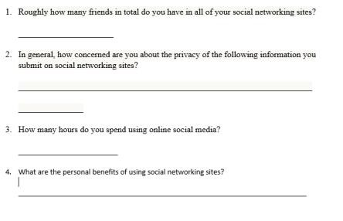

Figure 9 Type B interview question snippet

## 3.4 DATA ANALYSIS AND RESULTS

Twelve respondents were interviewed and the following information was gotten from the interviewing of these respondents and responses gotten were noted down by hand.

To analyse these data, results were split into two.

### 3.4.1 TYPE A QUESTIONS ANALYSIS

Information gotten from Type A interview questions were categorized into three components.

Teenagers may appear to have all the answers as it applies to life but the truth is that every child need an adult or parent that will caution his usage of online social media sites that will caution his usage of the sites in order to cut down on the excesses. Though most parents who were asked questions openly said that the try as much as the can in order to secure the privacy and security by setting some rules in the house and online to checkmate the kinds of activities they indulge in online. Suffice to said that some parents do not have the technical know-how as well as the discipline to monitor the activities of their children online instead the employ a third-party approach of involving the services of other close relatives and sometimes family friends to monitor their children activities online.

In terms of response, when asked what kind of information do teenagers disseminate on social media site, both respondent from the parents and teachers stated that most of the information that children or students post online cannot be regulated but it is possible to curtail some activities and posting online that has detrimental likelihood – which can affect both teenager in question as well as his family.

When asked of the number of hours that children spend online. Mostly parents give a vague estimate of the duration of time their children spend using online social networking sites.

### 3.4.2 TYPE B QUESTIONS ANALYSIS

For the Type B interview questions for individuals, the following information was found: When asked of the total number of friends or acquaintances that a respondents have on a social networking site 70% of teenagers said that they have about 2000 and above on Facebook, 600 on Instagram and 200 on Twitter while 40% opined that they have an average of 200 friends on Facebook and less number of friends on Instagram and Twitter. The number of teenagers that know or have a clue about privacy and security involve in using social networking sites are approximately 30% of the they total number of respondents while the larger majority do not have a clue on what privacy and security of social media is all about.

When asked of the total number of hours spend online, 60% of the respondent interviewed agreed that the spend 6 – 7 hours on the average using online social media on a daily basic while 40% stated there should be flexibility in in the number of hours spend depending on their time schedule.

100% of the respondents opined that that the online social media sites help them to share, communicate and post vital information for educational purposes

## 3.5 FINDINGS

In the previous section we analysed the raw data gathered from the interviews in order to yield a set of results. The result from the interviews led to several key findings. Looking at what was set out at the start, the interviews aimed at understanding the privacy and security concerns of using online social media sites These findings will be unveiled in the subsequent paragraphs.

The Type A interview questions meant for parents and teachers dwells on understanding how they can ensure the privacy and security of their children are secured by testing the level of their technical know-how, their awareness level in the aspect of online social networking sites. Results from the analysis indicated that larger portion of parents have low technical know-how in operating, managing and using online social networking sites adequately hence making parents very good candidate of guiding their children on the usage of such technology and also it is salient that in as much as parent lack the technicality involve in the usage of this technology; they should show some level of concern on how their children are prone to the dangers that is lurking behind the screen of mobile devices, laptops and desktop computers.

The Type B interview questions is concerned with the response teenagers give in an attempt to answer some of the questions asked such as the number of friends that are in his or her friend network or friend list, how much of a concern is the issue of privacy and security as it relate to the amount of information disseminated on online social sites as well as the amount of time spend teenagers on social media platform. It was revealed that most teenagers whose privacy and security have being compromise before are not in aware of some mobile tutorial application that can educate them on the possible ways of avoiding the dangers that is lurk behind the screen of most mobile devices, laptops and desktop computers. For those that are aware, services provided by such applications in the aspect of tutoring is not fun and catchy, hence the lost interest.

The third question Type A and Type B interview questions aimed at finding some characteristics of the proposed Mobile Augmented Reality prototype on the issues of teenagers privacy and security, instead of current proposed solution having an offline image target – a cloud base augmented reality can be used instead were the user will not encounter any form of difficulties having regulate update as the need arises. Even though cloud base augmented reality application is suitable for application that deal with multiple targets, below are some of the advantages over single image target augmented reality application:

1. More than a million target can be use in a single application which can lead into the development of a more elaborate application that is addictive for teenagers to use.
2. It delivers real time content that are dynamic to it users
3. It can integrate easily with existing content management systems

## 3.6 REQUIREMENT SPECIFICATION

The requirements of the system are divided into two: functional and non-functional requirements.

**Functional Requirements:** these are statements of services the system should provide, how the system should react to particular inputs and how the system should behave in particular situations

**Non-Functional Requirements:** These are constraints on the services or functions offered by the system such as timing constraints, constraints on the development process, reliability, I/O device capability and so on.

### 3.6.1 MARKER BASED MOBILE AUGMENTED REALITY

Below are the services that the mobile augmented reality needs to provide:

#### **3.6.1.1 FUNCTION REQUIREMENTS**

The System shall prompt the user for login credentials before commencing use of application

1. The system should allow users have access to the application.
2. The system shall provide access to the quiz section of the application
3. The system shall allow users to access the video tutorial section of the application
4. The system shall allow authorized personnel to be able to read textbook on the privacy and security of online social media site.

**3.6.1.2 NON-FUNCTIONAL REQUIREMENT**

1. All system interactions and updates must be nearly immediate
2. The system is available 24 hours every day for authorised users
3. The system is very simple to use
4. Very simple interface

### 3.6.2 Augmented Reality Application

Below are the services the mobile application would provide:

#### **3.6.2.1 FUNCTION REQUIREMENTS**

1. The system provides the user with a video scene where they can watch videos on privacy and security of online social media.
2. The system provides section for quiz
3. The system shall allow users to watch the tutorial segment of the application users can be able to write quiz
4. Users can as well play augmented reality game and also read a page curl book

#### **3.6.2.2 NON-FUNCTIONAL REQUIREMENTS**

Designing a system to be used in situations where every second counts requires very careful thoughts. The non-functional requirements enumerated below are every bit as important as the functional requirements.

**Ease of use:**

The system shall be designed to require simple interface for users to be able to navigate very easily without any hassle.

**Performance:**

1. The mobile device in use must have a very good camera and also minimum of 2 Giga bytes of Ram
2. The system shall run on both iOS and android devices

## 3.7 USE CASE MODEL

This is used to model interactions between a system and external actors (users or other systems).

Use cases focus on the behaviour of the system from an external point of view.

A use case describes the functions provided by the system that yields a visible result for an actor. An actor describes any entity that interacts with the system (e.g., a user, another system). The actors are outside the boundary of the system, whereas the use cases are inside the boundary of the system.

The application requires a single user as the use case. Figure 10 shows the interaction between the user and the mobile application.



MAIN MENU

PLAY TUTORIAL

VIDEOS

READ ABOUT

SOCIAL MEDIA

PLAY

3

D MODEL

TURIAL VIDEOS



WRITE QUIZ

QUIT

Figure 10 The use cases for authorized user of Mobile Augmented Reality Application

## 3.8 CONCLUSION

“The saying goes that prevention is better than cure. In the case of monitoring children’s online activities, this saying could certainly be applicable. After all, preventing kids from being influenced by inappropriate content is probably a better way of making sure they grow up with a good moral education than trying to instil good morals after they have already been negatively influenced. However, the definition of “prevention” in this context is often misconstrued. The point is not to prevent children from encountering inappropriate content, but rather to prevent them from being negatively influenced by such content” (KidGuard, 2017).

These findings lead to the generation of the user’s requirements which will serve as a basis of constructing the model of the prototype to address the problem stated at the start of this research. Chapter 4 will present this model and will go further to implement the prototype.

**CHAPTER FOUR**

**DESIGN, TESTING AND EVALUATION**

## 4.0 INTRODUCTION

The previous chapter discussed a survey in form of interviews. The data gotten from the interview were analysed to yield set of results and the results from the analysis led to several key findings and also this chapter is concerned with testing the prototypes to ensure it satisfies all necessary requirement specification.

Findings from the survey indicated that majority of the respondents will like to have the proposed solution brought to live, which takes this research to the next stage. This chapter shall present the model and will go further to implement the prototype thereby addressing the third subjective through the requirements gathered in the previous chapter. The chapter will commence by designing a conceptual model of the proposed solution and the model is then translated into an executable program.

## 4.1 DEVELOPMENT METHODOLOGY

The software development technique adopted for this project is the Object-Oriented Analysis and Design approach. It views the system as a collection of interacting objects that work together to accomplish tasks.

The incremental build model is used in this project development. Activities of planning, analysis, design and implementation were carried out in an overlapping manner. At every stage of development, improvements were made based upon the tests carried out on the application during development until the required result is

## 4.2 SYSTEM DESIGN

The purpose of this section is to provide an outline of the various methodologies and design techniques used in the analysis and design of the Mobile Augmented Reality prototype.

### 4.2.1 CONCEPTUAL MODEL

The conceptual model is the conceptual representation of how the proposed system should be done.

The user can basically navigate his way around the application from the main menu which have a set of options to help the user find information or execute program function.

MAIN MENU

OPTION

PLAY

QUIT

ABOUT OSM

ARGAME

QUIZ GAME

BACK

Figure 11 shows the conceptual model of the prototype.

### 4.2.2 ARCHITECTURE OF SECURITY AND PRIVACY OF ONLINE SOCIAL MEDIA USING MOBILE AUGMENTED REALITY

On initialization of the mobile application, the user can navigate to the option menu were he/she can watch an augmented reality videos, write a quiz based on the video watched, play an augmented reality first person shooter game and also read about the dangers that lurk behind the screen of mobile devices and how to avoid them.

The system is made up of the following basic component such as an Augmented Reality Videos, A quiz game, an option to read about the dangers that lurk behind the screen of most devices, and also an Augmented Reality Game. Figure 12 shows the architecture of the mobile application.

MOBILE AUGMENTED

REALITY APPLICATION ON

PRIVACY AND SECURITY OF

SOCIAL MEDIA FOR

TEENAGERS

READ ABOUT SOCIAL MEDIA

QUIZ GAME

AUGMENTED REALITY FIRST

PERSON SHOOTER GAME

AN AUGMENTED REALITY VIDEOS

Figure 12 Architecture of the Mobile Augmented Application

### 4.2.3 MOBILE AUGMENTED REALITY APPLICATION COMPONENT DESCRIPTION

1. **A Mobile Augmented Reality Video:** This scene is in charge of handling an augmented reality videos that will appeal to adolescent based on statistics of teenagers love for augmented reality technology.
2. **Quiz Game:** This scene is in charge of allowing teenagers to write quiz after watching couple of videos from mobile Augmented Reality Video scene.
3. **A Book about OSM**: this component is in charge of giving the option of reading a book on the dangers that lurk behind the screen of devices.
4. **An Augmented Reality Game**: This component is in charge giving teenagers chance to play an Augmented Reality First Person Shooter.

### 4.2.4 SYSTEM ALGORITHM (PSEUDO-CODE)

Pseudocode is an informal high-level description of the operating principle of a computer program or other algorithm. The subsections below describe the pseudocode for the Mobile Augmented Reality Application.

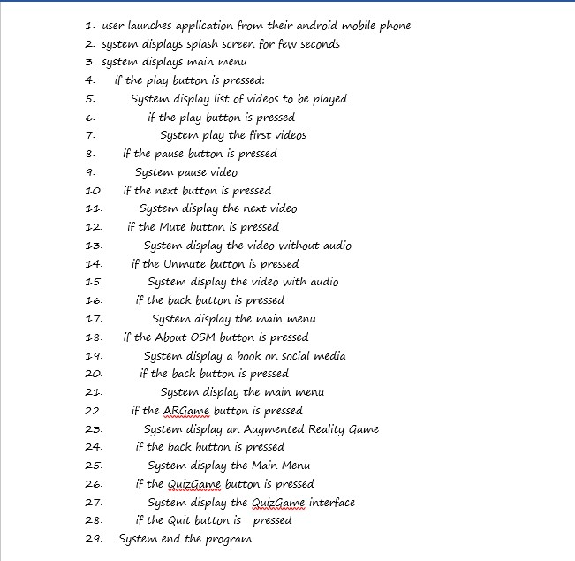

Figure 13 Activity diagram for mobile augmented reality application

### 4.2.5 CLASS DIAGRAM

The class diagram is a structural diagram. It depicts the various components of the system showing the class and the relationship that exists between these classes.

Figure 11 shows the class diagram of the Quiz Application in the Augmented Reality Application



Figure 14 Class diagram of quiz application

## 4.3 SYSTEM IMPLEMENTATION

System implementation is the phase where designed procedures are transferred into control specification by the help of a computer programming language. The rules and regulations that guide such a programming language should be obeyed to avoid, syntactic, semantic and logical errors.

**4.3.1 CHOICE OF TECHNOLOGIES**

As discussed in chapter 2, the following sub sections discusses the reasons why these technologies were chosen.

**4.3.1.1 C# PROGRMMING LANGUAGE**

. It is designed as a general-purpose machine language for the building applications on the Microsoft platform and the language is dependent on .NET Framework in order to work. C# programming language can be used to created anything but is particularly good in designing and creating games mainly in the Unity Game Engine which happen to be the most popular game engine today

Based on statistics more than one third of the games that are topping the chart were created with Unity, and there are approximately 770million active users of games created using the Unity engine. It is also used for Virtual Reality, with 90% of all Samsung Gear and 53% of all Oculus Rift VR games developed using Unity.

Reasons for choosing the language:

1. Most of the complex tasks in C# are abstracted away, so they programmer doesn’t have to worry about them.
2. It’s also a statically typed language, so the code is checked before it is turned into an application
3. It is more consistent than C++ programming language

(Mkhitaryan, 2017).

**4.3.1.2 Unity3D Game Engine**

Unity 3D has taken the world of video game development to a whole new level in the development and production of games over the years. As it stands, Unity3D is the most prefer gaming engine among others to both freelance game developers as well as development studio because of its versatility, flexibility, ease of use, platform independent and ease of access.

Unity3D Engine has large community of developers which rank at position 3rd on Stackoverflow (Mkhitaryan, 2017).

**4.3.1.3 Photoshop**

Photoshop is the most popular photo editing software for both graphics’ designers and web developers. It is user friendly and have more than enough that can help unleash your creative potentials. Below are some of the reasons for choosing Photoshop:

1. It transforms images artistically
2. Opportunity to express creative potentials

**4.3.1.4 CHOICE OF INTEGRATED DEVELOPMENT ENVIRONMENT (IDE)**

An integrated development environment (IDE) is a software application that provides comprehensive facilities to computer programmers for software development. The choice of IDE’s influence the speed of application development, for the purpose of this research, Unity3D Game Engine and Virtual Studio (Community Version) IDE. The following sub sections describes these development environments.

1. **Unity3D** **Game Engine**

It is a cross-platform real-time engine and has an easy to use user interface that can easily be customized by game developers and designers.

1. Visual Studio (Community version)

It provides an integrated development environment for development cross-platform applications that can run on Android, iOS, Mac, Windows, web and Cloud. It helps in ensuring your code runs fast, easy to debug and diagnose, ease of testing, easy to deploy and enhance developers’ collaborative effort.

**4.3.3 HARDWARE REQUIREMENT FOR THE IMPLEMENTATION**

System specification:

1. An up-to-date Windows10 operating system
2. Minimum of 6 GB RAM and maximum of 16 GB RAM.
3. Either Minimum of 250 Hard Disk Drive space or 128 Solid State Drive space.
   * 1. **SOFTWARE REQUIREMENT FOR THE IMPLEMENTATION**
4. Minimum of DirectX9 driver
5. Enabled virtualization in the Bios settings
6. Unity Hub
7. Unity3D
8. Vuforia
9. Android SDK
10. Visual Studio

## OPERATING THE PROTOTYPE

The following sub sections illustrates the operation of the mobile and web application.

### 4.4.1 OPERATING THE MOBILE AUGMENTED REALITY APPLICATION PROTOTYPE

**4.4.1.1 Main menu**

This is the first screen that is displayed after the user launches the prototype. Figure 15 shows the splash screen of the mobile application

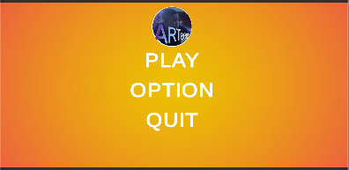

Figure 15 Main menu provides an interface for teenagers to navigate around the applications

**4.4.1.2 Unity Page Curl AR Book**

This allow teenagers to read on the dangers that lurk behind the screen of portable devices and to create awareness on what the ought to do whenever they are bedeviled with such dangers as shown in figure 16 below.

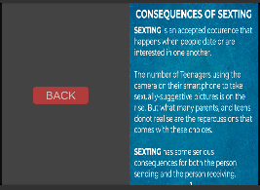

Figure 16 Unity page curl book allow teenagers to read on social media and the dangers that lurk behind portable devices screens.

**4.4.1.3 Quiz Scene**

Teenagers can attempt quiz questions as soon as the grasp the videos and books the read on the Augmented Reality application on the privacy and security of online social media as shown below in figure 17.

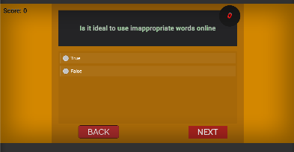

Figure 17 The quiz scene interface provides teenagers with the interface of attempting to answer some online social media questions.

**4.4.1.4 RESOLUTION SCREEN FOR CORRECT ANSWERS**

Whenever users choose correct answers the correct answer screen pop up indicating the answer selected from the list of options is correct as shown below in figure 18.



Figure 18 Resolution screen for correct answer comes up whenever the user selects the wrong answers during the quiz

**4.4.1.5 RESOLUTION SCREEN FOR WRONG ANSWERS**

Whenever users choose the wrong answer the wrong answer screen pop up indicating the answer selected from the list of options is correct as shown below in figure 19.



Figure 19 Resolution screen for wrong answer comes up whenever the user selects the wrong answers during the quiz

**4.4.1.5 QUIZ FINAL SCORE SCREEN**

As soon as the user finish answering all the questions the quiz final score screen pops up displaying how well or how poorly the user performs during the quiz as shown below in figure 20.

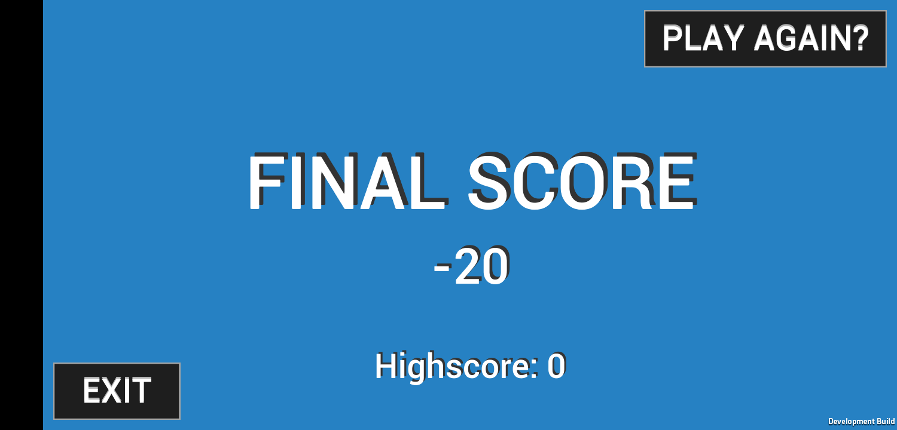

Figure 20 Illustration of the score board resolution screen as soon as the player finish answering all the questions in the quiz

**4.4.1.6 CAPTION TAKING FROM THE VIDEO SCENE**

Each video on the scene will educate teenagers on the privacy and security of using social media as shown in the image in figure 21

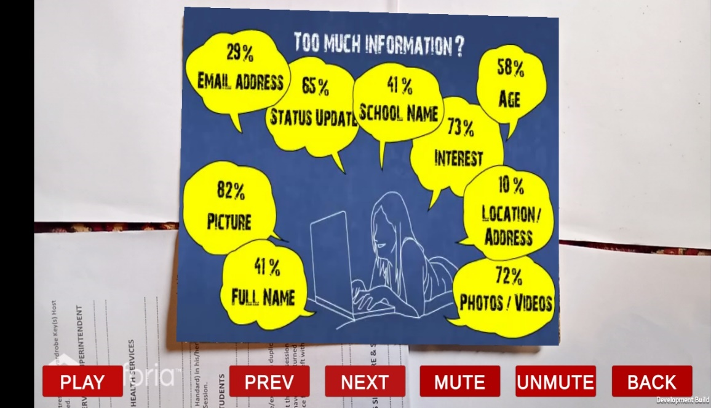

Figure 21 An image from one of the videos depicting the amount of information teenagers disseminate on social media without much regard for social media

**4.4.1.7 CAPTION TAKING FROM THE VIDEO SCENE**

Each video on the scene will educate teenagers on the privacy and security of using social media as shown in the image in figure 22

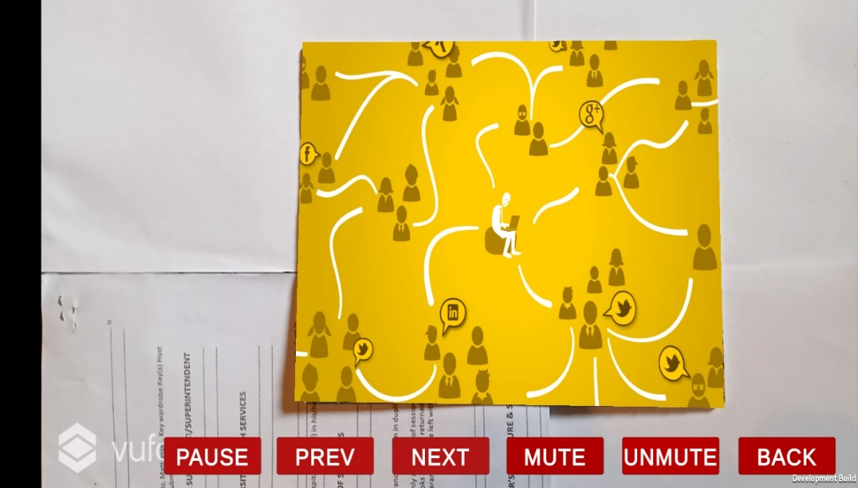

Figure 22 An image caption from a video in one of the scenes

**4.4.1.8 AR GAME SCENE**

Teenagers can play augmented reality first person shooter game were plane fly across the augmented reality environment as shown in the image in figure 23

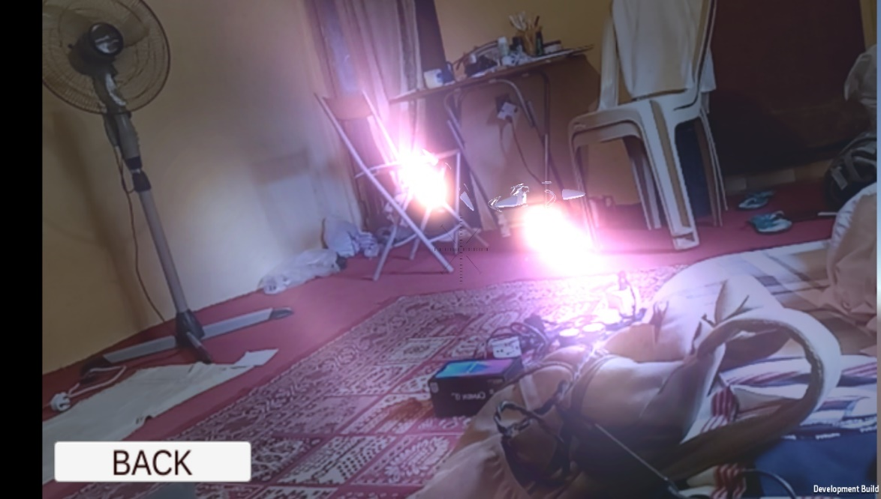

Figure 23: Illustration of an airplane flying across the room while the player shoot down the plane with a fixed-point target

**4.4.1.8 AR GAME SCENE**

Teenagers can play augmented reality first person shooter game were plane fly across the augmented reality environment as shown in the image in figure 24



Figure 24: Illustration of an airplane flying across the room while the player shoot down the plane with a fixed-point target

**4.4 TESTING**

Testing is an important skill that is often over looked by most programmers. It shows that a software program performed it assigned tasks and also to detect program defects while in use. The practice ignoring testing until the entire software program is up and running is strongly discouraged.

Testing and evaluation of the Mobile Augmented Reality Application was carried out incrementally as components that make up each individual application is developed. Testing of the system was carried out in two phases

**Phase one testing:** this involved testing of the Mobile Augmented Reality application. Tests carried out on the application includes:

* 1. **Unit testing:** Each unit of the program were tested to ensure that the program performs its function as defined in the program specification.
  2. **Integration testing:** modules were integrated into subsystems and were tested.
  3. **System testing:** For testing each system as a whole
  4. **Installation testing:** This is to verify that the android application would run on various versions of android operating system.
  5. **Usability testing:** carried out to check that the supposed requirements are met.

**Phase two testing:** This involve testing image target in which all the tutorials videos are overlay upon. Testing the image target option in the Vuforia configuration settings at the player setting to ensure the image target is present.

**4.5 INSTALLATION TESTING**

Installation testing is a software testing for android applications to help verify the configuration, the building and the deployment of the android apk file on different phone resolution screen as well as various android devices running different versions of android operating systems. Table 5.1 shows the results of the testing on various Unity3D software and issues that came up during testing.

Table 7: Installation test plan result

**4.6 FUNCTIONAL TESTING**

|  |  |  |  |
| --- | --- | --- | --- |
| **S/N** | **Different Versions of Unity3D and Vuforia Software** | **Result** | **Issues** |
| 1 | Unity 2018.2.10f1 (64-bit) and Vuforia | Installation was okay | Path to SDK and JDK problem was difficulty to resolve hence could not built software program |
| 2 | Unity 2018.2.10f1 (64-bit) and Vuforia | Installation was okay | The splash screen and the other aspects of the program worked well |
| 3. | Unity 2018.3.11f1 (64-bit) and Vuforia | Installation was okay | The splash screen and the other aspects of the program worked well |
| 4 | Unity 2019.1.1f1 (64-bit) and Vuforia Engine v8.1.10 | Installation was okay | Downward compatibility problem |

Table 7: Functional testing

**4.7 TEST PLAN FOR THE PROTOTYPE**

The prototype was tested by providing it with some related input so that the output can be evaluated to see how it conforms, relates or varies when compared to its base requirements. The next section shows the test plan and the test results of the functionality testing.

Two test plans were generated:

1. Test plan 1: For the Mobile Augmented Reality Application
2. Test plan 2: For the image target

The tables below show the test plans and their results

Table 5.2 shows the test plan for the various sections of the prototype showing the input, location of the input, expected result and actual results.

**4.7.1 TEST PLAN I: FOR MOBILE AUGMENTED REALITY APPLICATION**

|  |  |  |  |  |
| --- | --- | --- | --- | --- |
| **SECTION** | **INPUT** | **LOCATION** | **Expected Result** | **ACTUAL RESULT** |
| BUTTONS | Play button | Main Menu | Display series of augmented reality Videos for the user | Correct |
| Option button | Main Menu | Displays list of other options on the mobile application | Correct |
| OSM Button | Option Menu | Allow users to read a book danger lurking behind devices when using social media | Correct |
| Augmented Reality Game button | Option Menu | Allow users to play a first-person shooter game | Correct |
| Quiz button | Option Menu | Answering an auto generated questions on issues prevalent in social media | Correct |
| About |  | Provides information about the application | Correct |
| Logout |  | Logs user out of the application | Correct |

Table 8 Test plan Mobile augmented reality application test plan and result

**4.7.2 TEST PLAN II: MARKER BASED IMAGE TARGET**

Table 9 shows the test plan for various components of the application showing the input, expected results and actual results

|  |  |  |  |
| --- | --- | --- | --- |
| **SECTION** | **INPUT** | **EXPECTED RESULT** | **ACTUAL RESULT** |
| Database | Image Target | Verify the size, image composition and validity | Passed |

Table 9 Summary of beta test of the mobile Augmented Reality application.

**4.8 POPULATION SELECTED FOR TESTING**

The developed prototype was tested by different people through alpha testing. These people include my supervisor, 2 University of Jos Primary Students, myself 2 parents and 2 teenagers schooling here in University of Jos.

**4.9 USABILITY TESTING (Beta Testing)**

Usability testing is a way to see how easy a software can be used by testing it with real users. To determine the user experience, users were asked to complete tasks. The users were being observed to see where they encounter problems and experience confusion. Whilst traditional testing might be undertaken by a developer, designer or project manager, usability testing removes any bias by collecting feedback direct from the end user.

The intention of conducting this test is to observe if users were able to complete task adequately while documenting errors they encountered. The experiment recorded the problems encountered the similarity across the user pool towards identifying changes that can be employed to ensure a more positive user experience. Thus, overcome the usability issues encountered.

During the beta testing of the mobile Augmented Reality Application, 2 University of Jos teenage students were given the mobile application prototype to use and 2 teachers were given the prototype of the mobile application to use as well. Table 5.4 and Table 5.5 below shows the expected tasks to be accomplished by each user, the total number of participants for each task and the number of users that successfully completes each task for the mobile and web application respectively.

|  |  |  |  |
| --- | --- | --- | --- |
| **S/N** | **TASKs** | **NO. OF**  **PARTICIPANTS** | **NO. OF USERS TO**  **SUCCESSFULLY COMPLETE**  **TASK** |
| 1. | Read a book on usage of social media | 5 | 5 |
| 2. | Write a quiz | 5 | 5 |
| 3. | Play first person Shooter | 5 | 5 |
| 4. | Watch videos on the dangers that lurk behind the screen of our portable devices while using social media | 5 | 5 |

Table 10 User's Task description for mobile application

Table 10 below provides a summary of the findings in the beta test of the mobile Augmented Reality application. It shows the user id of the tester, the various complain from the users and the researcher’s observation during the test.

|  |  |  |
| --- | --- | --- |
| **USER**  **ID** | **USER COMPLAIN** | **OBSERVATION** |
| Tester  1 | The interface design was very good | The user had no problem with the quiz section of the application |
| Tester  2 | The plane flying in the augmented environment in the first shooter game hardly come to view and the target to shot at planes is fixed instead of moving in different direction | The number of enemy plane should increase and be in view . |
| Tester  3 | The book should be augmented into our real world rather than using conventional approach | Flipping the pages of the book is good but flipping and augmented the book is better |
| Tester  4 | The user interface design was dull | The users loves the augmented reality videos |
| Tester  5 | The augmented reality videos are too dull | All tasks were completed successfully. |

Table 11 Summary of beta test of the mobile Augmented Reality application.

# CHAPTER FIVE

## CONCLUSION AND RECOMMENDATION

## 5.0 INTRODUCTION

This chapter brings to an end this research work. The chapter will summarize all the previous chapters and re-state the problem statement together with the objective and solution to all subobjectives.

In chapter one, the problem statement is as follows: “To make teenagers understand why they must consider their intended audience before the post anything online such as friends, family members, class mate and a possible unintended audience that can have access to the personal information of teenagers due to the open access that is provided to users' personal information on the online social media sites”.

Subsequent chapters tried to address this problem by reviewing literatures, gathering requirements, designing and developing the prototype, and finally testing and evaluation of the proposed solution.

## 5.1 SUMMARY OF FINDINGS

This sub-section will summarize the findings from the whole research project highlighting only important points. To fully understand this summary, it is prerequisite that previous chapters of the whole research work has being read.

In the first chapter, Mobile Augmented Reality Application and its composition was discussed. The problem was stated. The aim of the research was identified and the primary and secondary objectives were outlined. From this perspective, chapter two started by going through literatures and review of the various types Mobile Augmented Reality application. Next a discussion on influence of Augmented Reality glasses on social media privacy and security concerns taking into cognizance the technologies involved. There after different kinds of augmented reality applications were reviewed, identifying features of these applications.

Chapter three started by describing the case study for this research, taking most of the findings from the previous chapters to identify the current tutorial application through the use of interviews. Findings from the interviews conducted showed that most respondents have little or no idea about privacy and security of social media and they have no prior knowledge of augmented reality tutorial application on the privacy and settings of social media applications. This encouraging fact indicates that there is high tendency of the masses accepting the proposed system when it is eventually brought to life.

Chapter four started by presenting the model and went further to implement the prototype. Consequently, chapter five evaluated the developed prototype to determine if the specifications outlined in chapter four. The next section will show the accomplishment of all the objectives as discussed in chapter one.

## 5.2 ACCOMPLISHMENT OF OBJECTIVES

This section will briefly discuss how the sub-objectives were accomplished and how it collectively meets the primary objective. This section will further mention how the primary objectives comprehensively addressed the problem statement in chapter one.

### 5.2.1 OBJECTIVES

As mentioned in chapter one, the primary objective is to design and implement an Emergency Response System to enable efficient management and response to emergency situations.

These secondary objectives became necessary:

1. Identify the features of Emergency Response Systems.
2. To gather all necessary requirements for the Emergency Response System
3. To design and implement a prototype as a proof of concept.

**5.2.1.1 FIRST SUB-OBJECTIVE**

The first sub-objective is to identify the features of emergency response systems. The method employed to meet this sub-objective was an extensive literature review of existing systems and it was discovered amongst other features; an emergency response system should be able to provide emergency responders with the approximate location of the emergency situation and also the nature of emergency. The second sub-objective will be discussed in the next sub-section

**5.2.1.2 SECOND SUB-OBJECTIVE**

The second sub-objective is to gather all necessary requirements for the Emergency Response System. This was realized by the means of interviews. This gave more insight on the way emergencies are handled and opinions regarding the functionality the web and mobile application should provide in other to enhance emergency response were acquired. These findings served as a footing for designing the model of the prototype to confront the problems of this body of work.

The third sub-objective will be discussed in the next sub-section.

**5.2.1.3 THIRD SUB-OBJECTIVE**

The third sub-objective is to design and implement a prototype as a proof of concept. This was achieved using models to present the system’s design. The web and mobile application components were shown, describing the function of each component and how the relate to form the system as a whole. The prototype was then developed to reflect the proposed solution providing an easy to use interface for both the web and mobile application making sure that they both met their required functionality.

Therefore, it is important to note that the three (3) sub-objectives collectively addresses the primary objective of this research work, which is “to design and implement an Emergency Response System to enable efficient management and response to emergency situations”. The primary objective, in turn, comprehensively addresses the problem statement which is: “There is no Emergency Response System here in University of Jos that allows reporting of emergency situations by a Student during a case of an emergency”. The next section of this chapter will mention any further suggestions for further research.

## 5.3 SUGGESTION FOR FURTHER RESEARCH

This research work is only limited to android operating systems. The researcher will recommend further studies on other mobile operating systems. The researcher will also recommend further enhancement of the prototype to be able to identify emergency response centres within a specified radius.

## 5.4 CONCLUSION

This project has identified the critical aspects needed to develop an emergency response system prototype. The features of this system were determined and finally a prototype that served as a proof of concept was designed and showcased. Therefore, the research can be said to have achieved it target objective. It is hoped that the use of this prototype will be extended beyond the university’s environment.

# REFERENCES

Amir Dirin, N. T. (2018). Unity 3DUnity was chosen as the main implementation tool for this project, since it supports both 2-dimensional and three-dimensional as well as augmented and virtual reality application development. Furthermore, the ability to build onto any platform fro.

A.T.M Shahjahan, K. U. (2014). Social Media Research and its Effect on Our Society. *International Journal of Information and Communication Engineering*, pp. 2009 - 2012.

Baillot, Y. S. (2003). A tracker alignment framework for. *In: IEEE International  
Symposium on Mixed and Augmented Reality*, 142–150.  
Dimitris Chatzopoulos, C. B. (2017). Mobile Augmented Reality Survey: From Where We Are to Where We Go. 1 -1.

Furht, B. (2011). *Handbook of Augmented Reality.* Florida: Springer.  
Houston H. Carr, C. A. (2019). Data Communication and Network Security.

Junwei Yu, L. F. (2016). Key technology and application.

Kaushik. (2018, March 3). *5-important-reasons-to-use-augmented-reality-ineducation*. Retrieved from techalpine: http://techalpine.com/5-importantreasons-to-use-augmented-reality-in-education/

Lazzarini, M. (2016, September 7). *augment*. Retrieved from Edshelf:  
https://edshelf.com/tool/augment/

Mkhitaryan, A. (2017, October 13). *why-is-c-among-the-most-popular-programming-languages-in-the-world-ccf268224ffcb*. From medium: http://medium.com/sololearn/why-is-c-among-the-most-popular-programming-languages-in-the-world-ccf268224ffcb

Mahmoudi Sidi Ahmed, H. S. (n.d.). Detection of Abnormal Motions in Video.

Mark D Griffiths, D. K. (2017, January). Adolescent Social Media Addiction  
(revisited). *Education and Health*, pp. 49 - 52.

Shabnoor Siddiqui, T. S. (2016). Social Media its Impact with Positive and Negative Aspects. *International Journal of Computer Applications Technology and Research*, pp. 71-75.\  
Shankhdhar, A. (n.d.). Social media and businss. *JIMS*.

Shelves. (n.d.). *word-lens*. Retrieved from edshelf: https://edshelf.com/tool/word-lens/

Stan Kurkovsky, R. K. (2012). Current Issues in Handheld Augmented  
Reality[online].

Waseem Akram, K. R. (2017, October 30). A study on Positive and Negative Effects of Social Media on Society. *International Journal of Computer Sciences and Engineering*, pp. 2347-2693.

Zunaira Ilyas Bhutta, S. U.-e.-H. (2015). The Next Problem to Solve in Augmented  
Reality.