# CHAPTER ONE

# INTRODUCTION

This chapter presents the background of the study, problem statement and scope of the study. Likewise contained in this chapter is the aim of the research, the research objectives and the research methodology that will be pursued to accomplish the said goal.

## 1.1 Background of the Study

Games are seen as tools, used for pleasure, academic research and can also be seen as a social tool which can be used to teach children and adults verbal or non-verbal skills.

Games as tools of pleasure are used to help relax the mind after a long day of hard work during our leisure time as stated by Guerra (2011). They have a way of making us to have a winning mentality as we carry out our day to day activities. It gives us a sense that we can easily overcome hurdles that come our way daily as we carry out with our day to day activities.

More so, games can be seen as tools for teaching in the classroom to aid the understanding of terms and concept in a particular subject under study.

Furthermore, games are use tools for research by psychologist to test behavioral patterns found among people, which suggests their reactions to things happening around them.

In today’s world everyone is using smart phones. As smart phones are reducing the work of memory, for youngsters and kids it is necessary to get some work for memory to sharpen it. The first jigsaw puzzle was created in Britain during the mid-1700s by John Spilsbury who used a map puzzle to teach world geography. During the 1900s, magazines and newspapers began entertaining the people with word puzzle. Over the last century, the use of puzzles has expanded and taken many different forms.

## 1.2 Problem Statement

Teaching methods today are not the same as they were even just a few years ago. The traditional or conventional method of teaching/learning has not been an effective way of teaching children. This is because the approach leads to one way transfer of information. There is limited participation of children in the learning process and children tend to lose attention easily. Children also tend to be bored in the classroom and they just do not like reading, writing and furthermore studying.

Children only learn about the physical human body parts via books. Meanwhile, in using such materials, children easily lack interest and may not fully understand. In addition, educational games serve as alternative to books but most educational games are too complicated, especially for children within four to six years old.

Educational games mostly do not have scoring mechanism to attract children to play the game again and again. Children need some encouragement and motivation while they play the game, scoring is a good suggestion to do so. In addition, scoring is used to measure the working memory, critical thinking, and problem solving ability of the child.

## 1.3 Aim and Objectives of the Study

The aim of this research is to discuss the difficulties children encounter learning through the conventional or traditional method of teaching and to implement an educational game that will teach and help children in identifying the various physical parts of the human body. The objectives of this research are to:

1. Make learning easy
2. Increase the child’s cognitive skills as they solve the problems of a puzzle.
3. Help the child manage and control his/her emotional skills as they learn patience.
4. Improve the social skills of the children as they work together and communicate about what fits where.
5. To develop scoring mechanism as a motivation factor for user to play again.

## 1.4 Significance of the Study

This project writing is targeted at producing a game that will be educative and  
helpful in the mental development of children. By building the child’s mental, cognitive, social and physical skills.

## 1.5 Methodology

This project will bring about the design of an Easy Learning for Kids game. In order to  
attain the specified aims and objectives, information will be gathered from online  
publications, thesis and articles.

In every case, the puzzle-solver’s goal is to solve a particular mentally challenging problem or accomplish a particular mentally challenging task. Most puzzle solving requires use of logical thinking and one’s problem-solving skills. Solving puzzles often requires strategic and creative thinking.

Although there are innumerable kinds of puzzles, they all are not on smart phones. Kids like cute simple games so this is the game made for them especially. They can enjoy playing this body puzzle. The C# (C sharp) programming language will be used to build the game, using Microsoft Visual Studio.

## 1.6 Scope of the Study

This research work focuses on designing and implementing an educational mobile device based game for children. It is a single player game. The game will provide a menu were the physical parts of the human body will be taught. There is also a section to play a puzzle game, a quiz and spelling challenge section to test their knowledge. This puzzle game focuses only on the physical or external parts of the human body and not the internal parts of the human body.

## 1.7 Limitation of the Study

1. The game application can only run on smartphone devices that run on Android Operating System and on desktop devices. Mobile devices such as iphone and windows phone cannot run the application.
2. The game will not teach the internal body organs.

## 1.8 Project Outline

Chapter one contains a brief introduction to the research work, the background of the study, problem statement, scope/limitation and aim of the research. Also contain in this chapter is the research objectives and the research methodology that will be followed to achieve the objectives. Furthermore, Chapter two focuses on the review work of computer educational game, why it is important to use game for learning. It will also discuss puzzle game, its properties and characteristics, search algorithms that are used to develop the game and how the android operating system works. In Chapter three, the methodology and solution design is discussed, the approach that is used to develop the game and the different fragments of the android operating system. Chapter four focuses on the implementation and evaluation/testing. How the application is being implemented and it’s evaluated to check for possible errors are discussed in this chapter. Finally, in chapter five, conclusions and recommendations are made and possible suggestions for future works are made.

# CHAPTER TWO

# LITERATURE REVIEW

## 2.0 Introduction

This Chapter discusses the history of educational game, a literature review of some educational games and the development trends in educational games.

## 2.1 History of educational games

Educational computer games and various forms of edutainment have gained much  
attention in the discipline of learning and teaching. Morgan. Children learn best through play. Most studies also show that learnt through play has proven to be a successful learning experience. Therefore, it is desirable to use educational computer games for teaching, which carry the objectives of play and learn in the classrooms. There are reasons for using computer games as a learning tool to enhance the learning experience of students. These reasons include the incorporation of rules, goals, engagement, challenge, feedback, fun, interactive, outcome and immediate reward. Even though most genres of the computer games in some ways are educational, educational computer games are designed with explicit educational purpose.

The first Educational game was made in 1967 called LOGO Programming which is about moving a turtle icon across the screen using small and basic programming commands in order to create geometric shapes, from spirals to stars to triangles, etc. This game created a stepping stone for later educational games. Other educational games created were; Lemonade Stand (1979) which taught economics and business, Snooper Troops (1982) which taught organization and how to take notes.

### 2.1.1 Review of literature

According to William B. Yeats, “education is not the filling of a pail, but the lighting of a fire.” A 2008 report by The New Media Institute on the use of games in education states that nearly 170 million people played computer and video games in that year. With increases in technology and accessibility of technology this number can only have been increasing yearly. This makes the implication of using games in education even more significant. (Susan Ambrose, 2010) Director of Carnegie Mellon’s Eberly Centre for Teaching Excellence, believes that good game-based learning is “motivational because games can help learners to understand the connection between the learning experience and the real world”.

Within a clearly defined Game-based Learning environment, students work towards, a goal, choosing actions and experiencing the consequences of those actions along the way. Game-based Learning allows for students to make mistakes in a risk-free setting and through experimentation. Games keep students engaged in practicing behaviors and thought processes which can be transferred from the simulation experience into real life.

Furthermore, research has suggested that computer games can help to stimulate a successful learning environment and provide motivational learning environment that suits various learners. Since 2006 Education Scotland’s Game-based learning initiative has worked with teachers in exploring the benefits of Game-based Teaching and Learning in schools throughout Scotland. They have recorded increased creativity beginning in early childhood and have also noted an increase in individual learning. It is not surprising then, that in his 2015 article Education Scotland, Foghlam Alba states the reality that many classrooms now have a wide range of game based technologies which are used to help make teaching and learning, challenging and appealing.

## 2.2 Development trends in educational game

Edutainment, or educational entertainment has been around since the 1970’s with the introduction of video games. Because our concept and expectations about how people learn are constantly changing and evolving, it is a field that is also very fluid and dynamic and that has adapted well to both technological and educational advancements. (Egenfeldt-Nielsen, 2008)

Edutainment is a term that includes several platforms of educational games; which include computer games, video games, and now apps. Educational learning is a response to a lot of the challenges presented when learning a new subject or skill set; how do we make a “tedious”, or “dry” subject engaging and motivational? (Prensky, 2003) Video games have the power to keep its users thoroughly engaged for long periods of time, the problem for designers is to translate this into the educational field.

Egenfeldt-Nielsen’s paper on edutainment deals with a lot of the research that has been conducted on the efficacy of playful learning; one of the first studies (conducted in 1981) regarding Math based computer games concludes that the games prove to be “motivating, engaging, and successful in teaching children the planned math concepts.” Another study done in 1987 that dealt with science learning concluded that while there was no real difference in the learning outcome, the students playing the games indicated to having learnt more through these games. (Egenfeldt-Nielsen, 2008). In another study held in 1995, Joseph Betz concluded that the use of video games in an engineering technology class proved to be generally more positive when compared to a class not using video games. Betz argued that not only were students more engaged in the course, but they also claimed to understand the topic and readings better because of the gaming experience. Egenfeldt-Nielsen (2008)

So even when video games are not necessarily making a difference on what and how we are learning, there is an almost placebo effect that comes when we are engaged in it.

Much more recently, with the refinement of the gaming industry, a lot of strategy based and simulation type of games have expanded the possible subjects and topics being covered by edutainment. Teaching people to code and program through games have proven to be a lot of more successful through these much more immersive type of games. (Egenfeldt-Nielsen, 2008)

The future of educational gaming is focused on the future technologies and what they can offer in terms of experiences. Current games already deal with ethical, identity and responsibility issues, so how much further can the games of the future expand our knowledge and help us become better and smarter humans?

## 2.3 Review of Educational Games

### 2.3.1 Panel

Some researchers (Resee, 2007) believe that serious games not only help in the learning process but also increase users’ knowledge of the virtual world or virtual space in which the game take place. In this game, the players have to answer questions on five topics distributed in five levels of difficulty. This game uses a question and answer format. When a player on one team does not know the answer the next team can answer the question. The rows show the five topic sand the columns the five level of difficulty. The objectives is to obtain the highest score. It is a game with a television format that involves different environment-related topics and is aimed at different age groups from primary school to secondary school levels.

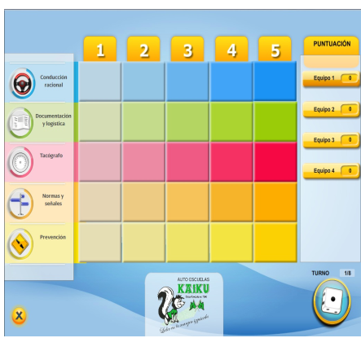

Source: www.gestionet.net

Figure 2.1 Screen from the panel game showing the rows and columns

### 2.3.2 Tik Tak Hitzak and Tik Tak zenbakiak

Tik Tak Hitzak and Tik Tak zenbakiak are two games for children aged 6 and over. The first is used to teach basic vocabulary in Basque, Spanish and English. The second is used to improve children’s numeracy skills in basic operations such as additions, subtractions, multiplications and divisions. It features a character called Punttu, who takes the form of a punctuation mark and takes care of the language. The objective is for players to help him to guess the word or the number which should appear below each picture and thus get the maximum score. In the course of these games pictures appear on screen and the main character must fill the gaps with the help of the learner.

There are three levels of difficulty with a number of different screens featuring enemies and objects to help learners. In the easy and difficult levels the words have missing letters and Punttu must fill the gaps. Once one word is completed the next one appears, and so on.

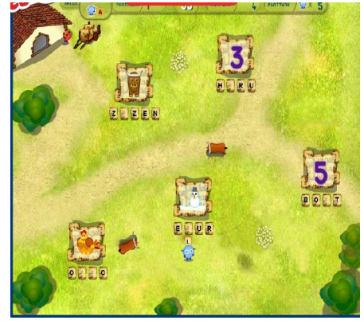

Source: txapelgames.com

Figure 2.2 Game screen of Tik Tak Hitzak game.

In this screenshot the main character “Punttu” (the blue dot in the middle of the screen) has to deal with bulls which appear suddenly and try to prevent him from completing the word (Fig.2.2).

These games have been used in some primary schools in the Basque Country and all the teachers involved say that the experience was very positive: students learnt new words easily and entertainingly. Moreover, the level of attention shown by all pupils was higher when the teachers worked with these games in class.

In this game “Punttu” has to deal with birds that try to distract him. 82.35% of parents who have gamed with their children say that both games are very useful in helping young children to learn basic vocabulary and basic mathematical operations (Figure 2.3). They therefore consider them to be valuable tools for improving children’s learning.

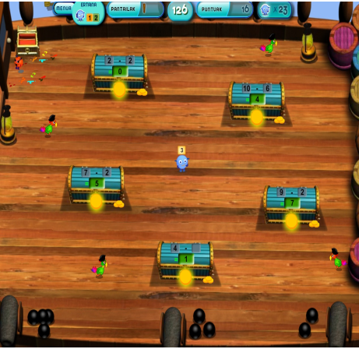

Source: txapelgames.com

Figure 2.3 screen display of Tik Tak zenbakiak game.

### 2.3.3 Games based on Trivial Pursuit and on the Game of Goose

These are board games. Users have to answer to questions which are classified in five categories related to different topics.

This type of game is used in education to elicit questions and answers. The questions are grouped according to courses and subjects related to the curriculum of a specific education stage. Such games (America´s Army, Triage Trainer) have begun to be used also in adult training with contents such as sustainability, environmental matters and management. In some countries the game of Goose is better known as Snakes and Ladders (Great Britain or USA).

An example is the game "A Day On the Trail", which is undoubtedly dynamic and entertaining. In this game children learn about green trails in a pleasant, entertaining, original way. It consists of a virtual board that simulates a green trail with all its typical elements: tunnels, bridges, stations, plants, and animals. This game was designed for Fundación de los Ferrocarriles Españoles [Spanish Railway Foundation] to make people aware of the former railway lines that had been turned into walking trails (Figure 4).

The players advance along the green trail whilst answering questions from different categories: the geography of the trail, its environment, its cultural heritage, environmental matters such as sustainability, health, road safety, etc. It is an educational game aimed at children aged 8-12, and players can choose between two levels: one for ages 6 to 8 and the other for ages 9 to 12.

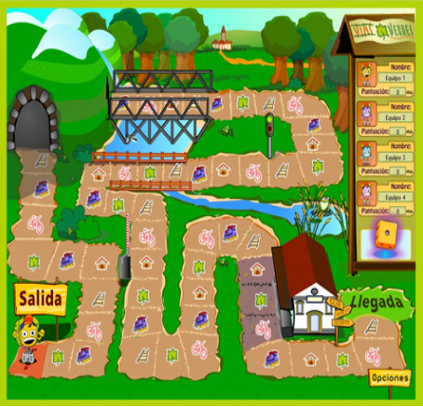

Source: www. Viasverdes.com

Figure 2.4 A Day on The Trial game showing play area.

The results for this game were very interesting because not only the children but also their parents learnt a lot due to the huge range of themes and topics included.

It has been used at primary and secondary schools in Spain in working on matters of human and environmental assets.

Teachers value its simplicity and the way in which it motivates children. They value its combination of entertainment and education, which enables them to involve children in their own learning.

## 2.4 Conclusion

The various cases of successful serious games examined enable us to conclude that the serious games have great potential for training because they have a highly positive effect on the learning process of users. This is due to the fact that they attract users in a simple, dynamic way and turn them into the protagonists of their own learning processes.

The aim of serious games such as educational games goes beyond pure amusement: they seek to be a mechanism that reinforces learning in a dynamic, interactive, motivating and entertaining way.

Serious games are flexible enough to be accessible from any device including PCs, Macs, mobile phones, Ipads and tablets.

# CHAPTER THREE

# SYSTEM DESIGN AND METHODOLOGY

## 3.0 Introduction

This chapter describes the techniques and steps used in carrying out this study. The game is made with the purpose to teach children the physical human parts of the body. This chapter also discusses the existing system of teaching and the proposed system which explains the strength. It also states the requirement and system design of the study.

## 3.1 System Analysis

### 3.1.1 Analysis of Existing System

Different methods of teaching have existed over the years. The formal and informal methods of teaching and learning are examples of the method of teaching and learning we have. The informal method of teaching is the first form of education every individual received from childhood.

The informal teaching method is delivered orally using a hands on approach. It teaches morals, cultures and household chores. The formal method of teaching and learning uses the conventional method of teaching (teacher to student), the use of books to learn, online platforms (youtube and online academics).The teacher to student method (conventional method) of teaching is an effective way of learning but provide a one way transfer of information. The teacher is the center of attraction. Students are not fully involved in the learning process and easily loss attention.

How does a kid learn to ride a bicycle? Definitely not by watching the teacher rides a bicycle, but by learning to ride himself (the act of doing).

### 3.1.2 Proposed System

The Easy Learning for Kids (ELK) is an educational game that teaches children the physical parts of the human body. The game provides a friendly user interface for kids. It allows them learn at their own pace, increase their cognitive skills as they solve the problem of puzzle. The game is educative and entertaining. Microsoft Visual Studio was used as the platform for developing the game.

## 3.2 Game Design

### The game design focuses on illustrations of how the implementation of the game can be achieved, using diagrams.

### 3.2.1 Core Classes of the Implementation

To give an understanding of the implementation of the game I focused on the model of the game. The classes used to model the game are the basic classes presented in Figure 5 below

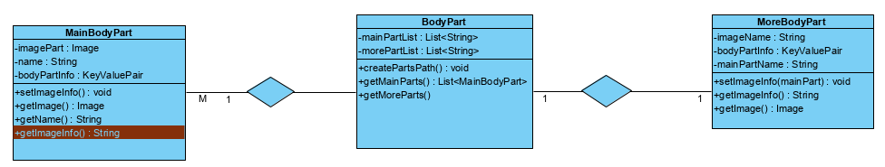

**Figure 3.1. Class diagram of Elk game**.

### 3.2.2 Model showing User’s activities

The user can play and make changes to the game board, in the use case diagram, the user can start the game, learn human body parts, solve puzzle and quit the game. For the use case diagram I identified main use cases and these use cases may include some sub use cases.

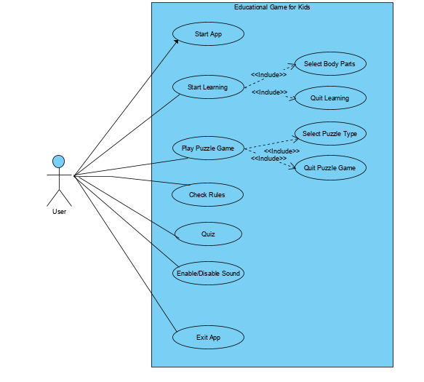

**Figure 3.2. Use case diagram of ELK game.**

## 3.4 Requirement specification

### 3.4.1 Functional requirements.

1. A user can be able to take a lesson on physical human body parts.
2. The system shall display images of physical body parts.
3. The system shall teach users how to spell different body parts.
4. The system shall display information about a selected body part.
5. The system shall provide voice command to teach.
6. A user can be able to play games.
7. A user can be able to take a quiz challenge.

### 3.4.2 Non-functional requirements

1. The system shall provide a friendly user interface.
2. The system shall have fast rate of operation and response time.
3. The system shall available to users at all time.

## 3.5 System Requirement

To run computer Easy Learning for Kids game, both hardware and software are required.

### 3.5.1 Hardware Requirement

The following are the minimum hardware requirement:

1. RAM: 2GB
2. Storage: 250GB hard disk
3. Android device
4. A desktop device

### 3.5.2 Software requirement

The following are the software requirements.

1. Windows operating system
2. Visual Studio IDE
3. Photoshop

## 3.6 Development Environment

With implementation requires a special platform. Microsoft Visual Studio is used for the implementation of the game with C# programming language as the choice of programming language.

### 3.6.1 Microsoft Visual Studio

Microsoft Visual Studio is an integrated development environment (IDE) from Microsoft. It is used to develop computer programs, as well as websites, web apps, web services and mobile apps. Visual Studio uses Microsoft software development platforms such as Windows API, Windows Forms, Windows Presentation Foundation, Windows Store and Microsoft Silverlight. It can produce both native code and managed code.

Visual Studio supports 36 different programming languages and allows the code editor and debugger to support (to varying degrees) nearly any programming language, provided a language-specific service exists. Built-in languages include C, C++, C++/CLI, Visual Basic .NET, C#, F#, JavaScript, TypeScript, XML, XSLT, HTML, and CSS. Support for other languages such as Python, Ruby, Node.js, and M among others is available via plug-ins. Java (and J#) were supported in the past.

### 3.6.2 C# Programming Language

It is designed as a general-purpose machine language for the building applications on the Microsoft platform and the language is dependent on .NET Framework in order to work. C# programming language can be used to create anything but is particularly good in designing and creating games.

#### 3.6.2.1. Reasons for choosing the language

Most of the complex tasks in C# are abstracted away, so they programmer doesn’t have to worry about them.

1. It’s also a statically typed language, so the code is checked before it is turned into an application
2. It is more consistent than C++ programming language.

### 3.6.3 Photoshop

Photoshop is the most popular photo editing software for both graphics’ designers and web developers. It is user friendly and have more than enough that can help unleash your creative potentials. Below are some of the reasons for choosing Photoshop:

1. It transforms images artistically.
2. Opportunity to express creative potential

# CHAPTER FOUR

# IMPLEMENTATION AND EVALUATION

## 4.0 Introduction

System implementation is the process of defining the user requirements and designing a system to meet such requirements. This is the stage of systems development in which hardware and software are acquired, developed and installed. System design is the architectural process in software projects, drawing from the global organization of the system, and informing the detail for development. In this phase the system and software design is prepared from the requirement specifications which were discussed in the previous chapter. The system design specifications serve as input for the next phase of the model, which is the implementation phase.

## 4.1 Testing and Evaluation

Thesoftware testing process is an investigation usually conducted by individuals or independent groups to provide users with information about the quality of a product or service under test. Software testing can also provide an objective, independent view of the software to allow any business to appreciate and understand the risk of software implementation. Test techniques include, but are not limited to, the process of executing a program or application with the intent of finding software bugs (errors or other defects).

### 4.1.1 Testing Objectives

Testing involves the execution of a software component or system component to evaluate one or more properties of interest. In general, these properties indicate the extent to which the component or system under test:

1. Meets the requirements that guided its design and development.
2. Responds correctly to all kinds of inputs.
3. Performs its functions within an acceptable time.
4. Is sufficiently usable.
5. Can be installed and run in its intended environments, and
6. Achieves the general result its user’s desire.

As the number of possible tests for even simple software components is practically infinite, all software testing uses some strategy to select tests that are feasible for the available time and resources.

### 4.1.2 System Testing

System testing is a test of a completely integrated system to verify that it meets its requirements. This type of test is used to find inconsistencies between specifications and implementations. It also involves reliability, performance, load and security testing.

After the integration of modules, the whole system was tested. The Easy Learning for Kids (ELK) game was played on the system and its performance was as expected. The system testing lasted for some days and the system performance was ok.

In this stage, the system is checked experimentally so that all the user requirements are fulfilled. The testing of the system takes places in different levels to ensure that the system is free from failure.

### 4.1.3 Test Plan

The testing is to reveal the inherent weakness in the proposed system. Real data are entered to test the efficiency and effectiveness of the system before the new system is finally implemented. Several activities must be carried out for it to work successfully. These Include:

#### 4.1.3.1 Module Testing

This is the process of testing the system module by module to ascertain the functionality of each of the modules. In this testing, the following modules were tested.

1. Learn Module
2. Game Module
3. Score Module
4. User Guide Module

#### 4.1.3.2 Integration Testing

The modules were integrated together and tested. Access to the modules was made available through the menu designed. The testing worked perfectly and the system designed is a workable one.

## 4.2 Modules in the game

The game is divided into different modules which are as follows:

**4.2.1 The main menu**

This is the first display a user sees when the software executes. The user selects from the list of options.

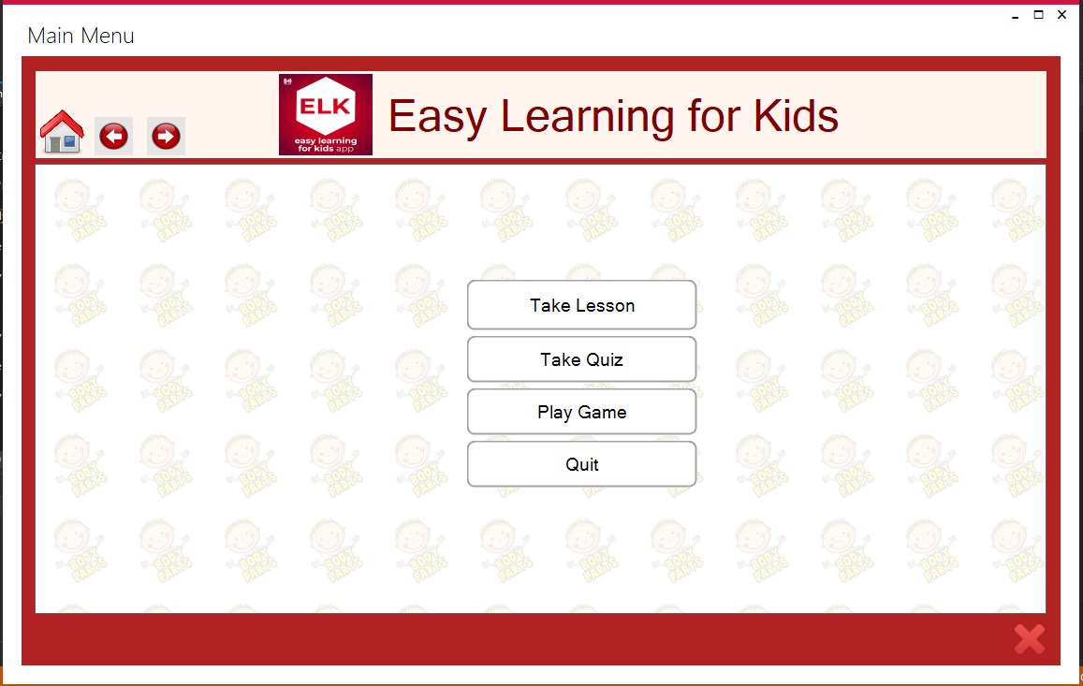

**figure 4.1. The main menu showing the**

### 4.2.2 Take Lesson

When the player clicks on the “Take Lesson” button, the lesson area is displayed.

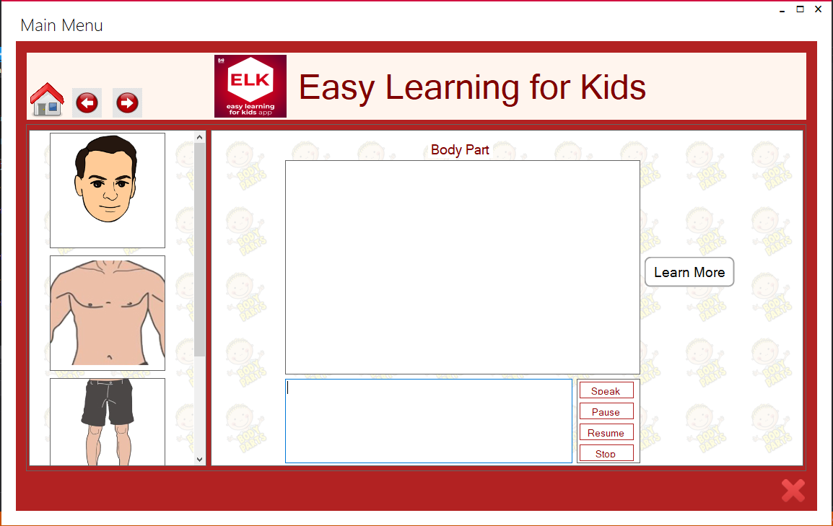

**Figure 4.2. Lesson Area.**

Here, the player can decide on which part of the body to start with. When the player clicks on any of the parts displayed, the selected part is been highlighted and information about the part is display and also read to the hearing of the user.

#### 4.2.2.1 “Head Clicked”

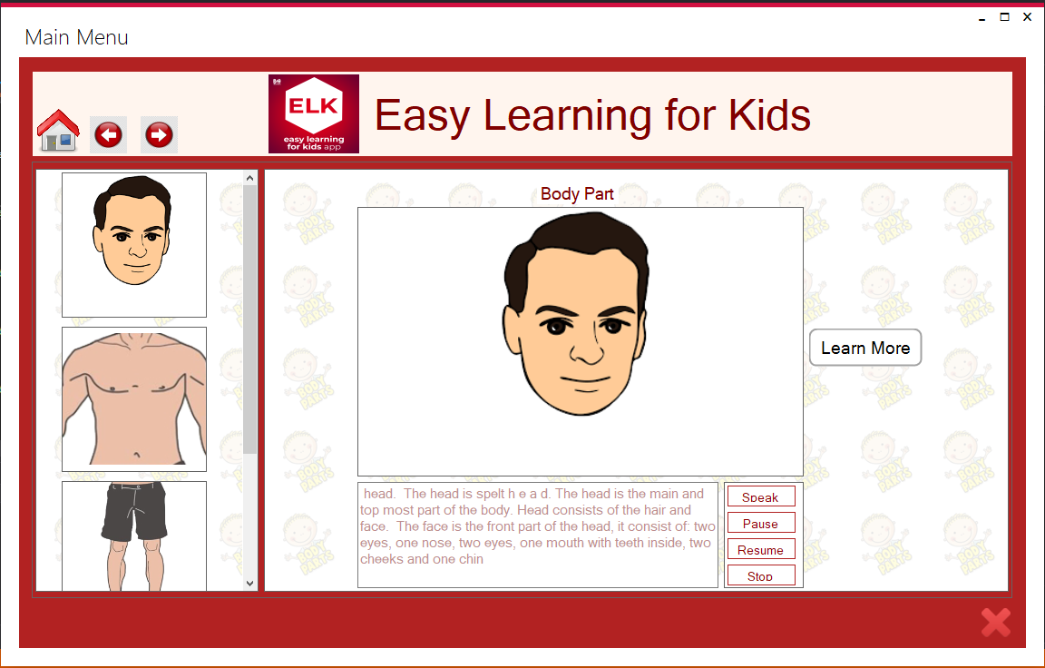

**Figure 4.3. Result shown when head is clicked**

This is what is displayed to the user when the user clicked on the head. Here, the user gets to learn about the head. A user can decide to learn more about the head by clicking on the “Learn More” button.

#### 4.2.2.2 Learn More

The “learn more” area allows a user to learn more about other parts of the body.

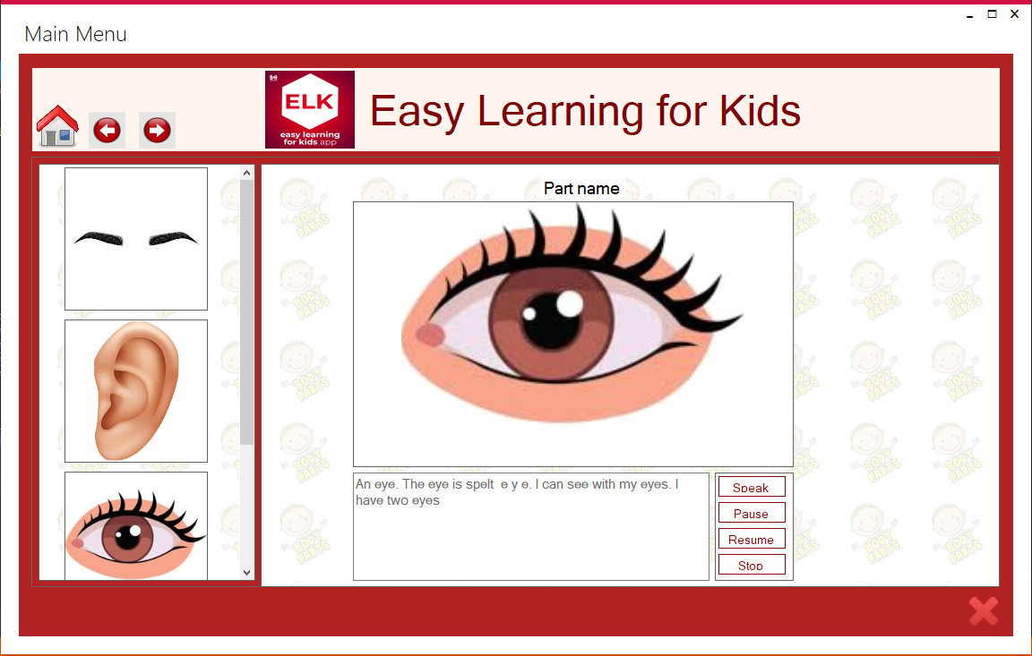

**Figure 4.4. The Learn More area.**

### 4.2.3 Take Quiz

A user can also decide to take a quiz challenge by clicking on the take quiz option on the main menu.

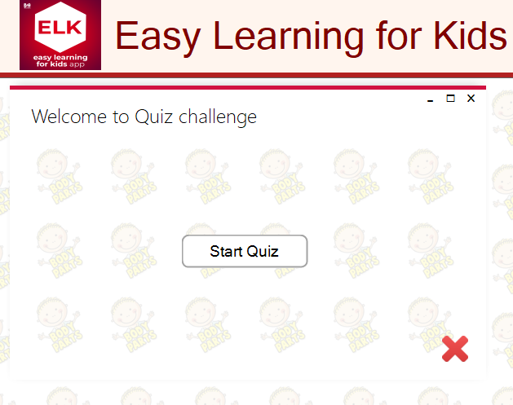

**Figure 4.5. Welcome to quiz challenge.**

Here the user can click the start quiz option to begin a quiz challenge.

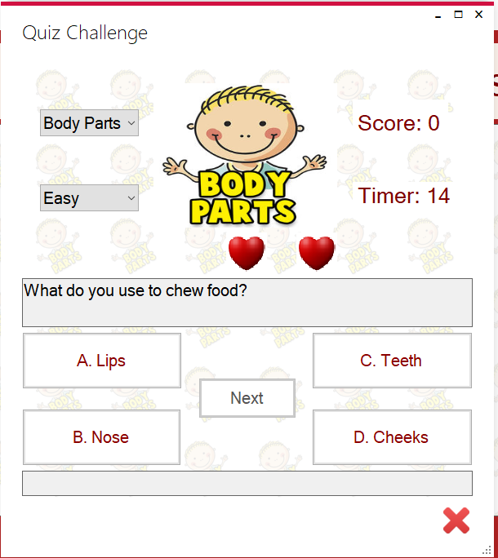

**Figure 4.6. Quiz challenge.**

From the screenshot below, the player can select the type of quiz to play. The player has a countdown of 25 seconds to answer each question and for each correct answer, the player gets a reward of 10 marks.

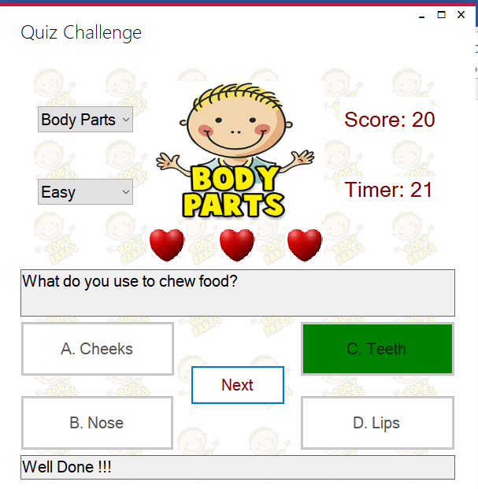

**Figure 4.7. Screen display of right answer**

If a player chooses the wrong answer, the system prompt a message “wrong answer” and display the correct answer to the player.

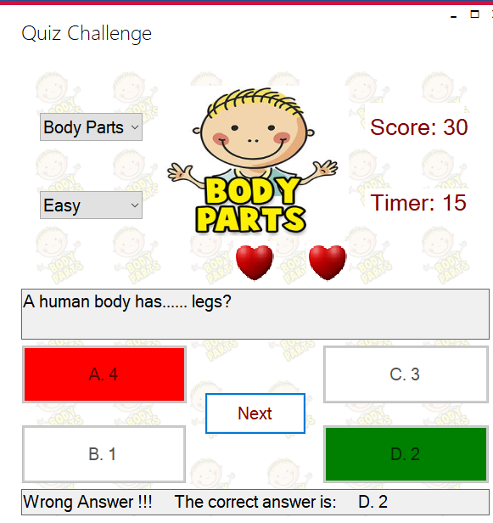

**Figure 4.8 Screen display of wrong answer.**

### 4.2.4 Play Game

The play game is an option the user can also select from the main menu screen. When the user clicks on “play Game” the screen below appears for the user.

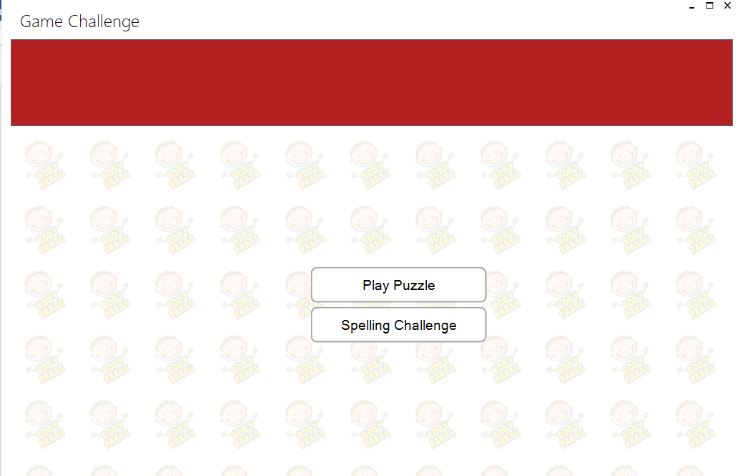

**Figure 4.9. Game challenge.**

The player has two options to select from. To play puzzle or take a spelling challenge.

If the player select the “play puzzle”, the puzzle screen appears and the player can select from the list of images to play.

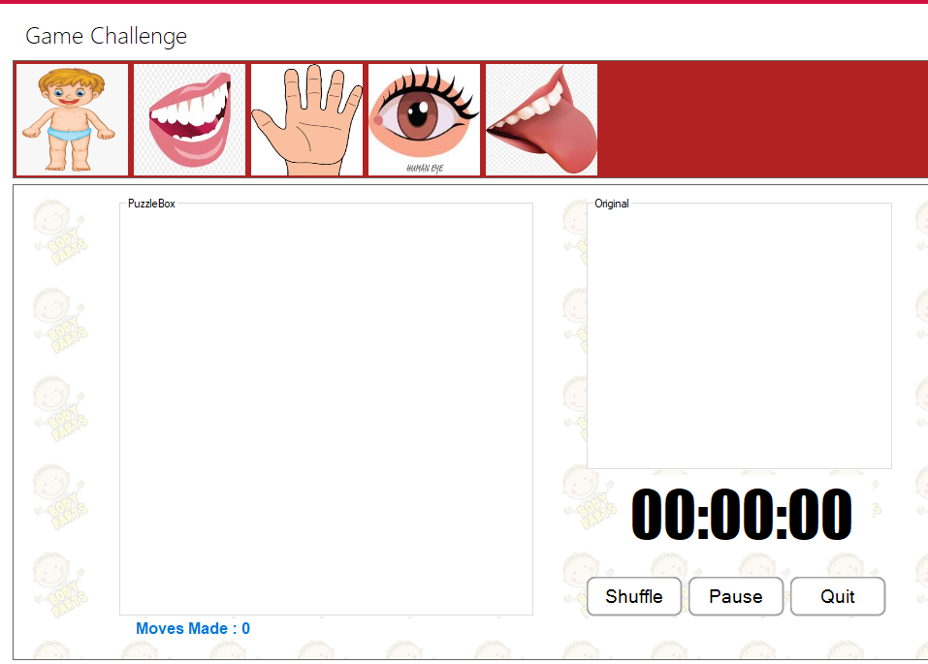

**Figure 4.10.Choose puzzle.**

When the player selects any image at the top of the screen, the player is presented with the puzzle to play.

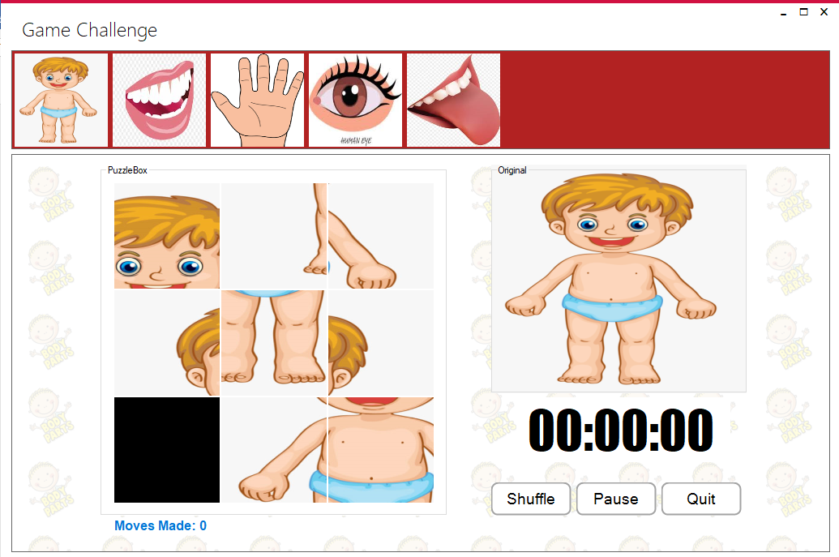

**Figure 4.11. Play puzzle.**

When the player starts playing, the time begins to read. Player has 15 minutes the complete the puzzle and also the number of moves made by the player is recorded. Player can also pause the game, shuffle to restart again or quit game.

## 4.3 Conclusion

After evaluating the game as a whole, I can say that I was able to achieve an educational game for kids that plays quite well and response without much delay and interesting too. Though, it is not a perfect app, there is a room for improvement to the game.

# CHAPTER FIVE

# CONCLUSION AND RECOMMENDATION

## 5.0 Conclusion

The development of computer games involves many phases. The approach used to achieve this project is the top-down approach (concentrating on what first, then how and moving to successive levels of details).

The first phase started with a detailed study of the problems. In the course of this project, many problems were discovered to have hindered the effectiveness of learning through the conventional method (teacher to student). These problems, information needs, and activities were documented and later used as the basis for system design, which immediately followed the first phase. The design phase was concerned primarily with the specification of the system elements in a manner that best met the game.

It is hoped that effective implementation of the Easy Learning for Kids (EKL) game would eliminate many problems discovered during the conventional way of teaching and learning analysis.

## 5.1 Recommendation

The following recommendations are made:

1. Playing of the game (ELK) should be encouraged as it helps to build logical reasoning.
2. Computer games should be encourage in schools and used in the classroom to better enhance learning.
3. The use of computer in playing games helps to reduce stress and should be encouraged.

# References

Ambrose, A. (2010). *How learning works: seven-research-based principles for smart teaching* SanFrancisco, CA : Jossey-Bass.

Anonymous. (2015). “what is game based learning?” in Ed Tech Review. Access online at Techreview.in/dictionary/288-what-is-game-based-learning.

Anonymous. (2019). The theory of game design. Retrieved from:

https://www.game-learn.com/the-theory-of-game-based-learning/

Diamond, A. (2013). “Game-based learning: Definition and examples.” Access online at: study.com/academy/lesson/game-based

Egenfeldt-Nielse, Simon. Making sweet music: The educational use of computer games. Center for Computer Games Research, 2008. University of Copenhagen.

Gee, James Paul. Learning by Design: good video games as learning machines. E-learning, V2, 2005. University of Wisconsin, USA

Guerra, J. (2011). *Classical Checkers*. Portugal: Technical University of Lisbon

Parimala, N. and Pushpavathi K. (2016). Android Application for Mind/Brain Puzzle Game*.* Retrieved from: [www.jchps.com](http://www.jchps.com).

Prensky, M. (2003). Digital game-based learning. Computers in Entertainment, 1, 21. doi:10.1145/950566.950596

Resee, W. (2007) History, Education and the school: Palgrave Macmillan US.

Sjostrand, J. (2019,April 15). KTH. Retrieved from Combinatorial Game Theory: https://www.math.kth.se/matstat/gru

Ulicsak, M; Wright, M. (2010). Games in education: Serious Games. Bristol, Futurelab

87pp.www.futurelab.org.uk/projects/games-in-education

William, B. Y. (2013, October 15) Education is the not the filling of a pail. *The Irish Times*. pp, B1, B3

# APPENDIX: program code

The main menu

using System;

using System.Collections.Generic;

using System.ComponentModel;

using System.Data;

using System.Drawing;

using System.Linq;

using System.Speech.Synthesis;

using System.Speech;

using System.Text;

using System.Threading.Tasks;

using System.Windows.Forms;

namespace KidsPuzzleGame

{

public partial class MainMenu : MetroFramework.Forms.MetroForm//Replace System.Windows.Forms.Form

{

public MainMenu()

{

InitializeComponent();

}

SpeechSynthesizer speechSynthesizerObj;

private PictureBox pbBodyPart;

private List<MainBodyPart> pbParts;

private MainBodyPart mainPart_active;

private string mainPartName;

private List<MoreBodyPart> pbMoreParts;

private MoreBodyPart morePart_active;

private string morePartName;

private Panel pnlPrevious;

private Panel pnlCurrent;

private Panel pnlNext;

private BodyPart bodyPart;

private void Form1_Load(object sender, EventArgs e)

{

/*.createPartsPath();

this.StyleManager = metroStyleManager1;

metroStyleManager1.Theme = MetroFramework.MetroThemeStyle.Light;

metroStyleManager1.Style = MetroFramework.MetroColorStyle.Green;*/

}

private void startVoice(String sentence)

{

if (speechSynthesizerObj == null)

{

if (sentence != "")

{

speechSynthesizerObj = new SpeechSynthesizer();

//Asynchronously speaks the contents present in RichTextBox1

speechSynthesizerObj.SpeakAsync(sentence);

btn_Pause.Enabled = true;

btn_Stop.Enabled = true;

}

}

}

private void Btn_Pause_Click(object sender, EventArgs e)

{

pauseVoice();

}

private void pauseVoice()

{

if (speechSynthesizerObj != null)

{

//Gets the current speaking state of the SpeechSynthesizer object.

if (speechSynthesizerObj.State == SynthesizerState.Speaking)

{

//Pauses the SpeechSynthesizer object.

speechSynthesizerObj.Pause();

btn_Resume.Enabled = true;

btn_Speak.Enabled = false;

}

}

}

private void Btn_Resume_Click(object sender, EventArgs e)

{

resumeVoice();

}

private void resumeVoice()

{

if (speechSynthesizerObj != null)

{

if (speechSynthesizerObj.State == SynthesizerState.Paused)

{

//Resumes the SpeechSynthesizer object after it has been paused.

speechSynthesizerObj.Resume();

btn_Resume.Enabled = false;

btn_Speak.Enabled = true;

}

}

}

private void Btn_Stop_Click(object sender, EventArgs e)

{

stopVoice();

}

private void stopVoice()

{

if (speechSynthesizerObj != null)

{

//Disposes the SpeechSynthesizer object

speechSynthesizerObj.Dispose();

speechSynthesizerObj = null;

btn_Speak.Enabled = true;

btn_Resume.Enabled = false;

btn_Pause.Enabled = false;

btn_Stop.Enabled = false;

}

}

private void PnlMainBodyParts_Paint(object sender, PaintEventArgs e)

{

}

private void displayMainParts()

{

if (bodyPart == null)

{

bodyPart = new BodyPart();

pbParts = bodyPart.getMainParts();

}

if (pbParts != null)

{

foreach (MainBodyPart mainBodyParts in pbParts)

{

try

{

mainBodyParts.getPicBox().Click += new System.EventHandler(PictureBox1_Click);

pnlParts.Controls.Add(mainBodyParts.getPicBox());

}

catch(Exception ex)

{

MessageBox.Show(ex.StackTrace);

}

}

}

else

{

}

}

private void PictureBox1_Click(object sender, EventArgs e)

{

stopVoice();

(pbDisplayPicture).Image = ((PictureBox)sender).Image ;

mainPart_active = getPartsObj(sender );

try

{

txtDisplayText.Text = mainPart_active.getImageInfo() ;

mainPartName = mainPart_active.getName();

}

catch

{

}

startVoice(txtDisplayText.Text );

}

private MainBodyPart getPartsObj(object sender)

{

foreach (MainBodyPart mainBodyParts in pbParts)

{

try

{

if (mainBodyParts.getPicBox().Equals(((PictureBox)sender)))

{

return mainBodyParts;

}

}

catch (Exception ex)

{

MessageBox.Show(ex.StackTrace);

}

}

return null;

}

private void displayMoreParts()

{

BodyPart bodyPart = new BodyPart();

pbMoreParts = bodyPart.getMoreParts (mainPartName );

if (pbMoreParts != null)

{

foreach (MoreBodyPart moreBodyPart in pbMoreParts)

{

try

{

moreBodyPart.getPicBox().Click += new System.EventHandler(PictureBox1_ClickM);

pnlBodyPartM .Controls.Add(moreBodyPart.getPicBox());

}

catch (Exception ex)

{

MessageBox.Show(ex.StackTrace);

}

}

}

else

{

clearMoreLesson();

}

}

private void clearMoreLesson()

{

pbDisplayPictureM.Image = null;

txtDisplayTextM.Text = "";

pnlBodyPartM.Controls.Clear();

}

private void PictureBox1_ClickM(object sender, EventArgs e)

{

stopVoice();

(pbDisplayPictureM).Image = ((PictureBox)sender).Image;

morePart_active = getMorePartsObj(sender);

try

{

morePartName = morePart_active.getName();

txtDisplayTextM.Text = morePart_active.getImageInfo(morePartName );

}

catch

{

}

startVoice(txtDisplayTextM.Text);

}

private MoreBodyPart getMorePartsObj(object sender)

{

foreach (MoreBodyPart moreBodyParts in pbMoreParts )

{

1 try

{

if (moreBodyParts.getPicBox().Equals(((PictureBox)sender)))

{

return moreBodyParts;

}

}

catch (Exception ex)

{

MessageBox.Show(ex.StackTrace);

}

}

return null;

}

private void BtnTakeLession_Click_1(object sender, EventArgs e)

{

pnlTakeLesson.Show();

pnlStartMenu.Hide();

displayMainParts();

btnBack.Enabled = true;

btnForward.Enabled = false;

}

private void BtnPlayGame_Click(object sender, EventArgs e)

{

new PuzzleGame().Show();

//pnlPlayGame.Show();

//pnlTakeLesson.Hide();

//pnlStartMenu.Hide();

}

private void Btn_Speak_Click(object sender, EventArgs e)

{

startVoice(txtDisplayText.Text );

}

private void Btn_Pause_Click_1(object sender, EventArgs e)

{

pauseVoice();

}

private void Btn_Resume_Click_1(object sender, EventArgs e)

{

resumeVoice();

}

private void Btn_Stop_Click_1(object sender, EventArgs e)

{

stopVoice();

}

private void BtnLearnMore_Click(object sender, EventArgs e)

{

}

private void BtnForward_Click(object sender, EventArgs e)

{

if(pnlMainBodyLesson.Visible)

{

stopVoice();

pnlMainBodyLesson.Hide();

pnlBodyPartLessonM.Show();

displayMoreParts();

btnForward.Enabled = false;

btnBack.Enabled = true;

}

//else

//{

//pnlStartMenu.Hide();

//pnlPlayGame.Show();

//btnForward.Enabled = false;

//btnBack.Enabled = true;

//}

}

private void BtnBack_Click(object sender, EventArgs e)

{

//if (pnlPlayGame.Visible)

//{

//pnlPlayGame.Hide();

//pnlStartMenu.Show();

//btnBack.Enabled = false;

//btnForward.Enabled = true;

//}

if(pnlMainBodyLesson.Visible)

{

stopVoice();

pnlMainBodyLesson.Hide();

pnlStartMenu.Show();

btnForward.Enabled = false;

btnBack.Enabled = false;

}

else if (pnlBodyPartLessonM.Visible)

{

stopVoice();

pnlBodyPartLessonM.Hide();

pnlMainBodyLesson.Show();

btnBack.Enabled = true;

btnForward.Enabled = true;

}

//else

//{

//pnlMainBodyLesson.Hide();

//pnlStartMenu.Show();

//btnForward.Enabled = false;

//btnBack.Enabled = false;

//}

}

private void Panel1_Paint(object sender, PaintEventArgs e)

{

}

private void PnlParts_Paint(object sender, PaintEventArgs e)

{

}

private void PnlMainBodyLesson_Paint(object sender, PaintEventArgs e)

{

}

private void PbDisplayPicture_Click(object sender, EventArgs e)

{

}

private void PnlBodyPartLessonM_Paint(object sender, PaintEventArgs e)

{

}

private void BtnSpeakM_Click(object sender, EventArgs e)

{

startVoice(txtDisplayTextM.Text);

}

private void BtnPauseM_Click(object sender, EventArgs e)

{

pauseVoice();

}

private void BtnResumeM_Click(object sender, EventArgs e)

{

resumeVoice();

}

private void BtnStopM_Click(object sender, EventArgs e)

{

stopVoice();

}

private void Panel3_Paint(object sender, PaintEventArgs e)

{

}

private void PbDisplayPictureM_Click(object sender, EventArgs e)

{

}

private void BtnHome_Click(object sender, EventArgs e)

{

btnBack.Enabled = false;

btnForward.Enabled = false;

pnlStartMenu.Show();

pnlMainBodyLesson.Hide();

pnlBodyPartLessonM.Hide();

}

private void BtnQuiz_Click(object sender, EventArgs e)

{

new QuizMenu().Show();

}

private void XuiButton1_Click(object sender, EventArgs e)

{

stopVoice();

pnlMainBodyLesson.Hide();

pnlBodyPartLessonM.Show();

displayMoreParts();

btnBack.Enabled = true;

btnForward.Enabled = false;

}

private void BtnExit_Click(object sender, EventArgs e)

{

AskPermissionBeforeQuite(sender, e as FormClosingEventArgs);

}

private void AskPermissionBeforeQuite(object sender, FormClosingEventArgs e)

{

DialogResult YesOrNO = MessageBox.Show("Are You Sure To Quit ?", "Main Menu", MessageBoxButtons.YesNo, MessageBoxIcon.Question);

if (sender.Equals(btnExit) && YesOrNO == DialogResult.No) e.Cancel = true;

if (sender.Equals(btnExit) && YesOrNO == DialogResult.Yes) Environment.Exit(0);

}

private void PnlHeader_Paint(object sender, PaintEventArgs e)

{

}

}

}

Body Parts

using System;

using System.Collections.Generic;

using System.Drawing;

using System.Linq;

using System.Text;

using System.Threading.Tasks;

using System.Windows.Forms;

namespace KidsPuzzleGame

{

class MainBodyPart

{

private Image imagePart;

private String name;

private String imageInfo;

private PictureBox pictureBox;

private KeyValuePair<String, String> bodyPartInfo;

public MainBodyPart(PictureBox pbox, Image imagePart, string name)

{

this.imagePart = imagePart;

this.name = name;

this.pictureBox = pbox;

setImageInfo(name);

}

private void setImageInfo(String name)

{

if (name == "Head")

{

this. bodyPartInfo = new KeyValuePair<string, string>("Head", " head. The head is spelt h e a d. The head is the main and top most part of the body. Head consists of the hair and face. The face is the front part of the head, it consist of: two eyes, one nose, two eyes, one mouth with teeth inside, two cheeks and one chin");

}

else if (name == "Trunk")

{

this.bodyPartInfo = new KeyValuePair<string, string>("trunk", "Trunk. The trunk includes the chest and shoulders. There are two shoulders on the human body The trunk is spelt t r u n k.");

}

else if(name == "Leg")

{

this.bodyPartInfo = new KeyValuePair<string, string>("leg", " Legs. Our legs helps us to walk, stand and run. Leg is spelt l e g.");

}

else if (name == "Arm")

{

this.bodyPartInfo = new KeyValuePair<string, string>("arm", "Arm. We have two arms. The two arms are joined to the shoulders. the arm is spelt a r m ");

}

}

public Image getImage()

{

return this.imagePart;

}

public String getName()

{

return this.name;

}

public String getImageInfo()

{

return this.bodyPartInfo.Value;

}

public PictureBox getPicBox()

{

return this.pictureBox;

}

}

}