*Spatial Statistics Lab 7*

**Onyedikachi J Okeke**

2024-03-12

### **0.0 To Load the library**

library(sp)  
library(spatstat)  
library(sf)  
library(spatstat.geom)  
library(ctv)  
library(terra)  
library(spdep)  
library(rgdal)  
library(rgdal)  
library(terra)  
library(RColorBrewer)  
library(classInt)  
library(epitools)  
library(DCluster)  
library(lmtest)  
library(car)  
library(spatialreg)  
library(spdep)  
library(classInt)  
library(spgwr)  
library(ggplot2)

##### Result

## Loading required package: spatstat.data

## Loading required package: spatstat.geom

## spatstat.geom 3.2-8

## Loading required package: spatstat.random

## spatstat.random 3.2-2

## Loading required package: spatstat.explore

## Loading required package: nlme

## spatstat.explore 3.2-5

## Loading required package: spatstat.model

## Loading required package: rpart

## spatstat.model 3.2-8

## Loading required package: spatstat.linnet

## spatstat.linnet 3.1-3

##   
## spatstat 3.0-7   
## For an introduction to spatstat, type 'beginner'

## Linking to GEOS 3.11.2, GDAL 3.7.2, PROJ 9.3.0; sf_use_s2() is TRUE

## terra 1.7.65

##   
## Attaching package: 'terra'

## The following objects are masked from 'package:spatstat.geom':  
##   
## area, delaunay, is.empty, rescale, rotate, shift, where.max,  
## where.min

## Loading required package: spData

## Please note that rgdal will be retired during October 2023,  
## plan transition to sf/stars/terra functions using GDAL and PROJ  
## at your earliest convenience.  
## See https://r-spatial.org/r/2023/05/15/evolution4.html and https://github.com/r-spatial/evolution  
## rgdal: version: 1.6-7, (SVN revision 1203)  
## Geospatial Data Abstraction Library extensions to R successfully loaded  
## Loaded GDAL runtime: GDAL 3.6.2, released 2023/01/02  
## Path to GDAL shared files: C:/Users/GIS/AppData/Local/R/win-library/4.3/rgdal/gdal  
## GDAL does not use iconv for recoding strings.  
## GDAL binary built with GEOS: TRUE   
## Loaded PROJ runtime: Rel. 9.2.0, March 1st, 2023, [PJ_VERSION: 920]  
## Path to PROJ shared files: C:\Program Files\PostgreSQL\14\share\contrib\postgis-3.2\proj  
## PROJ CDN enabled: FALSE  
## Linking to sp version:2.1-0  
## To mute warnings of possible GDAL/OSR exportToProj4() degradation,  
## use options("rgdal_show_exportToProj4_warnings"="none") before loading sp or rgdal.

##   
## Attaching package: 'rgdal'

## The following object is masked from 'package:terra':  
##   
## project

## Loading required package: boot

##   
## Attaching package: 'boot'

## The following object is masked from 'package:spatstat.explore':  
##   
## envelope

## Loading required package: MASS

##   
## Attaching package: 'MASS'

## The following object is masked from 'package:terra':  
##   
## area

## The following object is masked from 'package:spatstat.geom':  
##   
## area

## Loading required package: zoo

##   
## Attaching package: 'zoo'

## The following object is masked from 'package:terra':  
##   
## time<-

## The following objects are masked from 'package:base':  
##   
## as.Date, as.Date.numeric

## Loading required package: carData

##   
## Attaching package: 'car'

## The following object is masked from 'package:boot':  
##   
## logit

## The following object is masked from 'package:spatstat.model':  
##   
## bc

## The following object is masked from 'package:spatstat.geom':  
##   
## ellipse

## Loading required package: Matrix

##   
## Attaching package: 'spatialreg'

## The following objects are masked from 'package:spdep':  
##   
## get.ClusterOption, get.coresOption, get.mcOption,  
## get.VerboseOption, get.ZeroPolicyOption, set.ClusterOption,  
## set.coresOption, set.mcOption, set.VerboseOption,  
## set.ZeroPolicyOption

## NOTE: This package does not constitute approval of GWR  
## as a method of spatial analysis; see example(gwr)

### **0.1 Loading Boston data**

Boston <- readOGR(system.file("shapes/boston_tracts.shp", package="spData")[1])  
class(Boston)  
plot(Boston)

##### Result

## OGR data source with driver: ESRI Shapefile   
## Source: "C:\Users\GIS\AppData\Local\R\win-library\4.3\spData\shapes\boston_tracts.shp", layer: "boston_tracts"  
## with 506 features  
## It has 36 fields

## [1] "SpatialPolygonsDataFrame"  
## attr(,"package")  
## [1] "sp"

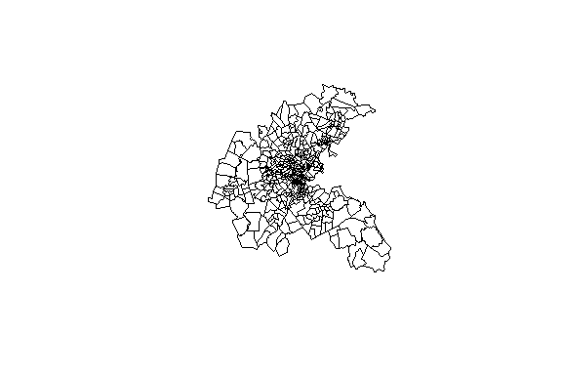

## **Part One**

### **0.1 Row-standardized data and OLS for Housing**

# creates a row-standardized "listw" object (default style = "W")  
Boston_queen_nb <- poly2nb(Boston, queen=TRUE)  
Boston_w <- nb2listw(Boston_queen_nb)  
  
# creates a non row-standardized "listw" object  
Boston_b <- nb2listw(Boston_queen_nb,style="B")  
  
# displays the "data.frame" attribute of the shape file  
  
boston_data <- attr(Boston, "data")  
# Extracting the first 10 rows  
first_5 <- head(boston_data, 5)  
# Extracting the last 10 rows  
last_5 <- tail(boston_data, 5)  
# Combining the first 10 and last 10 rows  
combined_rows <- rbind(first_5, last_5)  
  
# Display the combined rows  
print(combined_rows)  
  
# using log of median housing value instead of housing value  
Boston$LOGMEDV<-log(Boston$CMEDV)  
  
# OLS for housing value  
Boston_OLS <- lm(LOGMEDV~CRIM + CHAS + NOX + RM + AGE + DIS + B + LSTAT, data=Boston)  
summary(Boston_OLS)  
# saving residuals and fitted values  
Boston$olsresid<-residuals(Boston_OLS)  
Boston$ols_fitted <- fitted(Boston_OLS)  
# Moran test for residuals  
lm.morantest(Boston_OLS, Boston_w)

##### Result

## poltract TOWN TOWNNO TRACT LON LAT MEDV CMEDV  
## 0 0001 Boston Allston-Brighton 74 1 -71.0830 42.2172 17.8 17.8  
## 1 0002 Boston Allston-Brighton 74 2 -71.0950 42.2120 21.7 21.7  
## 2 0003 Boston Allston-Brighton 74 3 -71.1007 42.2100 22.7 22.7  
## 3 0004 Boston Allston-Brighton 74 4 -71.0930 42.2070 22.6 22.6  
## 4 0005 Boston Allston-Brighton 74 5 -71.0905 42.2033 25.0 25.0  
## 5 0006 Boston Allston-Brighton 74 6 -71.0865 42.2100 19.9 19.9  
## 6 0007 Boston Allston-Brighton 74 7 -71.0810 42.2080 20.8 20.8  
## 7 0008 Boston Allston-Brighton 74 8 -71.0865 42.2150 16.8 16.8  
## 8 0101 Boston Back Bay 75 101 -71.0590 42.2098 21.9 21.9  
## 9 0102 Boston Back Bay 75 102 -71.0595 42.2075 27.5 27.5  
## 496 5022 Rockland 67 5022 -70.9501 42.0825 17.2 17.2  
## 497 5031 Hanover 68 5031 -70.9275 42.0795 23.1 23.1  
## 498 5041 Norwell 69 5041 -70.9200 42.1016 24.5 24.5  
## 499 5051 Scituate 70 5051 -70.8550 42.1300 26.6 26.6  
## 500 5052 Scituate 70 5052 -70.8330 42.1150 22.9 22.9  
## 501 5061 Marshfield 71 5061 -70.8300 42.0775 24.1 24.1  
## 502 5062 Marshfield 71 5062 -70.8100 42.0590 18.6 18.6  
## 503 5071 Duxbury 72 5071 -70.8300 42.0485 30.1 30.1  
## 504 5081 Pembroke 73 5081 -70.8530 42.0520 18.2 18.2  
## 505 5082 Pembroke 73 5082 -70.8525 42.0300 20.6 20.6  
## CRIM ZN INDUS CHAS NOX RM AGE DIS RAD TAX PTRATIO B LSTAT  
## 0 8.98296 0 18.10 1 0.770 6.212 97.4 2.1222 24 666 20.2 377.73 17.60  
## 1 3.84970 0 18.10 1 0.770 6.395 91.0 2.5052 24 666 20.2 391.34 13.27  
## 2 5.20177 0 18.10 1 0.770 6.127 83.4 2.7227 24 666 20.2 395.43 11.48  
## 3 4.26131 0 18.10 0 0.770 6.112 81.3 2.5091 24 666 20.2 390.74 12.67  
## 4 4.54192 0 18.10 0 0.770 6.398 88.0 2.5182 24 666 20.2 374.56 7.79  
## 5 3.83684 0 18.10 0 0.770 6.251 91.1 2.2955 24 666 20.2 350.65 14.19  
## 6 3.67822 0 18.10 0 0.770 5.362 96.2 2.1036 24 666 20.2 380.79 10.19  
## 7 4.22239 0 18.10 1 0.770 5.803 89.0 1.9047 24 666 20.2 353.04 14.64  
## 8 3.47428 0 18.10 1 0.718 8.780 82.9 1.9047 24 666 20.2 354.55 5.29  
## 9 4.55587 0 18.10 0 0.718 3.561 87.9 1.6132 24 666 20.2 354.70 7.12  
## 496 0.06162 0 4.39 0 0.442 5.898 52.3 8.0136 3 352 18.8 364.61 12.67  
## 497 0.01870 85 4.15 0 0.429 6.516 27.7 8.5353 4 351 17.9 392.43 6.36  
## 498 0.01501 80 2.01 0 0.435 6.635 29.7 8.3440 4 280 17.0 390.94 5.99  
## 499 0.02899 40 1.25 0 0.429 6.939 34.5 8.7921 1 335 19.7 389.85 5.89  
## 500 0.06211 40 1.25 0 0.429 6.490 44.4 8.7921 1 335 19.7 396.90 5.98  
## 501 0.07950 60 1.69 0 0.411 6.579 35.9 10.7103 4 411 18.3 370.78 5.49  
## 502 0.07244 60 1.69 0 0.411 5.884 18.5 10.7103 4 411 18.3 392.33 7.79  
## 503 0.01709 90 2.02 0 0.410 6.728 36.1 12.1265 5 187 17.0 384.46 4.50  
## 504 0.04301 80 1.91 0 0.413 5.663 21.9 10.5857 4 334 22.0 382.80 8.05  
## 505 0.10659 80 1.91 0 0.413 5.936 19.5 10.5857 4 334 22.0 376.04 5.57  
## units cu5k c5_7_5 C7_5_10 C10_15 C15_20 C20_25 C25_35 C35_50 co50k median  
## 0 126 3 3 4 26 43 29 16 1 1 17800  
## 1 399 4 10 7 37 95 139 93 9 5 21700  
## 2 368 3 1 2 25 84 127 102 24 0 22700  
## 3 220 3 2 2 23 45 67 63 12 3 22600  
## 4 44 0 0 1 1 11 9 12 9 1 25000  
## 5 221 2 3 7 31 69 72 30 6 1 19900  
## 6 39 0 0 0 4 14 9 11 0 1 20800  
## 7 203 2 6 14 45 73 41 17 5 0 16800  
## 8 33 0 0 4 5 6 4 5 4 5 21900  
## 9 5 0 0 0 1 0 1 2 1 0 27500  
## 496 1043 7 7 39 267 455 199 66 2 1 17200  
## 497 2171 4 11 18 215 495 557 662 190 19 23100  
## 498 1698 3 6 19 98 330 437 432 283 90 24500  
## 499 2489 4 12 36 202 445 419 778 461 132 26600  
## 500 1164 3 5 34 131 253 271 280 141 46 22900  
## 501 1545 11 16 31 178 295 291 412 253 58 24100  
## 502 1788 2 18 75 397 546 449 258 36 7 18600  
## 503 1891 10 10 29 123 207 315 497 394 306 30100  
## 504 1792 5 35 82 376 608 422 227 30 7 18200  
## 505 716 0 2 8 64 258 217 143 22 2 20600  
## BB censored NOX_ID POP  
## 0 0.8 no 1 3962  
## 1 1.4 no 1 9245  
## 2 0.3 no 1 6842  
## 3 0.8 no 1 8342  
## 4 1.8 no 1 7836  
## 5 3.7 no 1 9276  
## 6 1.2 no 1 9730  
## 7 3.6 no 1 8441  
## 8 3.5 no 2 10244  
## 9 3.4 no 2 7812  
## 496 2.6 no 91 5274  
## 497 0.6 no 92 10107  
## 498 0.6 no 93 7796  
## 499 0.4 no 92 11649  
## 500 0.2 no 92 5324  
## 501 1.6 no 94 7087  
## 502 0.3 no 94 8136  
## 503 1.1 no 95 7636  
## 504 0.5 no 96 7975  
## 505 1.1 no 96 3218

##   
## Call:  
## lm(formula = LOGMEDV ~ CRIM + CHAS + NOX + RM + AGE + DIS + B +   
## LSTAT, data = Boston)  
##   
## Residuals:  
## Min 1Q Median 3Q Max   
## -0.74155 -0.12040 -0.02555 0.10726 0.96911   
##   
## Coefficients:  
## Estimate Std. Error t value Pr(>|t|)   
## (Intercept) 2.9243675 0.1666552 17.547 < 2e-16 ***  
## CRIM -0.0094454 0.0012515 -7.547 2.14e-13 ***  
## CHAS1 0.1444594 0.0364462 3.964 8.46e-05 ***  
## NOX -0.5353117 0.1401451 -3.820 0.000151 ***  
## RM 0.1351813 0.0168870 8.005 8.51e-15 ***  
## AGE -0.0005123 0.0005570 -0.920 0.358217   
## DIS -0.0396327 0.0074885 -5.292 1.81e-07 ***  
## B 0.0004169 0.0001134 3.677 0.000262 ***  
## LSTAT -0.0301493 0.0021561 -13.983 < 2e-16 ***  
## ---  
## Signif. codes: 0 '***' 0.001 '**' 0.01 '*' 0.05 '.' 0.1 ' ' 1  
##   
## Residual standard error: 0.2035 on 497 degrees of freedom  
## Multiple R-squared: 0.7554, Adjusted R-squared: 0.7515   
## F-statistic: 191.9 on 8 and 497 DF, p-value: < 2.2e-16

##   
## Global Moran I for regression residuals  
##   
## data:   
## model: lm(formula = LOGMEDV ~ CRIM + CHAS + NOX + RM + AGE + DIS + B +  
## LSTAT, data = Boston)  
## weights: Boston_w  
##   
## Moran I statistic standard deviate = 18.952, p-value < 2.2e-16  
## alternative hypothesis: greater  
## sample estimates:  
## Observed Moran I Expectation Variance   
## 0.490989041 -0.011131307 0.000701953

Q1. Describe the OLS regression model results and their significance.

### **Lagrange multiplier tests for residuals**

lm.LMtests(Boston_OLS, Boston_w, test="all")  
#Breusch Pagan test for heteroskedasticity  
bptest(Boston_OLS)

##### Result

##   
## Lagrange multiplier diagnostics for spatial dependence  
##   
## data:   
## model: lm(formula = LOGMEDV ~ CRIM + CHAS + NOX + RM + AGE + DIS + B +  
## LSTAT, data = Boston)  
## weights: Boston_w  
##   
## LMerr = 327.87, df = 1, p-value < 2.2e-16  
##   
##   
## Lagrange multiplier diagnostics for spatial dependence  
##   
## data:   
## model: lm(formula = LOGMEDV ~ CRIM + CHAS + NOX + RM + AGE + DIS + B +  
## LSTAT, data = Boston)  
## weights: Boston_w  
##   
## LMlag = 260.91, df = 1, p-value < 2.2e-16  
##   
##   
## Lagrange multiplier diagnostics for spatial dependence  
##   
## data:   
## model: lm(formula = LOGMEDV ~ CRIM + CHAS + NOX + RM + AGE + DIS + B +  
## LSTAT, data = Boston)  
## weights: Boston_w  
##   
## RLMerr = 99.454, df = 1, p-value < 2.2e-16  
##   
##   
## Lagrange multiplier diagnostics for spatial dependence  
##   
## data:   
## model: lm(formula = LOGMEDV ~ CRIM + CHAS + NOX + RM + AGE + DIS + B +  
## LSTAT, data = Boston)  
## weights: Boston_w  
##   
## RLMlag = 32.498, df = 1, p-value = 1.193e-08  
##   
##   
## Lagrange multiplier diagnostics for spatial dependence  
##   
## data:   
## model: lm(formula = LOGMEDV ~ CRIM + CHAS + NOX + RM + AGE + DIS + B +  
## LSTAT, data = Boston)  
## weights: Boston_w  
##   
## SARMA = 360.37, df = 2, p-value < 2.2e-16

##   
## studentized Breusch-Pagan test  
##   
## data: Boston_OLS  
## BP = 58.379, df = 8, p-value = 9.683e-10

Q2. Describe the diagnostics test results for spatial autocorrelation.

### **Spatial lag Regression**

Boston_spatial_lag <- lagsarlm(LOGMEDV ~ CRIM + CHAS + NOX + RM + AGE + DIS + B + LSTAT, data=Boston, Boston_w)  
summary(Boston_spatial_lag)  
# saving residuals and fitted values  
Boston$lagresid<-residuals(Boston_spatial_lag)  
Boston$lag_fitted <- fitted(Boston_spatial_lag)

##### Result

##   
## Call:lagsarlm(formula = LOGMEDV ~ CRIM + CHAS + NOX + RM + AGE + DIS +   
## B + LSTAT, data = Boston, listw = Boston_w)  
##   
## Residuals:  
## Min 1Q Median 3Q Max   
## -0.602982 -0.087559 -0.014017 0.079602 0.817612   
##   
## Type: lag   
## Coefficients: (asymptotic standard errors)   
## Estimate Std. Error z value Pr(>|z|)  
## (Intercept) 9.1935e-01 1.6647e-01 5.5225 3.342e-08  
## CRIM -5.1768e-03 9.9894e-04 -5.1823 2.191e-07  
## CHAS1 4.8343e-02 2.8108e-02 1.7199 0.085452  
## NOX -1.5241e-01 1.0914e-01 -1.3965 0.162567  
## RM 1.2963e-01 1.3040e-02 9.9405 < 2.2e-16  
## AGE -4.6463e-04 4.2565e-04 -1.0916 0.275014  
## DIS -2.9370e-02 5.8160e-03 -5.0499 4.421e-07  
## B 2.6460e-04 8.7251e-05 3.0326 0.002424  
## LSTAT -1.6652e-02 1.7990e-03 -9.2560 < 2.2e-16  
##   
## Rho: 0.54543, LR test value: 233.72, p-value: < 2.22e-16  
## Asymptotic standard error: 0.03174  
## z-value: 17.185, p-value: < 2.22e-16  
## Wald statistic: 295.31, p-value: < 2.22e-16  
##   
## Log likelihood: 208.9408 for lag model  
## ML residual variance (sigma squared): 0.024053, (sigma: 0.15509)  
## Number of observations: 506   
## Number of parameters estimated: 11   
## AIC: -395.88, (AIC for lm: -164.16)  
## LM test for residual autocorrelation  
## test value: 29.36, p-value: 6.0116e-08

## This method assumes the response is known - see manual page

Q3. Describe the spatial lag regression model results and its significance.

### **Error regression**

Boston_spatial_error <- errorsarlm(LOGMEDV ~ CRIM + CHAS + NOX + RM + AGE + DIS + B + LSTAT, data=Boston, Boston_w)  
summary(Boston_spatial_error)  
# saving residuals and fitted values  
Boston$error_resid<-residuals(Boston_spatial_error)  
Boston$error_fitted <- fitted(Boston_spatial_error)

##### Result

##   
## Call:errorsarlm(formula = LOGMEDV ~ CRIM + CHAS + NOX + RM + AGE +   
## DIS + B + LSTAT, data = Boston, listw = Boston_w)  
##   
## Residuals:  
## Min 1Q Median 3Q Max   
## -0.7127664 -0.0744056 -0.0083521 0.0677584 0.7394041   
##   
## Type: error   
## Coefficients: (asymptotic standard errors)   
## Estimate Std. Error z value Pr(>|z|)  
## (Intercept) 2.80261293 0.18191754 15.4060 < 2.2e-16  
## CRIM -0.00707212 0.00105312 -6.7154 1.875e-11  
## CHAS1 -0.01442505 0.03674072 -0.3926 0.6946019  
## NOX -0.80066014 0.18208348 -4.3972 1.096e-05  
## RM 0.16312717 0.01431568 11.3950 < 2.2e-16  
## AGE -0.00149580 0.00052020 -2.8754 0.0040351  
## DIS -0.04065136 0.01272359 -3.1950 0.0013985  
## B 0.00044147 0.00012811 3.4461 0.0005688  
## LSTAT -0.01907178 0.00198011 -9.6317 < 2.2e-16  
##   
## Lambda: 0.78429, LR test value: 277.61, p-value: < 2.22e-16  
## Asymptotic standard error: 0.032101  
## z-value: 24.432, p-value: < 2.22e-16  
## Wald statistic: 596.92, p-value: < 2.22e-16  
##   
## Log likelihood: 230.8859 for error model  
## ML residual variance (sigma squared): 0.020082, (sigma: 0.14171)  
## Number of observations: 506   
## Number of parameters estimated: 11   
## AIC: -439.77, (AIC for lm: -164.16)

## This method assumes the response is known - see manual page

Q4. Describe the spatial error regression model results and its significance.

## **Part Two**

### **create a data frame**

# create a data frame  
boston.df <- data.frame(Boston)  
names(boston.df) # gives us the column names  
colnames(boston.df) # alternative call; same thing  
  
attach(boston.df) #Now you can call the variable name without using “$”  
  
LOGCMEDV <- log(CMEDV)  
  
# we create this location using the coordinates of the centroids:  
XYgridtable <- cbind(LON, LAT)  
#using gwr.sel to find optimal parameters  
adaptive.bw<-gwr.sel(LOGCMEDV~CRIM+CHAS+NOX+RM+AGE+DIS+B+LSTAT,adapt=TRUE, method="cv", coords=XYgridtable)  
###gwr.Gauss() default  
  
#number of observations (polygon)  
dim(boston.df)[1]  
# how many points does each window take  
print(dim(boston.df)[1]*adaptive.bw )  
#run gwr using the optimal parameter found above  
bos.gwr<-gwr(LOGCMEDV ~ CRIM + CHAS + NOX + RM + AGE + DIS + B + LSTAT, adapt = adaptive.bw, gweight = gwr.Gauss, hatmatrix = TRUE, coords = XYgridtable)  
print(bos.gwr)  
#Plot local R2  
classes_fx <- classIntervals(bos.gwr$SDF$localR2, n=5, style="quantile")  
cols <- findColours(classes_fx,pal)  
pal <- brewer.pal(5, "YlOrRd")  
plot(Boston,col=cols, border="grey")  
legend(x="topleft", cex=0.65, fill=attr(cols,"palette"), bty="n", legend=names(attr(cols, "table")), title="Local R^2",ncol=1)  
#Plot Residual  
res <- bos.gwr$SDF$gwr.e  
classes_fx <- classIntervals(res, n=5, style="quantile")  
pal <- brewer.pal(5, "YlOrRd")  
cols <- findColours(classes_fx,pal)  
plot(Boston,col=cols, border="transparent")  
legend(x="topleft", cex=0.65, fill=attr(cols, "palette"), bty="n", legend=names(attr(cols, "table")), title="Residual", ncol=1)

##### Result

## [1] "poltract" "TOWN" "TOWNNO" "TRACT" "LON"   
## [6] "LAT" "MEDV" "CMEDV" "CRIM" "ZN"   
## [11] "INDUS" "CHAS" "NOX" "RM" "AGE"   
## [16] "DIS" "RAD" "TAX" "PTRATIO" "B"   
## [21] "LSTAT" "units" "cu5k" "c5_7_5" "C7_5_10"   
## [26] "C10_15" "C15_20" "C20_25" "C25_35" "C35_50"   
## [31] "co50k" "median" "BB" "censored" "NOX_ID"   
## [36] "POP" "LOGMEDV" "olsresid" "ols_fitted" "lagresid"   
## [41] "lag_fitted" "error_resid" "error_fitted"

## [1] "poltract" "TOWN" "TOWNNO" "TRACT" "LON"   
## [6] "LAT" "MEDV" "CMEDV" "CRIM" "ZN"   
## [11] "INDUS" "CHAS" "NOX" "RM" "AGE"   
## [16] "DIS" "RAD" "TAX" "PTRATIO" "B"   
## [21] "LSTAT" "units" "cu5k" "c5_7_5" "C7_5_10"   
## [26] "C10_15" "C15_20" "C20_25" "C25_35" "C35_50"   
## [31] "co50k" "median" "BB" "censored" "NOX_ID"   
## [36] "POP" "LOGMEDV" "olsresid" "ols_fitted" "lagresid"   
## [41] "lag_fitted" "error_resid" "error_fitted"

## Adaptive q: 0.381966 CV score: 19.45164   
## Adaptive q: 0.618034 CV score: 20.59138   
## Adaptive q: 0.236068 CV score: 18.32478   
## Adaptive q: 0.145898 CV score: 17.00162   
## Adaptive q: 0.09016994 CV score: 15.20693   
## Adaptive q: 0.05572809 CV score: 13.43434   
## Adaptive q: 0.03444185 CV score: 12.16576   
## Adaptive q: 0.02128624 CV score: 11.48963   
## Adaptive q: 0.01315562 CV score: 12.34929   
## Adaptive q: 0.02438278 CV score: 11.59113   
## Adaptive q: 0.01818062 CV score: 11.69557   
## Adaptive q: 0.02180867 CV score: 11.51344   
## Adaptive q: 0.02009999 CV score: 11.45838   
## Adaptive q: 0.01952185 CV score: 11.48955   
## Adaptive q: 0.02040351 CV score: 11.46344   
## Adaptive q: 0.02014758 CV score: 11.45902   
## Adaptive q: 0.01987916 CV score: 11.45627   
## Adaptive q: 0.01964877 CV score: 11.4714   
## Adaptive q: 0.01979116 CV score: 11.45583   
## Adaptive q: 0.01973677 CV score: 11.45926   
## Adaptive q: 0.01983185 CV score: 11.456   
## Adaptive q: 0.01979116 CV score: 11.45583

## [1] 506

## [1] 10.01433

## Call:  
## gwr(formula = LOGCMEDV ~ CRIM + CHAS + NOX + RM + AGE + DIS +   
## B + LSTAT, coords = XYgridtable, gweight = gwr.Gauss, adapt = adaptive.bw,   
## hatmatrix = TRUE)  
## Kernel function: gwr.Gauss   
## Adaptive quantile: 0.01979116 (about 10 of 506 data points)  
## Summary of GWR coefficient estimates at data points:  
## Min. 1st Qu. Median 3rd Qu. Max.  
## X.Intercept. 0.46639045 1.74004057 2.74084330 3.53255460 8.37525856  
## CRIM -0.38756924 -0.01231664 -0.00998365 -0.00756998 0.37331527  
## CHAS1 -0.17682389 0.01366529 0.15869549 0.57823993 3.06857177  
## NOX -4.45010132 -0.92336607 -0.58516056 -0.12435515 2.29273633  
## RM -0.22730751 0.08279618 0.18060022 0.26045226 0.36282998  
## AGE -0.02174969 -0.00371533 -0.00217082 -0.00060200 0.01354966  
## DIS -1.26025807 -0.13272898 -0.05461739 -0.02672744 0.40216030  
## B -0.00195998 0.00028663 0.00057108 0.00087532 0.00272656  
## LSTAT -0.04756575 -0.03235929 -0.01979628 -0.00846942 0.00350482  
## Global  
## X.Intercept. 2.9244  
## CRIM -0.0094  
## CHAS1 0.1445  
## NOX -0.5353  
## RM 0.1352  
## AGE -0.0005  
## DIS -0.0396  
## B 0.0004  
## LSTAT -0.0301  
## Number of data points: 506   
## Effective number of parameters (residual: 2traceS - traceS'S): 160.0712   
## Effective degrees of freedom (residual: 2traceS - traceS'S): 345.9288   
## Sigma (residual: 2traceS - traceS'S): 0.1249992   
## Effective number of parameters (model: traceS): 118.8724   
## Effective degrees of freedom (model: traceS): 387.1276   
## Sigma (model: traceS): 0.1181608   
## Sigma (ML): 0.1033535   
## AICc (GWR p. 61, eq 2.33; p. 96, eq. 4.21): -545.8805   
## AIC (GWR p. 96, eq. 4.22): -741.9968   
## Residual sum of squares: 5.405068   
## Quasi-global R2: 0.9357897

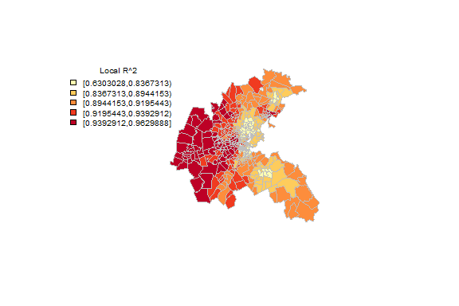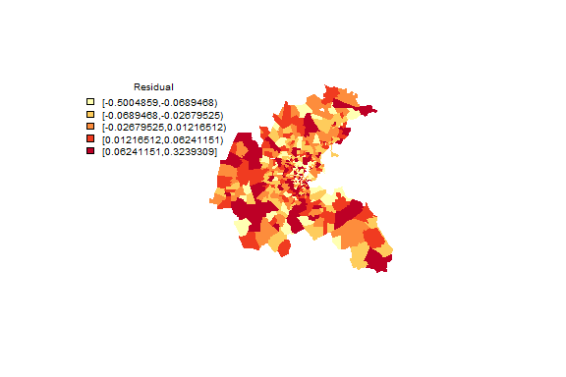

Q5. Take screenshots of the plots and describe the pattern of local R2 and residual.

### **Spatial lag Regression**

###plot local coefficient (CRIM)  
coef <- bos.gwr$SDF$CRIM  
classes_fx <- classIntervals(coef, n=5, style="quantile")  
cols <- findColours(classes_fx,pal)  
plot(Boston,col=cols, border="transparent")  
legend(x="topleft", cex=0.75, fill=attr(cols, "palette"), bty="n", legend=names(attr(cols, "table")), title = "Local Coefficient Estimates (CRIM)", ncol=1)  
  
###plot local coefficient (NOX)  
coef <- bos.gwr$SDF$NOX  
classes_fx2 <- classIntervals(coef, n=5, style="quantile")  
cols <- findColours(classes_fx2,pal)  
plot(Boston,col=cols, border="transparent")  
legend(x="topleft", cex=0.7, fill=attr(cols, "palette"), bty="n", legend=names(attr(cols, "table")), title="Local Coefficient Estimates (NOX)", ncol = 1)  
  
#Plot RM, AGE, DIS, B, LSTAT  
  
###plot local coefficient (RM)  
coef <- bos.gwr$SDF$RM  
classes_fx4 <- classIntervals(coef, n=5, style="quantile")  
cols <- findColours(classes_fx4,pal)  
plot(Boston,col=cols, border="transparent")  
legend(x="topleft", cex=0.7, fill=attr(cols, "palette"), bty="n", legend=names(attr(cols, "table")), title="Local Coefficient Estimates (RM)", ncol = 1)  
  
###plot local coefficient (AGE)  
coef <- bos.gwr$SDF$AGE  
classes_fx5 <- classIntervals(coef, n=5, style="quantile")  
cols <- findColours(classes_fx5,pal)  
plot(Boston,col=cols, border="transparent")  
legend(x="topleft", cex=0.7, fill=attr(cols, "palette"), bty="n", legend=names(attr(cols, "table")), title="Local Coefficient Estimates (AGE)", ncol = 1)  
  
  
###plot local coefficient (DIS)  
coef <- bos.gwr$SDF$DIS  
classes_fx6 <- classIntervals(coef, n=5, style="quantile")  
cols <- findColours(classes_fx6,pal)  
plot(Boston,col=cols, border="transparent")  
legend(x="topleft", cex=0.7, fill=attr(cols, "palette"), bty="n", legend=names(attr(cols, "table")), title="Local Coefficient Estimates (DIS)", ncol = 1)  
  
  
###plot local coefficient (B)  
coef <- bos.gwr$SDF$B  
classes_fx7 <- classIntervals(coef, n=5, style="quantile")  
cols <- findColours(classes_fx7,pal)  
plot(Boston,col=cols, border="transparent")  
legend(x="topleft", cex=0.7, fill=attr(cols, "palette"), bty="n", legend=names(attr(cols, "table")), title="Local Coefficient Estimates (B)", ncol = 1)

##### Result

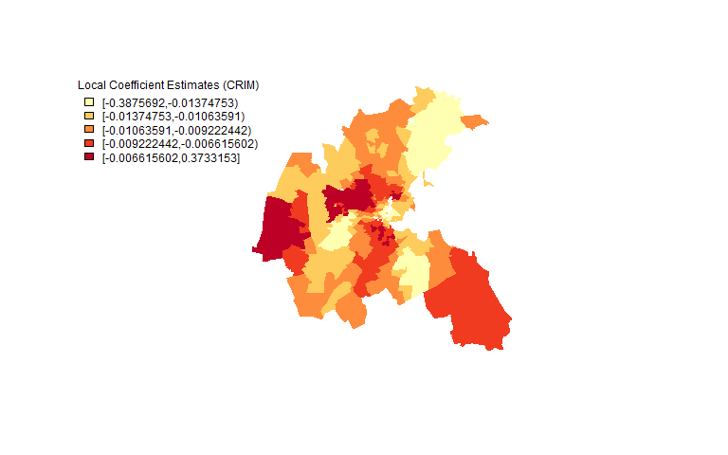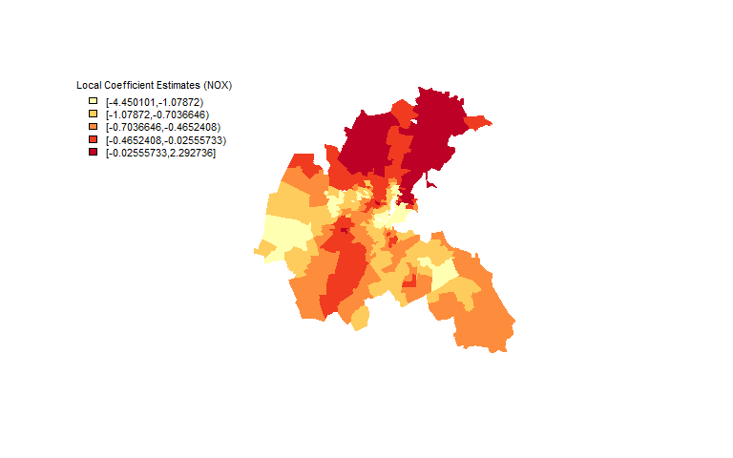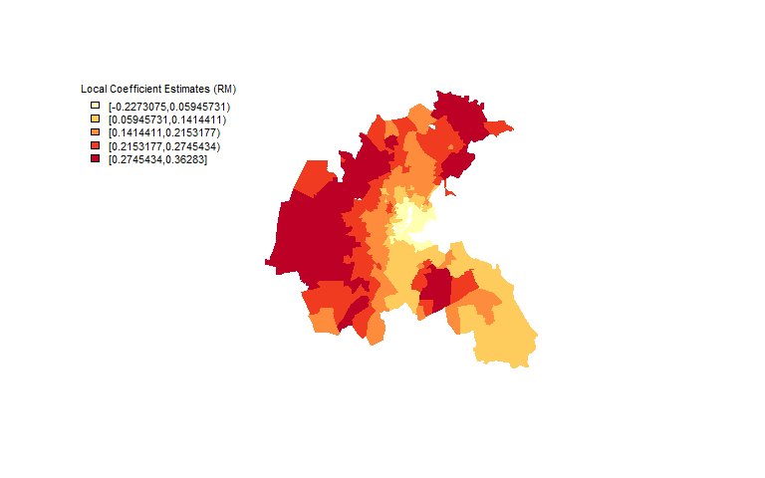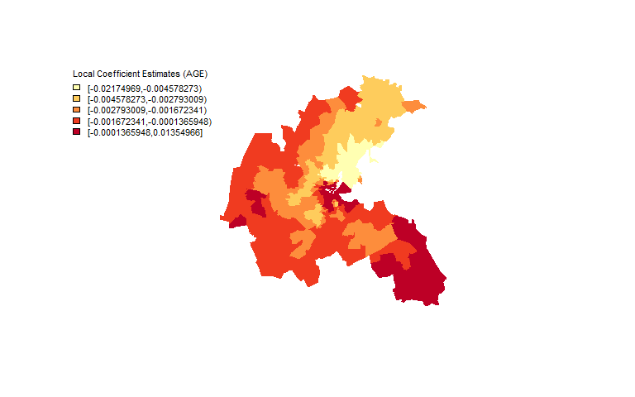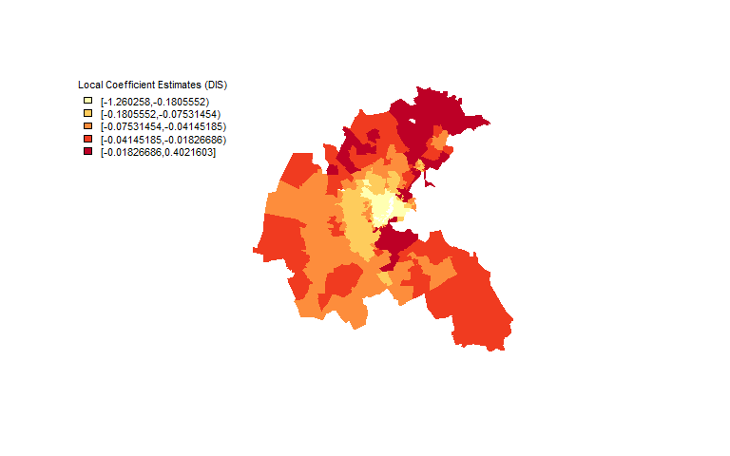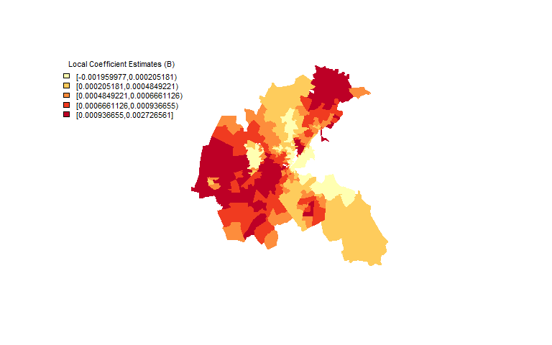

### **plot t values (CRIME)**

#plot t values (CRIME)  
bos.gwr$SDF$CRIM_t <- bos.gwr$SDF$CRIM/bos.gwr$SDF$CRIM_se  
tCRIM<-bos.gwr$SDF$CRIM_t  
display.brewer.pal(3, "RdBu")  
colors <- brewer.pal(3, "RdBu") # Stores colors in object color  
color.category.reg <- findInterval(tCRIM,  
c(min(tCRIM)-.0001, -1.96, -1.64,  
max(tCRIM)+.0001),all.inside=TRUE)  
#classes_fx <- classIntervals(tCRIM, n=5, style="quantile")  
#cols <- findColours(classes_fx,pal)  
plot(Boston,col=colors[color.category.reg], border="transparent")  
labels <- c("<-1.96", " -1.96 to -1.64", "Not significant")  
legend("bottom", legend=labels, fill=colors, cex=0.8,  
y.intersp = 0.99, bty="n")

##### Result

## 'summaryDefault' chr [1:12, 1:3] " 506" "256036" " 11" " 14" ...  
## - attr(*, "dimnames")=List of 2  
## ..$ : chr [1:12] "SDF" "lhat" "lm" "results" ...  
## ..$ : chr [1:3] "Length" "Class" "Mode"

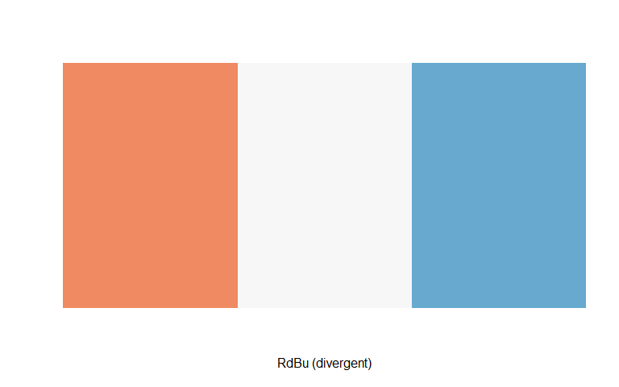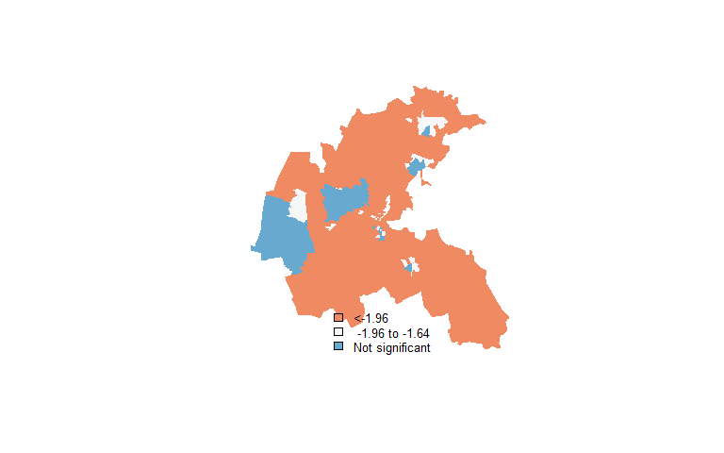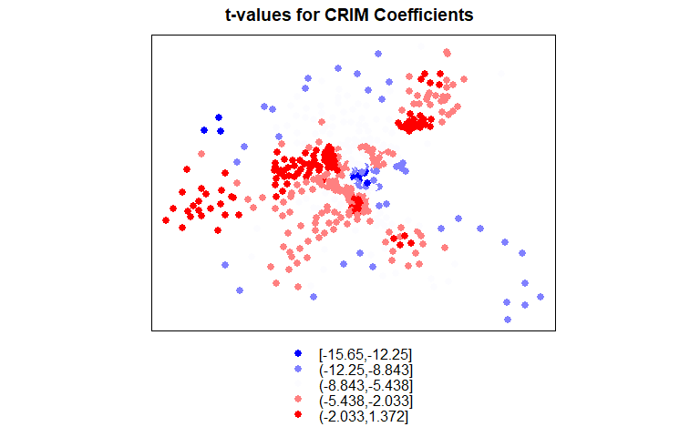

Q7. Take a screen shot of the plot and describe the pattern. (10 points) Q8. Describe the GWR model results and their significance. How does it compare with the regression results in part 1? (10 points) Q9. How could you use these results as a policymaker who is interested in environmental or social issues (pollution or affordable housing)?