Assignment 1 : Simple Book Inventory Shell Program

Done By:
Lindi Lamduan Wong | 4872721

TABLE OF CONTENTS
1 Requirements 3
1.1 Basic Requirements 3
1.2 Addition Self-Requirements 4
2 Diagram of Program Design 5
3 Summary of Implementation 6
3.1 Add New Book 6
3.2 Remove Existing Book Information 7
3.3 Update Book Information and Quantity 8
3.4 Search for Book by Title / Author 9
3.5 Process a Book Sold 9
3.6 Inventory Summary Report 10
3.7 Report Book Statistics (Own User-Defined Function) 10
3.8 Access Database Data (Own User-Defined Function) 10
3.9 Check If Book Exists (Own User-Defined Function) 10
3.10 Update Database (Own User-Defined Function) 10
4 Reflection on Program Development 11
5 Codes and Output 13
5.1 Global Variables/Array Declared 13
5.2 Add New Book 14
5.3 Remove Existing Book Information 17
5.4 Update Book Information and Quantity 19
5.5 Search for Book by Title / Author 23
5.6 Process a Book Sold 25
5.7 Inventory Summary Report 27
5.8 Report Book Statistics (Own User-Defined Function) 28
5.9 Access Database Data (Own User-Defined Function) 30
5.10 Check If Book Exists (Own User-Defined Function) 30
5.11 Update Database (Own User-Defined Function) 30
5.12 Final State of BookDB.txt 31

Requirements

Basic Requirements
- Add New Book into Database (add_new_book)
  - If the created book already exist in the BookDB, the creation would be denied and would require the user to create another new book. For every new book created, it should show up on the “Inventory Summary Report” output and also reflect on the BookDB.txt correctly in the last row

- Remove Existing Book Information from Database (remove_existing_book)
  - Only able to remove existing books from BookDB. If the user input a book title and author that does not exist, deletion of books would fail. If book is deleted, it should update on the “Inventory Summary Report” output and also reflect on the BookDB.txt

- Update Book Info and Quantity (update_book_info)
  - Only able to update existing books. If book is exisiting, user would be able to update the title, author, price, quantity available and quantity sold. Once user updates any one of the options, it should show up on the “Inventory Summary Report” output and also reflect on the BookDB.txt

- Search for Book by Title / Author from Database (search_book)
  - Able to search books by partial and/or full spelling, for both Title and Author Fields, one field (either Title or Author). If book does not exist, user will be alerted. However if both fields are empty, the program will prompt the user with a message, telling him that both fields are empty.

- Processing a Book Sold from the Database (process_book_sold)
  - Input in the number of books sold and from there, it will update the available and sold books. The output will show the before and after of selling for number of available books and number of sold books in total. Once processing is done, it should show up the correct number of available, sold and sales made on the “Inventory Summary Report” output and also reflect on the BookDB.txt

- Inventory Summary Report by getting Information from Database (inventory_summary_report)
  - Show the Summary Report of the final state of the BookDB.txt after all of the executed functions. It will show the title, author, and price, quantity available, quantity sold and also the total sales made from each book title. The final output from this function (data taken from array) should reflect on the BookDB.txt and also the data will appear in a sorted alphabetical way.

Addition Self-Requirements
- Function to Report Books Statistics (Popularity and Books require Stocking)
(report_books_statistics)
- This function will be doing the logic:
  - Sorting of books sold
- Through this sorting, I will be able to determine which top 5 books are the most popular and least popular (through the least popular, the book store owner will be able to determine if he wants to implement discounts on those books) and also show which books require restocking (20 books or lesser left)

- Function to Access Database Data (access_bookdb_data)
  - This function enables us to store the book data into an array so it will be easier to retrieve what is required in BookDB.txt and sort the data alphabetically for easier reading.

- Function to Check if Book Exists (does_book_exists)
  - This function helps by checking if the book exist before creating, deleting, searching and processing. If the book exists, user will be able to carry forward the actions that he/she would like to do

- Function to Update the Database whenever there are modifications (update_bookdb_data)
  - Whenever there are modifications made to the data like adding, deleting, updating and processing, it should reflect on BookDB.txt accordingly to what the output is given in “6. Inventory Summary Report”

Diagram of Program Design

BookDB.txt
Access BookDB Data

Books Statistics Report
Add New Book
Remove Book
Update Book Info
Search Book
Process Book Sold
Does Book Exists
Update BookDB
Does Book Exists
Does Book Exists
Does Book Exists

Summary Report

Summary of Implementation

Before the implementation, I would have to keep mind that Linux is a case-sensitive program.

Add New Book
To add a new book, the following criteria needs to be taken note of:

Title and Author fields must NOT be empty
- The book being created should go through a checking logic if it already exists in BookDB.txt. If it does not exist, the book will be created

So for this 2 criteria, I will have to have 2 variables which will store Boolean values to do the checking if it satisfies the requirements. One will be called empty (for the first requirement), and the other, exist (for the second requirement).

To start off when the user inputs the field for title, I would have to do a checking if the field is empty. If the field is empty, I would show an error message in red and prompt the user to fill in the field again. Same goes for the author field.

Once both fields are filled and entered, I would do a checking if book exists by calling in my user-defined function and passing in the value which is the title and author. Through this function, it would overwrite the value of “exist” (due to the logic in the function) and from there we can then start to put in the value for price, number of books available and also sold.

However, for these 3 fields, “Price”, “Number of Books Available” and “Number of Books Sold” would require some checking as well because the input value has to be numerical. The criteria for these 3 fields would be:

- Input values must be more than 0
- Input value must be numerical

Once requirements are fulfilled by user, the book will be successfully added into BookDB.txt and the array (title, author, and price, avail, sold) size would then increase due to the new book.

Remove Existing Book Information
Before removing a book, the following criteria has to be fulfilled:

Title and Author fields must NOT be empty
- The book being created should go through a checking logic if it already exists in BookDB.txt. If it does not exist, the book will be created

These 2 requirements and also the alternate flow of this requirement process will be the same as the first function (Add New Book), thus there will be 2 variables to store Boolean values to check if user has fulfilled them.
After which the system would have to check if the book exists in BookDB.txt.
If it does exists, I would then unset the element inside the 5 arrays that I have created according to the index of where the data belongs in (this index would be produced from my function which checks if the book exist. The 5 arrays are:
(TITLE, AUTHOR, PRICE, AVAIL, SOLD)
Through this unset build-in command, it removes the element, however, I have an assumption that the index of where the deleted data is stored at is still existing in somewhere in the program. So, I call in my 5 arrays and replace the new data which excludes the data that has been unset.
And from here, I will update my BookDB.txt to reflect the appropriate information in it.

Update Book Information and Quantity
Before removing a book, the following criteria has to be fulfilled:

Title and Author fields must NOT be empty
- The book being created should go through a checking logic if it already exists in BookDB.txt. If it does not exist, the book will be created

These 2 requirements and also the alternate flow of this requirement process will be the same as the first function (Add New Book), thus there will be 2 variables to store Boolean values to check if user has fulfilled them.
After which the system would have to check if the book exists in BookDB.txt.
If the book exists, the program would print out a sub-menu in this function which individually updates each variable (TITLE, AUTHOR, PRICE, and AVAIL, SOLD)
Here are the requirements and process needed for the input for each variable:
- Update Title (1 requirement)
  - Does the new book title exist within BookDB.txt?
YES: Show error message that book title already exists
NO: Update the old book title with the new title inputted by user
- Update Author (1 requirement)
  - Does the new book author exist within BookDB.txt?
YES: Show error message that book author already exists
NO: Update the old book author with the new author inputted by user
- Update Price (2 requirement)
  - Is the book price more than 0?
  - Is the book price numerical?
YES: Show error message that price must be more than 0 / must be numerical
NO: Update the book price inputted by user
- Update Quantity Available (2 requirement)
  - Is the quantity available more than 0?
  - Is the quantity available numerical?
YES: Show error message that quantity must be more than 0 / must be numerical
NO: Update the quantity available inputted by user
- Update Quantity Sold (2 requirement)
  - Is the quantity sold more than 0?
  - Is the quantity sold numerical?
YES: Show error message that quantity must be more than 0 / must be numerical
NO: Update the quantity sold inputted by user
Once user is done, BookDB.txt will be updated.

Search for Book by Title / Author
To search for a book, we have 2 types of category of search. Each of which contains 3 methods to search.
Category 1:
By Partial Search (Spelling in partial)
Method 1: Title Field has input, Author Field has NO input
Method 2: Title Field has NO input, Author Field has input
Method 3: Title Field has input, Author Field has input

Category 2:
By Full Search (Spelling in full)
Method 1: Title Field has input, Author Field has NO input
Method 2: Title Field has NO input, Author Field has input
Method 3: Title Field has input, Author Field has input

The following criteria has to be fulfilled after one of the method is used:
- The book being created should go through a checking logic if it already exists in BookDB.txt. If it does not exist, the book will be created
After which the system would have to check if the book exists in BookDB.txt.
Regardless of upper-case or lower-case, the program will still return the desired output which will contain have a counter to show the number of records retrieved, and also the Title and Author. The result of the output ultimately depends on the input of the user.

Process a Book Sold
For Processing a Book Sold, the first procedure would be identical to what the other functions do, which is to:
- Check if Title and Author fields are empty
- Check if the book exists in BookDB.txt

If both fields are not empty and book exists in BookDB.txt, I would then prompt the user to input the number of books sold. The number of books sold must be a positive numerical value, else the program will alert the user an error message that the input is invalid. Once the user has keyed in number of books sold, it will update BookDB.txt for the number of available books in store and also the number of books sold so far. The final state output of this function would show the old data of the book being searched and the new data of that book only that the difference would be the quantity in books available and books sold.

Inventory Summary Report
To generate an Inventory Summary Report, I would have to access into the BookDB.txt data and from there show the final state of the data after all of the modifications that has been done to the data. Modifications would include, adding, deleting, updating and processing the books. The final state which is the output in this function would need to be reflected on BookDB.txt.

Report Book Statistics (Own User-Defined Function)
To be able to relate to a real business for book industry, it is useful to have information on what books are popular and what books are not. When books are not popular, the company will strategize it’s method of clearing books left by giving discounts or other means. Additionally, it would be helpful when you know what books require re-stocking. To solve this dilemma in coding terms, it’s always best to sort the number of books sold and from there, sieve out the top 5 least and most popular books sold. And also retrieve which books require re-stocking which has exactly 20 or less than quantity left. Certain output of data requires reading from top down or bottom up.

Access Database Data (Own User-Defined Function)
From this function, I would need a location where BookDB.txt is located at, which is directly in the parent path where “menu.sh” (the driver file) belongs in. Thus, I create a file path that is easier for me to retrieve the BookDB.txt. (In future if the text file name has to be renamed, I can just change the file name in the codes in just one area under the file path variable).

Check If Book Exists (Own User-Defined Function)
To check if a book exists, it would be redundant to check up for the integer/double variables (PRICE, AVAIL, SOLD). So, I would need to check on the Title (According to the output given in the assignment, title comes first for the input so it’s best to check through all of the titles inside BookDB.txt).
For what I have to do next, I would need to check if the first parameter has been found, and then same for my second parameter (first parameter would be the input Title from the user, and input Author for the latter).
Once both of the parameters match the records in BookDB.txt, I would need to retrieve the position of where this matched data is lying within the array and also to set a variable to true which would mean that the book has actually been found.

Update Database (Own User-Defined Function)
To update the database, I would need to retrieve all of the final state of the data/element inside the 5 arrays that I have created. This is very much similar to C++ writing in file, except that I would need to echo the array elements out into my file path which belongs to my BookDB.txt.

Reflection on Program Development
There are many different things to begin with shell scripting, but one thing that strikes me after doing shell for a while is that it reminds me a lot of python, php and pseudo code added together. From my “so far” understanding of shell scripting, I feel that shell is a very low level type of computing language.
Just like any other language, there are a lot of ways to solve certain problems that should fulfil the program criteria. Having to know and learn certain build-in commands like grep will help a lot in our process of finding the solution.
Having a specific way of structuring our codes define how we our habits are, like do I comment my codes? Are my codes short and clean which in turn must be workable? I feel that these questions are important as we need to adopt a good habit of coding because not only are we the ones seeing our own codes, but other people will be assessing our codes as well. Thus, our codes always need to be short, clean and simple with comments for the other party to understand what each part of our codes mean.

Learning a totally new language which is shell scripting can be a tad bit difficult for me but the basic concept will always be identical to the other languages that I have learnt before.
Black box and white box testing are essential for the final product of the program as that is where we will be finding out where our logic flaw is and also if our input/output on the program are supposed to be shown that way (testing for main flow and alternate flow).
Having to start off this assignment with little to know about shell, was deemed difficult for me to start off because mainly of the loops, if statements, while and case statements etc. There are so many things that I need and want to learn, example, there are differences between [[ ]], [ ], and (( )), ( ). Not to mention that when assigning values to variables, there shouldn’t be any spaces while assignment (which was a bit annoying for me as I much prefer having to put in spaces because it looks cleaner to me). Not to mention that at certain lines I would need to put in ; and/or ;;. Just the slightest mistake could potentially cause a big error in the program because it is of human flaw to accidentally overlook certain things and forget about having to remove or add in commands because we have no idea where the error is after a while.
Sometimes when we have an error message saying that we have a syntax error on this line and that line, when we go back to our codes and review it, it may look fine to us and that we presume it should actually work, it’s always best to review our codes again and again to see where it went wrong and also have someone to look at that part and check if it is really the syntax error we have caused.

However, we would need to think about the other enhancements that we have to go out of our way to make the system a better one. It’s not about impressing other people that we are better than them because we did more work, but it’s all about product development when you think about the business world. There are tons of versions out there, be it software or websites. Having additional and relevant implementations will enhance the user experience when the user is interacting with the system.
I do feel that for my program, I could have done better in terms of functions that could better the program like generating an inventory report with the profit and loss for daily, weekly, monthly and yearly (however, this would require a timestamp in BookDB.txt, so I could be able to check my daily/weekly/monthly/yearly report). The very last function that I could do to enhance the experience of this program would be to improve the overall layout of the program. Just like C++, I can manipulate my font colour and many other things on my terminal. This may seem like it’s not really that important but, people will thank us when it is pleasant to the eyes because who would want to stare at a screen with black background, and a piercing colour for the font. It will be very straining to the eyes. Colours will always impact on a person’s impression (Just like how you would go and evaluate the overall of a website and judge the credibility due to the layout). At the end of the day, it’s all about smooth working logic flow and aesthetics.
There are so many things to learn yet so little time because of the time constraint given to us. Having to compress every single detail in just 7 weeks before exam is a bit hectic but I’m sure that I can do it.
Shell scripting has so much to offer in a sense that it can co-operate with C++ codes and provide a server service to us if we code out the correct stuff. Additionally, I have a strong feeling that shell scripting could also potentially provide an API service because we can actually ping to other websites with just shell scripting and I’m certain that we could download contents of other programs with just that method over the terminal.
It has proved to me that shell scripting is very helpful and that it is undoubtedly handy when we start working in the real world, although it does depend on what type of developer jobs we are pursuing.

Codes and Output

Global Variables/Array Declared
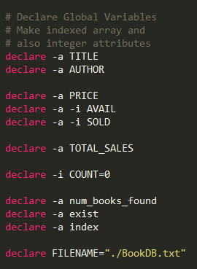

Add New Book
CODES:
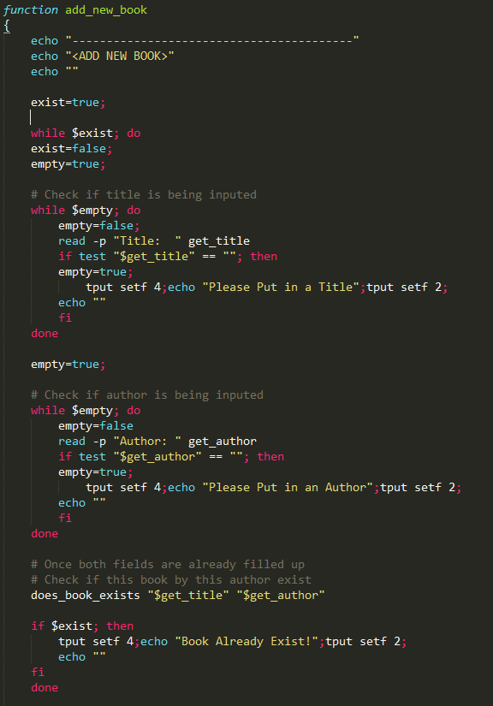
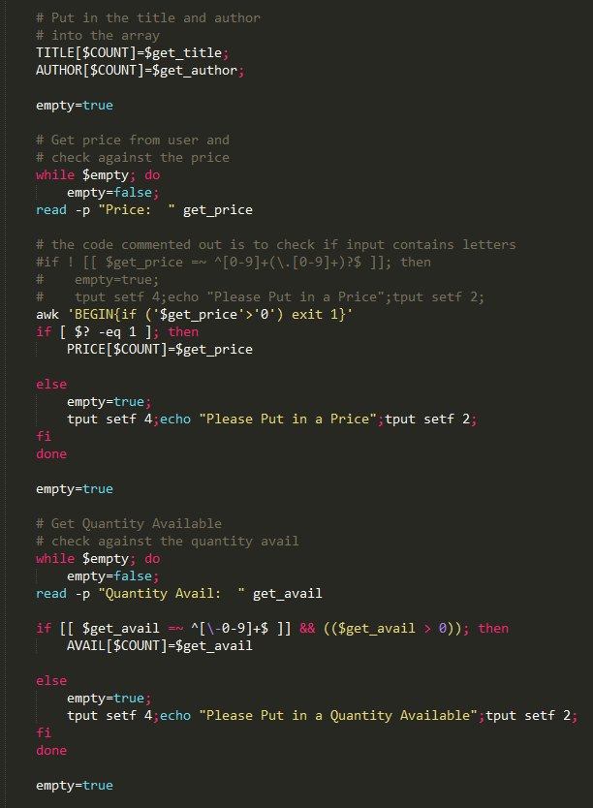
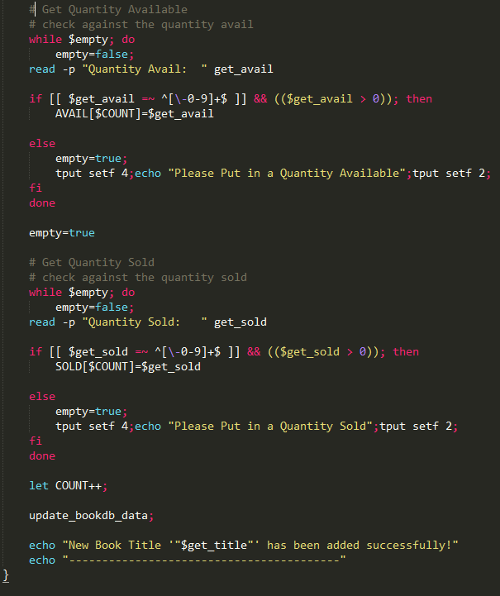
OUTPUT:
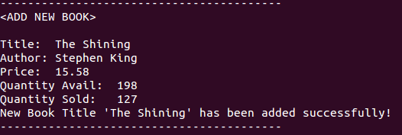

Remove Existing Book Information
CODES:
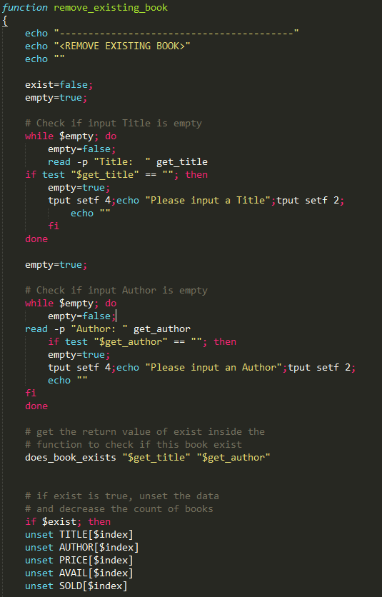
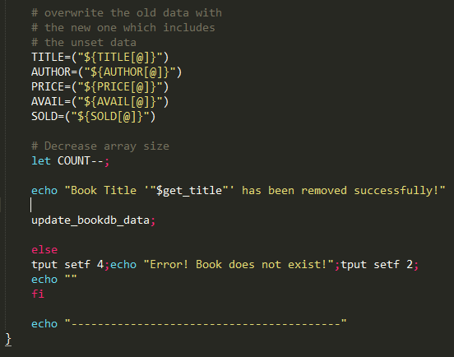
OUTPUT: (Happy Day – Mary Ann removed)
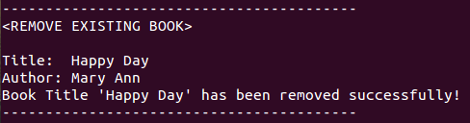

Update Book Information and Quantity
CODES:
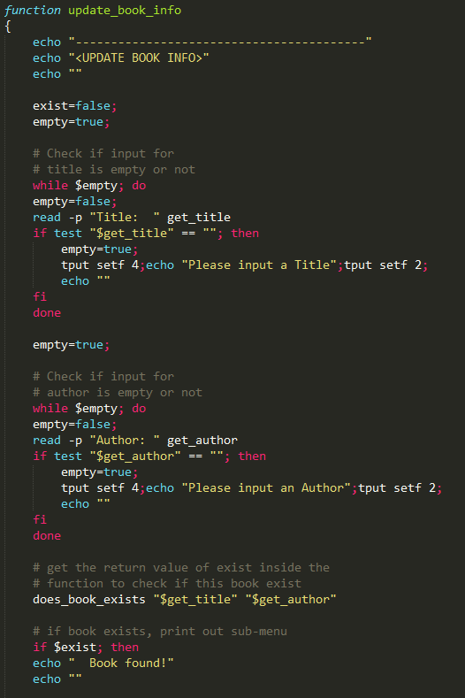
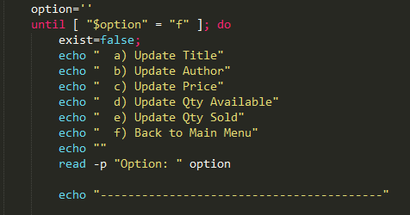
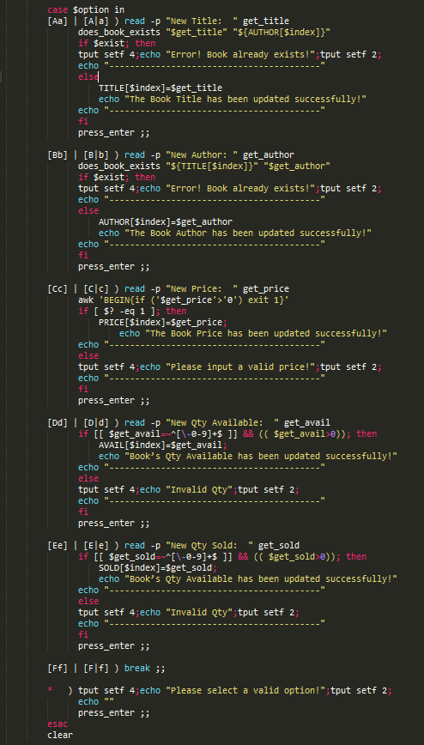
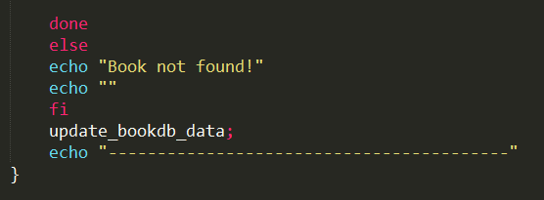
OUTPUT:
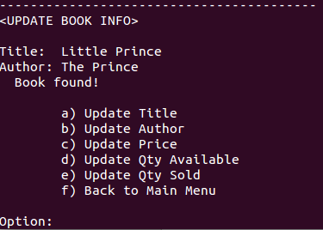
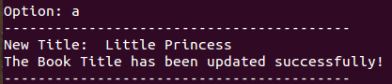
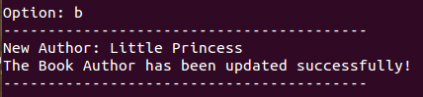
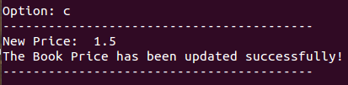
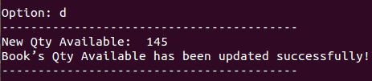
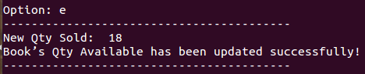

Search for Book by Title / Author
CODES:
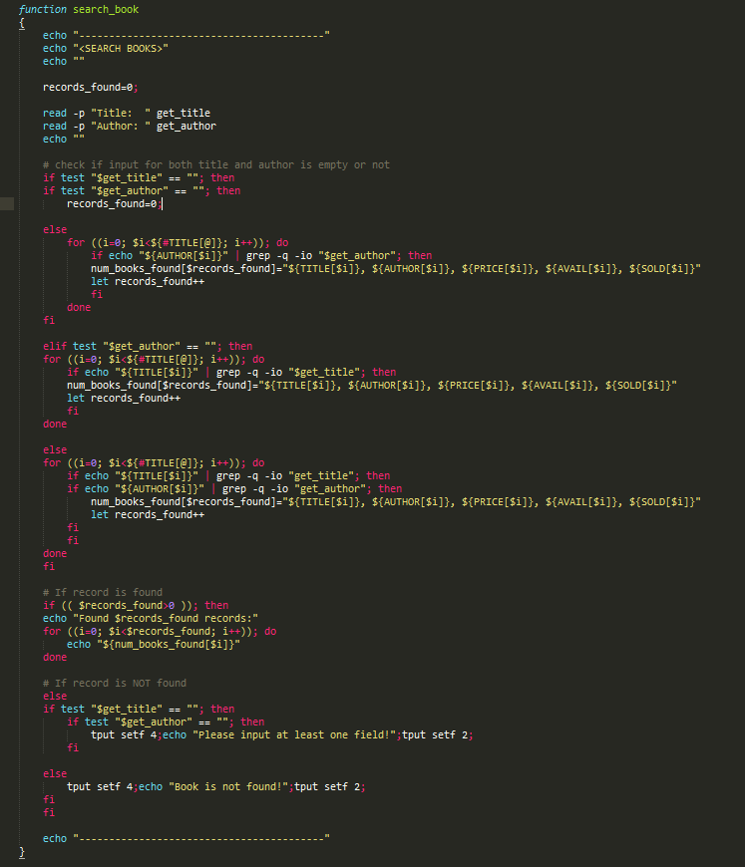

OUTPUT: (Search How to be Redundant 101 – Stephen Mayers)
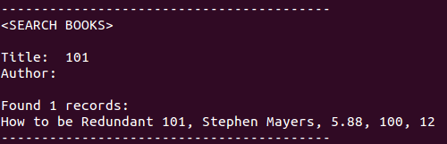

Process a Book Sold
CODES:
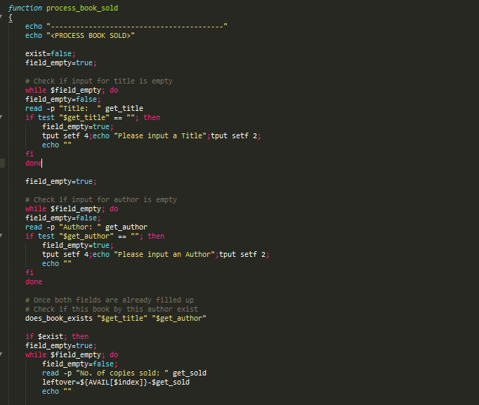
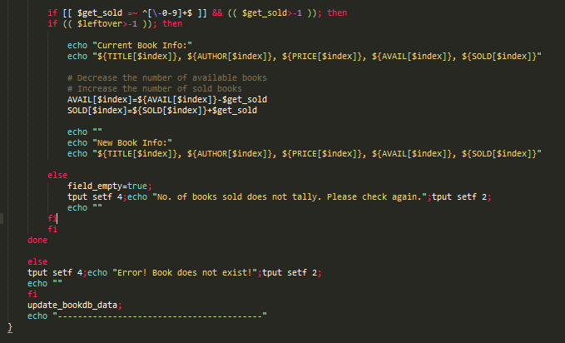
OUTPUT:
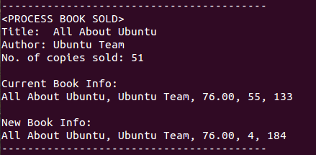

Inventory Summary Report
CODES:
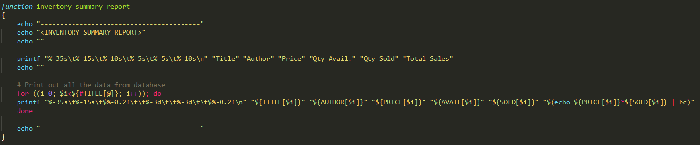
OUTPUT:
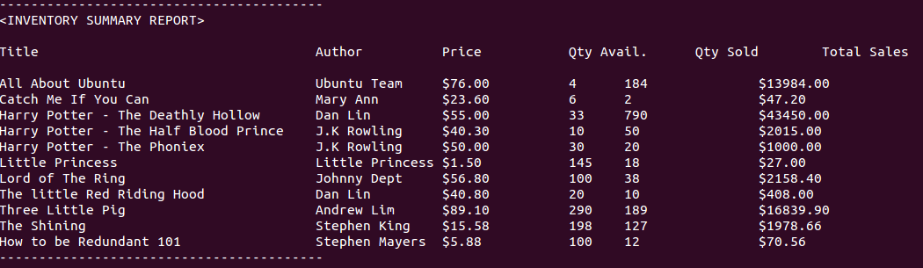

Report Book Statistics (Own User-Defined Function)
CODES:
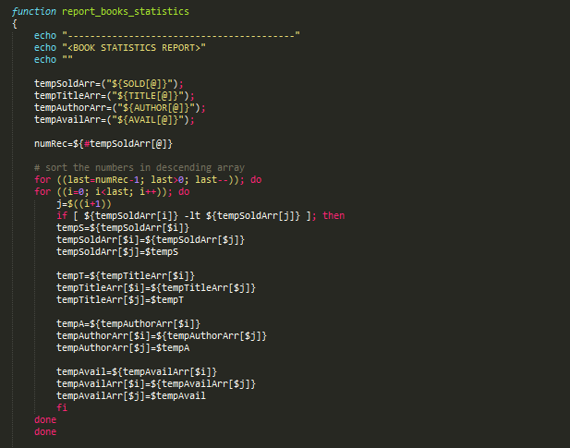
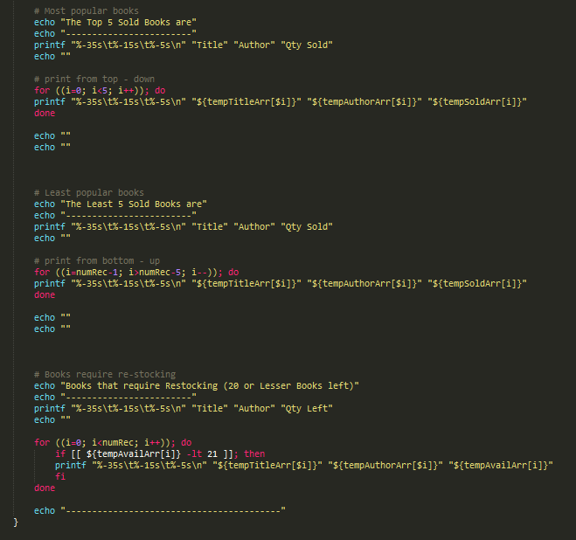

OUTPUT:
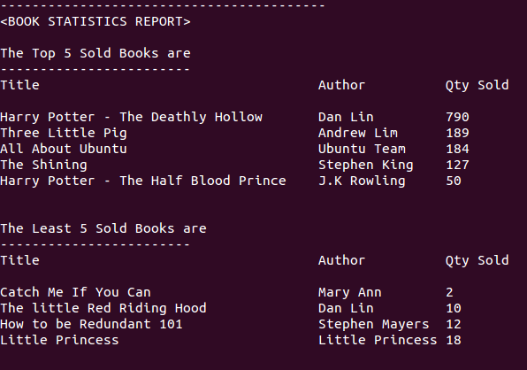
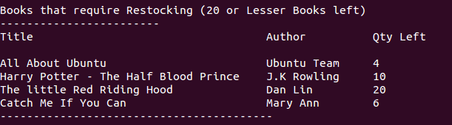

Access Database Data (Own User-Defined Function)
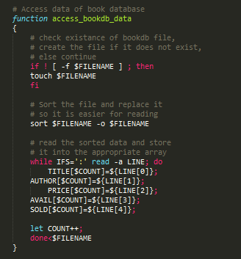

Check If Book Exists (Own User-Defined Function)
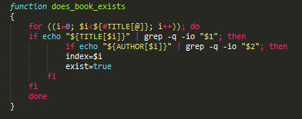

Update Database (Own User-Defined Function)
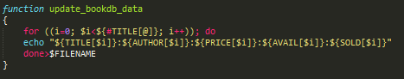

Final State of BookDB.txt
