Joshua Palicka

This program is designed to emulate the basics of a Yahtzee game and allow the basic attributes of Yahtzee (such as the number of dice and the number of sides each die has) to be adjustable. The classes in this program should be able to be easily built upon for future assignments.

I chose to include four classes for this assignment, a Die class, a Scorecard class, a Yahtzee game class, and a main class. The Die class creates die objects which have different attributes designed to emulate a physical die. The scorecard class emulates a Yahtzee scorecard. It creates a scorecard object which has dice and can roll the dice, outputting the scorecard values after each roll. The Yahtzee game class takes care of turns and builds a scorecard object. The main class builds a Yahtzee game object.

I didn’t have any major design issues with this program. It took a while for me to figure out how I wanted to build a dice sorter in an efficient manner due to never having sorted an object array before but this wasn’t too difficult.

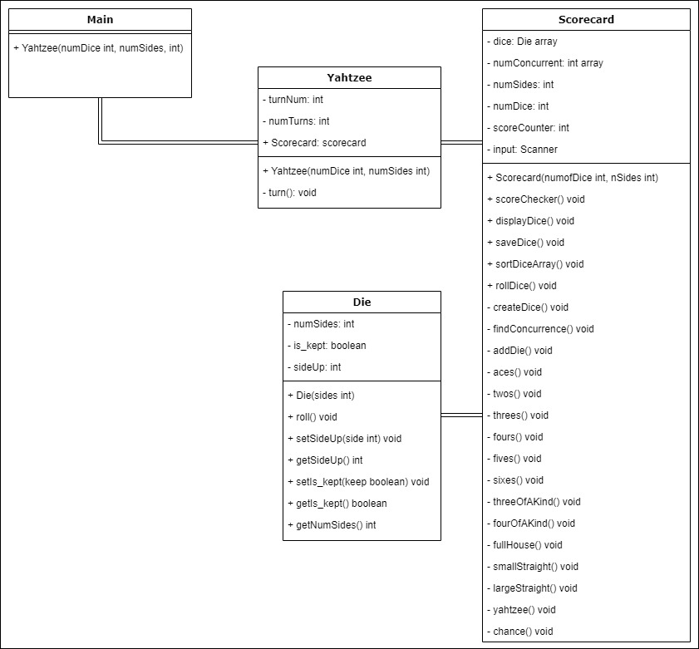If I had more time I probably would’ve started by creating a UML diagram in order to be more efficient in my design process.