
SIT102 Test 1 (Practice) - 2026 T1

Student Name: Saloni Mehta

Student ID: 434325
Official Use
⃝ Complete ⃝ Fix and resubmit ⃝ Redo
- Write the terminal command to create a new dotnet project in the current directory.
dotnet new console

- Write a terminal command to compile a C++ source file named Virus.cpp to an executable named virus using the SplashKit library.
clang++ Virus.cpp -o virus -l SplashKit

Read the following code, which contains a bug.
using static System . Console ; using static System . Convert ;

int valueKeeper ; int my Counter ; int dummy Var ; int i;

Write ( 11 Enter initial value: 11 ); valueKeeper = Tolnt32 ( Read Line () );

Write ( 11 Enter count value: 11 ); my Counter = Tolnt32 ( Read Line () );

i = 0;

do {
WriteLine ( valueKeeper ); II Print out valueKeeper valueKeeper --;
i++;

} while ( valueKeeper != my Counter );
- Hand execute this code with the following inputs: Enter initial value: 10
Enter count value: 8

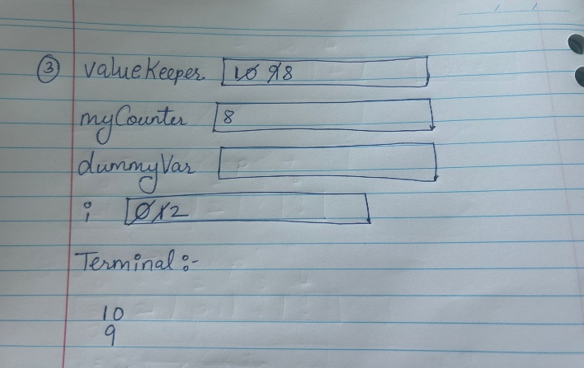
SIT1O2 Test 1 Term 1, 2O26
- Hand execute this code with the following inputs up to i == 4. Enter initial value: 14
Enter count value: 16

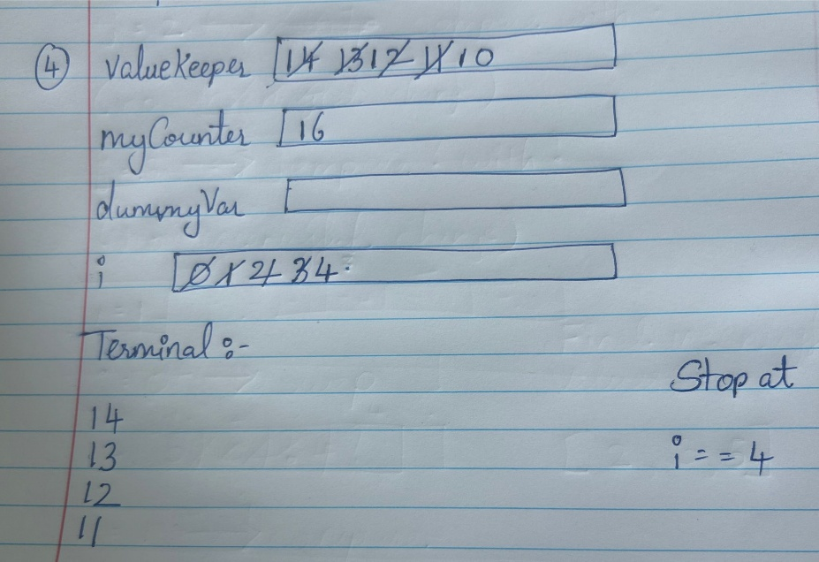

- What is the bug in this program?

valueKeeper--;

This only works when the initial value is greater than the count value. The bug is that valueKeeper is always
decreased using valueKeeper--. If myCounter is greater than valueKeeper, the loop will never reach the target value, so the loop runs forever.

- Write C# code which continuously prompts a user to input a number, terminating if the number is divisible by 11. Recall that the remainder operator in C# is %, so an integer stored in num is divisible by 11 if (num % 11) == 0.

using static SplashKitSDK.SplashKit;

using static System.Convert;

int num;

do
{
Write("Enter a number: ");
num = ToInt32(ReadLine());
}
while ((num % 11) != 0);

WriteLine("The number is divisible by 11. Program ended.");

