**Bluetooth LE Strain Module**

Joshua Sayavong

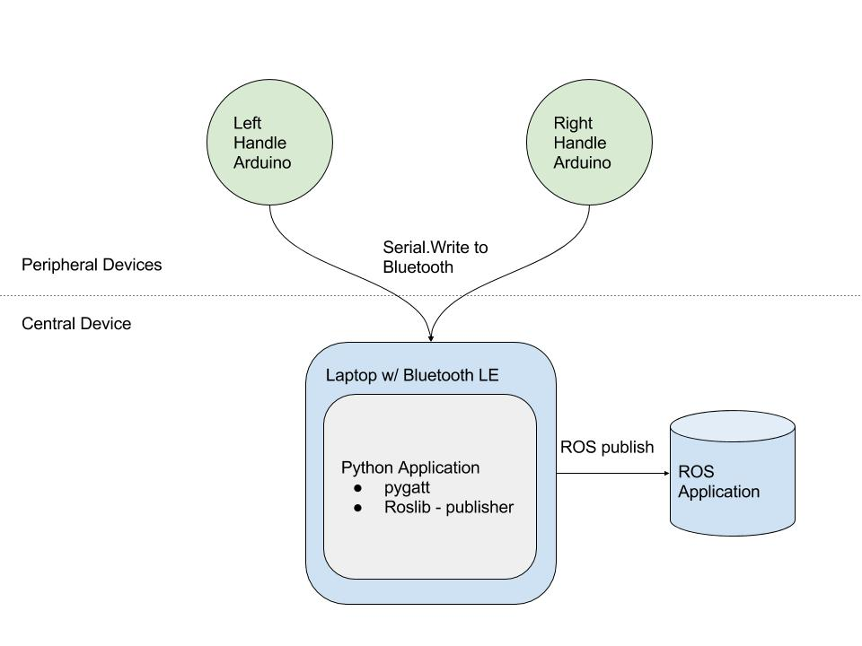

**Use AT Commands to configure the Bluno:**

<NL> +++

<NL+CR> AT+SETTING=DEFPERIPHERAL

<NL_CR> AT+NAME=<NAME>

Refer to:

https://www.dfrobot.com/wiki/index.php/Bluno_SKU:DFR0267#AT_Command_List

**Using Gatttool for Connection**

-install latest version of bluez

sudo hcitool lescan

sudo gatttool -b <ADDRESS> -I

char-scan

Refer to:

http://www.jaredwolff.com/blog/get-started-with-bluetooth-low-energy/

**Bluno Services Endpoints:**

Service:

0000dfb0-0000-1000-8000-00805f9b34fb

Serial Characteristic:

0000dfb1-0000-1000-8000-00805f9b34fb

**Arduino Program:**

-reads data from 3 sensors and sends the serial data in the following form:

-calibration is done within the arduino program

<START_BYTE> <ID> <X_VALUE> <Y_VALUE> <ZVALUE>

i.e. AB 01 BA 9D 3B

**PyGatt:**

-implements gatttools through python

-can be used to parse in data

Data Type:

**Appendix A: GATT - Generic Attribute Profile**

-contains services and characteristics

-16 bit ID’s

-ONE peripheral device can be connected to ONE central

-one central device can be connected to multiple peripherals

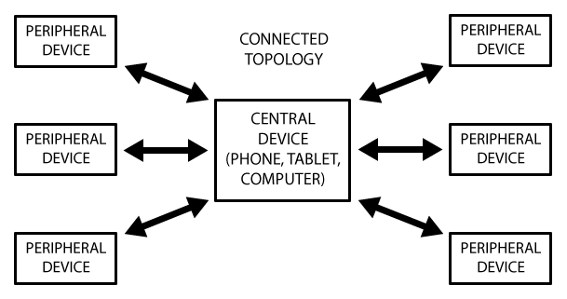-communication is done both ways

**Transactions:**

-slave/peripheral device is GATT Server (w/ ATT Lookup Data)

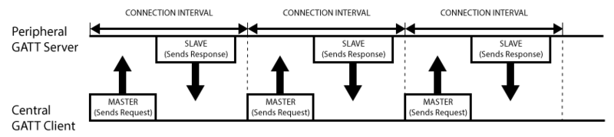-master/central device is GATT Client (phone, etc.)

-data exchange within connection interval:

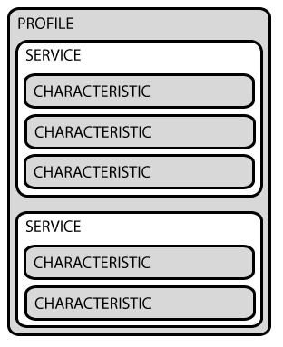**Services and Characteristics**

Profile

– predefined services compiled by Bluetooth SIG(Special interest group) or peripheral designer

Services

– Break up data into logic entities, offers services based on16bit or 128bit UID

Characteristics

- single data point, 16 bit or 128bit UUID

**Sources:**

https://learn.adafruit.com/introduction-to-bluetooth-low-energy/introduction