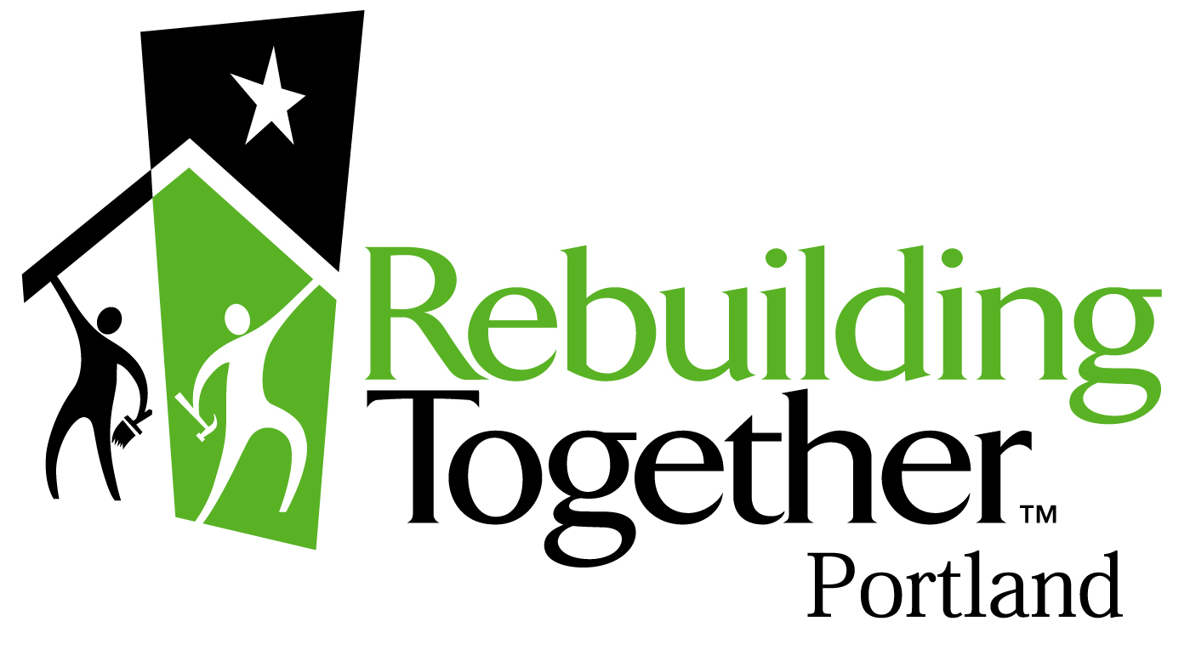 Rebuilding Together - Portland
Non-Profit Organization Referral Form – April 2012
(Please Print or Type)

Name of Non-profit organization(s):

Address:

Phone: How long at this address:

Monthly Income: _________________ Source: _____________________

This non-profit assists with: Elderly: ___ Disabled: ____ Low-Income: _ Children: _____ Other: ______

Please describe assistance: ______________

Pertinent information concerning organization situation and general condition of the facility:

Number of people using this facility: ________________________________________________

Description of the work the organization needs (be as specific as possible): ______

Is the non-profit organization aware of this referral: (Use reverse side for additional info/comments)
** Please explain that: 1.) this is a one-day program and all the work is done by volunteers
2.) this referral does not guarantee acceptance into our program,
3.) all requested projects may not be provided
4.) services are provided at no cost to the non-profit organization

Name of person submitting this referral:
Agency: __ Phone: _____ Date:

PLEASE SEND THIS FORM TO: Rebuilding Together - Portland
5000 N. WILLAMETTE BLVD.
PORTLAND, OR 97203 (Office) 943-7515 (fax) 943-7322
e-mail: mikemalone@rebuildingtogetherportland.org
www.rebuildingtogetherportland.org

