Concept of Design Patterns

MVC Pattern

This well known pattern pushes a split of concerns, it means local model and controller logic are not coupled from the user interface. As a result maintenance and testing of the application become simpler and easier.

MVC design pattern splits an application into three main pieces: Model, View and Controller

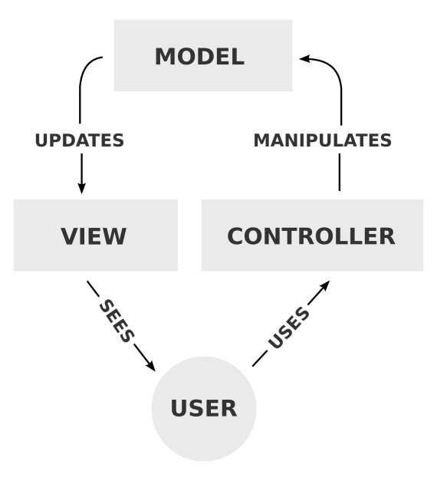

## MVP pattern

This pattern is similar to MVC pattern in which controller has been replaced by the presenter. This design pattern splits an application into three main aspects: Model, View and Presenter.

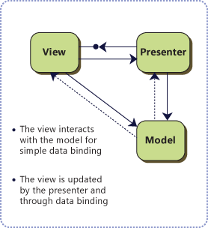

## MVVM pattern

MVVM stands for Model-View-View Model. This pattern supports two-way data binding between view and View model. This enables automatic propagation of changes, within the state of view model to the View. Typically, the view model uses the observer pattern to alert changes in the view model to model.

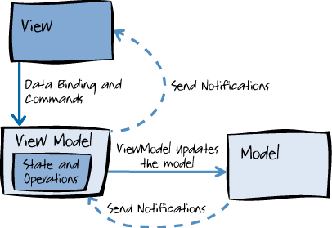

Program Help Screens

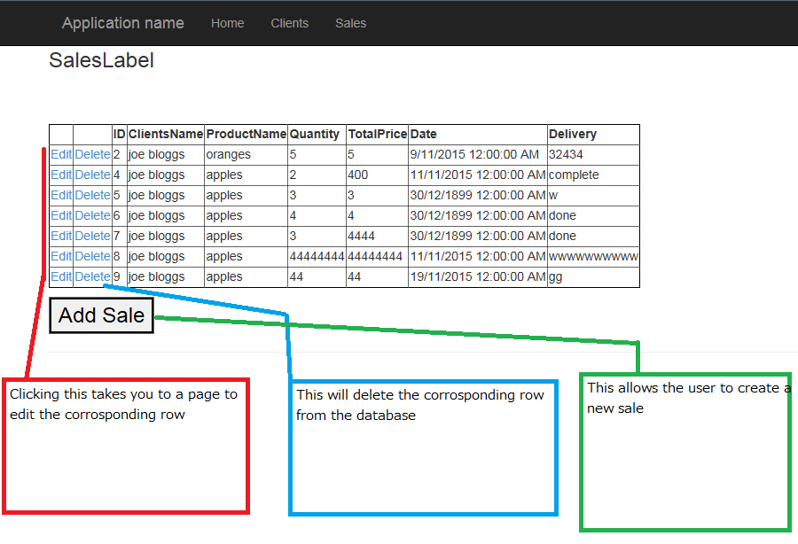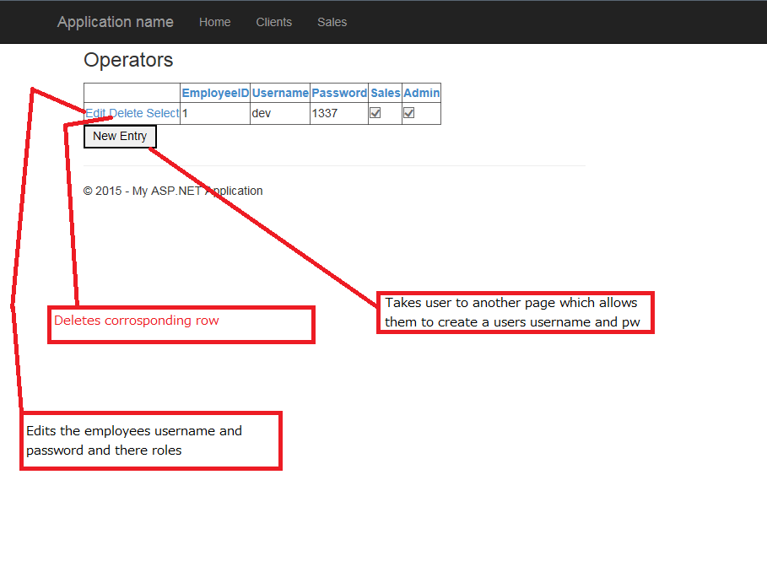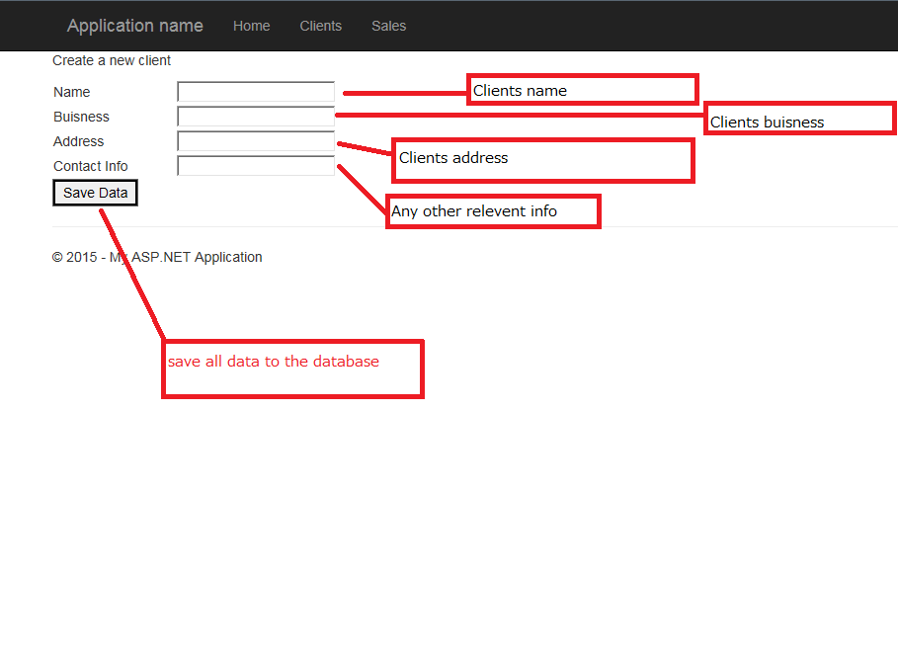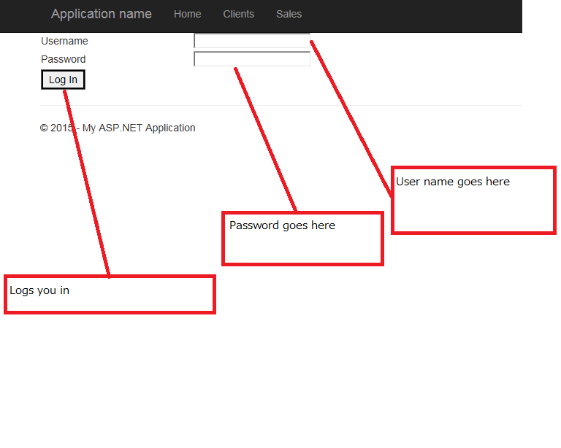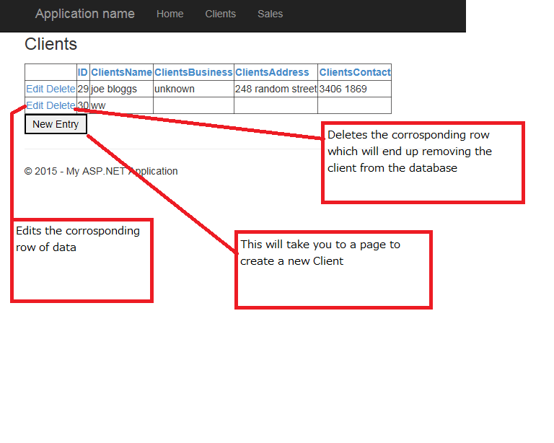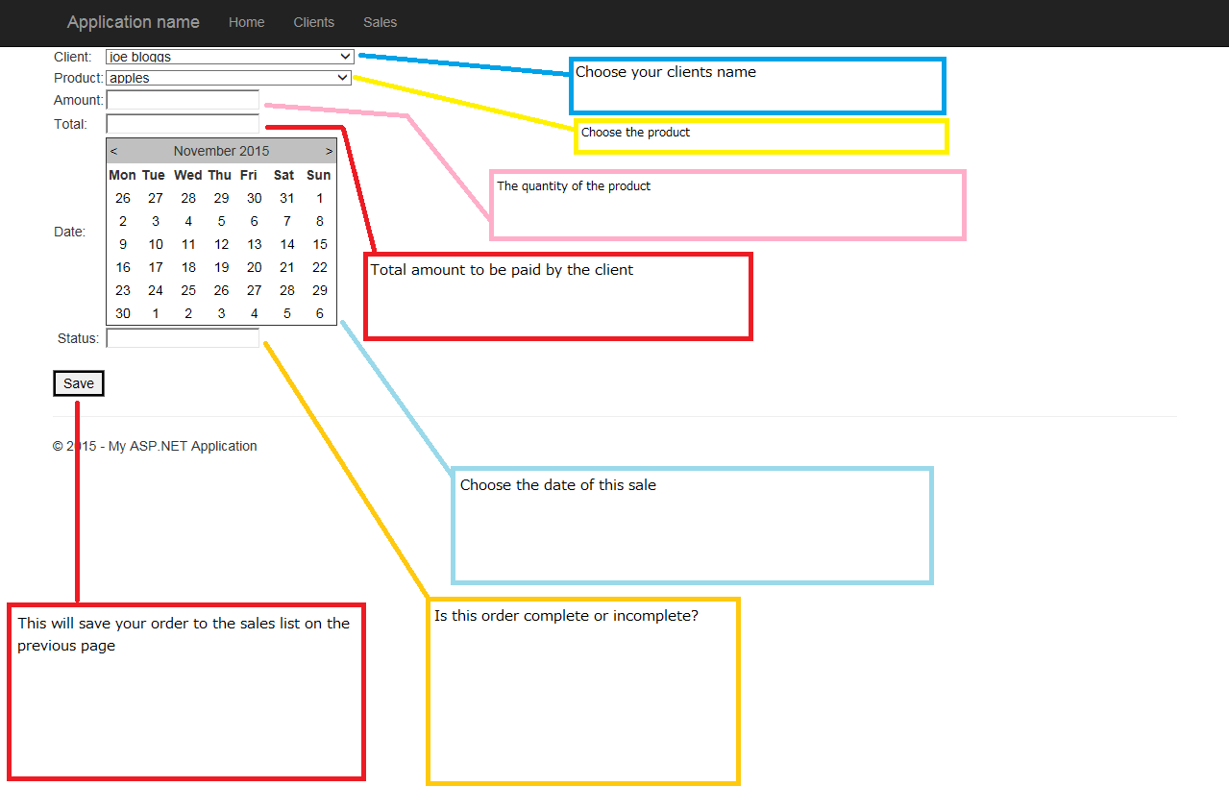

Solution explorer of Visual Studio

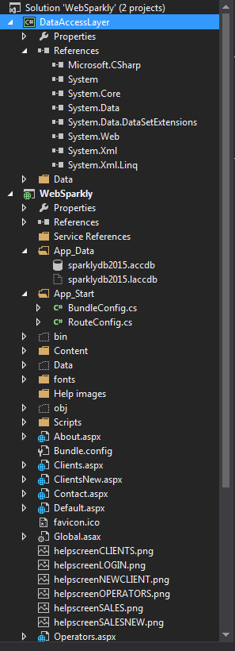

Logging frameworks

ObjectGuy Framework

The logging framework in Object provides you with a simple way to log information to any destination. It comes complete with loggers that maintain writing to the system console, a file on disk, a TCP/IP socket, and more.

Enterprise Library

The Microsoft Enterprise Library is a collection of reusable software mechanisms (application blocks) designed to help software developers with common enterprise development worries (such as logging, validation, data access, exception handling, and many others).

NLog

NLog is a free logging platform for .NET, Silverlight and Windows Phone with rich log routing and management capabilities. NLog makes it easy to produce and manage high-quality logs for your application regardless of its size or complexity.

Web Sparkly Flow Chart

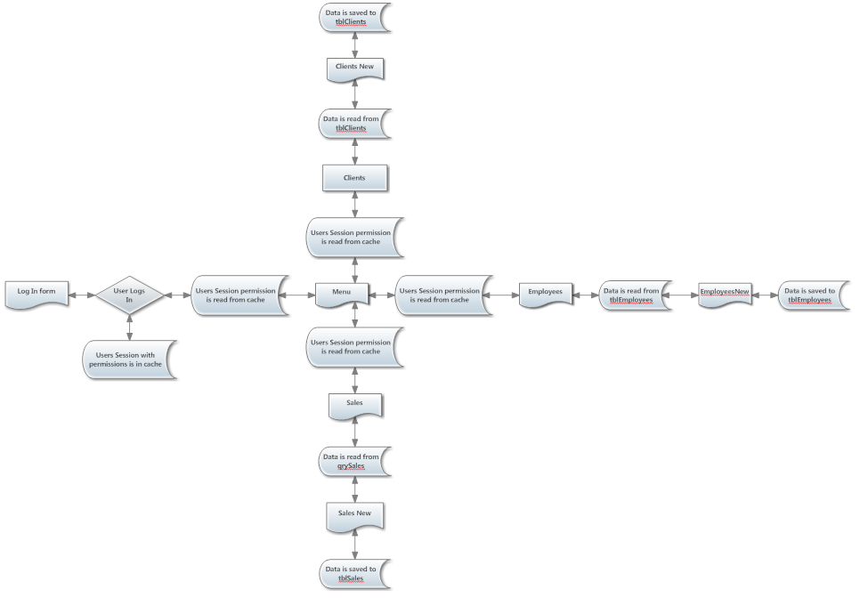

Version Control

The version control allows for remote access in which other users can add their code and feedback seamlessly.

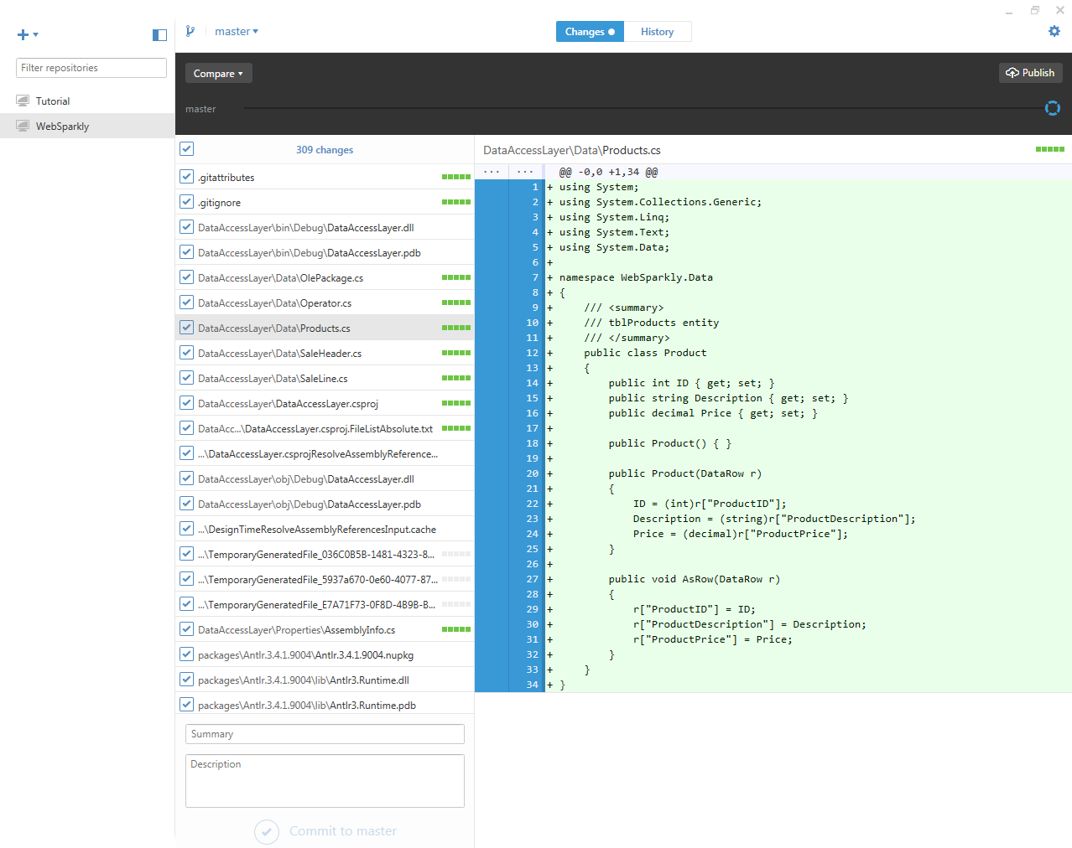

Test Sheet Tables

tblEmployees

|  |  |  |  |  |
| --- | --- | --- | --- | --- |
| EmployeeD | Username | Password | Prediction | Result |
| 5 | Bart | Simpson | Data will be saved with no problems | Data showed up with not problems |
| 6 | #$%^&*( | (*&^% | Some of these symbols may confuse the program but its most likely the program will read this as it does not interfere with mathematical or ID class. | There was no evidence of interference from these characters as they a valid for an OperatorName and OperatorPin. |
| 9999999999999999999 | 1 324234 | 0182 | I believe this will interfere with the data source and the ID has been modified which is automatically done by the data source. | The program displayed an error message. |

tblProducts

|  |  |  |  |  |  |  |
| --- | --- | --- | --- | --- | --- | --- |
| ID | ProductsName | ProductsSupplier | ProductsCost | ProductsSalePrice | Prediction | Result |
| 11 | $%^&* | asdfghj$ | 1 | 1 | Would be read by the program | Input string was not in the correct format thus a data error occurred as expected. |
| 12 | wafawf | $$$$$ | 2 | 2 | Would not be read by the program | Input string was not in the correct format and a data error event occurred as expected. |
| 13 | eSFsef | -+0.5 | 2 | 2 | Would not be read by the program | Input string was not in the correct format and an exception was given. |

tblClients

|  |  |  |  |  |  |  |
| --- | --- | --- | --- | --- | --- | --- |
| ID | ClientsName | ClientsBusiness | ClientsAddress | ClientsContact | Prediction | Result |
| 5 | Bart | Simpson | 349 saasdasdasd | 38071963 | Data will be saved with no problems | Data showed up with not problems |
| 6 | #$%^&*( | (*&^% | #$%^&* | #$%^&* | Some of these symbols may confuse the program but its most likely the program will read this as it does not interfere with mathematical or ID class. | There was no evidence of interference from these characters as they a valid for an ClientsName and ID. |
| 9999999999999999999 | 1 324234 | 0182 | 33424 | 324324 | I believe this will interfere with the data source and the ID has been modified which is automatically done by the data source. | The program displayed an error message. |

tblSales

|  |  |  |  |  |
| --- | --- | --- | --- | --- |
| Quantity | Paid | Client | Prediction | Result |
| 2 | 9.00 | joe bloggs | program will respond accordingly | Program proceeded to register the purchase |
| -4 | --9.0 | random name | will not validate the sale | Program ignored illegal characters and did not continue to payment. |
| ++5 | ++5 | random name | Program will do the same as the negative inputs | Program doesn’t allow the input of the “+” symbol. |
| !!!!!!! | !!!!! | !!!!!!!!! | Program will most likely not allow the input of these characters. | The program does not make use of the input of these characters. |

Test Data

|  |  |
| --- | --- |
| Step No. | Task |
| 1 | Open MS Access |
| 2 | Allocate the data from the test sheet into the data base |
| 3 | Attempt logging into the program |
| 4 | Go to clients and Operators and try adding/editing/deleting data |
| 5 | Go to Sales try editing/deleting data |
| 6 | Go to SalesNew try adding data |
| 7 | Document your findings. |

Sign off sheet

**Tasks**

Login ✓

Create a Sale Order ✓

Create a Product ✓

Create a Client ✓

Edit a Sale Order ✓

Edit a Product ✓

Edit a Client ✓

Delete a Sale Order ✓

Delete a Product ✓

Delete a Client ✓

**Assessor Name:**

**Assessor Signature:**

**Summary of Feedback / Action Plan:**

Defect logs

Tick once complete

Calendar in the sales form didn't update to the column ✓

Create a Sale Order ✓

Create a Product ✓

Create a Client ✓

Edit a Sale Order ✓

Edit a Product ✓

Edit a Client ✓

Delete a Sale Order ✓

Delete a Product ✓

Delete a Client ✓

**Assessor Name:**

**Assessor Signature:**

**Summary of Feedback / Action Plan:**

Error log

|  |  |  |  |
| --- | --- | --- | --- |
|  |  |  |  |
| Error | Location | Type | Solution |
| NullReferenceException | Default.aspx | Logic Error | Attempted to check user credentials before user had logged in. |
| Button Not Triggering | Operators.aspx | Syntax Error | OnClick event was not attached |
| OleDbException | ClientsNew.aspx | Syntax Error | Connection string was to reaching to the table |
| Missing assembly reference | ClientsNew.aspx | Compilation Error | Button was referenced in back end code but no design for the button existed |
| Invalid exception term | SalesNew.aspx | Syntax Error | Bracket was missing |

Debugging Techniques

When I tried saving data to tblClients I received this exception.

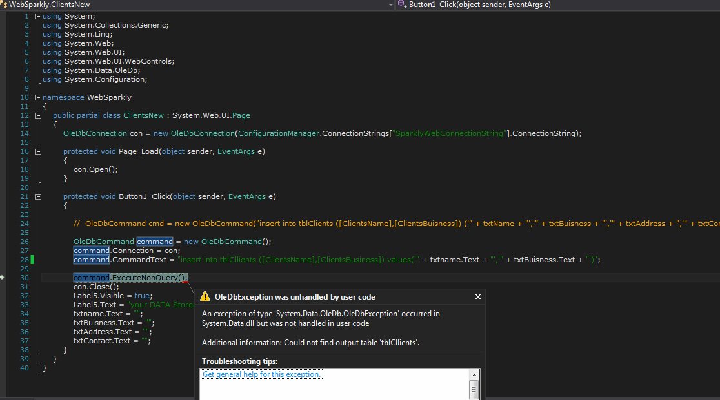

First thing I did was apply a line break around the connection string as previous errors have occurred, upon further inspection I noticed a typo in tblClients once that was fixed the program worked.

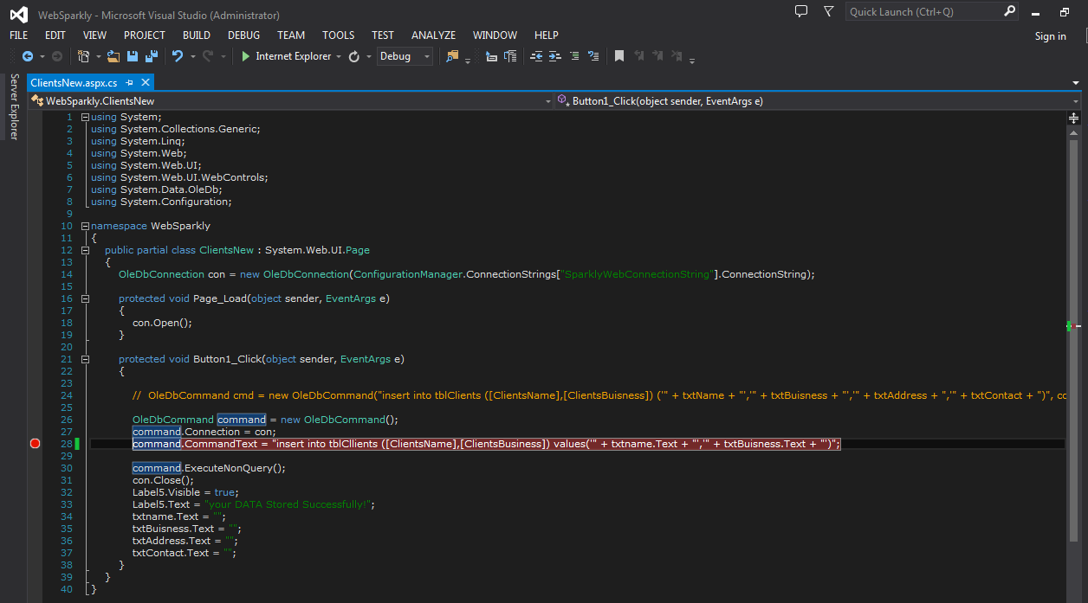

Pseudo-code

Loading Sales

Public Load Data()

{

Try this method

{

saleData = new data

connection (conn ) = new

conn.Open();

DataCommand (cmd) = new DataCommand("select from sales query ", conn);

DataReader= cmd.Execute

while (reader.Read)

{

saleData.Add (new SaleRecord)

}

Datagrid = saleData;

}

catch (Exception ex)

{

Txtcatch.txt = “didn’t work”

}

}

Sessions verification

{

if user permissions = “sales”

{

DataCommand command = new Datacommand();

Connection string = Con;

Data source = "select * from tblEmployees where Sales also Session ["USER_ID"];

Con.Open();

}

else

{

Send user to ("/Default.aspx");

}

}

catch

{

Send user to ("/Default.aspx");

}