**IDE: Visual Studio 2022**

Instructions on how to use the application forms:

1. Upon opening the SUBIDO_SkillTest.sln, right-click your project in **Solution Explorer**.

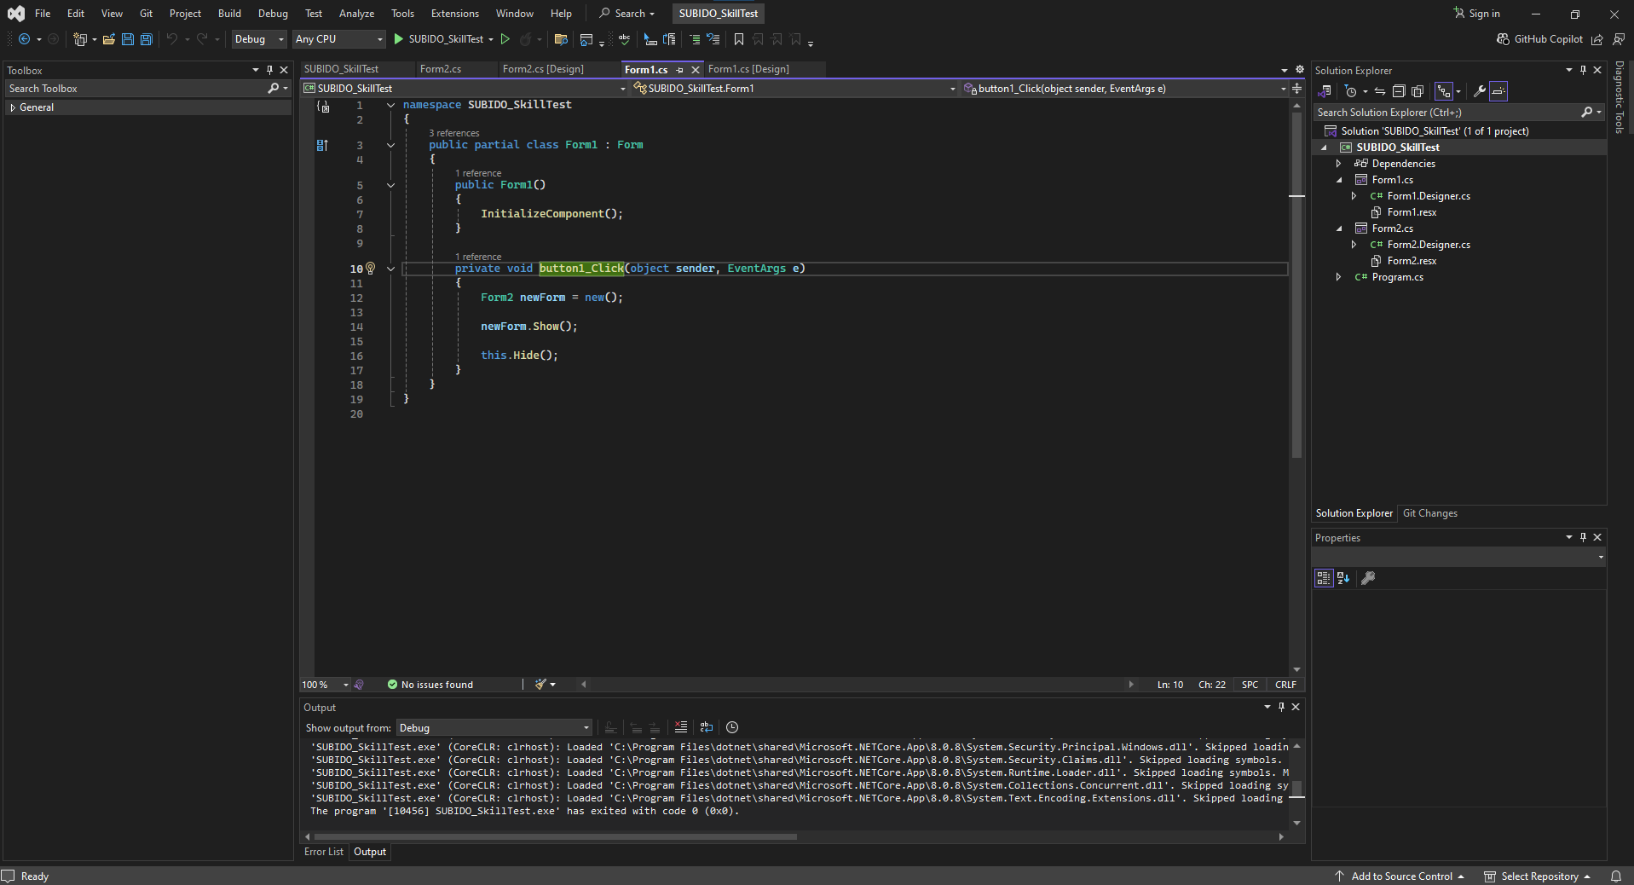

1. Go to **Properties**.

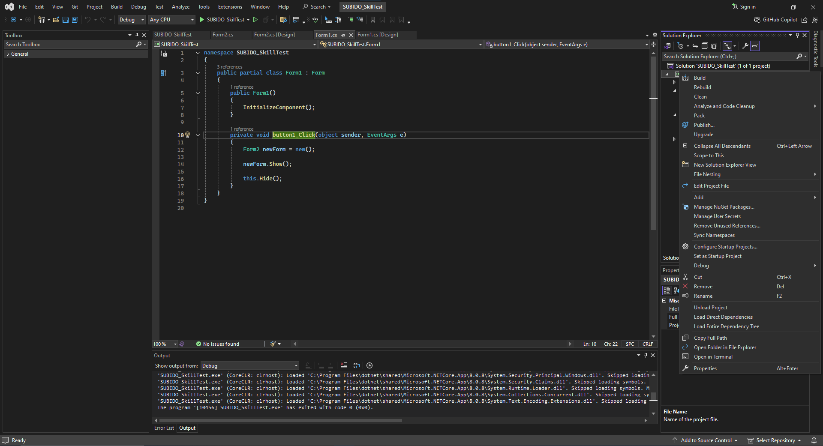

1. In the **Application** tab, find the **Startup object** dropdown.

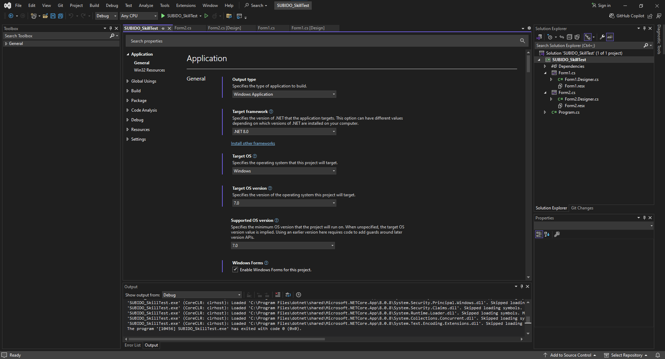

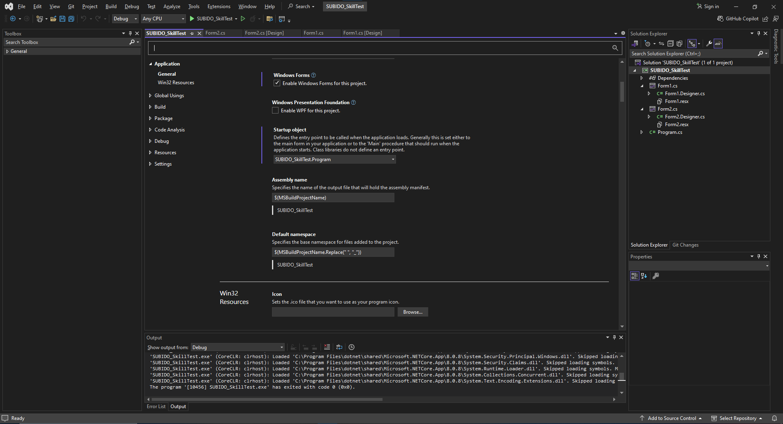

1. Choose either SUBIDO_SkillTest.Program (for the Windows Forms) or SUBIDO_SkillTest.TestSorting (for running your tests).

**If SUBIDO_SkillTest.Program is chosen**

* + Go to the **Application** tab, find the **Output type** dropdown.



* + Choose **Windows Application**.

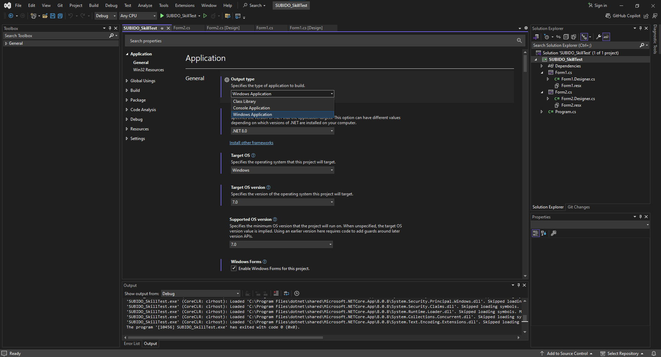

* + Press CTRL + Shift + B to rebuild the project.
  + 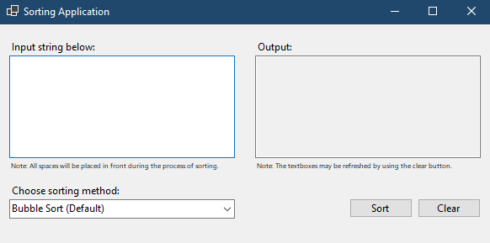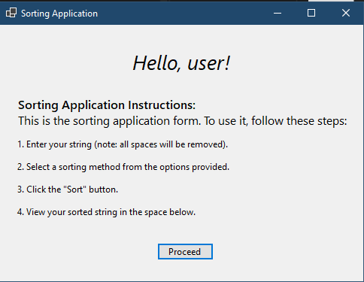Run the code to see the Application.

**If SUBIDO_SkillTest.Program is chosen**

* + If SUBIDO_SkillTest.TestSorting is chosen, go to the **Application** tab, find the **Output type** dropdown.



* + Choose **Console Application**.



* + Press CTRL + Shift + B to rebuild the project.
  + Start Debugging (F5) to see the Console.

