National Aeronautics and Space Administration

[[CENTER]]
[[CENTER_ADDRESS]]
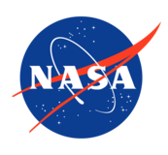

[[DATE]]

Reply to Attn of: [[ATTN_OF]]

TO: NASA Civil Servants

FROM: [[FROM_LINE]]

SUBJECT: [[SUBJECT_LINE]]

Applicable references: FAR 15.101; NFS CG 1815.11(i); NFS CG 1815.27(b); NASA Source Selection Guide §3.24.
[[ACQUISITION_INTRO]]

[[BLACKOUT_BODY]]

[[CO_REFERRAL]]

[[RELATED_CONTRACTS]]

[[OPTIONAL_RESOURCES]]

[[RESOURCES_FIREWALL]]

_______________________
[[SIGNER_NAME]]
[[SIGNER_TITLE]]

